STEP BY STEP APPROACH OF MY “NEWS-API” WEB APPLICATION

My APPLICATION INCLUDES:

\* REGISTER PAGE

\* LOGIN PAGE

\* NEWS SEARCH PAGE

My Registration page looks like the following, includes

-Username, User Email, Password, Confirm Password, User Telephone

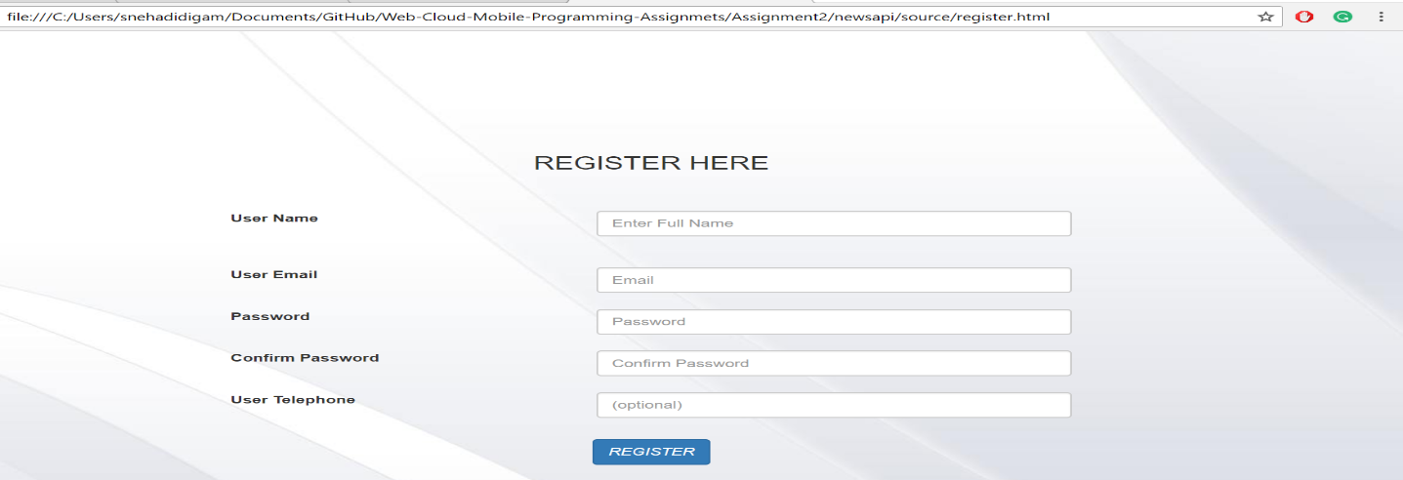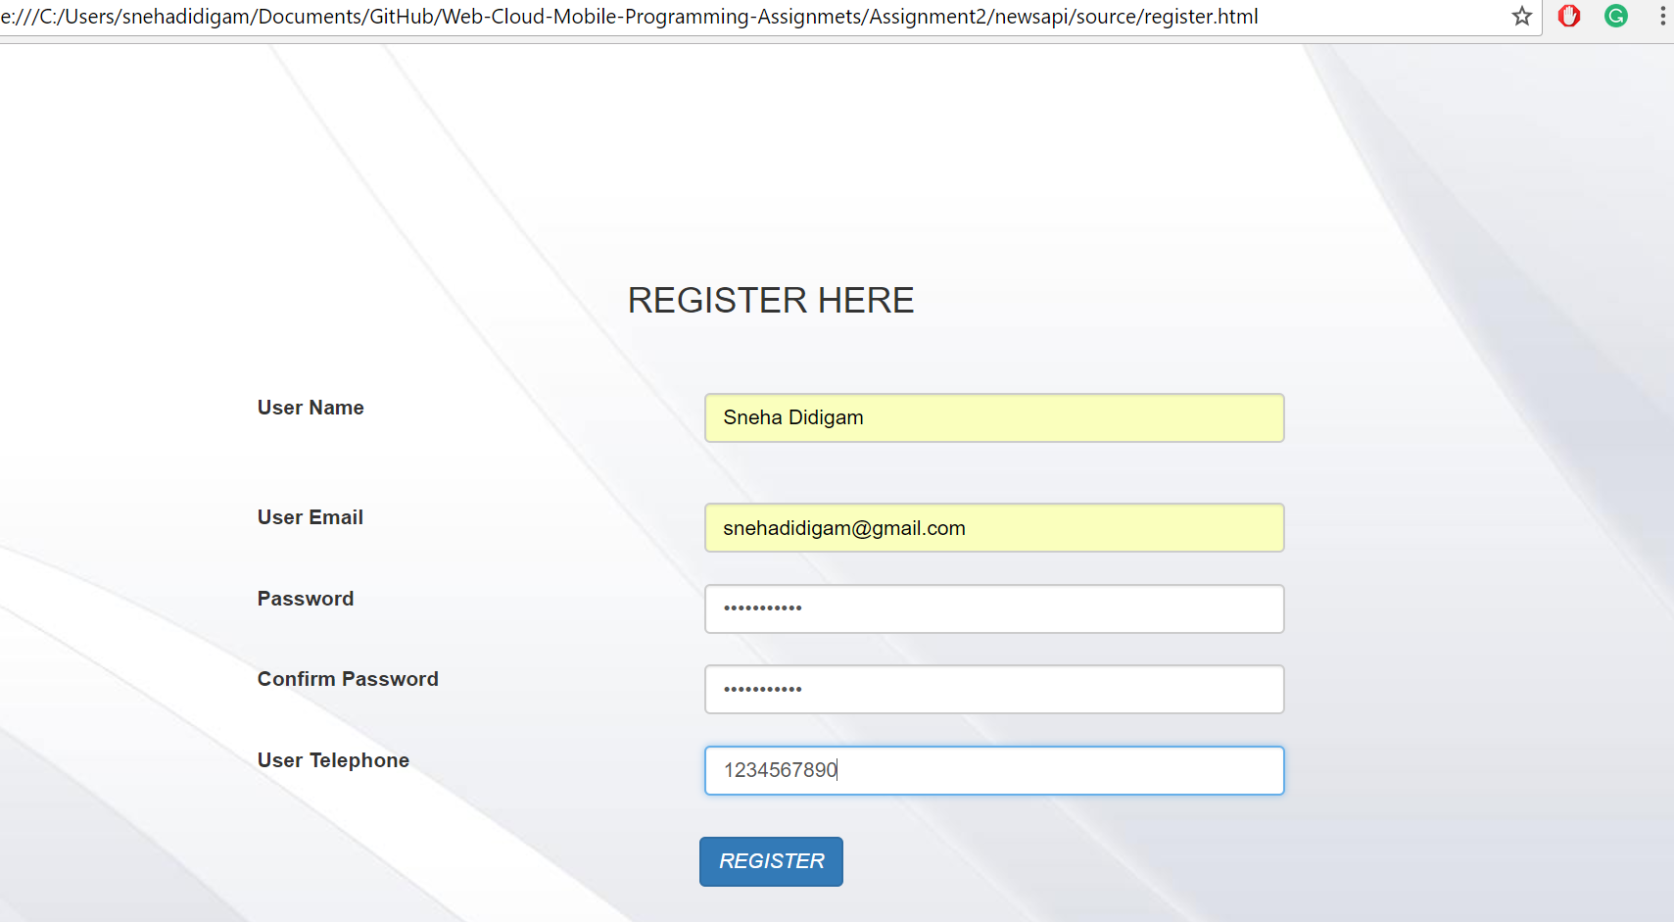

After clicking the "REGISTER" button. It will navigate to the "LOGIN" Page.

My Login page looks like the following, includes

-User Email, Password

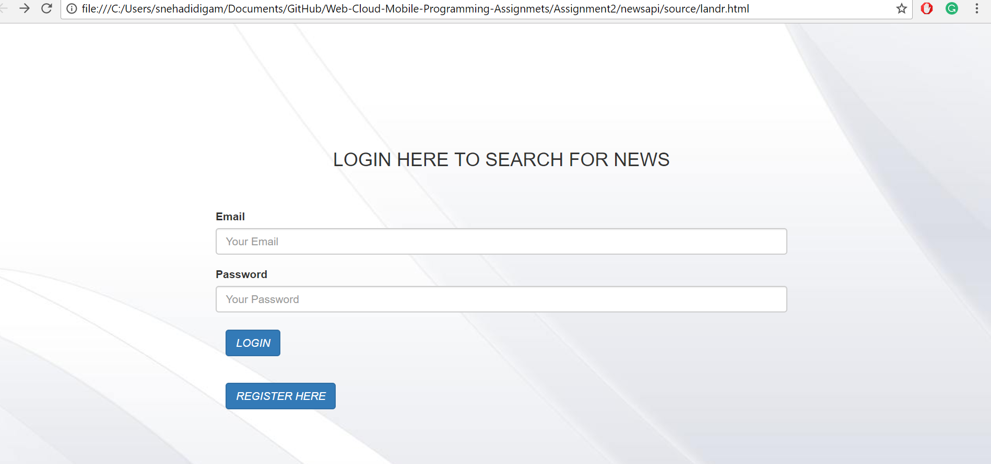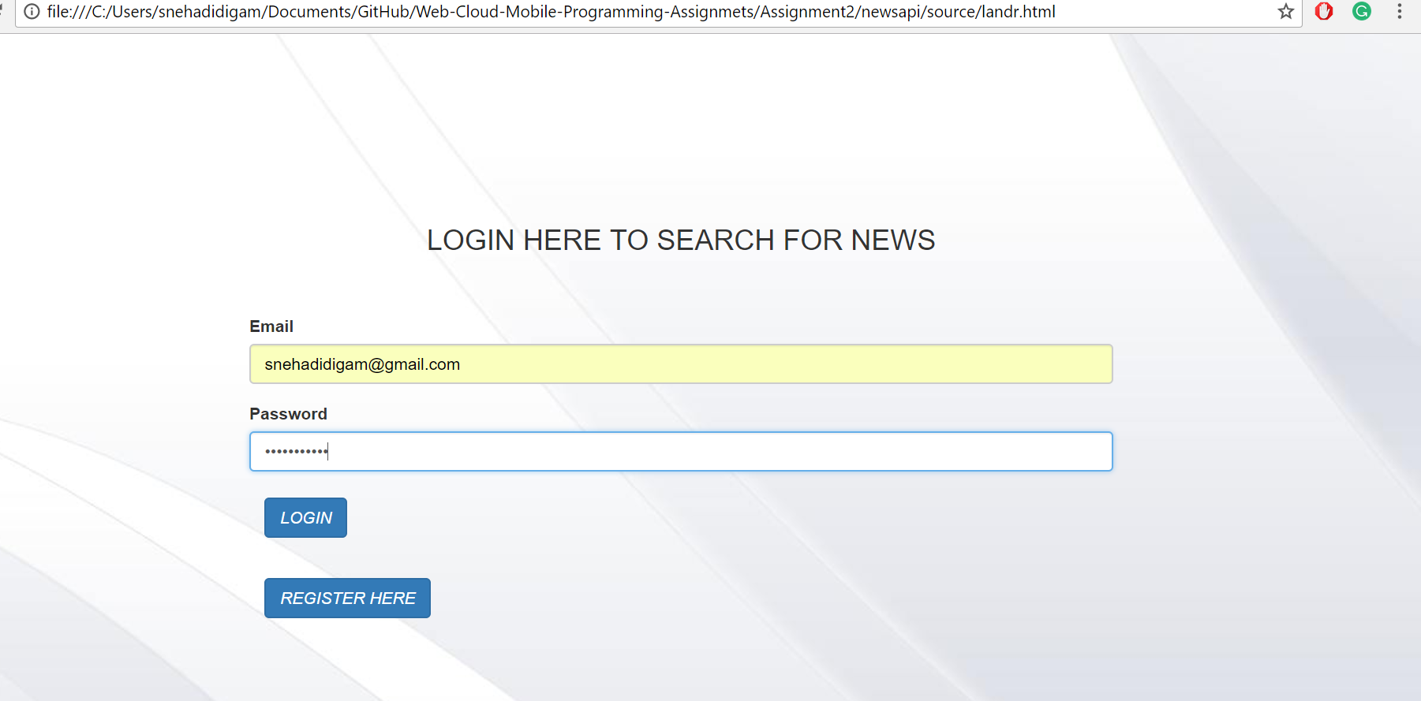

After successful login, My application navigates to the search page :

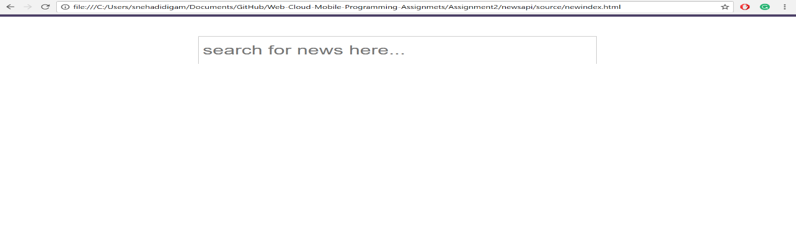

In the search bar, User can search for topics.

My search results the top 10 results include:

\* Article Title

\* Author

\* Description

\* Article URL

\* Image

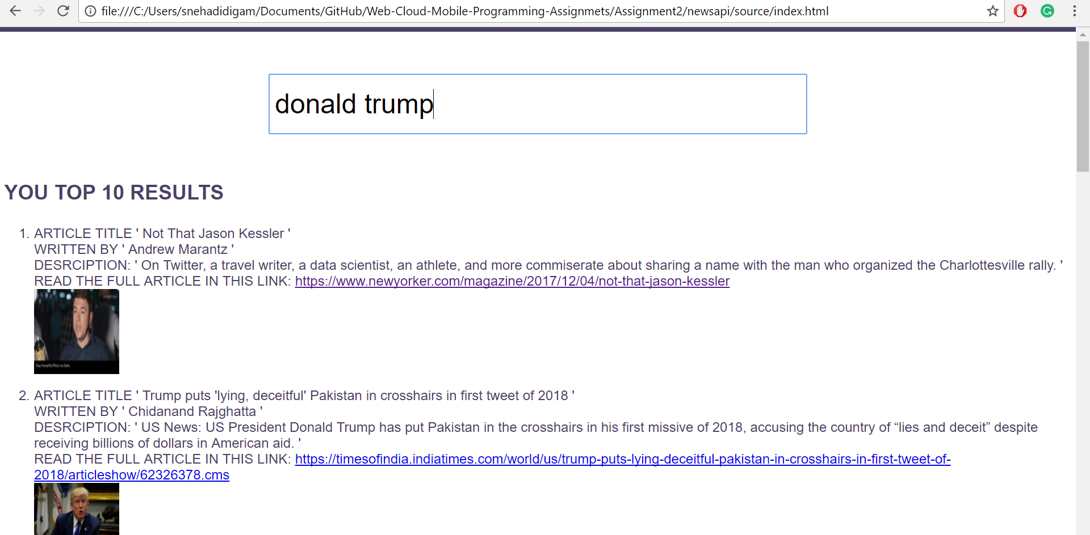

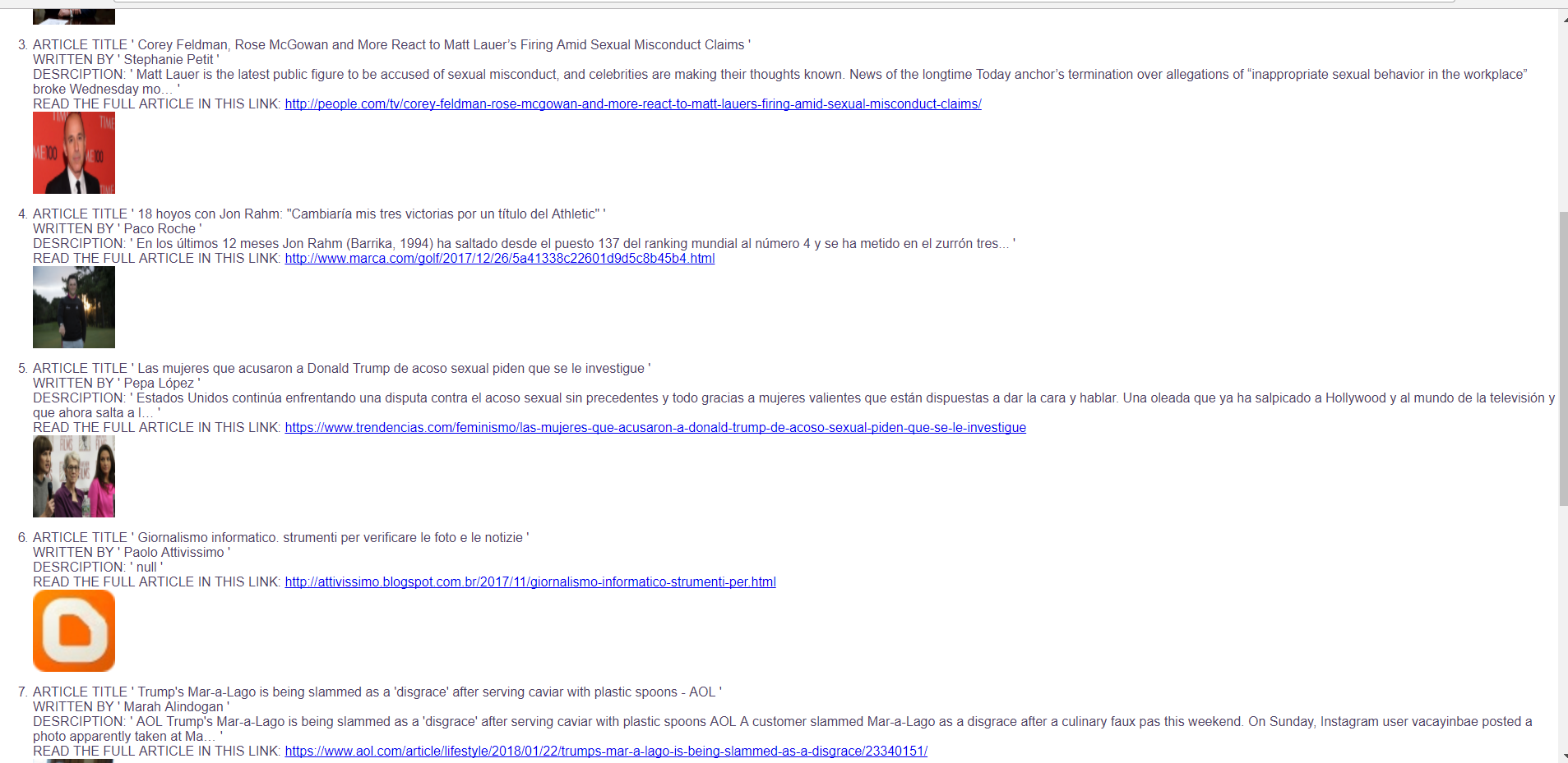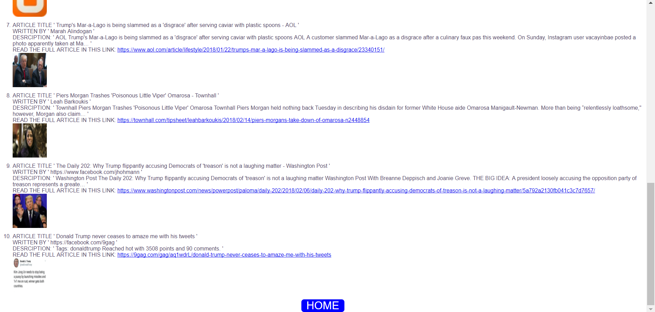

On clicking the HOME button navigates to the Search page again.

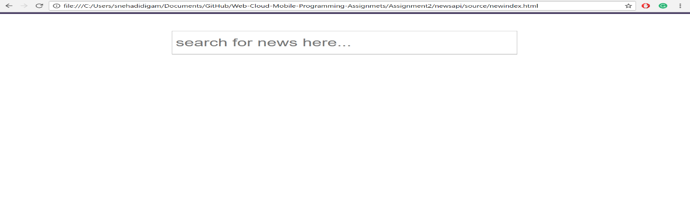

On clicking on image or url will redirect the page to the full article:



The curl results of my search:

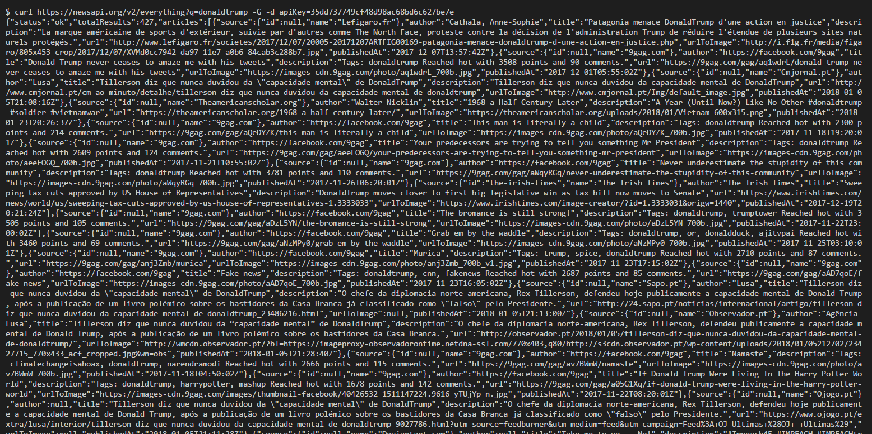

STEP BY STEP APPROACH OF MY “NEWS-API” WEB APPLICATION

\*My Game is for 2 players

\*It is the game developed in Angular js

Home page:

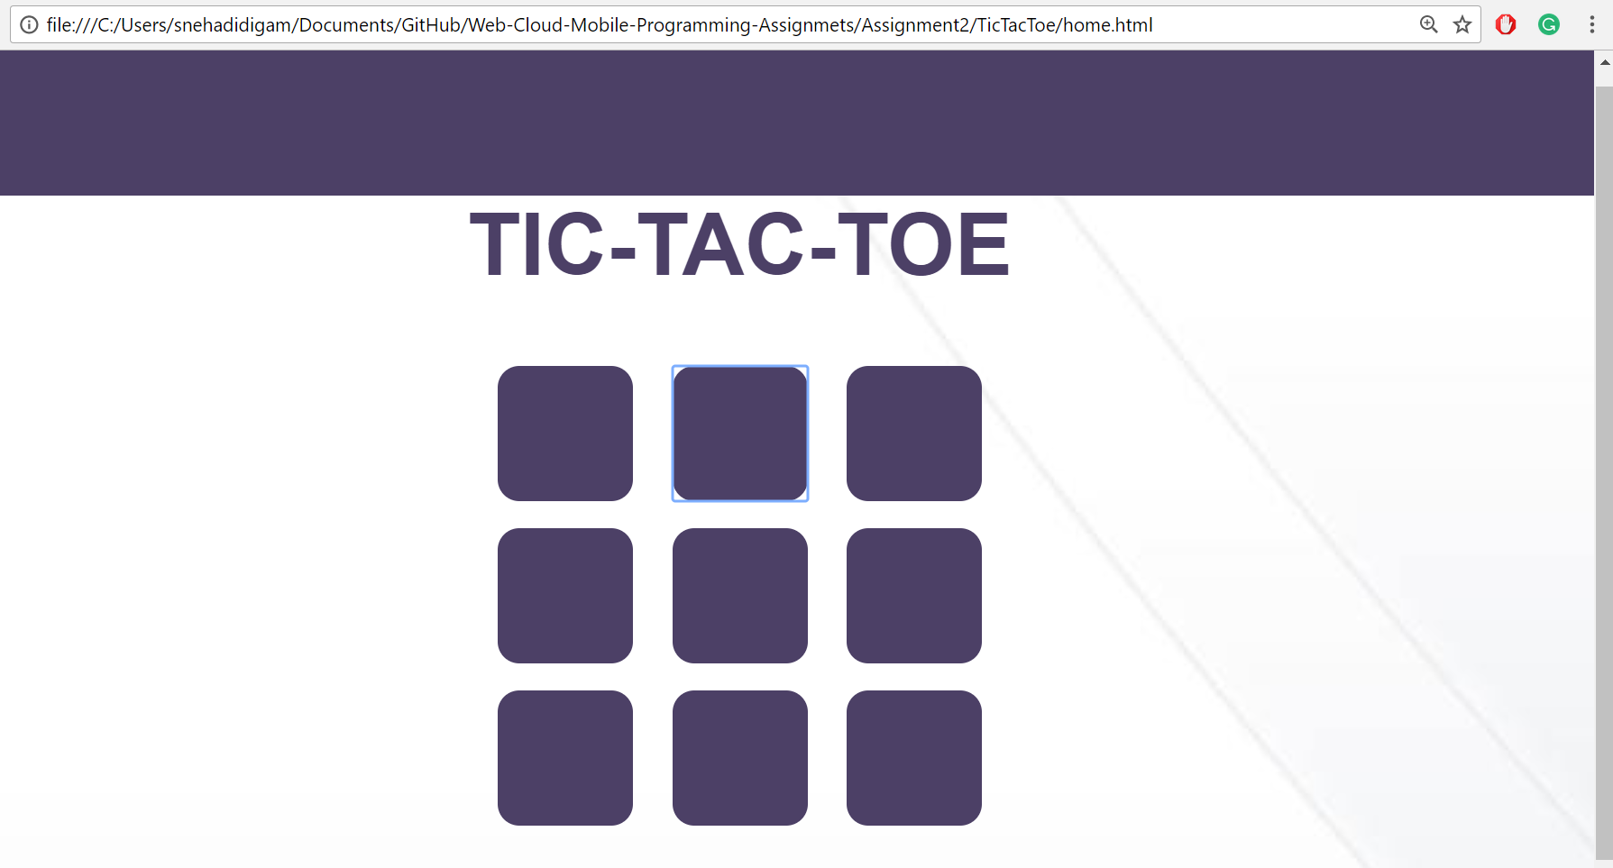After playing the game:

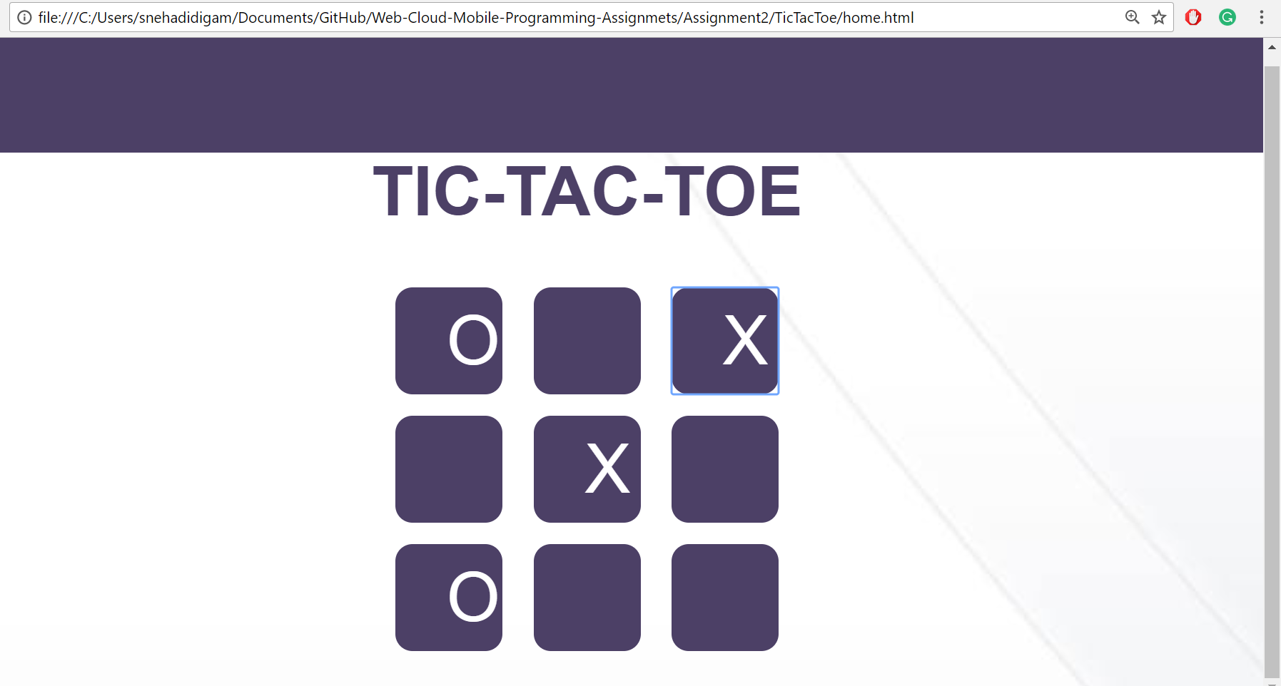

After finishing the game the result is alerted to the user

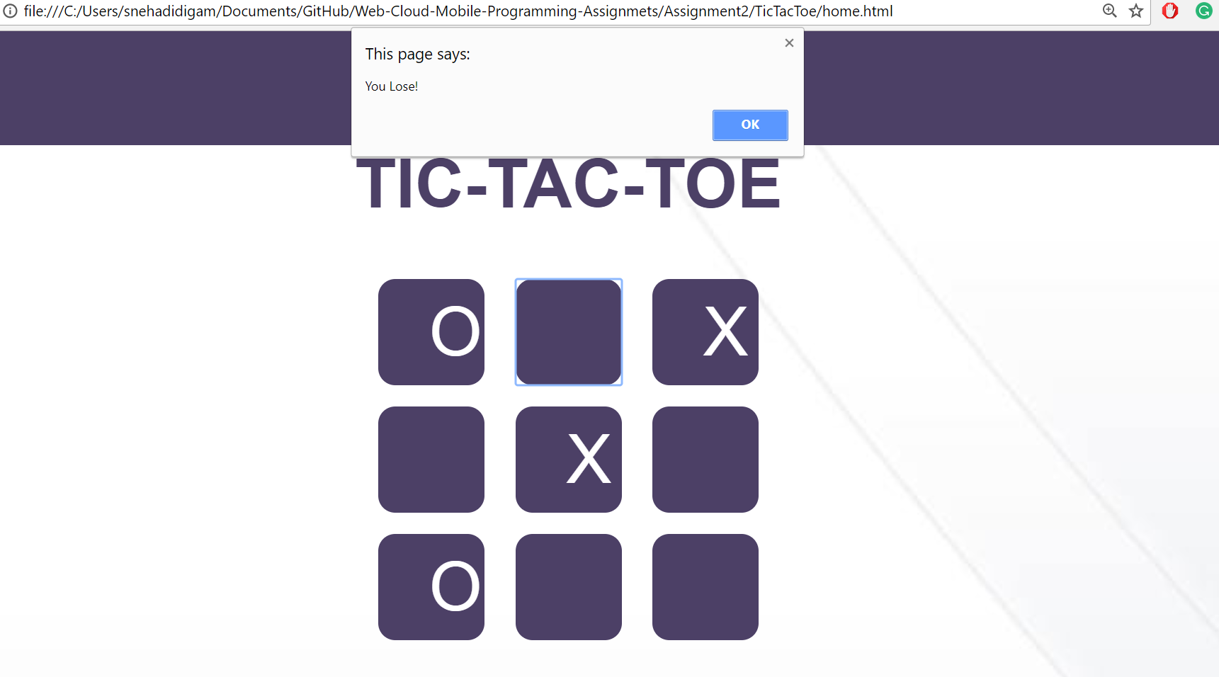 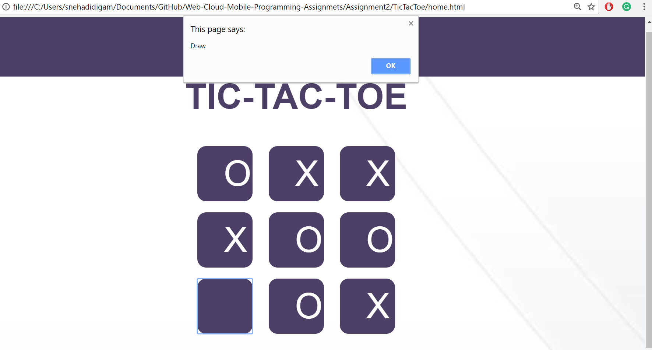

on clicking "Ok" will navigate to the game again.