MY HOME PAGE

\* Created a Web Page which displays different levels of education, semesters and career options

\* User can Select the desired combination

\* Listed levels in dropdown list

\* Below are the screenshots of my Web Page

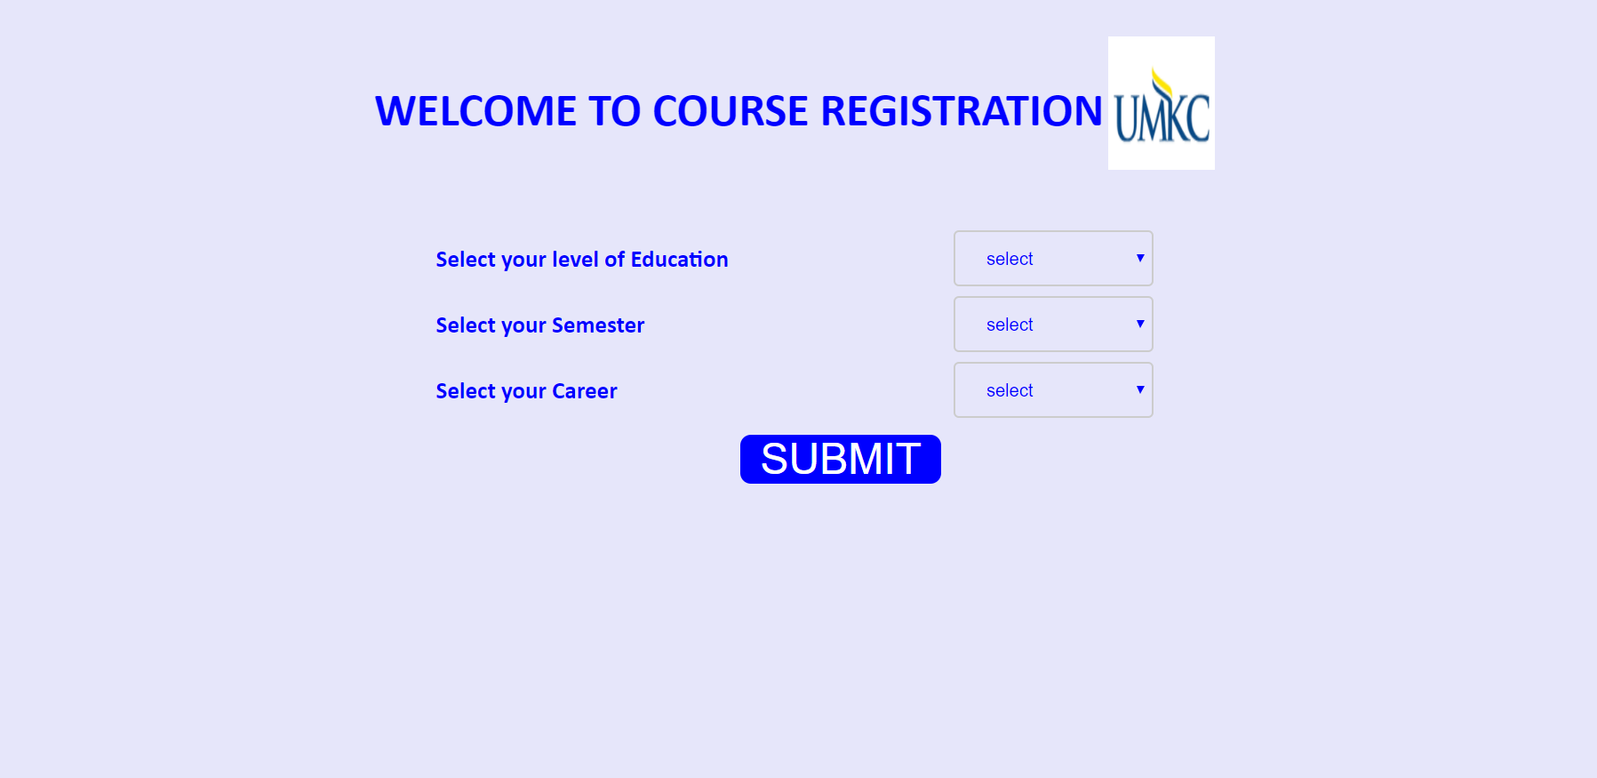

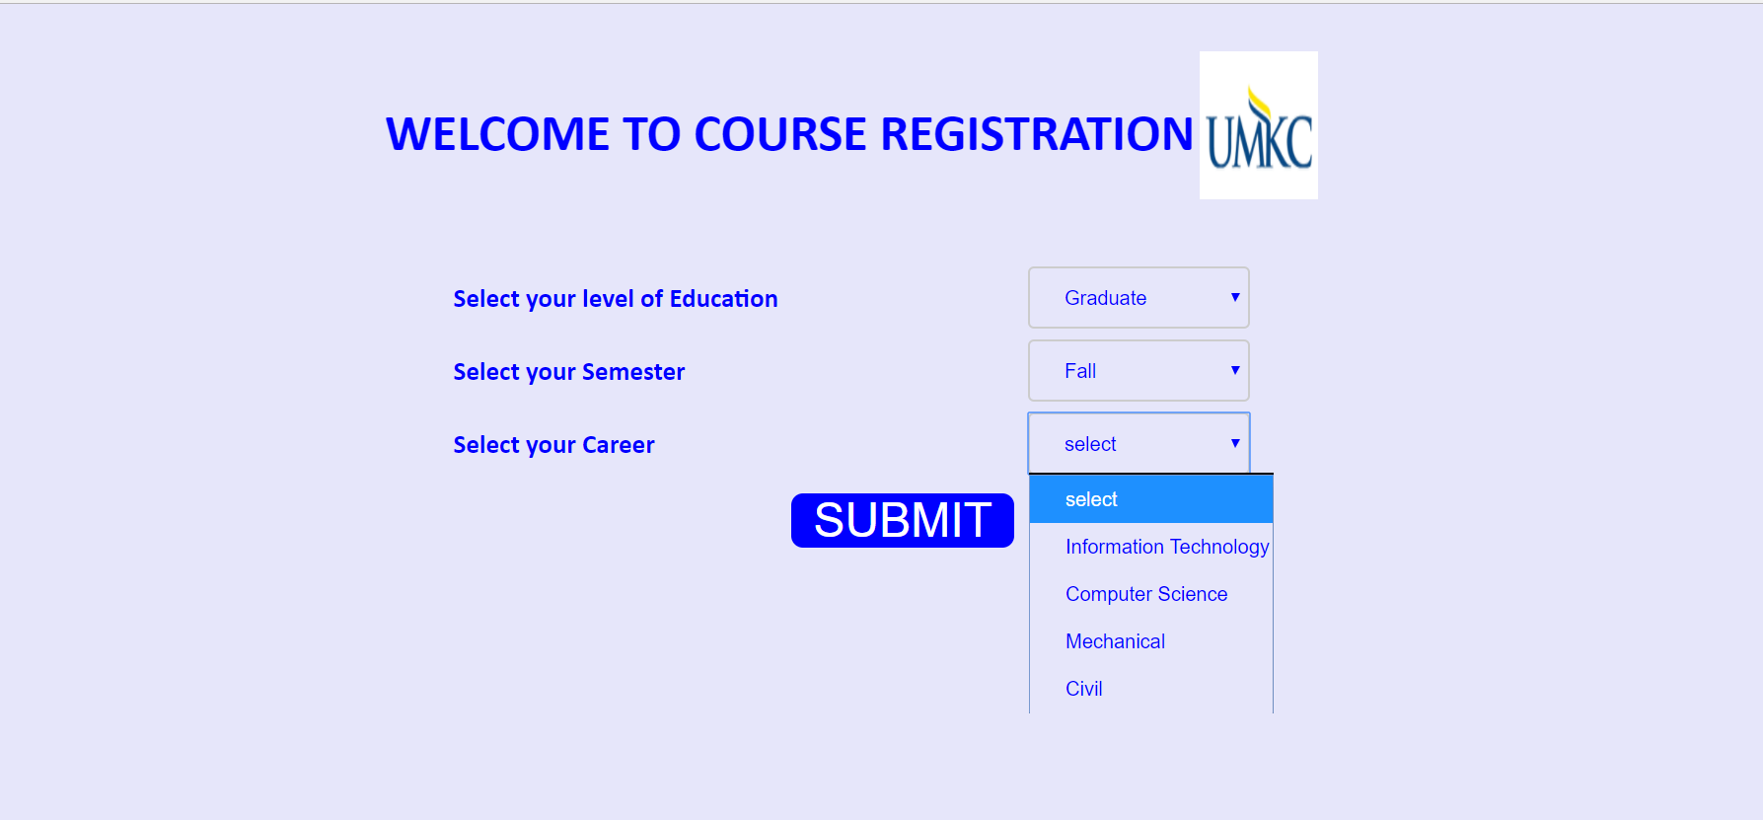

\* On selecting the desired combination it will navigate to the below page

\* The list of available courses, course description, credit hours, location, Time and Seats information

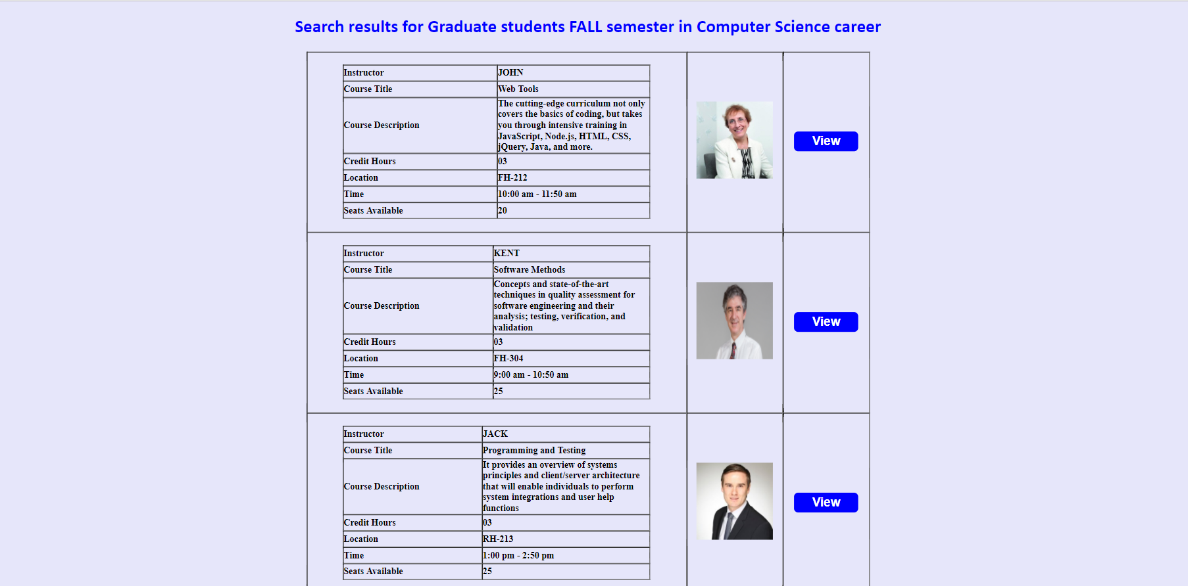

\* Another combination

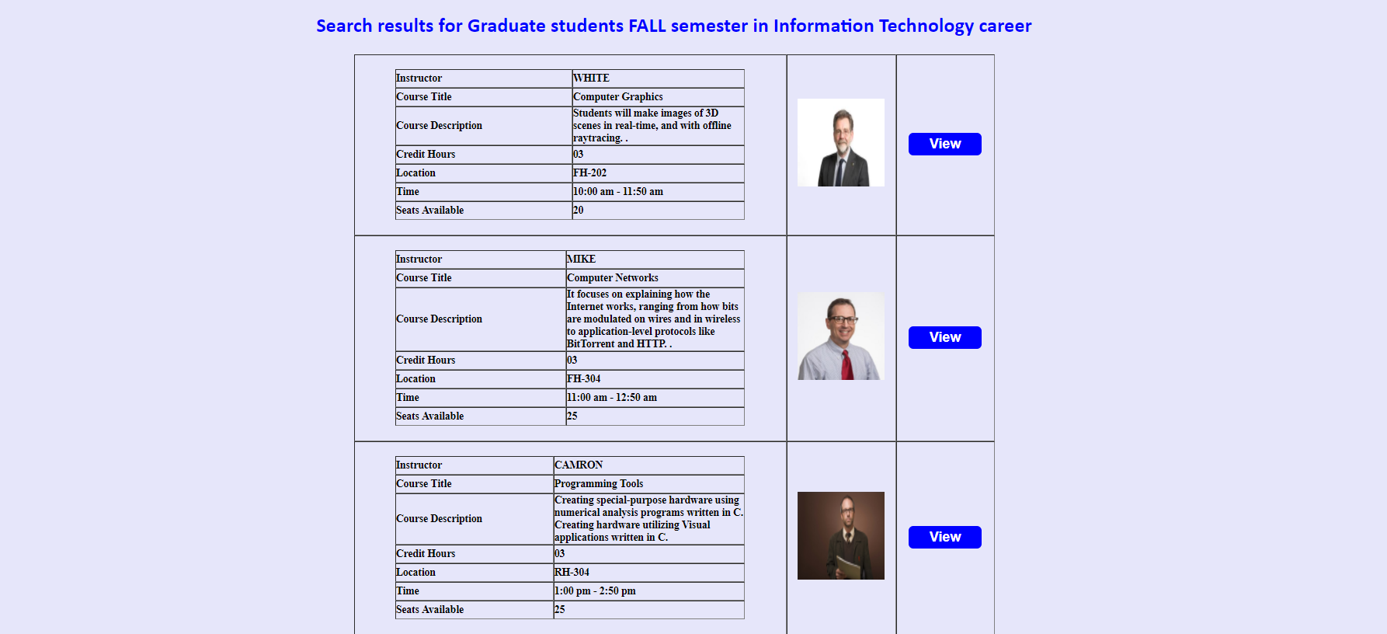

\* When clicked on View, it will navigate to the Professor Profile which lists courses, course description, credit hours, location, Time and Seats information, Rating and Reviews by other Students

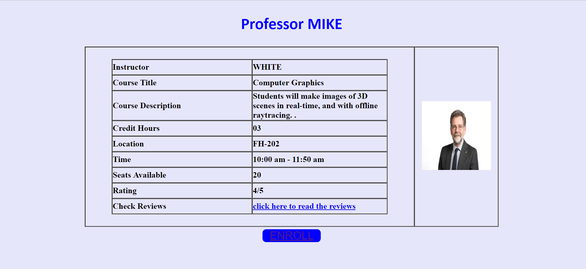

\* User can Enroll to Course here and the page displays the Success Information and the number of available seats is also

updated

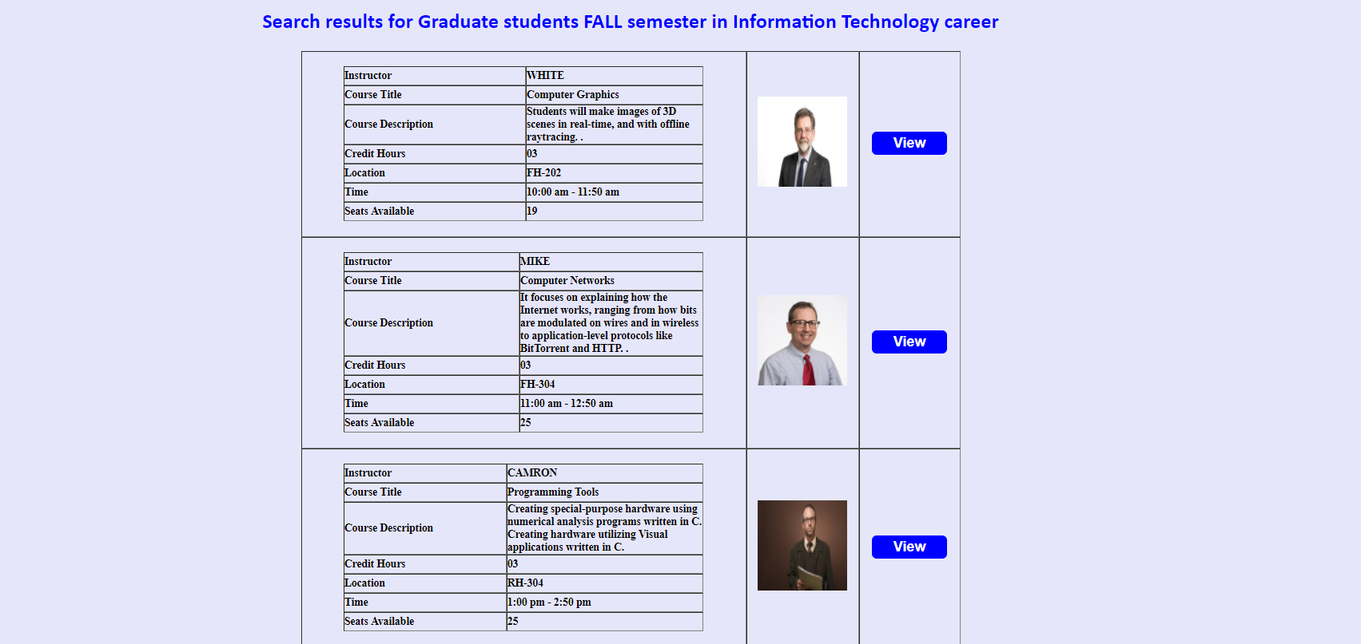

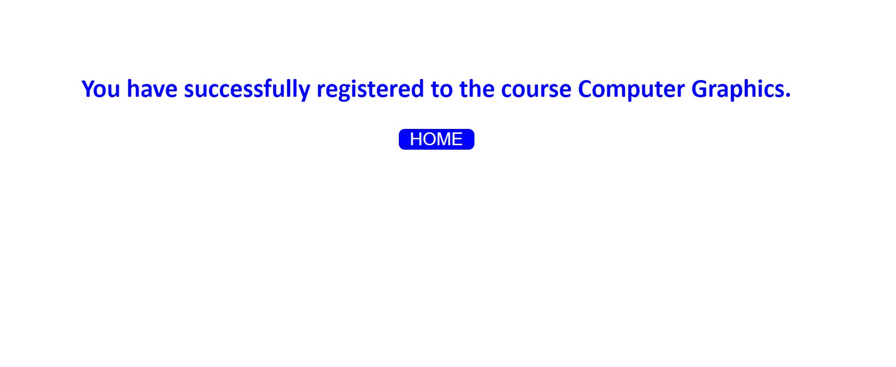

\* Student also has an option to read the reviews submitted by other Students from Professor profile

