**ASSIGNMENT-1**

**TECHNOLOGY : ARTIFICIAL INTELLIGENCE**

**DOMAIN : Emerging Methods For Early Detection of Forest Fires**

**QUESTION-1 :**

**Write a program which will find all such numbers which are divisible by 7 but are not a multiple of 5, between 2000 and 3200 (both included). The numbers obtained should be printed in a comma- separated sequence on a single line?**

**PROGRAM :**

**I**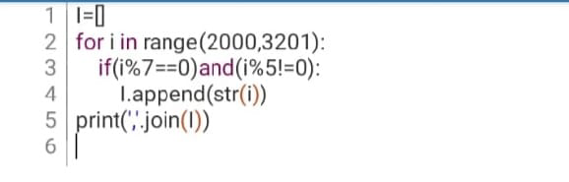

**OUTPUT:**

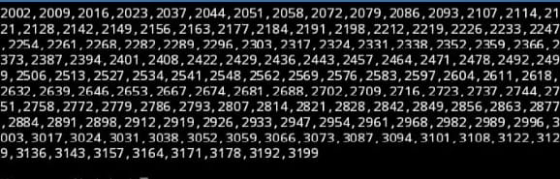

**QUESTION-2 :**

**With a given integral number n, write a program to generate a dictionary that contains (i, i*i) such that is an integral number between 1 and n (both included). and then the program should print the dictionary.Suppose the following input is supplied to the program:8**

**Then, the output should be:**

**{1: 1, 2: 4, 3: 9, 4: 16, 5: 25, 6: 36, 7: 49, 8: 64}?**

**PROGRAM:**

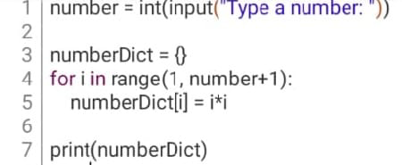

**OUTPUT**:

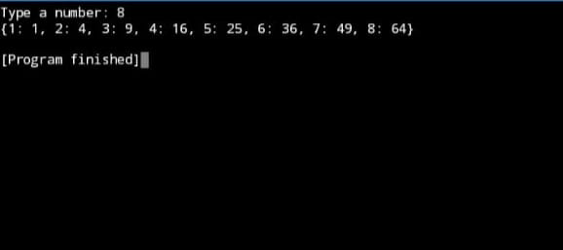

**TEAM LEADER : Sneha .V**

**TEAM MEMBERS:**

* **Jalcy .J**
* **Christina Vasanthra .A**
* **Vishalini .K**

**TEAM ID : PNT2022TMID37986**

**TEAM SIZE : 4**

**TEAM MENTOR : Miss . Mahima**