Content Strategy Memo: Netflix Catalog Trends
Prepared by: Sneha Dubey | Data: Netflix Movies and TV Shows (Kaggle), 8,807 titles, till Sept 2021
Maine catalog ko genre, country, release year aur movie length ke hisaab se dekha. Neeche 3 baatein hain jo content team ke kaam aa sakti hain.

Insight 1: TV Shows tezi se badh rahe hain
Evidence: Catalog mein 70% movies (6,131) hain aur 30% TV Shows (2,676). Par 2015 mein naye releases ka sirf 29% hissa TV Shows tha, 2020 tak ye 46% ho gaya.
Recommendation: Limited series aur short-season shows ko priority do, kyunki ye share already badh raha hai.
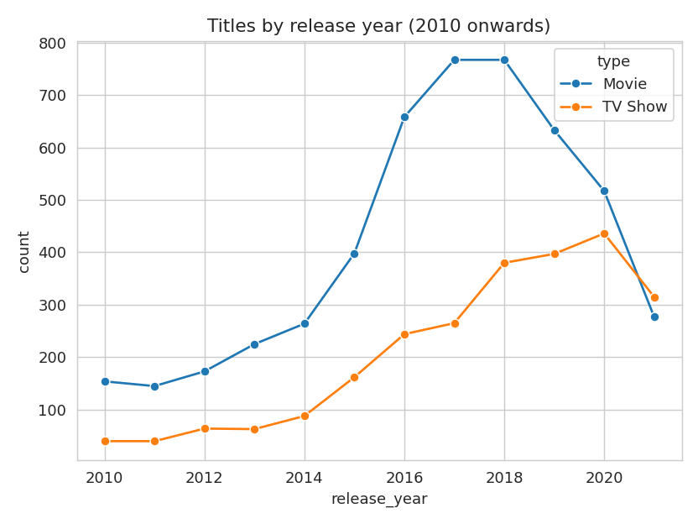

Insight 2: India dusra sabse bada market hai
Evidence: US ke 3,211 titles ke baad India ke 1,008 titles hain, UK ke 628 se kaafi aage. Genre mein Dramas (1,600) aur Comedies (1,210) sabse upar hain.
Recommendation: Indian drama aur comedy mein local originals par invest karo. Catalog mein India ki maujoodgi pehle se hai, par US se abhi bhi teen guna kam hai.
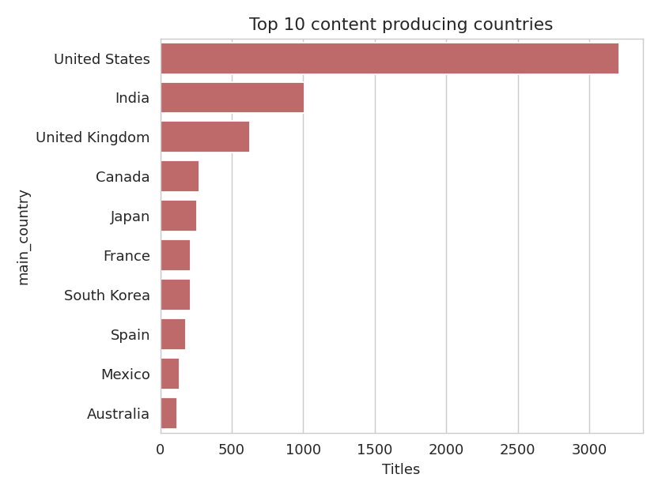

Insight 3: Movies chhoti ho rahi hain
Evidence: 2000-02 mein average movie lagbhag 115-119 min ki thi. 2020 tak ye ghatke 92 min reh gayi.
Recommendation: 90 min ke aas-paas ki movies banao ya acquire karo, ye log aasani se ek baar mein dekh lete hain.
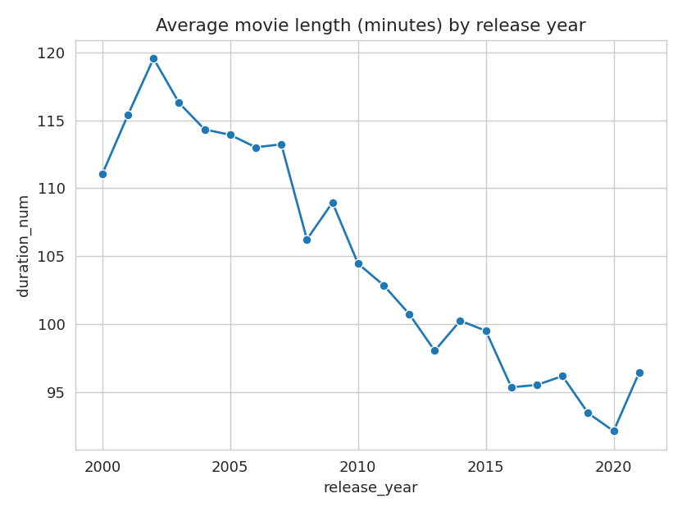

Conclusion
Catalog abhi bhi movie-heavy hai, par naya content shows aur regional kahaniyon ki taraf ja raha hai. Limitation: har title ka sirf pehla country aur genre liya gaya hai, aur 2021 ka data adhura hai. Ye approach Prime ya Hotstar ke data par bhi lag sakti hai.

