|  |
| --- |
|  |
| **Anti-Lock Braking System** |
| 214875 |

|  |
| --- |
| Sneha Dubey  18-12-2020 |

Anti-Lock Braking system

ABS assists driver to keep the steering control during hard braking. In the absence of ABS, it is difficult to stop the car from spinning because of wheel lockup in hard braking conditions, particularly on slippery surfaces.

Mostly ABS are used with conventional brakes e.g., hydraulic or pneumatic pressure brakes.

The ABS starts working after driver pushes the brakes due to which the hydraulic system is pressurized so as to squeeze the brake pads against the disc causing the car to stop, ABS detects the application of the brakes on all four wheels through the sensors, if the ABS detects some fluctuation among wheels during brakes then it subsequently reduces the pressure by opening the pressure release valve to overcome the slippage.

In this report, I have applied the mathematical formulae that come in scope for designing an ABS, the results are demonstrated below with different inputs.

The wheel rotates with an initial angular speed that corresponds to the vehicle speed before the brakes are applied. We used separate integrators to compute wheel angular speed and vehicle speed. We use two speeds to calculate slip, which is determined by the below equation.

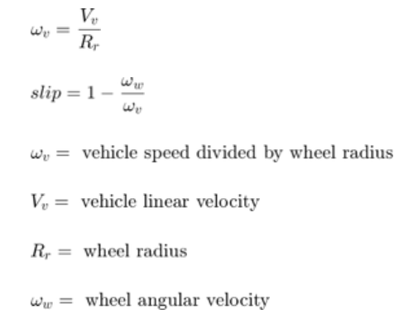

Slip is zero when wheel speed and vehicle speed are equal, and slip equals one when the wheel is locked. A desirable slip value is 0.2, which means that the number of wheel revolutions equals 0.8 times the number of revolutions under non-braking conditions with the same vehicle velocity.

This maximizes the adhesion between the tire and road and minimizes the stopping distance with the available friction.

In this model, we used an ideal anti-lock braking controller, that uses 'bang-bang' control based upon the error between actual slip and desired slip.

To control the rate of change of brake pressure, the model subtracts actual slip from the desired slip and feeds this signal into a bang-bang control (+1 or -1, depending on the sign of the error). 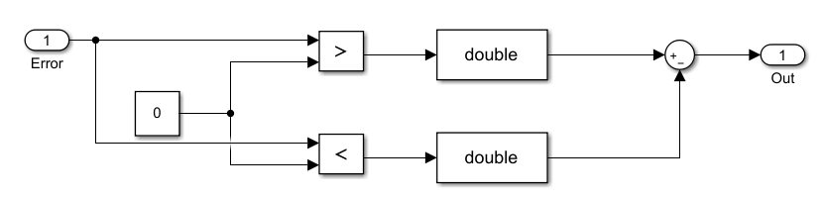

This on/off rate passes through a first-order lag that represents the delay associated with the hydraulic lines of the brake system. The model then integrates the filtered rate to yield the actual brake pressure.

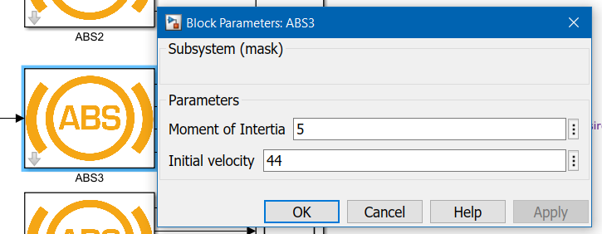For the values of mass of vehicle, moment of inertia, gravitational constant, initial speed and radius of wheel, **callbacks** are used so to automatically feed in the data into the system during simulation and not feed it from base workspace.

We can also change value of v0 and moment of inertia from the **mask** of ABS in the model to check how the output changes with these changes.

All of these data is **logged** in and can be compared using data inspector for each run, logging in the wheel speed, vehicle speed, stopping distance and actual relative slip with time.

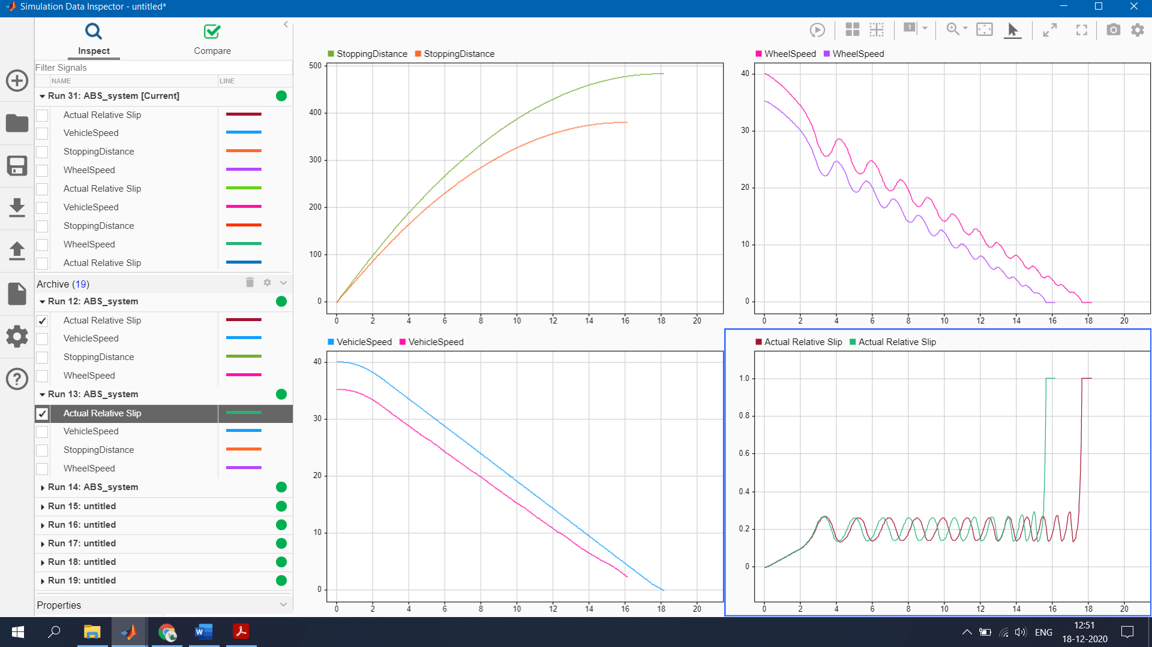

The ideal (with 0.2 desired slip) plots will automatically appear once the simulation is run, due to the callbacks. You can open the other scopes to see outputs for different inputs too.

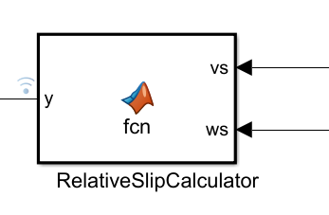The **solver** strategy that I have used here is that we need the data to be checked at smaller instance that means smaller step sizes are required as the system is very dynamic and the calculation with time needs to be precise so I select ode45, the variable step solver with maximum step size to 0.1.

The **MATLAB function block** is used here for the relative slip calculation, which uses the wheel speed and vehicle speed to get the output.

The friction coefficient between the tire and the road surface, mu, is an empirical function of slip, known as the mu-slip curve. We created mu-slip curves by passing values into the block diagram using a **Simulink lookup table**.

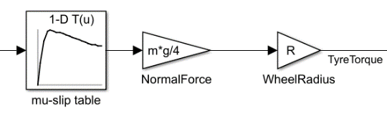The model multiplies the friction coefficient, mu, by the weight on the wheel, W, to yield the Tire torque acting on the circumference of the tire. Tire torque is divided by the vehicle mass to produce the vehicle deceleration, which the model integrates to obtain vehicle velocity.

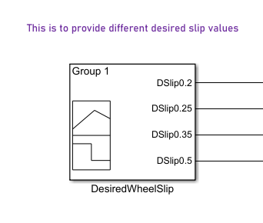**Using signal builder** to provide input for desired slip to the system, it should be 0.2 ideally to get a proper response but we check output for different slips requirements too.

All of the things are connected and updated with best fit values to get proper stopping distance depending on wheel and vehicle speed and actual slip with desired input.

The following are the results that we get when we put some set of Inputs to the ABS.

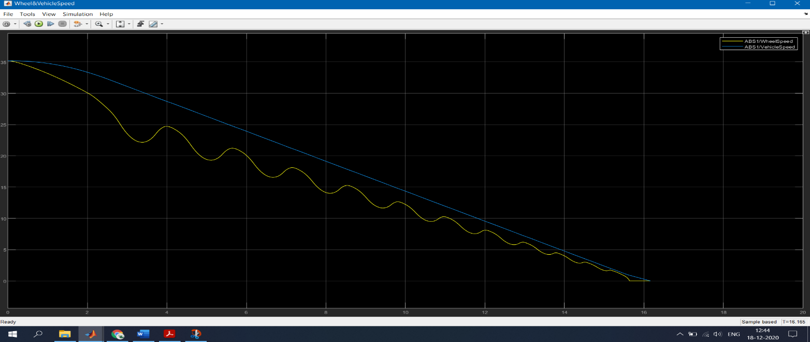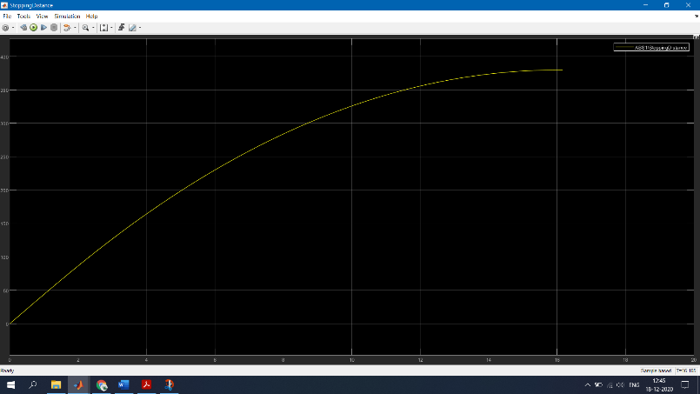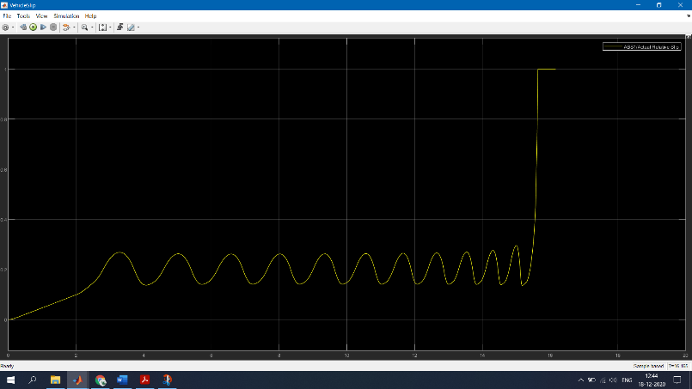

Other outputs can be checked by opening other scopes of the systems.

This way working ABS is demonstrated for different inputs.