At 1.2 seconds

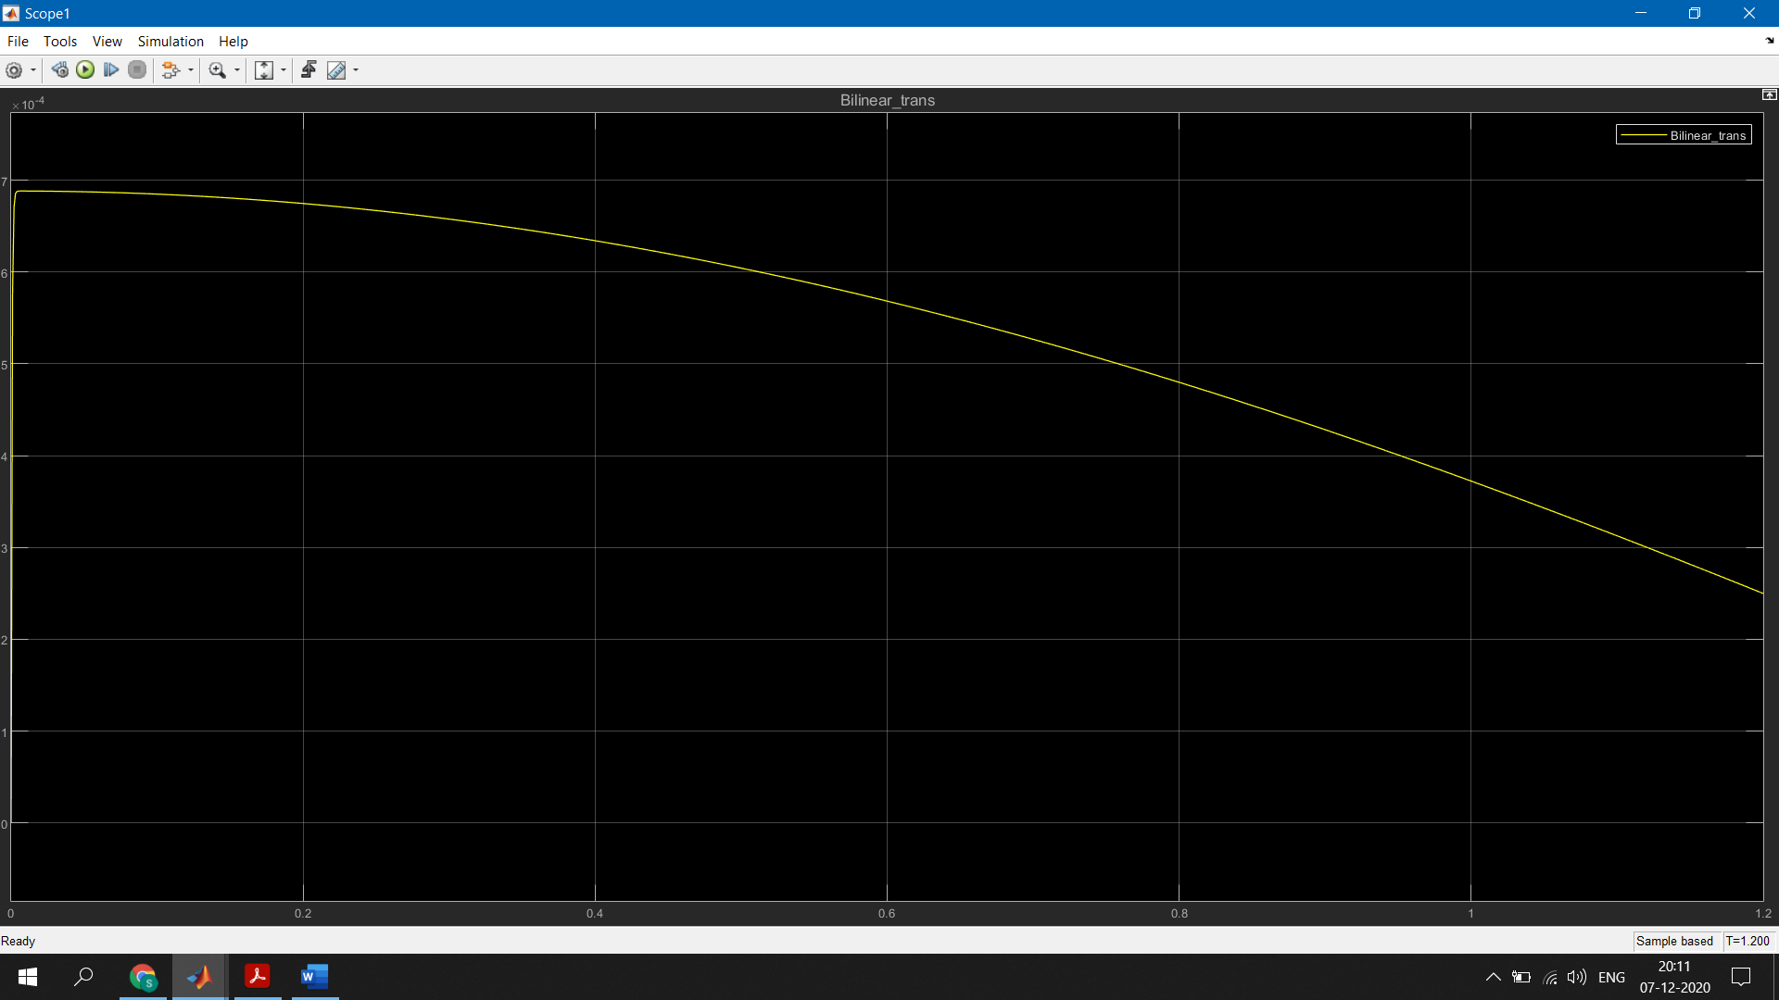

At 0.0001 seconds 🡪 10000Hz

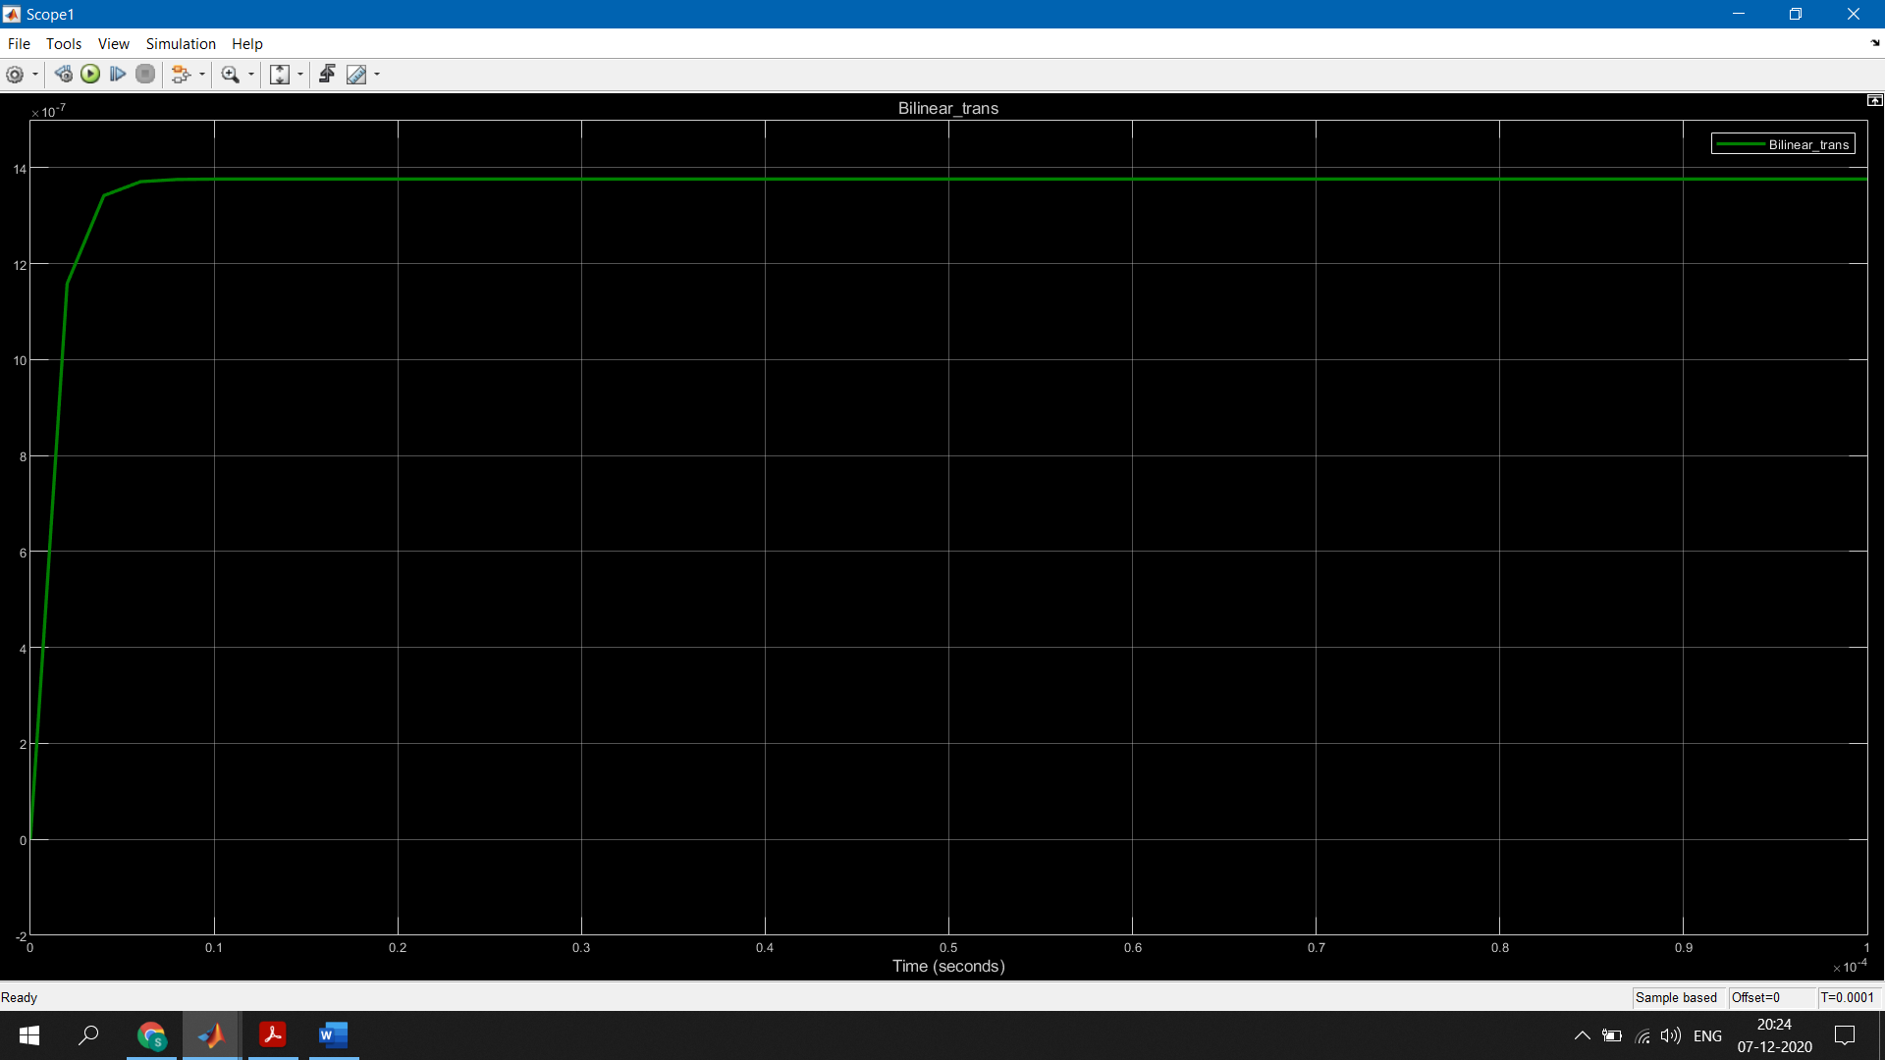

At 0.001 seconds 🡪 1000Hz

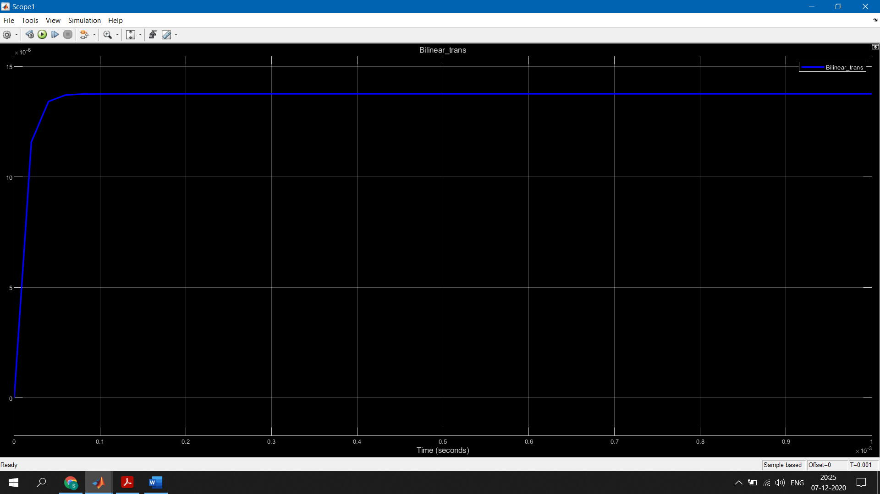

At 0.0029 seconds 🡪 345 Hz

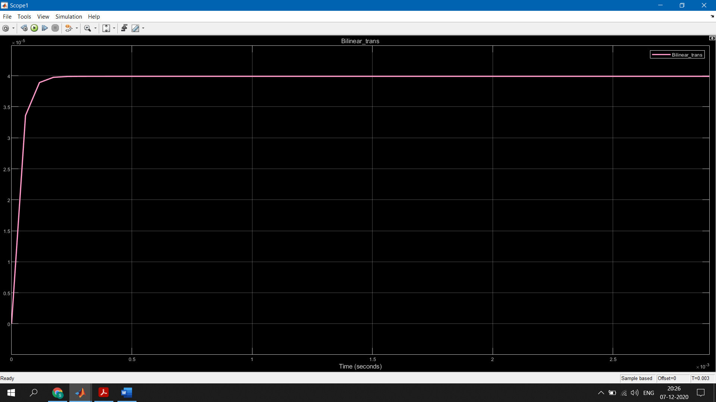

At 0.01 seconds🡪 100 Hz

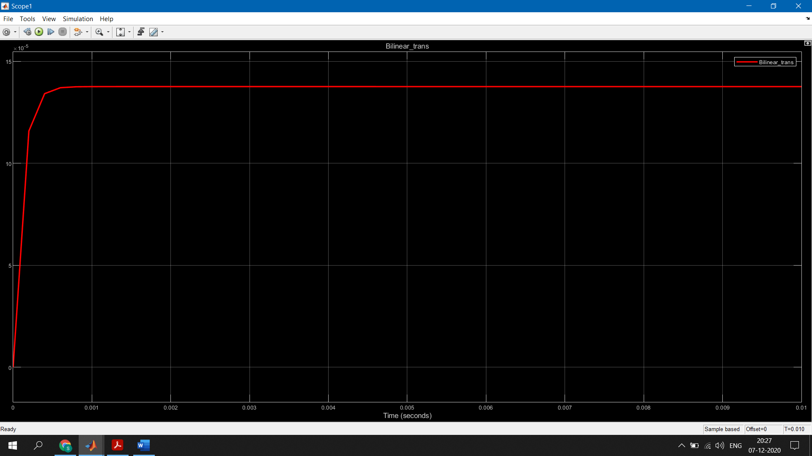

At 0.1 seconds🡪 10Hz

