EduTrack – Database Schema Design

Document

Project Title
EduTrack – Student Performance & Academic Tracking System

Overview
EduTrack is a student performance and academic tracking platform that helps educational institutions monitor student progress, manage academic records, and improve communication between students, teachers, and administrators.
The system allows users to easily track attendance, marks, assignments, and academic performance in one centralized platform.

Database Technology
Database System: MySQL / PostgreSQL Database Design Type: Relational Database
Schema Model: Entity-Relationship Model (ER Model)

Database Entities
Students – Stores student information Teachers – Stores teacher details
Courses – Stores course information Attendance – Stores student attendance Assignments – Stores assignment details
Marks – Stores student academic performance data

Table Structures
Students Table
Column | Data Type | Description
student_id | INT (PK) | Unique student identifier
name | VARCHAR | Student full name
email | VARCHAR | Student email (unique)
password | VARCHAR | Encrypted password
phone | VARCHAR | Contact number
course_id | INT(FK) | Reference to Courses table

Teachers Table
Column | Data Type | Description
teacher_id | INT (PK) | Teacher ID
name | VARCHAR | Teacher full name
email | VARCHAR | Teacher email (unique)
password | VARCHAR | Encrypted password

Courses Table
Column | Data Type | Description
course_id | INT (PK) | Courses ID
teacher_id | INT (FK) | Teacher reference
course_name | VARCHAR | Name of course

Attendance Table
Column | Data Type | Description
attendance_id | INT (PK) | Attendance ID
student_id | INT (FK) | Student reference
course_id | INT (FK) | Course reference
attendance_date | DATE | Attendance date
status | VARCHAR | Attendance status

Assignments Table
Column | Data Type | Description
assignment_id | INT (PK) | Assignment ID
course_id | INT (FK) | Course reference
title | VARCHAR | Course title
description | TEXT | Course description
Due_date | DATE | Submit date

Marks Table
Column | Data Type | Description
mark_id | INT (PK) | Mark ID
student_id | INT (FK) | Student reference
course_id | INT (FK) | Course reference
grade | VARCHAR | Grade status

Key Relationships
Students → Attendance (One student can have many attendance record)

Students → Marks (One student can have many marks entries)
Teachers → Courses (One teacher can teach multiple courses)
Courses → Assignments (One assignment can be submitted by many students)

Assignments → Submissions (One student can submit multiple assignments)

Students → Submissions (One student can submit multiple assignments)

Students → Marks (Marks are assigned to students per course)

Courses → Attendance (Attendance records belong to a specific course)

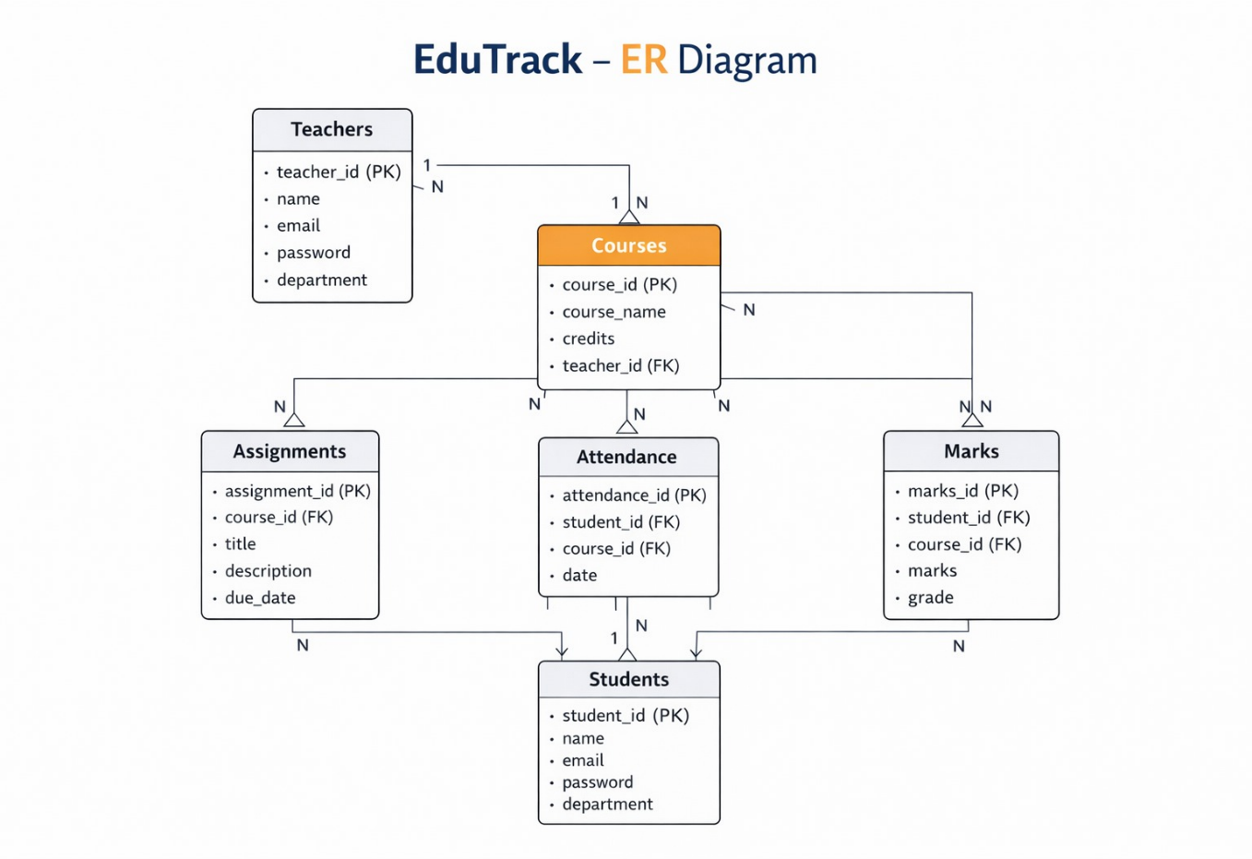
ER Diagram

Future Improvements
Mobile application for students and teachers, AI-based student performance analysis, parent portal for monitoring student progress, online exam and result management system, automated attendance using face recognition, real-time notifications for assignments and announcements, advanced analytics dashboard for academic performance insights, integration with learning management systems, and secure cloud-based data storage for scalability and reliability.

