NETAJI SUBHASH UNIVERSITY OF TECHNOLOGY

DATABASE MANAGEMENT SYSTEM

PROJECT

III SEMESTER

SNEHA GUPTA

2021UCA1859

PROBLEM STATEMENT:

The registrar at a small college wants an application that will help their department keep track of the schedule of classes, the courses and lecturers appearing in the schedule, and the students registering for courses according to the schedule.

Courses are scheduled every semester and this is documented in the schedule of classes, which also documents the lecturers assigned to each schedule of a class. Students register for courses according to the schedule of classes.

Users (students, lecturers, and other college staff) must login to the application to gain access, and the application must keep track of user logins/logouts. In addition, users must have different levels of access, which will determine their access to different parts of the application.

CREATING AN ER MODEL:

STEP I:

Identifying all the collective nouns and nouns in the statement of the problem that represent ENTITIES from the problem domain:

The registrar at a small college wants an application that will help their department keep track of the schedule of classes, the courses and lecturers appearing in the schedule, and the students registering for courses according to the schedule.

Courses are scheduled every semester and this is documented in the schedule of classes, which also documents the lecturers assigned to each schedule of a class. Students register for courses according to the schedule of classes.

Users (students, lecturers, and other college staff) must login to the application to gain access, and the application must keep track of user logins/logouts. In addition, users must have different levels of access, which will determine their access to different parts of the application.

DISCOVERED OBJECTS OF INTEREST (ENTITIES):

* Scheduled Classes (Schedule of classes or Schedule)
* Courses
* Lecturers
* Students
* Semesters
* Users
* User Logins/Logouts (Log Entries)
* Levels of Access (Access Levels)

STEP II:

Assigning possible attributes to each entity discovered

\***Bold** and underlined attributes are the primary keys

\**Italics and* purplecolored are the derived attributes

*Orange colored are multivalued attributes

Ṣ

STEP III:

Deriving unary and binary relationships: Building and filling the Matrix

|  |  |  |  |  |  |  |  |  |
| --- | --- | --- | --- | --- | --- | --- | --- | --- |
|  | Students | Courses | Scheduled classes | Semesters | Lecturers | Users | Access levels | Log entries |
| Students |  |  | Register |  |  | Assigned |  |  |
| Courses |  | Pre-requisite | scheduled |  | Lecture |  |  |  |
| Schedules classes | register | Scheduled |  | Created for | lecture |  |  |  |
| Semesters |  |  | Created for |  |  |  |  |  |
| Lecturers |  | lecture | Lecture |  |  | Assigned |  |  |
| Users | assigned |  |  |  | assigned | create | designated | Create |
| Access levels |  |  |  |  |  | Designated |  |  |
| Log entries |  |  |  |  |  | create |  |  |

Ignoring the top half of the Matrix drawn down the diagonal from the top left of the Matrix to the bottom right of the Matrix since it is a mirror image of the bottom half

Resulting matrix:

|  |  |  |  |  |  |  |  |  |
| --- | --- | --- | --- | --- | --- | --- | --- | --- |
|  | Students | Courses | Scheduled classes | Semesters | Lecturers | Users | Access levels | Log entries |
| Students |  |  |  |  |  |  |  |  |
| Courses |  | Pre-requisite |  |  |  |  |  |  |
| Schedules classes | register | Scheduled |  |  |  |  |  |  |
| Semesters |  |  | Created for |  |  |  |  |  |
| Lecturers |  | lecture | Lecture |  |  |  |  |  |
| Users | assigned |  |  |  | assigned | create |  |  |
| Access levels |  |  |  |  |  | Designated |  |  |
| Log entries |  |  |  |  |  | create |  |  |

FINAL ER MODEL:

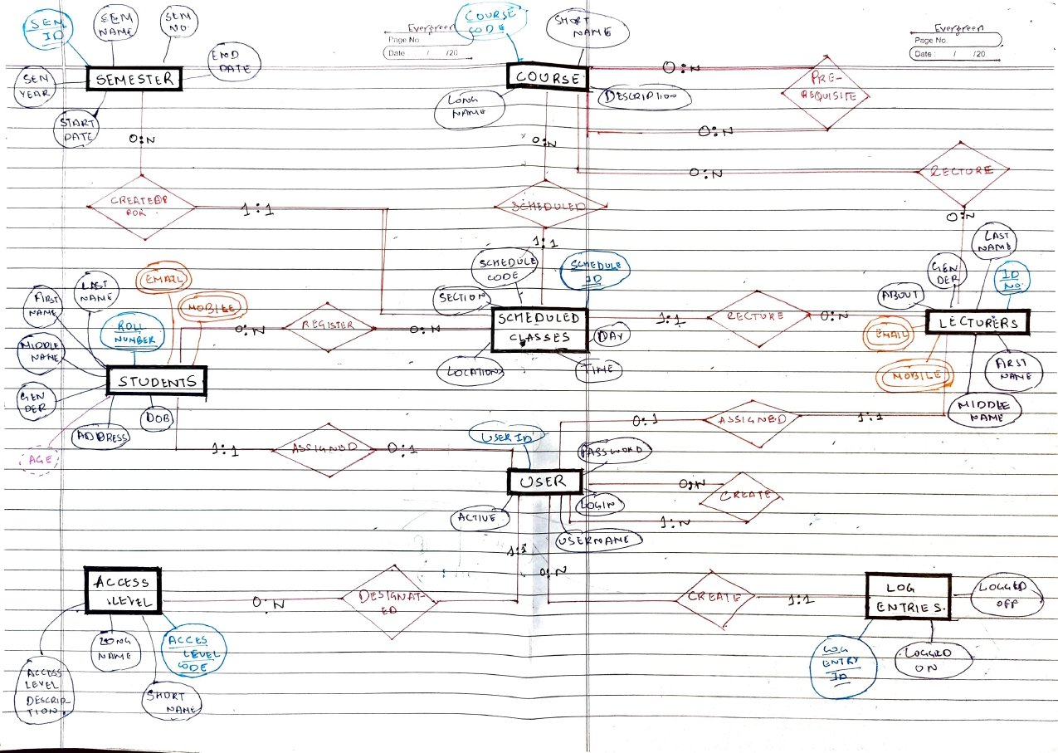

CONVERTING ER MODEL TO RELATIONAL SCHEMA (following tables are in BCNF form):

1. Courses(course_code, short_name, long_name, course_description)
2. Semesters(semester_id, semester_number, semester_year, start_date, end_Date)
3. AccessLevels(access_level_code, short_name, long_name, access_level_description)
4. Users(user_id, login, username, password, access_level_code (FK))
5. Students(roll_number, last_name, first_name, middle_name, gender, dob, email, mobile, address, user_id (FK))
6. Lecturers(lecturer_id, last_name, first_name, middle_name, gender, user_id (FK))
7. LogEntries(log_entry_id, logged_on, logged_off, user_id (FK))
8. ScheduledClasses(schedule_id, schedule_code, section, day, time, location, semester_id (FK), course_code (FK), lecturer_id (FK))
9. CoursePreRequisites(course_pre_req_id, course_code (FK), course_code1 (FK), min_pass_grade)
10. CourseLecturers(course_lecturer_id, course_code (FK), lecturer_id (FK))
11. StudentsScheduledClasses(students_schedule_id, roll_number (FK), schedule_id (FK), registered_date)

SQL COMMANDS:

CREATING DATABASE AND TABLES:

DATABASE “dbmsproject”

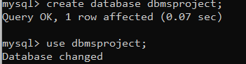

TABLE “courses:

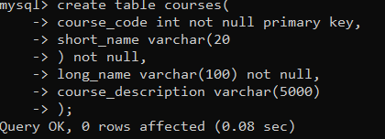

TABLE “semesters”

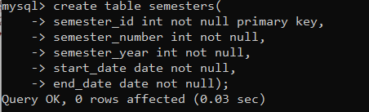

TABLE “AccessLevels”

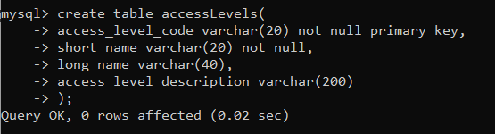

TABLE “users”

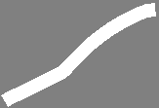

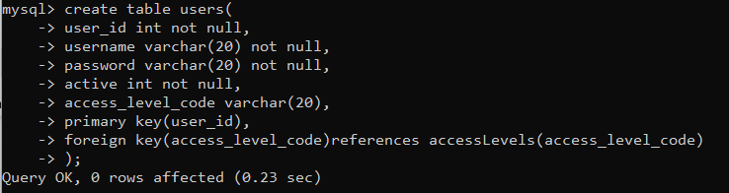



TABLE “students”

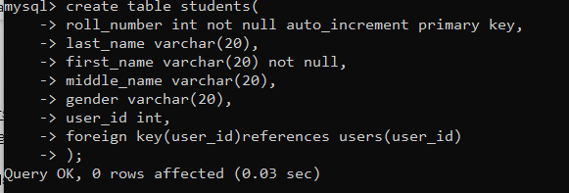

TABLE “lecturers”

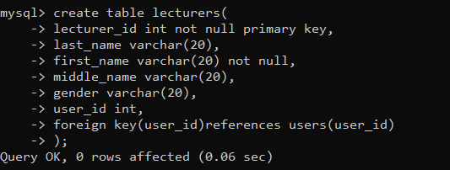

TABLE “LogEntries”

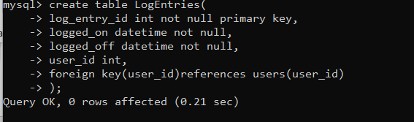

TABLE “ScheduledClasses”

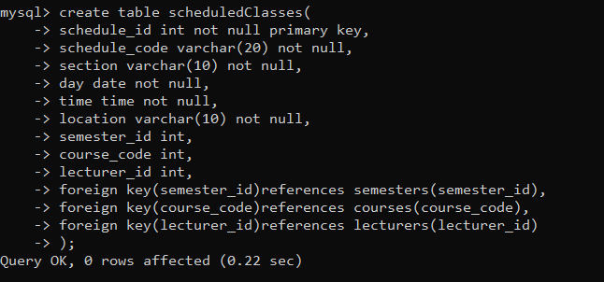

TABLE “CoursePreRequisites”

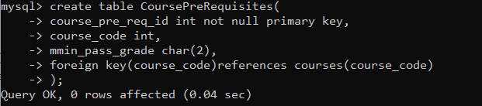

TABLE “StudentsScheduledClasses”

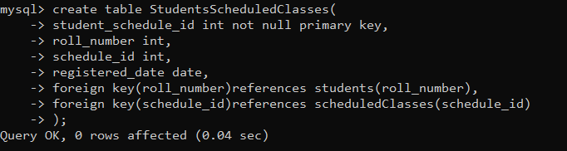

INSERTING INTO TABLES:

TABLE “courses”

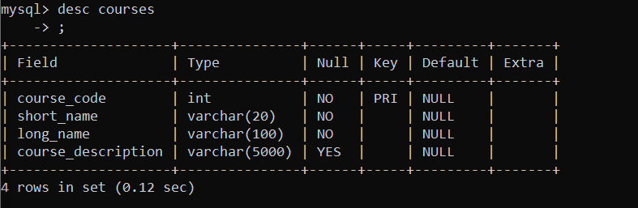

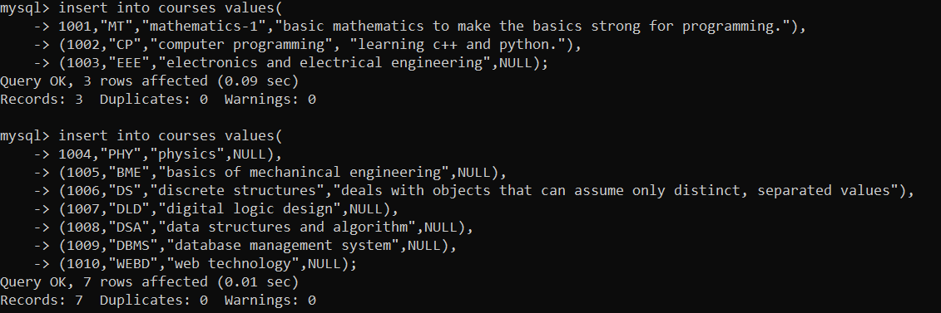

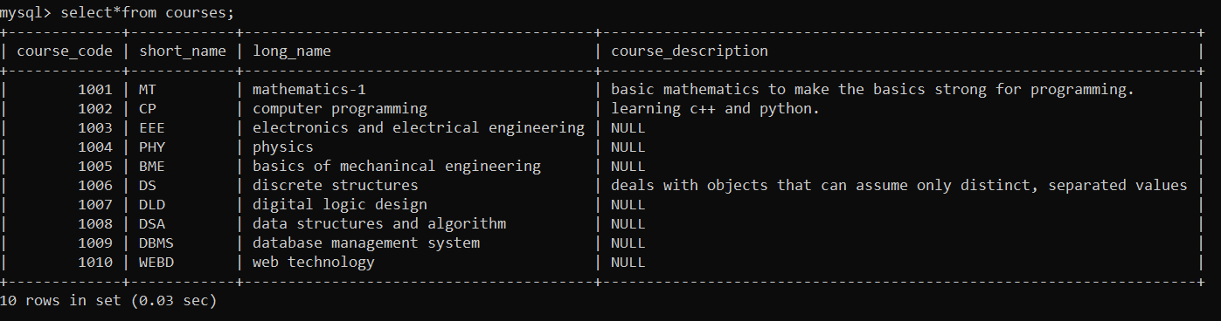

TABLE “semesters”

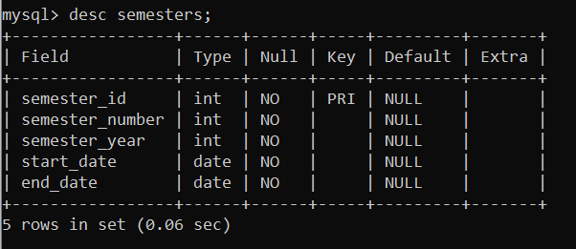

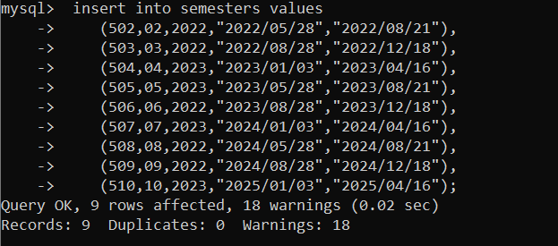

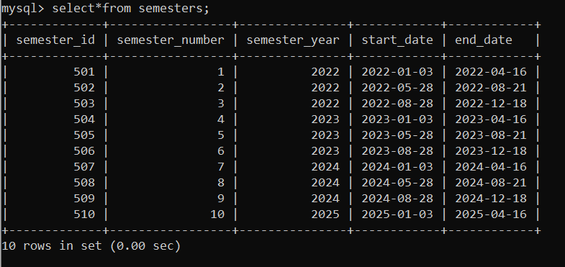

TABLE “accessLevels”

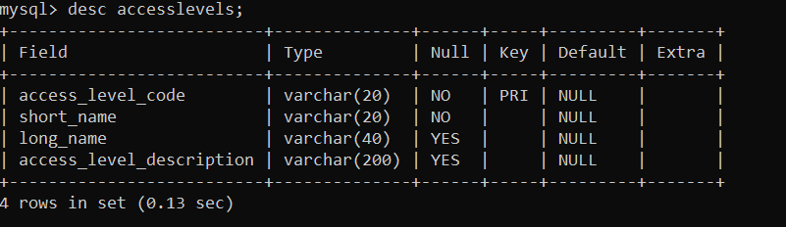

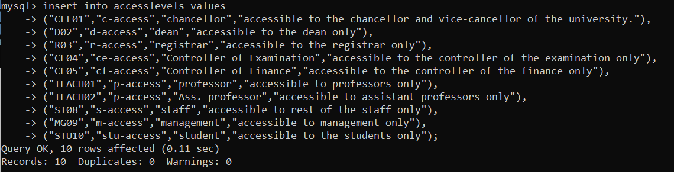

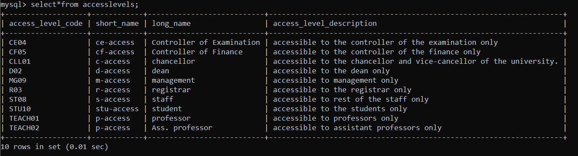

TABLE “users”

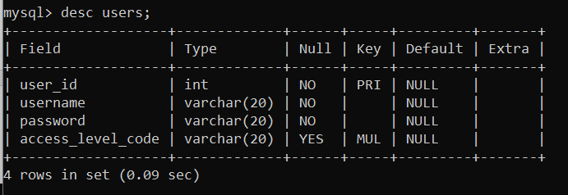

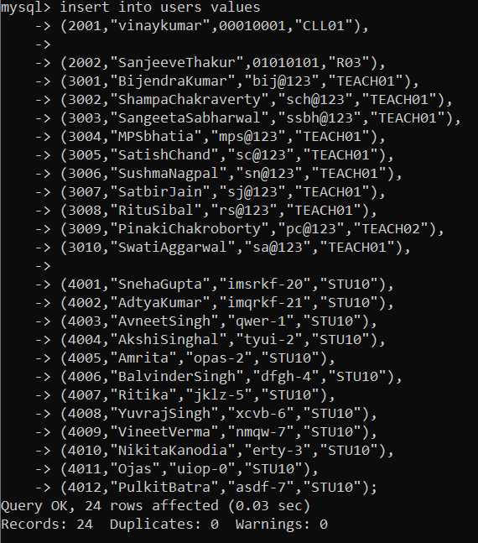

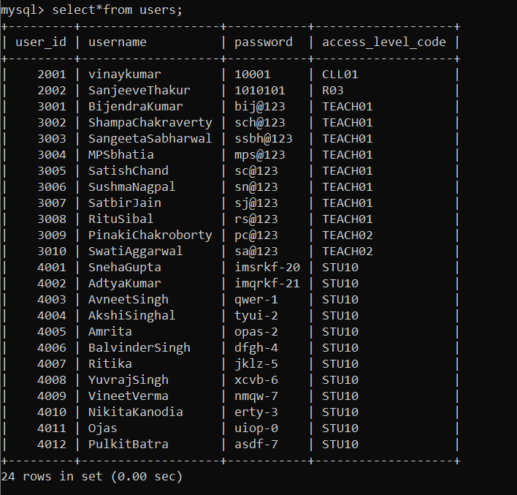

TABLE “students”

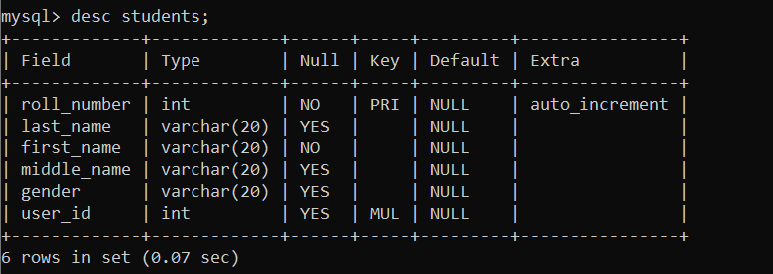

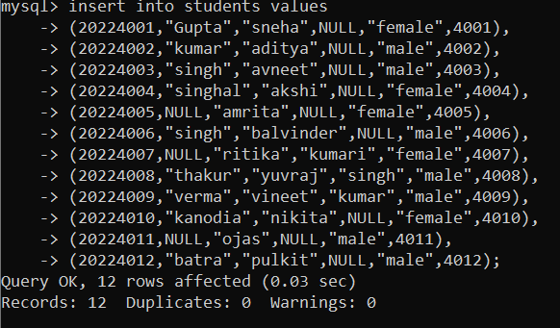

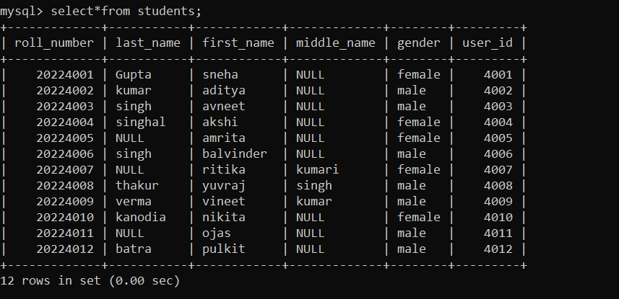

TABLE “lecturers”

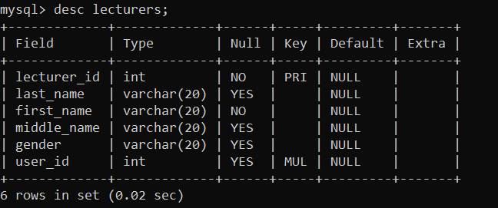

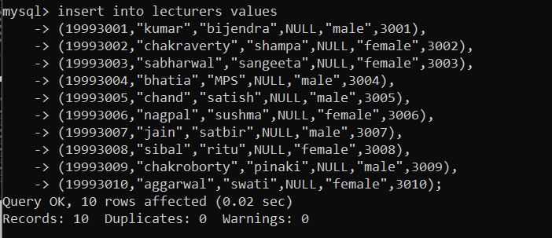

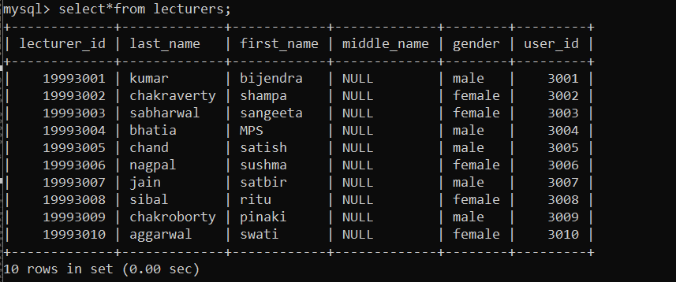

TABLE “logEntries”

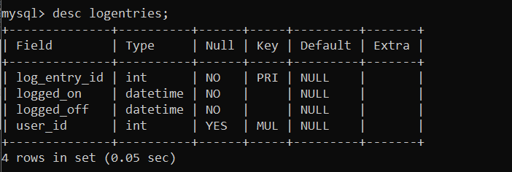

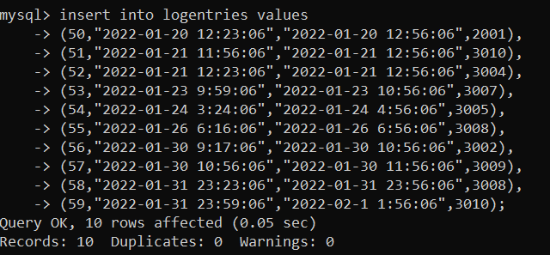’ 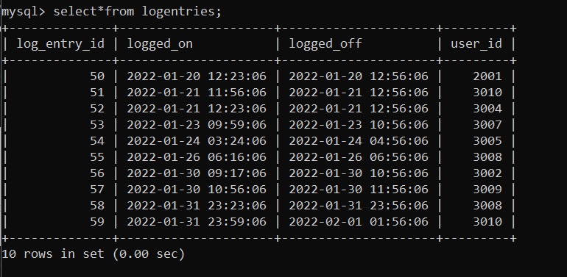

TABLE “ScheduledClasses”

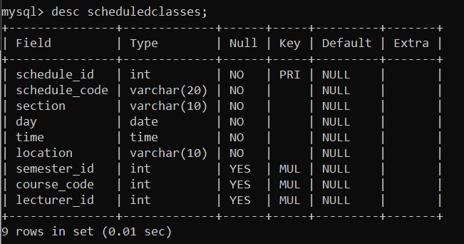

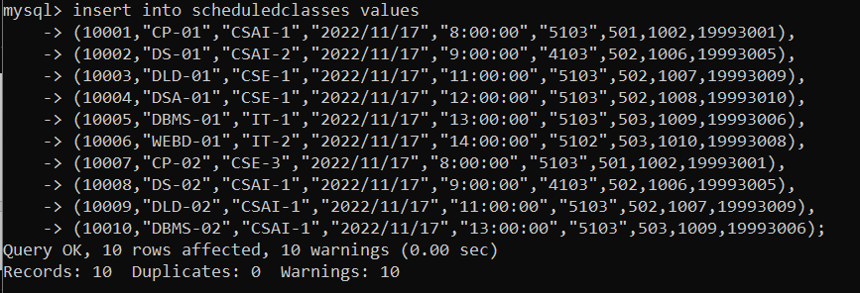

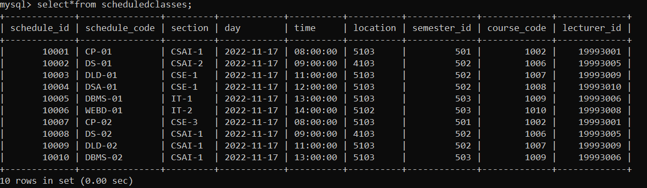

TABLE “CoursePreRequisites”

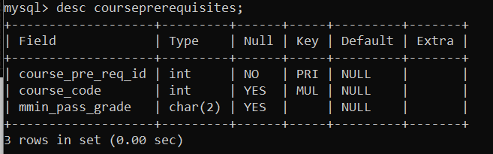

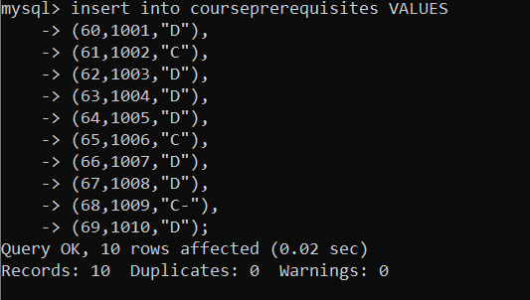

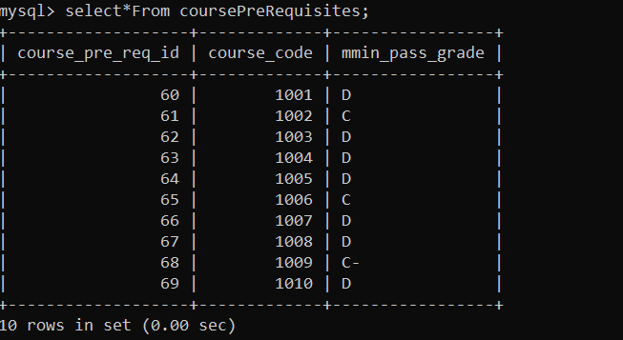

TABLE “StudentsScheduledClasses”

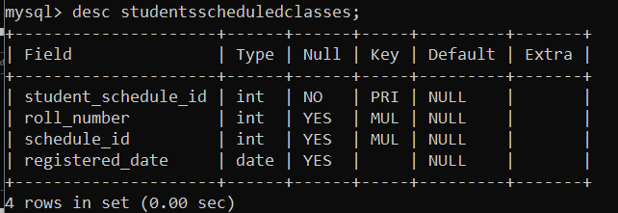

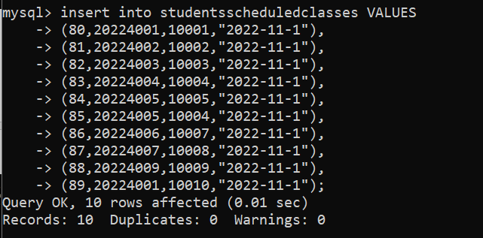

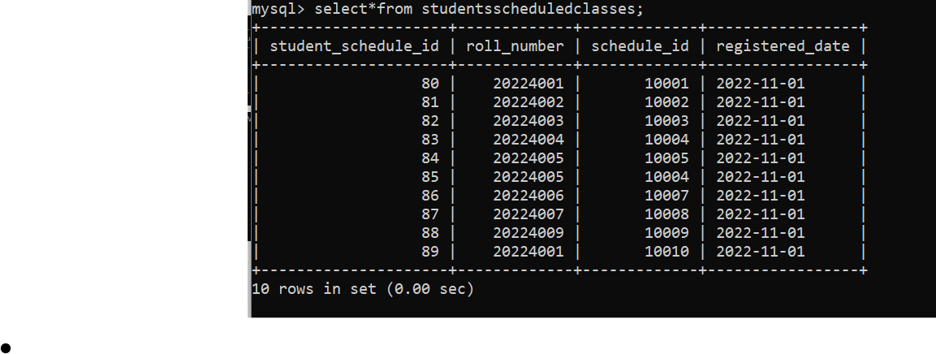

UPDATING THE RECORDS:

DELETE RECORDS:

ALTER THE SCHEMA:

PERFORMING AGGREGATE FUNCTIONS:

WRITING A TRIGGER:

CREATING AND USING VIEW: