NETAJI SUBHASH UNIVERSITY OF TECHNOLOGY



WEB TECHNOLOGY

COURSE CODE: CACSC04

PROJECT

III SEMESTER

SNEHA GUPTA: 2021UCA1859

**WEB Technology Lab Practical List**

1. Create a table using rowspan and colspan attributes.

CODE:

HTML:

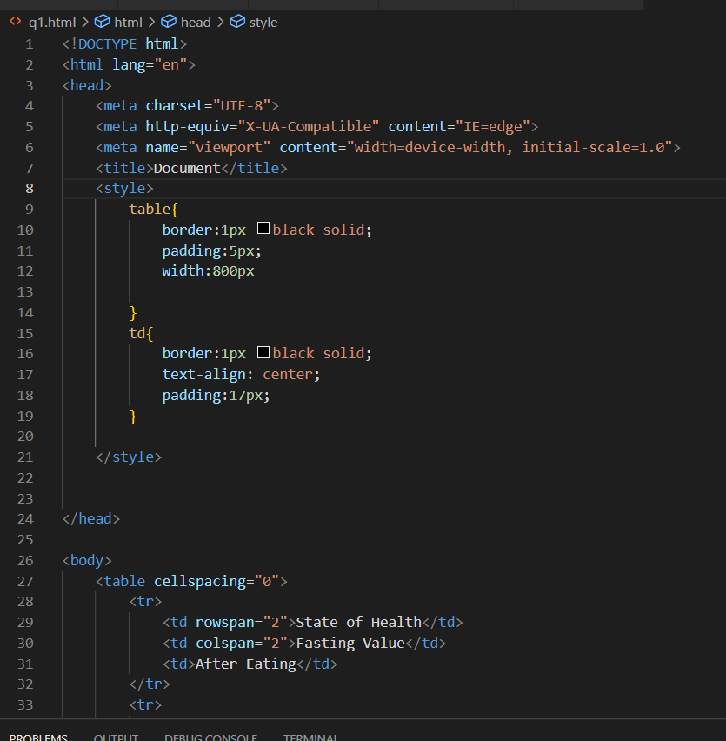

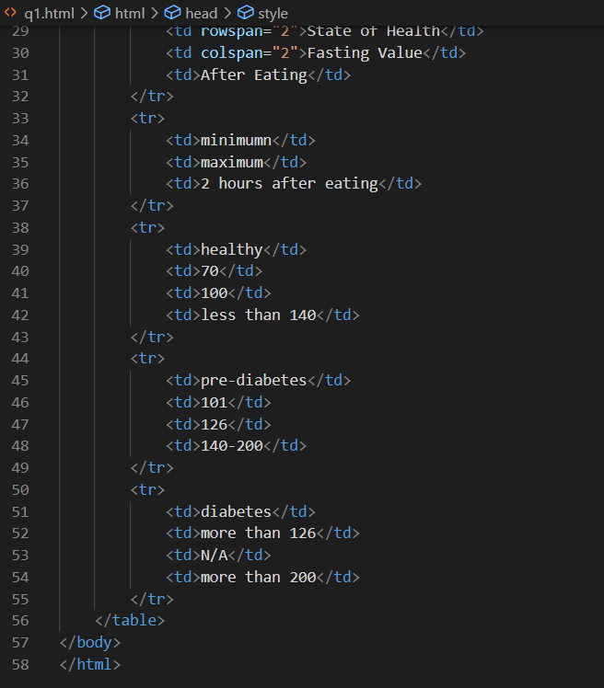

OUTPUT::

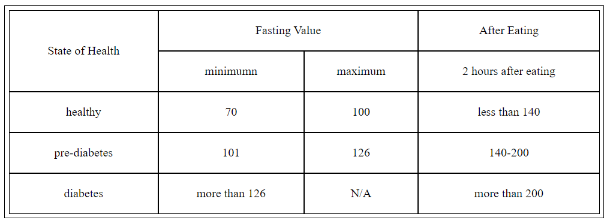

____________________________________________________________________________

1. Create a form using following attributes:
2. Label
3. Input
4. Dropdown list
5. Radio Button
6. TextArea
7. Button

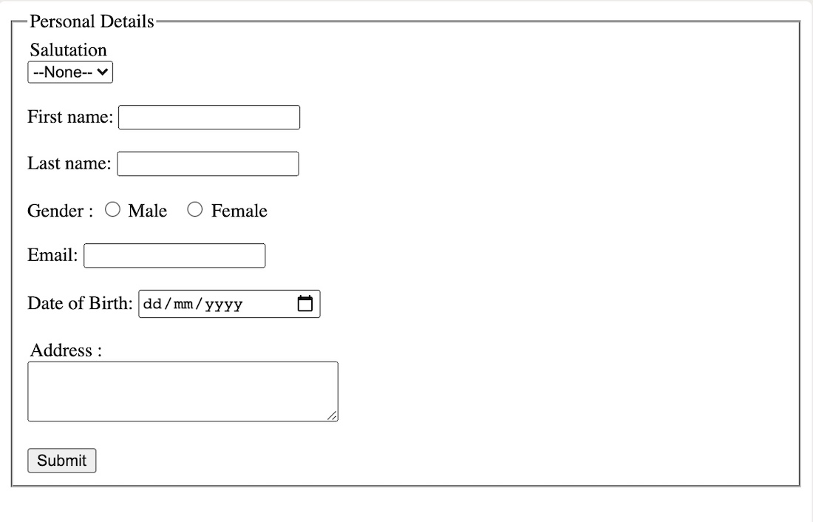

CODE::

HTML::

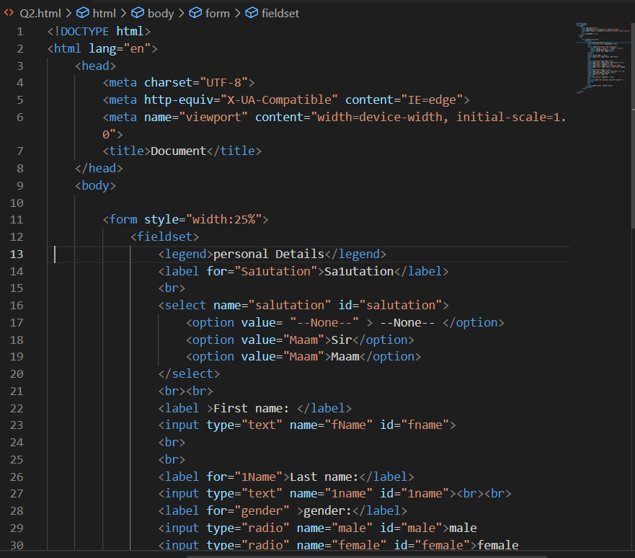

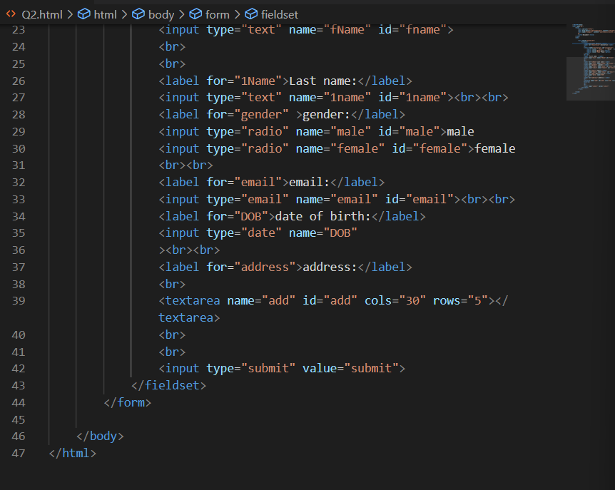

OUTPUT::

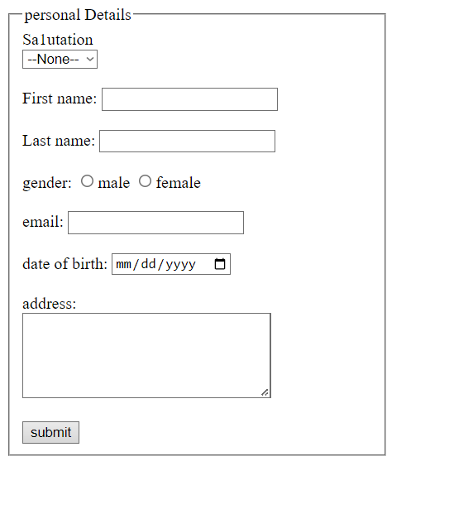

1. In this exercise, you test your CSS positioning skills. Each block will be absolutely positioned in a diagonal top-left to bottom-right direction. The middle box should appear on top

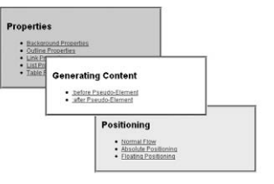

CODE:

HTML:

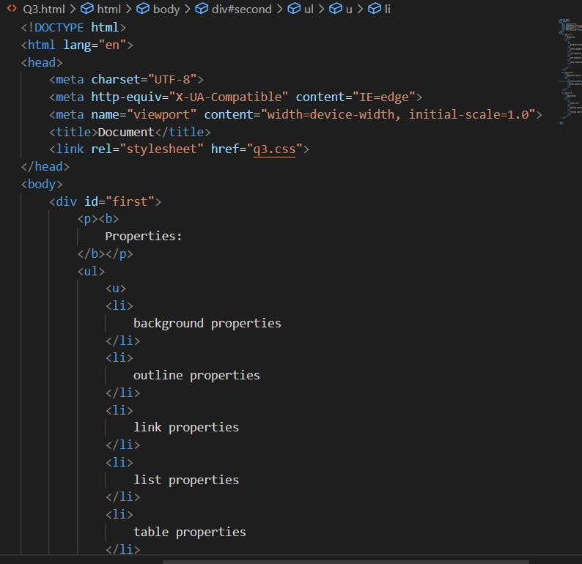

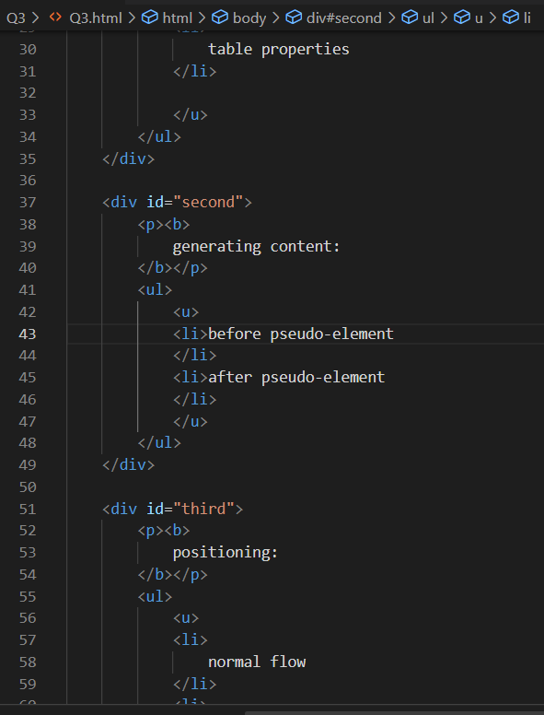

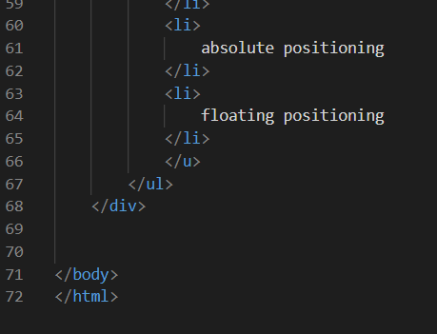

CSS:

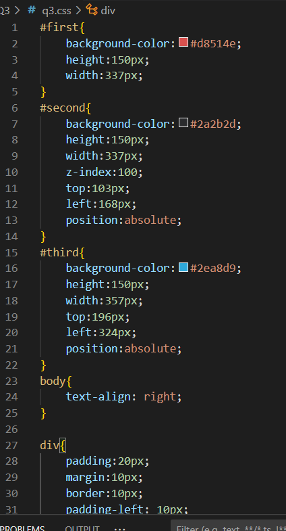

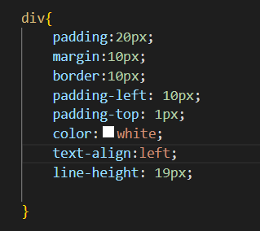

OUTPUT::

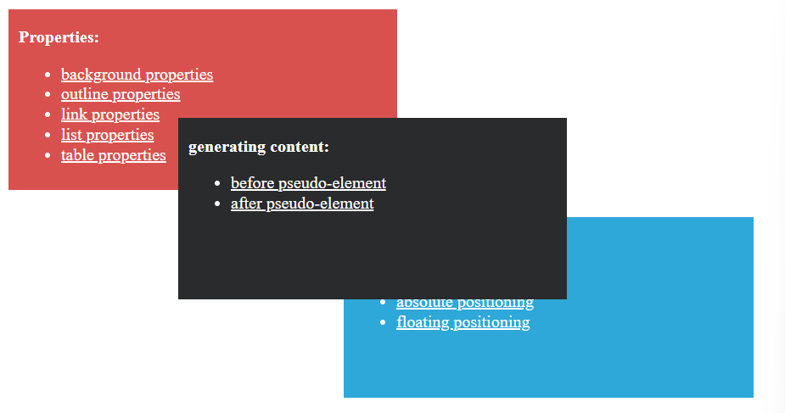

_______________________________________________________________________

1. Create a following given webpage:

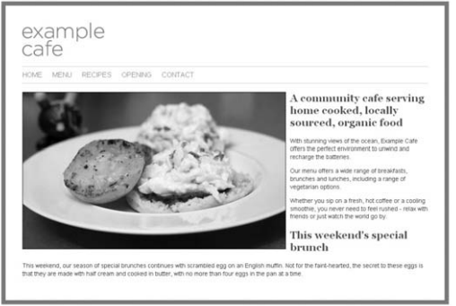

CODE::

HTML::

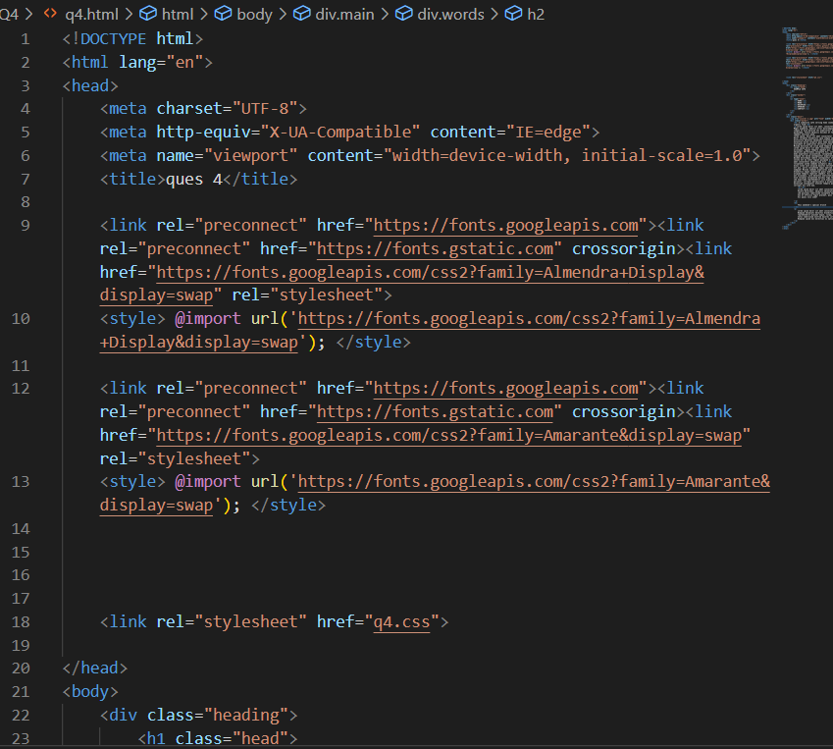

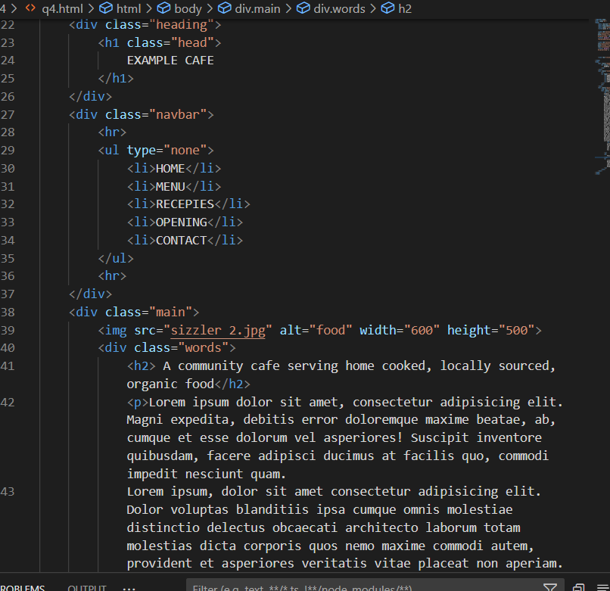

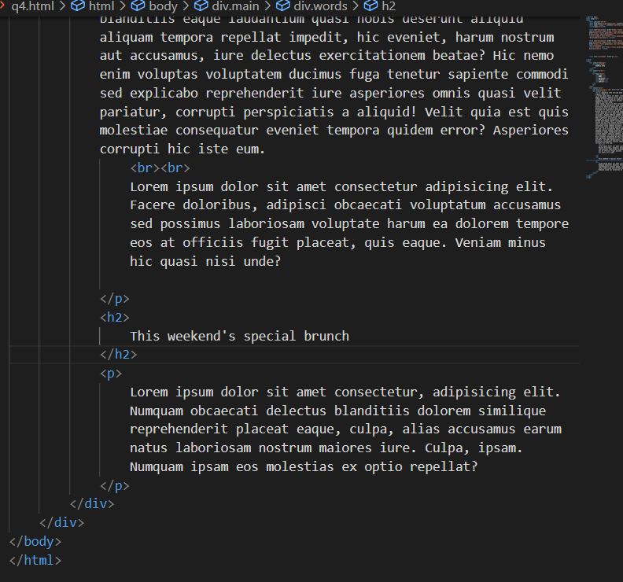

CSS:

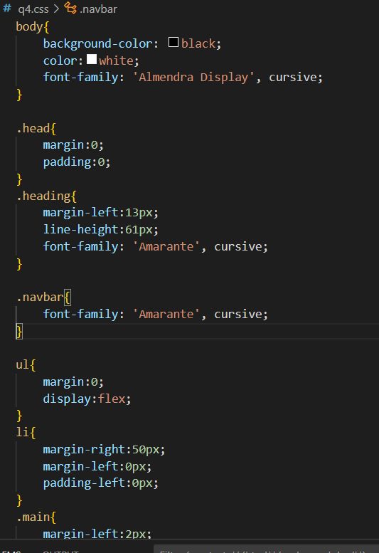

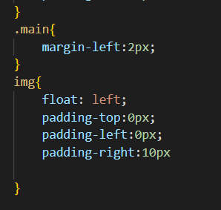

OUTPUT::

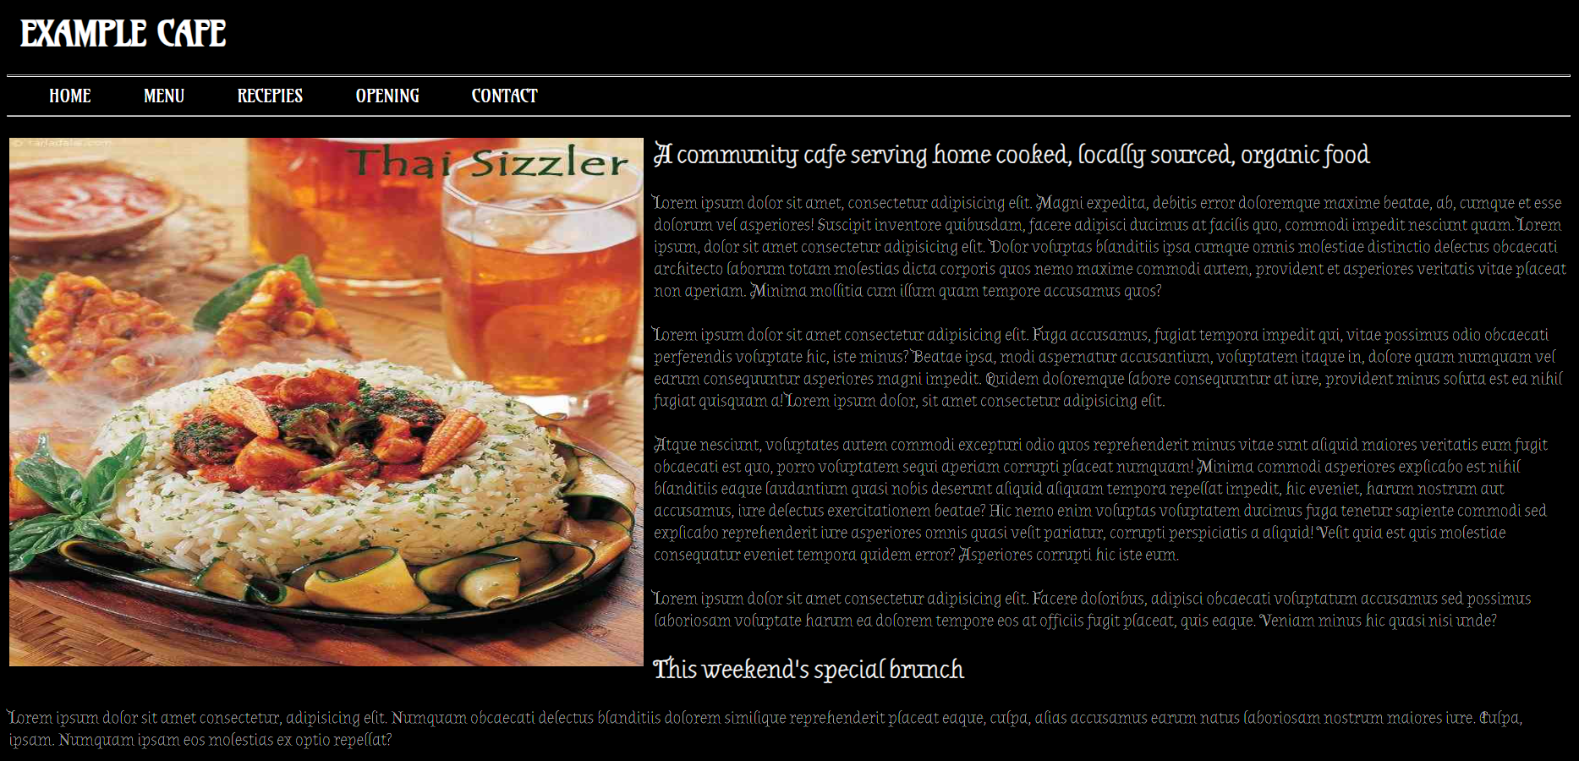

______________________________________________________________________________

1. Write a JavaScript code to add five images and when a user click on a button then among 5 images, random image will appear on the page.

CODE:

HTML::

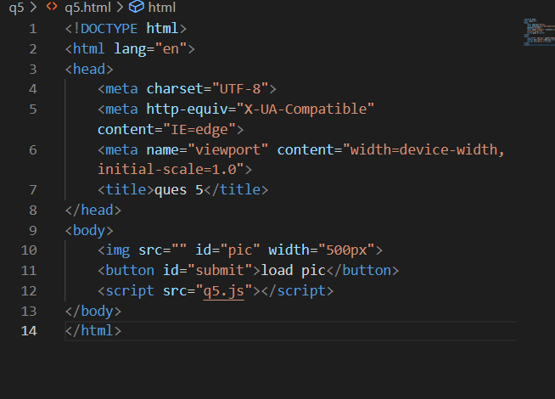

JS::

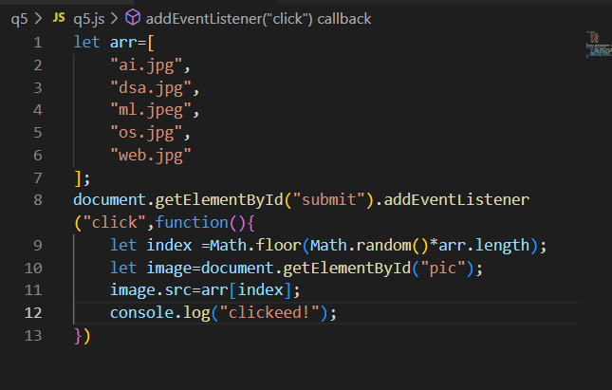

1. Create an XML FILE with the following structure.

Root Element- <BankAccountDetails>

Child Elements as - a) Account No b) Account Type c) Balance d) Customer_id e) Customer Name

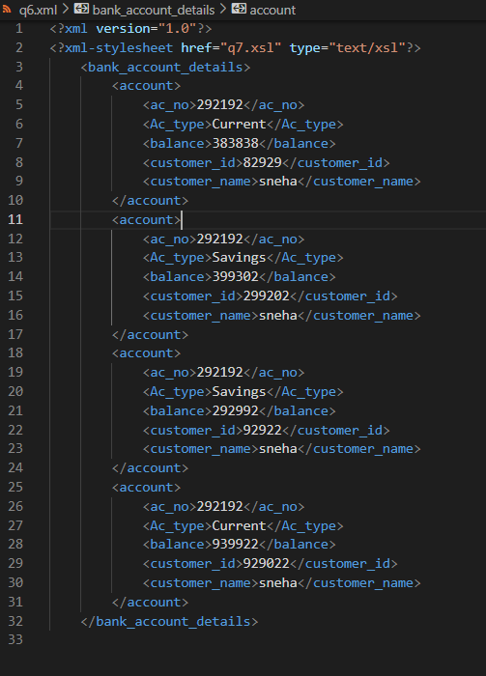

1. Create an XSLT FILE to read the above XML File.

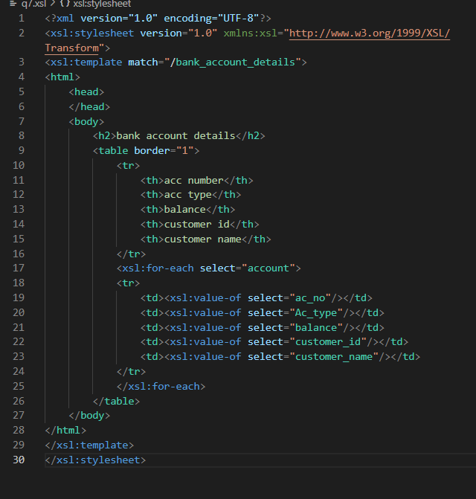

1. $colour = array (4 => 'white', 6 => 'green', 11=> 'red');  
   Write a PHP script to get the first element of the above array.

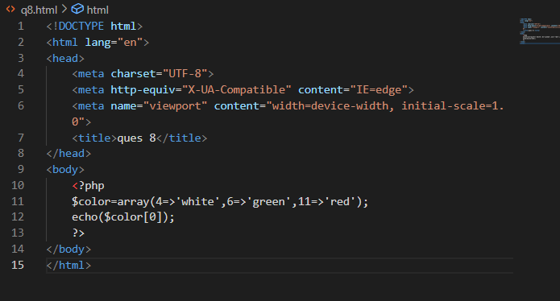

1. $colour = array ('white', 'green', 'red''). Write a PHP script which will display the colours

in the following way:   
 *Output:*   
 white, green, red.

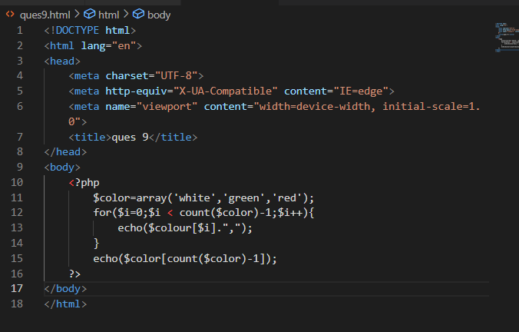

1. Write a code to depict a concept of AJAX that sends request to server and getting back the response and display the text in the webpage.

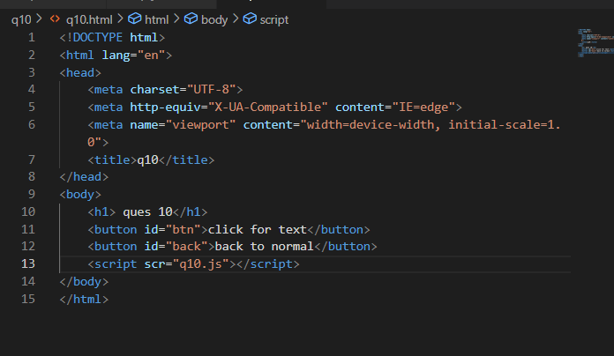

JS::

