### **The Dataset**

The dataset contains 1,999 records including 15 columns representing key parameters of supply chain operations such as order, delivery, shipping mode, customer segment, product category, and geographic dimensions.

### **Insight 1: Delivery Status & It’s Distribution**

**Data:**

The following is shown in the table of this schedule of delivery status with respect to the number of orders.

**Analysis:**

A lot of the orders have been categorised by the descriptor 'Late delivery', indicating internal inefficiencies or delays with the supply chain. Taking late deliveries to a minimum level is critical to increase customer satisfaction and service level.

**Recommendations:**

Find out why deliveries are taking longer than expected: Question whether this could be shipping mode, type of product, regional blockage etc. Utilise monitoring applied sciences to foresee and even proactively deal with loans liable to excessive menace orders.

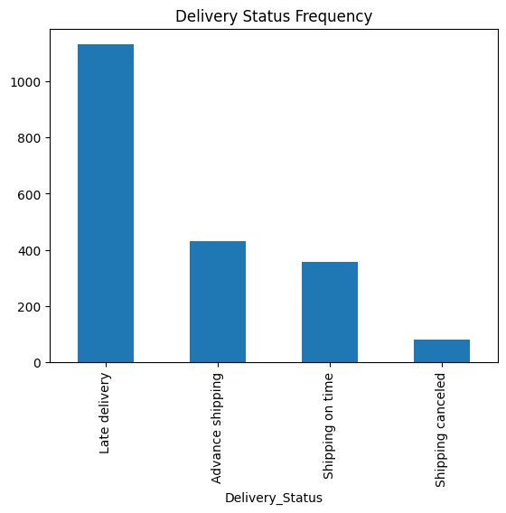

Figure 1 Frequency of delivery status

### **Insight 2: Breakdown by Order Type**

**Data:**

To see how transactions are handled, the order type is shown in the Payments, Debit, and Cash breakdown.

**Analysis:**

Payouts and Expenses are the most common transactions, which support typical purchasing workflows. Orders are weak in cash but that is normal to in line with a heavy focus on digital or institutional sales.

**Recommendations:**

Check if order type policies match the preferences of the customers and match with the operational efficiency. Investigate potential to increase digital payment alternatives where feasible.

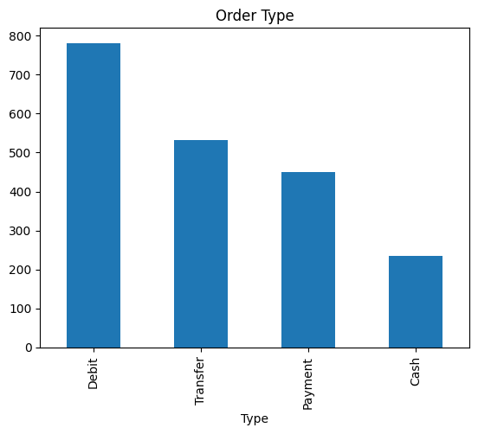

Figure 2 Distribution over order type

### **Insight 3: Logistic Regarding the Shipping Method Values**

**Data:**

This breaks down the prevalence of the various modes of shipping Standard, First and Class and Second class.

**Analysis:**

Standard Class shipping is strong which would indicate a focus on the cheaper end of the delivery service sector. Less popular to use is "1st 2nd class" shipping methods which may be only Expedited orders.

**Recommendations:**

Check how shipping modes and customer experience with them compare. Think about shipping mode selection with the dimensions of delivery urgency and cost.

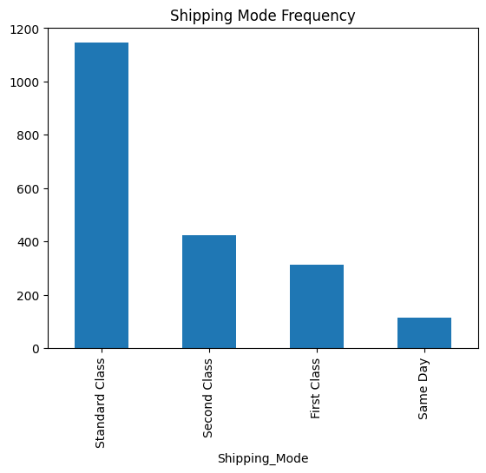

Figure 3 Shipping mode frequency

### **Insight 4: Distribution of customers by segments**

**Data:**

The chart shows the number of customers by segments of Consumer, Corporate, and Home Office.

**Analysis:**

The customer base is divided in Consumer and Corporate, with no clear "red" view, thus indicating a distribution between pure B2C and B2B. The home office category is a smaller one, which suggests potential for niche investing.

**Recommendations:**

Market and provide services that maximize value of our major segments, especially corporate Clients. Investigate niche campaigns for underrepresented categories (specifically: Home Office) to grow.

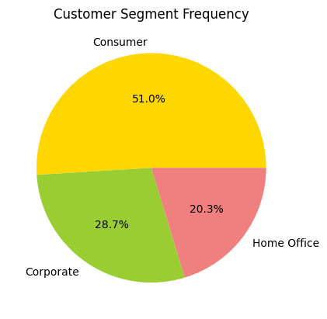

Figure 4 Customer Segment Distribution

### **Insights 5: Correlation Analysis**

**Data:**

A correlation heatmap analyses the relationships between multiple numerical features, such as time of shipment, delivery risk, and discount.

**Analysis:**

Significant relationships between shipping delays, risk factors and offered discount could emerge. Knowing these relationships provides insight into and accelerates the identification of the origin of inefficiencies.

**Recommendations:**

It should also predict and mitigate risk using regression based models with correlated features.

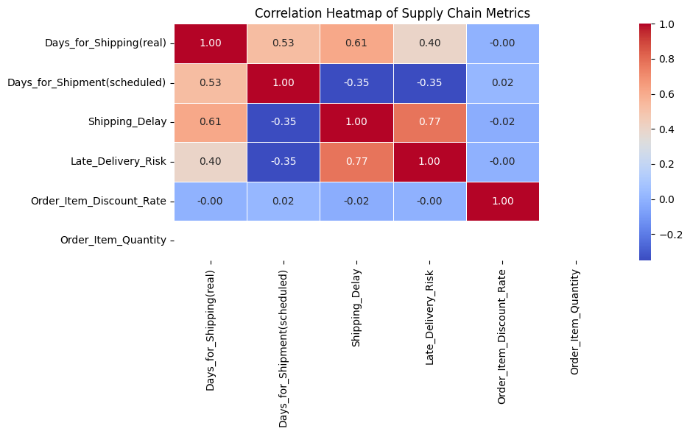

Figure 5 Correlation heatmap

### **Insight 6: Order Volume Over Time**

**Data:**

Figure 10 illustrates a time series chart that shows monthly sales that can help to observe recurrent customer preferences.

**Analysis:**

Changes in volume indicate seasonal affectations or operational-bottlenecks that affect fulfilment.

**Recommendations:**

Sync inventory management and workforce planning with the observed demand cycles to be more responsive.

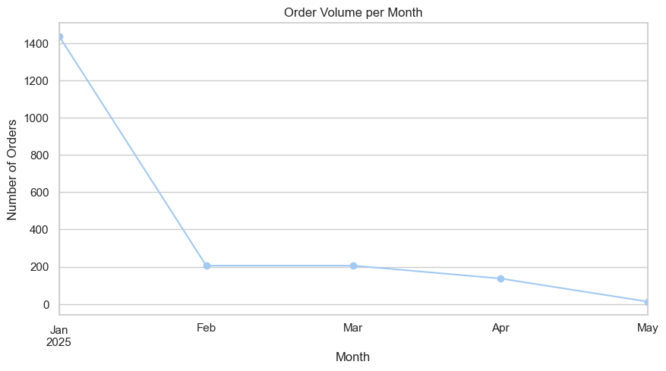

Figure 6 Order volume over time

### **Conclusion**

Insights delivered from the EDA is going to be essential across delivery performance, customer segmentation, logistics strategy and temporal sales pattern. These insights can be used to improve supply chain performance, customer satisfaction, and the efficiency of operations.