1. Write a program to count the number of lines, words, and characters in a text file.[10 marks]

2. Write a program to copy the contents of one file to another.[10 marks]

3. Write a program to find and replace a specific word in a file with another word.[10 marks]

4. Implement a program to read a CSV file and display its contents in a tabular format.[10 marks]

5. Develop a program that counts the occurrence of each word in a file.[10 marks]

6. Create a class Student with the attributes such as id, name, address, admission year, level, section. Instantiate the object of class to take input for all the attributes and display the output. [10 marks]

7.Write a program to implement a class called employee with attributes such as empid, name, address, contact_number, spouse name, number_of_child, salary. Instantiate this class to input the values for multiple employees and write it in a file “employees.csv”. Allow the user of your program to see the list of employees and their details as well. Try to use the concept of try/except too in the program. [20 marks]

8.Write a program to implement a basic library book management with the functionalities such as issue the book, return the book and search the book. Use the concept of OOP to create the necessary classes on your own and implement the concept of other OOP features. For the storage of book details, use the file handling along with the exception handling. [20 marks]

1) Write a program to copy the contents of one file to another.[
def copy_file(source_file, destination_file):
try:
with open(source_file, 'r') as source:
content = source.read()
with open(destination_file, 'w') as destination:
destination.write(content)
print(f"File copied successfully from '{source_file}' to '{destination_file}'")
return True
except FileNotFoundError:
print(f"Error: Source file '{source_file}' not found.")
return False
except PermissionError:
print(f"Error: Permission denied. Check if you have proper access rights.")
return False
except Exception as e:
print(f"An error occurred: {e}")
return False
def main():
source = input("Enter the source filename: ")
destination = input("Enter the destination filename: ")
copy_file(source, destination)
if _name_ == "_main_":
main()
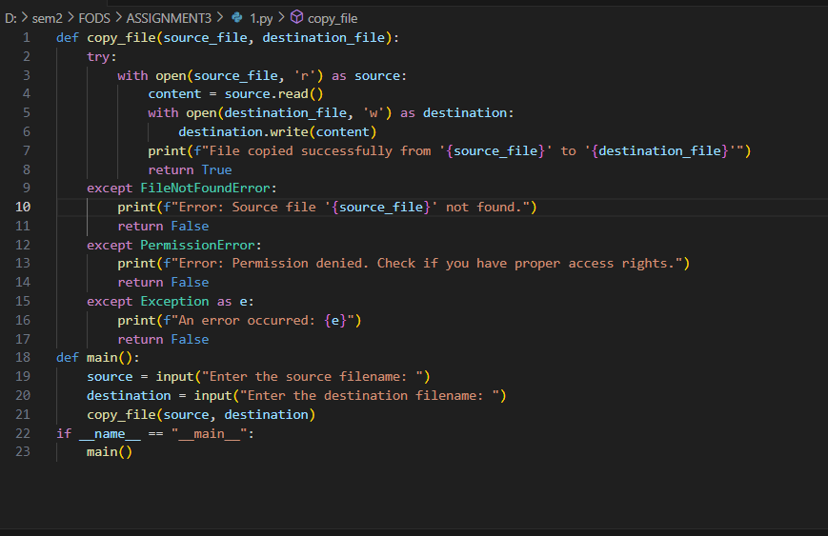
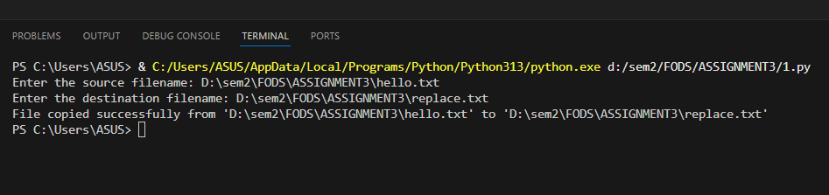
Replace.txt (copied from hello.txt)

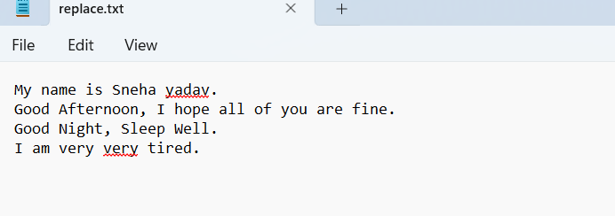

2)Write a program to count the number of lines, words, and characters in a text file.
def count_file_statistics(filename):
"""
Count the number of lines, words, and characters in a given file.

Args:
filename (str): The name of the file to analyze

Returns:
tuple: Contains count of (lines, words, characters)
"""
try:
# Open the file in read mode
with open(filename, 'r') as file:
# Read the entire content
content = file.read()

# Count characters
char_count = len(content)

# Reset file pointer to beginning to count lines and words
file.seek(0)

# Count lines
lines = file.readlines()
line_count = len(lines)

# Count words by splitting the content by whitespace
word_count = len(content.split())

return (line_count, word_count, char_count)

except FileNotFoundError:
print(f"Error: The file '{filename}' was not found.")
return (0, 0, 0)
except Exception as e:
print(f"An error occurred: {e}")
return (0, 0, 0)

def main():
# Get filename from user
filename = input("Enter the filename to analyze: ")

# Get statistics
lines, words, chars = count_file_statistics(filename)

# Display results if file was successfully processed
if lines > 0 or words > 0 or chars > 0:
print("\nFile Statistics:")
print("-" * 20)
print(f"Number of lines: {lines}")
print(f"Number of words: {words}")
print(f"Number of characters: {chars}")

# Execute the main function when script is run
if _name_ == "_main_":
main()
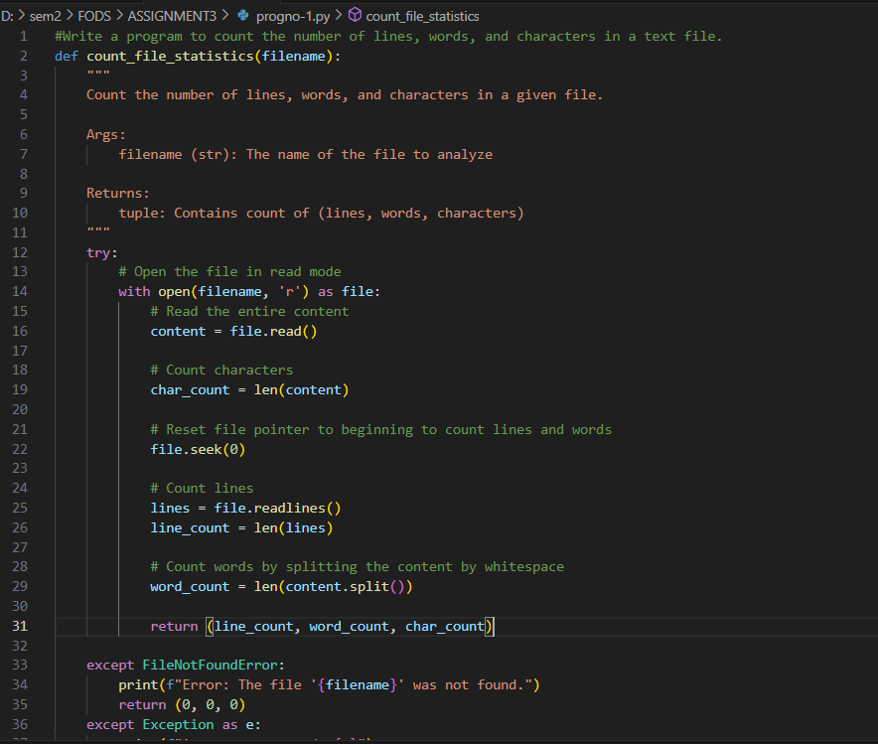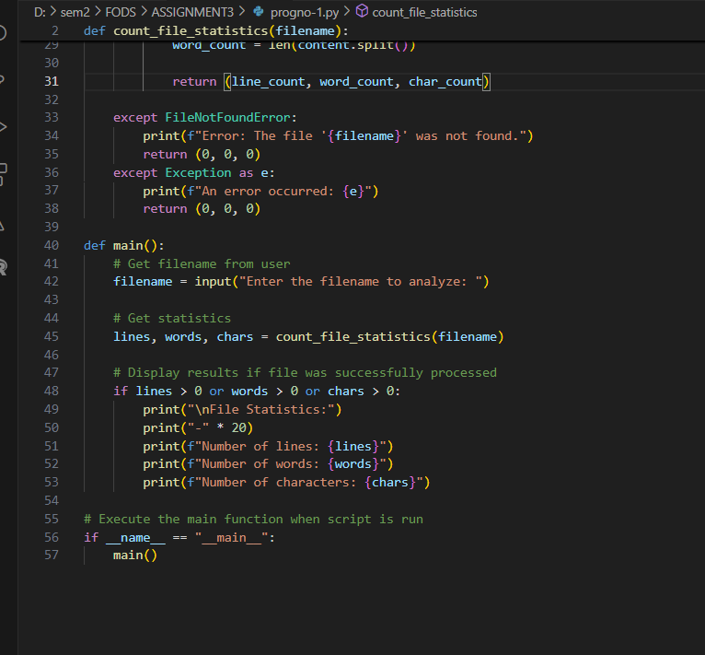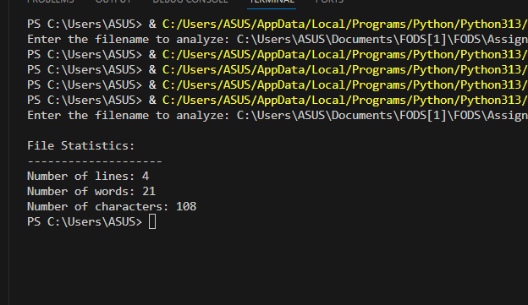

3) Write a program to find and replace a specific word in a file with another word
def find_and_replace(filename, word_to_find, replacement_word):
try:
with open(filename, 'r') as file:
content = file.read()
occurrences = content.count(word_to_find)
if occurrences == 0:
print(f"The word '{word_to_find}' was not found in the file.")
return 0
modified_content = content.replace(word_to_find, replacement_word)
with open(filename, 'w') as file:
file.write(modified_content)
print(f"Successfully replaced {occurrences} occurrence(s) of '{word_to_find}' with '{replacement_word}'")
return occurrences
except FileNotFoundError:
print(f"Error: The file '{filename}' was not found.")
return 0
except PermissionError:
print(f"Error: Permission denied. Check if you have proper access rights.")
return 0
except Exception as e:
print(f"An error occurred: {e}")
return 0
def main():
filename = input("Enter the filename: ")
word_to_find = input("Enter the word to find: ")
replacement_word = input("Enter the replacement word: ")
find_and_replace(filename, word_to_find, replacement_word)
if _name_ == "_main_":
main()

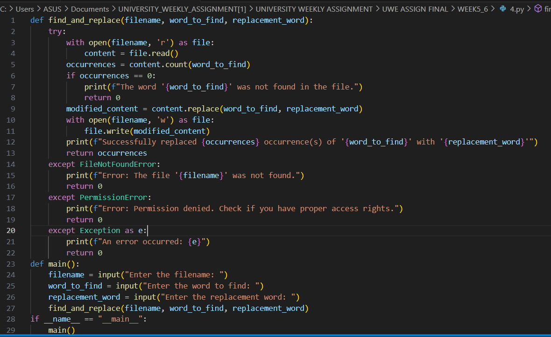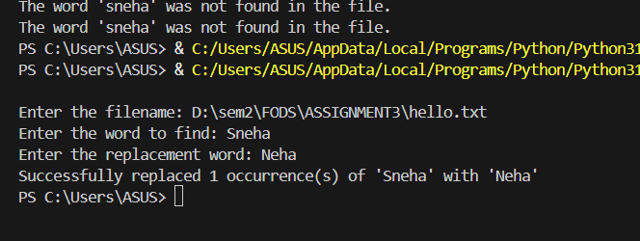
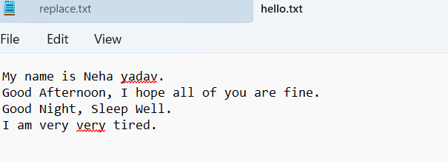
4) Implement a program to read a CSV file and display its contents in a tabular format
import csv
def display_csv(filename):
try:
with open(filename, 'r', newline='') as file:
csv_reader = csv.reader(file)
rows = list(csv_reader)
if not rows:
print("The CSV file is empty.")
return False
col_widths = []
for row in rows:
while len(col_widths) < len(row):
col_widths.append(0)
for i, cell in enumerate(row):
col_widths[i] = max(col_widths[i], len(str(cell)))
print("\nCSV File Contents:")
print("-" * (sum(col_widths) + 3 * len(col_widths) + 1))
for i, row in enumerate(rows):
row_str = "| "
for j, cell in enumerate(row):
if j < len(col_widths):
row_str += str(cell).ljust(col_widths[j]) + " | "
print(row_str)
if i == 0:
print("-" * (sum(col_widths) + 3 * len(col_widths) + 1))

print("-" * (sum(col_widths) + 3 * len(col_widths) + 1))
return True
except FileNotFoundError:
print(f"Error: The file '{filename}' was not found.")
return False
except csv.Error as e:
print(f"CSV Error: {e}")
return False
except Exception as e:
print(f"An error occurred: {e}")
return False
def main():
filename = input("Enter the CSV filename to display: ")
display_csv(filename)
if __name__ == "__main__":
main()
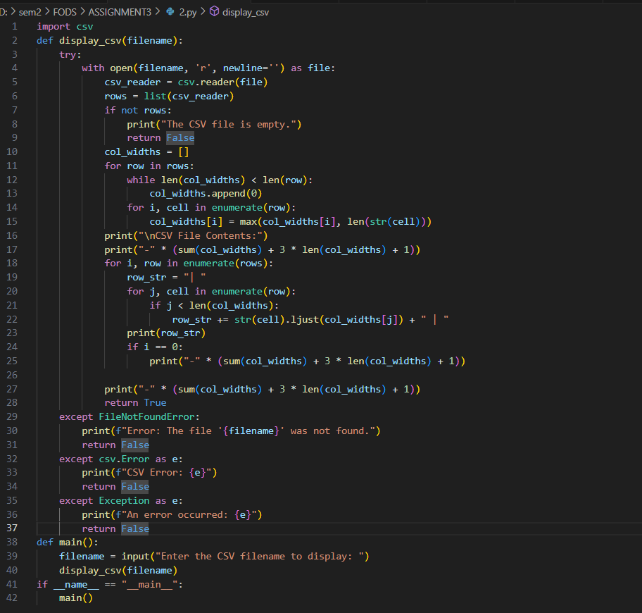
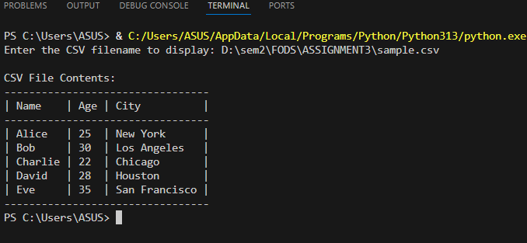
5) Develop a program that counts the occurrence of each word in a file
import re
import string
def count_word_occurrences(filename):
try:
word_counts = {}
with open(filename, 'r') as file:
content = file.read().lower()
for punct in string.punctuation:
content = content.replace(punct, ' ')
words = content.split()
for word in words:
word = re.sub(r'[^a-zA-Z0-9]', '', word)
if not word:
continue
if word in word_counts:
word_counts[word] += 1
else:
word_counts[word] = 1
return word_counts
except FileNotFoundError:
print(f"Error: The file '{filename}' was not found.")
return {}
except Exception as e:
print(f"An error occurred: {e}")
return {}
def display_word_counts(word_counts):
if not word_counts:
print("No words to display.")
return
sorted_counts = sorted(word_counts.items(), key=lambda x: x[1], reverse=True)
max_word_len = max(len(word) for word in word_counts.keys())
print("\nWord Occurrences:")
print("-" * (max_word_len + 15))
print(f"{'Word'.ljust(max_word_len)} | Occurrences")
print("-" * (max_word_len + 15))
for word, count in sorted_counts:
print(f"{word.ljust(max_word_len)} | {count}")
print("-" * (max_word_len + 15))
print(f"Total unique words: {len(word_counts)}")
def main():
filename = input("Enter the filename to analyze: ")
word_counts = count_word_occurrences(filename)
display_word_counts(word_counts)
if __name__ == "__main__":
main()
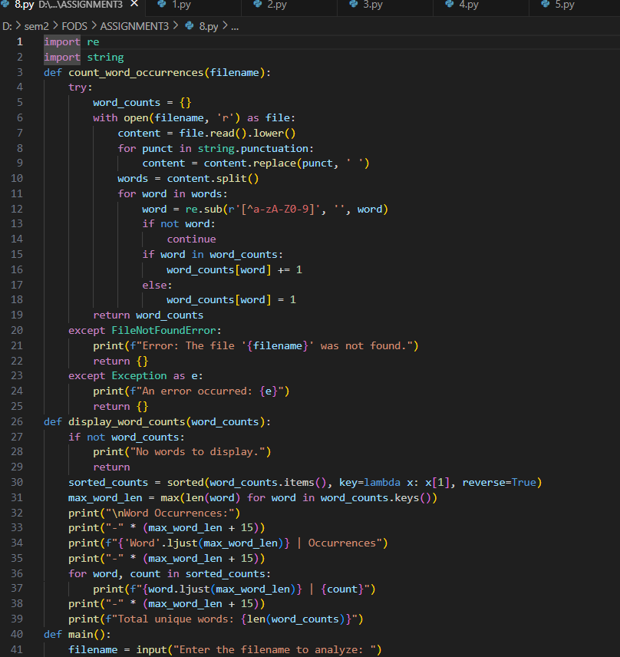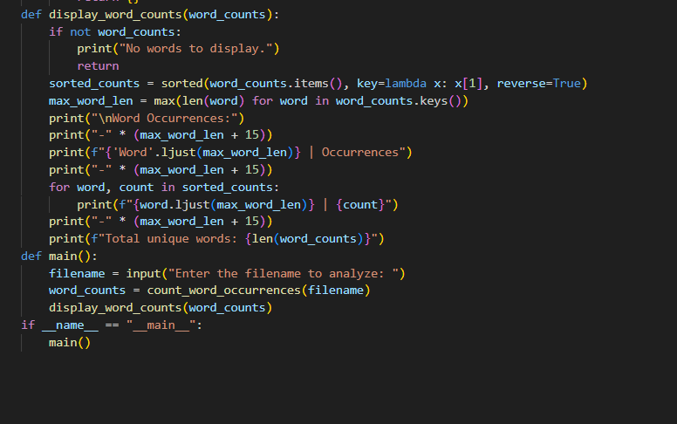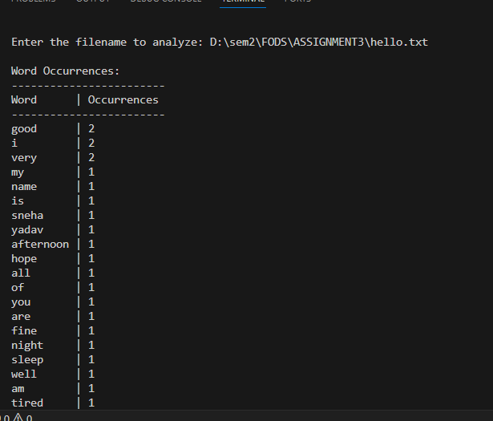

6) . Create a class Student with the attributes such as id, name, address, admission year, level, section. Instantiate the object of class to take input for all the attributes and display the output

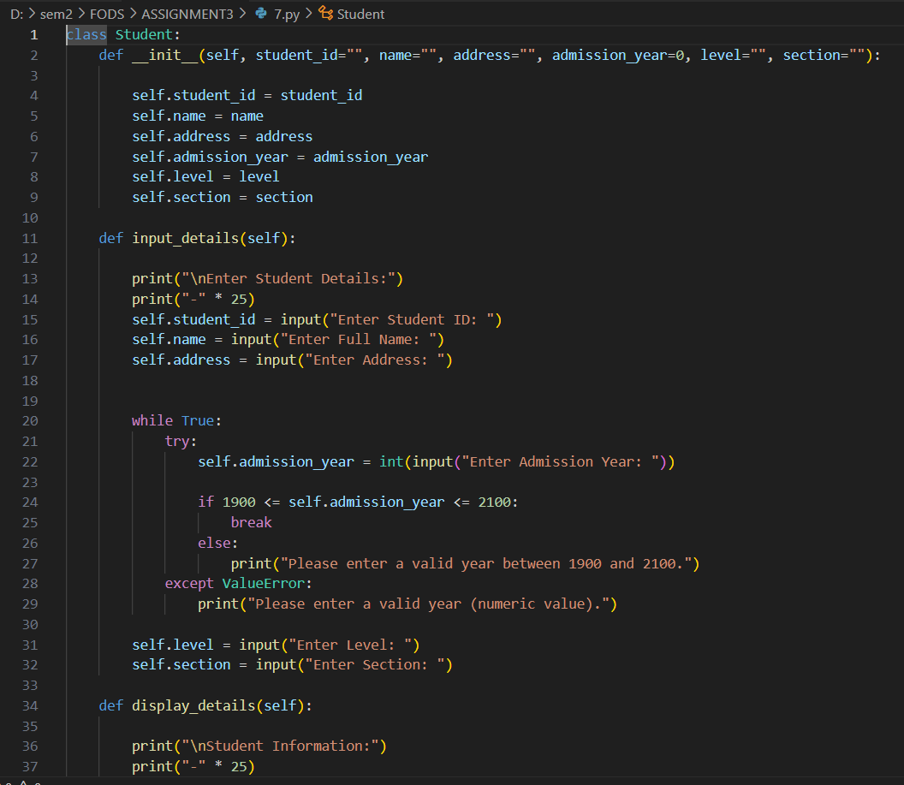
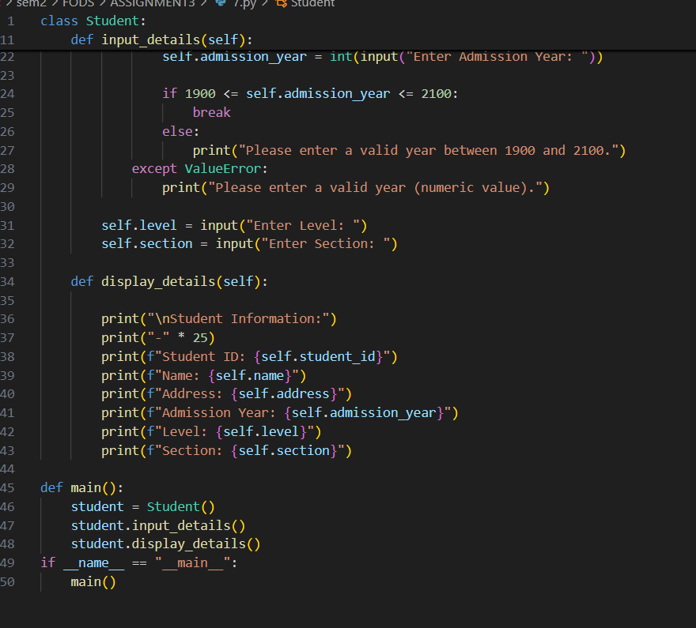
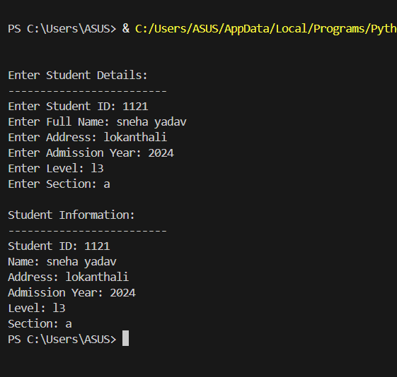
7) Write a program to implement a class called employee with attributes such as empid, name, address, contact_number, spouse name, number_of_child, salary. Instantiate this class to input the values for multiple employees and write it in a file “employees.csv”. Allow the user of your program to see the list of employees and their details as well. Try to use the concept of try/except too in the program.
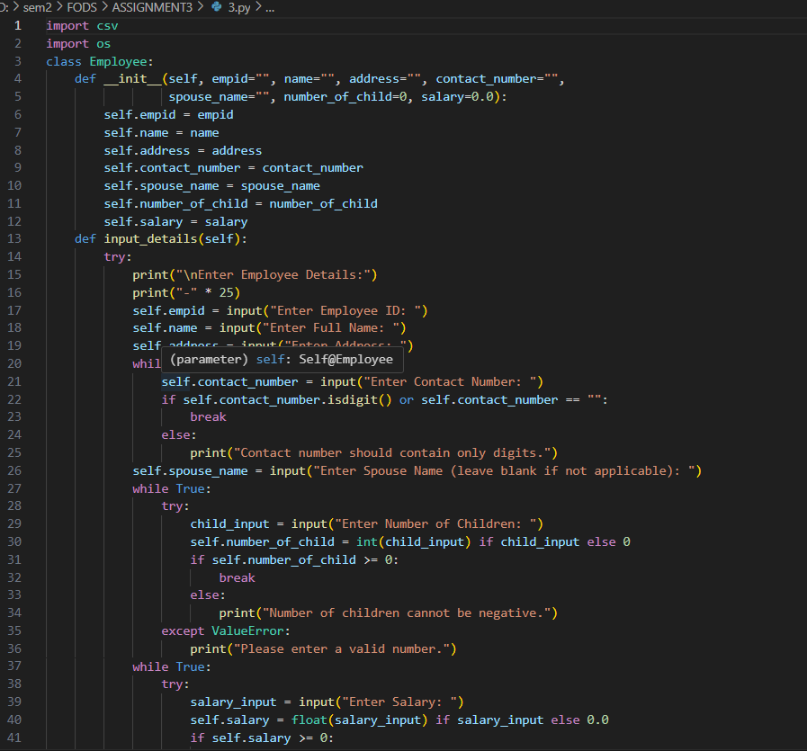
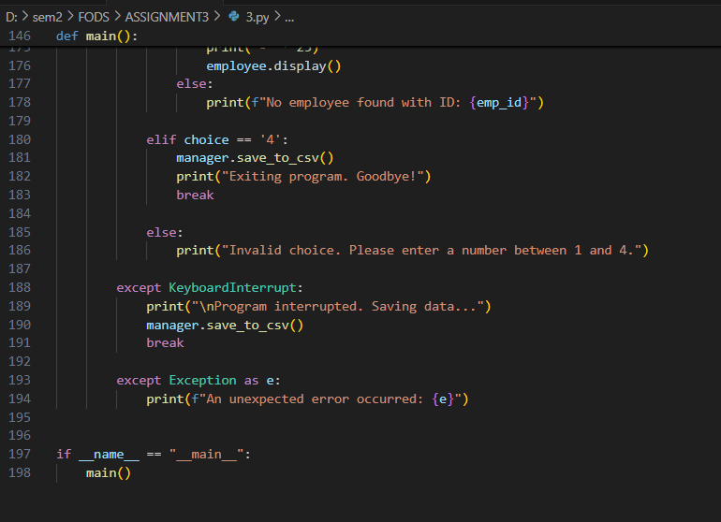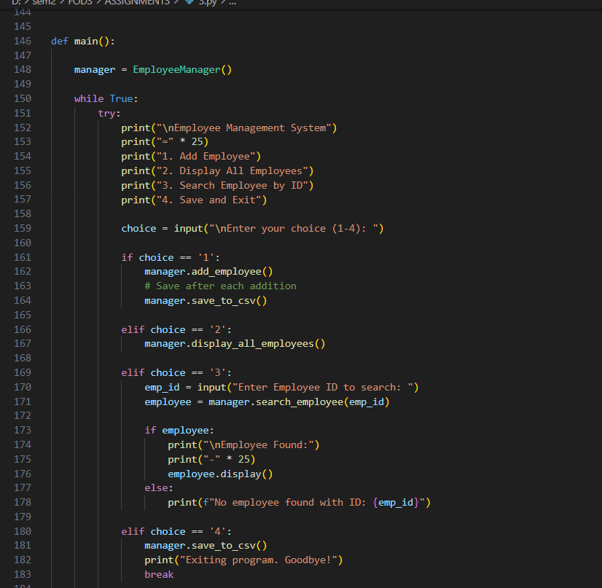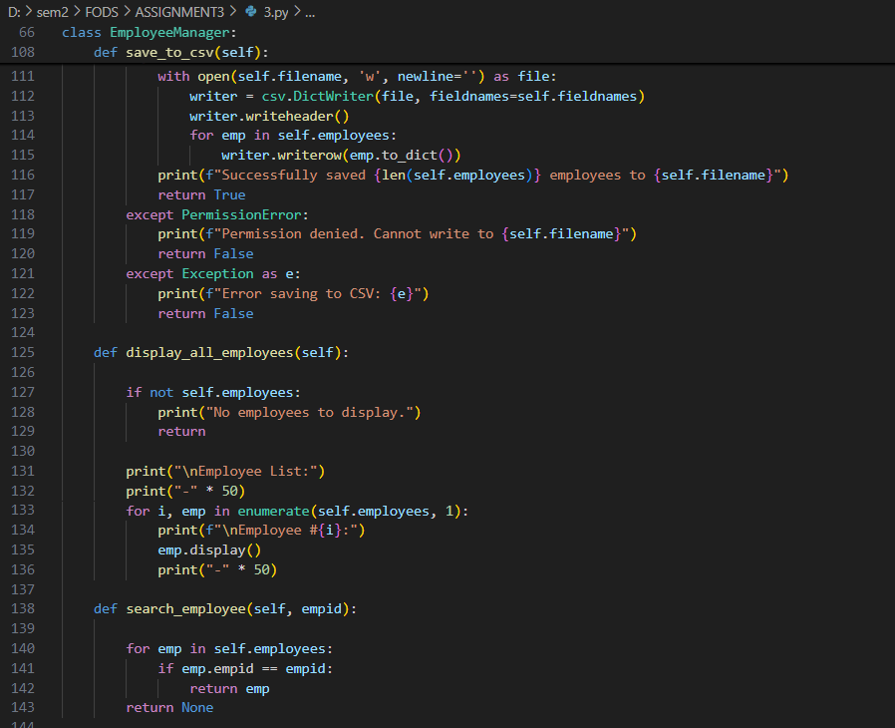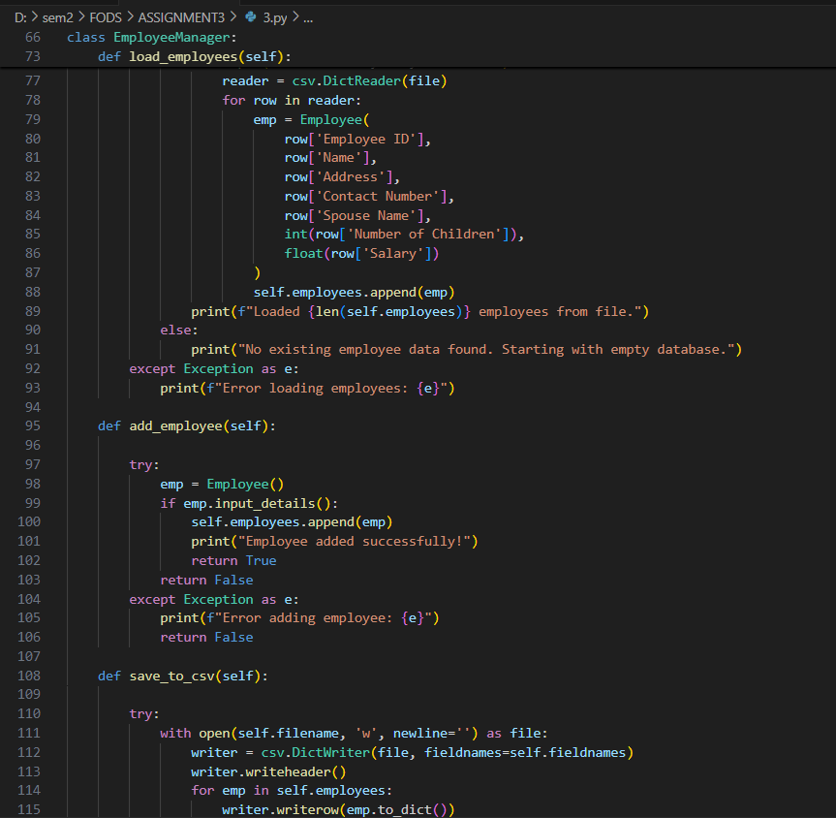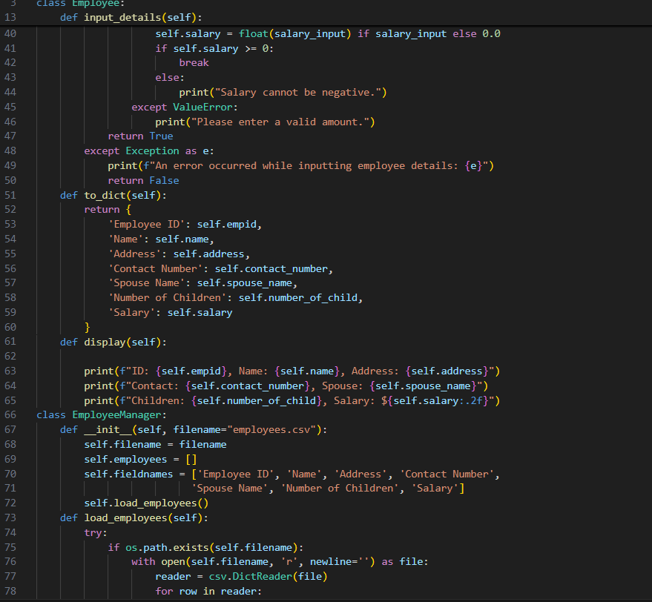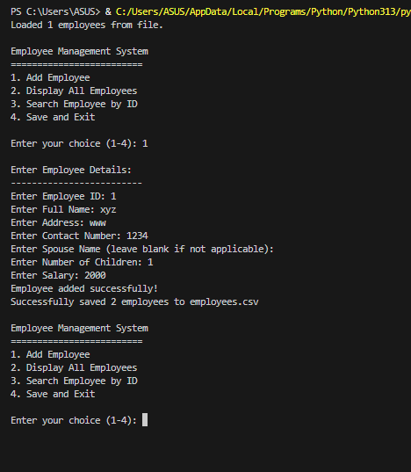

8) Write a program to implement a basic library book management with the functionalities such as issue the book, return the book and search the book. Use the concept of OOP to create the necessary classes on your own and implement the concept of other OOP features. For the storage of book details, use the file handling along with the exception handling.
