TATA
# Project Objective:
This project aims to analyze a customer dataset to identify patterns and key factors that contribute to account delinquency. By examining variables such as income, credit score, loan balance, payment history, and credit utilization, the goal is to understand which types of customers are more likely to default on their payments. The analysis involves data cleaning, exploratory data analysis, and visualization to uncover relationships between customer behavior and delinquency. The expected outcome is to generate actionable insights that can help financial institutions identify high-risk customers early and make better data-driven decisions for risk management and customer segmentation.

# graph :
we are visually comparing important features like Income and Credit Score with delinquency status. The boxplots help us see differences between delinquent (1) and non-delinquent (0) customers
Credit score vs delinquency :
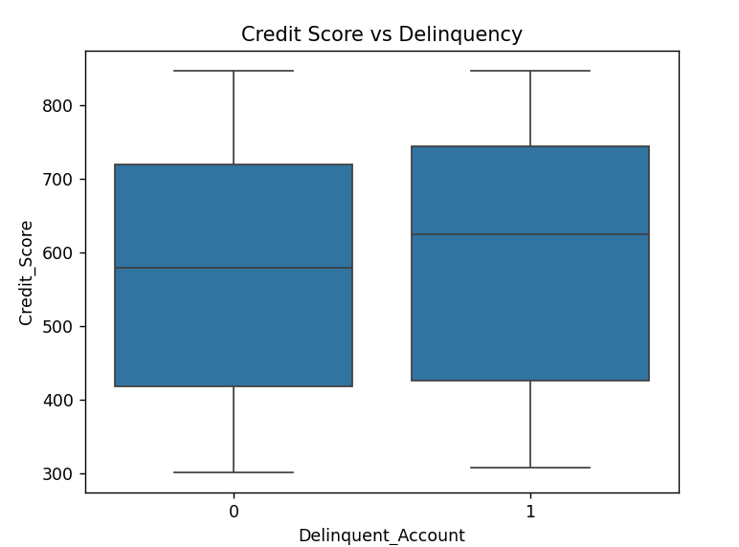
Difference is not very strong , Credit score alone is not clearly separating the groups

Income vs delinquency :
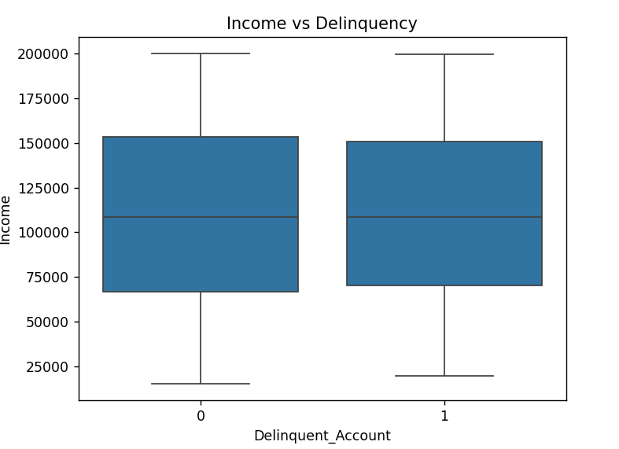
Income does not show a significant difference between delinquent and non-delinquent customers, indicating that income alone is not a strong predictor of delinquency.

So far:
- Income - not strong
- Credit Score - slightly useful but not strong

Which means:
Real factors will be in:
- Payment history
- Missed payments
- Credit utilization

our dataset has:
Month_1 → Month_6
(values like: On-time, Late, Missed) i.e. the payment histor

# missed payments vs delinquency :

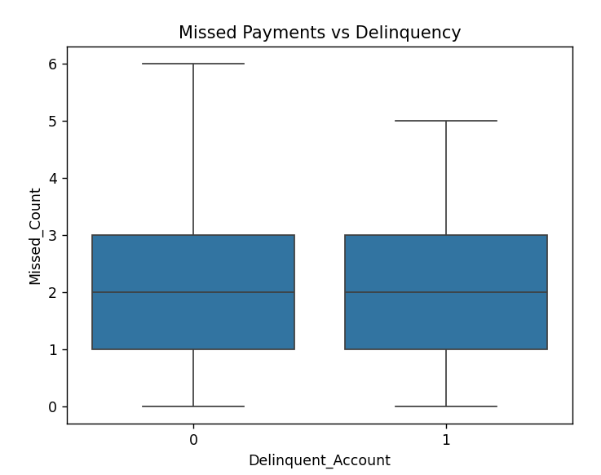
Delinquent_Account
0 2.016667
1 2.012500
Average missed payments are nearly the same for delinquent and non-delinquent accounts, so Missed_Count is not a strong standalone indicator of delinquency.

# Credit utilization vs delinquency & debt to income vs delinquency :
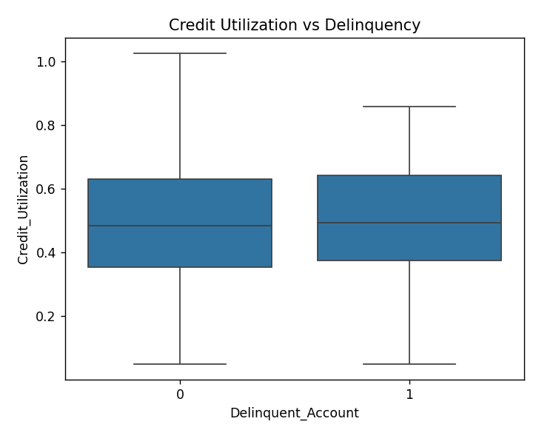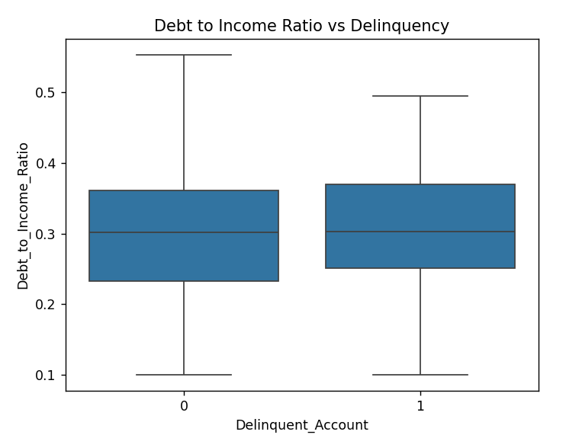
Here also :
- Data is not giving obvious patterns
- Which is very realistic in real-world datasets

- What project is showing till now :
- Income - not strong
- Credit Score - weak
- Missed Payments - not useful
- Credit Utilization - weak
- Debt Ratio - weak

NOTE :
- After the analysis, we can see that no single thing like income, credit score, or missed payments clearly explains delinquency by itself. The graphs overlap a lot, so there is no clear pattern. This means delinquency depends on many factors together, not just one factor.
We’ll make the project interesting by: Combining features
- Here, we are creating a new feature called Risk_Category to divide customers into groups based on their credit score, like High Risk, Medium Risk, and Low Risk. Instead of looking at the credit score directly, we turn it into categories so the pattern is easier to understand. Then we check how many people in each category are delinquent, meaning which group has a higher risk of default. This helps us see whether combining or simplifying features gives better patterns. It is similar to real-world analysis, where raw data is changed into useful insights

- Risk_Category
- High Risk 0.137405
- Medium Risk 0.195312
- Low Risk 0.172727
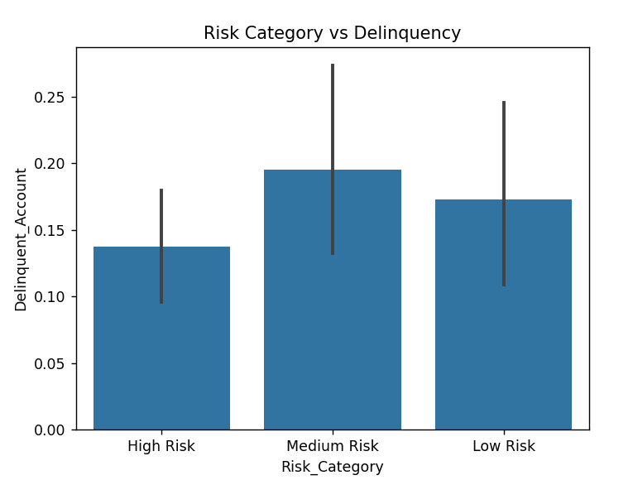
Medium risk customers show slightly higher delinquency, but the difference across categories is not very significant
- This risk category analysis shows that the medium-risk group has slightly more delinquent customers than the high-risk and low-risk groups. But the values are very close for all three groups, so we cannot see a strong difference.

SUMMARY :
Raw Analysis
We analyzed each feature separately, such as income, credit score, credit utilization, and debt-to-income ratio, to see how each one relates to delinquency. When compared directly with Delinquent_Account using boxplots, no single feature showed a very strong separation between delinquent and non-delinquent customers.

Behavioral Analysis
We studied customer payment behavior using the monthly payment history from Month_1 to Month_6. We also created a new feature called Missed_Count to count how many payments were missed, and then compared it with delinquency to understand whether past behavior affects future risk.

Feature Engineering
We transformed the existing data into a more meaningful feature called Risk_Category by grouping credit scores into High, Medium, and Low risk. This made it easier to identify patterns and compare customer groups more clearly.

- Final Insights
Overall, the analysis shows that delinquency is not driven by one single factor. Individual features had a lot of overlap between delinquent and non-delinquent customers, and payment history also did not show a very strong difference. After feature engineering, the medium-risk group showed slightly higher delinquency, but the difference was still small. So, delinquency appears to be a multi-factor problem influenced by several variables together rather than one clear predictor.

