WEEK 3 TASK
ADVANCED DATA ANALYSIS AND VISUALIZATION IN LOGISTICS
Python-based Exploratory Data Analysis (EDA) Report
Prepared by: Sneha R Hongal
Dataset: 200 hypothetical shipment records | Currency: INR

1. Executive Summary
This report presents an exploratory analysis of 200 simulated logistics shipments. The analysis examines delivery times, transport costs, shipment volume, route distance, transport mode, and region. Python, pandas, NumPy, and Matplotlib were used to calculate summary statistics and create six visualizations. The simulated data show a correlation of 0.82 between distance and transportation cost and 0.38 between shipment volume and transportation cost. These results suggest that distance and load size are useful variables to monitor when investigating cost variation. Average delivery time differs by region and mode, which can help identify areas for further investigation. Because the dataset is hypothetical, all findings are illustrative and should be validated against actual operational data before decisions are made.

2. Objectives
- Explore the structure and quality of a simulated logistics dataset.
- Calculate central tendency, spread, distributions, and correlations.
- Visualize patterns in delivery times, costs, shipment volume, distance, modes, and regions.
- Interpret the results to identify possible efficiency opportunities and operational bottlenecks.
- Provide reproducible Python code and practical recommendations.

3. Dataset Simulation and Structure
The dataset contains one row per shipment and 200 rows in total. It was generated for this assignment and does not represent a real logistics company. Variables include a shipment identifier, region, transport mode, distance in kilometres, shipment volume in units, delivery time in days, transportation cost in Indian rupees, and cost per unit. The simulated records include different route lengths and transport modes to support comparisons. Two intentionally unusual values were retained to demonstrate why analysts should inspect outliers rather than automatically delete them.
Variable | Type | Purpose
Shipment_ID | Categorical identifier | Distinguishes shipments
Region | Categorical | Compares regional performance
Transport_Mode | Categorical | Compares Road, Rail, and Air
Distance_km | Numeric | Measures route distance
Shipment_Volume_Units | Numeric | Represents shipment load
Delivery_Time_Days | Numeric | Measures delivery duration
Transportation_Cost_INR | Numeric | Measures transport spend
Cost_per_Unit_INR | Numeric | Normalizes cost by shipment volume

4. Methodology and Tools
The workflow followed a typical EDA sequence: load the CSV file, inspect dimensions and data types, check missing values, calculate descriptive statistics, group shipments by transport mode and region, compute a correlation matrix, and create charts. Pandas was used for data handling and grouped summaries; NumPy supported reproducible data generation; Matplotlib produced the charts. The random seed was fixed so the simulated data can be reproduced.

Python code excerpt
import pandas as pd
import matplotlib.pyplot as plt
df = pd.read_csv("logistics_shipments.csv")
print(df.shape)
print(df.isna().sum())
print(df.select_dtypes("number").describe().round(2))
mode_summary = df.groupby("Transport_Mode").agg(
shipments=("Shipment_ID", "count"),
avg_delivery_days=("Delivery_Time_Days", "mean"),
avg_cost_inr=("Transportation_Cost_INR", "mean")
)
print(mode_summary.round(2))
print(df.select_dtypes("number").corr().round(2))

5. Exploratory Data Analysis

5.1 Data quality and preparation
The dataset has 200 rows and 8 columns. The generated file contains 0 missing values. Shipment_ID is an identifier, while region and transport mode are categorical. The numeric fields were checked for plausible ranges and summarized before charting. In a real project, additional checks would include duplicate shipment IDs, invalid negative distances or costs, date/time consistency, and agreed business rules for delivery status.

5.2 Descriptive statistics
Metric | Count | Mean | Median | Std. dev. | Minimum | Maximum
Distance_km | 200 | 756.71 | 791.00 | 427.15 | 56.00 | 1499.00
Shipment_Volume_Units | 200 | 79.02 | 78.50 | 41.32 | 6.00 | 150.00
Delivery_Time_Days | 200 | 4.86 | 4.76 | 1.72 | 0.80 | 12.81
Transportation_Cost_INR | 200 | 1058.31 | 1044.99 | 411.21 | 202.10 | 2912.78
Cost_per_Unit_INR | 200 | 22.20 | 12.93 | 30.95 | 2.97 | 248.86
The mean describes the average, while the median is less affected by extreme values. Standard deviation indicates how widely shipments vary around the mean. Comparing mean and median can signal skew or outliers; unusually high values should be reviewed with operational context before being treated as errors.

6. Visualizations and Interpretation

Figure 1. Distribution of delivery times.
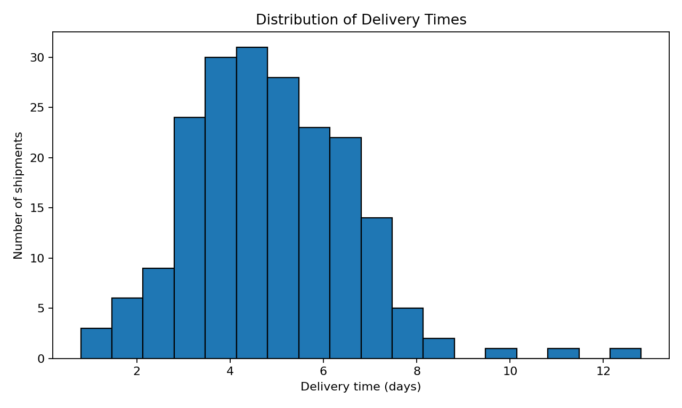
A histogram shows how frequently delivery durations fall within different ranges. It is useful for understanding the typical delivery window, spread, and unusually slow shipments. A long right tail or isolated high values can indicate exceptional routes, handling delays, or data-quality issues. The team should compare these durations with a formally defined service-level target.

Figure 2. Average transportation cost by mode.
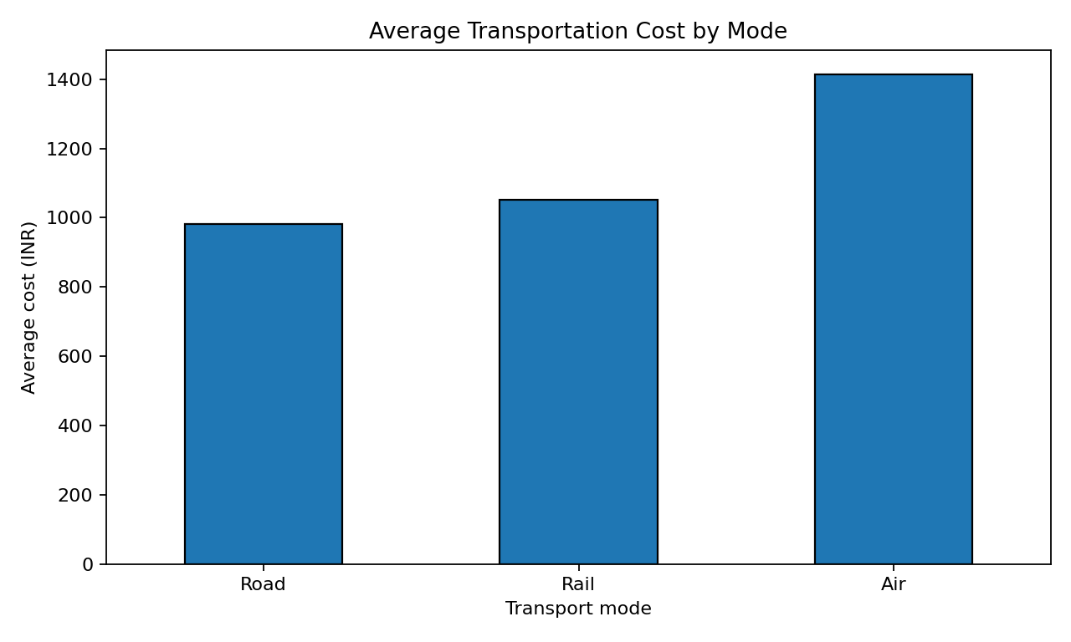
A bar chart is appropriate for comparing average cost across categories. Air is expected to have a higher average cost in this simulated dataset because the data-generation rules add an air-mode premium. This is a cost trade-off rather than proof that air is inefficient: speed, product urgency, and service requirements should be considered alongside cost.

Figure 3. Distance versus transportation cost.
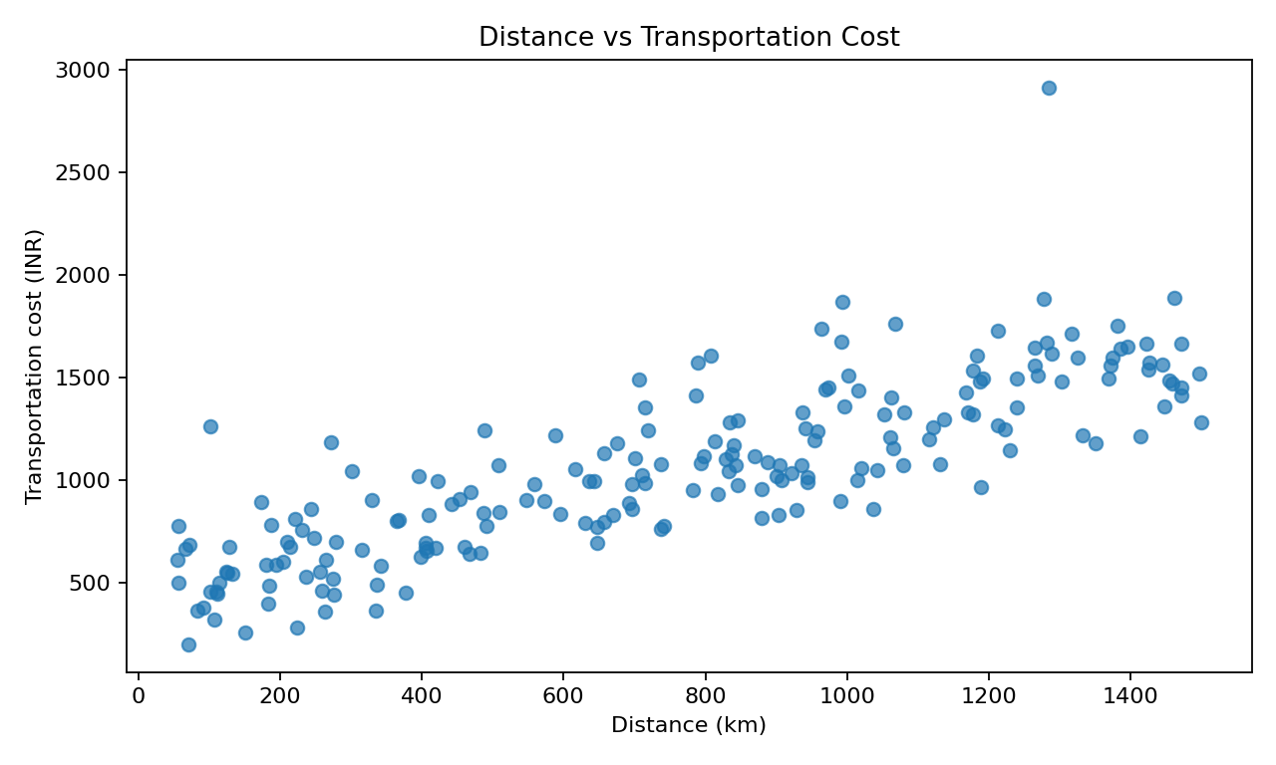
A scatter plot reveals the relationship between two numeric variables and makes unusual shipments visible. The observed correlation is 0.82. A positive relationship is operationally plausible because longer routes usually require more resources. Points far above the general pattern should be checked for expedited services, tolls, special handling, or recording errors.

Figure 4. Shipment volume versus transportation cost.
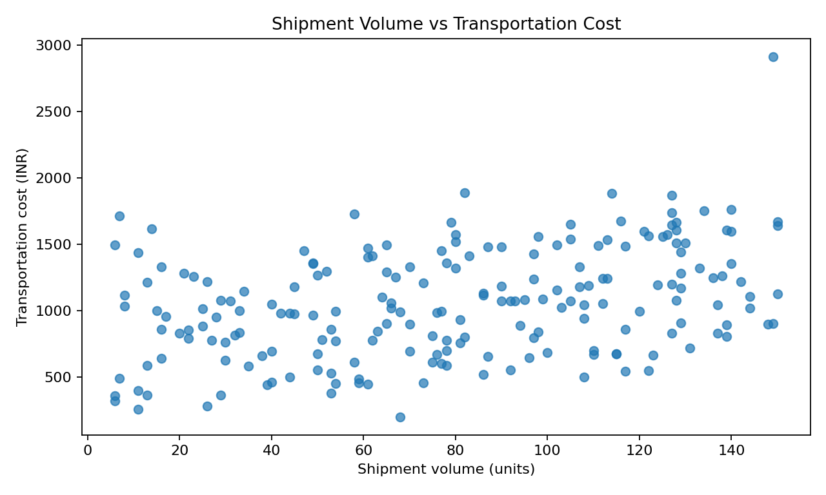
The scatter plot compares load size with total transport cost. The observed correlation is 0.38. Total cost may rise with volume, but cost per unit is also important: larger shipments may use capacity more efficiently. Analysts should compare cost per unit across shipment sizes before recommending consolidation.

Figure 5. Correlation matrix.
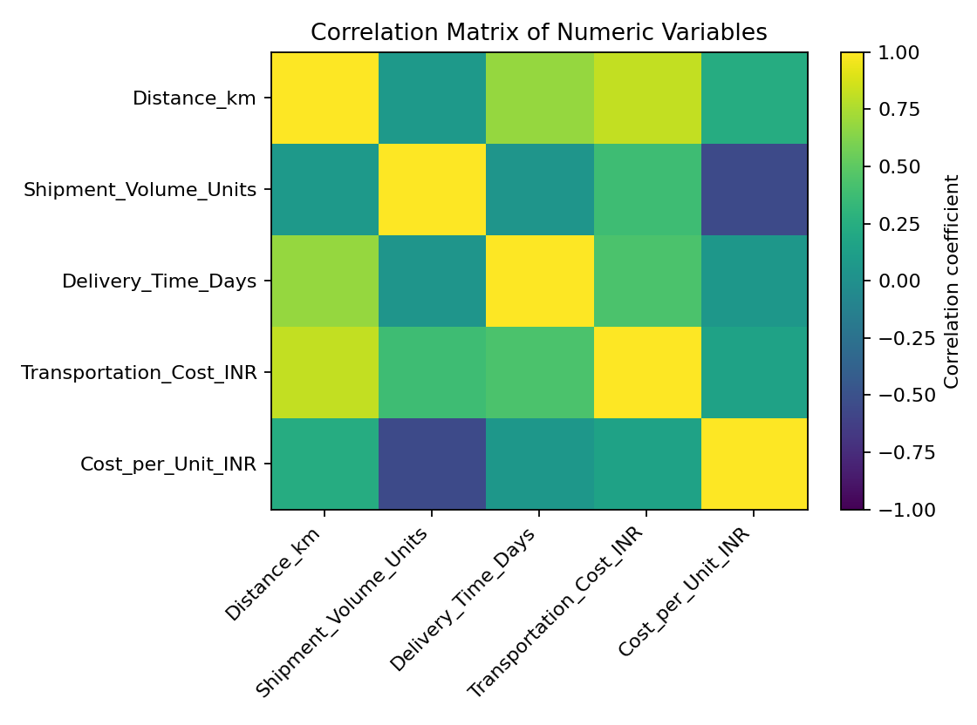
The correlation matrix summarizes linear relationships among numeric variables. Values near +1 indicate a strong positive linear relationship, values near -1 a strong negative relationship, and values near 0 little linear association. Correlation does not establish causation and may be affected by mode, region, or unusual observations. Use it to prioritize questions for deeper analysis, not as a standalone decision rule.

Figure 6. Average delivery time by region.
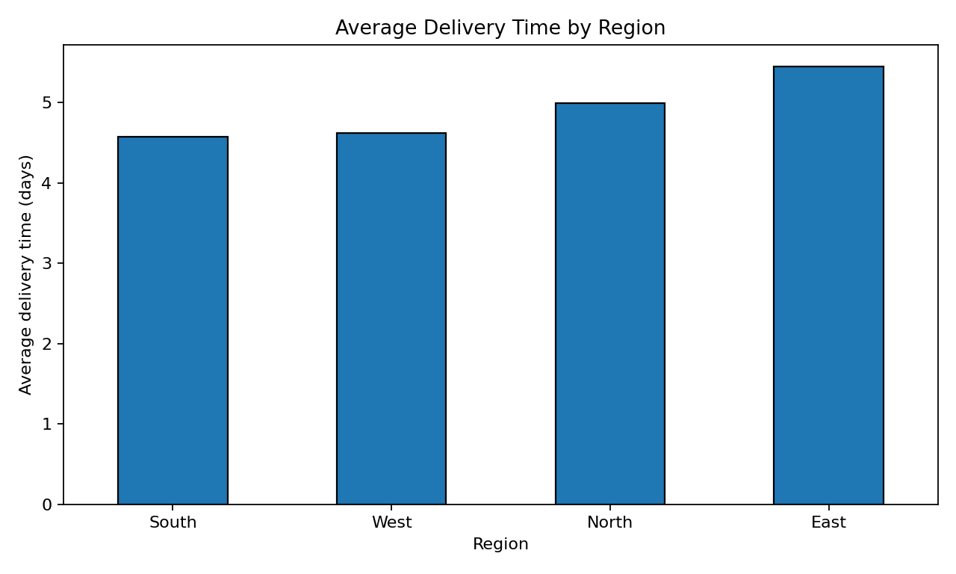
A bar chart compares regional average delivery durations and helps prioritize follow-up. Regional differences in this simulated dataset may reflect the way records were generated, not real geographic conditions. In a real operation, investigate route distance, traffic, weather, warehouse processing, carrier performance, and the proportion of air, rail, and road shipments in each region.

7. Grouped Analysis

7.1 By transport mode
The table below summarizes shipment count, average delivery time, average total cost, and average cost per unit by mode.
Mode | Shipments | Avg delivery (days) | Avg cost (INR) | Avg cost/unit (INR)
Air | 28 | 3.46 | 1413.91 | 44.66
Rail | 47 | 4.54 | 1051.65 | 19.86
Road | 125 | 5.30 | 981.16 | 18.04
Mode selection should be based on the required delivery window and total landed cost. A fair comparison would control for distance, volume, and shipment urgency rather than comparing raw averages alone.

7.2 By region
Region | Shipments | Avg delivery (days) | Avg cost (INR)
East | 40 | 5.45 | 1153.62
North | 49 | 5.00 | 1006.67
South | 59 | 4.57 | 1056.70
West | 52 | 4.62 | 1035.49

8. Key Findings
- Distance and cost have a correlation of 0.82, supporting distance as a candidate cost driver in the simulated data.
- Shipment volume and total cost have a correlation of 0.38; total spend should be interpreted together with cost per unit.
- Distance and delivery time have a correlation of 0.68; delivery time is also affected by mode, region, and random delay in this dataset.
- 44.0% of simulated shipments take longer than 5 days. This is an illustrative threshold only, not an externally defined SLA.
- The mode and region summaries show how group-level metrics can help identify where to investigate further, but the data do not support causal claims.

9. Recommendations
- Establish clear service-level targets by service type and calculate on-time delivery rate using promised delivery dates, not an arbitrary threshold.
- Track cost per shipment and cost per unit alongside total transportation spend to avoid penalizing larger but more efficient loads.
- Investigate unusually expensive shipments and unusually long delivery times with a structured exception review.
- Compare transport modes within similar distance, volume, urgency, and region groups to make fair comparisons.
- Evaluate shipment consolidation where service windows allow, and monitor whether consolidation reduces cost per unit without increasing delays.
- Build a recurring dashboard with delivery-time percentiles, on-time delivery, cost per unit, volume, mode mix, and regional trends.
- Validate these hypotheses with real operational data and consult logistics managers before implementing changes.

10. Limitations
The dataset is synthetic and relatively small. It does not include promised delivery dates, pickup/dispatch timestamps, carrier IDs, fuel prices, tolls, weather, traffic, failed delivery attempts, warehouse dwell time, or customer priority. Consequently, the report can demonstrate analytical methods but cannot verify real-world performance or explain causation. The correlation coefficient only captures linear association and may be influenced by confounding variables and outliers.

11. Conclusion
This project demonstrates how exploratory data analysis and visualizations can support logistics performance reviews. Descriptive statistics summarize typical values and variation, histograms reveal the distribution of delivery times, bar charts compare categories, scatter plots explore cost drivers, and a correlation matrix highlights relationships worth investigating. The most useful next step is to apply the same workflow to validated shipment records with agreed service-level definitions, then monitor the resulting KPIs over time.

12. Reproducibility and Project Files
The accompanying project includes the CSV dataset, a Python script, package requirements, a data dictionary, and the generated chart images. To reproduce the analysis, install the packages listed in requirements.txt and run logistics_analysis.py from the project folder. The script prints summary outputs and recreates the visualizations.

