Trader Performance vs. Bitcoin Market Sentiment
An Analysis of Hyperliquid Historical Trade Data and the Fear & Greed IndexAn Analysis of Hyperliquid Historical Trade Data and the Fear & Greed Index
Prepared for: Primetrade.ai — Data Science Hiring Assignment
Date: July 7, 2026

1. Executive Summary
This analysis examines 211,224 trades from 32 Hyperliquid accounts between May 2023 and May 2025, joined against the daily Bitcoin Fear & Greed Index. The goal was to determine whether trader profitability, risk-taking, and positioning shift systematically with market-wide sentiment.
The headline finding is counter-intuitive: traders in this dataset were most consistently profitable during Fear and Extreme Greed, and least profitable — though still net positive — during Extreme Fear. Win rates ranged from 76% in Extreme Fear to 89% in Extreme Greed, and average realized profit per trade nearly doubled between the weakest and strongest sentiment regimes. Trading volume and activity were also inversely related to the numeric sentiment score, meaning the desk traded more heavily as sentiment cooled toward Fear.

2. Data & Methodology
- Bitcoin Market Sentiment Dataset: 2,645 daily records (Feb 2018 – May 2025) classifying each day as Extreme Fear, Fear, Neutral, Greed, or Extreme Greed.
- Hyperliquid Historical Trades: 211,224 individual fills from 32 accounts across 246 symbols, spanning May 2023 – May 2025, including execution price, size, side, closed PnL, and fees.
- Trades were joined to the sentiment index by calendar date (IST). Only 6 of 211,224 trades (<0.01%) fell outside the sentiment index's date range and were excluded.
- "Realized" trades are fills with a non-zero Closed PnL, i.e. positions actually closed out — used for win-rate and per-trade profitability metrics. All fills (including position-building trades with zero realized PnL) are used for volume and activity metrics.
- Win rate = share of realized trades with Closed PnL > 0.

3. Key Findings

3.1 Win Rate by Market Sentiment
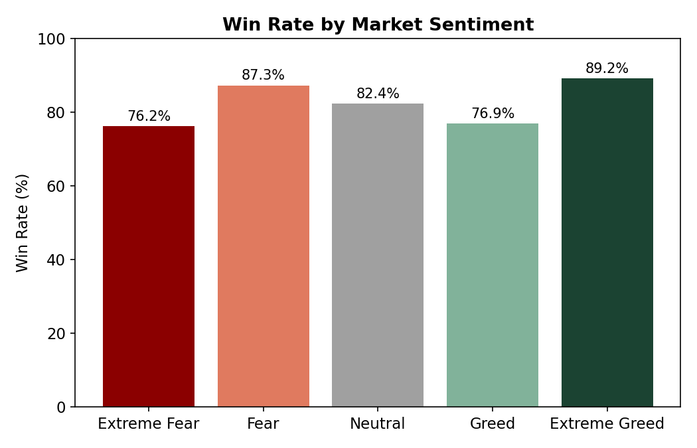
Win rates were highest in Extreme Greed (89.2%) and Fear (87.3%), and lowest in Extreme Fear (76.2%) and Greed (76.9%). Neutral sat in between at 82.4%. This suggests the traders in this book perform worst not during the calmest periods, but during the most panicked ones — consistent with panic-driven exits or being caught on the wrong side of sharp reversals.

3.2 Average Profit per Trade by Sentiment
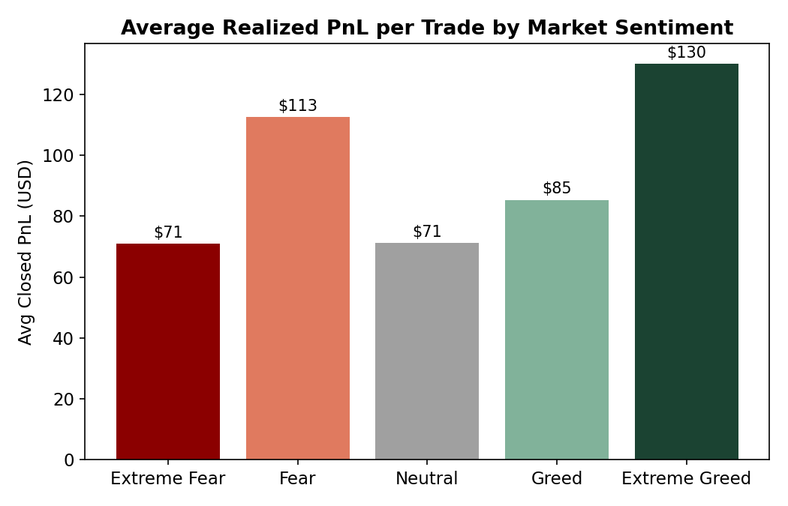
Average realized PnL per trade follows a similar pattern: $130 in Extreme Greed and $113 in Fear, versus just $71 in both Extreme Fear and Neutral. Extreme Greed and Fear — the two "emotionally extreme but directionally different" states — were where this book made the most money per trade, while Extreme Fear (panic) was the weakest, despite still being profitable on average.

3.3 Trading Volume and Activity by Sentiment
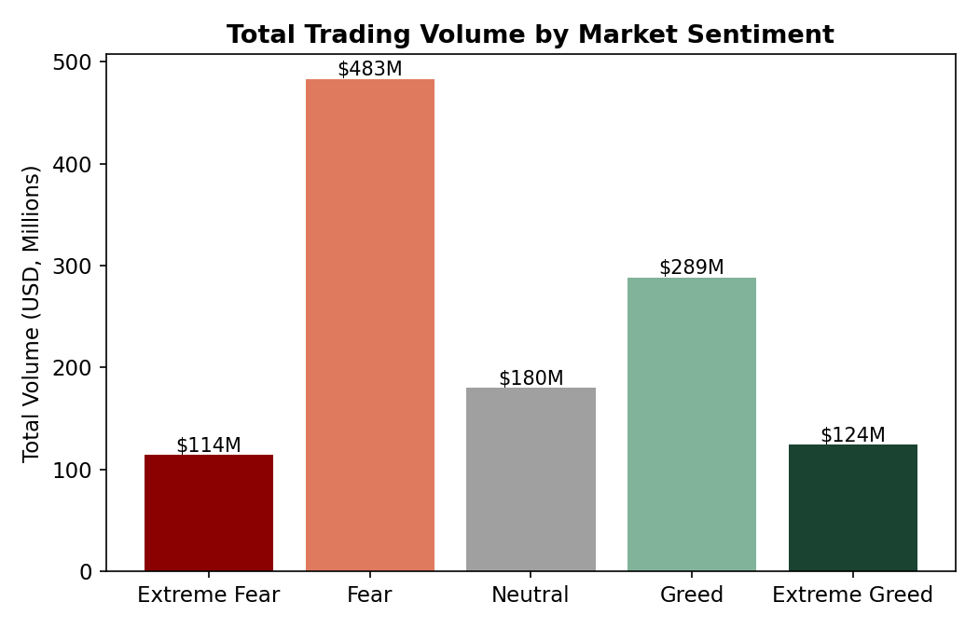
Total trading volume was highest during Fear ($483M) and Greed ($289M), and lowest during Extreme Fear ($114M) and Extreme Greed ($124M) — the two emotional extremes. Interestingly, the correlation between the raw sentiment score (0–100) and both daily volume (r = -0.26) and daily trade count (r = -0.25) was negative: activity picked up as sentiment moved toward Fear, not Greed. This points to Fear regimes being the busiest trading periods for this desk, likely driven by volatility and repositioning.

3.4 Directional Bias (Buy vs. Sell)
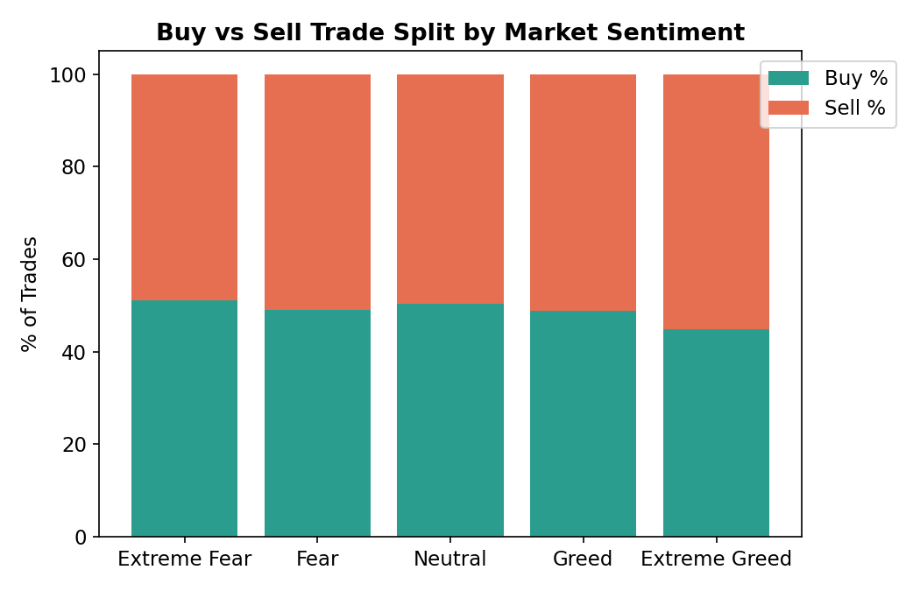
The buy/sell split stayed close to 50/50 across sentiment states, with one notable tilt: Extreme Greed saw the most sell-side activity (55.1% sell vs. 44.9% buy), consistent with profit-taking or fading euphoric price action rather than chasing it.

3.5 BTC/ETH vs. Altcoins by Sentiment
Sentiment | Avg PnL – Altcoins ($) | Avg PnL – BTC/ETH ($)
Extreme Fear | 25.31 | 87.83
Fear | 44.78 | 91.02
Neutral | 33.70 | 37.49
Greed | 42.64 | 43.14
Extreme Greed | 74.76 | 13.20

This is one of the more actionable patterns: BTC/ETH positions were dramatically more profitable than altcoins during Fear and Extreme Fear (roughly 2-3x), while altcoins outperformed BTC/ETH by more than 5x during Extreme Greed. This is consistent with a classic "flight to quality" dynamic — large-caps hold up (or are traded more skillfully) during downturns, while speculative altcoins rip hardest during euphoric, high-risk-appetite phases.

4. Correlation Summary
Metric vs. Sentiment Score (0-100) | Pearson r
Daily total realized PnL | -0.083
Daily trading volume | -0.264
Daily trade count | -0.245

All correlations are weak-to-moderate and negative, reinforcing that this dataset's activity and (slightly) its profitability skew toward lower sentiment scores rather than scaling up with greed, contrary to the popular assumption that traders overtrade during euphoric markets.

5. Notable Extremes
The single best trading day was 2025-03-03 (+$616K total realized PnL) and the worst was 2025-04-23 (-$419K) — both can be cross-referenced against that date's sentiment classification and broader market news for deeper case-study analysis if needed.

6. Strategic Implications
- Extreme Fear deserves the most risk caution: it has the lowest win rate (76%) despite lower volume, suggesting panic conditions degrade decision quality even when position sizes shrink.
- Extreme Greed is not uniformly "euphoric overtrading" — this book's win rate and per-trade PnL were actually the highest here, but concentrated in altcoins and skewed toward selling, suggesting disciplined profit-taking rather than chasing.
- A large-cap (BTC/ETH) tilt during Fear/Extreme Fear and an altcoin tilt during Extreme Greed both outperformed the alternative — a rotation strategy conditioned on sentiment may improve risk-adjusted returns.
- Because volume and trade count rise as sentiment sours toward Fear, liquidity and slippage risk should be modeled as sentiment-dependent, not assumed constant.

7. Limitations & Further Work
- Only 32 accounts are represented; results may reflect a handful of large or skilled traders rather than the broader market.
- Sentiment is measured daily and market-wide (BTC-based), while trades span 246 symbols — coin-specific sentiment could sharpen the analysis.
- No leverage or margin field was available to directly assess risk-adjusted (rather than nominal) returns.
- Statistical significance testing (e.g., bootstrapped confidence intervals on win-rate differences) would strengthen the causal interpretation of these patterns.

