Self-Pruning Neural Network Case Study

NAME:SNEHA S
REG NO:22MID0225

1. Introduction
Deep neural networks are powerful but often contain a large number of parameters, making them computationally expensive and memory intensive. This case study focuses on designing a self-pruning neural network that can automatically remove unnecessary weights during training, improving efficiency without significantly affecting performance.

2. Problem Statement
The objective is to build a neural network where each weight is associated with a learnable gate parameter. These gates control whether a connection is active or pruned. The challenge is to design a mechanism that enables the network to learn which weights are redundant during training.

3. Methodology
A custom layer called PrunableLinear is implemented. Each weight has a corresponding gate score. The sigmoid function is applied to convert gate scores into values between 0 and 1. The effective weight is computed as: pruned_weight = weight × sigmoid(gate_score). This allows the network to dynamically suppress unnecessary connections.

4. Loss Function
The total loss is defined as:
Total Loss = Classification Loss + λ × Sparsity Loss
The classification loss is Cross-Entropy Loss. The sparsity loss is the L1 norm of gate values, which encourages many gates to become close to zero, enabling pruning.

5. Dataset
The model is trained and evaluated on the CIFAR-10 dataset, which contains 60,000 images across 10 classes.

6. Results
Lambda | Accuracy | Sparsity
0.1 | 55.34% | 1.49%
1.0 | 56.22% | 22.96%
10.0 | 55.76% | 85.96%
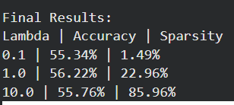
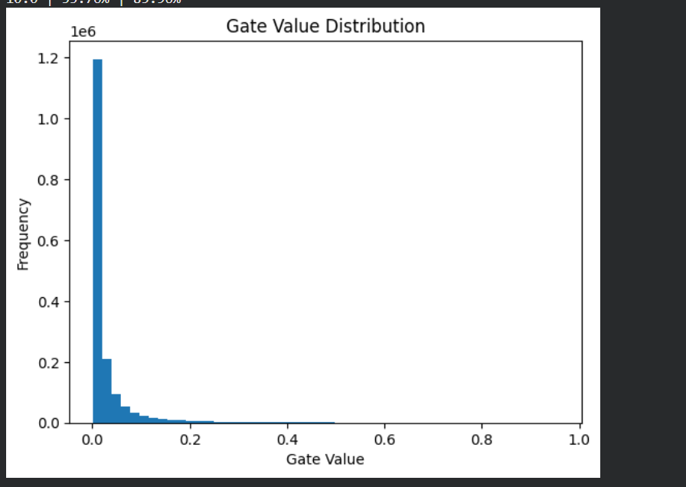

7. Analysis
The results demonstrate a clear trade-off between sparsity and model performance. As the regularization parameter λ increases, sparsity increases significantly. At λ = 10.0, the model achieves approximately 86% sparsity, meaning most weights are effectively pruned. Despite this high level of pruning, the accuracy remains relatively stable, indicating that the network contains redundant connections that can be removed without major performance loss.

8. Gate Distribution Analysis
The distribution of gate values shows a large concentration near zero, confirming that many connections are pruned. A smaller number of gates remain active, representing important connections required for prediction.

9. Conclusion
This study demonstrates that neural networks can be trained to prune themselves during learning. The use of learnable gates and L1 regularization effectively reduces model complexity while maintaining performance. This approach is useful for building efficient models suitable for real-world deployment.

10. Future Work
Future improvements include applying this approach to convolutional neural networks, exploring structured pruning techniques, and optimizing models for deployment on resource-constrained devices.

