Self-Pruning Neural Network Case Study

1. Introduction
Deep neural networks often contain a large number of parameters, making them computationally expensive and memory-intensive. To address this, pruning techniques are used to remove unnecessary weights. In this case study, we implement a self-pruning neural network that learns to remove its own weights during training using a gating mechanism.

2. Problem Statement
The goal is to design a neural network where each weight is associated with a learnable gate parameter. Gate ≈ 1 means the weight is active, while Gate ≈ 0 means the weight is pruned. The network should automatically identify and remove unnecessary connections.

3. Methodology
A custom PrunableLinear layer is implemented. Each weight has a gate score, and sigmoid is used to convert it into a gate value. The effective weight is obtained by multiplying the original weight with the gate value. This allows dynamic pruning during training.

4. Loss Function
Total Loss = Classification Loss + λ × Sparsity Loss.
Classification Loss is Cross-Entropy Loss.
Sparsity Loss is the L1 norm of gate values, encouraging sparsity.

5. Dataset
The CIFAR-10 dataset is used, consisting of 60,000 images across 10 classes.

6. Results
Lambda | Accuracy | Sparsity
0.1 | 55.34% | 1.49%
1.0 | 56.22% | 22.96%
10.0 | 55.76% | 85.96%
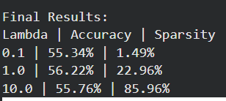

7. Analysis
As lambda increases, sparsity increases significantly while accuracy remains relatively stable. This shows that the model can remove redundant weights without major loss in performance.
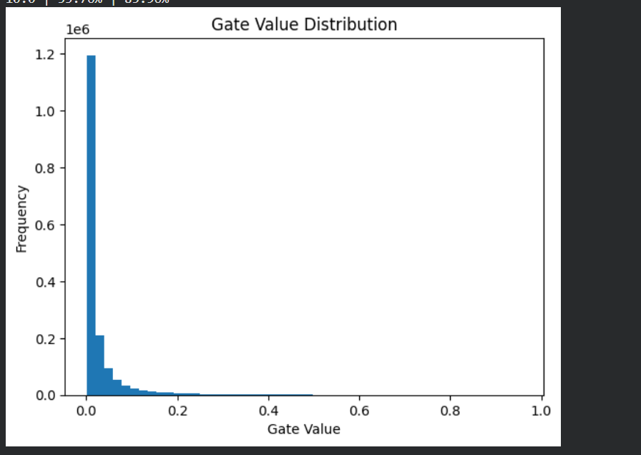

8. Conclusion
The self-pruning neural network successfully learns to remove unnecessary connections during training. It achieves high sparsity while maintaining reasonable accuracy, demonstrating effective model compression.

