**Experiment No.: 1**

**Aim:** Familiarization of linux commands.

**CO2:** Perform system administration task.

**Procedure:**

1.pwd - Print the working directory find the path of the current working directory

$pwd



2.ls – To view the content of the directory

$ls

1.ls -R – To list the contents of sub directory

$ls -R

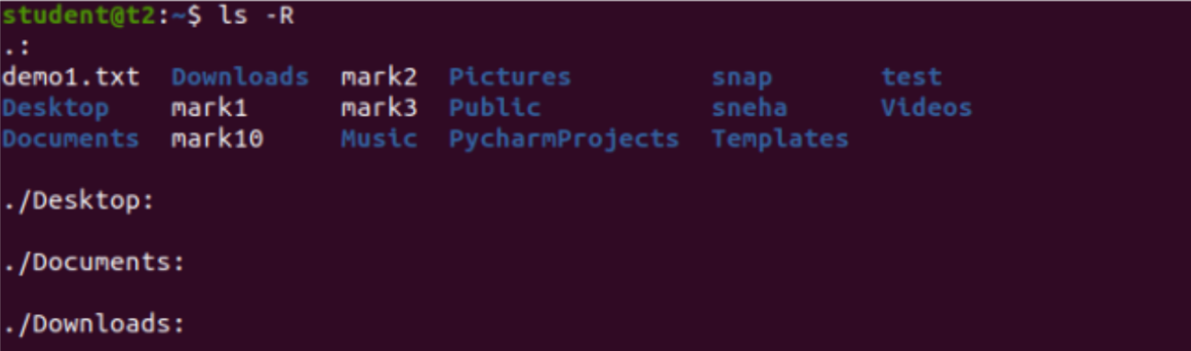2.ls -l – Long listing of the contents

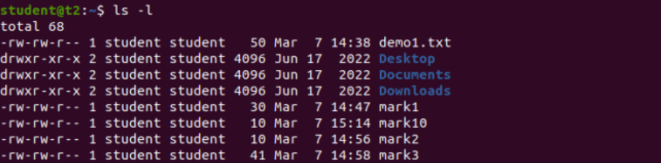

3.ls -a – To list the all hidden files

$ls -a



4.ls -al – List the files and directorys with detaild information.

$ls -al

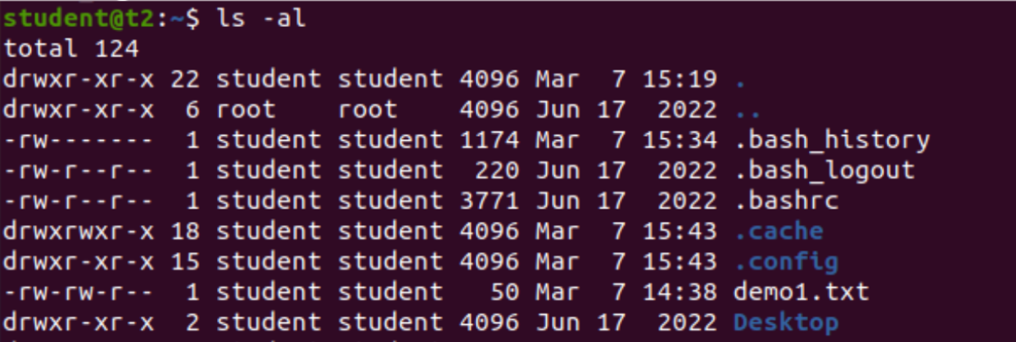

5.ls -t – List the files sorted in the order of last modified.

$ls -t

6.ls -r – To reverse the natural sorting order

$ls -r



3.history – To review the command that have been previously executed for a certain period of time.

$history

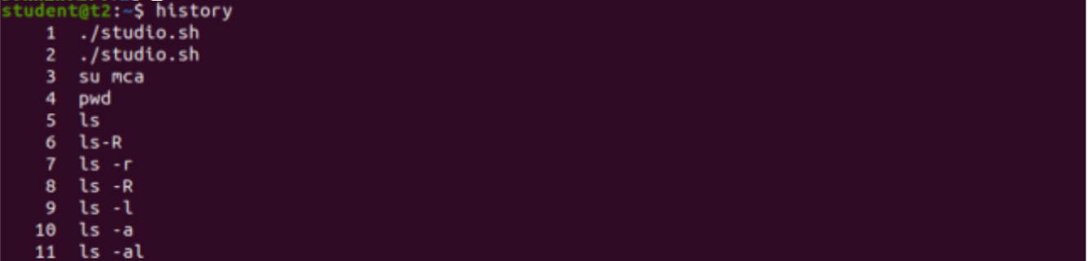

4.man – learn and understand about different command right from the shell using man command

$man

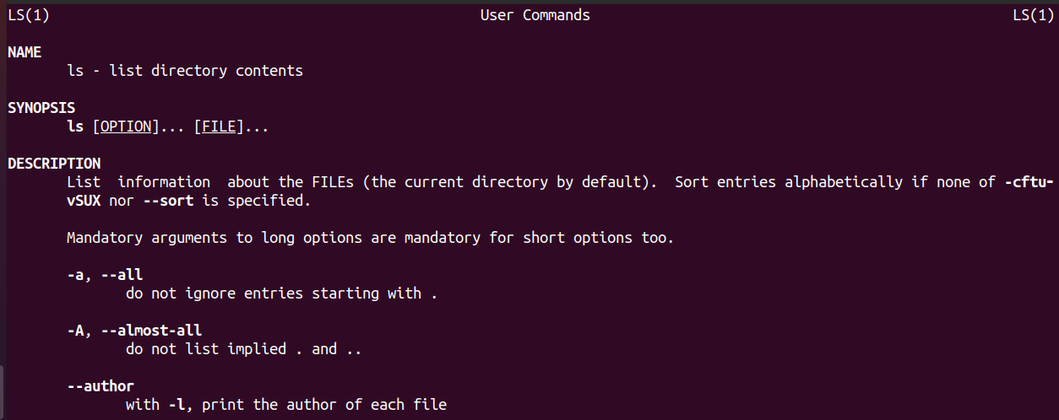

5.mkdir – To create a new directory

$mkdir

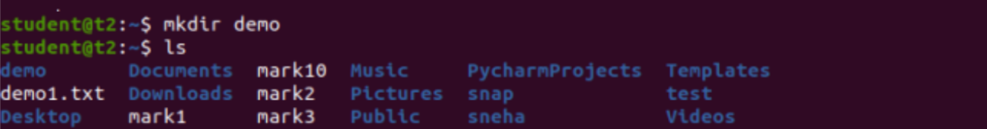

6.rmdir – To remove a directory

$rmdir



7.touch – To create new empty file

$touch



8.cat – Concatenate the files and print on the standard output

$cat

a.1: cat > filename.txt – To create a file with inserting contents

$cat > file.txt

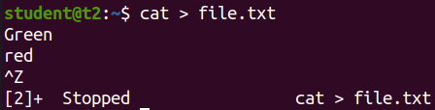

b.2: cat filename.txt – To view the content of the file

$cat file.txt

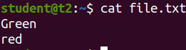

c.3: cat >> filename.txt – To append new contents to an existing file

$cat >> file.txt

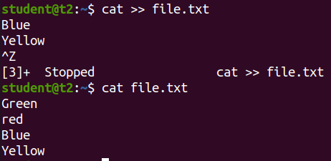

d.4: cat -n filename.txt – Number all output lines

$cat -n file.txt

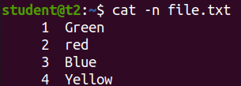

e.5: cat -b filename.txt – To remove the empty lines

$cat -b file.txt

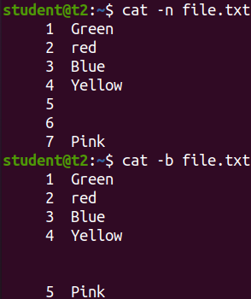

f.6: cat -E filename.txt – Display $ at end of each line

$cat -E file.txt

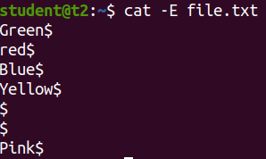

g.7: cat filename.txt| tr a-z A –Z > output.txt

$cat names | tr a-z A-Z > outputs

$cat outputs

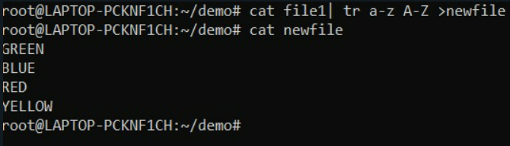

**Experiment No.: 4**

**Aim:**

Familiarization of linux commands.

**CO2:**

Perform system administration task.

**Procedure:**

1.Cut by Byte position

$cut –b1 filename.tx

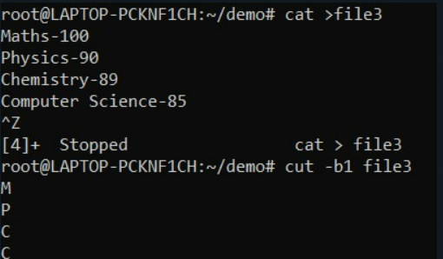

2.Cut by Character

$cut -c1 filename.txt

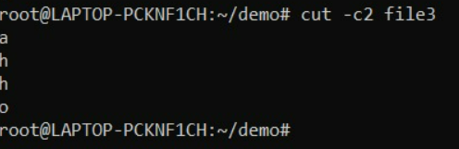

3.$cut -d - -f1 file3

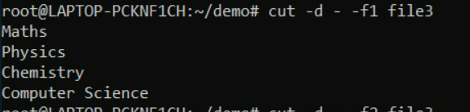

4.$cut -d - - f2 file3

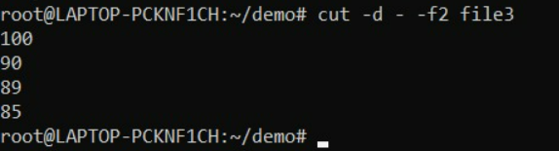

5.paste file3 file1

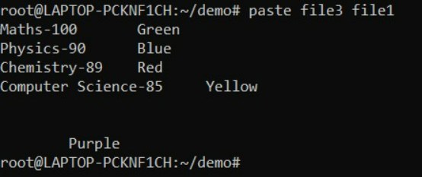

6.paste -d | file3 file1

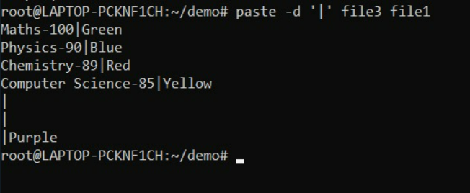

7.paste -s file1

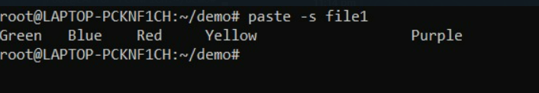

**Result**

The program was executed and the result was successfully obtained. Thus CO1 was obtained.