Access Control Policy Report

PG Cybersecurity Program – Access Control PolicyReport

Organization Name : PG Cybersecurity Program
Document Owner : Data Defenders (Project Group-8)

Approved By :
Role :
Signature :
Date :

Abstract
This Access Control Policy Framework defines a structured and risk-based approach to managing access across organizational systems and data. The framework establishes clear policy design principles, a consistent development methodology, and standardized access control requirements to ensure secure authentication, authorization, and privileged access management. It further outlines practical implementation and communication mechanisms to support effective adoption and enforcement. Governance and maintenance processes are defined to ensure ongoing compliance, accountability, and continuous improvement.
The framework supports audit readiness and ensures access controls remain effective as organizational and regulatory requirements evolve. Together, these five sections provide a comprehensive, auditable, and sustainable access control framework aligned with regulatory, operational, and security objectives.

Purpose
The purpose of this Access Control Policy Framework is to define standardized requirements for managing user access to organizational systems, applications, and data. It aims to ensure secure, controlled, and auditable access by enforcing least privilege, preventing unauthorized use, and supporting regulatory and security compliance.

Scope
This policy applies to all users, systems, applications, data assets, and access mechanisms within the organization, including employees, contractors, administrators, and third-party users. It covers access provisioning, authentication, authorization, privileged access, and ongoing access governance across the enterprise.

Keywords
Access Control, Identity Governance, Authentication Mechanisms, Authorization Models, Role-Based Access Control (RBAC), Attribute-Based Access Control (ABAC), Privileged Access Management (PAM), Zero Trust Architecture (ZTA), Secure Access Enforcement, Policy Implementation, Governance Framework, Compliance Monitoring, Risk Management, User Access Reviews (UAR), Least Privilege Principle, Continuous Authentication, Audit Logging, Regulatory Compliance, Security Operations, Access Lifecycle Management

Table Of Content
Section 1: Policy Framework Design
1.1 Purpose of the Access Control Policy Framework
1.2 Access Control Policy Hierarchy
1.3 Access Control Policy (Top-Level Intent)
1.4 Access Control Standards
1.5 Access Control Procedures
1.6 Access Control Guidelines
1.7 Modern Workplace Considerations
1.8 Access Control Maturity Framework
1.9 Policy Metrics and Key Performance Indicators
Section 2: Policy Development Methodology
2.1 Stakeholder Engagement & Legal Framework
2.2 Core Technical Methodology
2.3 Modern Workplace Scenarios
2.4 Approval, Implementation, and Enforcement Methodology
Section 3: Core Policy Content
3.1 Policy Statements
3.2 Modern Workplace Considerations
3.3 Enforcement
3.4 Zero Trust Architecture (ZTA) Overlay for Access Control
3.5 Review Procedures
Section 4: Implementation and Communication
4.1 Implementation of the Access Control Program
4.2 Communication and Policy Rollout Strategy
4.3 Policy Implementation and Communication Lifecycle
Section 5: Governance and Maintenance
5.1 Governance Structure
5.2 Review Cycles
5.3 Exception Handling
5.4 Compliance Monitoring
5.5 Continuous Improvement
5.6 Documentation and Records

Section 1: Policy Framework Design

1.1 Purpose of the Access Control Policy Framework
The Access Control Policy Framework defines a structured approach for establishing, approving, implementing, and maintaining access control requirements across the organization. It ensures that access controls are authoritative, auditable, and aligned with governance, risk, and compliance objectives, while allowing controlled flexibility in implementation.
This framework aligns with recognized standards such as ISO/IEC 27001 and NIST SP 800-53. [2],[3]

1.2 Access Control Policy Hierarchy
The framework follows a layered policy hierarchy that defines authority, scope, and change control across different policy artifacts.
Level | Artifact | Purpose | Authority | Change Frequency
Policy | Access Control Policy | Defines mandatory organizational intent | Board / Executive | Low
Standards | Access Control Standards | Specifies enforceable security requirements | Security Leadership | Medium
Procedures | Access Control Procedures | Describes operational execution | Operations Teams | High
Guidelines | Access Control Guidelines | Provides recommended practices | Advisory | As needed
This structure preserves governance control while enabling operational adaptability.

1.3 Access Control Policy (Top-Level Intent)
The Access Control Policy establishes the organization’s mandatory requirements for granting, managing, and reviewing access to systems, applications, and data.
Policy Statement
Access to organizational information assets shall be granted based on verified identity, explicit authorization, and business necessity, and shall be reviewed periodically.
Core Policy Principles
- Least Privilege
- Need-to-Know
- Separation of Duties (SoD)
- Zero Trust alignment
These principles ensure that access is restricted to what is necessary, justified, and continuously validated [2],[4],[11] .

1.4 Access Control Standards
Standards translate policy intent into measurable and auditable requirements.

1.4.1 Authentication Standards
- Multi-Factor Authentication (MFA) is mandatory for [1]:
  - Privileged access
  - Remote access
  - Cloud administrative roles
- Phishing-resistant or passwordless authentication is preferred where supported

1.4.2 Authorization Standards
- Role-Based Access Control (RBAC) is the default model [5].
- Attribute-Based Access Control (ABAC) is applied where contextual risk exists
- Privileged Access Management (PAM) is required for elevated roles

1.4.3 Identity Lifecycle Standards (Joiner–Mover–Leaver)
- Joiner: Provision minimum baseline access
- Mover: Re-evaluate all entitlements
- Leaver: Revoke access within defined SLAs
These standards ensure consistent, enforceable, and auditable access management.

1.5 Access Control Procedures
Procedures define how standards are operationally executed across systems.
Typical access control procedures include:
- Access request submission
- Manager and data owner approval
- IAM-based provisioning
- Logging and monitoring of access activity
- Periodic access recertification
Automated controls are preferred, with manual exception handling tracked and reviewed through governance processes.

1.6 Access Control Guidelines
Guidelines provide non-mandatory, adaptive recommendations to support evolving business and technology contexts.
Examples include:
- BYOD access through virtualized or containerized environments
- Federated identity and scoped tokens for AI and SaaS platforms
- Role-based restrictions for social media access from corporate devices
Guidelines support flexibility without weakening enforceable controls.

1.7 Modern Workplace Considerations
The framework addresses contemporary access risks:
- Remote Work: Zero Trust access and device posture validation
- BYOD: Conditional access with limited entitlements
- AI Tools: Identity-scoped API access and logging
These considerations ensure relevance in hybrid and cloud-native environments.

1.8 Access Control Maturity Framework
A maturity model is used to assess and improve access control capabilities over time.
Level | Maturity Stage | Characteristics | Risk Posture
0 | Non-Existent | No formal controls | Critical
1 | Initial | Manual access, no reviews | Very High
2 | Repeatable | Basic RBAC | High
3 | Defined | IAM, MFA, access reviews | Moderate
4 | Managed | Risk-based access, monitoring | Low
5 | Optimized | Zero Trust, automation | Minimal
Maturity is evaluated across governance, technology, processes, and monitoring dimensions [9],[10] .

1.9 Policy Metrics and Key Performance Indicators
Metrics enable governance oversight, audit readiness, and continuous improvement.
Key metrics include:
- MFA coverage and privileged MFA adoption
- Excess privilege and dormant account rates
- Access review completion rates
- Mean time to detect and revoke unauthorized access
Metrics are reviewed periodically by governance bodies and retained as audit evidence.

Section 2: Policy Development Methodology

2.1 Stakeholder Engagement & Legal Framework

2.1.1 The Consultative Approach
Policy development cannot exist in a vacuum. We utilize a cross-functional engagement model inspired by ISO 27001 governance standards.
- Human Resources (HR): Critical for defining the "Joiner, Mover, Leaver" (JML) process. HR systems must act as the "Source of Truth" for identity.
- Legal & Compliance: Reviews alignment with external regulations (GDPR for data privacy, SOX for financial integrity).
- Business Unit Leaders: Validates that access controls do not unduly hinder operational velocity (Availability vs. Confidentiality).
- DevOps / Engineering: Ensures policy requirements can be technically implemented via Infrastructure as Code (IaC).

2.1.2 Regulatory & Legal Review
For financial and corporate sectors, the Access Control Policy must satisfy specific legal requirements:
Regulation | Relevance to Access Control | Implementation Requirement
SOX (Sec. 404) | Financial Reporting Integrity | Strict Segregation of Duties (SoD) to prevent fraud
GLBA / FFIEC | Financial Data Privacy | Multifactor Authentication (MFA) for all external access
GDPR / CCPA | Data Sovereignty | Granular access logs to prove who accessed PII and when
NIST SP 800-53 | Federal / General Best Practice | Least Privilege and Separation of Duties
Implementation requirements are aligned with recognized security frameworks [2], [3].2.2 Core Technical Methodology

2.2.1 Authentication Requirements (AuthN)
Authentication validates the identity of the user. The methodology moves beyond passwords toward passwordless and cryptographic verification.
- Multi-Factor Authentication (MFA):
  - Mandate: All users must utilize MFA. SMS-based 2FA is deprecated due to SIM-swapping risks.
  - Standard: Use FIDO2/WebAuthn hardware tokens (YubiKeys) or app-based push notifications (Microsoft Authenticator / Okta Verify).
  - Password policies aligned with NIST SP 800-63B [1].
- Identity Provider (IdP) Centralization:
  - Federate all logins through a single IdP (e.g., Azure AD, Okta) to ensure a single choke point for access revocation.
- Adaptive Authentication:
  - Implement risk-based challenges triggered by anomalous geo-location or device behavior.

2.2.2 Authorization Procedures (AuthZ)
Authorization determines what an authenticated user is allowed to do.
- Hybrid Model (RBAC + ABAC):
  - Role-Based Access Control (RBAC): Permissions assigned based on job function (e.g., Teller, Investment Banker, DevOps Lead).
  - Attribute-Based Access Control (ABAC): Adds contextual conditions such as device trust and network location.
- Least Privilege Principle:
  - Default deny posture with permissions granted strictly based on business necessity.

2.2.3 Access Review Processes (Governance)
Static permissions lead to privilege creep.
- User Access Reviews (UAR):
  - Frequency: Quarterly for high-risk roles; semi-annually for standard users.
  - Workflow: Managers certify or revoke access via automated dashboards, with non-response defaulting to revocation.
- Trigger-Based Reviews:
  - Automatic access review upon job role change (Mover phase of JML).

2.3 Modern Workplace Scenarios

2.3.1 Remote Work & BYOD
Policy:
Access to corporate data on personal devices is permitted only via managed containers.
Technical Implementation:
- Mobile Application Management (MAM) for application sandboxing
- Device health attestation (patching, jailbreak detection)
- Virtual Desktop Infrastructure (VDI) for high-security roles

2.3.2 AI Tool Integration
Risk: Data leakage through public AI platforms.
Policy:
- Prohibited: Inputting PII, proprietary code, or financial data into public AI tools
- Permitted: Enterprise-licensed AI platforms with data training disabled
Enforcement:
DLP controls at browser and endpoint levels to block sensitive data exposure.

2.3.3 Social Media & External Communications
- Access to corporate social media accounts is protected using Privileged Access Management (PAM).
- Clear separation of personal and professional identities is enforced to reduce phishing and social engineering risk.

2.4 Approval, Implementation, and Enforcement Methodology

2.4.1 Workflow for Policy Approval
- Drafting by Security Analysts using version control
- Peer review for technical feasibility
- Legal and compliance validation
- Executive approval via Change Control Board
- Publication through the GRC platform

2.4.2 Enforcement Mechanisms
- Automated Provisioning: SCIM-based account lifecycle automation
- Policy-as-Code (PaC): Enforcement using Open Policy Agent (OPA)
- Break-Glass Access: Vaulted emergency accounts with SOC alerting

2.4.3 Disciplinary Actions
- Low-risk violations: Automated warnings and mandatory re-training
- Repeated or intentional violations: Access revocation and HR escalation

This approach ensures consistent implementation, clear communication, and effective enforcement of access control policies.
Continuous monitoring enables ongoing alignment with organizational and regulatory requirements.
Section 3: Core Policy Content

3.1 Policy Statements

3.1.1. Authentication Requirements
Authentication verifies the identity of a user or system entity. The organization adopts a strict "Verify Explicitly" approach.
- Unique user IDs for all users
- MFA mandatory for:
  - Remote access
  - Administrative privileges
  - Access to PHI systems
- Password policies aligned with NIST SP 800-63B

3.1.1.1. Multi-Factor Authentication (MFA)
- MFA is mandatory for all user access to corporate resources, including remote and administrative access, with no exceptions.
- SMS and voice-based 2FA are prohibited due to SIM-swapping and related security risks.
- FIDO2/WebAuthn hardware keys or biometrics are required for high-privilege and high-risk accounts.
- Mobile push-based MFA with number matching is the minimum standard for general users.

3.1.1.2. Password Hygiene (Where Passwordless is not yet active)
- Minimum password length of 14 characters with required complexity.
- Password rotation only after compromise, not on a fixed schedule.
- Block use of known compromised passwords [1].

3.1.1.3. Service Account Authentication
- Service accounts must utilize certificate-based authentication or API keys with automated rotation.
- Interactive login for service accounts must be disabled.

3.1.2. Authorization Procedures
- Access is granted based on defined job roles and required contextual attributes.
- Privileged access requires documented manager and security approval.

3.1.2.1. Principle of Least Privilege
- Users receive only access essential for their role.
- Default access for all users is none.

3.1.2.2. RBAC and ABAC
- RBAC: Access assigned according to job function.
- ABAC: Context (time, location, device status) applied for sensitive access.

3.1.2.3. Separation of Duties
- Critical actions require at least two distinct individuals.
- Production access is restricted; developers have no write access.

3.1.3. Privileged Access Management (PAM)
Privileged accounts (e.g., Domain Admin, Root) represent the highest risk.
- Just-in-Time (JIT) Access: Standing privileges are prohibited. Administrators must request ephemeral access for a specific time window.
- Session Monitoring: All privileged sessions are logged for audit purposes.
- Credential Vaulting: Privileged credentials must be securely vaulted and never hardcoded.

3.1.3.1 Access Reviews
Aspect | Requirement
Review Frequency | Quarterly for privileged, PHI, and third-party access; annually for standard users
Trigger Events | Role change, termination, privilege escalation, security incident
Review Scope | User accounts, privileged accounts, service/system accounts, dormant accounts, remote access
Responsibility | Review and re-certification by System Owner and Line Manager
Remediation | Excess or unauthorized access removed within defined timelines; high-risk accounts disabled immediately
Evidence & Retention | Access review logs, approvals, and revocation records retained as per regulatory requirements

3.2. Modern Workplace Considerations

3.2.1. Remote Work & Telecommuting
- Device-Centric Security: The device is treated as the primary security perimeter.
- ZTNA Enforcement: VPN-based full network access is replaced with application-level ZTNA.
- Traffic Control: Split tunneling for corporate traffic is disabled and routed via SWG.
- Screen Privacy: Remote users must prevent unauthorized screen visibility in public spaces.
- Session Management: Automatic session timeouts are enforced.

3.2.2. Bring Your Own Device (BYOD)
Morgan Stanley and JP Morgan maintain strict controls on personal devices to comply with SEC record-keeping rules.
- Containerization: BYOD usage is permitted only via MDM (Mobile Device Management) solutions (e.g., Microsoft Intune) that create an encrypted "work profile."
- Data Isolation: Copy/paste between the work profile and personal apps is disabled.
- Jailbreaking: Access is automatically revoked if a device is detected as jailbroken or rooted.

3.2.3 Artificial Intelligence (AI) & LLM Usage
The rise of Generative AI (e.g., ChatGPT, Copilot) introduces data exfiltration risks.
- Strict Prohibition on PII/IP: It is strictly forbidden to input Personally Identifiable Information (PII), proprietary code, or financial data into public, non-enterprise LLMs.
- Sanctioned Tools: Only enterprise-licensed AI tools with "Zero Data Retention" policies (where the vendor agrees not to train models on our data) are permitted.
- Output Validation: AI-generated code must undergo the same rigorous security scanning (SAST/DAST) as human-written code.

3.2.4 Social Media & External Communications
- Credential Separation: Corporate email addresses must not be used to register for personal social media accounts.
- Access Tokens: Third-party social media management tools must use OAuth tokens rather than shared passwords.
- Posting Authority: Only authorized personnel (Marketing/PR) may post on behalf of the company.

3.3. Enforcement
- Non-compliance may result in financial, reputational, and regulatory impact.
- Technical controls will automatically block non-compliant access (e.g., missing MFA, insecure devices).
- Monitoring: SOC will track access anomalies using centralized logging and UEBA.
- Disciplinary action will follow HR procedures, up to termination or legal action.

3.4. Zero Trust Architecture (ZTA) Overlay for Access Control

3.4.1 Zero Trust Principles
- Never trust, always verify
- Continuous authentication and authorization\
- Explicit, risk-based access decisions
- Zero Trust is an architectural and operating model, not a product [6] .

3.4.2 Zero Trust Pillars
Zero Trust Pillar | Policy Integration
Identity | Strong IAM, MFA
Devices | Device posture checks
Network | VPN, ZTNA concepts
Applications | Role- and attribute-based access
Data | Classification & encryption
Visibility | Logging & monitoring

3.5. Review Procedures
Access control requires continuous review to ensure appropriateness of granted access.

3.5.1 User Access Reviews (UAR)
- Frequency: Quarterly for sensitive systems; semi-annual for standard systems.
- Process: Managers must approve or revoke user access.
- Automation: Unreviewed access is automatically suspended.

3.5.2 Trigger-Based Reviews
- Role Change: Previous access is revoked; new access must be requested.
- Termination: All access is immediately revoked through HR-IdP integration.
Section 4: Implementation and Communication

4.1 Implementation of the Access Control Program
The implementation of the Access Control Program follows a structured, policy-driven approach aligned with the Access Control Policy Framework, Implementation Guidelines, Compliance Checklist, and Training Requirements documents. Implementation is designed to translate policy intent into enforceable technical, administrative, and procedural controls.

4.1.1 Policy-to-Practice Alignment
Implementation activities are directly mapped to the approved policy artifacts to ensure consistency and traceability
Table: Alignment of Deliverables to Implementation Activities
Deliverable | Role in Implementation
Policy Framework | Defines authority, ownership, and governance structure
Access Control Policy | Specifies mandatory access control requirements
Implementation Guidelines | Guides phased technical and operational rollout
Training Requirements | Ensures user awareness and role-based competency
Compliance Checklist | Verifies adherence and identifies gaps
Governance & Maturity Model | Supports continuous improvement and optimization
This alignment ensures that implementation remains standardized, auditable, and adaptable to evolving risk and regulatory requirements.

4.1.2 Training and Capability Enablement
Training is a foundational implementation control and is executed in accordance with the Access Control Training Requirements document.
- All users receive mandatory access control awareness training during onboarding and at defined intervals.
- Privileged users, administrators, and access approvers receive enhanced, role-based training aligned with elevated risk levels.
- Training content covers authentication responsibilities, least privilege enforcement, access request and approval processes, incident reporting, and acceptable use expectations.
Training completion is tracked centrally and serves as a prerequisite for access provisioning, reinforcing behavioral accountability as defined in the policy and compliance checklist.

4.1.3 Policy Acknowledgment and Enforcement Integration
Formal acknowledgment of access control policies is integrated into identity and access workflows to ensure enforceability and legal defensibility.
- Users must acknowledge the Access Control Policy prior to receiving system access.
- Re-acknowledgment is required following material policy updates.
- Acknowledgment records are retained as audit evidence and are referenced during compliance assessments.

4.1.4 Stakeholder Roles and Responsibilities
To support consistent implementation and accountability, stakeholder responsibilities for key access control activities are defined using a RACI (Responsible, Accountable, Consulted, Informed) model.

Task/  Process | CISCO/  Security | IAM  Team | HR | Business/  Dept  Owner | IT  Operations | Legal/  Compliance
Policy Definition | A/R | C | I | C | I | C
RBAC Role Design | C | R | I | A | C | C
MFA Implementation | A | R | I | I | C | I
JML(Joiner/Mover/Leaver) | C | R | A | I | C | I
Access Recertification | A | C | I | R | I | C
Disciplinary  Enforcement | I | I | R | C | I | A

4.2 Communication and Policy Rollout Strategy
Effective communication ensures access control requirements are understood and consistently applied. Communication activities align with governance expectations defined in the Policy Framework and Compliance Checklist.

4.2.1 Structured Policy Communication
Policy communication follows a formal, organization-wide rollout approach:
- Approved policies and supporting documents are published through official channels.
- Communication emphasizes policy purpose, scope, and user responsibilities without altering enforceable requirements.
- Targeted communications are issued for high-impact changes, such as MFA enforcement, remote access restrictions, or revised access review processes.
This approach ensures clarity while maintaining policy authority and consistency.

4.2.2 Ongoing Awareness and Reinforcement
- Periodic reminders and training refreshers reinforce key access control principles.
- Established feedback channels allow users and managers to seek clarification or raise implementation concerns through governance pathways.

4.2.3 Monitoring and Continuous Improvement
Implementation effectiveness is monitored through defined compliance and maturity assessment mechanisms.
- Training completion, policy acknowledgment, and access review outcomes are periodically assessed.
- Identified gaps trigger corrective actions in line with governance procedures.
This ensures continuous alignment with organizational and regulatory expectations.

4.3 Policy Implementation and Communication Lifecycle
The Access Control Program is implemented through a structured lifecycle that ensures approved policies are effectively communicated, enforced, and continuously improved. This lifecycle links policy governance, implementation, training, acknowledgment, and compliance monitoring into a single, repeatable process aligned with the six policy deliverables.
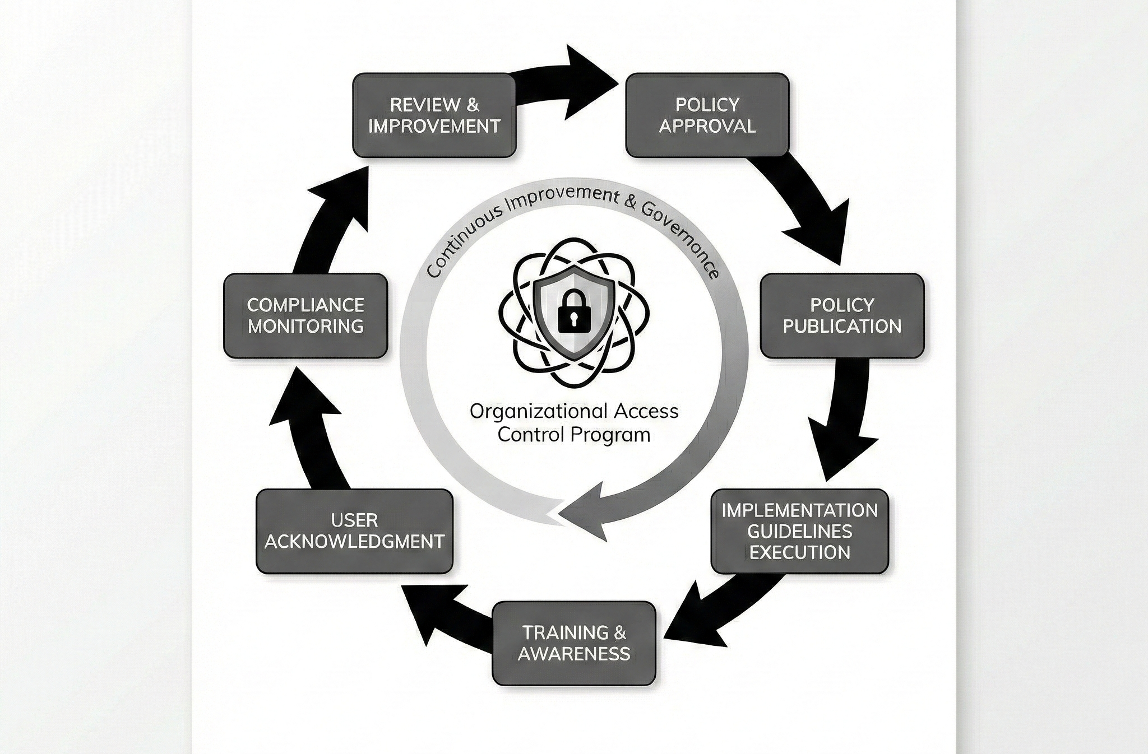

4.3.1 Lifecycle Stages
The policy implementation and communication lifecycle includes the following stages:
- Policy Approval – Formal authorization of policies in accordance with the Policy Framework.
- Policy Publication – Controlled release of approved policies through official channels.
- Implementation Guidelines Execution – Operationalization of policy requirements using approved implementation guidance.
- Training and Awareness – Role-based training to ensure understanding of access control responsibilities.
- User Acknowledgment – Formal confirmation of policy understanding and acceptance.
- Compliance Monitoring – Ongoing validation using the Compliance Checklist.
- Review and Improvement – Periodic updates based on audits, incidents, and review outcomes.

4.3.2 Continuous Improvement
The lifecycle operates as a continuous loop, where outcomes from audits, incidents, and compliance monitoring inform updates to policies, training, and implementation practices, ensuring long-term effectiveness.

Section 5: Governance and Maintenance

5.1 Governance Structure

5.1.1 Ownership Model
Executive:
• CISO (ultimate accountability), CIO (operational feasibility), CCO (regulatory compliance)
Operational:
• IAM Team (daily administration), SOC (monitoring/response), IT Ops (maintenance)
Functional:
• Business Managers (requirements), Data Owners (classification), Application Owners (system controls)

5.1.2 Governance Bodies
• Access Control Steering Committee (Quarterly):
Strategic direction, policy updates, risk decisions, budget approval
• IAM Working Group (Monthly):
Implementation planning, process improvements, tool evaluation
• Access Review Board (Bi-weekly):
Exception requests, high-risk approvals, violation investigations

5.2 Review Cycles

Review Type | Frequency | Focus
Policy Comprehensive | Annual | Complete review, regulatory assessment, risk update
Policy Tactical | Semi-annual | Procedures, metrics, incident analysis
Policy Operational | Quarterly | Exceptions, compliance, emerging threats
Privileged Access | Quarterly | User certification, role validation
Sensitive Data Access | Semi-annual | Data owner approval verification
Standard Access | Annual | Business user access rights
Contractor/Vendor | Quarterly | External access validation

5.3 Exception Handling

5.3.1 Categories & Approval

• Temporary (≤90 days): Business justification, automatic expiration, IAM Manager/Review Board approval
• Permanent: ACSC approval, annual revalidation, compensating controls required
• Emergency (≤72 hours): Break-glass procedures, CISO approval, 48-hour post-review

5.3.2 Workflow Process
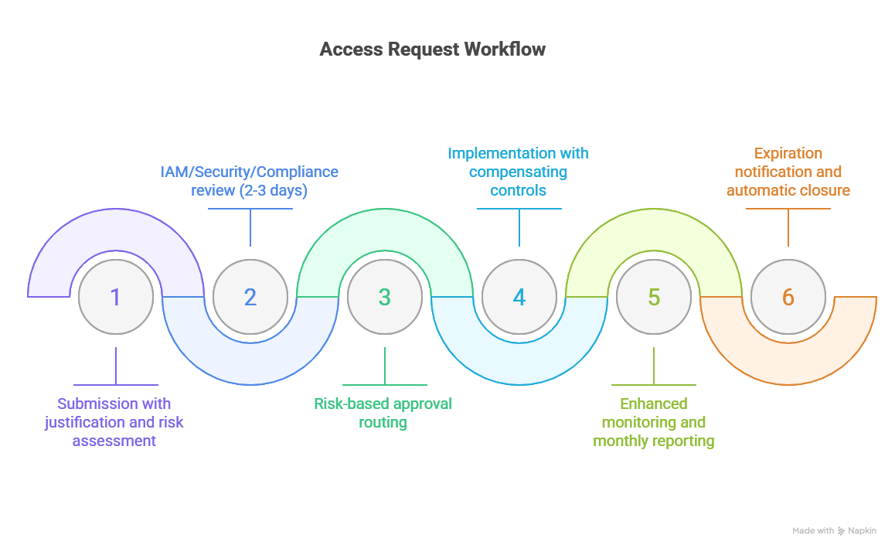

5.3.3 Compensating Controls
Enhanced logging and behavioural analytics, multi-person authorization for critical actions, time/geographic restrictions, privileged session recording, read-only access where feasible, data masking/redaction.

5.4 Compliance Monitoring

5.4.1 Continuous Monitoring
Automated:
• Unusual logins, failed attempts, privilege escalation, policy violations, SoD conflicts, configuration drift [7].
Monitoring practices align with structured log management and control validation standards [8], [11].
Manual:
• Monthly access patterns, quarterly privilege analysis, semi-annual data audits
KPI | Target
User provisioning time | < 4 hours
User deprovisioning time | < 1 hour
Certification completion | > 95% in 30 days
Exception approval time | < 3 business days
Dormant account remediation | > 90% in 7 days

5.4.2 Audit & Reporting
• Internal: Quarterly focused audits, annual comprehensive review, ad-hoc investigations
• External: SOC 2 Type II, ISO 27001, regulatory audits, penetration testing [3] , [12] .
• Reports: Executive dashboard (monthly), operational metrics (weekly), compliance status (quarterly)

5.4.3 Regulatory Compliance
Framework | Requirements
GDPR | Art. 32, Art. 25
HIPAA | §164.308(a)(4), §164.312(a)(1)
SOX | Section 404
PCI DSS | Req. 7, Req. 8
NIST CSF | PR.AC
ISO 27001 | Annex A.9

5.5 Continuous Improvement

5.5.1 Improvement Cycle
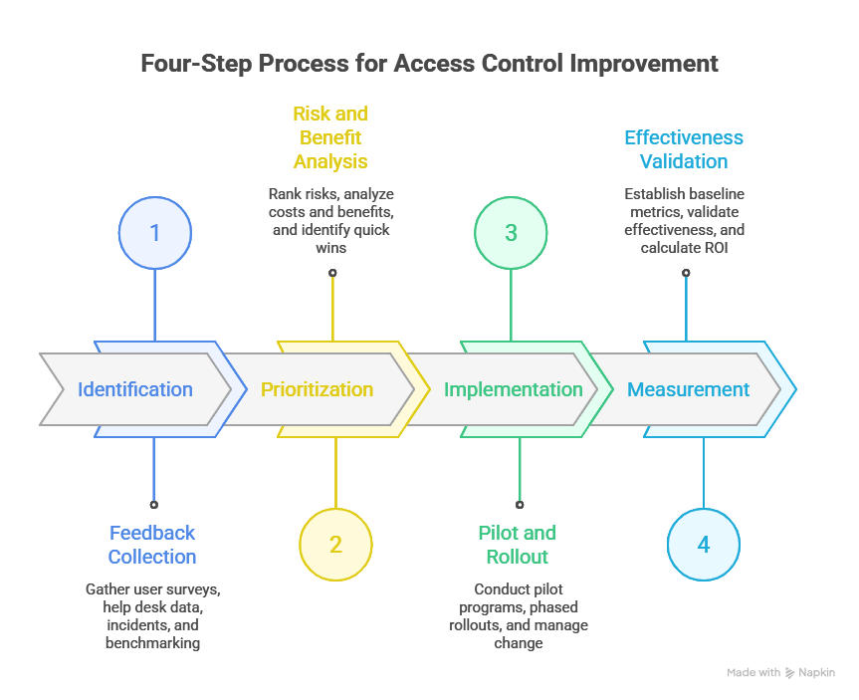
Continuous improvement mechanisms follow risk-based governance principles [9], [10].

5.5.2 Training & Awareness

• Mandatory: New hire orientation, annual refresher, role-based training
• Awareness: Monthly tips, quarterly phishing simulations, Security Awareness Month
• Specialized: IAM tools, incident response, compliance training

5.6 Documentation & Records

5.6.1 Required Documentation
• Policy: Master policy, procedures, role matrices, exception forms
• Operational: Logs, certifications, approvals, incident and audit records
Record Type | Retention
Active user records | 7 years post-termination
Access logs | 1–7 years
Audit reports | ≥7 years
Policy versions | Indefinite
Security incidents | 7 years

Conclusion
This Access Control Policy Framework establishes a structured, risk-based approach to controlling access across organizational systems, applications, and data. By integrating clear policy principles, standardized access requirements, practical implementation guidance, and strong governance mechanisms, the framework ensures consistent enforcement, regulatory compliance, and accountability. Continuous monitoring, periodic reviews, and defined improvement processes enable the framework to adapt to evolving threats, technologies, and business needs, supporting a secure, auditable, and sustainable access control environment.

References
[1] NIST Special Publication 800-63B – Digital Identity Guidelines: Authentication and Lifecycle Management. National Institute of Standards and Technology, 2017.
[2] NIST Special Publication 800-53 Rev. 5 – Security and Privacy Controls for Information Systems and Organizations. National Institute of Standards and Technology, 2020.
[3] ISO/IEC 27001:2022 – Information Security Management Systems – Requirements. International Organization for Standardization, 2022.
[4] ISO/IEC 27002:2022 – Information Security Controls and Code of Practice. International Organization for Standardization, 2022.
[5] OWASP Identity and Access Management (IAM) Guidelines – Open Web Application Security Project, 2023. https://owasp.org/www-project-identity-and-access-management/
[6] Zero Trust Architecture (NIST Special Publication 800-207) – NIST Guidelines on Implementing Zero Trust Security Models. National Institute of Standards and Technology, 2020.
[7] NIST Special Publication 800-61 Rev. 2 – Computer Security Incident Handling Guide. National Institute of Standards and Technology, 2012.
[8] NIST Special Publication 800-92 – Guide to Computer Security Log Management. National Institute of Standards and Technology, 2006.
[9] NIST Cybersecurity Framework (CSF) 2.0 – Framework for Improving Critical Infrastructure Cybersecurity. National Institute of Standards and Technology, 2024.
[10] ISO/IEC 27005:2022 – Information Security Risk Management. International Organization for Standardization, 2022.
[11] CIS Controls v8 – Center for Internet Security Critical Security Controls. Center for Internet Security, 2021.
[12] Cloud Security Alliance (CSA) – Cloud Controls Matrix (CCM). Cloud Security Alliance, 2023.

