Create a CRUD HTTP API with Lambda and DynamoDB
In this project, we will build a serverless CRUD API using AWS services. The goal is to create an API that allows you to perform Create, Read, Update, and Delete operations on data stored in a DynamoDB table. This API will be exposed through API Gateway, and the backend logic will be powered by AWS Lambda functions. The entire solution will be serverless, meaning there is no need to manage infrastructure such as servers or databases manually.
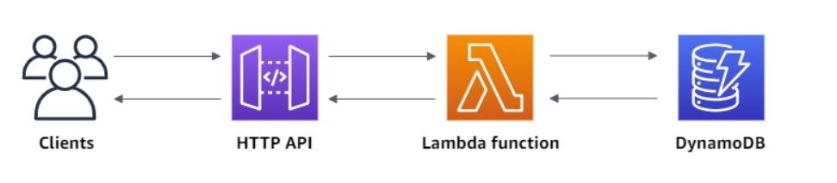
- Step1: Create DynamoDB table

- Step 2: Create an IAM Policy, Attach it to an IAM Role, and Associate the Role with Lambda Function
In this step, we configure the necessary IAM (Identity and Access Management) permissions for your Lambda function to interact with DynamoDB.
- Create a Custom IAM Policy: We define a custom policy that grants the Lambda function permission to perform CRUD operations (Create, Read, Update, Delete) on the DynamoDB table. This policy specifies which actions (e.g., PutItem, GetItem, etc.) are allowed on the DynamoDB table.
- Create an IAM Role: We create an IAM role that will hold the policy. This role is meant to be assumed by the Lambda function, allowing it to access DynamoDB.
- Attach the Role to Lambda: The IAM role is then attached to the Lambda function. This step allows the Lambda function to use the permissions defined in the IAM role when interacting with DynamoDB.

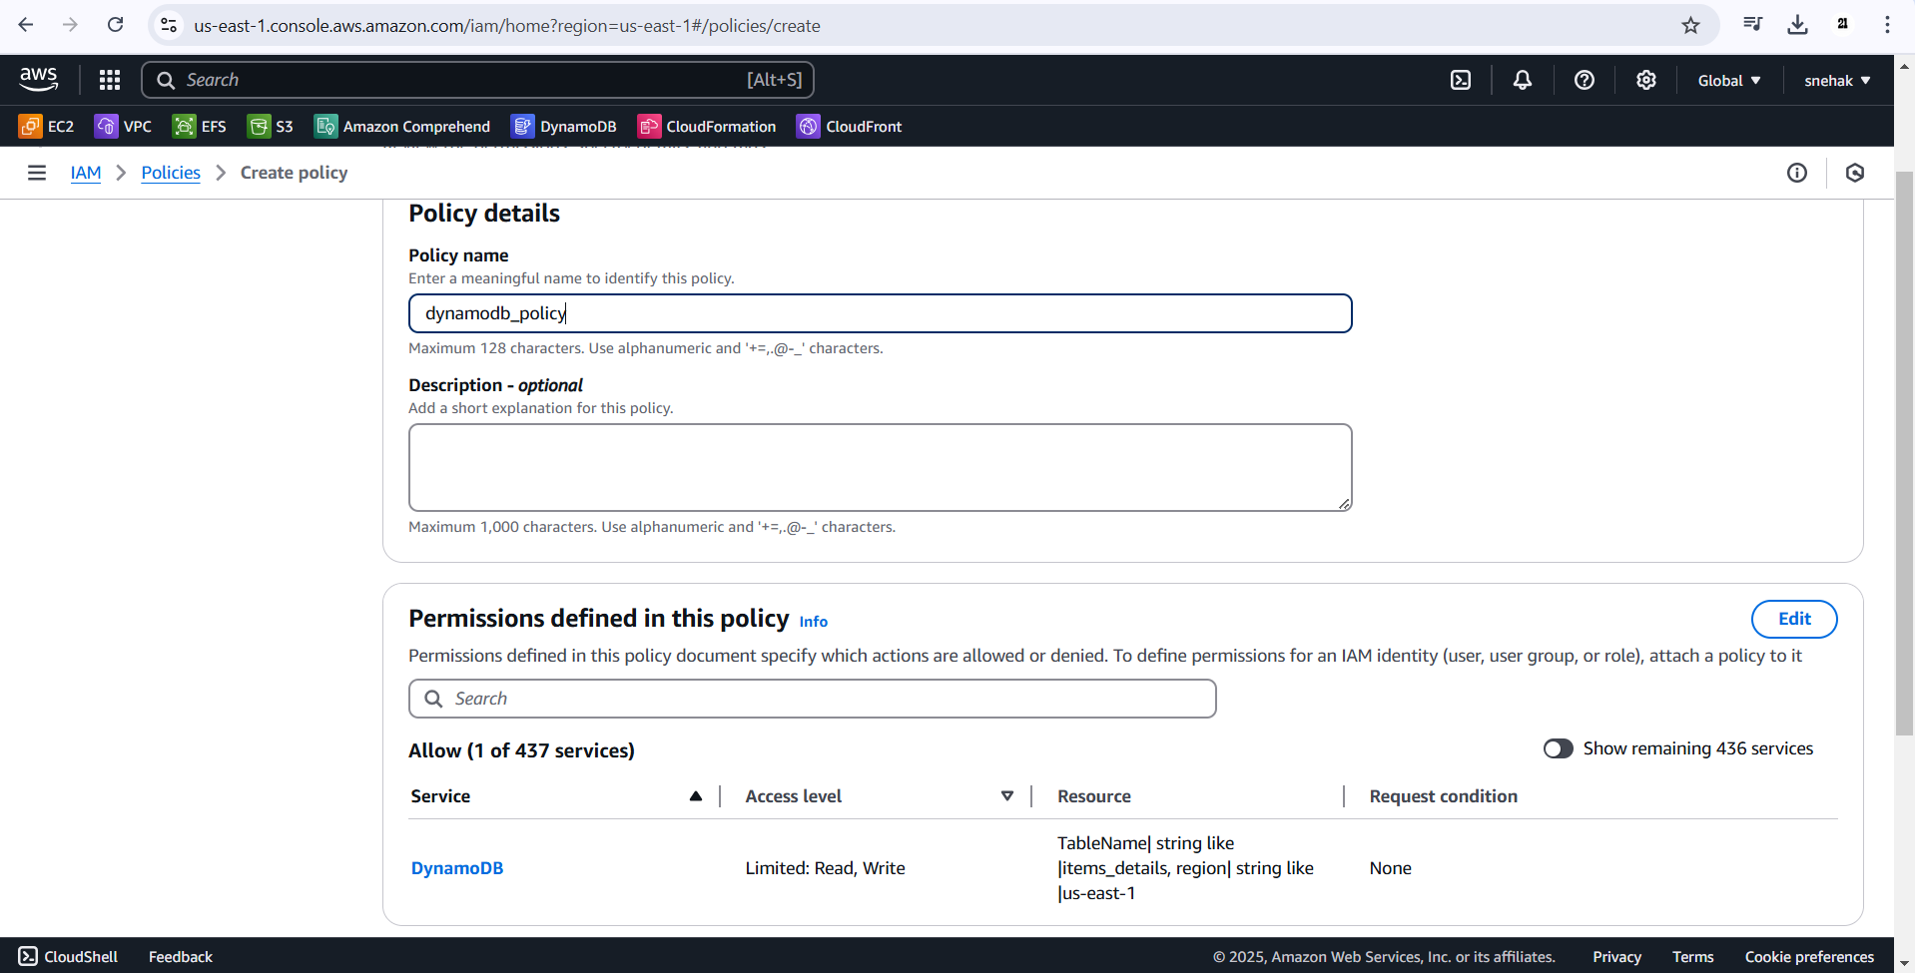
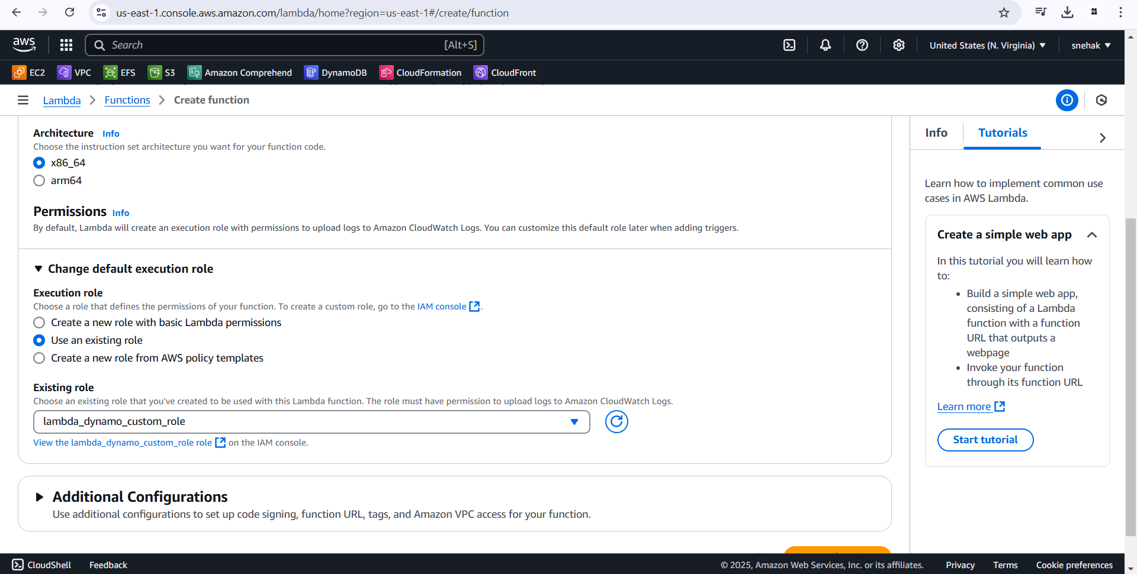

Create lambda function which will handle the backend logic for each API request. These functions will interact with DynamoDB to manage items, including inserting, updating, fetching, and deleting records.
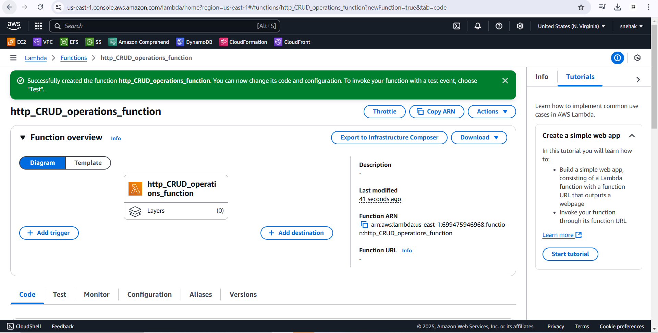

- Step 3: Create an HTTP API
API Gateway will act as the front-end interface for our Lambda function. It will expose HTTP endpoints that clients can call to interact with the Lambda function.
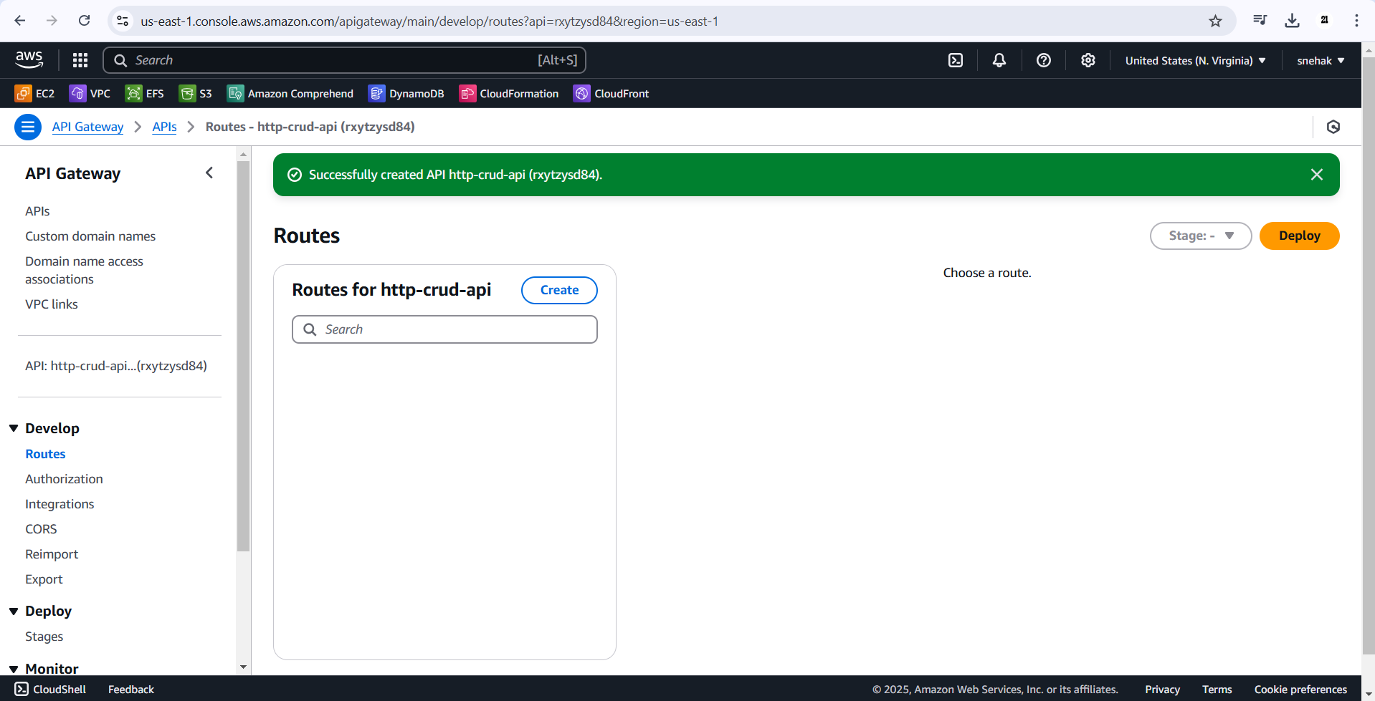

Step 4: Create routes
Routes are a way to send incoming API requests to backend resources. Routes consist of two parts: an HTTP method and a resource path, we create four routes:
- GET /items/{id}
- GET /items
- PUT /items
- DELETE /items/{id}
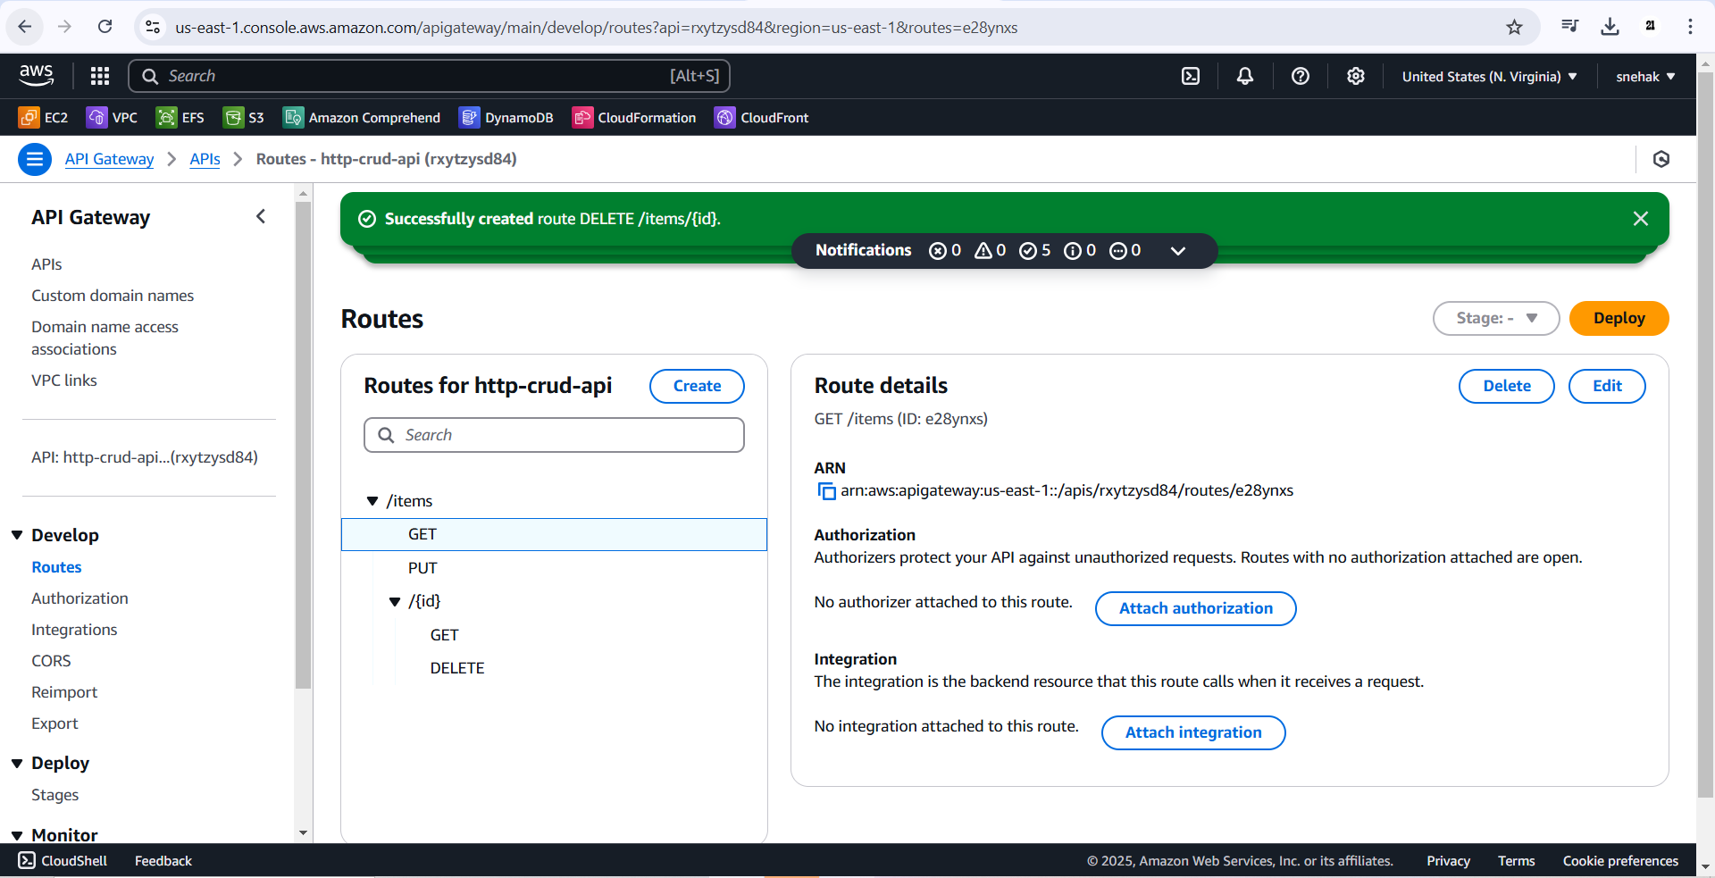
Step 5: Create an integration and attach your integration to routes

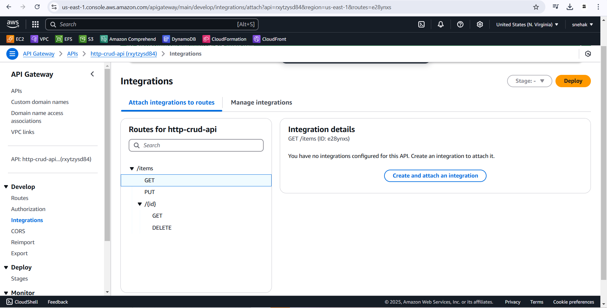
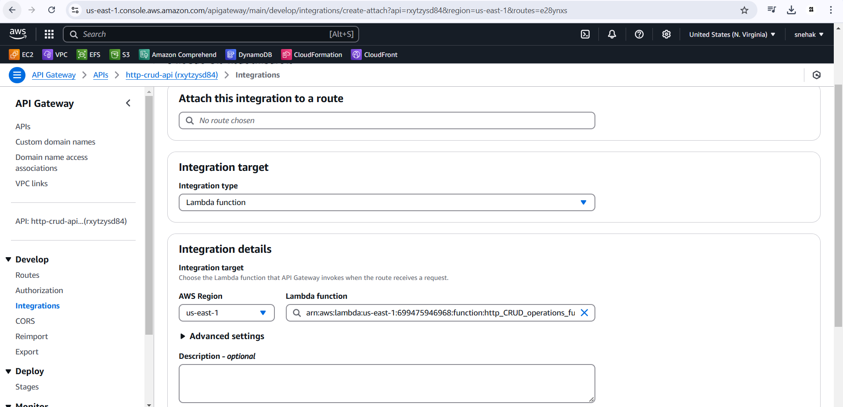
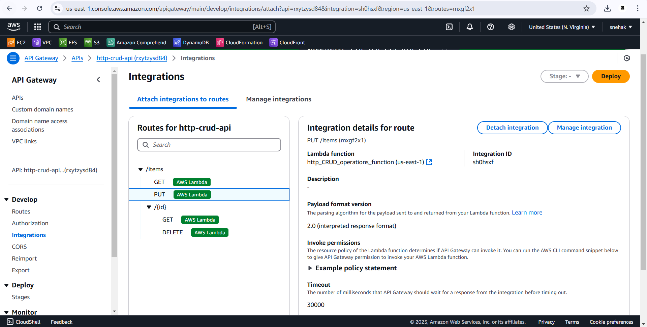

Test:
- Create (add) data to table
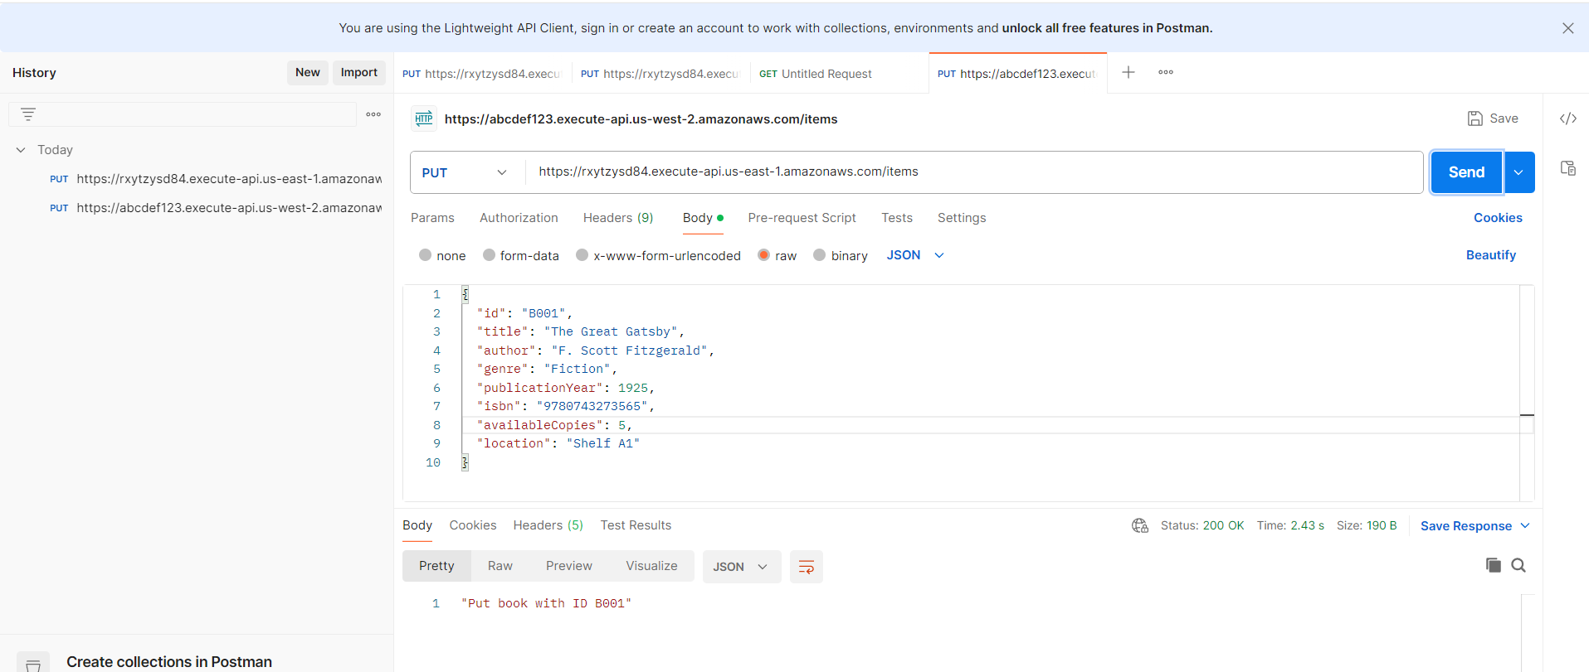

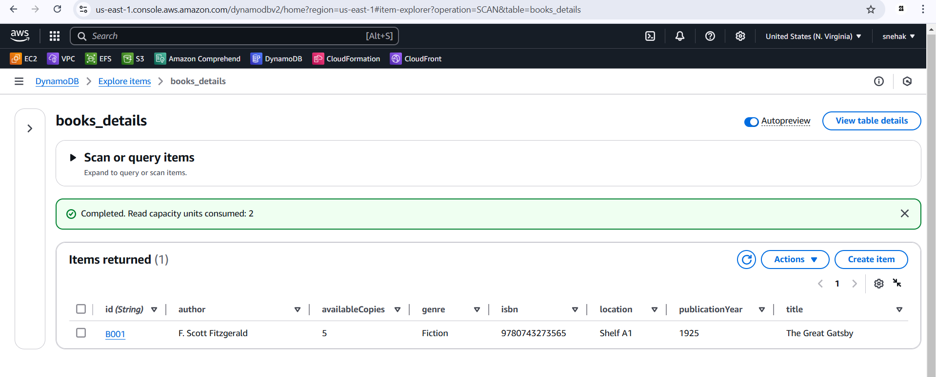
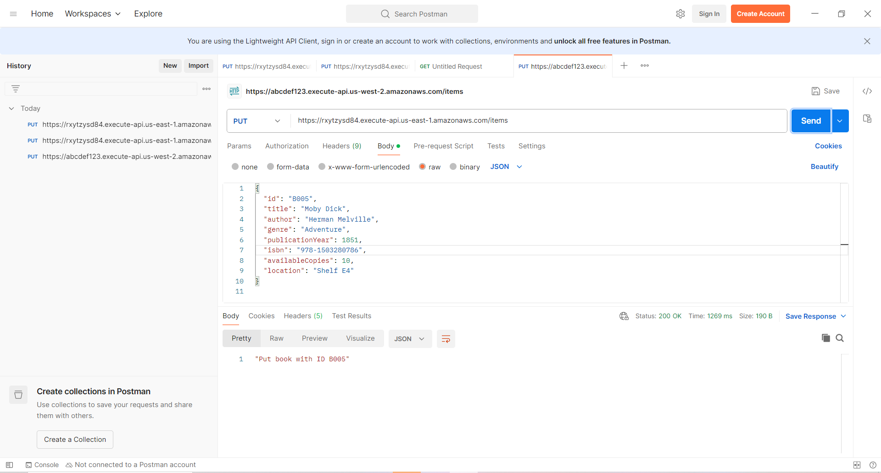
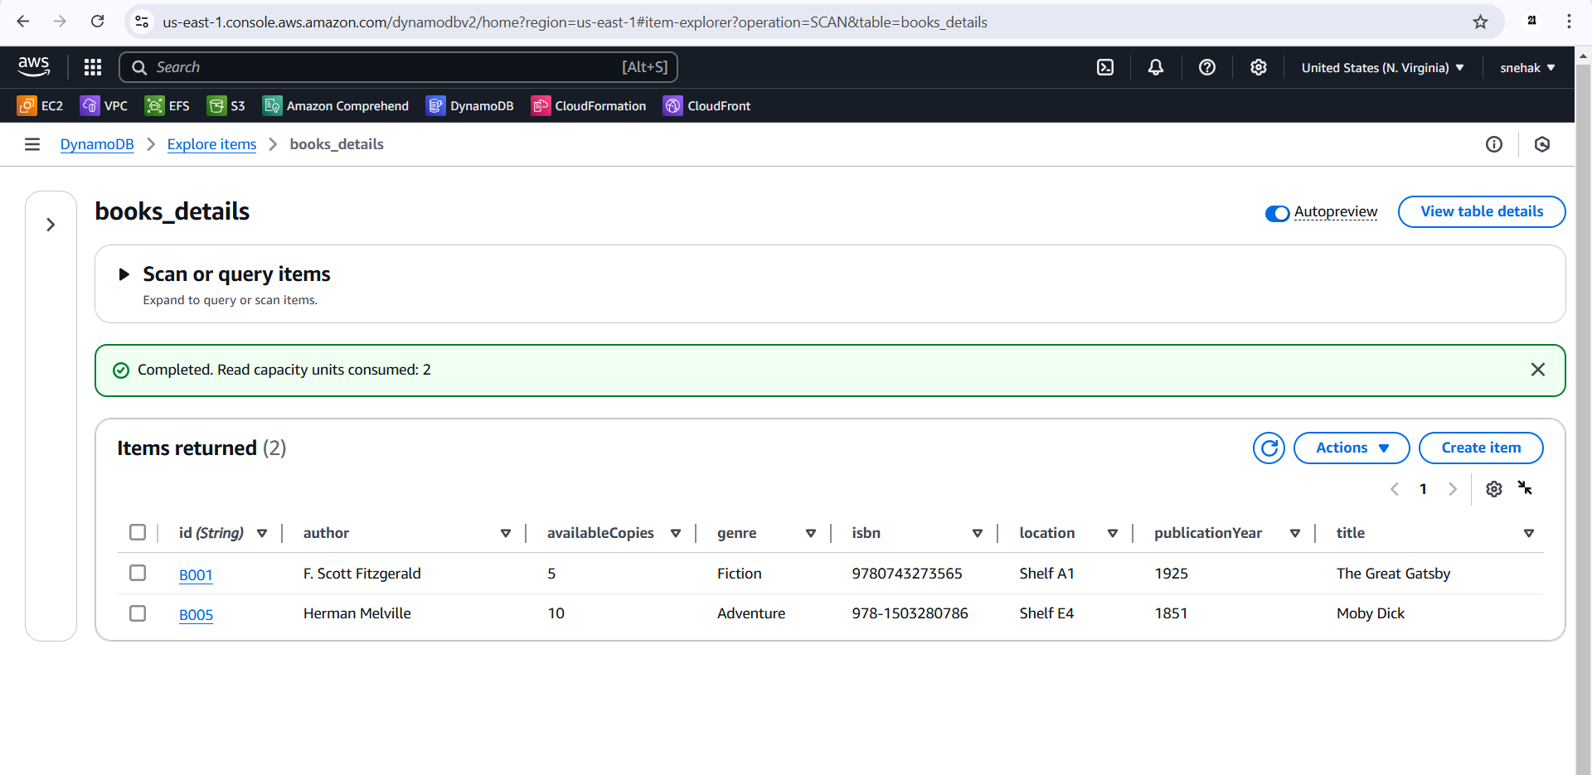

- Retrieve all data from table
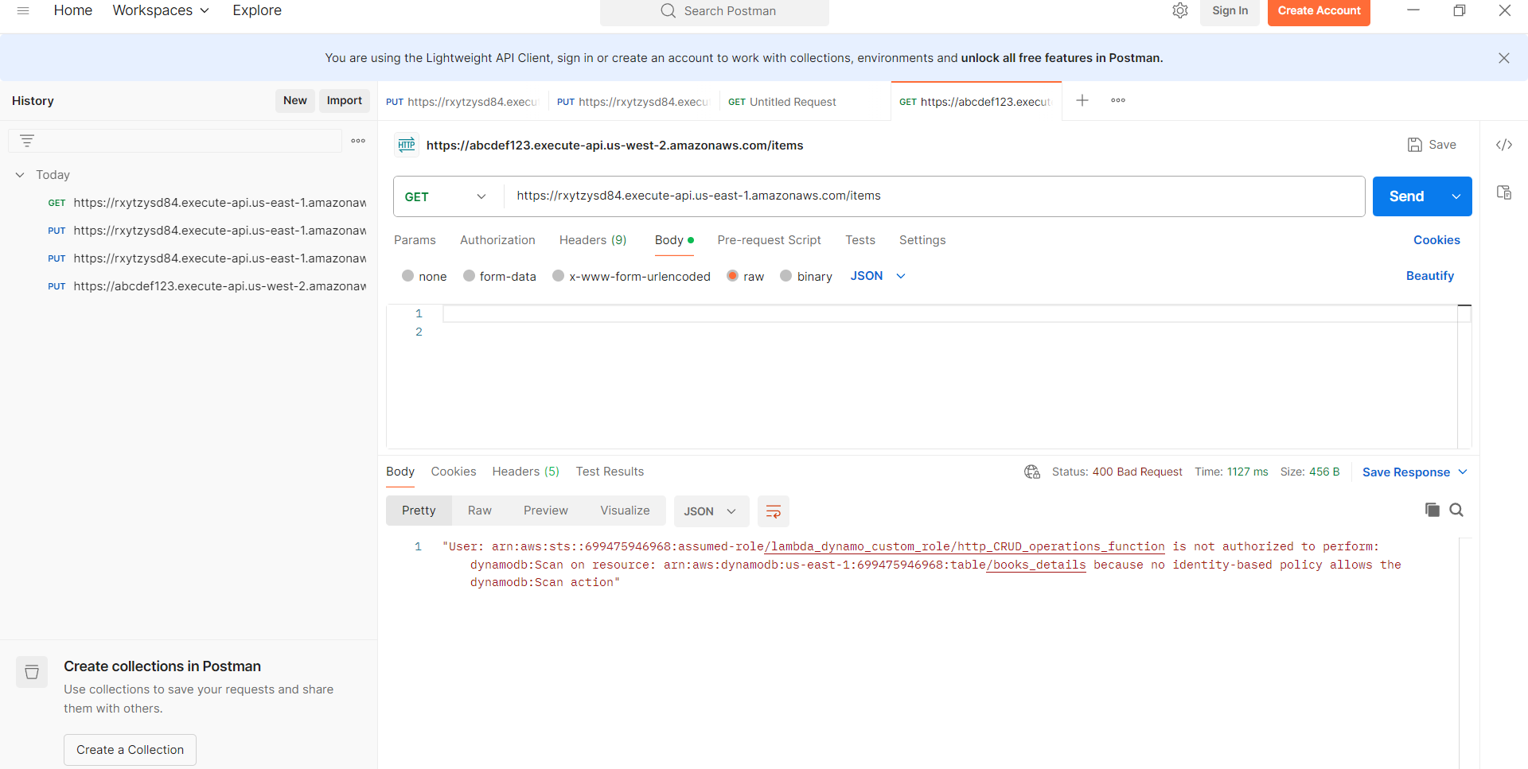
Error is fixed by adding permission dynamodb:scan in the policy.
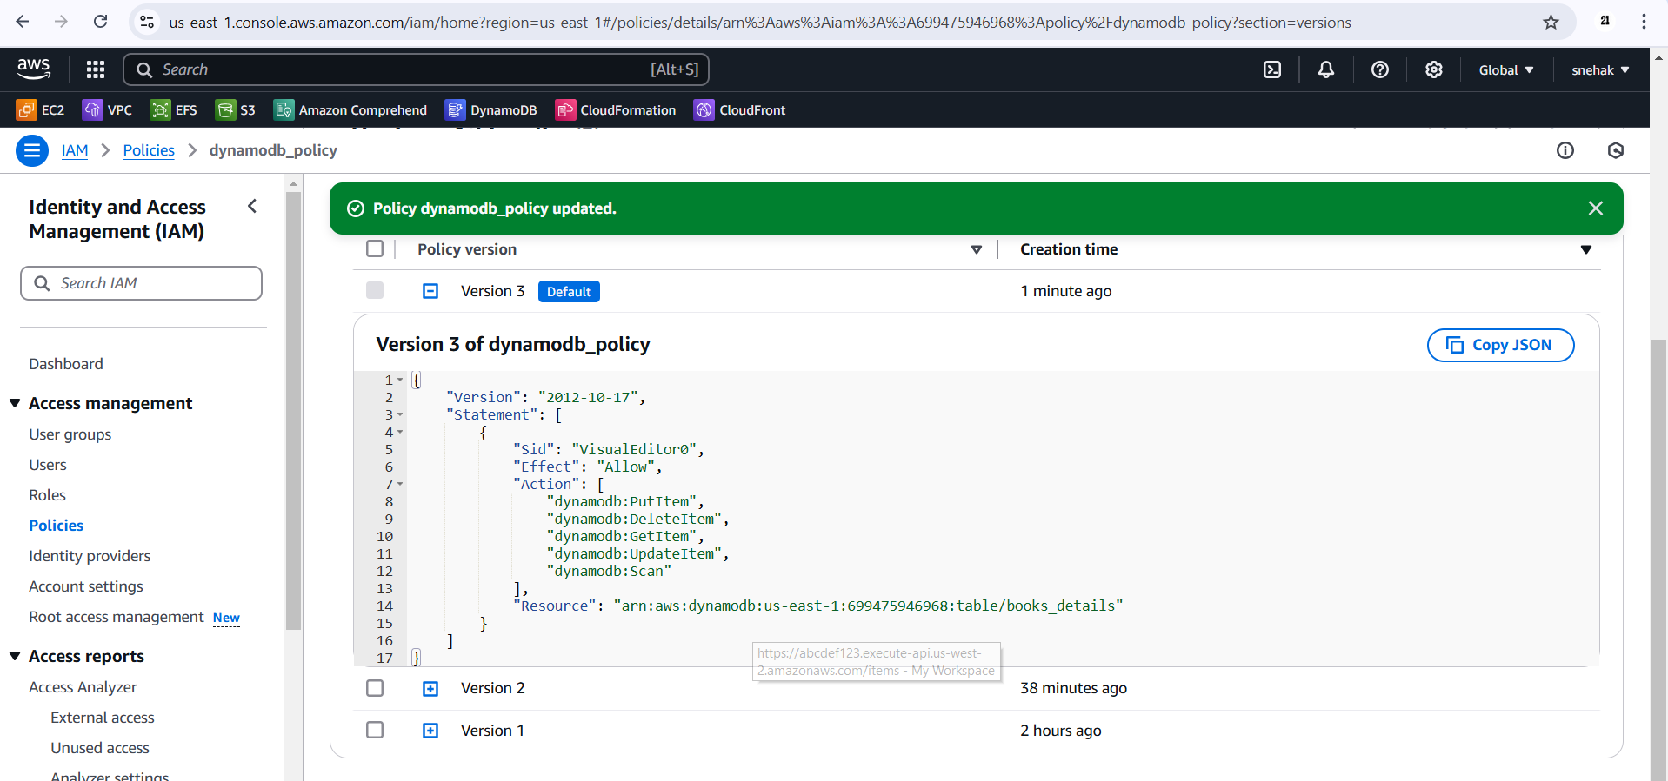
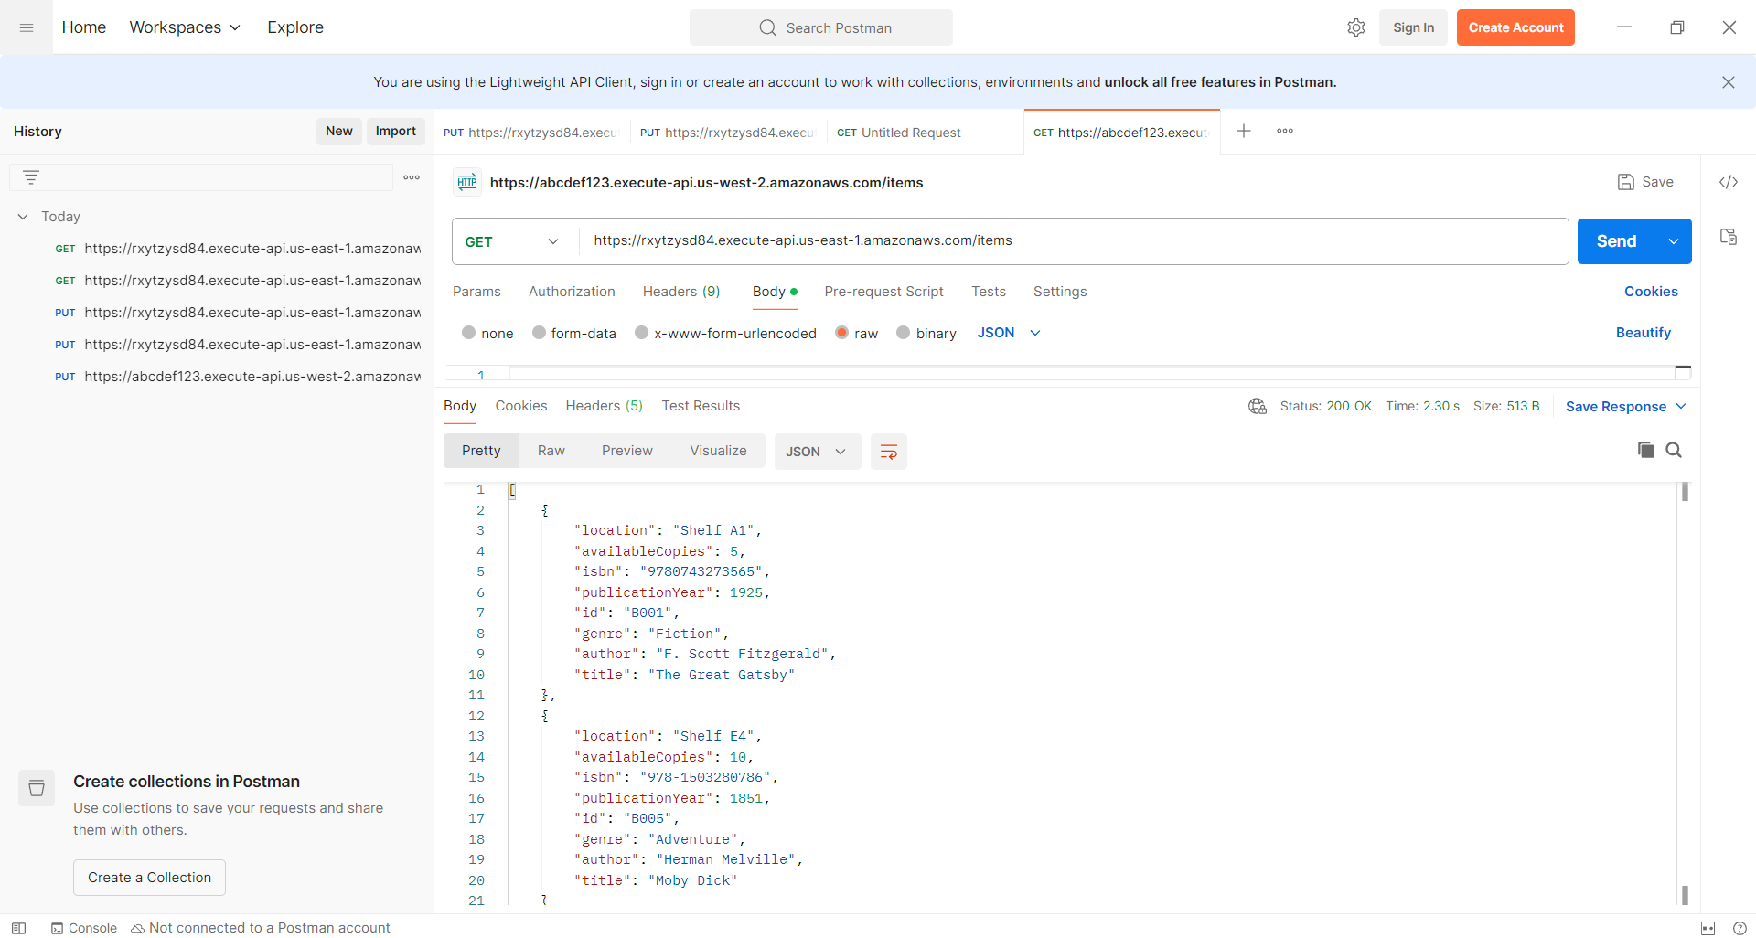
- Get a specific book/item

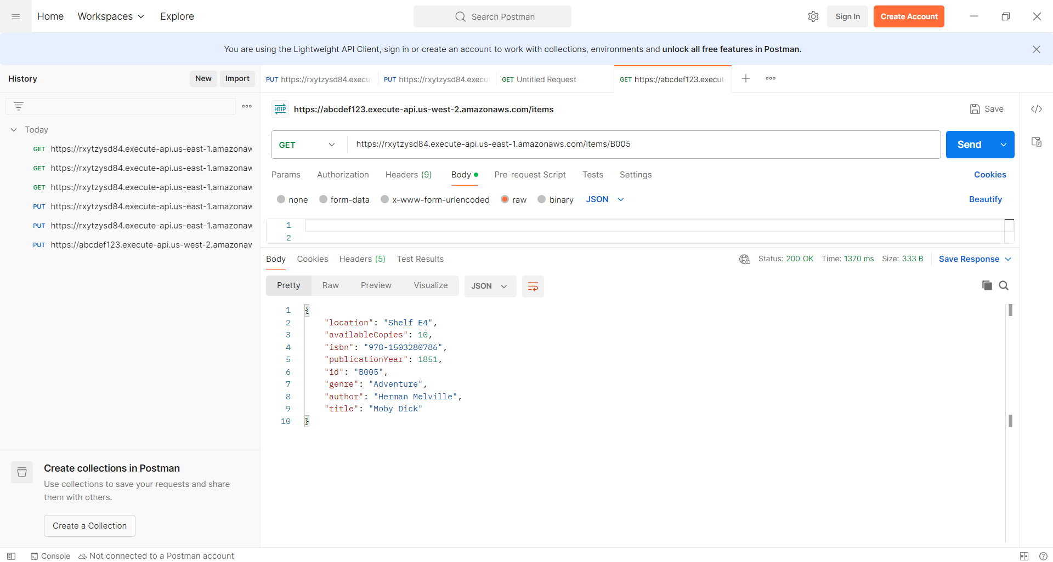

- Update book details
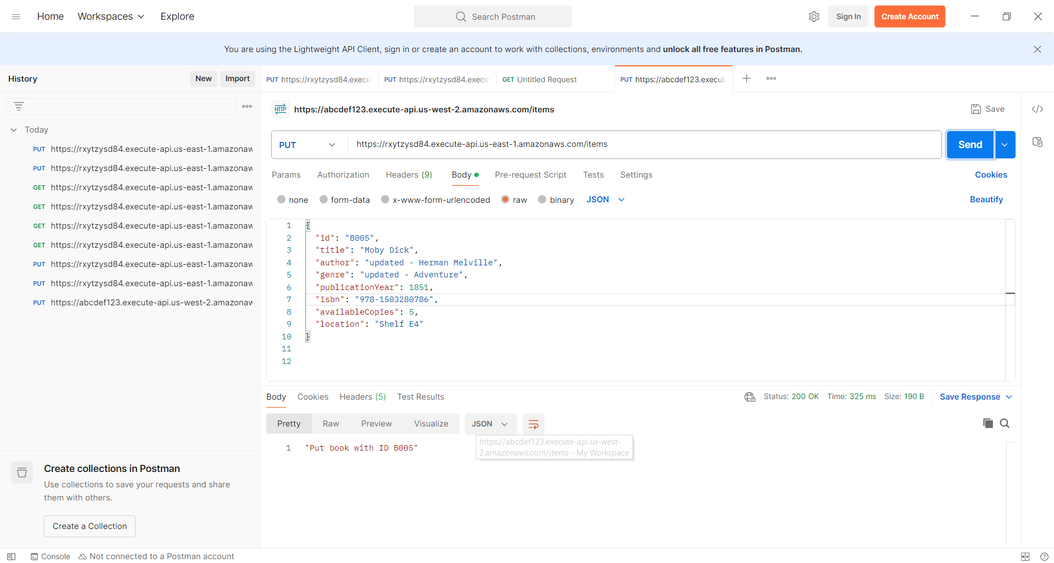
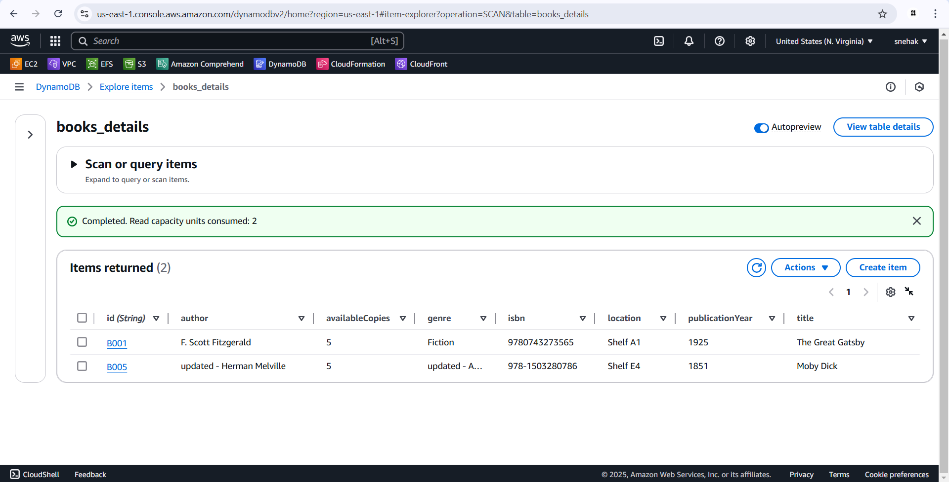

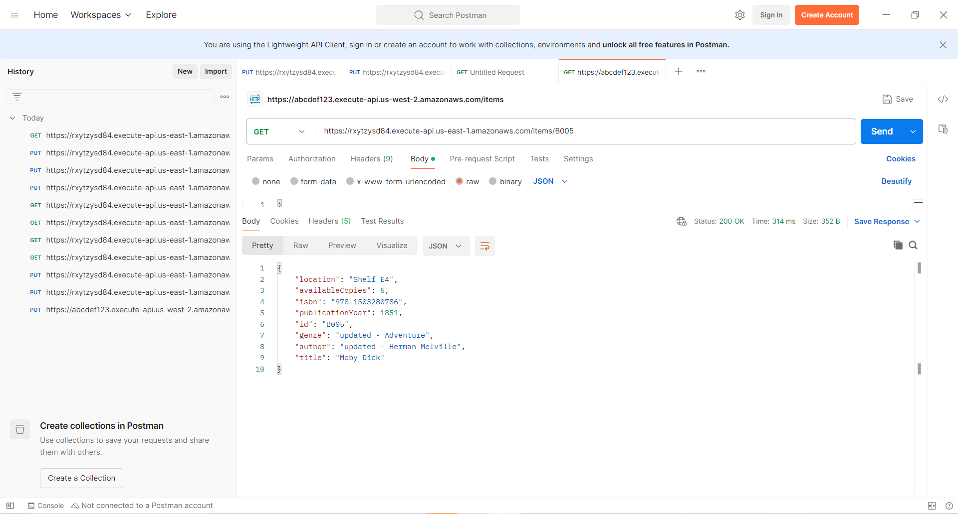
- Delete book
