JAVA DEVELOPMENT
WEEK 5 ASSIGNMENT REPORT

Intern Name | Sneha Kesharwani
College | Narula Institute of Technology
Branch | CSE
Assignment Duration | 1 Week (7 days)
Total Marks | 100

Objective:
The objective of this assignment is to understand advanced Java concepts including Packages, Interfaces, Abstract Classes, File Handling, and Multithreading Basics through practical programming tasks.

Table of Contents:

No. | Section | Marks
1 | Task 1: Packages — Organizing Java Code | 15
2 | Task 2: Interface — Payment System | 20
3 | Task 3: Abstract Classes — Shape Calculator | 20
4 | Task 4: File Handling — Student Records | 20
5 | Task 5: Multithreading Basics — Multiple Tasks | 15

Tools and Requirements:
Java JDK and a Java IDE - Visual Studio Code are used to write, compile, and execute the programs. The source files are saved with the .java extension.

Task 1: Packages — Organizing Java Code Objective: Create a custom Java package named studentmanagement. Inside the package, create a class named Student containing: Student ID Student Name Course Create another Java class outside the package and import the Student class. Create a Student object and display the student information.
CODE:
Student.java:
package studentmanagement;
public class Student {
int studentId;
String studentName;
String course;
public Student(int studentId, String studentName, String course) {
this.studentId = studentId;
this.studentName = studentName;
this.course = course;
}
public void displayStudentInfo() {
System.out.println("Student ID: " + studentId);
System.out.println("Student Name: " + studentName);
System.out.println("Course: " + course);
}
}
Main.java:
import studentmanagement.Student;
public class Main {
public static void main(String[] args) {
Student student = new Student(
101,
"Sneha Kesharwani",
"B.Tech Computer Science and Engineering"
);
student.displayStudentInfo();
}
}
OUTPUT:
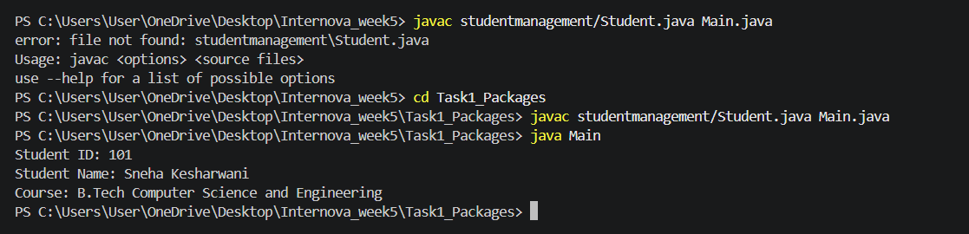

Task 2: Interface — Payment System Objective: Create an interface named Payment with methods such as: pay() showPaymentDetails() Create at least two classes that implement the interface, for example: UPIPayment CardPayment Implement the methods differently in both classes. Create objects of both classes and demonstrate their functionality. Requirements Create an interface. Use the implements keyword. Implement all required interface methods. Demonstrate how different classes can implement the same interface.
CODE:
Main.java:
public class Main {
public static void main(String[] args) {
// Creating UPIPayment object
Payment upiPayment = new UPIPayment(
"sneha@upi",
500.00
);
// Creating CardPayment object
Payment cardPayment = new CardPayment(
"1234-5678-9012",
1000.00);
System.out.println("----- UPI PAYMENT -----");
upiPayment.pay();
upiPayment.showPaymentDetails();
System.out.println();
System.out.println("----- CARD PAYMENT -----");
cardPayment.pay();
cardPayment.showPaymentDetails();
}
}
CardPayment.java:
class CardPayment implements Payment {
private String cardNumber;
private double amount;
CardPayment(String cardNumber, double amount) {
this.cardNumber = cardNumber;
this.amount = amount;
}
@Override
public void pay() {
System.out.println("Payment made using Card.");
System.out.println("Amount Paid: Rs. " + amount);
}
@Override
public void showPaymentDetails() {
System.out.println("Card Number: " + cardNumber);
}
}
UPIPayment.java:
class UPIPayment implements Payment {
private String upiId;
private double amount;
UPIPayment(String upiId, double amount) {
this.upiId = upiId;
this.amount = amount;
}
@Override
public void pay() {
System.out.println("Payment made using UPI.");
System.out.println("Amount Paid: Rs. " + amount);
}
@Override
public void showPaymentDetails() {
System.out.println("UPI ID: " + upiId);
}
}
Payment.java:
interface Payment {
void pay();
void showPaymentDetails();
}
OUTPUT:
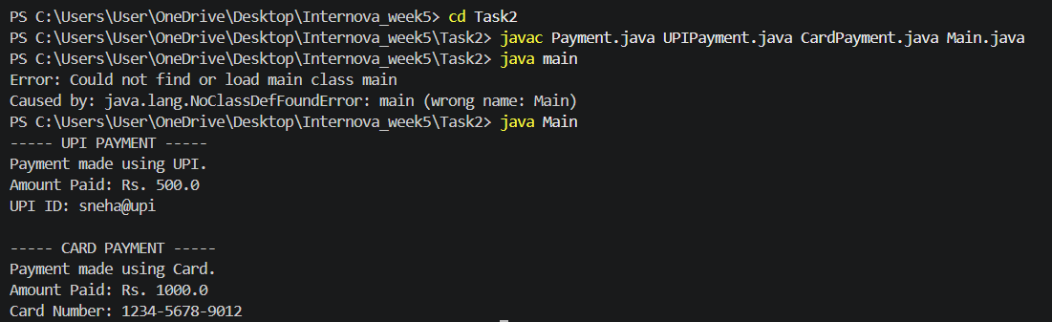

EXPLANATION:
An interface in Java is used to define a set of methods that implementing classes must provide.
In this program:
- Payment is the interface.
- It contains two methods: pay() and showPaymentDetails().
- UPIPayment implements the Payment interface using the implements keyword.
- CardPayment also implements the same Payment interface.
- Both classes provide their own implementation of pay() and showPaymentDetails().
- Objects of both classes are created and their functionality is demonstrated.

Task 3: Abstract Classes — Shape Calculator
Objective: Create an abstract class named Shape. It should contain: An abstract method calculateArea() A normal method to display a message Create at least two child classes: Circle Rectangle Implement calculateArea() differently in both classes. Create objects and display the calculated areas. Requirements Use the abstract keyword. Create an abstract method. Create a normal method inside the abstract class. Extend the abstract class using extends.
CODE:
Main.java :
public class Main {
public static void main(String[] args) {
// Creating Circle object
Shape circle = new Circle(5);
System.out.println("----- CIRCLE -----");
circle.displayMessage();
circle.calculateArea();
System.out.println();
// Creating Rectangle object
Shape rectangle = new Rectangle(10, 5);
System.out.println("----- RECTANGLE -----");
rectangle.displayMessage();
rectangle.calculateArea();
}
}
Circle.java:
class Circle extends Shape {
double radius;
Circle(double radius) {
this.radius = radius;
}
@Override
void calculateArea() {
double area = Math.PI * radius * radius;
System.out.println("Area of Circle: " + area);
}
}
Rectangle.java:
class Rectangle extends Shape {
double length;
double width;
Rectangle(double length, double width) {
this.length = length;
this.width = width;
}
@Override
void calculateArea() {
double area = length * width;
System.out.println("Area of Rectangle: " + area);
}
}
Shape.java:
abstract class Shape {
// Abstract method
abstract void calculateArea();
// Normal method
void displayMessage() {
System.out.println("Calculating area of the shape...");
}
}
OUTPUT: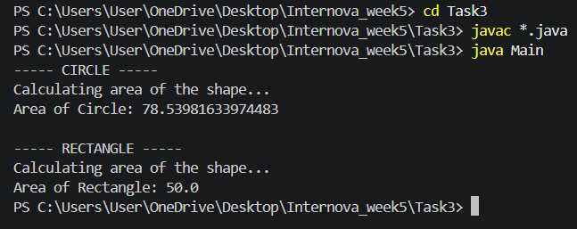

EXPLANATION:
An abstract class is a class declared using the abstract keyword. It can contain both abstract methods and normal methods.
In this program:
- Shape is the abstract class.
- calculateArea() is an abstract method, so it does not have a body in Shape.
- displayMessage() is a normal method with a body.
- Circle and Rectangle use extends Shape.
- Both child classes provide their own implementation of calculateArea().
- Objects are created using Circle and Rectangle, and their areas are calculated.

Task 4: File Handling — Student Records Objective: Create a Java program that stores student information in a text file. The program should: Create a file. Write student information into the file. Read the information from the file. Display the file contents in the console. Use appropriate exception handling for file operations. Student Information Store details such as: Student ID Student Name Course Marks Requirements Demonstrate both: Writing to a file Reading from a file CODE:
System.out.println("Employee ID : " + employeeId);
System.out.printf("Salary : Rs. %.2f%n", salary);
}
}
class Developer extends Employee {
String import java.io.File;
import java.io.FileWriter;
import java.io.FileReader;
import java.io.BufferedReader;
import java.io.IOException;
public class StudentFileHandling {
public static void main(String[] args) {
String fileName = "student.txt";
try {
// Step 1: Create a file
File file = new File(fileName);
if (file.createNewFile()) {
System.out.println("File created successfully.");
} else {
System.out.println("File already exists.");
}
// Step 2: Write student information into the file
FileWriter writer = new FileWriter(fileName);
writer.write("Student ID: 101\n");
writer.write("Student Name: Sneha Kesharwani\n");
writer.write("Course: B.Tech Computer Science and Engineering\n");
writer.write("Marks: 85\n");
writer.close();
System.out.println("Student information written to the file.");
// Step 3: Read information from the file
FileReader reader = new FileReader(fileName);
BufferedReader bufferedReader = new BufferedReader(reader);
System.out.println("\n----- STUDENT RECORD -----");
String line;
while ((line = bufferedReader.readLine()) != null) {
System.out.println(line);
}
bufferedReader.close();
} catch (IOException e) {
System.out.println("An error occurred while handling the file.");
System.out.println(e.getMessage());
}
}
}
OUTPUT:
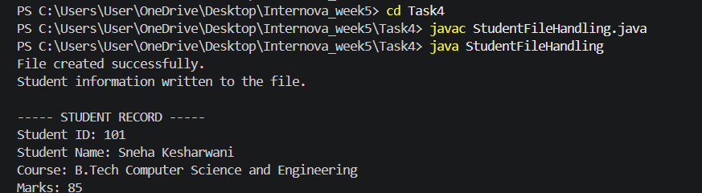

EXPLANATION:
File handling in Java is used to create, write, read, and manage files.
In this program:
- File is used to create the text file.
- FileWriter is used to write student information into the file.
- FileReader and BufferedReader are used to read the information.
- while loop reads the file line by line.
- IOException is handled using try-catch to handle possible file-related errors.
- The contents of student.txt are displayed in the console.

Task 5: Multithreading Basics — Multiple Tasks
Objective: Create a Java program demonstrating basic Multithreading. Create two threads that perform different tasks. Example Thread 1: Print numbers from 1 to 10. Thread 2: Print a message such as: Learning Java Multithreading multiple times. Requirements Create two threads. Start both threads. Demonstrate that both threads can execute independently. Use an appropriate thread creation approach.
CODE:
class NumberThread extends Thread {
@Override
public void run() {
for (int i = 1; i <= 10; i++) {
System.out.println("Thread 1 - Number: " + i);
try {
Thread.sleep(200);
} catch (InterruptedException e) {
System.out.println("Thread 1 interrupted.");
}
}
}
}
class MessageThread extends Thread {
@Override
public void run() {
for (int i = 1; i <= 10; i++) {
System.out.println("Thread 2 - Learning Java Multithreading");
try {
Thread.sleep(200);
} catch (InterruptedException e) {
System.out.println("Thread 2 interrupted.");
}
}
}
}
public class MultithreadingDemo {
public static void main(String[] args) {
// Create two thread objects
NumberThread thread1 = new NumberThread();
MessageThread thread2 = new MessageThread();
// Start both threads
thread1.start();
thread2.start();
}
}
OUTPUT:
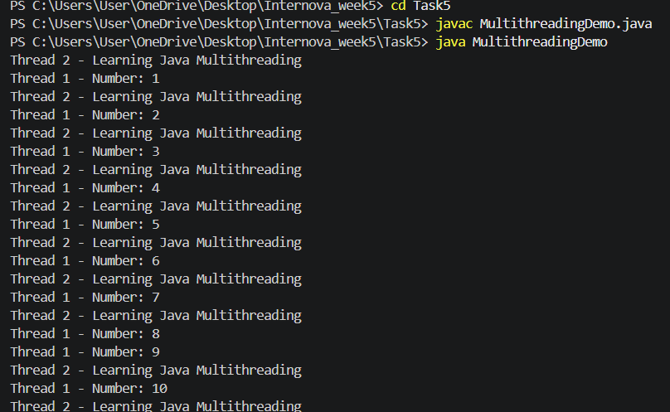

EXPLANATION:
Multithreading is a Java feature that allows multiple tasks to execute concurrently.
In this program:
- NumberThread extends the Thread class and prints numbers from 1 to 10.
- MessageThread extends the Thread class and prints "Learning Java Multithreading" 10 times.
- The run() method contains the task performed by each thread.
- start() is used to start both threads.
- Thread.sleep(200) temporarily pauses each thread, making the concurrent execution easier to observe.
- Since both threads run independently, their output may appear in a different order each time.

