JAVA DEVELOPMENT
WEEK 2 ASSIGNMENT REPORT

Intern Name | Sneha Kesharwani
College | Narula Institute of Technology
Branch | CSE
Assignment Duration | 1 Week (7 days)
Total Marks | 100

Objective:
The objective of this assignment is to understand Java control flow, loops, methods, parameters, return types, and arrays. Students will practice these concepts through problem-solving programs.

Table of Contents:

No. | Section | Marks
1 | Task 1 – Conditional Statements — Student Result | 15
2 | Task 2 – Loops — Number Practice | 20
3 | Task 3 – Methods — Calculator | 20
4 | Task 4 – Method Parameters & Return Types | 15
5 | Task 5 – 1D Array — Student Marks | 15
6 | Task 6 – 2D Array — Matrix Operations | 15
7 | Conclusion

Tools and Requirements:
Java JDK and a Java IDE - Visual Studio Code are used to write, compile, and execute the programs. The source files are saved with the .java extension.

Task 1: Conditional Statements – Student Result
Objective: Create a Java program that: Takes marks of a student in 3 subjects as input. Calculates the total marks and percentage. Uses conditional statements to determine the result. Display: Student Name Total Marks Percentage Result.
CODE:
import java.util.Scanner;
public class Conditional_Statement {
public static void main(String[] args) {
Scanner sc = new Scanner(System.in);
System.out.print("Enter a Student Name:");
String name = sc.nextLine();
System.out.print("Enter marks in subject 1:");
int marks1 = sc.nextInt();
System.out.print("Enter marks in subject 2:");
int marks2 = sc.nextInt();
System.out.print("Enter marks in subject 3:");
int marks3 = sc.nextInt();
int totalMarks = marks1 + marks2 + marks3;
double percentage = (totalMarks / 300.0) * 100;
String result;
if(marks1 < 35 || marks2 < 35 || marks3 < 35)
{
result = "Fail";
} else if(percentage >= 60) {
result = "First Division";
} else if(percentage >= 50) {
result = "Second Division";
} else if(percentage >= 35) {
result = "Third Division";
} else {
result = "Fail";
}
System.out.println("\n---- Result --");
System.out.println("Student Name: " + name);
System.out.println("Total Marks: " + totalMarks);
System.out.println("Percentage: " + percentage + "%");
System.out.println("Result: " + result);
sc.close();
}
}

OUTPUT:
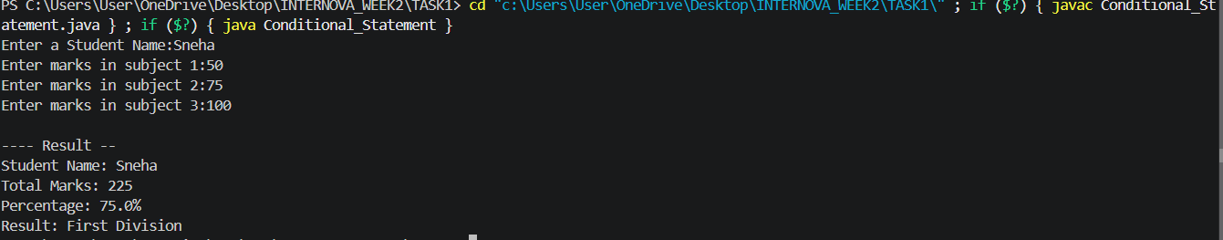

Explanation:
This program takes the student's name and marks in three subjects as input. It calculates the total marks and percentage. Using conditional statements, it checks whether the student has passed or failed based on the marks obtained in each subject.

Task 2 : Loops – Number Practice
Objective: Create a Java program using loops to: Print numbers from 1 to 100. Print all even numbers between 1 and 100. Print all odd numbers between 1 and 100. Calculate the sum of numbers from 1 to 100.
CODE:
public class NumberPractice {
public static void main(String[] args) {
// 1. Print numbers from 1 to 100
System.out.println("Numbers from 1 to 100:");
for (int i = 1; i <= 100; i++) {
System.out.print(i + " ");
}
// 2. Print all even numbers between 1 and 100
System.out.println("\n\nEven numbers between 1 and 100:");
for (int i = 1; i <= 100; i++) {
if (i % 2 == 0) {
System.out.print(i + " ");
}
}
// 3. Print all odd numbers between 1 and 100
System.out.println("\n\nOdd numbers between 1 and 100:");
for (int i = 1; i <= 100; i++) {
if (i % 2 != 0) {
System.out.print(i + " ");
} }
// 4. Calculate the sum of numbers from 1 to 100
int sum = 0;
for (int i = 1; i <= 100; i++) {
sum = sum + i;
}
System.out.println("\n\nSum of numbers from 1 to 100: " + sum);
} }
OUTPUT:
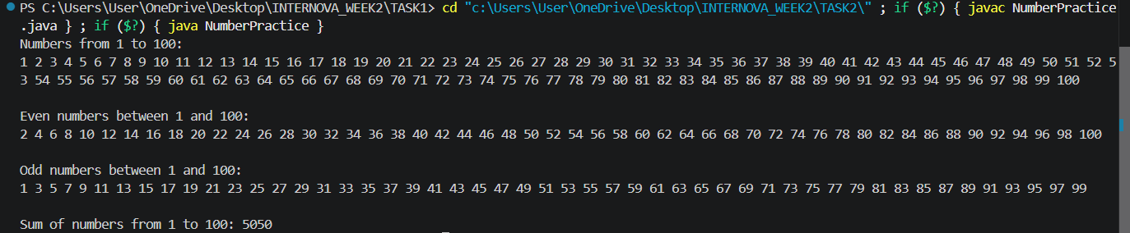

Explanation:
This program demonstrates the use of loops in Java. It prints numbers from 1 to 100, displays all even and odd numbers, and calculates the sum of numbers from 1 to 100 using for and while loops.
Task 3 : Methods – Calculator
Objective: Create a calculator program using separate methods for: Addition Subtraction Multiplication Division Modulus Take two numbers as input from the user and call the appropriate methods to perform the operations.
CODE:
import java.util.Scanner;
public class Calculator {
// Method for Addition
static double addition(double a, double b) {
return a + b;
}
// Method for Subtraction
static double subtraction(double a, double b) {
return a - b;
}
// Method for Multiplication
static double multiplication(double a, double b) {
return a * b;
}
// Method for Division
static double division(double a, double b) {
return a / b;
}
// Method for Modulus
static double modulus(double a, double b) {
return a % b;
}
public static void main(String[] args) {
Scanner sc = new Scanner(System.in);
// Taking input from the user
System.out.print("Enter first number: ");
double num1 = sc.nextDouble();
System.out.print("Enter second number: ");
double num2 = sc.nextDouble();
// Calling methods
System.out.println("\n----- Calculator Results -----");
System.out.println("Addition : " + addition(num1, num2));
System.out.println("Subtraction : " + subtraction(num1, num2));
System.out.println("Multiplication : " + multiplication(num1, num2));
if (num2 != 0) {
System.out.println("Division : " + division(num1, num2));
System.out.println("Modulus : " + modulus(num1, num2));
} else {
System.out.println("Division : Cannot divide by zero");
System.out.println("Modulus : Cannot divide by zero");
}
sc.close();
}
}
OUTPUT:
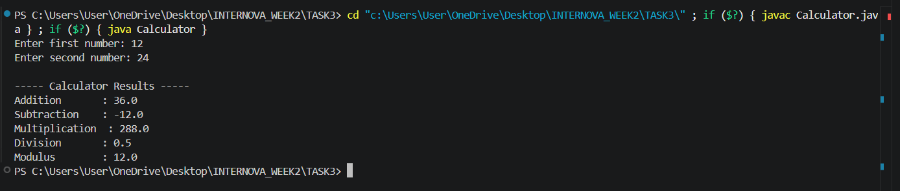

Explanation:
This program demonstrates the use of methods in Java by creating separate methods for addition, subtraction, multiplication, division, and modulus. Two numbers are taken as input and passed to the appropriate methods to perform the calculations.

Task 4 : Methods Parameter and Return Types
Objective: Create methods for the following operations: Find the square of a number. Find the cube of a number. Find the average of three numbers. Find the maximum of two numbers. Each method should accept parameters and return the appropriate result.
CODE:
public class MethodOperations {
// Method to find the square of a number
static int square(int num) {
return num * num;
}
// Method to find the cube of a number
static int cube(int num) {
return num * num * num;
}
// Method to find the average of three numbers
static double average(double a, double b, double c) {
return (a + b + c) / 3;
}
// Method to find the maximum of two numbers
static int maximum(int a, int b) {
if (a > b) {
return a;
} else {
return b;
} }
public static void main(String[] args) {
// Calling the methods with parameters
int num = 5;
int num1 = 10;
int num2 = 20;
double a = 15;
double b = 25;
double c = 35;
System.out.println("----- Method Operations -----");
System.out.println("Number : " + num);
System.out.println("Square : " + square(num));
System.out.println("Cube : " + cube(num));
System.out.println("\nThree Numbers: " + a + ", " + b + ", " + c);
System.out.println("Average : " + average(a, b, c));
System.out.println("\nTwo Numbers : " + num1 + ", " + num2);
System.out.println("Maximum : " + maximum(num1, num2));
} }
OUTPUT:
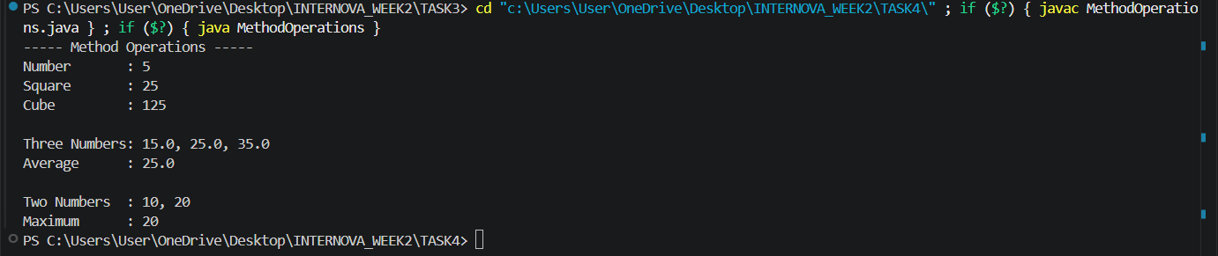

Explanation:
This program demonstrates methods with parameters and return types. It contains methods to calculate the square and cube of a number, the average of three numbers, and the maximum of two numbers. Each method receives input through parameters and returns the calculated result.

Task 5 : 1D Arrays – Student Marks
Objective: Create a Java program that: Stores marks of 5 students in a 1D array. Takes marks as input from the user. Displays all the marks. Calculates and displays: Total marks Average marks Highest marks Lowest marks.
CODE:
import java.util.Scanner;
public class StudentMarks {
public static void main(String[] args) {
Scanner sc = new Scanner(System.in);
// Create a 1D array to store marks of 5 students
int[] marks = new int[5];
// Take marks as input
System.out.println("Enter marks of 5 students:");
for (int i = 0; i < 5; i++) {
System.out.print("Student " + (i + 1) + ": ");
marks[i] = sc.nextInt();
}
// Display all marks
System.out.println("\n----- Student Marks -----");
for (int i = 0; i < 5; i++) {
System.out.println("Student " + (i + 1) + ": " + marks[i]);
}
// Calculate total marks
int total = 0;
for (int i = 0; i < 5; i++) {
total = total + marks[i];
}
// Calculate average
double average = (double) total / 5;
// Find highest and lowest marks
int highest = marks[0];
int lowest = marks[0];
for (int i = 1; i < 5; i++) {
if (marks[i] > highest) {
highest = marks[i];
}
if (marks[i] < lowest) {
lowest = marks[i];
}
}
// Display results
System.out.println("\n----- Result -----");
System.out.println("Total Marks : " + total);
System.out.println("Average Marks : " + average);
System.out.println("Highest Marks : " + highest);
System.out.println("Lowest Marks : " + lowest);
sc.close();
}
}
OUTPUT:
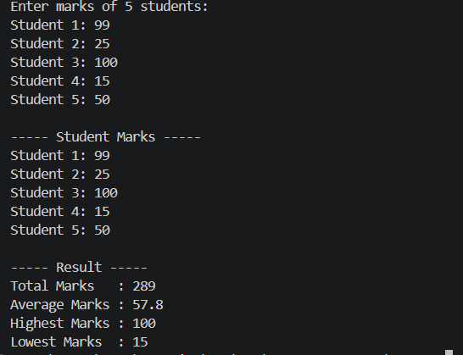

Explanation:
This program uses a one-dimensional array to store the marks of five students. It takes marks as input and displays them. It then calculates the total marks, average marks, highest marks, and lowest marks using array elements.

Task 6 : 2D Arrays – Matrix Operations
Objective: Create a Java program using a 2D array to store a 3 × 3 matrix. The program should: Take matrix elements as input. Display the matrix in proper format. Calculate and display the sum of all elements.
CODE:
import java.util.Scanner;
public class MatrixOperations {
public static void main(String[] args) {
Scanner sc = new Scanner(System.in);
// Create a 3 x 3 matrix
int[][] matrix = new int[3][3];
// Take matrix elements as input
System.out.println("Enter elements of 3 x 3 matrix:");
for (int i = 0; i < 3; i++) {
for (int j = 0; j < 3; j++) {
System.out.print("Enter element [" + i + "][" + j + "]: ");
matrix[i][j] = sc.nextInt();
}
}
// Display the matrix
System.out.println("\n----- Matrix -----");
for (int i = 0; i < 3; i++) {
for (int j = 0; j < 3; j++) {
System.out.print(matrix[i][j] + "\t");
}
System.out.println();
}
// Calculate the sum of all elements
int sum = 0;
for (int i = 0; i < 3; i++) {
for (int j = 0; j < 3; j++) {
sum = sum + matrix[i][j];
}
}
// Display the sum
System.out.println("\nSum of all elements: " + sum);
sc.close();
}
}
OUTPUT:
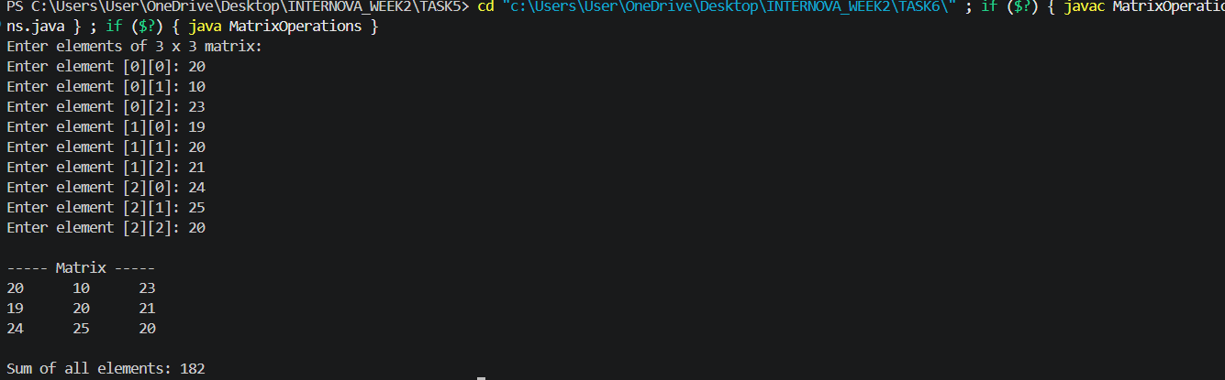
Explanation:
This program uses a two-dimensional array to store a 3 × 3 matrix. It takes matrix elements as input, displays them in proper row-and-column format, and calculates the sum of all elements in the matrix.

Conclusion
This assignment helped in understanding and implementing important Java programming concepts such as conditional statements, loops, methods, method parameters, return types, and arrays. Through these six programs, practical experience was gained in taking user input, performing calculations, making decisions, repeating operations, and storing data using 1D and 2D arrays. Overall, the assignment improved problem-solving skills and provided a strong foundation for writing structured Java programs.

