JAVA DEVELOPMENT
WEEK 1 ASSIGNMENT REPORT
Intern Name | Sneha Kesharwani
College | Narula Institute of Technology
Branch | CSE
Assignment Duration | 1 Week (7 days)
Total Marks | 100
Objective:
The objective of this assignment is to understand the fundamentals of Java programming by learning Java syntax, variables, data types, user input, operators, and type casting. This assignment will help students build a strong foundation for upcoming Java programming concepts.

Table of Contents:

No. | Section | Marks
1 | Task 1 – Java Setup & Hello World | 10
2 | Task 2 – Variables & Data Types | 20
3 | Task 3 – Input & Output using Scanner | 20
4 | Task 4 – Operators | 20
5 | Task 5 – Type Casting | 15
6 | Task 6 – Java Fundamentals Practice | 15
7 | Conclusion

Tools and Requirements:
Java JDK and a Java IDE - Visual Studio Code are used to write, compile, and execute the programs. The source files are saved with the .java extension.

Task 1: Java Setup & Hello World
Objective: Create the first Java program and display the student's name, college, branch, and a welcome message.
CODE:
public class TASK1 {
public static void main(String[] args) {
System.out.println("Hello, World!");
System.out.println("Name: Sneha Kesharwani");
System.out.println("College: Narula Institute of Technology");
System.out.println("Course: Computer Science");
} }
OUTPUT:
Hello, World!
Name: Sneha Kesharwani
College: Narula Institute of Technology
Course: Computer Science
Explanation: This program demonstrates the basic structure of a Java application. The main() method is the
starting point of execution, and System.out.println() displays information on the cosole.
Task 2: Variables & Data Types
Objective: Store and display personal/student information using suitable Java data types.
CODE:
public class TASK2 {
public static void main(String[] args) {

// Storing information
String name = "Sneha Kesharwani";
int age = 20;
float height = 5.4; // in feet
double weight = 55.5; // in kg
double cgpa = 8.60f;
char gender = 'F';
boolean isStudent = true;

// Displaying information
System.out.println("----- Student Information -----");
System.out.println("Name : " + name);
System.out.println("Age : " + age);
System.out.println("Height : " + height + " ft");
System.out.println("Weight : " + weight + " kg");
System.out.println("CGPA : " + cgpa);
System.out.println("Gender : " + gender);
System.out.println("Is Student : " + isStudent);
}
}
OUTPUT:
----- Student Information -----
Name : Sneha Kesharwani
Age : 20
Height : 5.4 ft
Weight : 55.5 kg
CGPA : 8.6
Gender : F
Is Student : true
DATA TYPE USED:
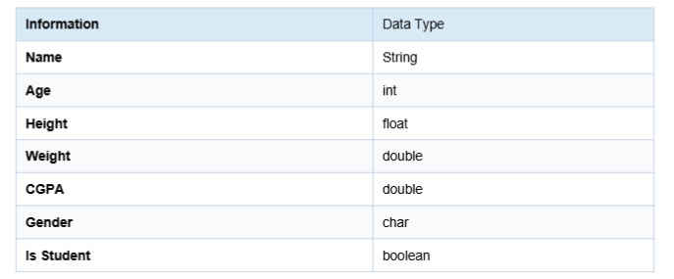
Task 3: Input & Output using Scanner Class
Objective: Accept full name, age, college name, branch, and city from the user and display the entered
information in a well-formatted manner.
CODE:
import java.util.Scanner;

public class TASK3 {
public static void main(String[] args) {

Scanner sc = new Scanner(System.in);

// Taking input from the user
System.out.print("Enter Full Name: ");
String fullName = sc.nextLine();

System.out.print("Enter Age: ");
int age = sc.nextInt();
sc.nextLine(); // Consume the leftover newline

System.out.print("Enter College Name: ");
String collegeName = sc.nextLine();

System.out.print("Enter Branch: ");
String branch = sc.nextLine();

System.out.print("Enter City: ");
String city = sc.nextLine();

// Displaying the entered information
System.out.println("\n===== Student Details =====");
System.out.println("Full Name : " + fullName);
System.out.println("Age : " + age);
System.out.println("College Name : " + collegeName);
System.out.println("Branch : " + branch);
System.out.println("City : " + city);

sc.close();
}
}
OUTPUT:
Enter Full Name: SNEHA
Enter Age: 20
Enter College Name: NiT
Enter Branch: CSE
Enter City: KOLKATA

===== Student Details =====
Full Name : SNEHA
Age : 20
College Name : NiT
Branch : CSE
City : KOLKATA

Explanation: The Scanner class is used to accept runtime input from the user. nextLine() reads a complete
line, while nextInt() reads an integer. The extra nextLine() after nextInt() consumes the remaining newline
character before reading the next text input.

Task 4: Operators Practice
Objective: Create a calculator that performs addition, subtraction, multiplication, division, and modulus using
two numbers entered by the user.
CODE:
import java.util.Scanner;
public class TASK4 {
public static void main(String[] args) {
Scanner sc = new Scanner(System.in);
// Taking input
System.out.print("Enter first number: ");
double num1 = sc.nextDouble();
System.out.print("Enter second number: ");
double num2 = sc.nextDouble();
// Performing operations
double addition = num1 + num2;
double subtraction = num1 - num2;
double multiplication = num1 * num2;
double division = num1 / num2;
double modulus = num1 % num2;

// Displaying results
System.out.println("===== Calculator Results =====");
System.out.println("Addition : " + addition);
System.out.println("Subtraction : " + subtraction);
System.out.println("Multiplication : " + multiplication);
System.out.println("Division : " + division);
System.out.println("Modulus : " + modulus);
sc.close();
}
}
OUTPUT:
Enter first number: 23
Enter second number: 8
===== Calculator Results =====
Addition : 31.0
Subtraction : 15.0
Multiplication : 184.0
Division : 2.875
Modulus : 7.0

OPERATORS USED:
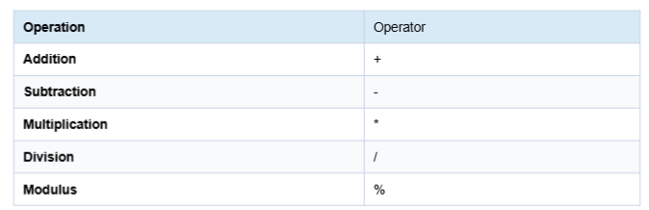

Task 5: Type Casting
Objective: Demonstrate implicit and explicit type casting and show the values before and after conversion.
CODE:
public class TASK5 {
public static void main(String[] args) {
// Implicit Type Casting (Widening)
int num1 = 100;
double implicitCast = num1;
System.out.println("----- Implicit Type Casting -----");
System.out.println("Before Casting (int) : " + num1);
System.out.println("After Casting (double) : " + implicitCast);

// Explicit Type Casting (Narrowing)
double num2 = 99.99;
int explicitCast = (int) num2;
System.out.println("\n----- Explicit Type Casting -----");
System.out.println("Before Casting (double) : " + num2);
System.out.println("After Casting (int) : " + explicitCast);
}
}
OUTPUT:
----- Implicit Type Casting -----
Before Casting (int) : 100
After Casting (double) : 100.0

----- Explicit Type Casting -----
Before Casting (double) : 99.99
After Casting (int) : 99

Explanation: Implicit type casting is the automatic conversion of a smaller compatible data type into a
larger data type. It is also called widening conversion. For example, an int can automatically be converted into a
double. Explicit type casting is performed manually by the programmer using the target data type in
parentheses. It is commonly used when converting a larger data type into smaller one.

Task 6: Java Fundamentals Practice
Objective: Accept integer, float, and double values from the user and demonstrate implicit and explicit type
casting.
CODE:
import java.util.Scanner;
public class TASK6 {
public static void main(String[] args) {
Scanner sc = new Scanner(System.in);
// Accepting input
System.out.print("Enter an integer value: ");
int intValue = sc.nextInt();
System.out.print("Enter a float value: ");
float floatValue = sc.nextFloat();
System.out.print("Enter a double value: ");
double doubleValue = sc.nextDouble();
// Displaying original values
System.out.println("\n===== Original Values =====");
System.out.println("Integer : " + intValue);
System.out.println("Float : " + floatValue);
System.out.println("Double : " + doubleValue);

// Implicit Type Casting (Widening)
float intToFloat = intValue;
double floatToDouble = floatValue;
System.out.println("\n===== Implicit Type Casting =====");
System.out.println("Integer to Float : " + intToFloat);
System.out.println("Float to Double : " + floatToDouble);
// Explicit Type Casting (Narrowing)
int floatToInt = (int) floatValue;
float doubleToFloat = (float) doubleValue;
int doubleToInt = (int) doubleValue;
System.out.println("\n===== Explicit Type Casting =====");
System.out.println("Float to Integer : " + floatToInt);
System.out.println("Double to Float : " + doubleToFloat);
System.out.println("Double to Integer : " + doubleToInt);
sc.close();
}
}
OUTPUT:
Enter an integer value: 23
Enter a float value: 5.8
Enter a double value: 28.00

===== Original Values =====
Integer : 23
Float : 5.8
Double : 28.0

===== Implicit Type Casting =====
Integer to Float : 23.0
Float to Double : 5.800000190734863

===== Explicit Type Casting =====
Float to Integer : 5
Double to Float : 28.0
Double to Integer : 28

Short Note: Type casting is commonly used when different data types need to work together in a Java program.
It is useful in mathematical calculations where decimal values are required. Explicit casting can be used when
converting double or float values into integers. Type casting is also useful when handling data from different
sources and controlling the type of result produced by an operation.
Conclusion
Through this assignment, I learned the fundamental concepts of Java programming, including Java syntax,
variables, data types, user input using the Scanner class, operators, and type casting. I also gained practical
experience in writing, compiling, executing, and debugging basic Java programs. These concepts provide a
strong foundation for learning advanced Java programming concepts.

