JAVA DEVELOPMENT
WEEK 3 ASSIGNMENT REPORT

Intern Name | Sneha Kesharwani
College | Narula Institute of Technology
Branch | CSE
Assignment Duration | 1 Week (7 days)
Total Marks | 100

Objective:
The objective of this assignment is to understand the fundamental concepts of Object-Oriented Programming in Java and apply them to create structured and reusable programs using classes, objects, constructors, inheritance, polymorphism, encapsulation, and abstraction.

Table of Contents:

No. | Section | Marks
1 | Task 1 – Classes & Objects — Student Management | 15
2 | Task 2 – Constructors — Employee Information | 20
3 | Task 3 – "this" & "static" — Bank Account | 20
4 | Task 4 – Inheritance — Employee Management | 15
5 | Task 5 – Polymorphism — Method Overloading & Overriding | 15
6 | Task 6 – Encapsulation & Abstraction — Banking System | 15

Tools and Requirements:
Java JDK and a Java IDE - Visual Studio Code are used to write, compile, and execute the programs. The source files are saved with the .java extension.

Task 1: Classes & Objects – Student Management
Objective: Create a "Student" class with the following attributes: - Student Name - Roll Number - Branch - CGPA Create objects of the "Student" class and display the information of at least 3 students.
CODE:
class Student {
String studentName;
int rollNumber;
String branch;
double cgpa;
Student(String studentName, int rollNumber, String branch, double cgpa) {
this.studentName = studentName;
this.rollNumber = rollNumber;
this.branch = branch;
this.cgpa = cgpa;
}
void displayInfo() {
System.out.println("Student Name : " + studentName);
System.out.println("Roll Number : " + rollNumber);
System.out.println("Branch : " + branch);
System.out.println("CGPA : " + cgpa);
System.out.println("----------------------------");
}
}
public class StudentManagement {
public static void main(String[] args) {
Student student1 = new Student("Sneha Kesharwani", 101, "CSE", 8.78);
Student student2 = new Student("Rahul Sharma", 102, "CSE", 8.45);
Student student3 = new Student("Priya Singh", 103, "CSE", 9.12);
student1.displayInfo();
student2.displayInfo();
student3.displayInfo();
}
}
OUTPUT:
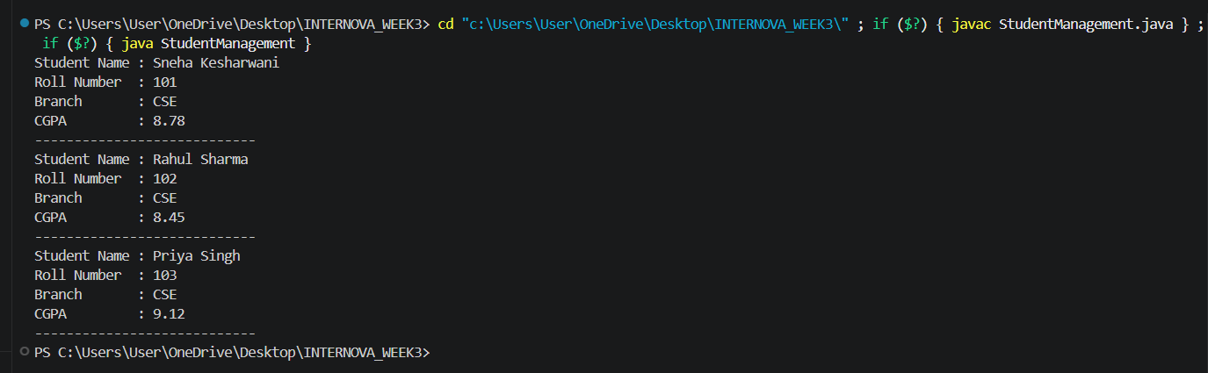

Task 2 : Constructors — Employee Information
Objective: Create an "Employee" class with: - Employee ID - Employee Name - Department - Salary Implement: - A default constructor - A parameterized constructor Create objects using both constructors and display their information.
CODE:
class Employee {
int employeeId;
String employeeName;
String department;
Employee() {
employeeId = 0;
employeeName = "Unknown";
department = "Not Assigned";
salary = 0.0;
}
Employee(int employeeId, String employeeName, String department, double salary) {
this.employeeId = employeeId;
this.employeeName = employeeName;
this.department = department;
this.salary = salary;
}
void displayInfo() {
System.out.println("Employee ID : " + employeeId);
System.out.println("Employee Name : " + employeeName);
System.out.println("Department : " + department);
System.out.println("Salary : ₹" + salary);
System.out.println("------------------------------");
}
}
public class EmployeeInformation {
public static void main(String[] args) {
Employee employee1 = new Employee();
Employee employee2 = new Employee(101, "Rahul Sharma", "IT", 55000);
Employee employee3 = new Employee(102, "Priya Singh", "HR", 50000);
System.out.println("Employee 1 - Default Constructor");
employee1.displayInfo();
System.out.println("Employee 2 - Parameterized Constructor");
employee2.displayInfo();

System.out.println("Employee 3 - Parameterized Constructor");
employee3.displayInfo();
}
}
OUTPUT:
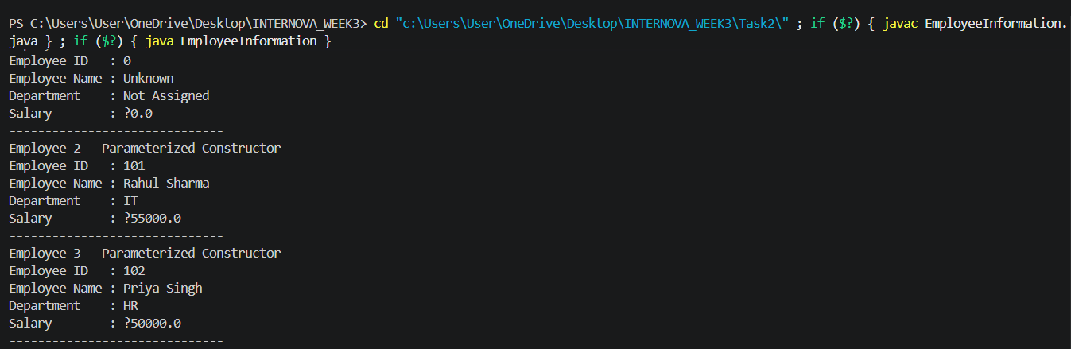

EXPLANATION:
Constructor:
A constructor is a special method in Java that is automatically called when an object is created. It is used to initialize the object's data. A constructor has the same name as the class and does not have a return type.
- Default Constructor: Initializes objects with default values.
- Parameterized Constructor: Accepts parameters to initialize objects with specific values.

Task 3 : "this" & "static" — Bank Account
Objective: Create a "BankAccount" class containing: - Account Holder Name - Account Number - Balance Use the "this" keyword to differentiate instance variables from constructor parameters. Also create a "static" variable to keep track of the total number of bank accounts created. Create at least 3 objects and display: - Account details - Total number of accounts
CODE:
import java.util.Scanner;
class BankAccount {
String accountHolderName;
long accountNumber;
double balance;
static int totalAccounts = 0;
BankAccount(String accountHolderName, long accountNumber, double balance) {
this.accountHolderName = accountHolderName;
this.accountNumber = accountNumber;
this.balance = balance;
totalAccounts++;
}
void displayAccountDetails() {
System.out.println("Account Holder Name : " + accountHolderName);
System.out.println("Account Number : " + accountNumber);
System.out.println("Balance : Rs" + balance);
System.out.println("-------------------------------");
}
}
public class BankAccountManagement {
public static void main(String[] args) {
Scanner sc = new Scanner(System.in);
System.out.println("Enter details for Account 1:");
System.out.print("Account Holder Name: ");
String name1 = sc.nextLine();
System.out.print("Account Number: ");
long number1 = sc.nextLong();
System.out.print("Balance: ");
double balance1 = sc.nextDouble();
sc.nextLine();
BankAccount account1 =
new BankAccount(name1, number1, balance1);
System.out.println("\nEnter details for Account 2:");
System.out.print("Account Holder Name: ");
String name2 = sc.nextLine();
System.out.print("Account Number: ");
long number2 = sc.nextLong();
System.out.print("Balance: ");
double balance2 = sc.nextDouble();
sc.nextLine();
BankAccount account2 =
new BankAccount(name2, number2, balance2);
System.out.println("\nEnter details for Account 3:");
System.out.print("Account Holder Name: ");
String name3 = sc.nextLine();
System.out.print("Account Number: ");
long number3 = sc.nextLong();
System.out.print("Balance: ");
double balance3 = sc.nextDouble();
BankAccount account3 =
new BankAccount(name3, number3, balance3);
System.out.println("\n===== BANK ACCOUNT DETAILS =====");
account1.displayAccountDetails();
account2.displayAccountDetails();
account3.displayAccountDetails();
System.out.println("Total Number of Accounts: "
+ BankAccount.totalAccounts);
sc.close();
}
}
OUTPUT:
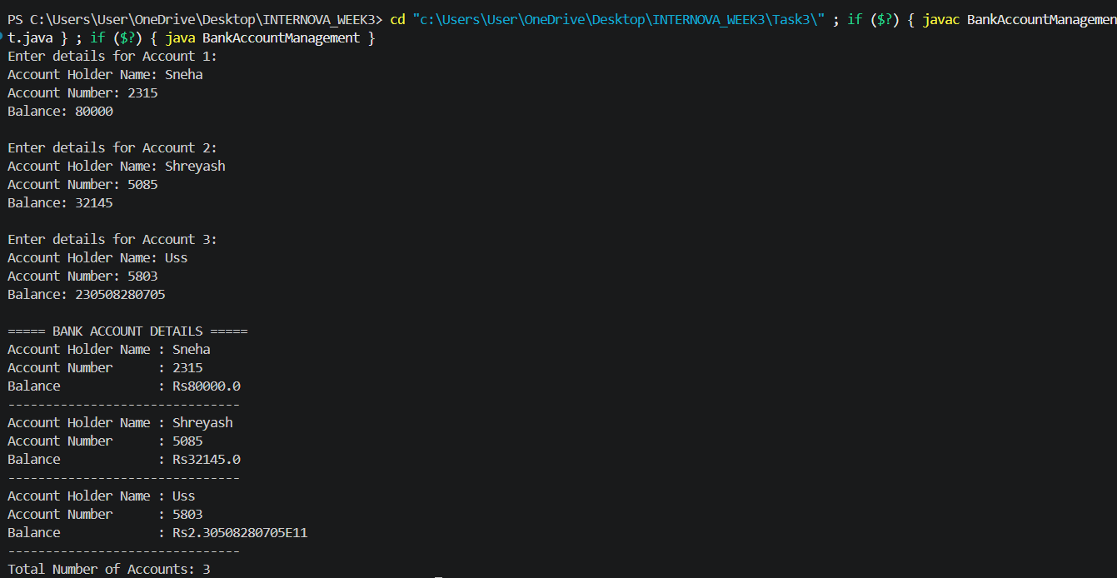

EXPLANATION:
this Keyword:
The this keyword refers to the current object. It is commonly used to differentiate between instance variables and constructor parameters when they have the same name.
static Keyword:
The static keyword indicates that a variable or method belongs to the class rather than individual objects. A static variable is shared among all objects of the class.
Task 4 : Inheritance — Employee Management
Objective: Create a parent class named "Employee". Add common properties such as: - Name - Employee ID - Salary Create two child classes: - "Developer" - "Manager" Add at least one additional property or method specific to each child class. Create objects of both child classes and display their details. Requirements: - Demonstrate "extends". - Demonstrate code reusability through inheritance. - Use parent and child class methods/properties.
CODE:
import java.util.Scanner;
class Employee {
String name;
int employeeId;
double salary;
Employee(String name, int employeeId, double salary) {
this.name = name;
this.employeeId = employeeId;
this.salary = salary;
}
void displayEmployeeDetails() {
System.out.println("Name : " + name);
System.out.println("Employee ID : " + employeeId);
System.out.printf("Salary : Rs. %.2f%n", salary);
}
}
class Developer extends Employee {
String programmingLanguage;
Developer(String name, int employeeId, double salary,
String programmingLanguage) {
super(name, employeeId, salary);
this.programmingLanguage = programmingLanguage;
}
void displayDeveloperDetails() {
displayEmployeeDetails(); // Parent method
System.out.println("Programming Language : " + programmingLanguage);
}
}
class Manager extends Employee {
int teamSize;
Manager(String name, int employeeId, double salary, int teamSize) {
super(name, employeeId, salary);
this.teamSize = teamSize;
}
void displayManagerDetails() {
displayEmployeeDetails(); // Parent method
System.out.println("Team Size : " + teamSize);
}
}
public class EmployeeManagement {
public static void main(String[] args) {
Scanner sc = new Scanner(System.in);
System.out.println("Enter Developer Details");
System.out.print("Name: ");
String devName = sc.nextLine();
System.out.print("Employee ID: ");
int devId = sc.nextInt();
System.out.print("Salary: ");
double devSalary = sc.nextDouble();
sc.nextLine();
System.out.print("Programming Language: ");
String language = sc.nextLine();
Developer developer =
new Developer(devName, devId, devSalary, language);
System.out.println("\nEnter Manager Details");
System.out.print("Name: ");
String managerName = sc.nextLine();
System.out.print("Employee ID: ");
int managerId = sc.nextInt();
System.out.print("Salary: ");
double managerSalary = sc.nextDouble();

System.out.print("Team Size: ");
int teamSize = sc.nextInt();
Manager manager =
new Manager(managerName, managerId, managerSalary, teamSize);
System.out.println("\n===== DEVELOPER DETAILS =====");
developer.displayDeveloperDetails();
System.out.println("\n===== MANAGER DETAILS =====");
manager.displayManagerDetails();
sc.close();
}
}

OUTPUT:
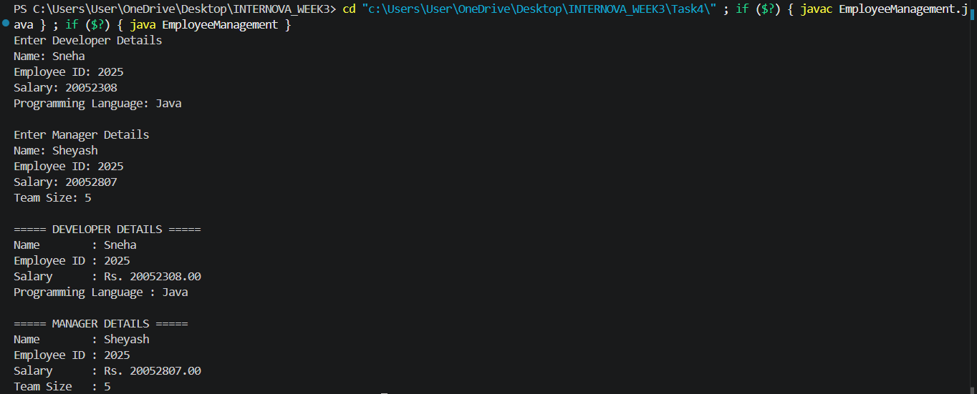

EXPLANATION:
Inheritance:
Inheritance is an OOP concept where a child class acquires the properties and methods of a parent class. In Java, it is implemented using the extends keyword. It promotes code reusability and reduces duplicate code.

Task 5 : Polymorphism — Method Overloading & Overriding
Objective: Create a Java program demonstrating both types of polymorphism. Part A: Method Overloading Create a class with multiple methods having the same name but different parameters. For example: - "calculate(int, int)" - "calculate(double, double)" - "calculate(int, int, int)" Part B: Method Overriding Create a parent class "Vehicle" with a method such as "start()". Create child classes such as: - "Car" - "Bike" Override the "start()" method in both child classes. Display the different outputs when the methods are called.
CODE:
import java.util.Scanner;
class Calculator {
int calculate(int a, int b) {
return a + b;
}
double calculate(double a, double b) {
return a + b;
}
int calculate(int a, int b, int c) {
return a + b + c;
}
}
class Vehicle {
void start() {
System.out.println("Vehicle is starting.");
}
}
class Car extends Vehicle {
@Override
void start() {
System.out.println("Car starts with a key or push button.");
}
}
class Bike extends Vehicle {
@Override
void start() {
System.out.println("Bike starts with a self-start or kick.");
}
}
public class PolymorphismDemo {
public static void main(String[] args) {
Scanner sc = new Scanner(System.in);
System.out.println("===== METHOD OVERLOADING =====");
Calculator calculator = new Calculator();
System.out.print("Enter first integer: ");
int a = sc.nextInt();
System.out.print("Enter second integer: ");
int b = sc.nextInt();
System.out.println("calculate(int, int) = "
+ calculator.calculate(a, b));
System.out.print("\nEnter first decimal number: ");
double x = sc.nextDouble();
System.out.print("Enter second decimal number: ");
double y = sc.nextDouble();
System.out.println("calculate(double, double) = "
+ calculator.calculate(x, y));
System.out.print("\nEnter third integer: ");
int c = sc.nextInt();
System.out.println("calculate(int, int, int) = "
+ calculator.calculate(a, b, c));
System.out.println("\n===== METHOD OVERRIDING =====");
Vehicle vehicle = new Vehicle();
Vehicle car = new Car();
Vehicle bike = new Bike();
vehicle.start();
car.start();
bike.start();
sc.close();
}
}
OUTPUT:
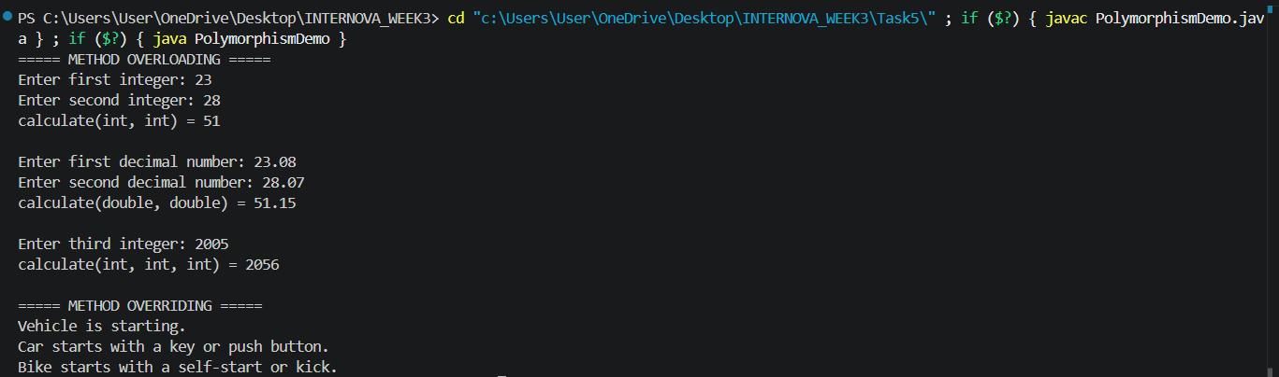

EXPLANATION:
Method Overloading:
Method overloading occurs when multiple methods have the same name but different parameters in the same class. It is an example of compile-time polymorphism.
Method Overriding:
Method overriding occurs when a child class provides its own implementation of a method already defined in the parent class. It is an example of runtime polymorphism.

Task 6 : Encapsulation & Abstraction — Banking System
Objective: Create a simple banking system demonstrating encapsulation and abstraction. Encapsulation Create a "BankAccount" class with private variables: - Account Number - Account Holder Name - Balance Use appropriate getter and setter methods to access and modify the data. Abstraction Create an abstract class named "Account" containing: - At least one abstract method - At least one normal method Create a child class that extends the abstract class and implements the abstract method. Display the account details and demonstrate the implemented functionality. CODE:
import java.util.Scanner;
abstract class Account {
abstract void calculateInterest();
void displayAccountType() {
System.out.println("Account Type : Bank Account");
}
}
class BankAccount extends Account {
private long accountNumber;
private String accountHolderName;
private double balance;
public long getAccountNumber() {
return accountNumber;
}
public String getAccountHolderName() {
return accountHolderName;
}
public double getBalance() {
return balance;
}
public void setAccountNumber(long accountNumber) {
this.accountNumber = accountNumber;
}
public void setAccountHolderName(String accountHolderName) {
this.accountHolderName = accountHolderName;
}
public void setBalance(double balance) {
this.balance = balance;
}
@Override
void calculateInterest() {
double interest = balance * 0.05;
System.out.printf("Interest at 5%% : Rs. %.2f%n", interest);
}
void displayAccountDetails() {
System.out.println("Account Number : " + getAccountNumber());
System.out.println("Account Holder Name : " + getAccountHolderName());
System.out.printf("Balance : Rs. %.2f%n", getBalance());
}
}
public class BankingSystem {
public static void main(String[] args) {
Scanner sc = new Scanner(System.in);
BankAccount account = new BankAccount();
System.out.print("Enter Account Number: ");
long accountNumber = sc.nextLong();
sc.nextLine();
System.out.print("Enter Account Holder Name: ");
String accountHolderName = sc.nextLine();
System.out.print("Enter Balance: ");
double balance = sc.nextDouble();
account.setAccountNumber(accountNumber);
account.setAccountHolderName(accountHolderName);
account.setBalance(balance);
System.out.println("\n===== ACCOUNT DETAILS =====");
account.displayAccountDetails();
account.displayAccountType();
account.calculateInterest();
sc.close();
}
}
OUTPUT:
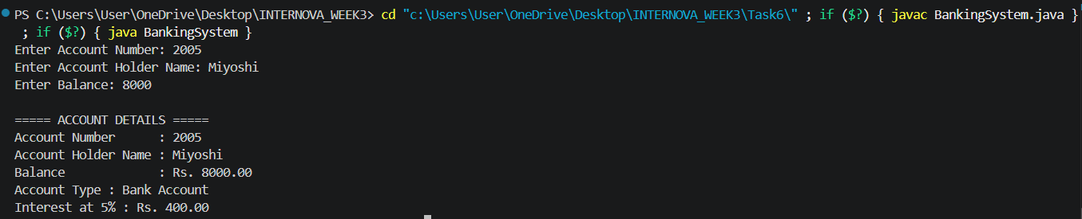

EXPLANATION:
Encapsulation:
Encapsulation is the process of wrapping data and methods together in a class and restricting direct access to the data. In Java, it is commonly achieved using private variables and getter/setter methods.
Abstraction:
Abstraction means hiding implementation details and showing only the essential features to the user. In Java, it can be achieved using abstract classes and interfaces.

