PROJECT REPORT
(Summer Training Project June-July 2026)

EMPLOYEE MANAGEMENT SYSTEM WITH AUTOMATED CI/CD PIPELINE

SUBMITTED BY:
Sneha Gupta: 12404336
Priyal Aggarwal: 12410855
Sneha Kumari: 12417738

COURSE CODE: PETV137

Under the Guidance of
Priyanka Gupta
Dr. Harpreet Kaur

School of Computer Science and Engineering



Declaration

We hereby declare that the project work entitled “Employee Management System with Automated CI/CD pipeline” is an authentic record of our own work carried out as a requirement of the Project for the award of the B.TECH in Computer Science and Engineering from Lovely Professional University, Phagwara, under the guidance of Priyanka Gupta and Dr. Harpreet Kaur, during June to July 2026. All the information furnished in this report is based on our own work and genuine.

Sneha Gupta: 12404336
Priyal Aggarwal: 12410855
Sneha Kumari: 12417738

Date: 12-07-2026

Certificate

This is to certify that the declaration statement made is correct to the best of my knowledge and belief. We have completed this Project under my guidance and supervision. The present work is the result of their original investigation, effort and study. No part of the work has ever been submitted for any other degree at any University. The Project is fit for submission and partial fulfilment of the conditions for the award of the B.TECH in Computer Science and Engineering from Lovely Professional University, Phagwara.
School of Computer Science and Engineering,
Lovely Professional University, Phagwara, Punjab.
Date: 12 July 2026

Acknowledgement

We would like to express our sincere gratitude to our mentor, Priyanka Gupta and Dr. Harpreet Kaur for their invaluable guidance, encouragement, and support throughout the course of this project. Their insights into DevOps practices and software engineering principles were instrumental in shaping the outcome of this work.
We are also thankful to the School of Computer Science and Engineering, Lovely Professional University, for providing the resources, infrastructure, and learning environment that made this project possible. Finally, we thank our peers and families for their continuous support and motivation.

Table of Contents

1 | Introduction
2 | Scope of the study (Problem Statement)
3 | Existing System
4 | Problem Analysis
5 | Software Requirement Analysis
6 | Design
7 | Testing
8 | Implementation
9 | Project Legacy
11 | Source Code or System Snapshots
12 | Bibliography

Introduction
The Employee management System with Automated CI/CD pipeline is a full-stack web application built to manage employee records while simultaneously demonstrating a complete, production-style DevOps workflow – from code commit to automated testing, containerization, and deployment on Kubernetes.

In this project, Every code push to the GitHub repository is automatically checked by Jenkins, tested using an automated pytest suite, packaged into a docker image, published to Docker Hub, and deployed with zero intervention after ‘git push’. This mirrors how modern software teams in the industry ship code.

The Application Layer itself is a Flask-based Employee Management System that allows HR/administrative staff to add, view, edit, delete and search employee records, with safeguards such as duplicate – email validation.

Objectives of the Project

- To design and develop a functional, database-backed Employee Management web application using Python (Flask) and SQLAlchemy.
- To implement an automated test suite (pytest) that validates core CRUD functionality before any deployment.
- To containerize the application using Docker for consistent, portable deployment across environments.
- To design and implement a Jenkins CI/CD pipeline that automates checkout, dependency installation, testing, image build, image publishing, and deployment.
- To orchestrate the containerized application using Kubernetes, demonstrating horizontal scaling and self-healing.
- To trigger the pipeline automatically via a GitHub webhook, eliminating manual “Build Now” steps.

2. Scope of the study (Problem Statement)

Organizations that manage employee data manually – through spreadsheets or disconnected local scripts face problems of data duplication, lack of validation, difficulty in searching records, and no audit trail of changes. When such applications are eventually built, deploying updates to them is often a manual, error-prone process: a developer builds the code locally, manually copies it to a server, restarts services by hand, and hopes nothing breaks. This manual deployment process does not scale with team size or release frequency, and it introduces the risk of “words of my machine” failures.

The Scope of this project covers two integrated problem areas:
- Application-level Problem: providing a reliable, validated, searchable digital systems to manage employee records (Add, Delete, Edit, Search), replacing manual/spreadsheet-based record keeping.

- Delivery-level Problem: eliminating manual built-test -deploy steps by implementing an automated CI/CD pipeline so that every change is tested, containerized, and deployed consistently and repeatedly.

The project uses a local Jenkins server, Docker Hub, and a local Kubernetes cluster, with ngrok used to expose the local Jenkins wehbook endpoint.

3. EXISTING SYSTEM

Introduction
Before Undertaking this project, employee record management in small organizations is handled using spreadsheets or standalone desktop scripts with no centralised database, no automated validation, and no deployment pipeline. Software changes, when made, are deployed manually by a developer logging into the server and restarting the application by hand.

Existing software
Spreadsheet tools provide basic tabular storage but lack relational integrity, lack a web interface for concurrent multi-user access, and provide no mechanism for automated testing or deployment. Where a basic web application does exist, it is commonly deployed by manually running the app on a server without containerization, meaning environment inconsistencies are common, and there is no automated verification that a new change hasn’t broken existing functionality.

DFD for Present System

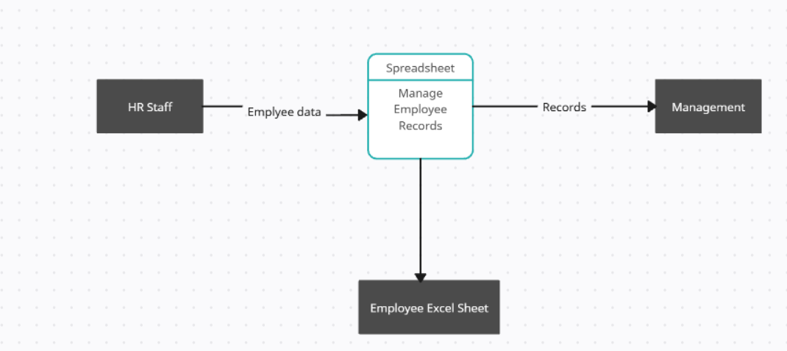

What's New in the System to be Developed
- A centralized, database-backed (SQLite via SQLAlchemy) web application replacing spreadsheets, enforcing data integrity (e.g., unique email constraint).
- A built-in search feature to instantly filter employees by name or department.
- An automated pytest suite (8 tests) that validates every core feature before deployment is even attempted.
- Full containerization with Docker, ensuring the application runs identically in development, testing, and production.
- A Jenkins-driven CI/CD pipeline that automatically tests, builds, and deploys on every `git push`, removing manual deployment steps entirely.
- Kubernetes orchestration providing horizontal scaling (multiple replicas) and self-healing (automatic pod restart on crash).

4. Problem Analysis

Problem Definition
The Product is a two-part system:
- A Flask + SQLAlchemy web application (“Employee Management System”) offering CRUD operations and search over employee records.
- A DevOps delivery pipeline built on Git, Jenkins, Docker, Docker Hub, and Kubernetes that automatically tests, packages, and deploy the application on every code changes.

Feasibility Analysis
- Technical feasibility
All technologies used like Flask, SQLAlchemy, pytest, Docker, Jenkins, and Kubernetes are free, open-source, well-documented, and widely adopted in the industry, making the project technically achievable within an academic setting.

- Economic feasibility
The project incurs no licensing cost. Jenkins, Docker, Kubernetes, SQLite, and Flask are all open-source. Docker Hub's free tier is sufficient for storing the project's image, and kind allows a local Kubernetes cluster without cloud infrastructure costs.

- Operational feasibility
The system is straightforward to operate: developers interact with it through familiar ‘git push’ commands and the pipeline requires no manual steps thereafter. The web application itself uses a simple, intuitive interface for non-technical HR staff.

Project Plan
Member | Role | Key Responsibilities
Member 1 | Application Developer | Flask application, database schema, CRUD routes, pytest test suite
Member 2 | Docker Engineer | Dockerfile design, containerization, image optimization, Docker Hub publishing
Member 3 | CI/CD and Kubernetes Engineer | Jenkins pipeline (Jenkinsfile), GitHub webhook integration, Kubernetes manifests and deployment

5. Software requirement analysis

Introduction
This section specifies the functional and non-functional requirements of the Employee Management and its supporting CI/CD pipeline, along with the hardware and software environment needed to build, run, and deploy it.

General Description
The system follows a client-server web architecture. The Flask application serves HTML pages over HTTP. Data is persisted in a SQLite database via the SQLAlchemy ORM. The delivery side of the system is event-driven: a GitHub webhook notifies Jenkins of new commits, and Jenkins orchestrates testing, image build, registry push, and deployment as a declarative pipeline (Jenkins file).
- User Characteristics
- End users (HR/admin staff): interact only with the web UI to add, search, edit, and delete employee records — no technical knowledge required.
- Developers/DevOps engineers: interact with Git, Jenkins, Docker, and kubectl to maintain and extend the application and its pipeline.

Specific Characteristics
- Functional Requirements
  - The system shall allow users to add a new employee with name, email, department, position, and salary.
  - The system shall reject a new/edited employee record if the email already exists (duplicate-email validation).
  - The system shall list all employees sorted by name on the home page.
  - The system shall allow searching employees by name or department (case-insensitive partial match).
  - The system shall allow editing and deleting existing employee records.
  - The CI/CD pipeline shall automatically run on every push to the GitHub repository via webhook.
  - The pipeline shall halt (fail) the build if any automated test fails, preventing a broken build from being deployed.
  - The pipeline shall build a Docker image, push it to Docker Hub, and deploy the updated container automatically upon successful tests.

- Non-Functional Requirements
  - Portability: the application must run identically across environments via Docker containerization.
  - Scalability: the Kubernetes deployment must support horizontal scaling to multiple replicas without code changes.
  - Reliability/Self-healing: Kubernetes must automatically restart any pod that crashes or is deleted.
  - Maintainability: the pipeline definition (Jenkins file) is version-controlled alongside the application code (Pipeline-as-Code).

- Hardware and Software Requirements
Category | Requirements
Operating System | Windows / Linux / macOS (Docker Desktop compatible)
Processor & RAM | Dual-core or better, minimum 8 GB RAM (for running Docker + Jenkins + Kubernetes locally)
Language / Framework | Python 3.11+, Flask 3.1.3
Database / ORM | SQLite, SQLAlchemy 2.0 / Flask-SQLAlchemy 3.1
Testing | pytest 9.1.1, pytest-flask 1.3.0
Containerization | Docker Desktop
CI/CD Server | Jenkins (with Pipeline and Docker Pipeline plugins)
Container Registry | Docker Hub
Orchestration | Kubernetes (kind — Kubernetes in Docker)
Version Control | Git, GitHub (with webhook + ngrok for local tunneling)

6. Design

System Design
The overall system is composed of two cooperating subsystems: the Flask web application and the CI/CD delivery pipeline (build + test + package + deploy automation). The figure below shows how a code change flows from the developer's machine to a running, scaled deployment.

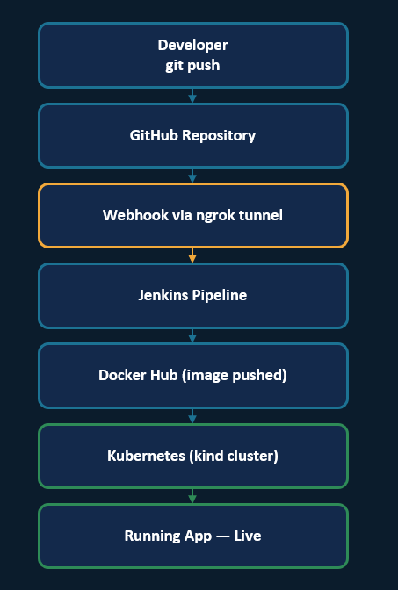

Design Notations
Standard notations are used throughout this report: rectangles represent processes/stages, ellipses represent external entities/pipeline start-end points, cylinders/rectangles with a left bar represent data stores, and directional arrows represent data or control flow, consistent with conventional DFD and flowchart notation.

Detailed Design
- Data Model (ER diagram)
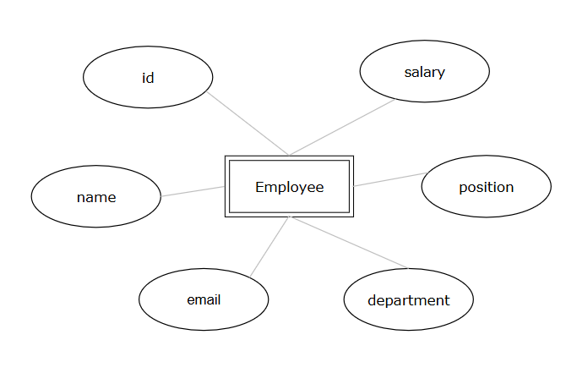
- Module Design
  - app/__init__.py — application factory (`create_app`), initializes Flask, SQLAlchemy, and registers the blueprint.
  - app/models.py — defines the `Employee` SQLAlchemy model.
  - app/routes.py — defines the Blueprint `main` with routes: `/` (list), `/search`, `/add`, `/edit/<id>`, `/delete/<id>`.
  - app/templates/, app/static/ — Jinja2 HTML templates and static assets (CSS/JS) for the UI.
  - tests/test_employees.py — pytest test suite covering all routes and validation rules.
  - Dockerfile — container build definition for the Flask app.
  - Jenkinsfile — declarative six-stage CI/CD pipeline definition.
  - k8s/deployment.yaml, k8s/service.yaml — Kubernetes Deployment (2 replicas) and NodePort Service manifests.
- Flowchart
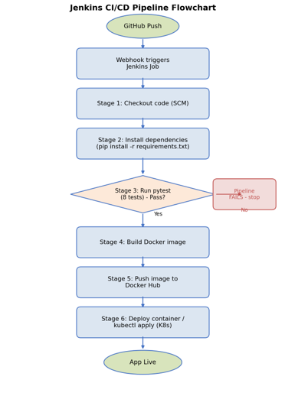
- Pseudo code
  - Add Employee
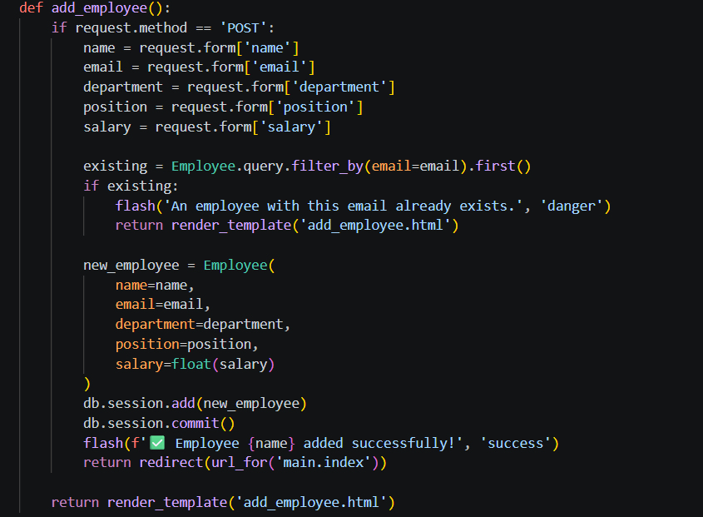
  - Search Employee
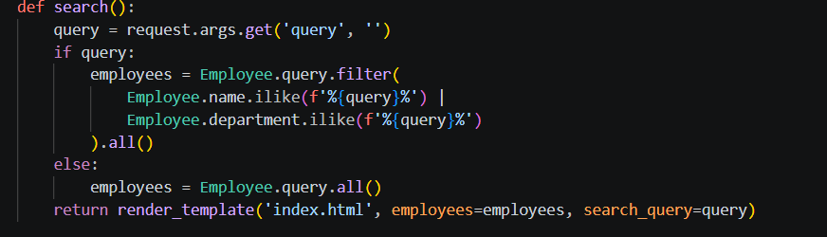
  - Jenkins Pipeline
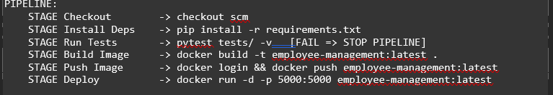

7. Testing

Functional Testing
Functional testing verifies that each feature behaves according to its requirement. The pytest suite in `tests/test_employees.py` exercises the home page, the add-employee form, the add/edit/delete/search operations, and the duplicate-email validation rule, asserting both HTTP response codes and resulting database state.

Structural Testing
Structural (white-box) testing was applied at the route level, ensuring each conditional branch in `routes.py` — such as the duplicate-email branch inside `add_employee` and `edit_employee` — is exercised by at least one test case (`test_duplicate_email_rejected`).

Levels of Testing
  - Unit-level: individual route handlers and model behaviour, tested in isolation using an in-memory SQLite database (`sqlite:///:memory:`).
  - Integration-level: Flask test client requests exercising the full request → route → ORM → database → response cycle.
  - Pipeline-level: the Jenkins “Run Tests” stage acts as a continuous integration gate — if any test fails, the Build/Push/Deploy stages never execute.

Testing the Project
# | Test Case | Verifies
1 | test_home_page_loads | GET / returns HTTP 200
2 | test_add_employee_page_loads | GET /add returns HTTP 200
3 | test_add_employee | POST /add creates a new employee record
4 | test_employee_appears_in_list | Newly added employee appears on the home page
5 | test_edit_employee | POST /edit/<id> updates name, department, position, salary
6 | test_delete_employee | POST /delete/<id> removes the employee from the database
7 | test_search_employee | GET /search?query=... returns matching employees
8 | test_duplicate_email_rejected | Adding an employee with an existing email is rejected

8. Implementation

Implementation of the project
- Containerization
The Dockerfile uses a slim Python 3.11 base image, installs dependencies from `requirements.txt`, copies the application code, exposes port 5000, and runs the Flask app via `flask run --host=0.0.0.0`. A `docker-compose.yml` is also provided for local development with live volume mounting.
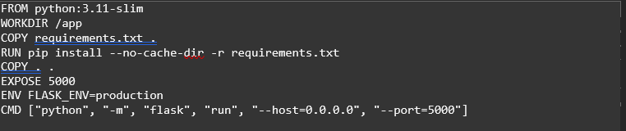

- CI/CD pipeline (Jenkinsfile)
The Jenkinsfile defines a declarative, six-stage pipeline (Checkout, Install Dependencies, Run Tests, Build Docker Image, Push to Docker Hub, Deploy), reading the pipeline definition directly from the GitHub repository (Pipeline-as-Code via SCM). Docker Hub credentials are injected securely using Jenkins' `withCredentials` block rather than being hard-coded.
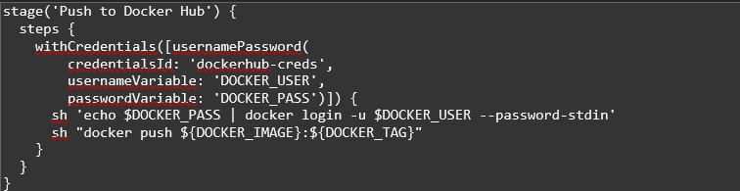

- Github Wehbook Trigger
A GitHub webhook notifies Jenkins the moment new commits arrive, removing the need to manually trigger builds. Since Jenkins runs on localhost in this development setup, ngrok is used to expose a temporary public URL that GitHub can reach; because free ngrok URLs are not persistent across restarts, the live webhook trigger was captured via a recorded walkthrough for demonstration.

- Kubernetes Deployment
The `k8s/deployment.yaml` manifest defines a Deployment with 2 replicas of the application image, and `k8s/service.yaml` exposes it via a NodePort Service on port 30081, enabling scaling and self-healing:
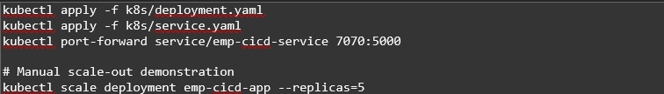

Conversion Plan
The project moved through a staged conversion:
(1) local execution via `python run.py` for functional development.
(2) containerized execution via `docker run` for environment parity.
(3) automated pipeline-driven build/push/deploy via Jenkins.
4) orchestrated deployment via Kubernetes for scalability and resilience.
Each stage was validated before progressing to the next, ensuring no regression was introduced.

Post-Implementation and Software Maintenance
The Jenkinsfile is stored in the repository (Pipeline-as-Code), any future change to the pipeline itself is picked up automatically on the next build with no manual Jenkins reconfiguration. Kubernetes' self-healing capability means that if the application container crashes, it is automatically restarted, maintaining the desired replica count without operator intervention. Ongoing maintenance primarily involves updating dependencies in `requirements.txt`, extending the pytest suite as new features are added, and monitoring Docker Hub image tags.

9. Project Legacy

Current Status of the Project
The application is fully functional with all CRUD and search features implemented and covered by an 8-test automated suite. The Jenkins pipeline successfully performs checkout, dependency installation, testing, Docker image build, Docker Hub push, and local container deployment. The Kubernetes manifests successfully deploy the application with 2 replicas, and manual scaling and self-healing have been demonstrated. The GitHub webhook trigger has been verified functional via a recorded walkthrough, given the temporary nature of the local ngrok tunnel.

Remaining Areas of Concern
  - The Jenkins server and ngrok tunnel run locally rather than on persistent cloud infrastructure, so the webhook URL changes on every restart.
  - The application uses SQLite, which is suitable for demonstration but not for concurrent multi-user production workloads; a managed relational database would be needed for production use.
  - There is no authentication/authorization layer, so any user with network access to the app can modify employee records.
  - The Kubernetes Service is exposed via NodePort rather than an Ingress/LoadBalancer with TLS, so there is no HTTPS in the current setup.
  - There is no centralized logging/monitoring (e.g., Prometheus/Grafana) integrated with the Kubernetes deployment yet.

Technical Areas of Concern
- Technical Lessons
  - Storing credentials via Jenkins' credential store (`withCredentials`) rather than hard-coding them is essential for pipeline security.
  - Automated tests must run before the image-build stage so that broken code is never containerized or deployed — “fail fast” is a core CI/CD principle.
  - Kubernetes' declarative model (desired replica count) simplifies both scaling and recovery compared to manually managing individual containers.
- Managerial Lessons
  - Dividing the team by pipeline stage (Application / Docker / CI-CD-Kubernetes) allowed parallel progress but required close coordination at integration points, particularly around the Dockerfile and image naming conventions shared across the Jenkinsfile and Kubernetes manifests.
  - Maintaining the pipeline definition in version control (Pipeline-as-Code) proved valuable for team collaboration, since pipeline changes could be reviewed the same way as application code changes.

10. Source Code Snapshots

1. app/models.py
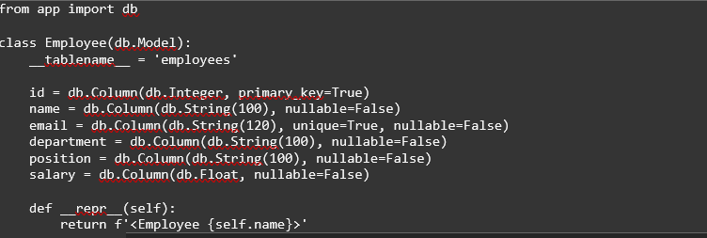

2. app/__init__.py
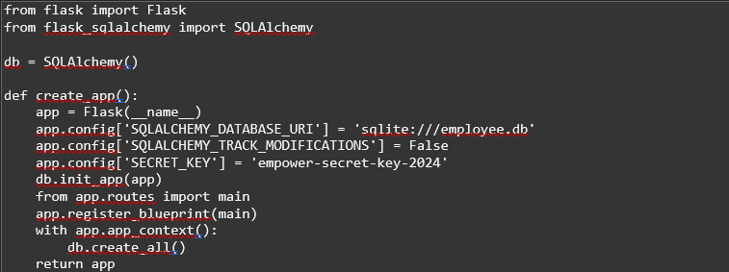

k8s/deployment.yaml
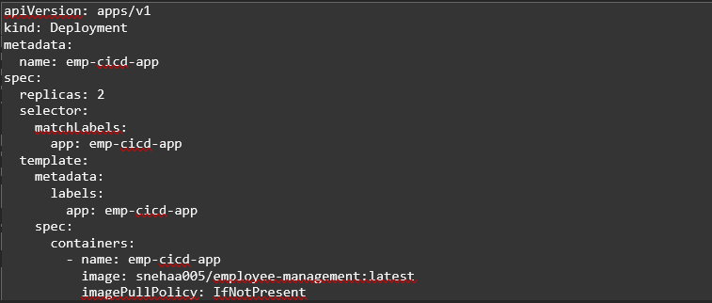

4. System Snapshots
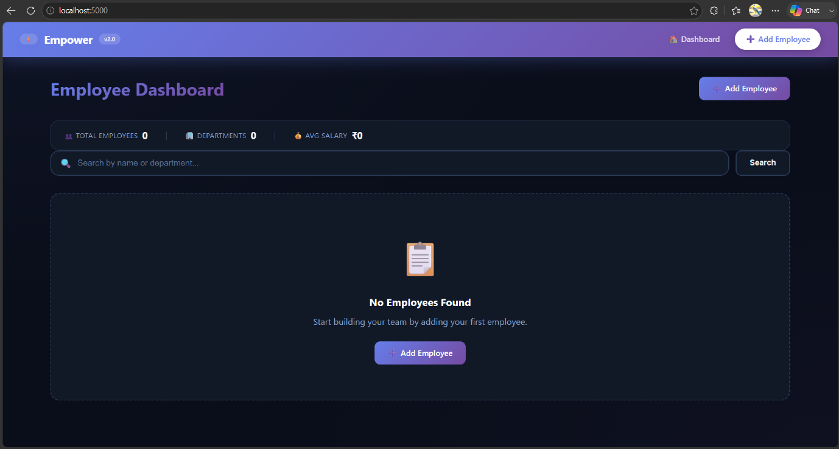
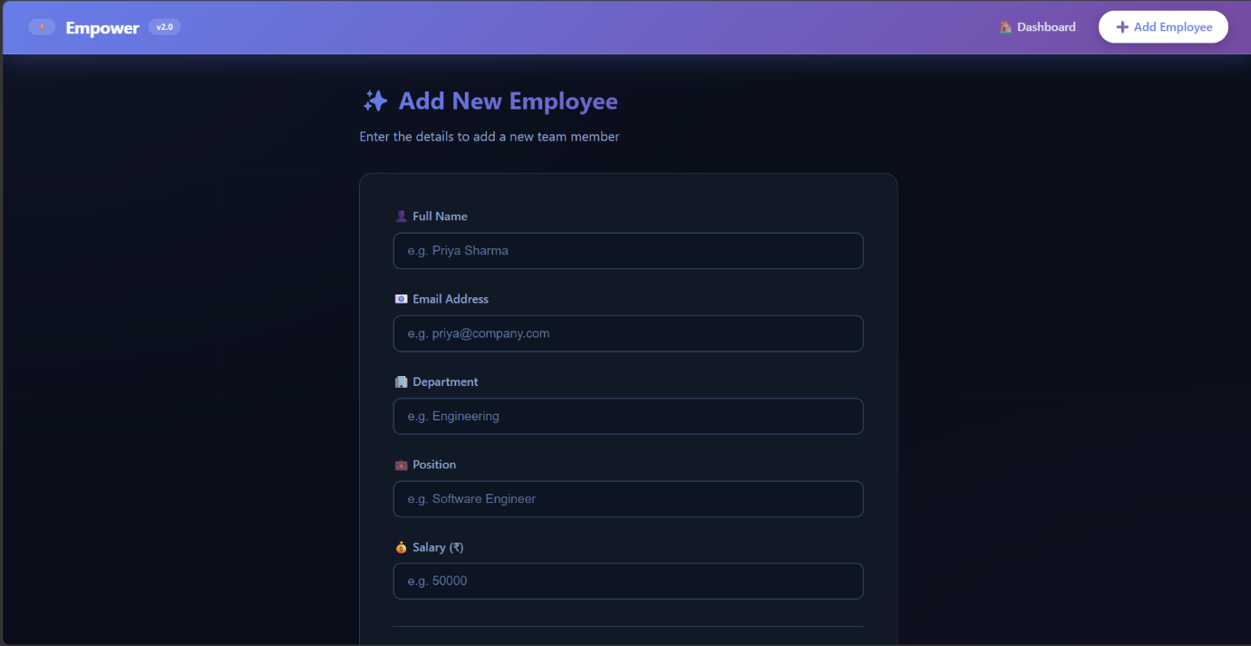
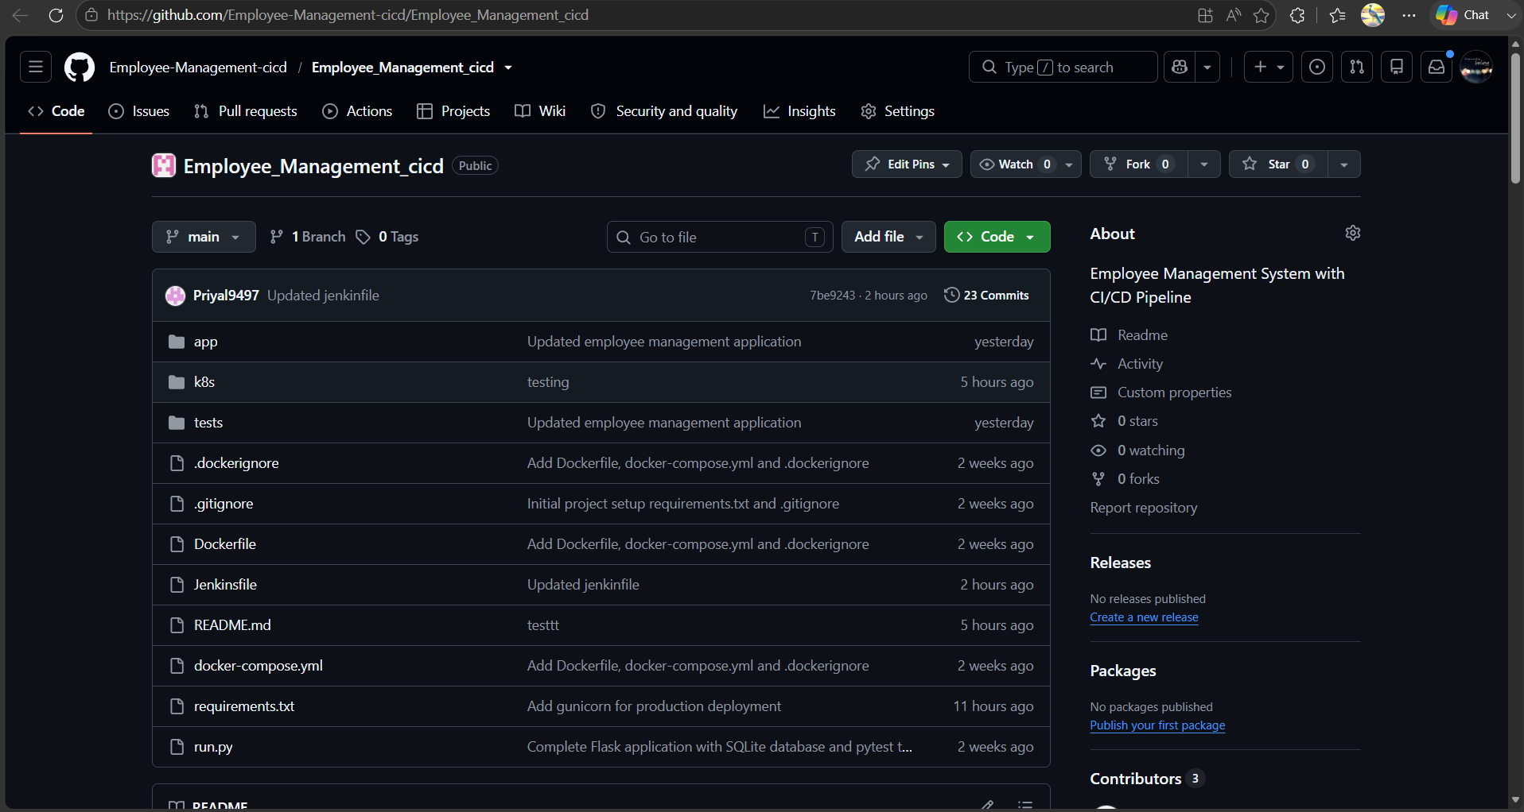
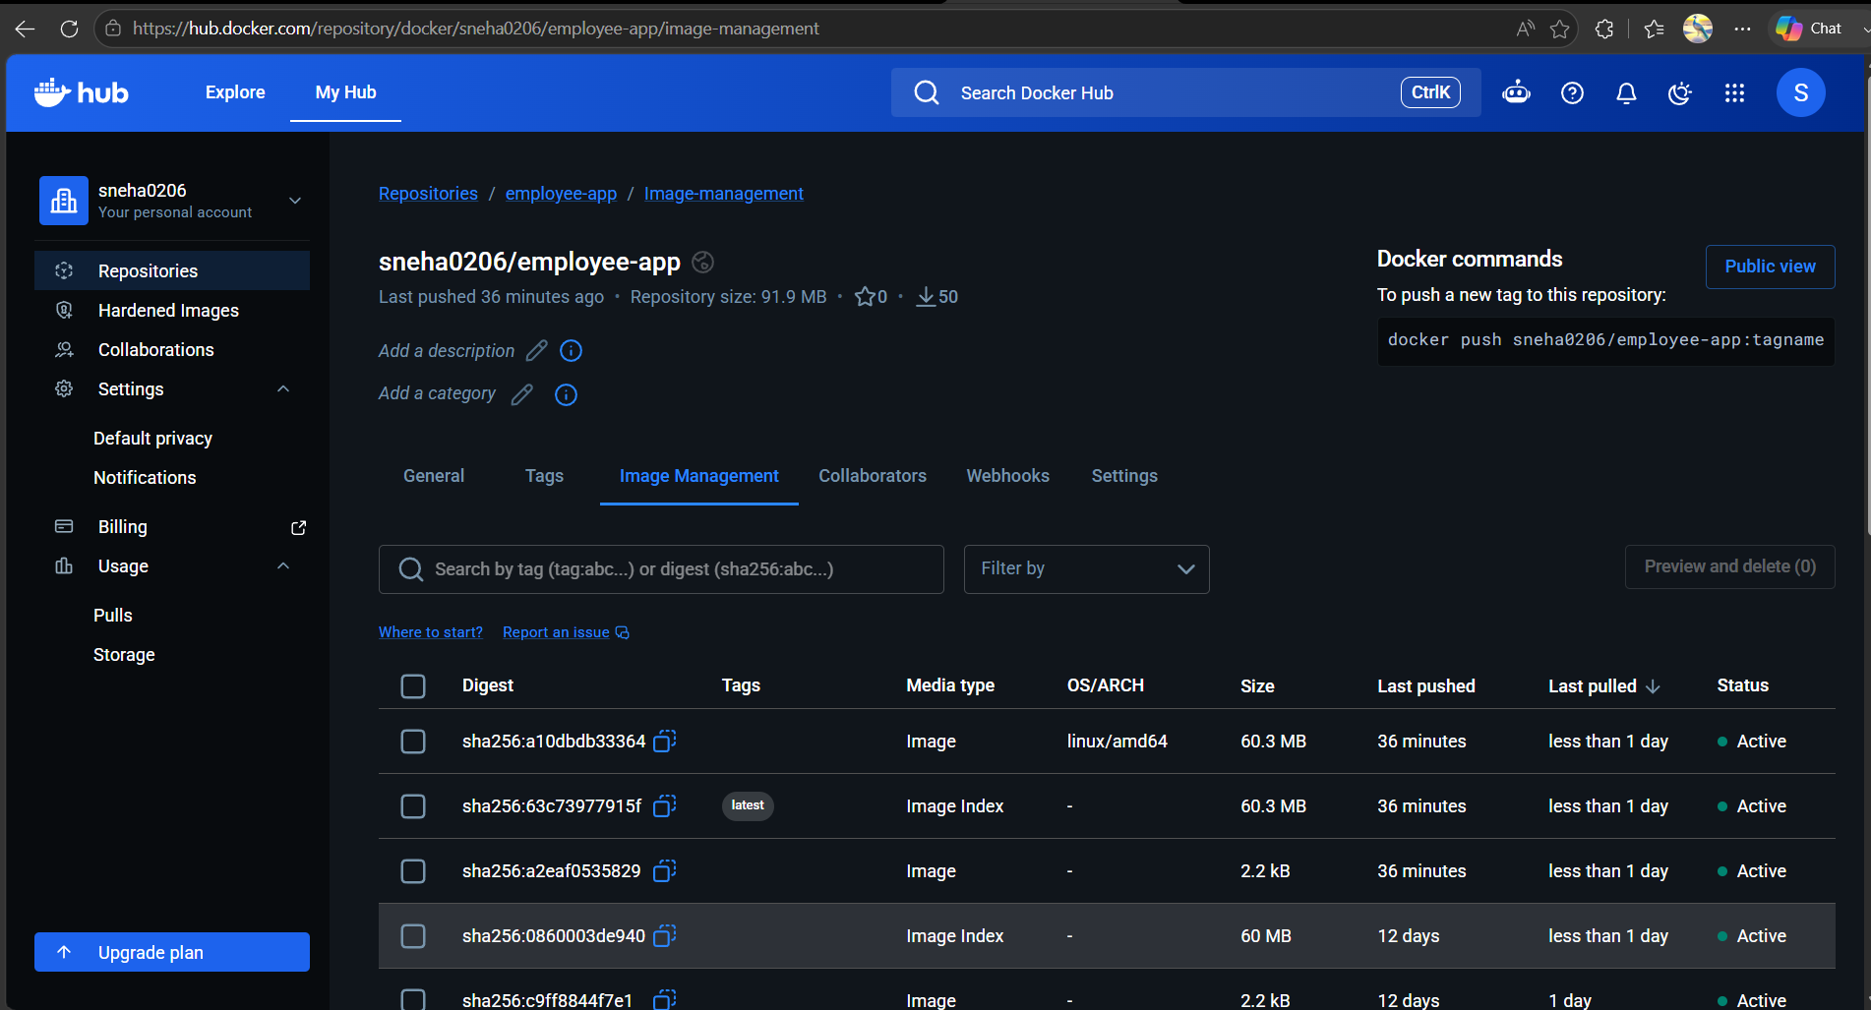
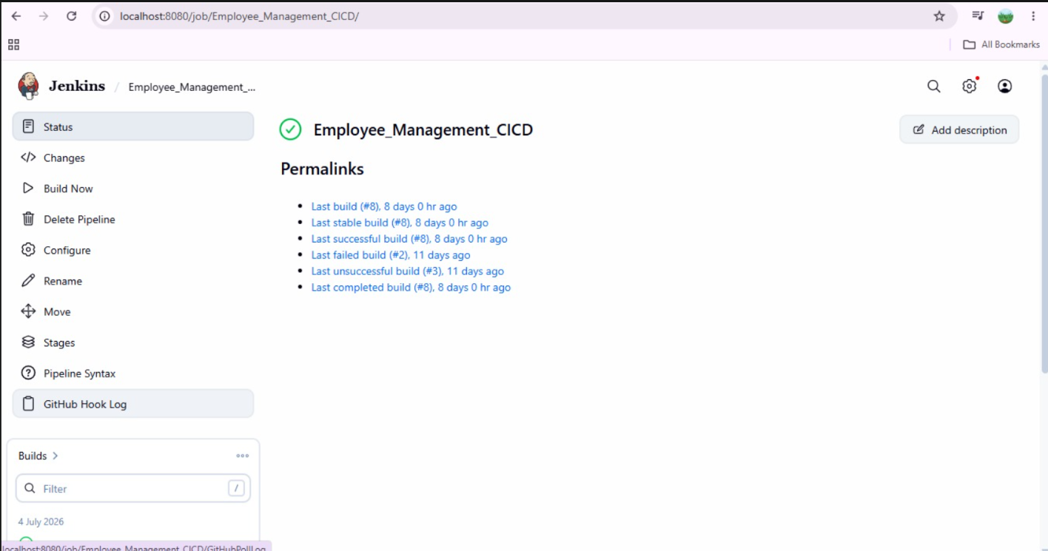
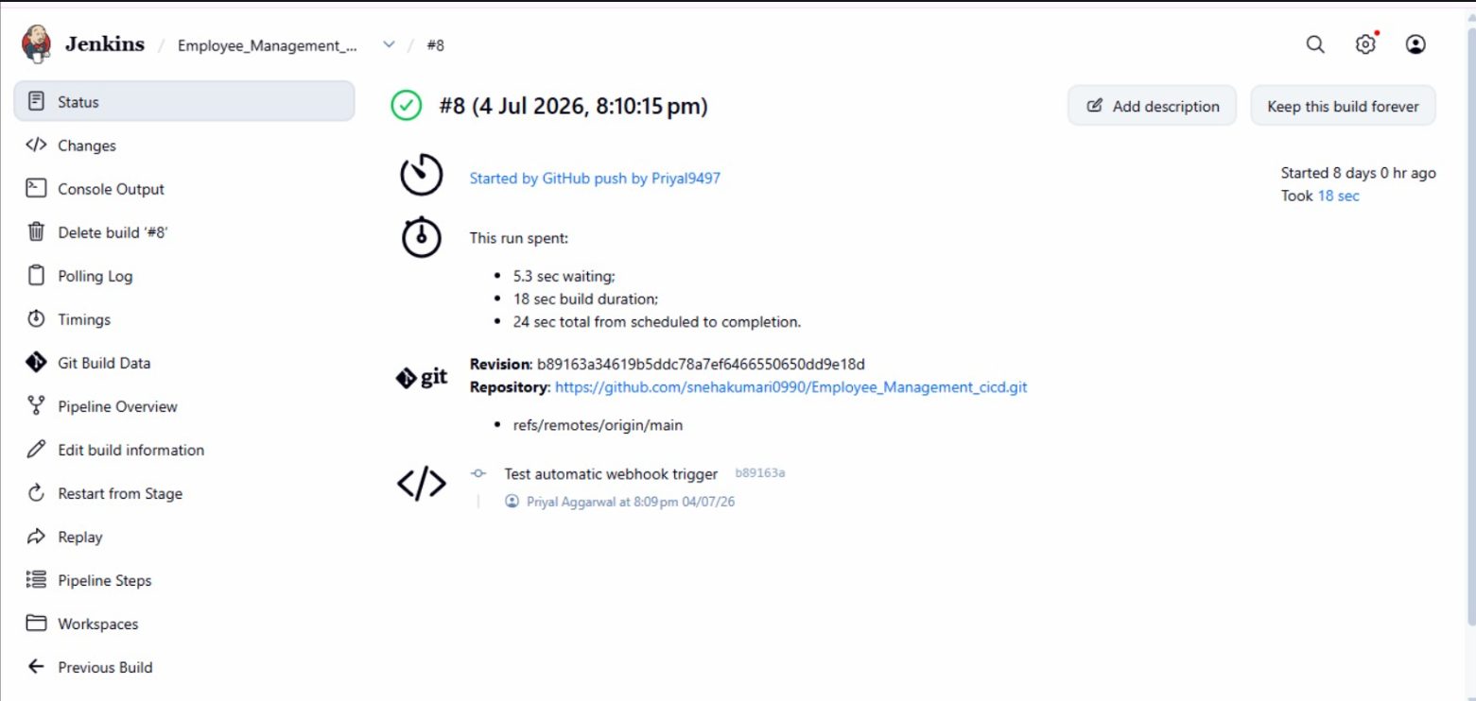

11. Biblography
- Flask Documentation — https://flask.palletsprojects.com/
- Flask-SQLAlchemy Documentation — https://flask-sqlalchemy.palletsprojects.com/
- pytest Documentation — https://docs.pytest.org/
- Docker Documentation — https://docs.docker.com/
- Jenkins Documentation — https://www.jenkins.io/doc/
- Kubernetes Documentation — https://kubernetes.io/docs/
- kind (Kubernetes in Docker) — https://kind.sigs.k8s.io/
- Project repository —
https://github.com/Employee-Management-cicd/Employee_Management_cicd.git

