1. **GIT STASH:**

it is used to save changes that you have made in your working directory without any commits and push commands.

it is also used to store changes temporarily.we can switch to another branch do some work and come back to original branch and continue the changes.

Overall, **git stash** is a useful command for temporarily saving work in progress that is not yet ready to be committed or pushed to a remote repository.

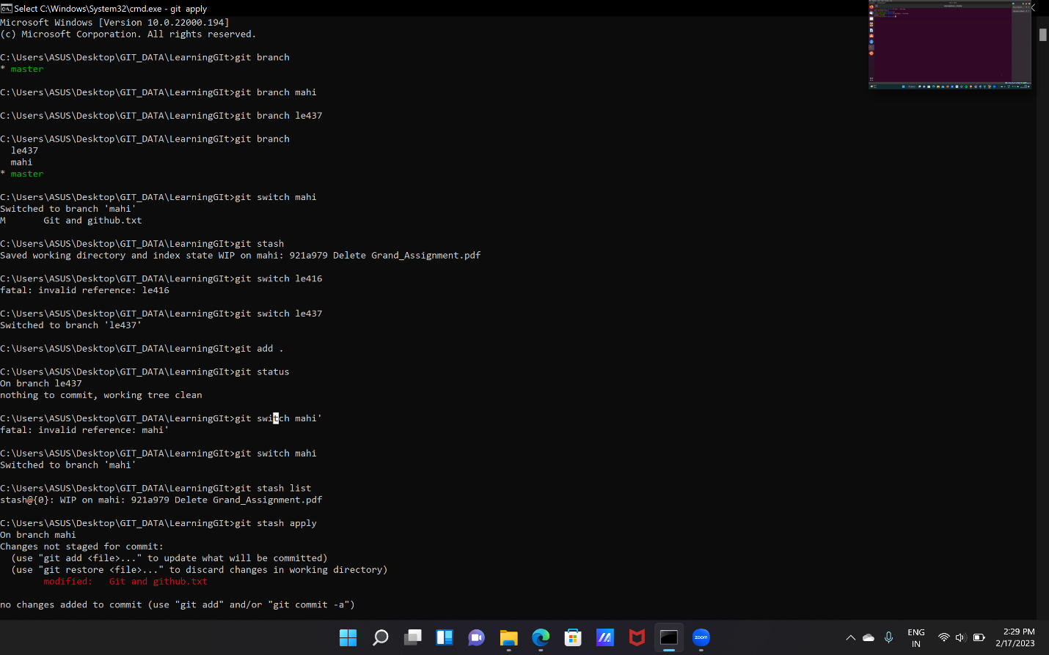

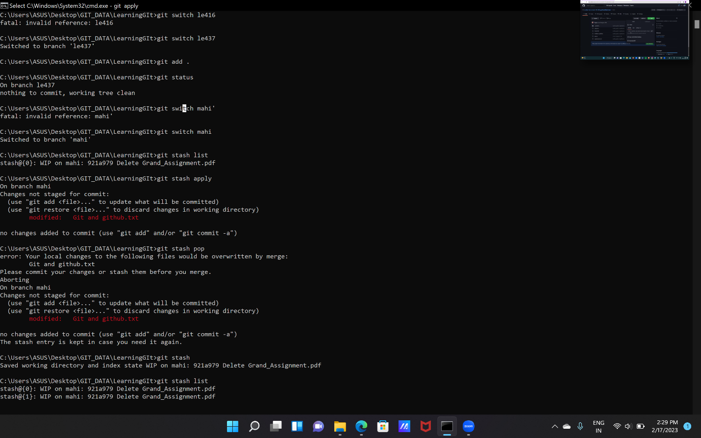

**2.GIT FETCH AND GIT MERGE:**

**GIT MERGE** : git merge is used to integrate changes from one branch into the another branch. when we merge two branches.

git is combined the changes made on those branches and create s a new merge commit.

we use "git merge <branch_ name>" for merging a branch and "git merge <master>" for merging master with a branch.

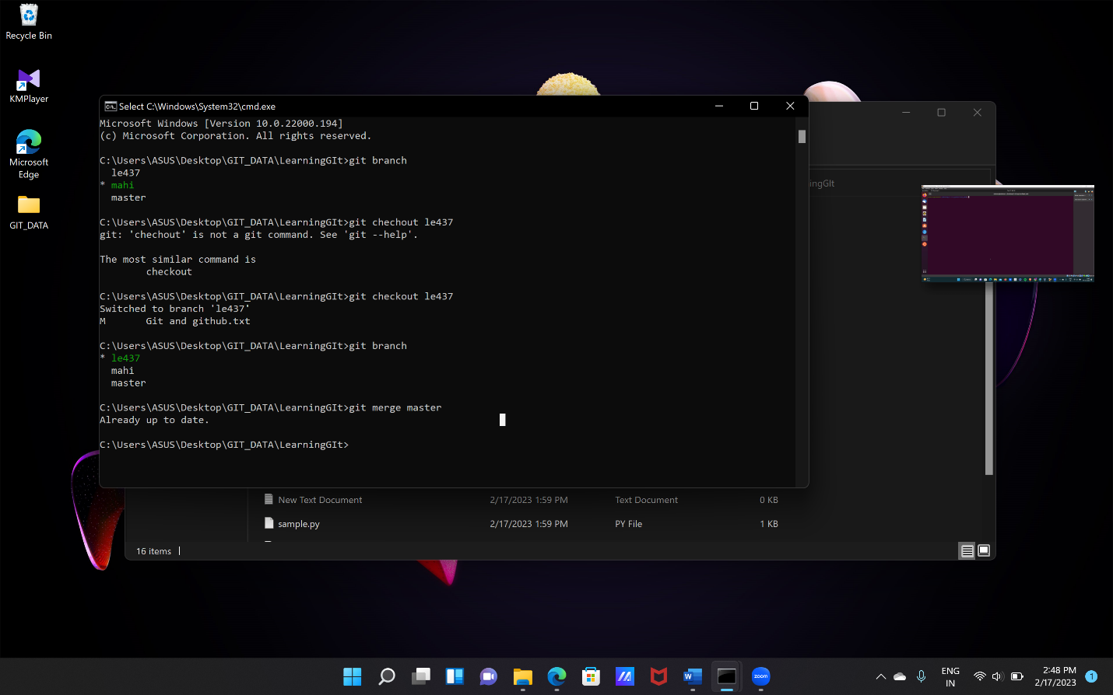

**GIT FETCH**:

It is used to retrieves the data from a remote repository but does not merge it into the local repository.

It allows you to see what changes have been made and interact with a remote repository without affecting your local repository.

The "git fetch" command is used to pull the updates from remote-tracking branches.

Additionally, we can get the updates that have been pushed to our remote branches to our local machines.

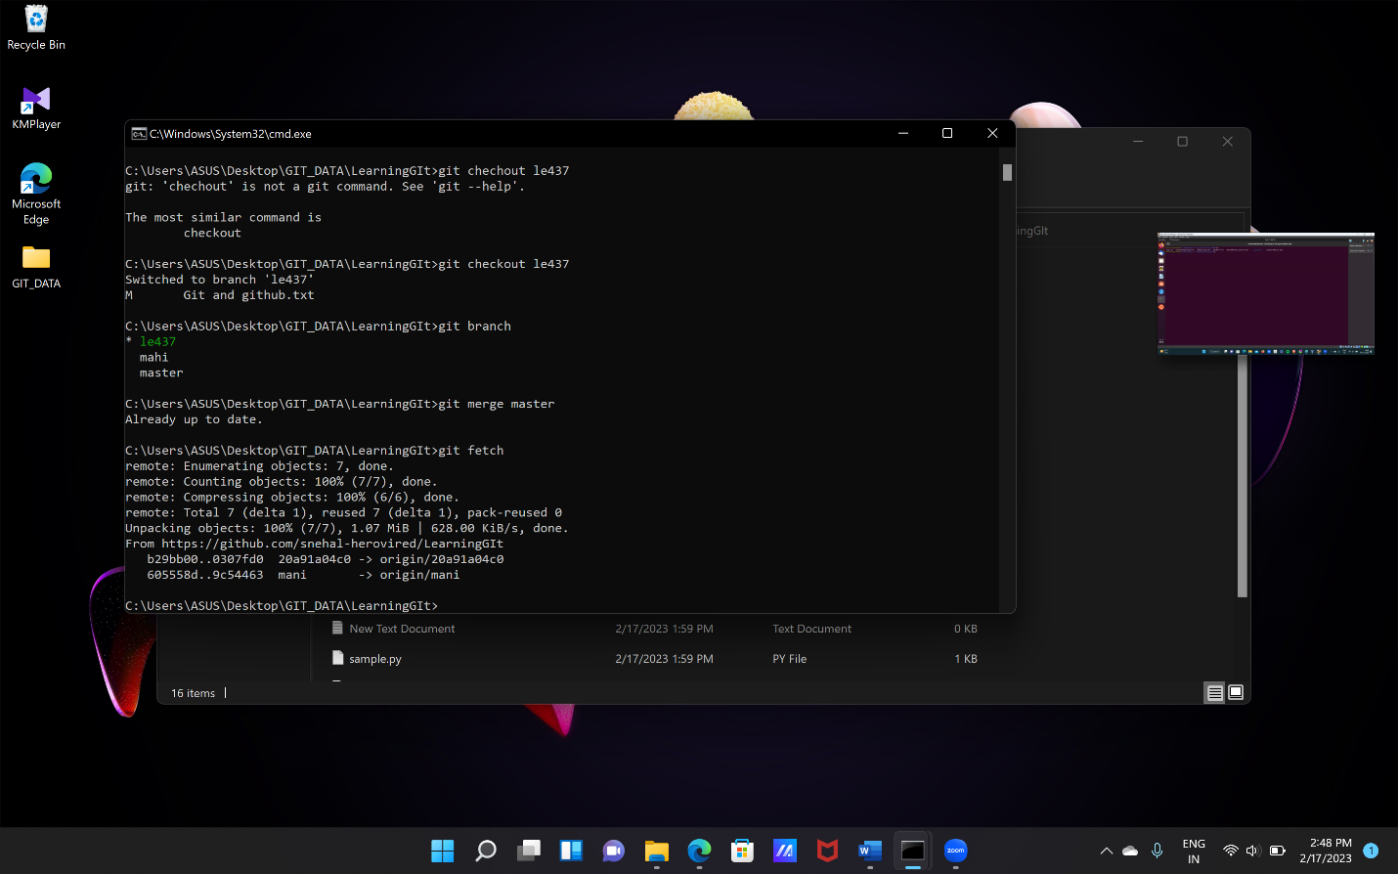

**3**.**DIFFERENCE BETWEEN FETCH AND PULL:**

fetch and pull are related to obtaining updates from a remote repository.

**Fetch** is used to retrieves the data from a remote repository but does not merge it into the local repository.

It allows you to see what changes have been made and interact with a remote repository without affecting your local repository

**PULL** is used to retrieves the data from a remote repository and merge it into local repository.



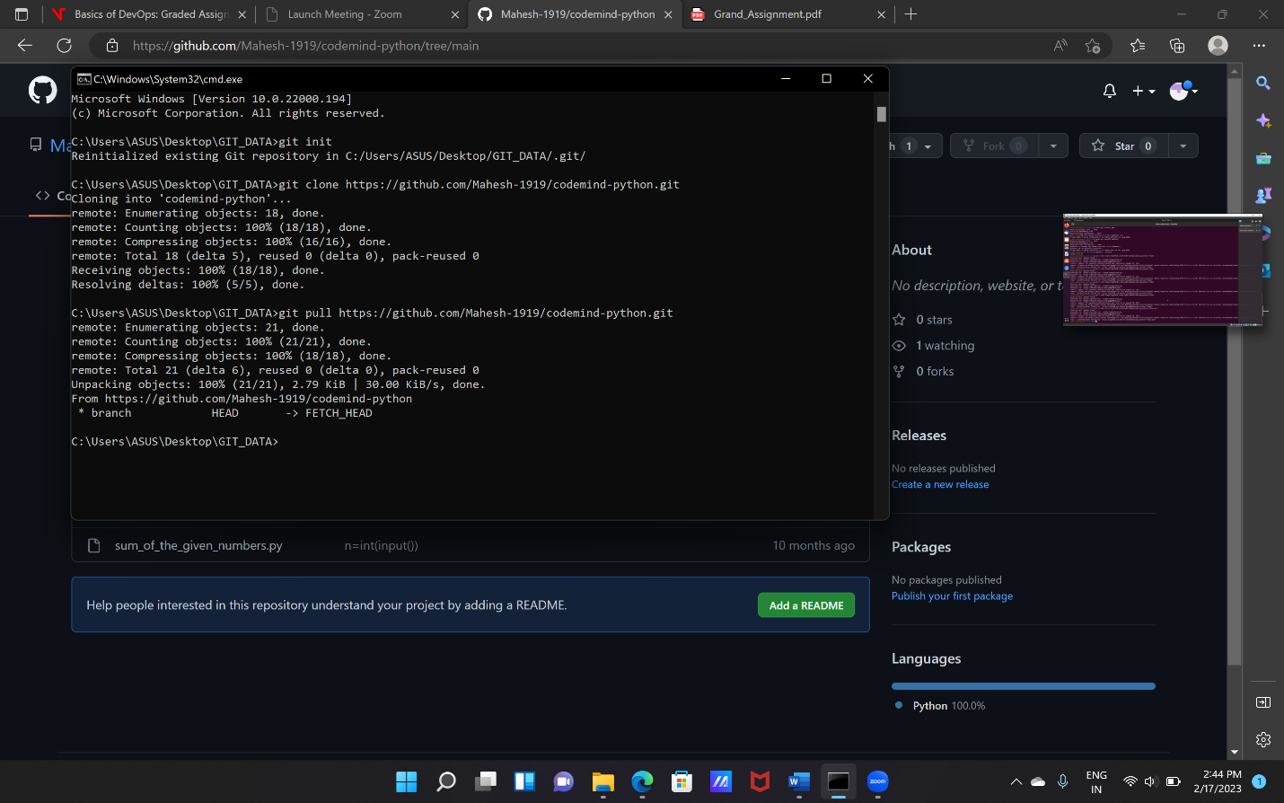

**4.Prime Numbers from the range 1 to 20.**

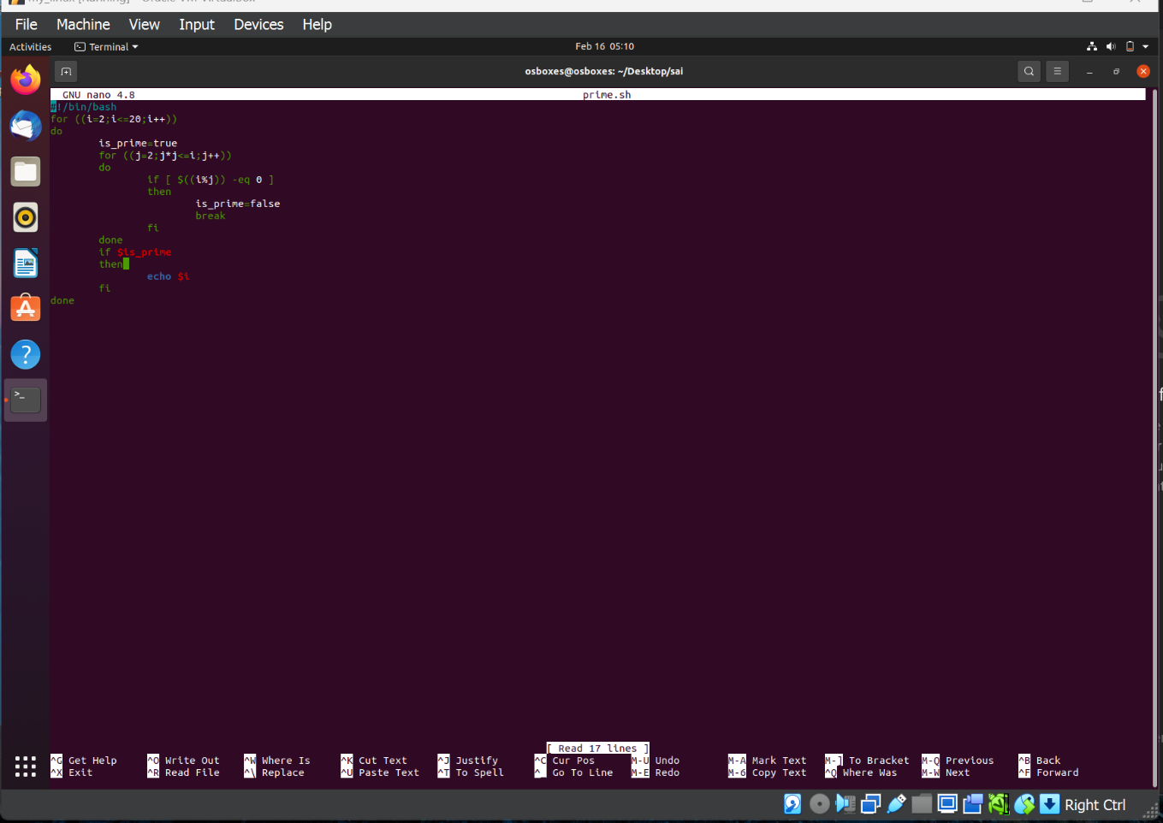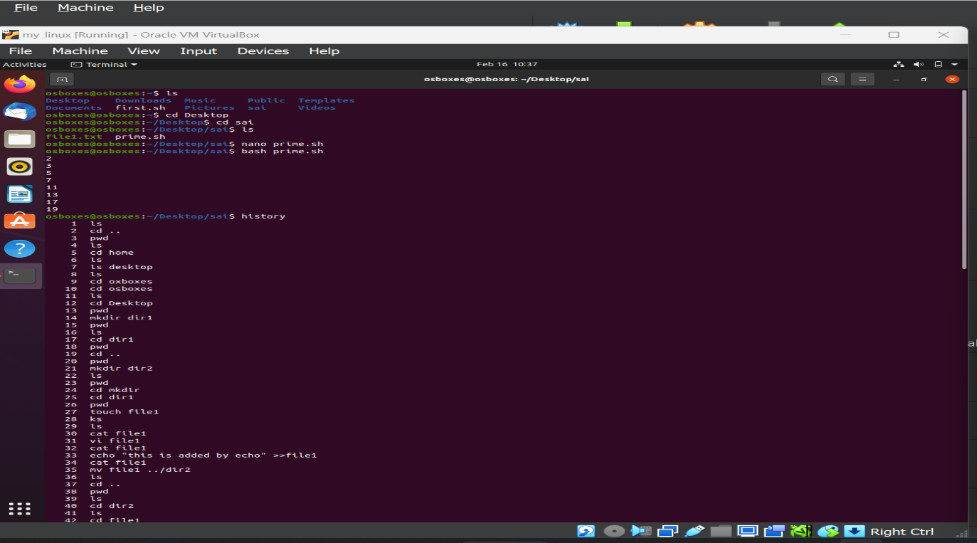

**Q5. Set up a container and run a Ubuntu operating system**.

The docker is used to create the containers.

PROCEDURE:

1.open the folder which is having the docker file .

2.open the git bash through the folder and it will directly open the git bash.

3.login with your docker hub login credentials.

4.now use the "docker pull image_ name" to pull the ubuntu image.

5.by using the "docker run -it image_ name" command run the ubuntu operating system by

creating a container using docker hub.

6. to exit from the interactive mode use "exit" command.

7.it will show that the ubuntu OS is running in the container in docker hub.

8. after the use terminate or stop the container.

