**Question1 :**You are provided with a ReactJS application and it can be found on the repository with the link provided below.

Create a Dockerfile for this React application and also create image and run the image as container and the output of the ReactJS application should be shown on the localhost.

Link to github :<https://github.com/snehal-herovired/sample_react_aditya_devops>

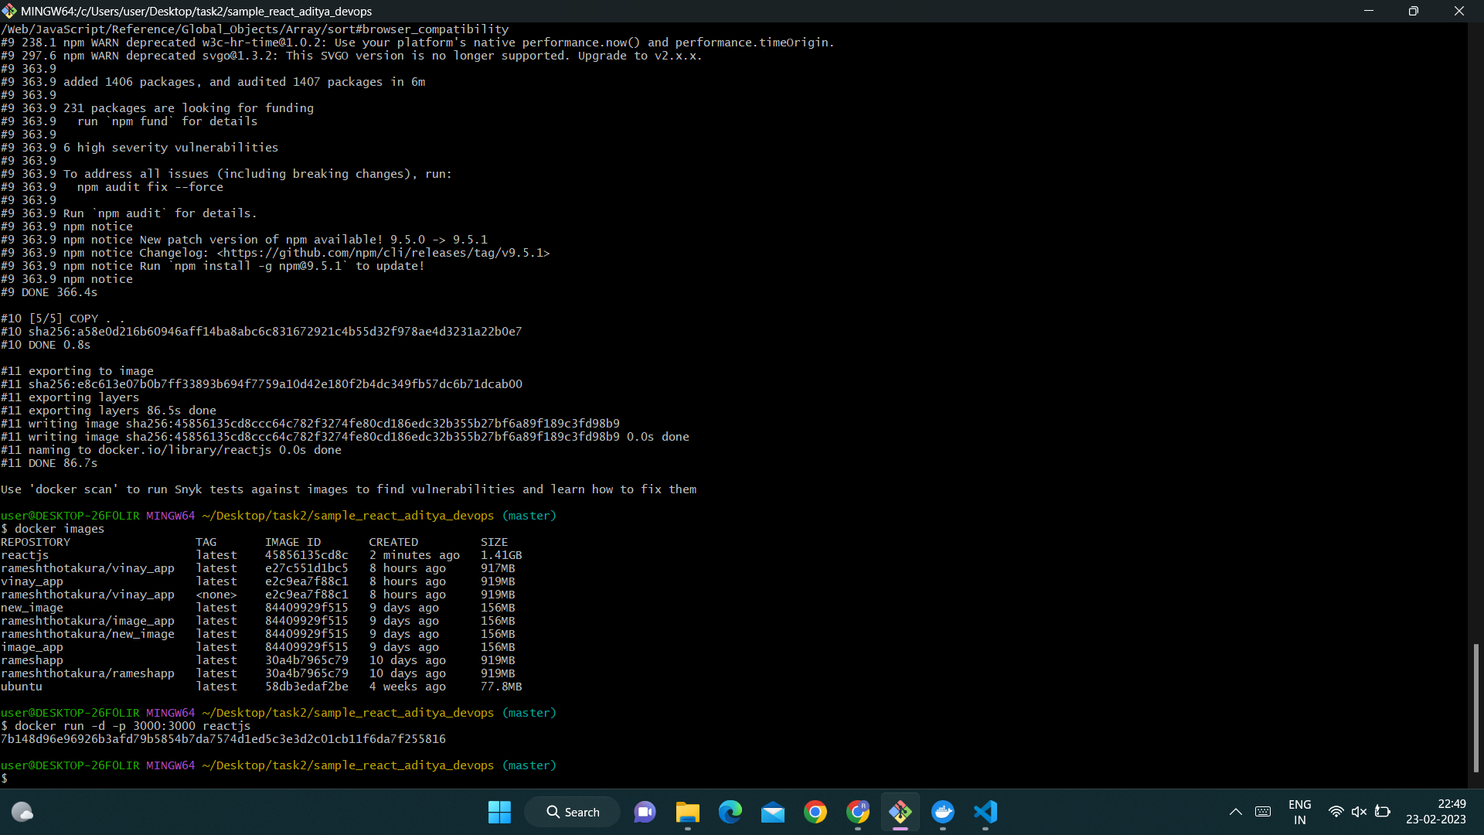

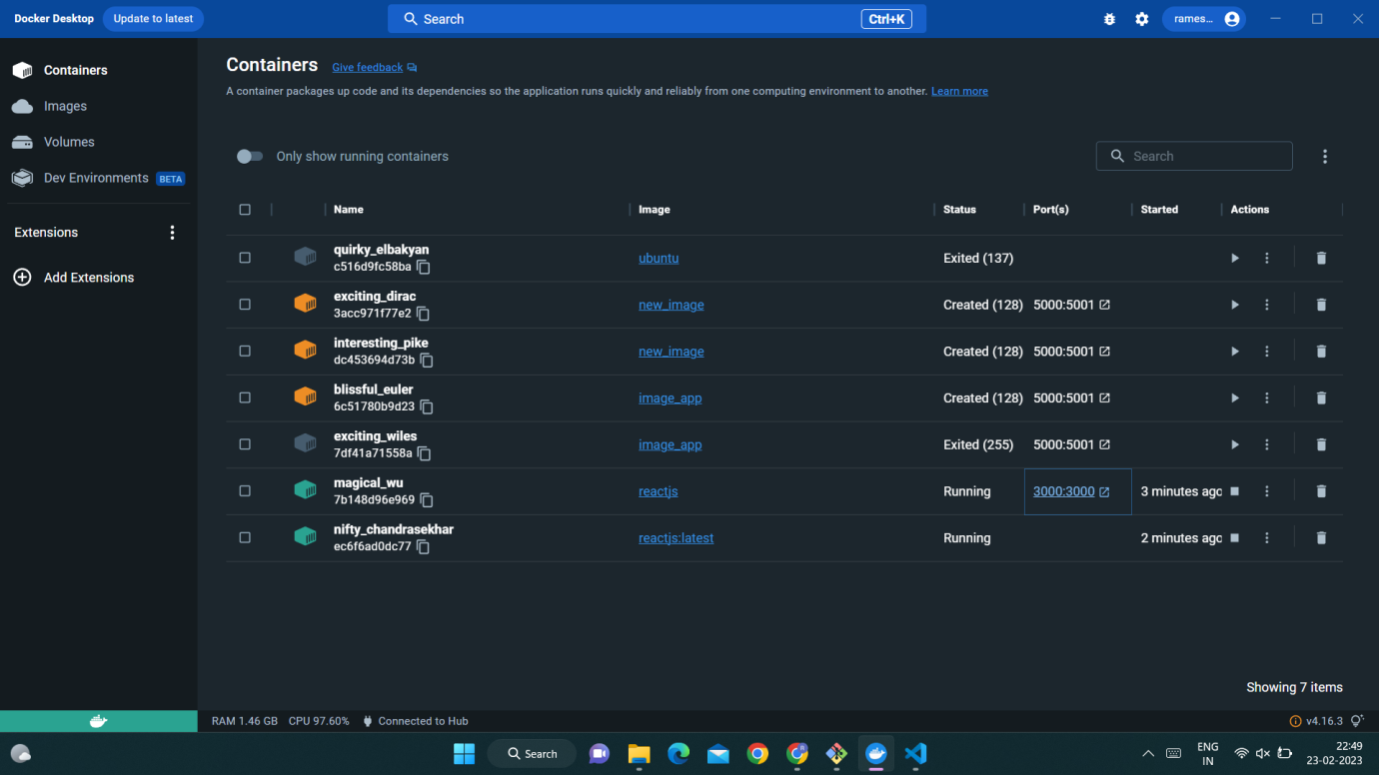

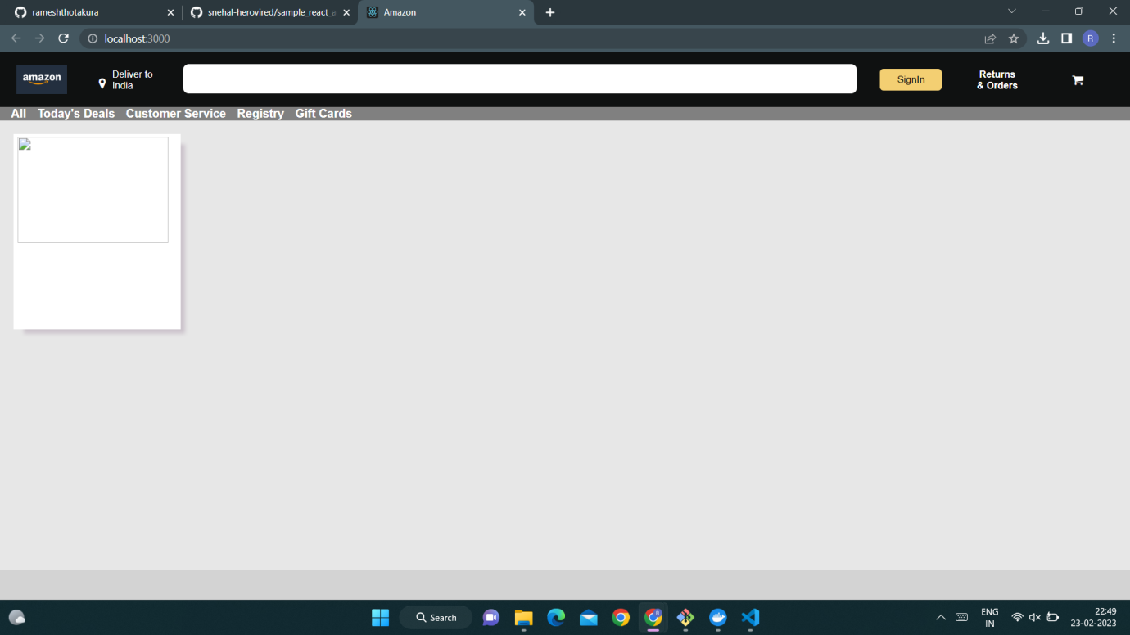

Intially i clone the data into new file from given in Q1 and after make use of that information i done the task

from the file i go into the git base and after login into docker in that i bulid the application reactjs after install

that i written the code for that than it is docker and than after i run the created docker file application.

And than i go into the local host in docker than we see the result as the Image of Amazon applicaton.

Question 2:

Describe the CI-CD pipeline and also describe the role of jenkins here.

You have to create a manual ci-cd pipeline through bash script and cron jobs for a nodejs simple application.

For the Node JS application you can have the same application provided to you on the repository here :<https://github.com/snehal-herovired/LearningGIt>.

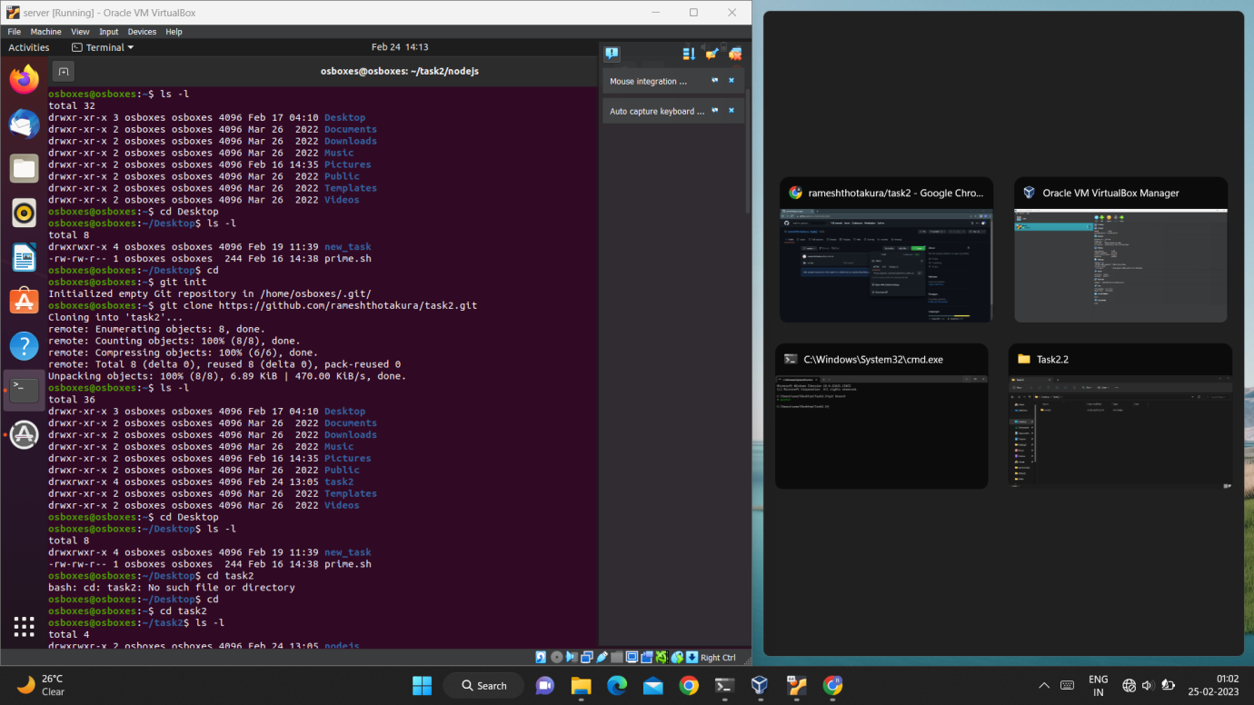

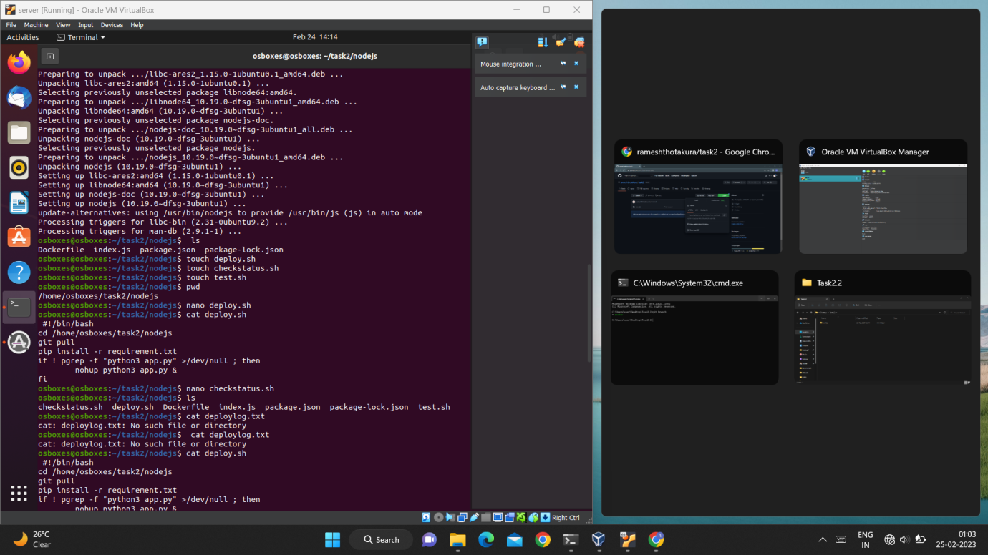

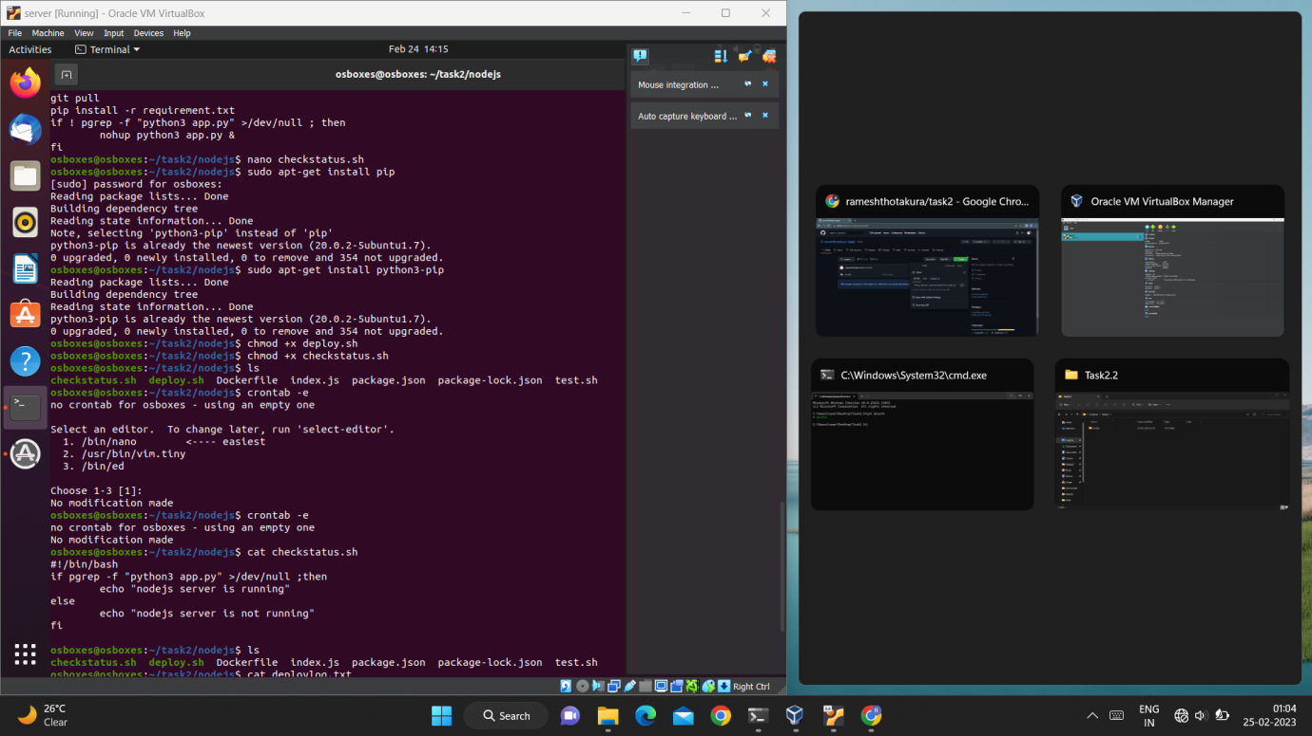

In this Question intially i created a new file and after paste the nodejs application in it after that by make use of cmd form i push the data into new repository in my Git hub And after go into the ubntu in it i initially intilizite the git and after a clone the repo link by make that i accessed data from that after that by using touch command created the deploy.sh and by use nano command i write the code init as the same way by make of touch i created checkstatus.sh and by use nano command i write the code use of bash and after i use the command like sudo apt-get install python3-pip and chmod +x deploy.sh,chmod +x checkstatus.sh.for reading purpose i use the command cat,for installing crontab i use the command crontab –e hence the application created by using the bash and cron jobs.