Aditya college of engineering and technology

Name:T Ramesh Rgno:20P31A04B0

Q1. create a ubuntu and centos vm from scratch

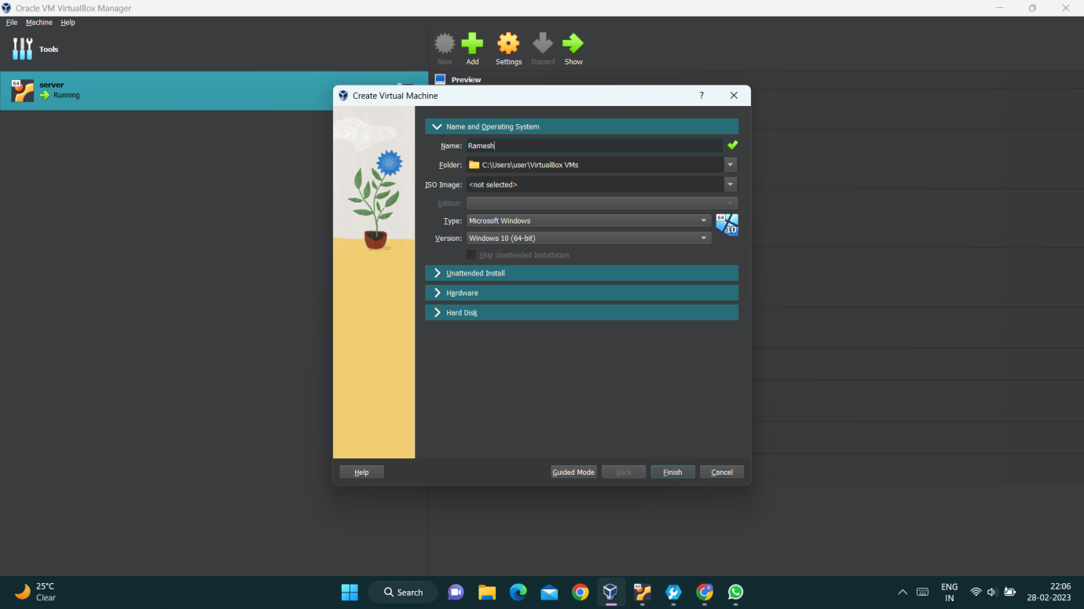

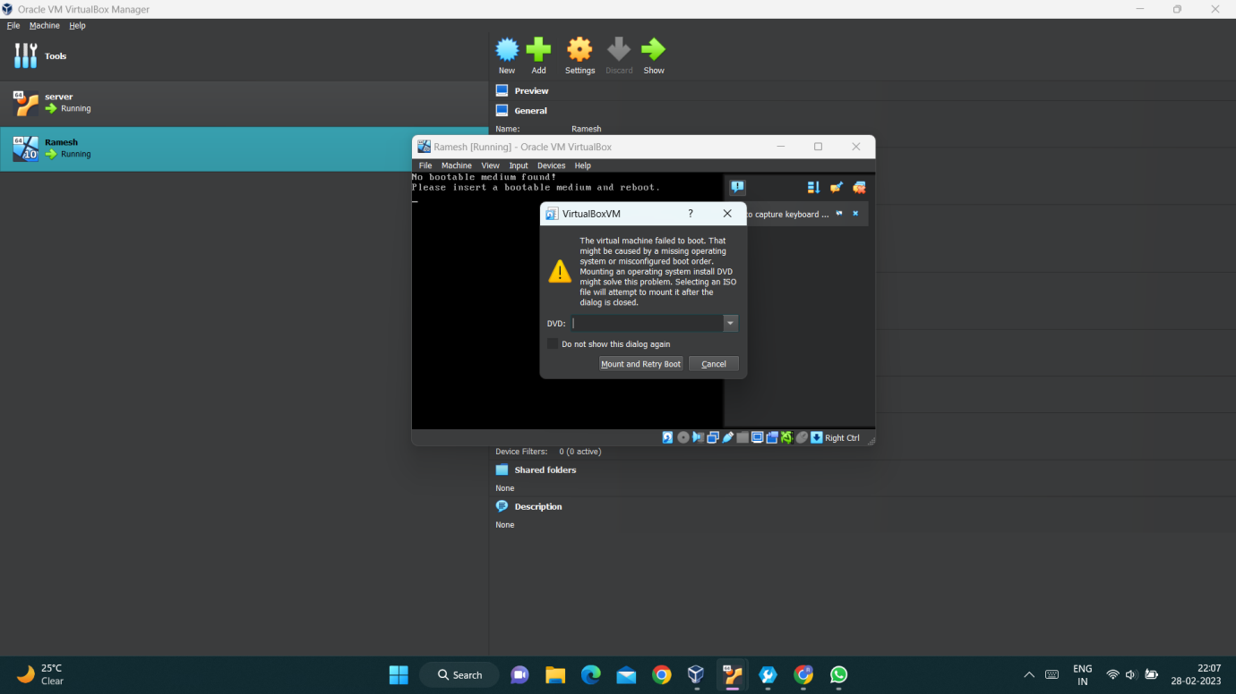

Q2. using linux command in linux vm create user and signin to that user .

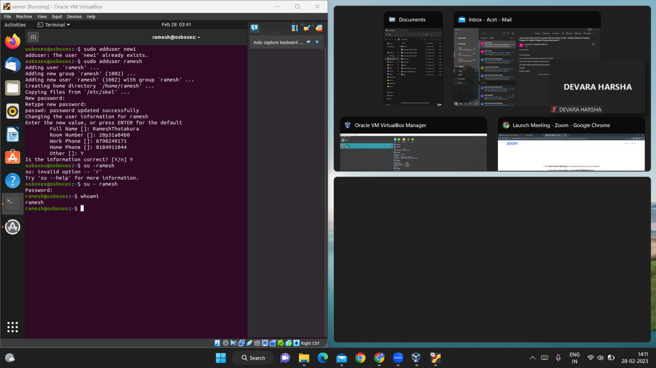

Q3.How to change file permissions in linux with example and screeshot.

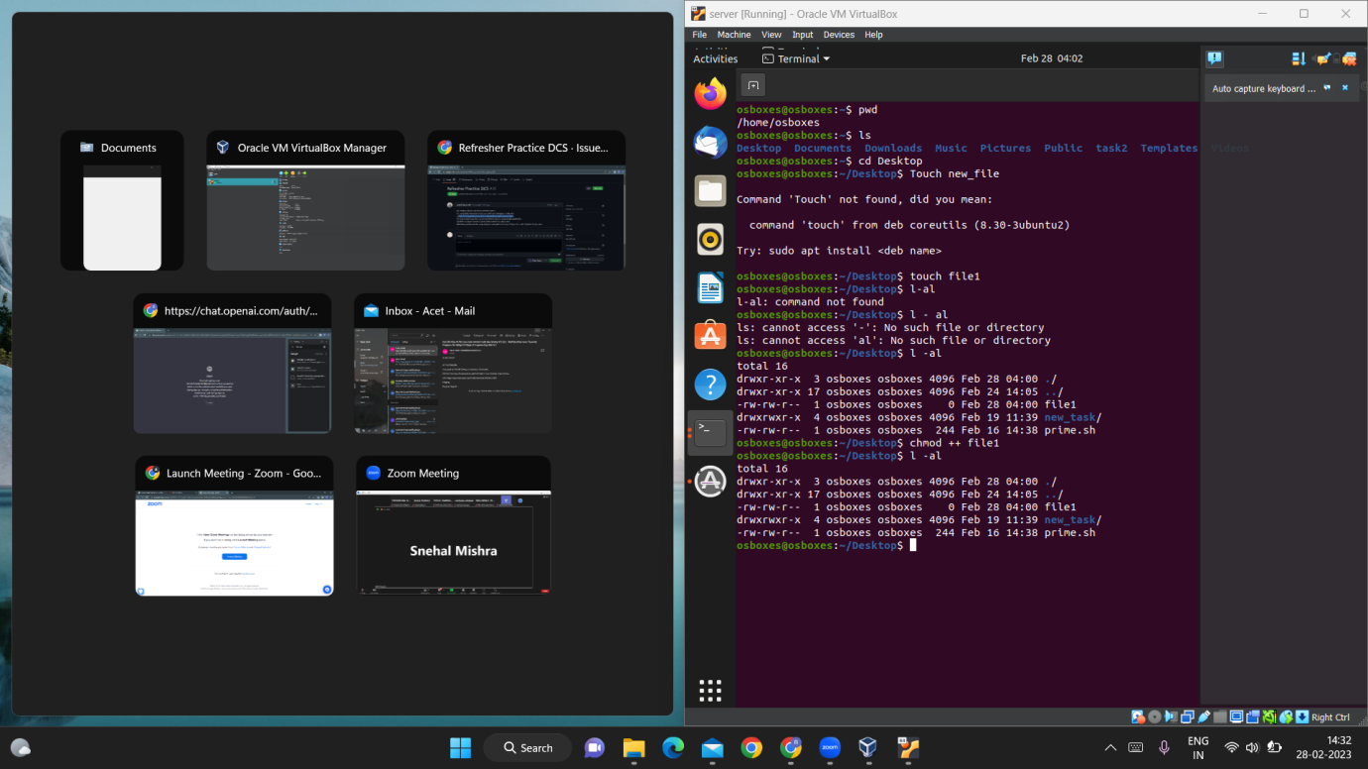

Q4. how to pull image from docker and how to create a image of java application

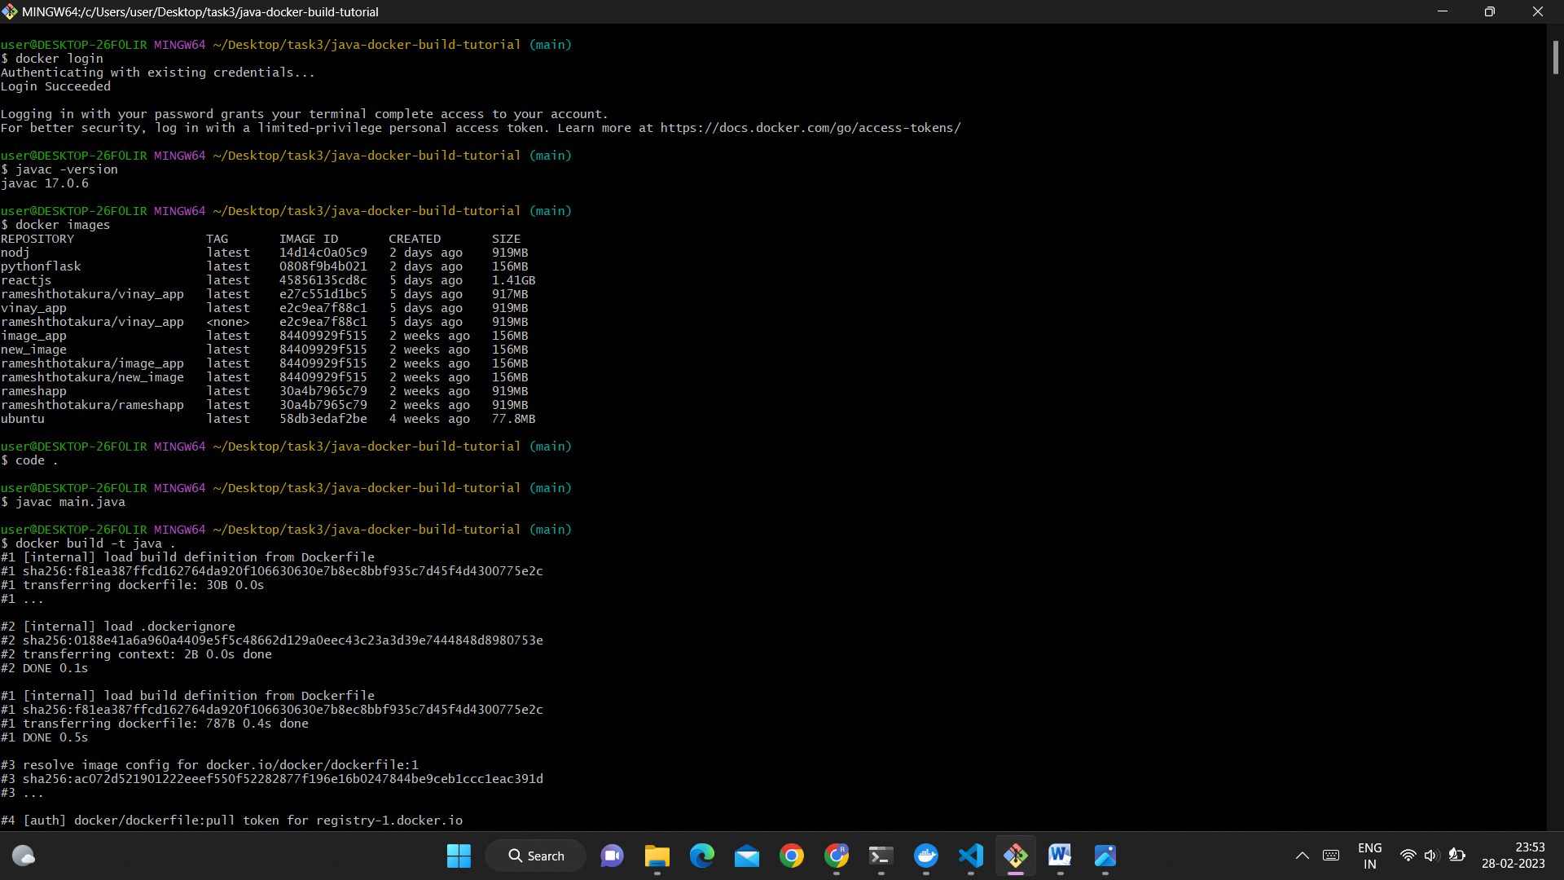

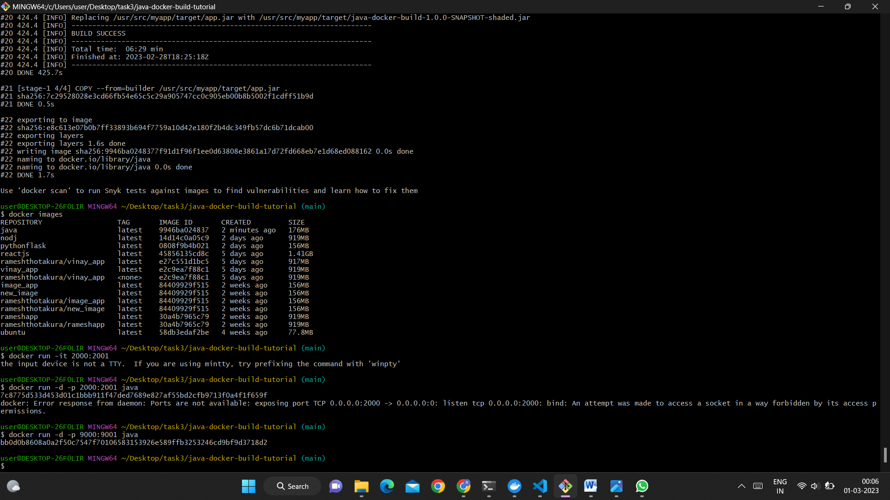

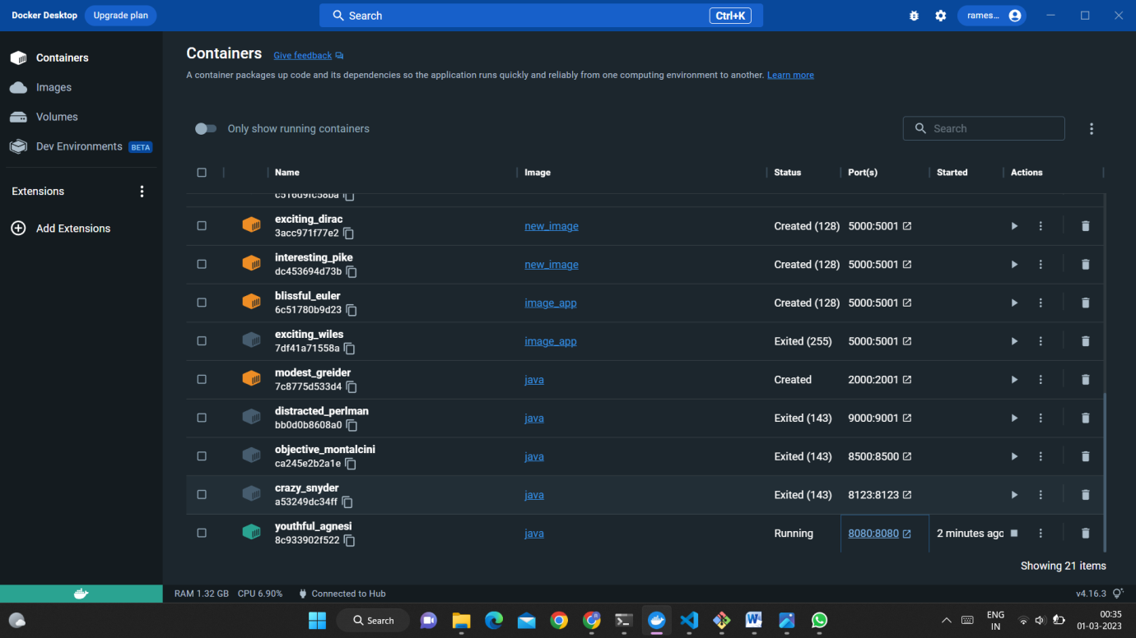

Q5.Write a program of how to print prime number in a bash script.

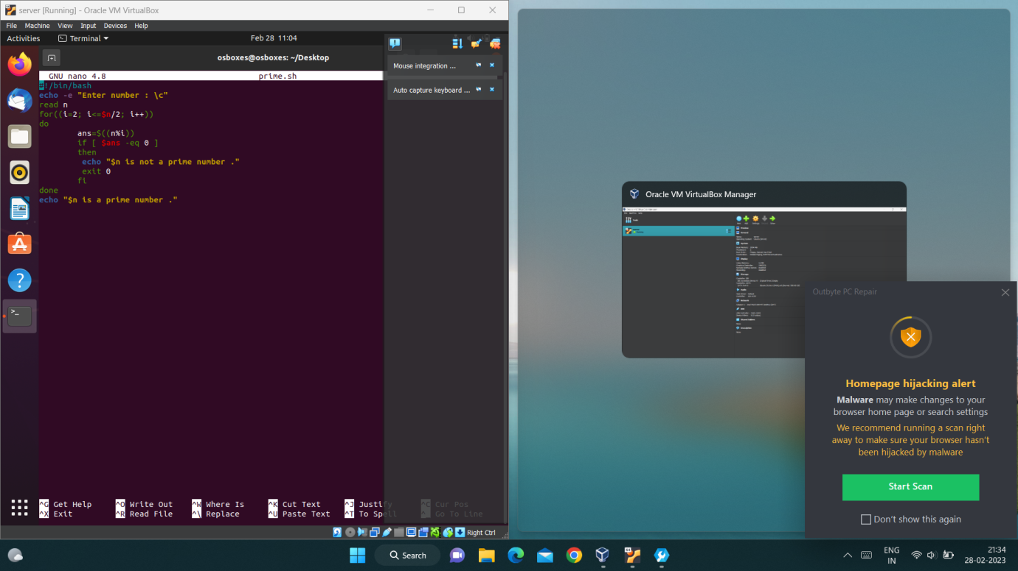

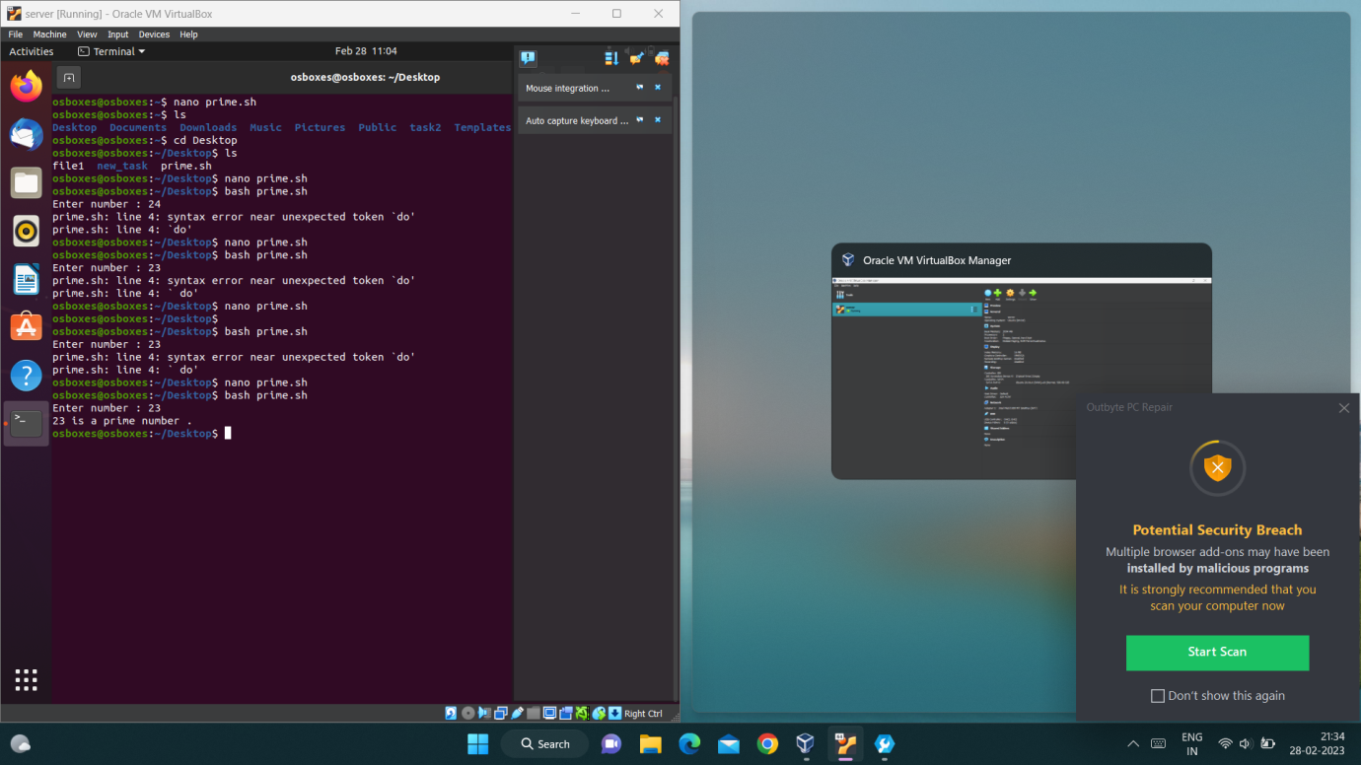

Q6.Display jenkins pipleline setup using any example.Here focus on if you can create a pipeline for java app

