1. **Git stash**

git stash temporarily saves or stashes changes you've made to your working copy so you can work on something else, and then come back and re-apply them later on.

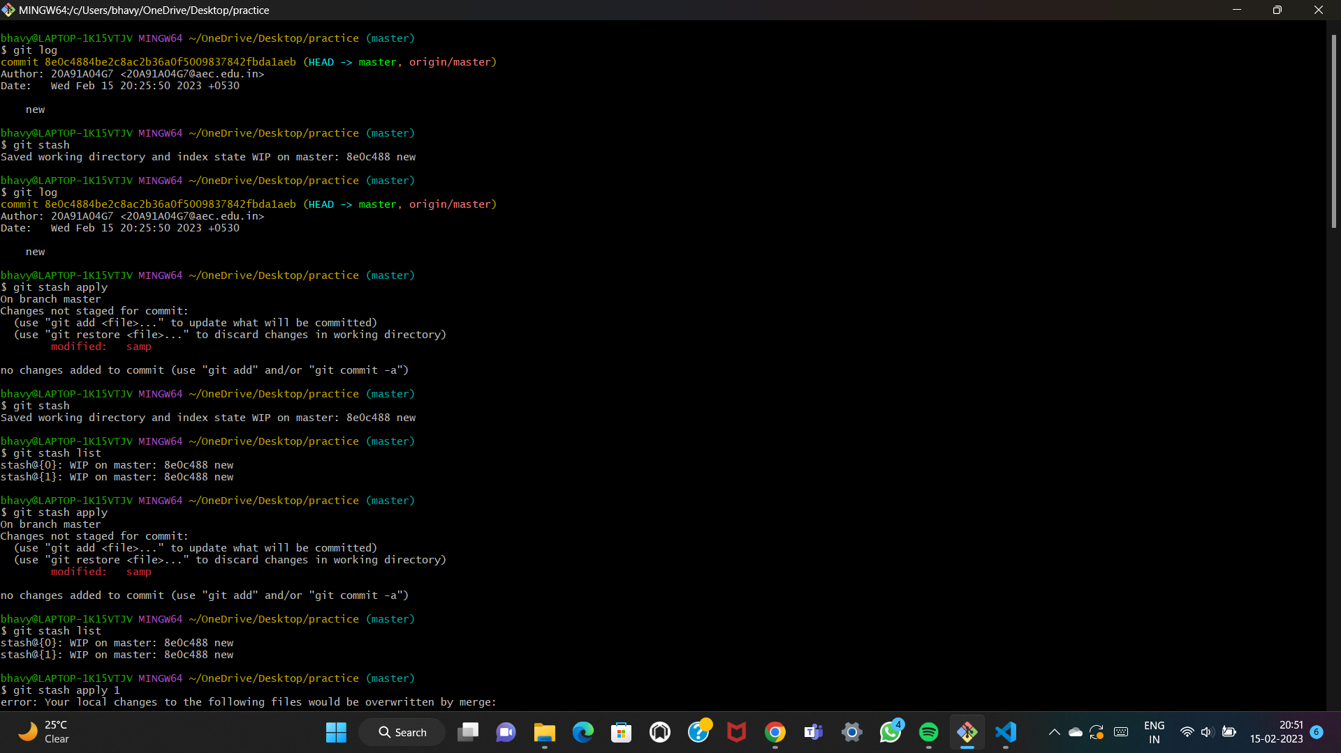

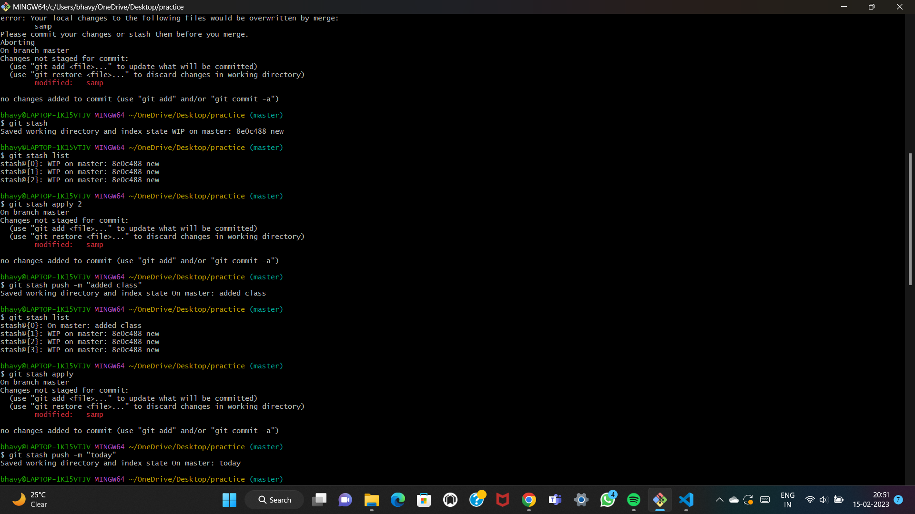

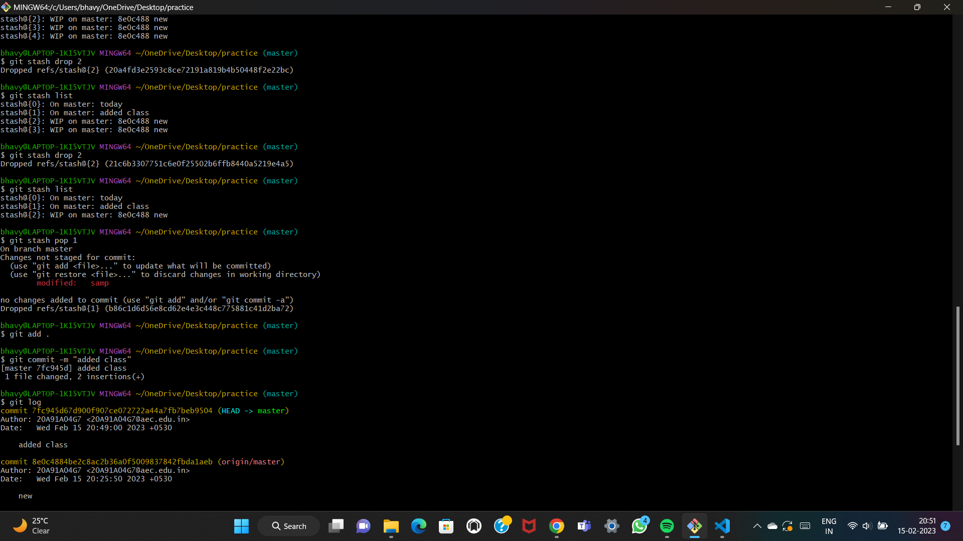

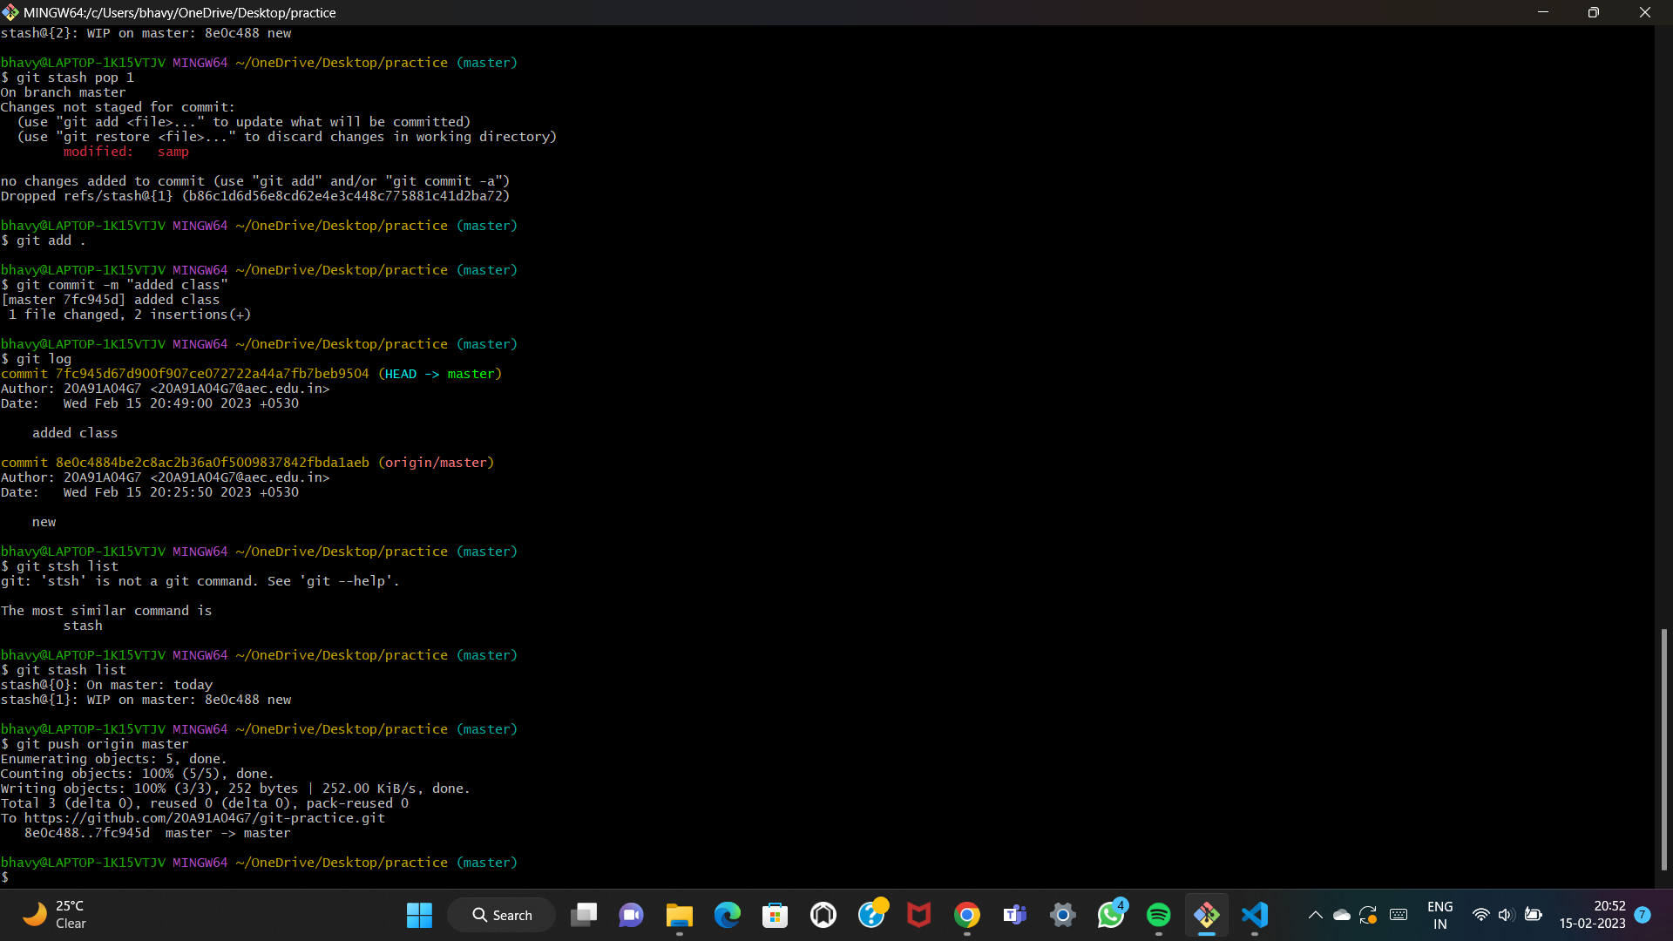

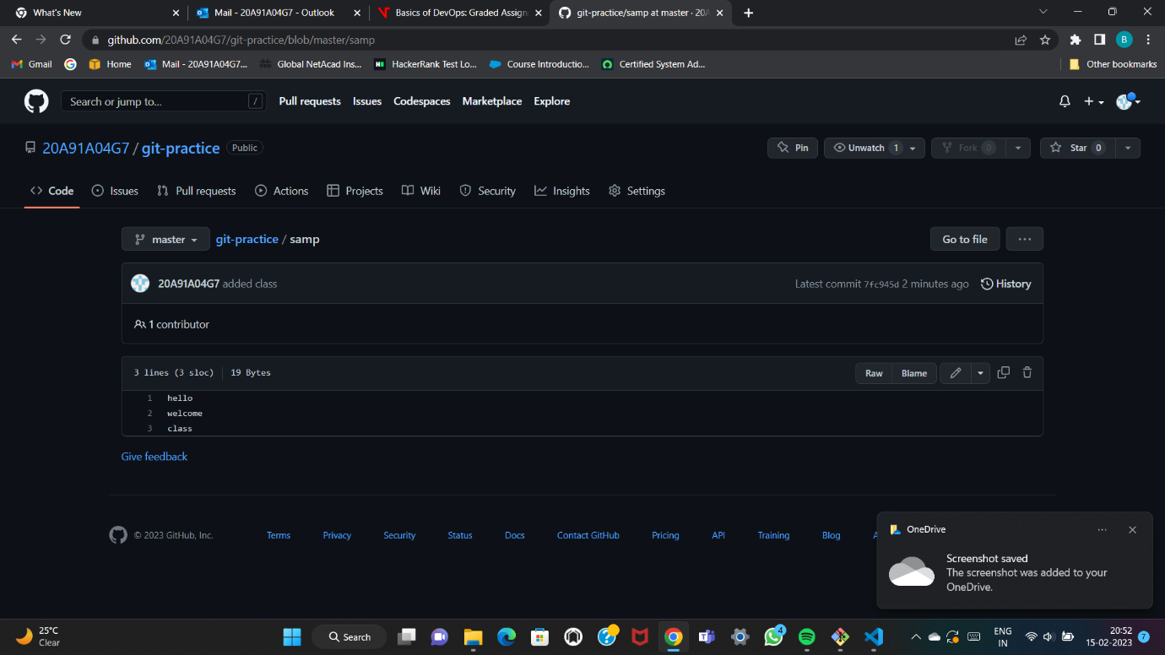

To perform git stash we use the following commands:

Git stash: to save as a temporary change

Git stash list : to display the stashes we’ve made

Git stash apply : to re-make the changes and commit

Git stash apply number (or) Git stash apply stash@{number} : to save the particular change

Git stash push -m “…..” : to push the changes

Git stash pop stash@{number} : removes the changes from stash and applies them to your working file

Git stash drop stash@{number} : to delete a stash /recent stash

Git stash clear : clears all the stashes created

**3)Git fetch and Git pull:**

git fetch shows us the changes that are made. In layman terms we can say that it acts just like notifications. The changes made in remote repository are not shown in local repository.

Git pull is quite opposite to git fetch. It directly makes the changes that are made in remote repository into local repository.

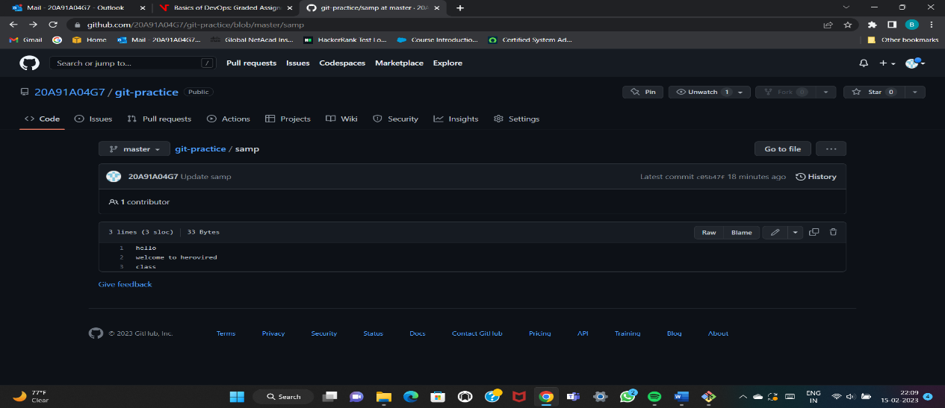

Changes are made to remote repository.

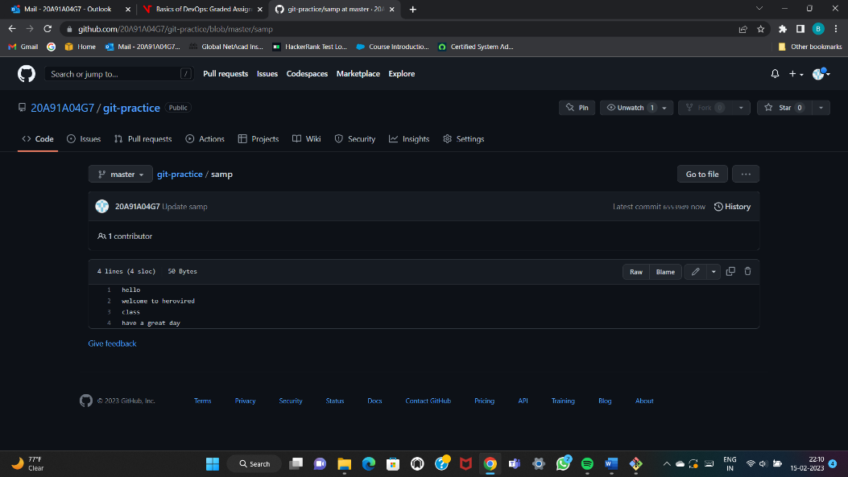

Git fetch command showing the changes that are made.

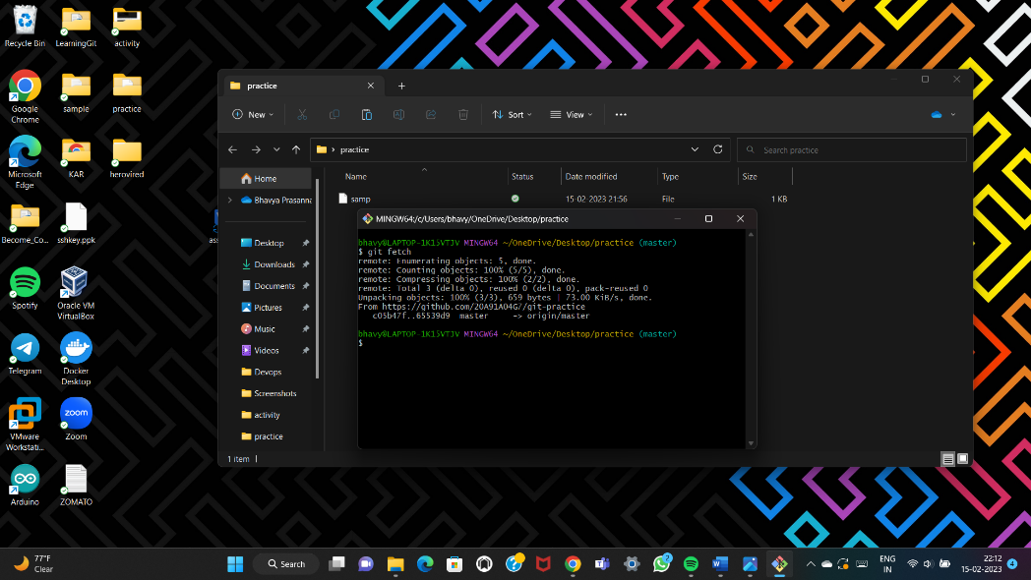

No changes are made in local repository.

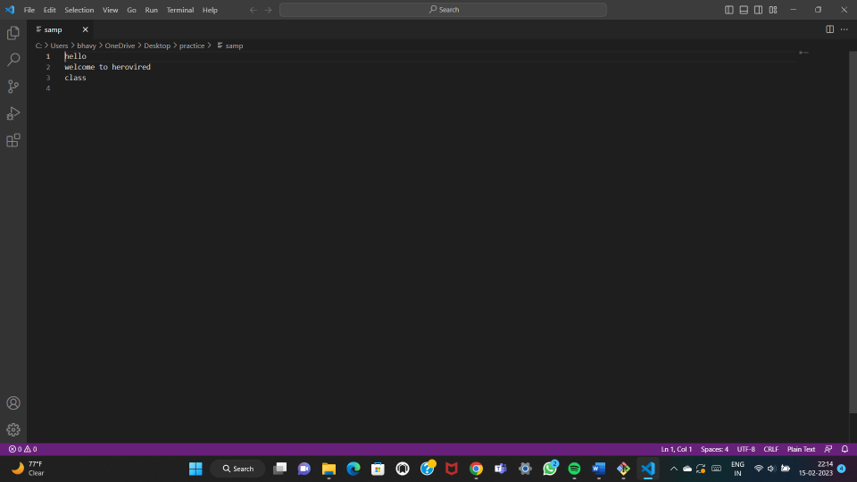

Git pull command pulls all the changes that are made in remote repository.

Command : git pull origin master

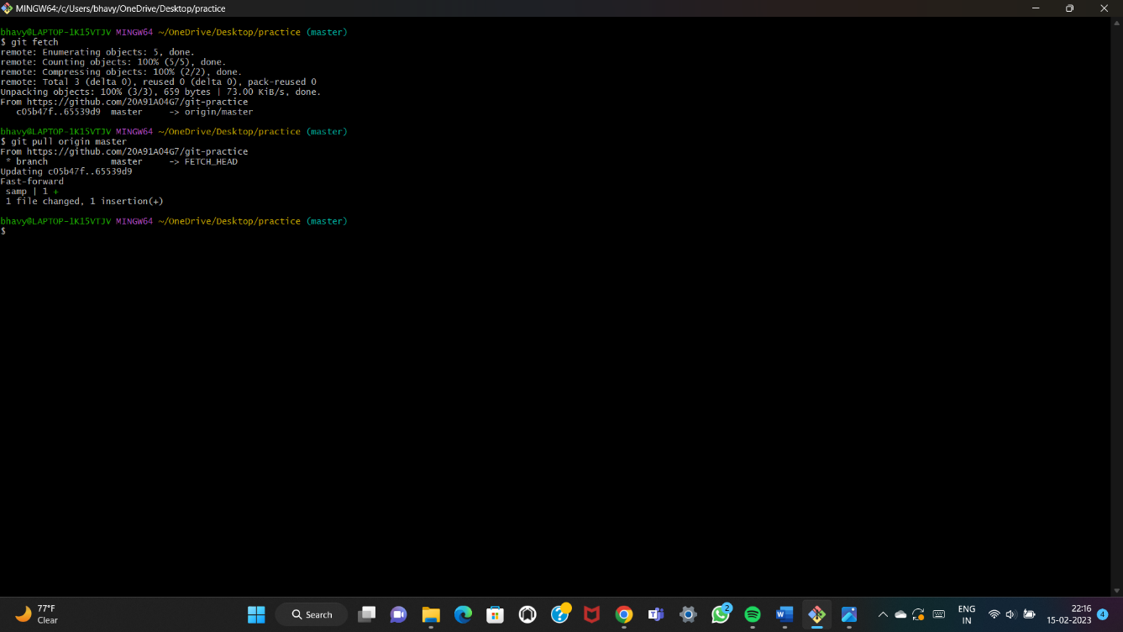

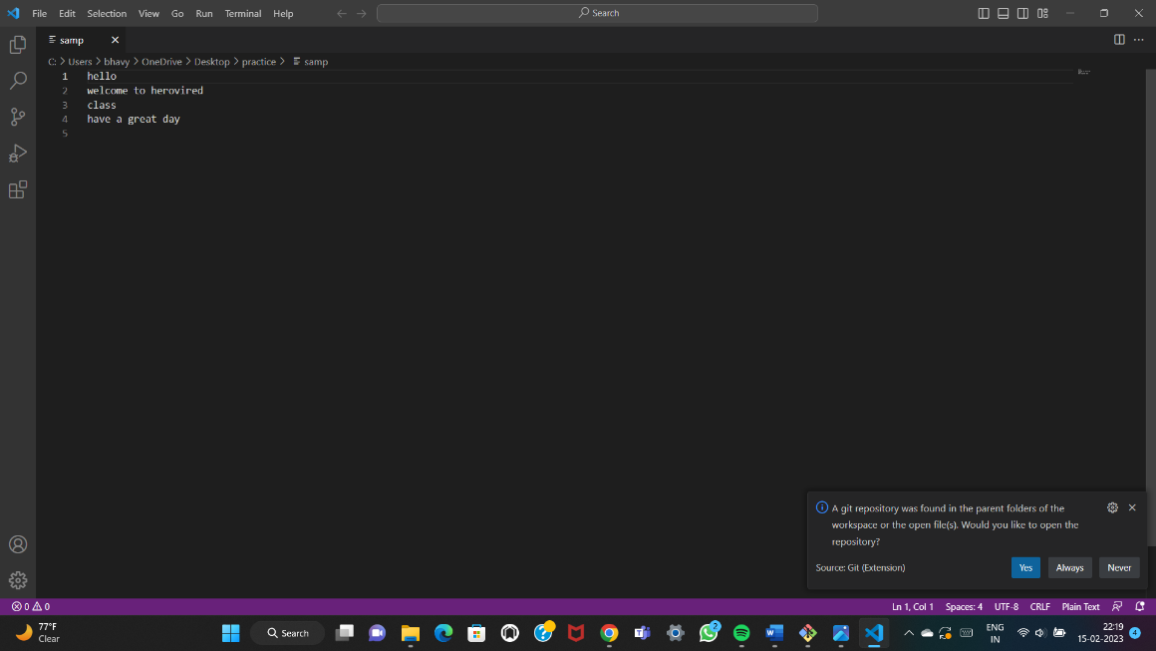The changes are also made in local repository.

**2)Git fetch and Git merge:**

As we know that git fetch gives the details about the changes that are there in the remote repository. By using the git merge we can be able to merge two branches and also can be able to save the changes.

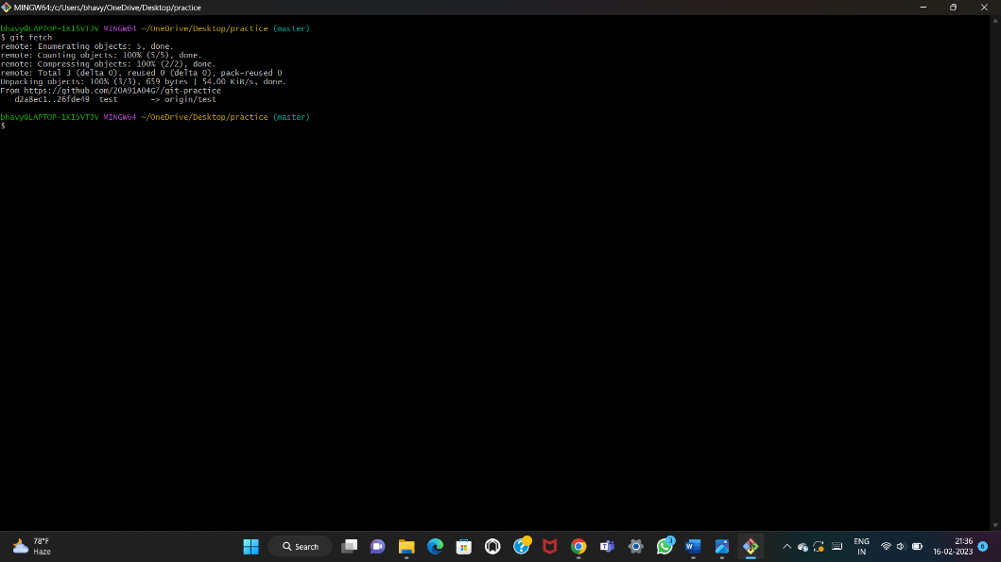

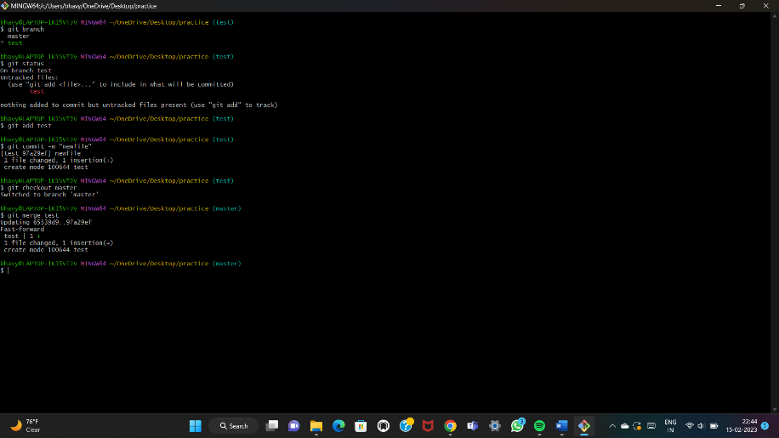

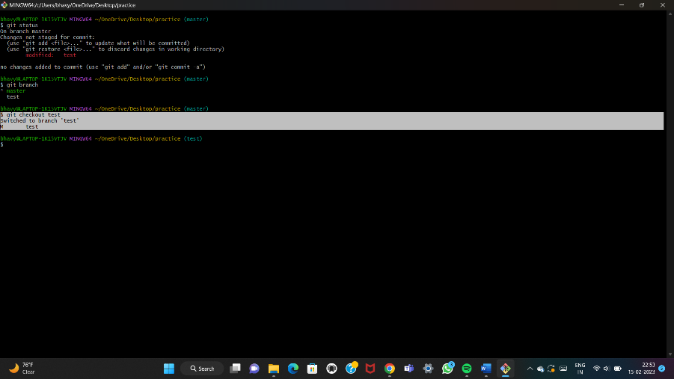

**4) AWK command:**

The awk command is used for text processing in Linux. It is used to scan a file line by line. It performs various actions/tasks on a file like searching a specified text & more.

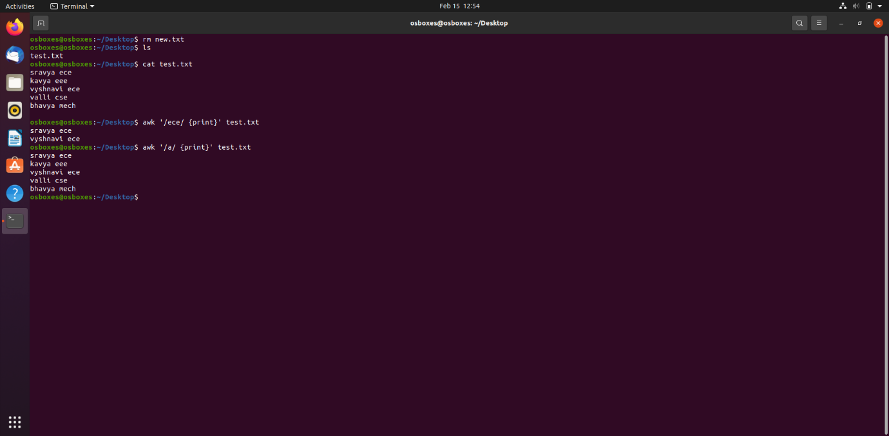

Bash script file program to find primes range in 1 to 20.

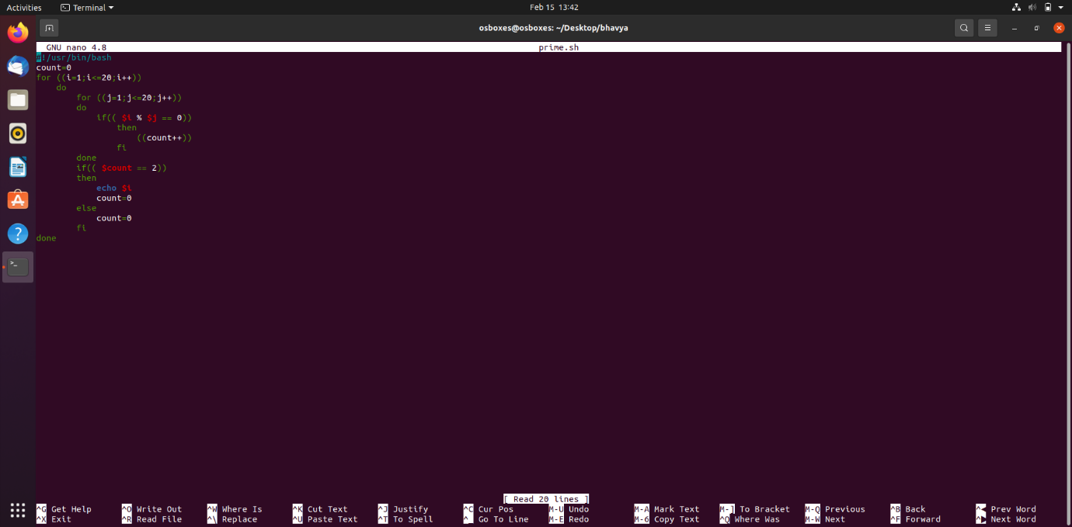

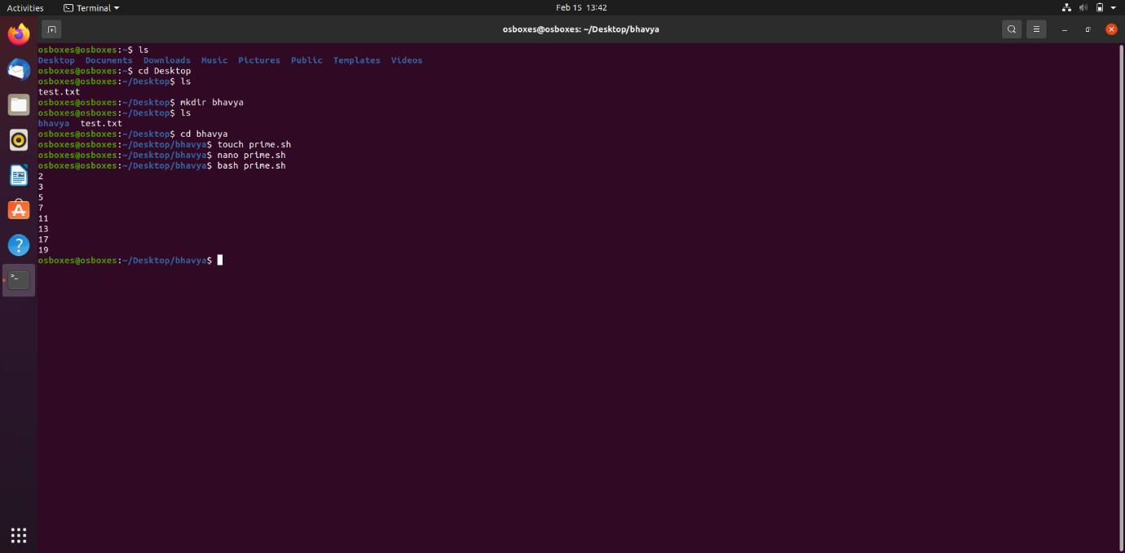

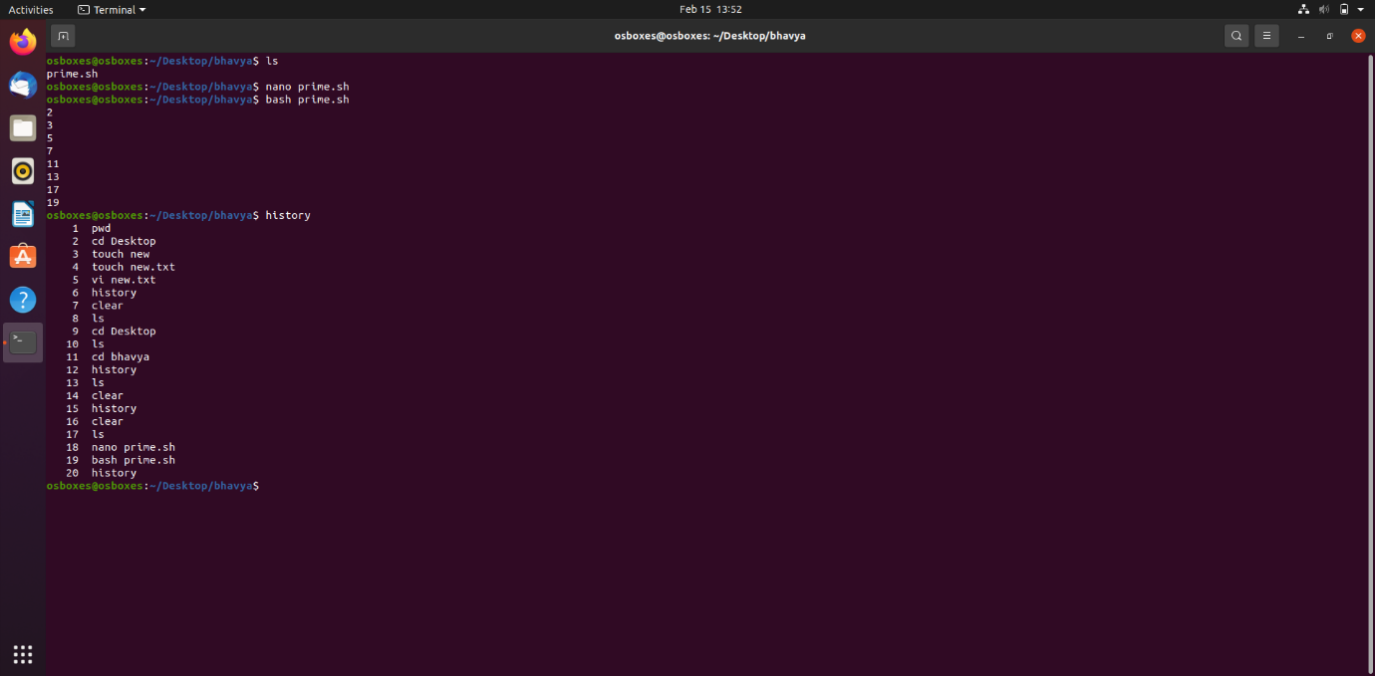

**5)Docker container – ubuntu:**

