_-GIT STASH COMMAND-_

Stash means to store (changes) safely in a hidden place (the stash stack).

Stashing the current working directory's staged or unstaged changes or

untracked files and then storing them in the stash stack reverts the

current working directory to the last commit.

Use git stash when you want to record the current state of the

working directory and the index, but want to go back to a clean working directory.

The command saves your local modifications away and reverts the working directory

to match the HEAD commit.

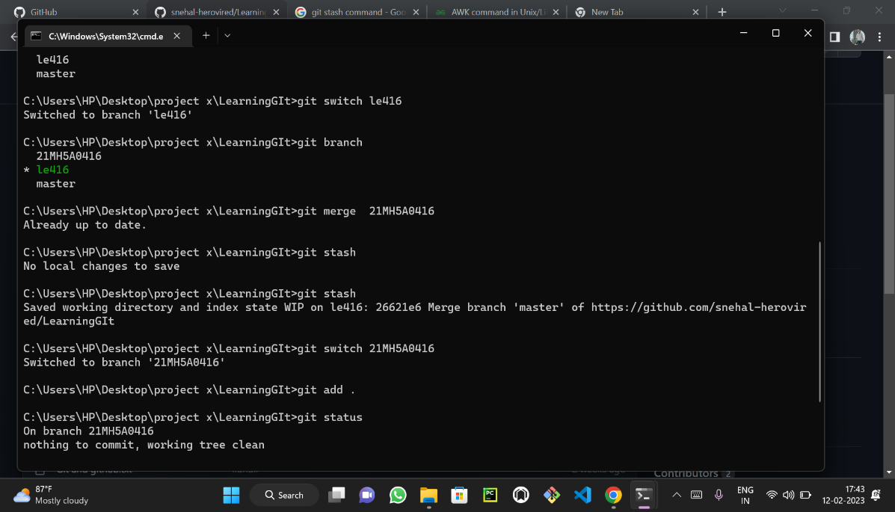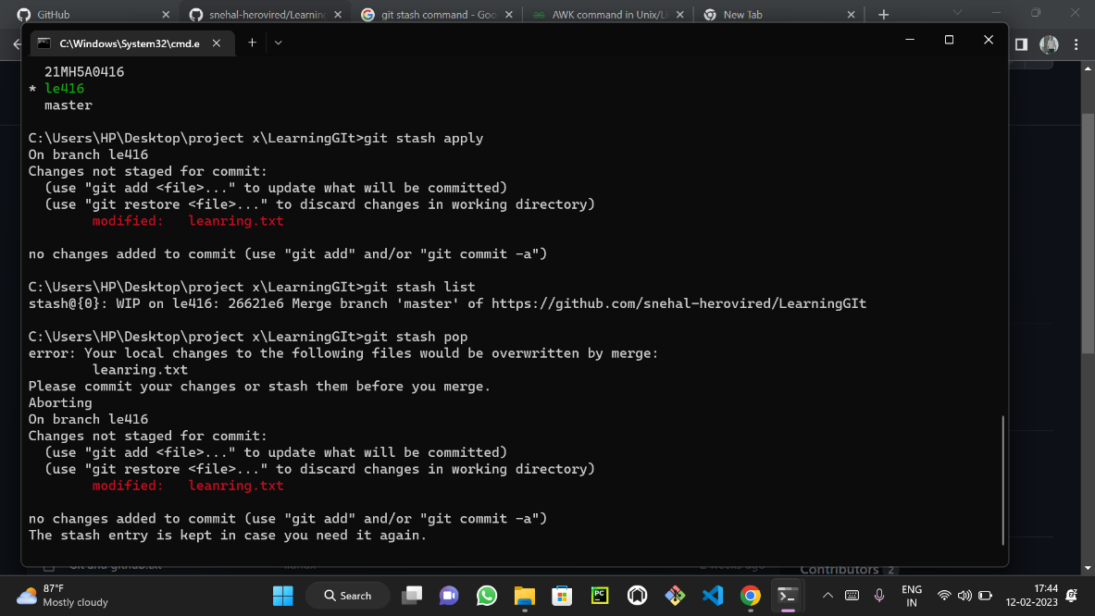

We use git stach command to save the current work without any commits .

After the stash it will be stored in stash memory

We can switch to another branch or directory to complete any work and we can return to previous stashed branch so that we can continue our work.

We use git stash pop to retrive the previous info regarding the stashed work .

We use stash apply to apply the changes and we can see the list of the stashed files using the stach list command.

