GIT FETCH AND GIT MERGE

1. git fetch is a primary command used to download contents from a remote repository.
2. git fetch is used in conjunction with git remote , git branch , git checkout
3. git reset to update a local repository to the state of a remote.
4. The git fetch command is a critical piece of collaborative git work flows.
5. The "git fetch" command is used to pull the updates from remote-tracking branches.
6. Additionally, we can get the updates that have been pushed to our remote branches to our local machines.
7. As we know, a branch is a variation of our repositories main code,
8. so the remote-tracking branches are branches that have been set up to pull and push from remote repository

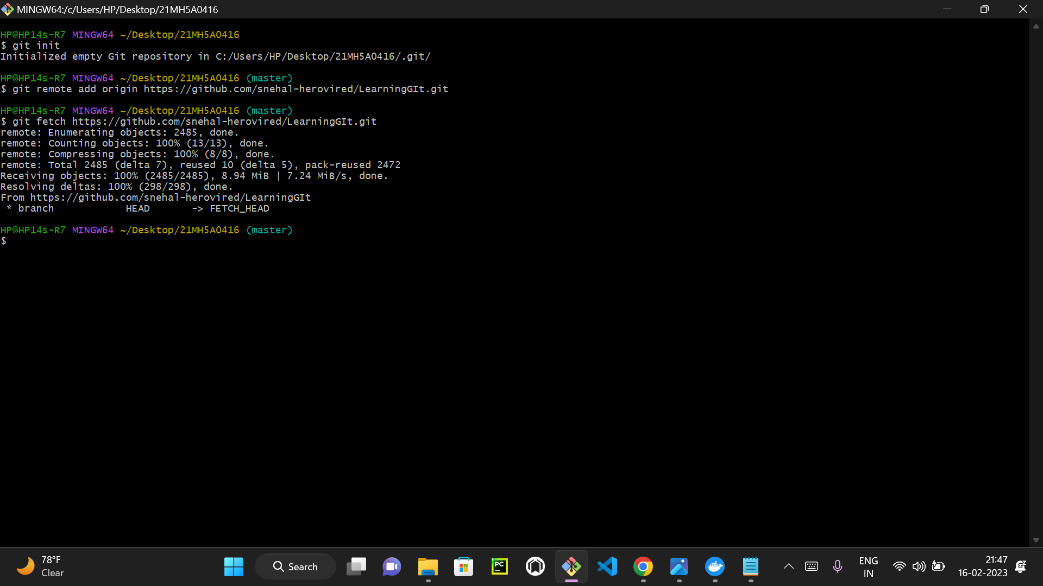

GIT MERGE:

1.The "merge" command is used to integrate changes from another branch.

2.Creates a merge commit even when a fast-forward would be possible.

3.the merging of branches or master will involves the conflicts due to modifications

4.we use "git merge <branch_name>" for merging a branch

And "git merge <master>" for merging master with a branch.

5.it will show uptodate if they were alredy merged.

