**GIT FETCH**: Gives the information of a new change from a remote repository without merging into the current branch. and

Git fetch basically imports the commits to local branches as to keep data up-to-date that what everybody is working on.

command:- "" git fetch <remote> ""

**GIT PULL**: Brings the copy of all the changes from a remote repository and merges them into the current branch.

by using git pull we will face merge conflicts.

command:- "" git pull origin <branch name> ""

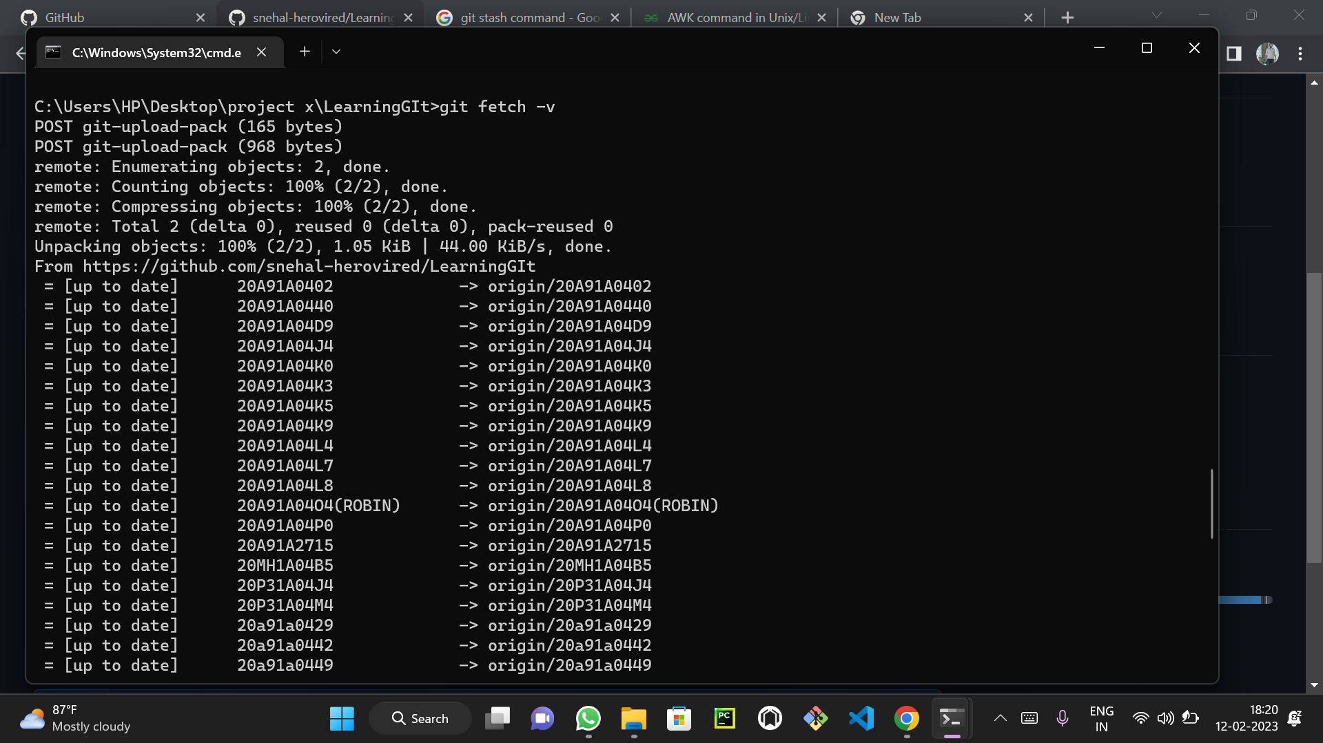

Both commands are used to download the data from a remote repository. But both of these commands work differently. Like when you do a git pull, it gets all the changes from the remote or central repository and makes it available to your corresponding branch in your local repository. When you do a git fetch, it fetches all the changes from the remote repository and stores it in a separate branch in your local repository. You can reflect those changes in your corresponding branches by merging.

git pull = git fetch + git merge

