AWK COMMAND IN LINUX:

The awk command is a Linux tool and programming language that allows users to process and manipulate data and produce formatted reports. The tool supports various operations for

advanced text processing and facilitates expressing complex data selections

Awk is mostly used for pattern scanning and processing.

It searches one or more files to see if they contain lines

that matches with the specified patterns and then perform the associated actions

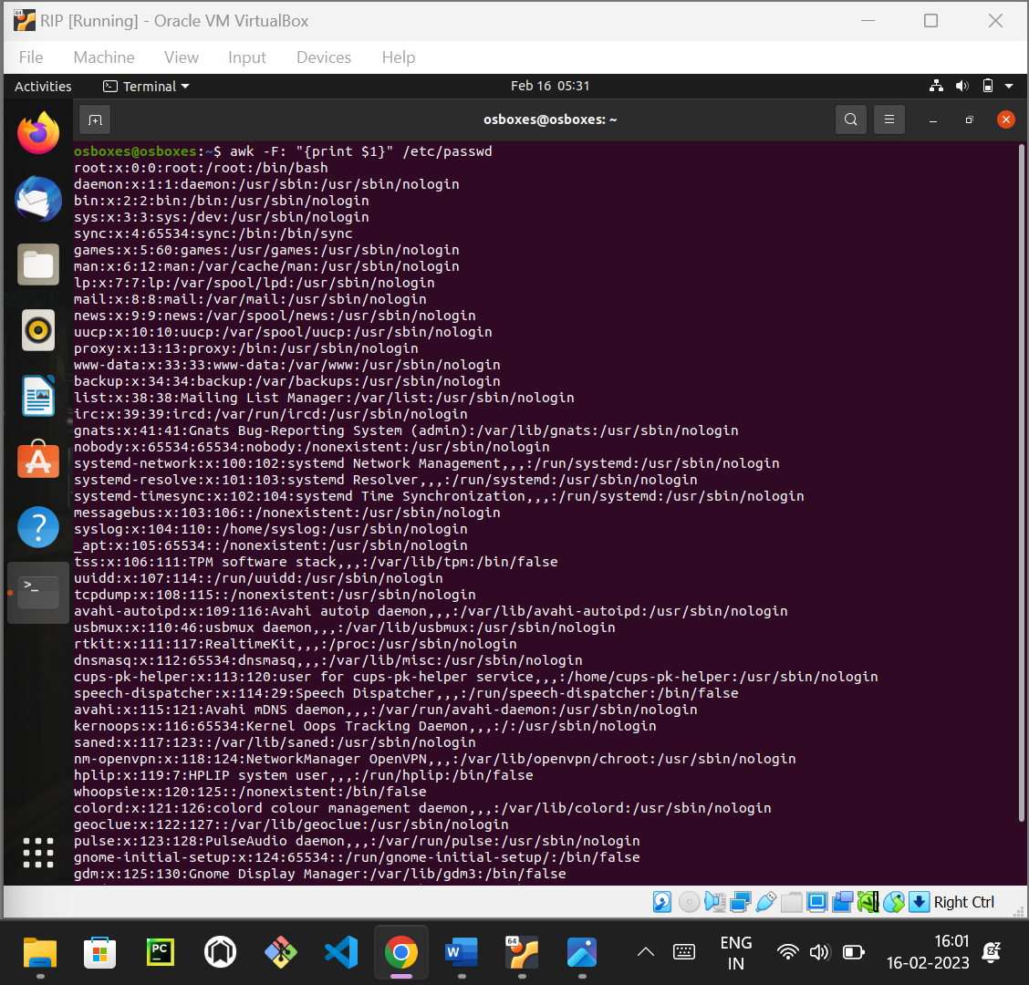

BASH PROGRAM TO PRINT 1-20 PRIME NUMBERS:

1.create a file using the Touch command.

2.edit the file using Nano file name command and write down the program

3.Run the file using Bash filename command.

