**NAME-Vivek Kethala , CLG ID – 20A91A04L8**

2.ADD A NEW USER IN LINUX

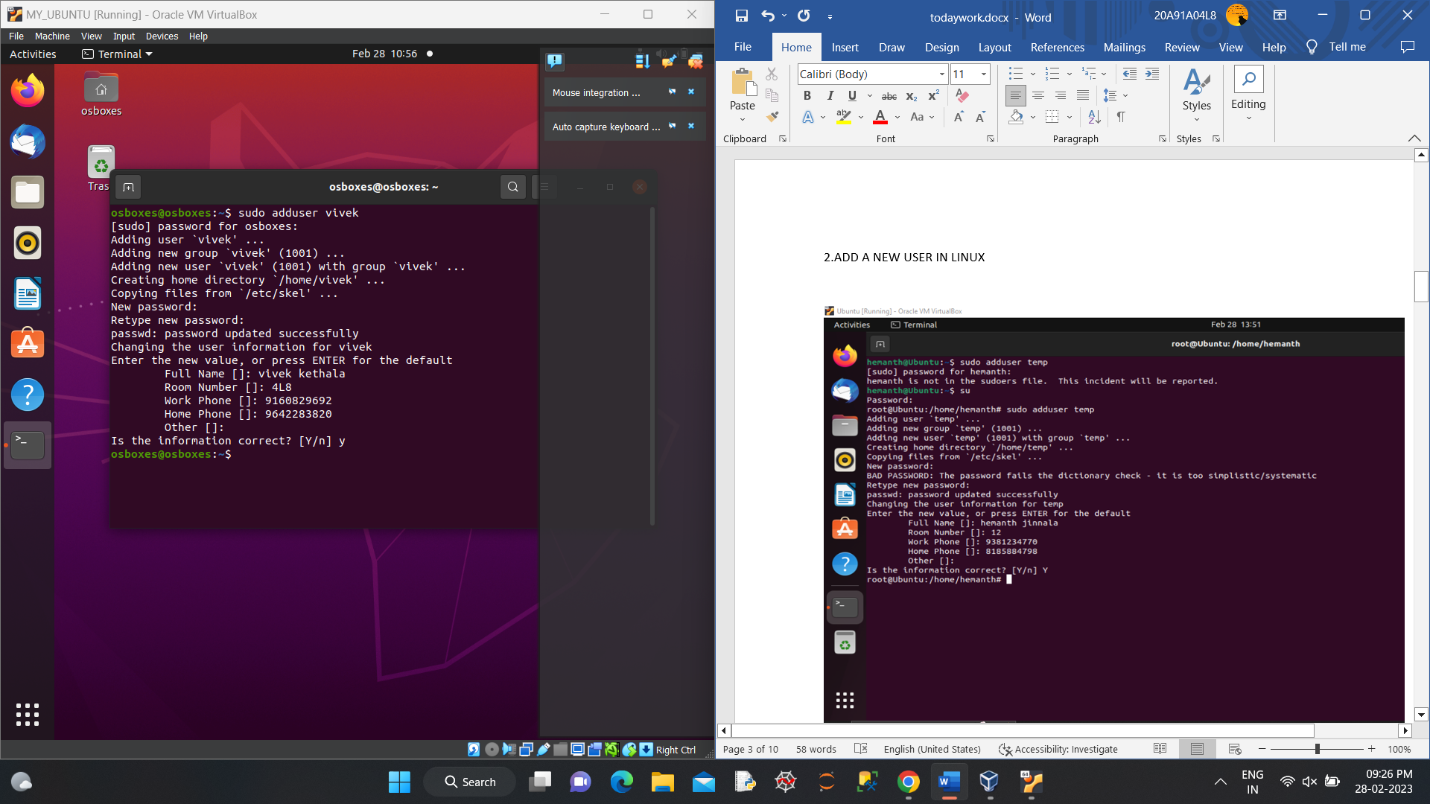

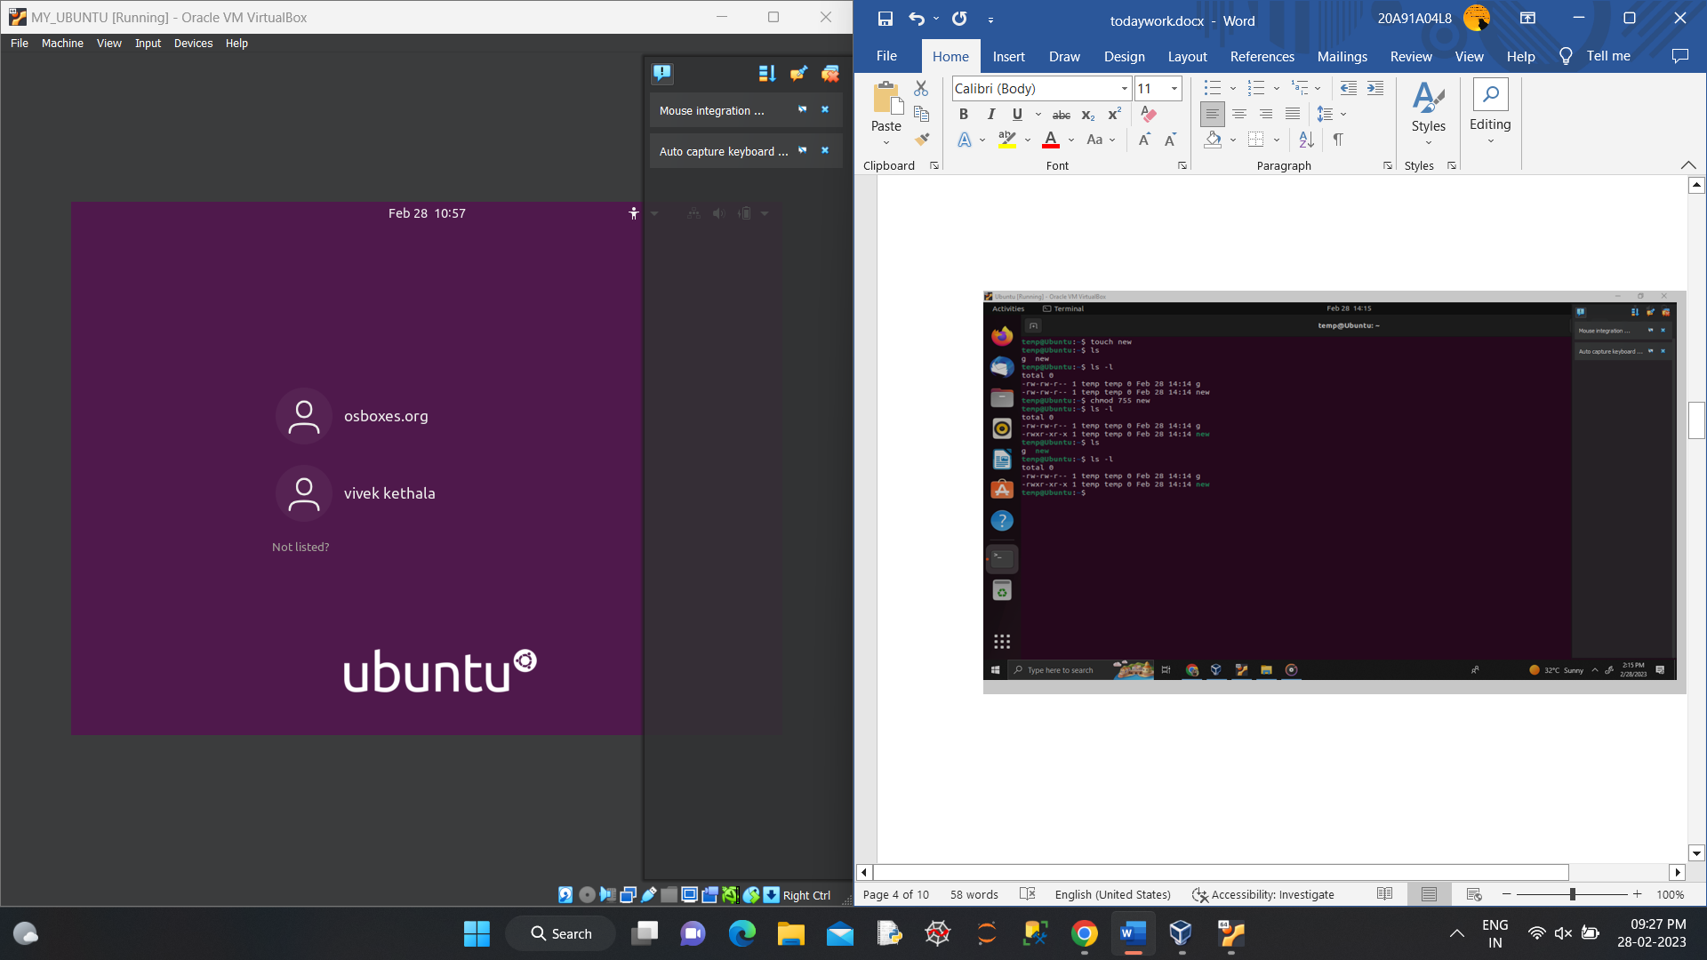

3 .CREATE A FILE IN LINUX AND CHANGE USER FILE PERMISSIONS

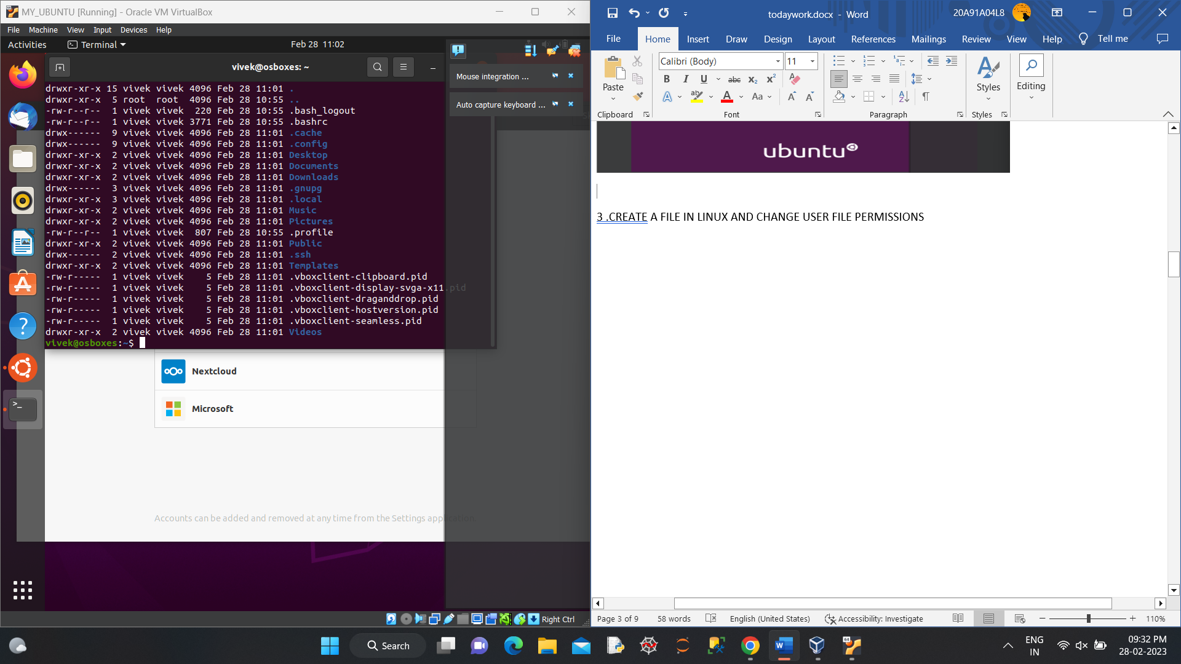

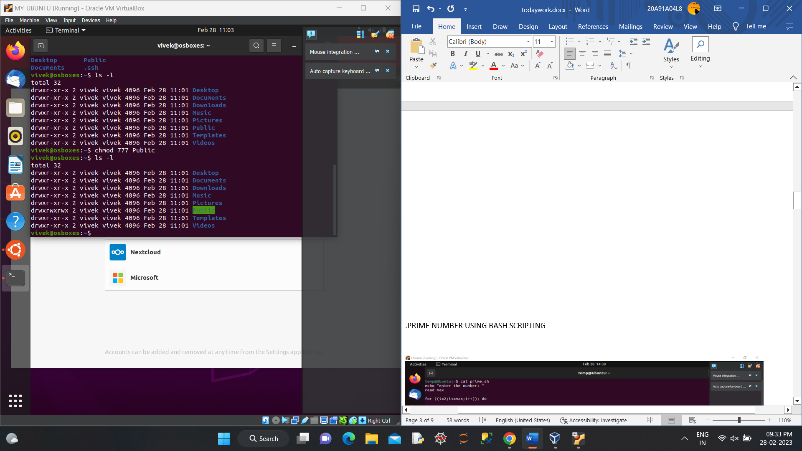

.PRIME NUMBER USING BASH SCRIPTING

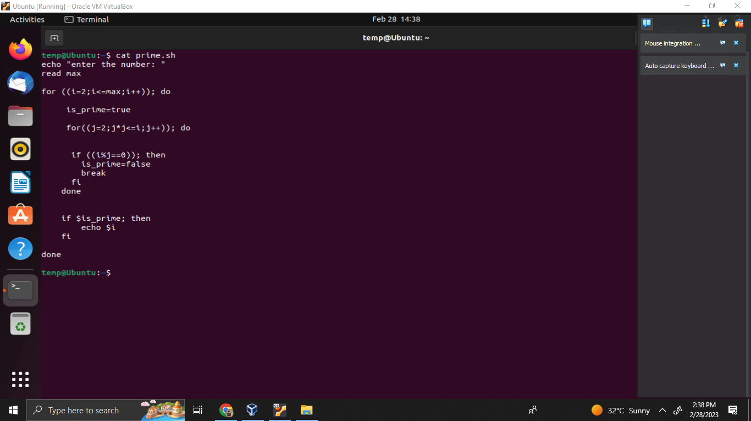

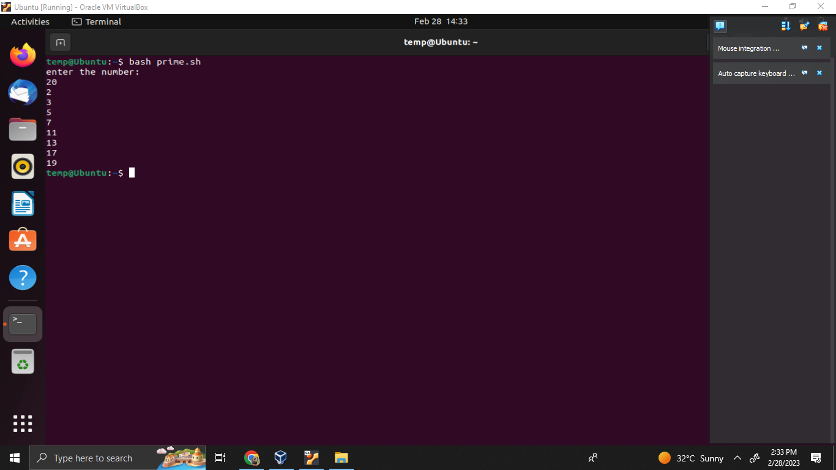

5.CREATE IMAGE USING DOCKER

