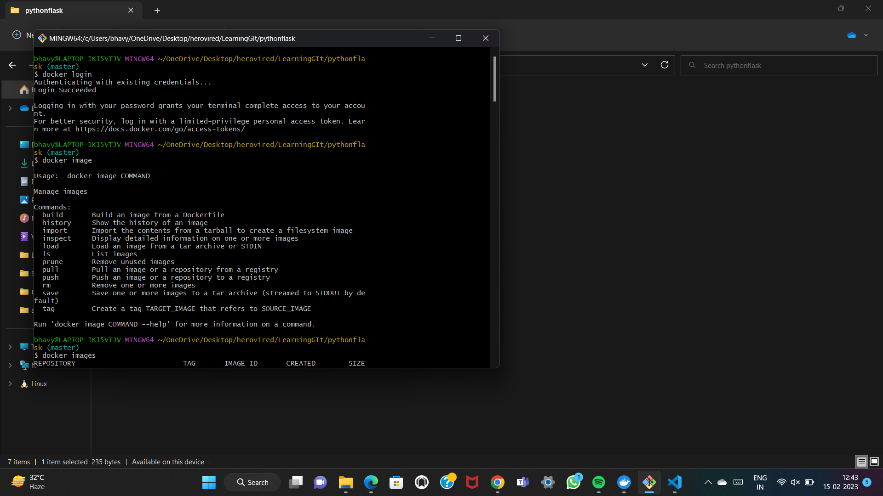Initially we need to login to our docker desktop through gitbash. Then docker images allows us to know the images present or already available images are displayed.

Then use the command “ docker build -t imagename ” to create an image.

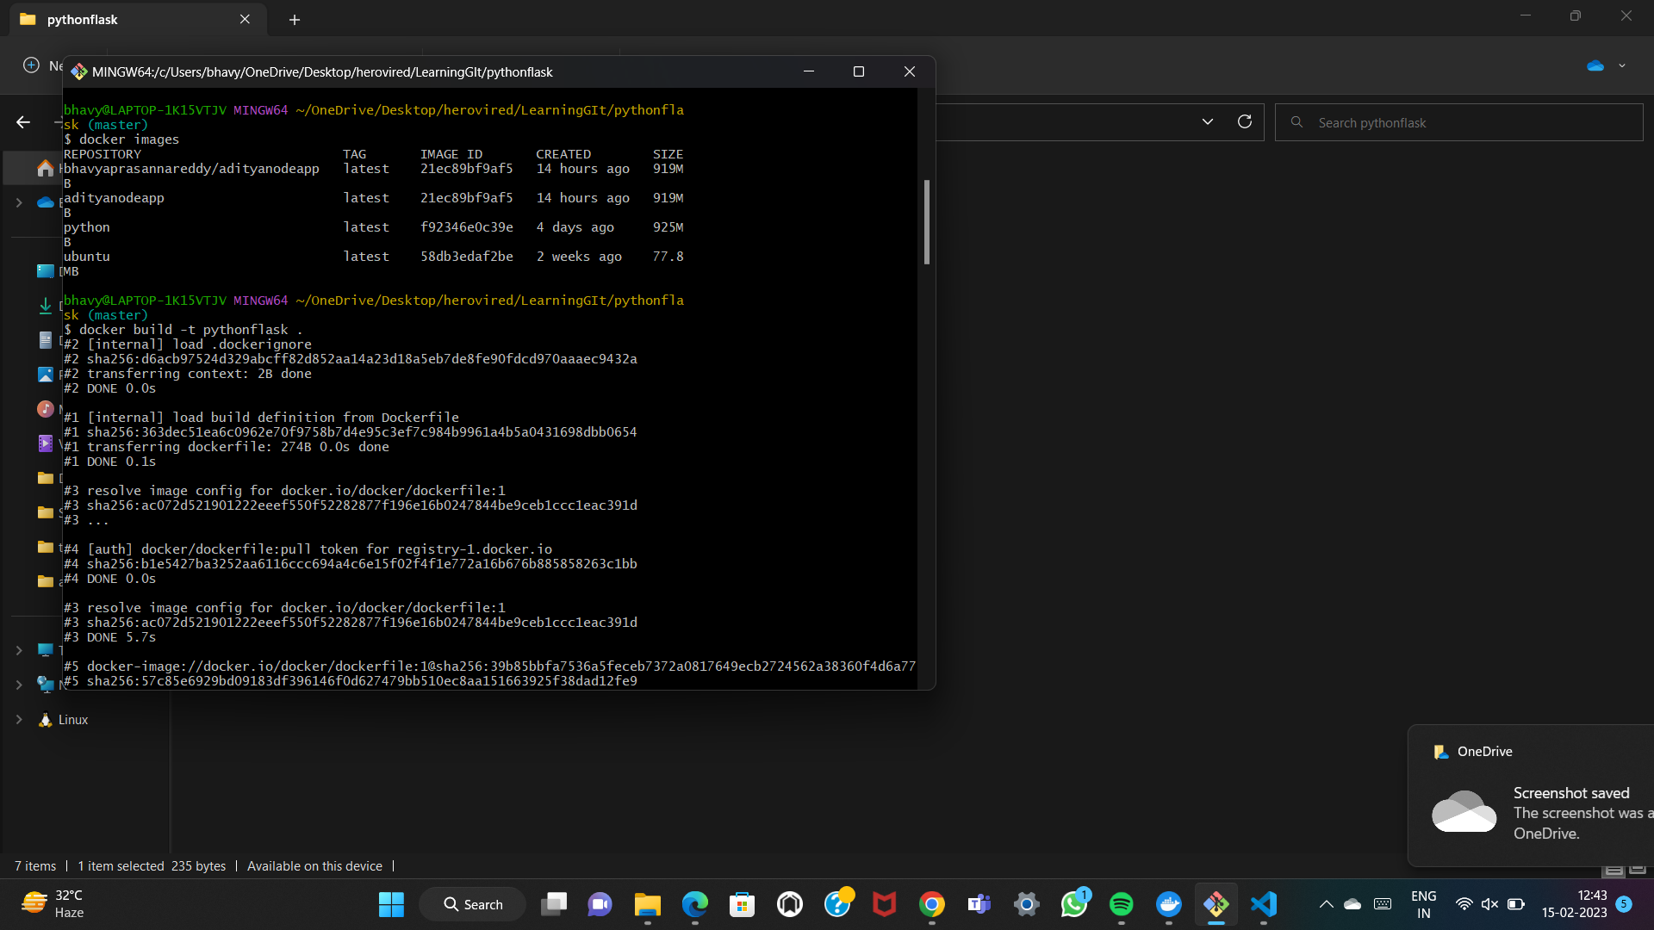

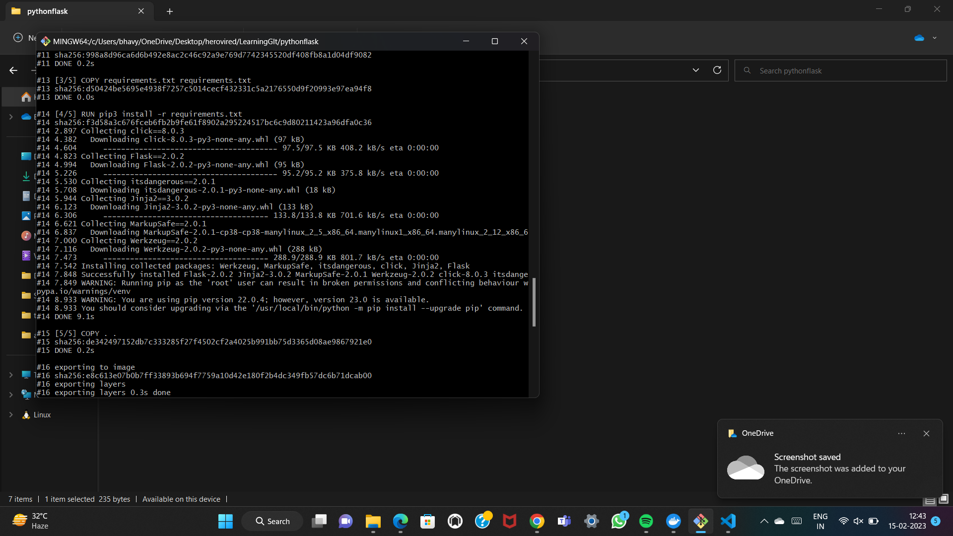

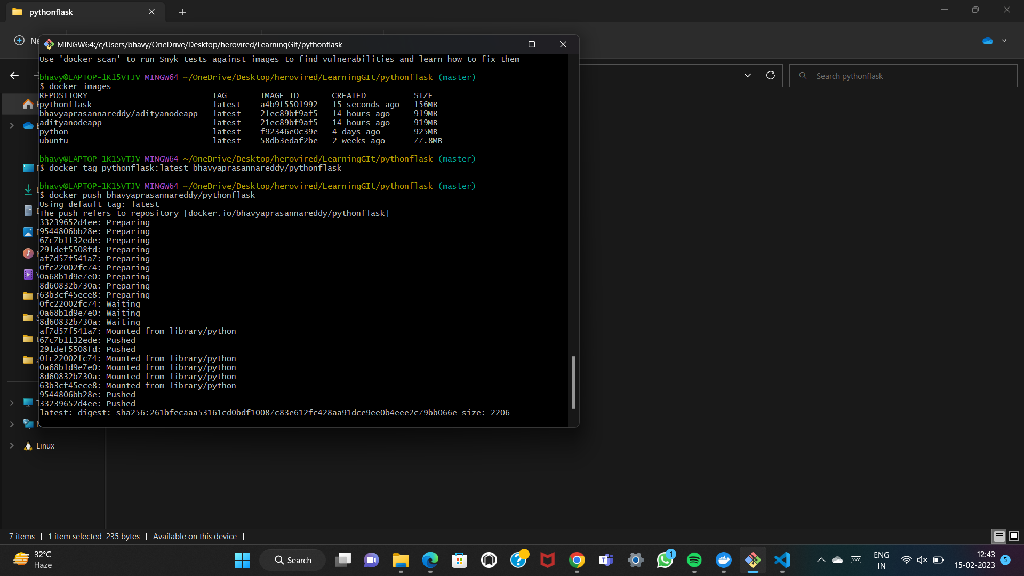“docker tag imagename:tag username/imagename” creates a repo in docker.

Now by using the command “ docker push username/imagename” it pushes the image to our docker container.

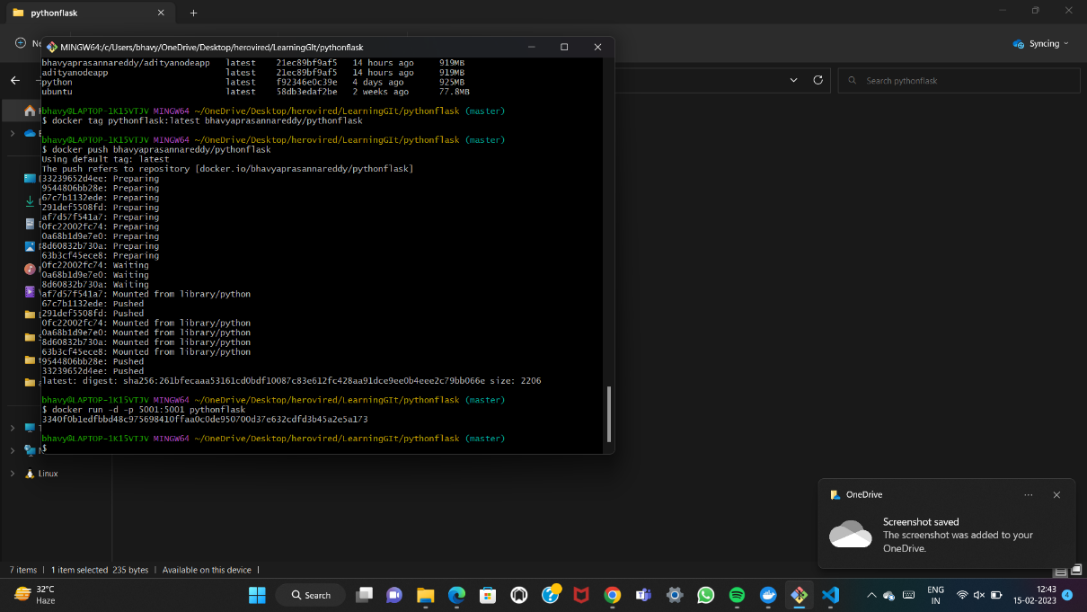To run the container in a detached mode we use “ docker run -d -p 5001:5001 imagename” .

