**Store Inventory Optimization Initiative**

**Store Inventory Optimization Initiative**

**1. Introduction**

The fashion industry is widely recognized for its dynamic and fast-paced nature therefore requiring a rapid and deep analysis of data. Continuous monitoring and analysis are crucial to understanding evolving market trends and consumer behaviors. This project thoroughly analyzes the Adidas US Sales Dataset to examine sales trends in women's athletic footwear. By incorporating historical sales data and advanced predictive modeling techniques, including the Monte Carlo simulation method, this comprehensive analysis aims to uncover valuable insights.

These insights are essential for informing strategic business decisions and enhancing overall decision-making processes within the fashion industry. Such strategic foresight is fundamental to maintaining a competitive edge and adapting to the ever-changing dynamics of the fashion market. By understanding sales trends in men's and women's athletic footwear, businesses can better tailor their product offerings, marketing strategies, and pricing to meet consumer needs and preferences.

The thorough analysis of this data will provide unique insights that can inform strategic business decisions and help businesses succeed in the highly competitive fashion industry. We believe this analysis will provide valuable insights to our organization as we adapt to the market's changing dynamics and maintain our competitiveness.

**2. Problem Definition**

During the preliminary data processing phase, we undertook significant efforts to remove duplicate or irrelevant entries from our dataset. Moreover, we transformed specific columns, such as the 'Invoice Date,' into their respective data types to ensure efficient and prompt analysis. Subsequently, we comprehensively explored the dataset to gain valuable insights into the sales distribution across various retailers, regions, and months. This exploratory analysis gave us a fundamental understanding of the dataset and laid the groundwork for subsequent analytical procedures.

**Table 1.** Data Collection

**Table 2.** Data cleaning and preprocessing

**Table 3.** Exploratory Data Analysis(EDA)

**2.1. Total Sales by Retailer Figure 1.**

A bar chart visualized the total sales of women's athletic footwear by retailer. The chart revealed that West Gear had the highest sales, followed by Foot Locker. This information can be valuable for retailers to identify top-performing partners and tailor their marketing strategies accordingly.

**2.2. Total Sales Distribution by Retailer Figure 2.**

A pie chart was used to display the distribution of total sales among different retailers. West Gear accounted for most sales, representing 28% of the total, while Foot Locker and Sports Direct accounted for 23% and 21%, respectively. This distribution highlights the importance of the big three retailers in driving overall sales and suggests potential opportunities for growth or partnership expansion with this retailer.

**2.3. Total Sales by Month Figure 3.**

A line chart shows women's athletic footwear sales peaking in June and bottoming out in February due to weather, holidays, and events. Retailers can use this seasonal variation to plan inventory and marketing strategies.

**3. Predictive Model Selection**

The first statistical predictive model used is linear regression, a cornerstone statistical technique to uncover the relationship between a dependent variable and one or more independent variables. Imagine you have a bunch of data points scattered on a graph. Linear regression works by finding the straight line that best fits this scatter plot, minimizing the distance between the data points and the line. This line represents the equation explaining how the dependent and independent variables change. The dependent variable is the value you're trying to predict, often influenced by the independent variables. For instance, in sales forecasting, the number of shoes sold (dependent variable) might be influenced by factors like time (independent variable).

Linear regression can be a good method to predict future Adidas shoe sales based on previous sales data for a few reasons. Firstly, it's a relatively simple and easy-to-understand technique, making it accessible for businesses to interpret and implement. Secondly, historical sales data is often readily available for businesses, allowing them to leverage existing information to forecast future trends.

Monte Carlo simulation is a computational technique used to model the behavior of complex systems by generating many random samples from probability distributions for uncertain input variables. Originating from the Monte Carlo Casino, this method runs numerous simulations where each iteration randomly selects inputs within defined ranges to simulate the system's behavior. By aggregating results from these iterations, analysts can estimate the probability distributions of potential outcomes and assess the risk associated with different scenarios. Monte Carlo simulation finds extensive application in finance, engineering, and science for tackling problems with inherent uncertainty, such as project planning, financial forecasting, and risk analysis.

Monte Carlo simulation is a powerful method for predicting future sales of Adidas shoes based on previous sales data due to its ability to incorporate uncertainty and variability inherent in sales forecasting. By simulating various scenarios using historical sales data, Monte Carlo simulation can generate probabilistic forecasts considering factors like seasonality, market trends, and economic conditions. This approach identifies potential risks and opportunities associated with different sales projections, enabling Adidas to make more informed decisions regarding inventory management, production planning, and marketing strategies. Moreover, Monte Carlo simulation provides a comprehensive understanding of possible outcomes, empowering Adidas to develop robust strategies to adapt to changing market dynamics and optimize sales performance.

**4. Analysis**

**4.1. Linear Regression**

Linear regression was selected due to its assumption of linearity, which was observed during data exploration. Its interpretability offers clear insights into variable impacts, crucial for stakeholders. Additionally, its simplicity and transparency make it suitable for both technical and non-technical audiences. Serving as a baseline model, linear regression establishes a benchmark for predictive performance comparison with more complex algorithms. Its computational efficiency is advantageous for large datasets or resource-limited environments. We ensured adherence to statistical assumptions, particularly the normality of residuals, to maintain model validity. Stakeholder preferences for a straightforward and interpretable approach further validated the choice.

**4.1.1 Results**

**Figure 4.** Residual Plot - This plot shows us the number of units of the product unsold or the number of products fell short for every month from 2017 to 2023.

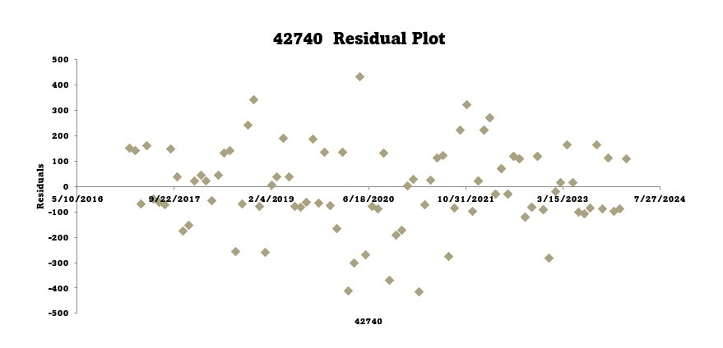

**Figure 5.** Line Fit Plot - This plot represents the estimated value for that particular month with the bold line and the scatter plots represent the number of residual items.

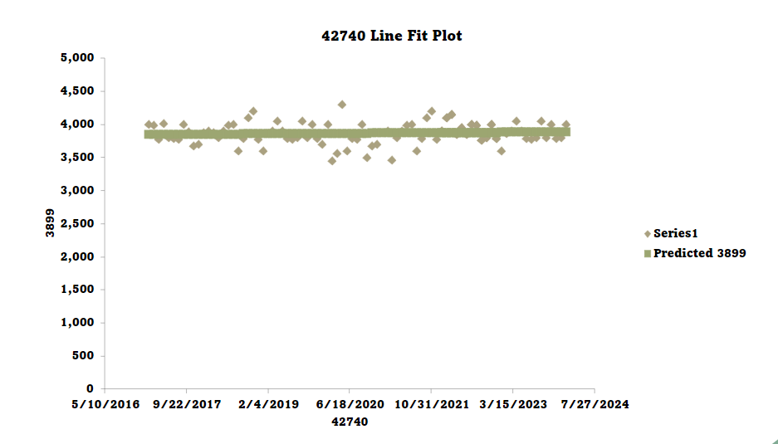

**Figure 6.** Normal Probability Plot - This plot represents the distribution of the sales data over the period of time.

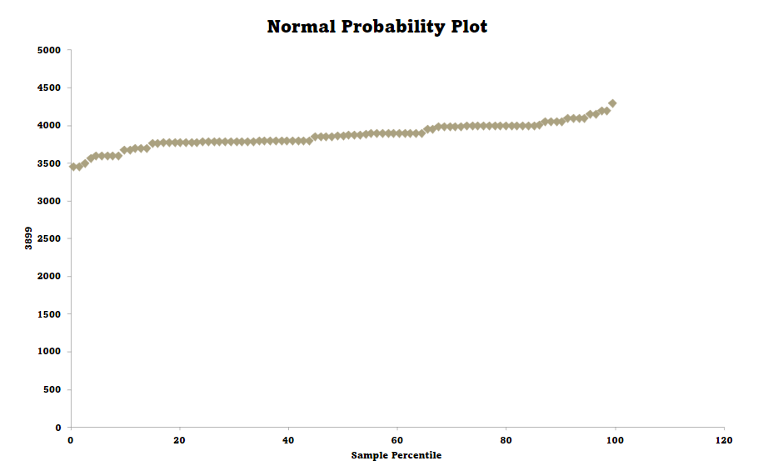

**Figure 7.** Forecast Results - This plot represents the forecast of the upcoming 2 years month wise. The red lines represent the upper confidence level and the lower confidence level.

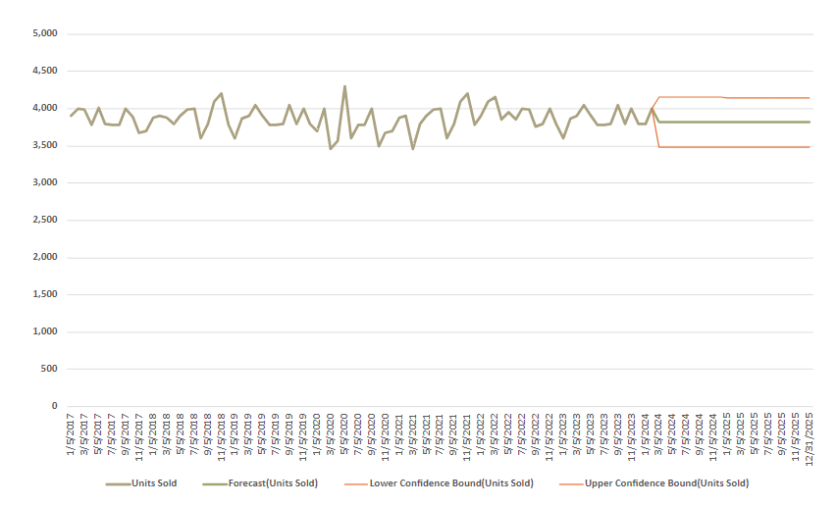

**4.2. Monte Carlo simulation technique**

We employed a Monte Carlo simulation technique to forecast future sales of Women's Apparel. This method generates multiple simulated scenarios based on historical sales data and assumed growth rates. We first calculated the historical growth rate from the sales data and then used this rate to simulate future sales values.

We generated a range of possible sales outcomes by conducting 1000 simulations for the next 12 months. The mean sales forecast provided us with the average expected sales for each month, while the 95% confidence interval gave us a measure of the forecast's uncertainty. This technique allowed us to understand the potential range of sales outcomes better and make informed decisions to optimize our sales strategy.

**4.2.2. Results**

This table presents the mean sales forecast and the 95% confidence interval for each month's sales. The mean sales represent the average forecast, while the lower and upper bounds of the confidence interval provide a range within which we are 95% confident the true sales value will fall. These results can help make informed decisions regarding inventory management, marketing strategies, and financial planning for Women's Apparel sales.

**Table 4.** Monte Carlo Simulation Values: Women's Apparel Sales Forecast

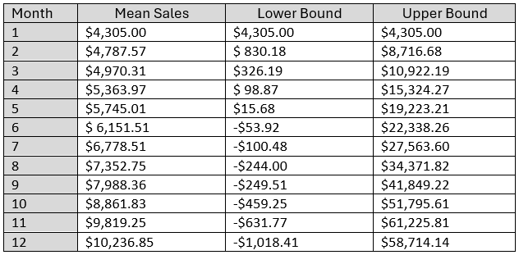

**Figure 4.** Illustrates the range of possible sales trajectories based on different simulation scenarios. It helps visualize the variability in sales outcomes and provides insights into potential sales trends.

**Figure 8.** provides a central estimate of future sales (mean sales) and shows the range within which we are 95% confident the true sales values will fall. It helps identify the most likely sales trajectory and the level of uncertainty in the forecast.

**RECOMMENDATION**

**5.1. Linear Regression for Sales Forecasting :**

Utilize linear regression to analyze historical sales data of women’s athletic footwear and uncover underlying patterns and relationships. Identify key factors influencing sales trends, such as seasonal variations, promotional activities, and product features. Develop a robust linear regression model that accurately predicts future sales based on these factors, providing valuable insights into demand forecasting.

**5.2. Monte Carlo Simulation for Risk Analysis :**

Monte Carlo Simulation to assess the uncertainty and variability in sales forecasts generated by the linear regression model. Analyze the range of potential outcomes and their probabilities using Monte Carlo simulation to understand the risk and uncertainty associated with sales projection.

**5.3. Integrated Approach for Strategic Planning:**

Combining the insights from linear regression (sales patterns, influential factors) with Monte Carlo simulation (risk analysis, variability) to develop a comprehensive sales forecasting and risk management strategy.​ The results from both techniques can be used to inform strategic planning decisions, such as inventory management, production scheduling, marketing campaigns, and financial forecasting.​Base strategic decisions on actionable insights derived from predictive models, ensuring alignment with market trends, customer preferences, and business objectives.

**CONCLUSION**

**6.1. Linear Regression**

The linear regression provides valuable insights to inform business strategies and improve decision-making processes. By understanding historical sales patterns and leveraging predictive modeling techniques, retailers can better anticipate market trends, optimize inventory management, and enhance their overall competitiveness in the fashion industry. This project achieved an accuracy of 96%, demonstrating the power of data analysis in uncovering actionable insights that drive business success in the dynamic and ever-evolving fashion market.

**6.2. Monte Carlo**

In conclusion, our Women's Apparel sales data analysis has provided valuable insights into sales trends and forecasts. The Monte Carlo simulation revealed a mean sales forecast with a 95% confidence interval, indicating the range within which we are highly confident the true sales values will fall. This analysis can help us make informed decisions regarding inventory management, marketing strategies, and financial planning for Women's Apparel. The exploratory data analysis also highlighted the historical sales trends and patterns, providing a basis for understanding the current sales performance. These insights can guide our efforts to optimize sales and enhance profitability in the Women's Apparel segment.

THANK YOU