DevOps Assignment 3

# Introduction

This report outlines the steps taken to configure and manage a secure, monitored, and well-maintained development environment for two developers, Sarah and Mike, at TechCorp. The tasks cover system monitoring setup, user management and access control, and backup configuration for web servers. Each task is detailed with commands used, implementation steps, and sample outputs.

# Task 1: System Monitoring Setup

Objective: Configure a monitoring system to ensure the development environment’s health, performance, and capacity planning.  
Scenario: The development server is reporting intermittent performance issues. New developers need visibility into system resource usage for their tasks. System metrics must be consistently tracked for effective capacity planning.  
Requirements:  
- Install and configure monitoring tools (htop or nmon).  
- Monitor disk usage using df and du.  
- Identify resource-intensive processes.  
- Create basic reports saved to log files.

* 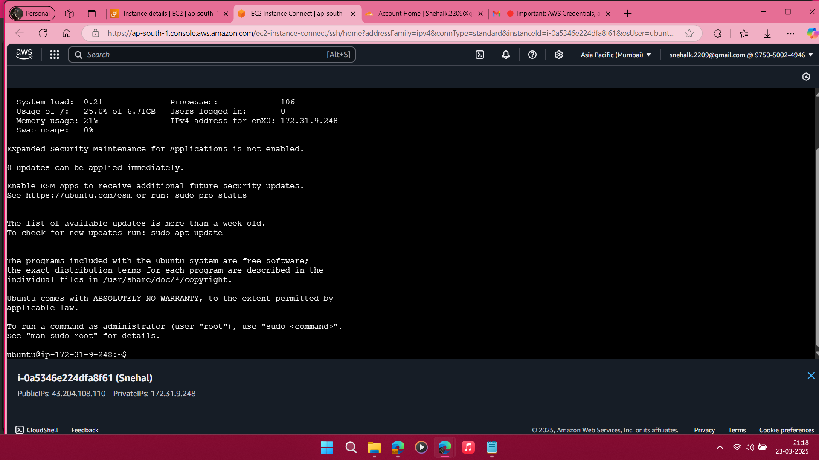Implementation Steps:

Create Linux Ubuntu Instance and connect to instance

1. Install htop and nmon: Run the following commands for monitoring system statistics

sudo apt update  
sudo apt install htop nmon -y

2. Monitor CPU, Memory, and Processes using htop or nmon.

Run top command: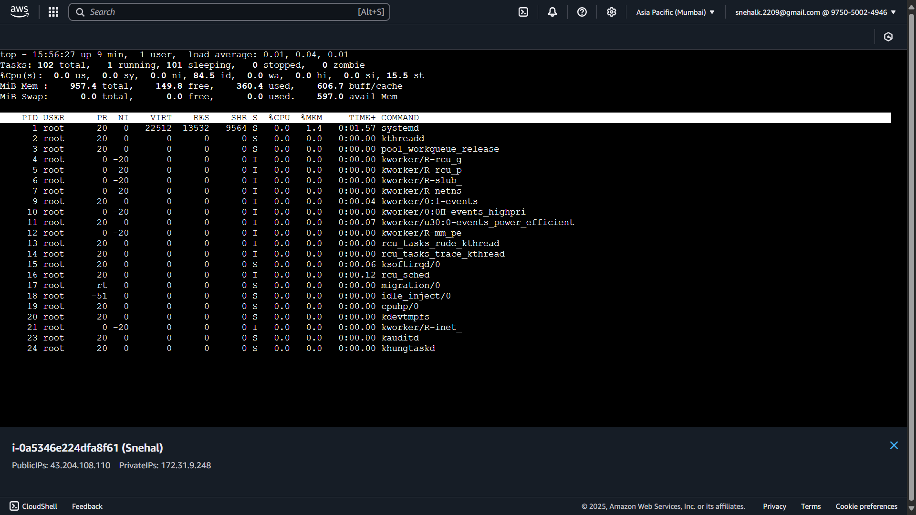

Run htop command: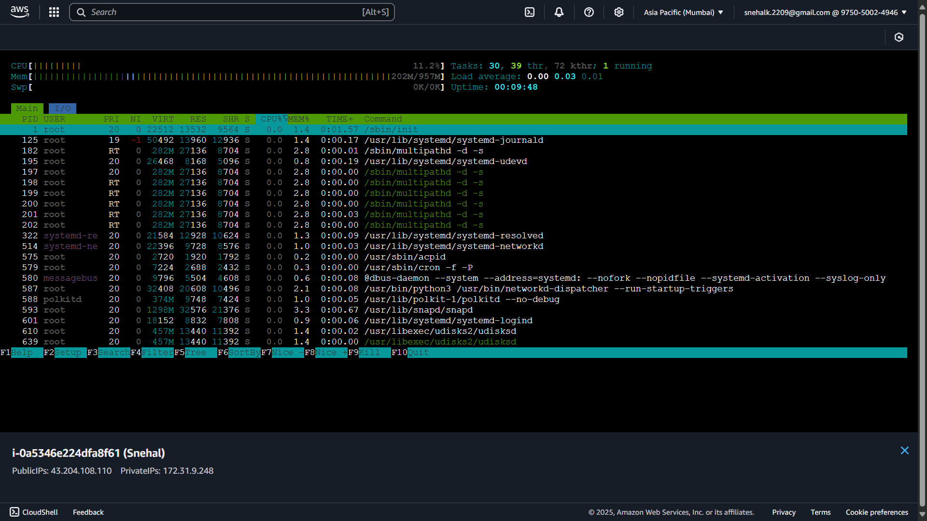

Press c to check CPU utilization:

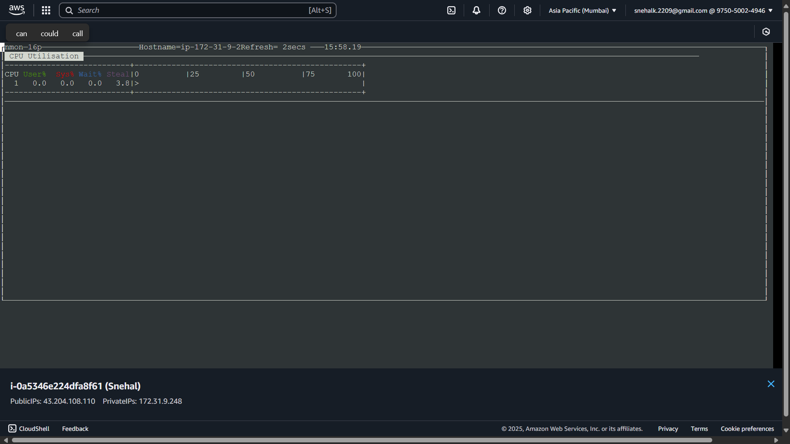

Press C to check detailed CPU utilization: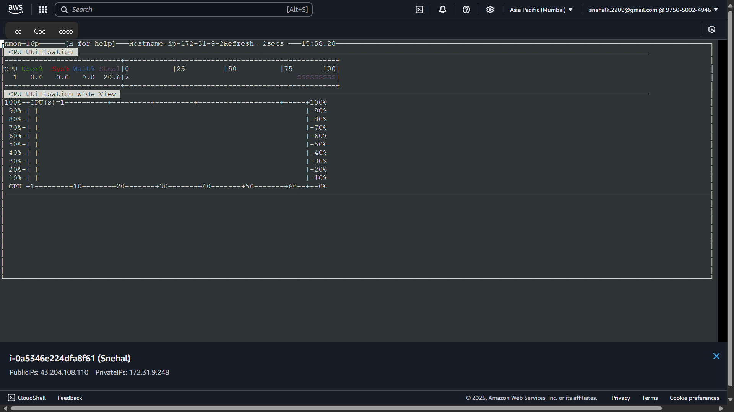

3. Disk Usage Monitoring: Run following command

df -h > /var/log/disk_usage_report.log  
du -sh /home/* >> /var/log/disk_usage_report.log

4. Reporting: Logs were saved in /var/log for future review and analysis.

***cat /var/log/disk_usage_report.log***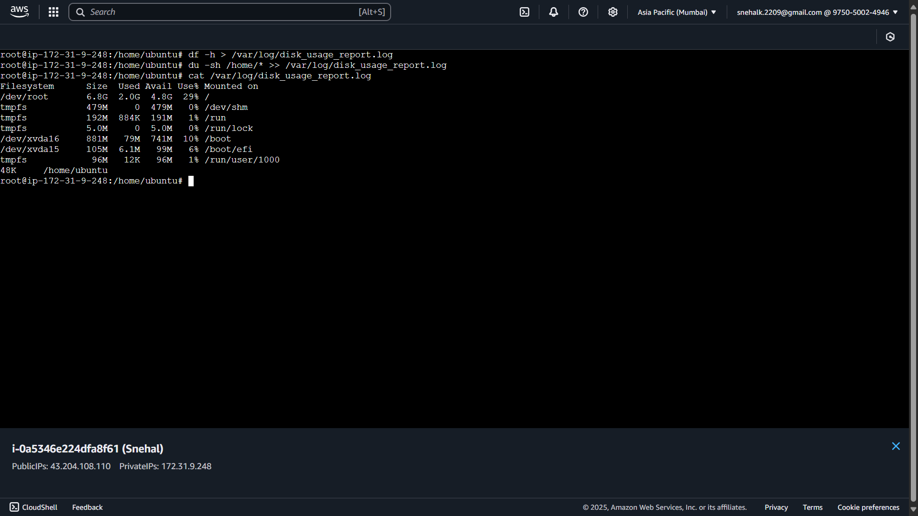

# Task 2: User Management and Access Control

Objective: Set up user accounts and configure secure access controls for the new developers.  
Scenario: Sarah and Mike require isolated, secure environments for development tasks. Proper user management and password policies must be enforced.  
Requirements:  
- Create user accounts for Sarah and Mike.  
- Set up dedicated workspace directories.  
- Restrict access permissions.  
- Enforce password expiration and complexity policies.

* Implementation Steps:

1. Create Users:  
sudo useradd -m Sarah  
sudo useradd -m mike  
sudo passwd Sarah  
sudo passwd mike

2. Setup Workspace Directories:  
sudo mkdir /home/Sarah/workspace  
sudo mkdir /home/mike/workspace

3. Set Ownership and Permissions:  
sudo chown Sarah:Sarah /home/Sarah/workspace  
sudo chmod 700 /home/Sarah/workspace  
sudo chown mike:mike /home/mike/workspace  
sudo chmod 700 /home/mike/workspace

4. Enforce Password Policy:  
Edit /etc/login.defs and set:  
PASS_MAX_DAYS 30

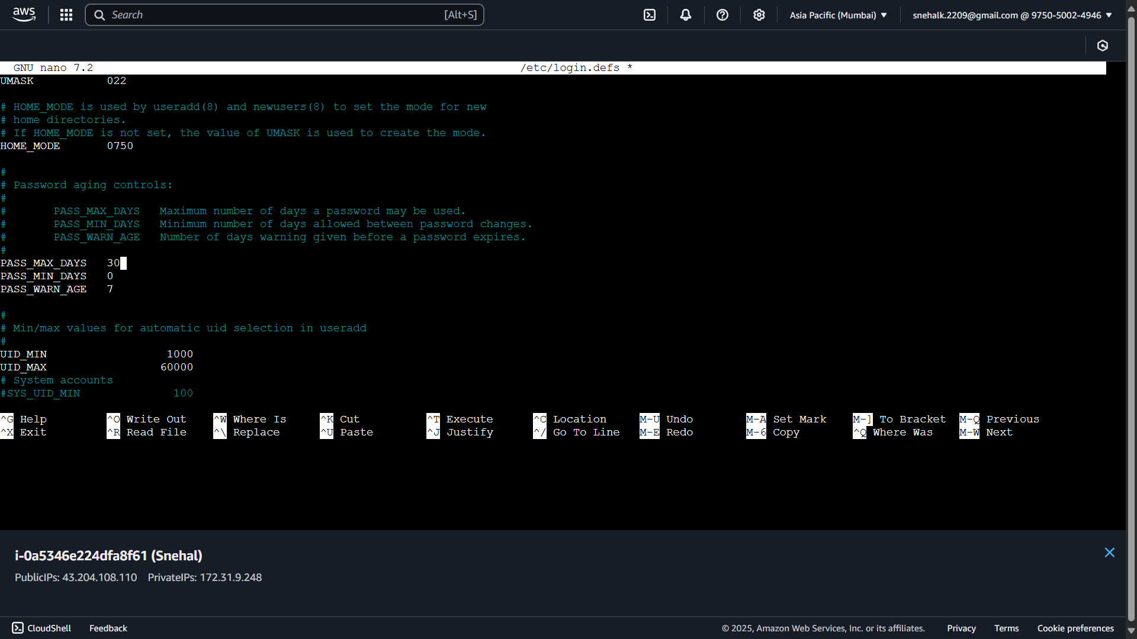  
PASS_MIN_LEN 8

Then apply:  
sudo chage -M 30 Sarah  
sudo chage -M 30 mike

# Task 3: Backup Configuration for Web Servers

Objective: Configure automated backups for Apache and Nginx web servers to ensure data integrity and disaster recovery.  
Scenario: Sarah manages the Apache server, while Mike manages the Nginx server. Each must automate and verify backups weekly.  
Requirements:  
- Backup configurations and document roots.  
- Automate backups via cron jobs.  
- Name backups with date stamps.  
- Verify backup integrity.

* Implementation Steps:

1. Create Backup Directory:  
sudo mkdir -p /backups

* 2. Create Backup Scripts:  
  For Sarah: login from sarah’s account ***su sarah*** and enter password ***Sarah@123***

Creating script file and ***nano /home/Sarah/workspace/apache_backup.sh*** add following script and save file

#!/bin/bash  
DATE=$(date +%F)  
tar -czvf /backups/apache_backup_$DATE.tar.gz /etc/httpd/ /var/www/html/  
ls -lh /backups/apache_backup_$DATE.tar.gz > /backups/apache_backup_verify_$DATE.log

Change file permission: chmod +x /home/Sarah/apache_backup.sh

* Setup Cron Jobs:  
  ***crontab -e***  
  Add the following lines:

0 0 * * 2 /home/Sarah/workspace/apache_backup.sh

* For Mike: login from mike’s account ***su mike*** and enter password ***Mike@123***

Creating script file and ***nano /home/Mike/workspace/nginx_backup.sh*** add following script and save file

#!/bin/bash  
DATE=$(date +%F)  
tar -czvf /backups/nginx_backup_$DATE.tar.gz /etc/nginx/ /usr/share/nginx/html/  
ls -lh /backups/nginx_backup_$DATE.tar.gz > /backups/nginx_backup_verify_$DATE.log

Change file permission:

chmod +x home/Mike/workspace/nginx_backup.sh

* Setup Cron Jobs:  
  crontab -e  
  Add the following lines:

0 0 * * 2 /home/mike/workspace/nginx_backup.sh

* 3. Backup Verification:  
  Verifying using `ls -lh` to confirm files and log contents.