- Create Database and Use It.
CREATE DATABASE CollegeDB;
USE CollegeDB;

- Create Tables:
CREATE TABLE Department (
DeptID INT PRIMARY KEY,
DeptName VARCHAR(50) NOT NULL
);
CREATE TABLE Student (
RollNo INT PRIMARY KEY,
Name VARCHAR(50) NOT NULL,
Gender VARCHAR(10),
City VARCHAR(30),
Marks INT,
DeptID INT,
FOREIGN KEY (DeptID) REFERENCES Department(DeptID)
);

3) Insert Records
Insert into Department
INSERT INTO Department VALUES
(1, 'Computer Science'),
(2, 'Data Science'),
(3, 'Cyber Security');

Insert into Student
INSERT INTO Student VALUES
(101, 'Amit Patil', 'Male', 'Pune', 78, 1),
(102, 'Neha Sharma', 'Female', 'Mumbai', 85, 2),
(103, 'Rohit Deshmukh', 'Male', 'Pune', 66, 1),
(104, 'Priya Kulkarni', 'Female', 'Nashik', 91, 3),
(105, 'Kiran Joshi', 'Male', 'Mumbai', 72, 2);
INSERT INTO Student VALUES
(101, 'Amit Patil', 'Male', 'Pune', 78, 1),
(102, 'Neha Sharma', 'Female', 'Mumbai', 85, 2),
(103, 'Rohit Deshmukh', 'Male', 'Pune', 66, 1),
(104, 'Priya Kulkarni', 'Female', 'Nashik', 91, 3),
(105, 'Kiran Joshi', 'Male', 'Mumbai', 72, 2);
Query 1) Display all students
SELECT * FROM Student;
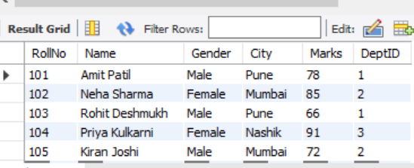

Query 2) Display only Name and Marks of students.
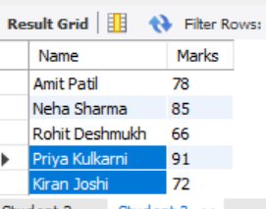

SELECT Name, Marks FROM Student;


Query 3) Display students with Marks ≥ 80
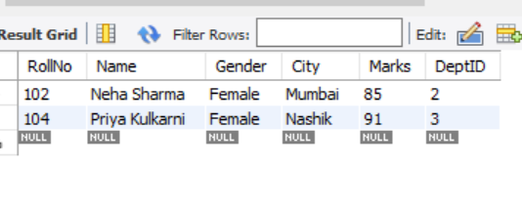
SELECT * FROM Student
WHERE Marks >= 80;
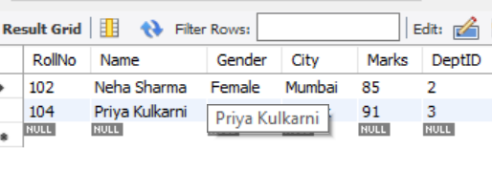

4) Display students from Pune
SELECT * FROM Student
WHERE City = 'Pune';
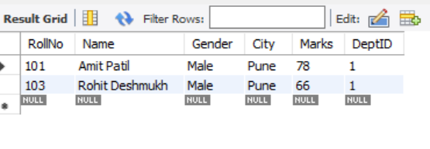
5) Display students sorted by Marks (Highest first)
SELECT * FROM Student
ORDER BY Marks DESC;
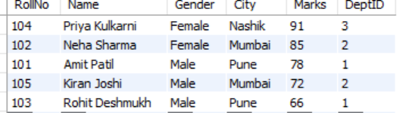

6) Count total number of students
SELECT COUNT(*) AS TotalStudents FROM Student;
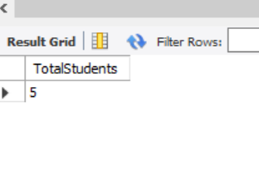
7) Find average marks of all students
SELECT AVG(Marks) AS AverageMarks FROM Student;
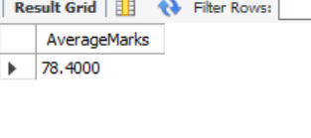
8) Find maximum and minimum marks
SELECT MAX(Marks) AS MaxMarks, MIN(Marks) AS MinMarks FROM Student;
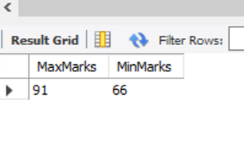
9) Display department-wise student count
SELECT DeptID, COUNT(*) AS StudentCount
FROM Student
GROUP BY DeptID;
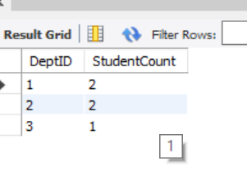
10) Display students along with Department Name (JOIN)
SELECT s.RollNo, s.Name, s.City, s.Marks, d.DeptName
FROM Student s
JOIN Department d ON s.DeptID = d.DeptID
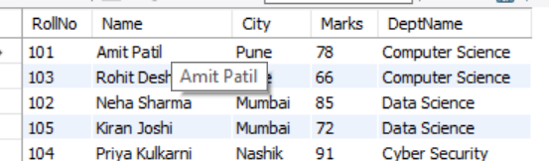

11) Display students of “Data Science” department
SELECT s.RollNo, s.Name, s.Marks, d.DeptName
FROM Student s
JOIN Department d ON s.DeptID = d.DeptID
WHERE d.DeptName = 'Data Science';
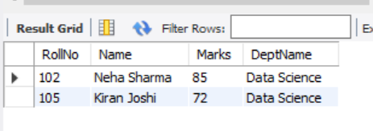

Step 1: Create Database
CREATE DATABASE CollegeDB;
USE CollegeDB;

Step 2: Create Student Table
CREATE TABLE Student (
StudentID INT PRIMARY KEY,
Name VARCHAR(50),
Dept VARCHAR(30),
Marks INT,
City VARCHAR(30)
);

Step 3: Insert Sample Records
INSERT INTO Student VALUES
(1, 'Amit', 'CSE', 80, 'Pune'),
(2, 'Neha', 'CSE', 90, 'Mumbai'),
(3, 'Rohit', 'AIML', 70, 'Pune'),
(4, 'Priya', 'CSE', 85, 'Nashik'),
(5, 'Omkar', 'AIML', 75, 'Mumbai'),
(6, 'Sneha', 'DSAI', 88, 'Pune'),
(7, 'Raj', 'DSAI', 92, 'Mumbai');
OUTPUT:
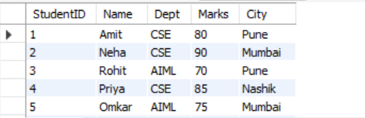
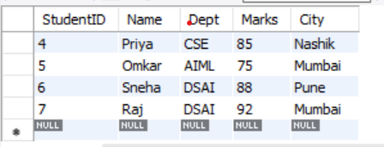

ORDER BY Examples
Example 1: Sort students by Marks (Ascending)
SELECT * FROM Student ORDER BY Marks;
OUTPUT:
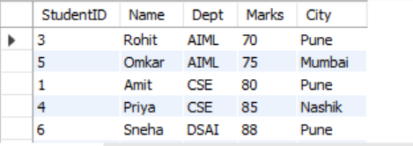
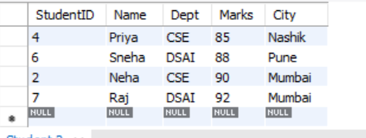

Example 2: Sort students by Marks (Descending)
SELECT * FROM Student ORDER BY Marks DESC;
OUTPUT:
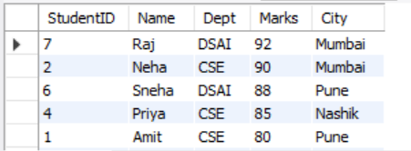
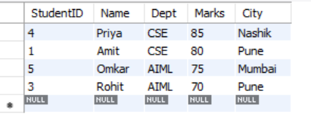

Example 3: Sort by Department then Marks
SELECT * FROM Student ORDER BY Dept ASC, Marks DESC;
OUTPUT:
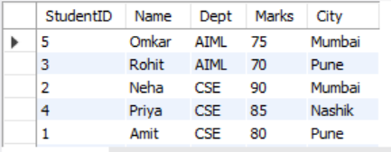
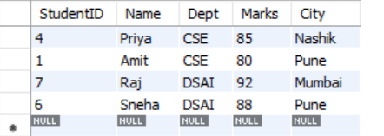

GROUP BY Examples
Example 1: Count students department-wise
SELECT Dept, COUNT(*) AS Total_Students FROM Student GROUP BY Dept;
OUTPUT:
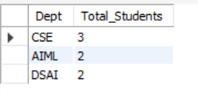
Example 2: Average marks department-wise
SELECT Dept, AVG(Marks) AS Average_Marks FROM Student GROUP BY Dept;
OUTPUT:
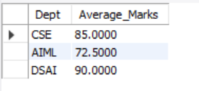
Example 3: Maximum marks department-wise
SELECT Dept, MAX(Marks) AS Highest_Marks FROM Student GROUP BY Dept;
OUTPUT:
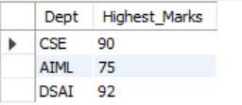
Example 4: City-wise total students
SELECT City, COUNT(*) AS Total FROM Student GROUP BY City;
OUTPUT:
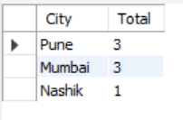

HAVING Examples
Example 1: Departments having more than 2 students
SELECT Dept, COUNT(*) AS Total_Students FROM Student GROUP BY Dept HAVING COUNT(*) > 2;
OUTPUT:
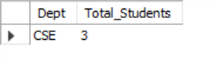

Example 2: Departments with average marks greater than 80
SELECT Dept, AVG(Marks) AS Average_Marks FROM Student GROUP BY Dept HAVING AVG(Marks) > 80;
OUTPUT:
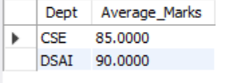

Example 3: Cities having more than 1 student
SELECT City, COUNT(*) AS Total FROM Student GROUP BY City HAVING COUNT(*) > 1;
OUTPUT:
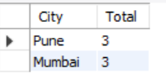

Combined Example (GROUP BY + HAVING + ORDER BY)
SELECT Dept, AVG(Marks) AS Average_Marks
FROM Student
GROUP BY Dept
HAVING AVG(Marks) > 75
ORDER BY Average_Marks DESC;
OUTPUT:
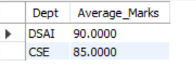

1) Create Database and Table
CREATE DATABASE LabDB;
USE LabDB;
CREATE TABLE Student (
StudentID INT PRIMARY KEY,
Name VARCHAR(50) NOT NULL,
Dept VARCHAR(30),
City VARCHAR(30),
CGPA DECIMAL(3,2),
Email VARCHAR(60)
);
INSERT INTO Student (StudentID, Name, Dept, City, CGPA, Email) VALUES
(101,'Amit Patil','CSE','Pune',8.45,'amit101@jspm.edu'),
(102,'Neha Joshi','CSE','Mumbai',9.10,'neha102@jspm.edu'),
(103,'Rohit Deshmukh','AIML','Pune',7.80,'rohit103@jspm.edu'),
(104,'Priya Kulkarni','DSAI','Nashik',8.90,'priya104@jspm.edu'),
(105,'Omkar Shinde','CSE','Pune',7.20,'omkar105@jspm.edu');
SELECT *FROM Student
OUTPUT:
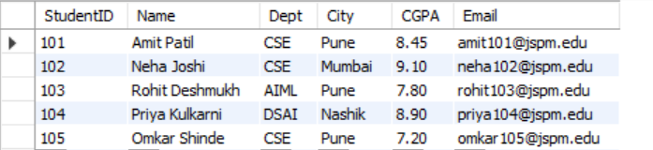
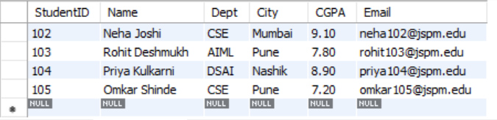
3) Create Index on a Column (Dept)
CREATE INDEX idx_dept ON Student(Dept);
OUTPUT:

4) Create Composite Index (Dept + City)
CREATE INDEX idx_dept_city ON Student(Dept, City);
OUTPUT:
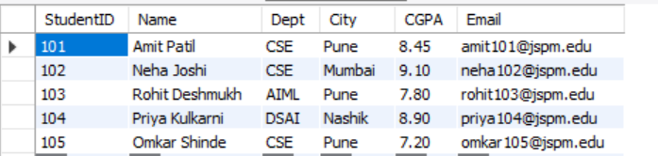
5) Create Unique Index (Email)
CREATE UNIQUE INDEX idx_unique_email ON Student(Email);
OUTPUT:
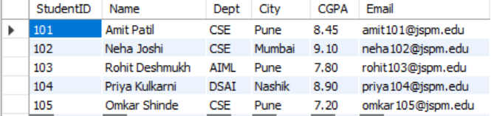

6) View Indexes
SHOW INDEX FROM Student;
OUTPUT:
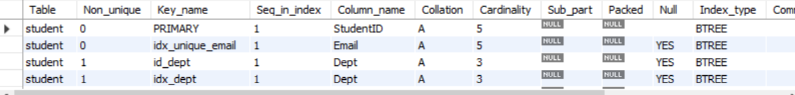

7) Performance Check Using EXPLAIN
EXPLAIN SELECT * FROM Student WHERE Dept='CSE';
EXPLAIN SELECT * FROM Student
WHERE Dept='CSE' AND City='Pune';
OUTPUT:

8) Drop an Index
DROP INDEX idx_dept ON Student;
OUTPUT:

1) Create Database & Table
CREATE DATABASE IF NOT EXISTS msc_db;
USE msc_db;
DROP TABLE IF EXISTS student_marks;
CREATE TABLE student_marks (
roll_no INT PRIMARY KEY,
name VARCHAR(50),
marks INT,
grade CHAR(2)
);
2) Insert Sample Data
INSERT INTO student_marks (roll_no, name, marks, grade) VALUES
(1, 'Amit', 92, NULL),
(2, 'Neha', 76, NULL),
(3, 'Ravi', 61, NULL),
(4, 'Pooja', 48, NULL),
(5, 'Imran', 35, NULL);
OUTPUT:
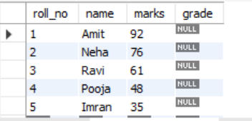
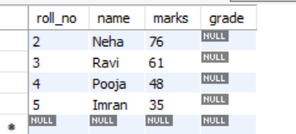
3) Cursor-Based Stored Procedure (Grade Assignment)
DELIMITER $$
DROP PROCEDURE IF EXISTS assign_grades $$
CREATE PROCEDURE assign_grades()
BEGIN
-- Variables to hold fetched values
DECLARE v_roll INT;
DECLARE v_marks INT;
DECLARE v_grade CHAR(2);
-- Cursor control variable
DECLARE done INT DEFAULT 0;
-- Declare cursor
DECLARE cur_students CURSOR FOR
SELECT roll_no, marks FROM student_marks;
-- Handler: when cursor finishes, set done = 1
DECLARE CONTINUE HANDLER FOR NOT FOUND SET done = 1;
-- Open cursor
OPEN cur_students;
grade_loop: LOOP
-- Fetch row into variables
FETCH cur_students INTO v_roll, v_marks;
-- Exit loop when no more rows
IF done = 1 THEN
LEAVE grade_loop;
END IF;
-- Grade logic
IF v_marks >= 90 THEN
SET v_grade = 'A';
ELSEIF v_marks >= 75 THEN
SET v_grade = 'B';
ELSEIF v_marks >= 60 THEN
SET v_grade = 'C';
ELSEIF v_marks >= 40 THEN
SET v_grade = 'D';
ELSE
SET v_grade = 'F';
END IF;
-- Update grade
UPDATE student_marks
SET grade = v_grade
WHERE roll_no = v_roll;
END LOOP;
-- Close cursor
CLOSE cur_students;
END $$
DELIMITER ;
OUTPUT:
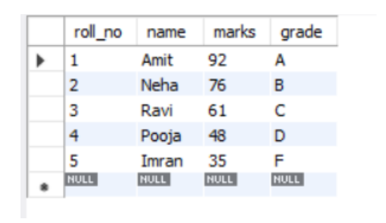

CREATE DATABASE college_db;
USE college_db;
CREATE TABLE student (
sid INT PRIMARY KEY,
sname VARCHAR(50),
course VARCHAR(50)
);
INSERT INTO student VALUES
(1, 'Amit', 'BSc CS'),
(2, 'Priya', 'BCA'),
(3, 'Rahul', 'BTech');
CREATE USER 'student_user'@'localhost' IDENTIFIED BY 'stud123';
GRANT SELECT ON college_db.student TO 'student_user'@'localhost';
FLUSH PRIVILEGES;
SHOW GRANTS FOR 'student_user'@'localhost';
GRANT INSERT ON college_db.student TO 'student_user'@'localhost';
REVOKE INSERT ON college_db.student FROM 'student_user'@'localhost';
GRANT ALL PRIVILEGES ON college_db.* TO 'student_user'@'localhost';
REVOKE ALL PRIVILEGES ON college_db.* FROM 'student_user'@'localhost';
FLUSH PRIVILEGES;
OUTPUT:
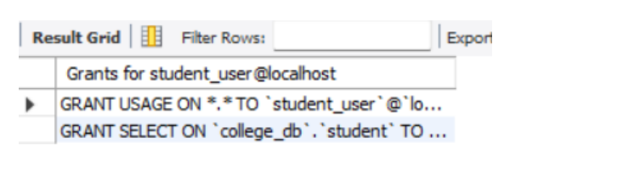

CREATE TABLE Student (
id INT,
name VARCHAR(50),
marks INT,
dept_id INT
);

CREATE TABLE Department (
dept_id INT,
dept_name VARCHAR(50)
);
INSERT INTO Student VALUES
(1, 'Neha', 85, 101),
(2, 'Riya', 90, 102),
(3, 'Amit', 75, 101),
(4, 'Raj', 60, 103);
INSERT INTO Department VALUES
(101, 'Computer'),
(102, 'IT'),
(103, 'Mechanical');
SELECT name
FROM Student
WHERE dept_id IN (
SELECT dept_id
FROM Department
WHERE dept_name = 'Computer'
);
OUTPUT:
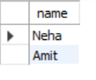
CREATE TABLE Employee (
emp_id INT,
emp_name VARCHAR(50),
salary DECIMAL(10,2),
department VARCHAR(50)
);

-- Create Log table
CREATE TABLE Employee_Log (
log_id INT AUTO_INCREMENT PRIMARY KEY,
emp_id INT,
action_performed VARCHAR(20),
action_time DATETIME
);

-- Create Trigger
DELIMITER $$

CREATE TRIGGER emp_after_insert
AFTER INSERT ON Employee
FOR EACH ROW
BEGIN
INSERT INTO Employee_Log(emp_id, action_performed, action_time)
VALUES (NEW.emp_id, 'INSERT', NOW());
END$$

DELIMITER ;

-- Insert data (this will fire trigger)
INSERT INTO Employee VALUES (1, 'Rahul Sharma', 50000, 'HR');

OUTPUT:

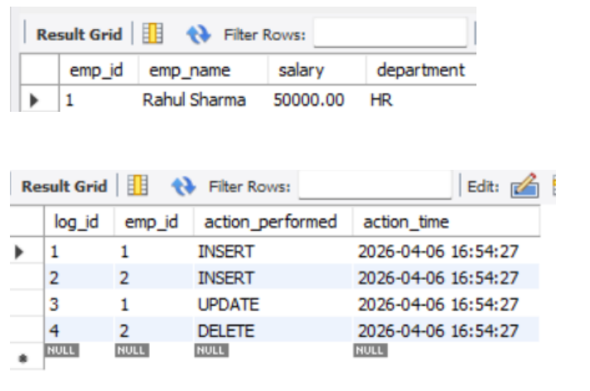

CREATE DATABASE IF NOT EXISTS HotelManagementDB;
USE HotelManagementDB;
DROP TABLE IF EXISTS payments;
DROP TABLE IF EXISTS bookings;
DROP TABLE IF EXISTS rooms;
DROP TABLE IF EXISTS customers;
DROP TABLE IF EXISTS staff;
CREATE TABLE customers (
customer_id INT PRIMARY KEY,
first_name VARCHAR(50),
last_name VARCHAR(50),
address TEXT,
id_proof VARCHAR(50)
);
CREATE TABLE rooms (
room_id INT PRIMARY KEY,
room_number VARCHAR(10),
room_type VARCHAR(30),
price_per_night DECIMAL(10,2),
status VARCHAR(20)
);
CREATE TABLE bookings (
booking_id INT PRIMARY KEY,
customer_id INT,
room_id INT,
check_in DATE,
check_out DATE,
total_amount DECIMAL(10,2),
booking_status VARCHAR(20),
FOREIGN KEY (customer_id) REFERENCES customers(customer_id),
FOREIGN KEY (room_id) REFERENCES rooms(room_id)
);
CREATE TABLE payments (
payment_id INT PRIMARY KEY,
booking_id INT,
payment_date DATE,
amount DECIMAL(10,2),
payment_method VARCHAR(30),
FOREIGN KEY (booking_id) REFERENCES bookings(booking_id)
);
CREATE TABLE staff (
staff_id INT PRIMARY KEY,
name VARCHAR(100),
role VARCHAR(50),
phone VARCHAR(15),
salary DECIMAL(10,2)
);
-- Staff
INSERT INTO staff VALUES
(101, 'Amit Verma', 'Manager', '9876543210', 45000.00);

-- Room
INSERT INTO rooms VALUES
(201, 'A-101', 'Deluxe', 3500.00, 'Available');

-- Customer
INSERT INTO customers VALUES
(1, 'Rahul', 'Sharma', 'Mumbai, India', 'Aadhar1234');

-- Booking
INSERT INTO bookings VALUES
(501, 1, 201, '2026-04-10', '2026-04-12', 7000.00, 'Confirmed');

-- Payment
INSERT INTO payments VALUES
(901, 501, '2026-04-10', 7000.00, 'Credit Card');
SELECT
b.booking_id,
c.first_name,
r.room_number,
b.total_amount
FROM bookings b
JOIN customers c ON b.customer_id = c.customer_id
JOIN rooms r ON b.room_id = r.room_id;
OUTPUT:
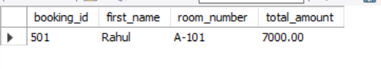

CREATE DATABASE IF NOT EXISTS UniversityDB;
USE UniversityDB;
DROP TABLE IF EXISTS Enrollment;
DROP TABLE IF EXISTS Course;
DROP TABLE IF EXISTS Faculty;
DROP TABLE IF EXISTS Student;
DROP TABLE IF EXISTS Department;
CREATE TABLE Department (
dept_id INT PRIMARY KEY AUTO_INCREMENT,
dept_name VARCHAR(100) NOT NULL
);
CREATE TABLE Student (
student_id INT PRIMARY KEY AUTO_INCREMENT,
first_name VARCHAR(50),
last_name VARCHAR(50),
email VARCHAR(100) UNIQUE,
phone VARCHAR(15),
dept_id INT,
FOREIGN KEY (dept_id) REFERENCES Department(dept_id)
);
CREATE TABLE Faculty (
faculty_id INT PRIMARY KEY AUTO_INCREMENT,
name VARCHAR(100),
email VARCHAR(100) UNIQUE,
phone VARCHAR(15),
dept_id INT,
FOREIGN KEY (dept_id) REFERENCES Department(dept_id)
);
CREATE TABLE Course (
course_id INT PRIMARY KEY AUTO_INCREMENT,
course_name VARCHAR(100),
credits INT,
dept_id INT,
FOREIGN KEY (dept_id) REFERENCES Department(dept_id)
);
CREATE TABLE Enrollment (
enrollment_id INT PRIMARY KEY AUTO_INCREMENT,
student_id INT,
course_id INT,
enrollment_date DATE,
grade CHAR(2),
FOREIGN KEY (student_id) REFERENCES Student(student_id),
FOREIGN KEY (course_id) REFERENCES Course(course_id)
);
-- Departments
INSERT INTO Department (dept_name) VALUES
('Computer Science'),
('Mechanical'),
('Civil');

-- Students
INSERT INTO Student (first_name, last_name, email, phone, dept_id) VALUES
('Amit', 'Patil', 'amit@gmail.com', '9876543210', 1),
('Neha', 'Sharma', 'neha@gmail.com', '9876501234', 2);

-- Faculty
INSERT INTO Faculty (name, email, phone, dept_id) VALUES
('Dr. Rao', 'rao@gmail.com', '9999999999', 1),
('Dr. Mehta', 'mehta@gmail.com', '8888888888', 2);

-- Courses
INSERT INTO Course (course_name, credits, dept_id) VALUES
('DBMS', 4, 1),
('Thermodynamics', 3, 2);

-- Enrollment
INSERT INTO Enrollment (student_id, course_id, enrollment_date, grade) VALUES
(1, 1, '2026-04-01', 'A'),
(2, 2, '2026-04-02', 'B');
SELECT * FROM Student;
SELECT
s.first_name,
s.last_name,
d.dept_name
FROM Student s
JOIN Department d
ON s.dept_id = d.dept_id;
SELECT
s.first_name,
c.course_name,
e.enrollment_date,
e.grade
FROM Enrollment e
JOIN Student s
ON e.student_id = s.student_id
JOIN Course c
ON e.course_id = c.course_id;
OUTPUT:
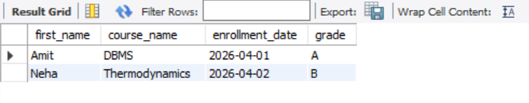

CREATE DATABASE IF NOT EXISTS EcommerceDB;
USE EcommerceDB;
DROP TABLE IF EXISTS Payments;
DROP TABLE IF EXISTS Order_Items;
DROP TABLE IF EXISTS Orders;
DROP TABLE IF EXISTS Products;
DROP TABLE IF EXISTS Customers;
CREATE TABLE Customers (
customer_id INT PRIMARY KEY AUTO_INCREMENT,
first_name VARCHAR(50),
last_name VARCHAR(50),
email VARCHAR(100) UNIQUE,
phone VARCHAR(15),
address VARCHAR(255)
);
CREATE TABLE Products (
product_id INT PRIMARY KEY AUTO_INCREMENT,
product_name VARCHAR(100),
category VARCHAR(50),
price DECIMAL(10,2),
stock INT
);
CREATE TABLE Orders (
order_id INT PRIMARY KEY AUTO_INCREMENT,
customer_id INT,
order_date DATE,
total_amount DECIMAL(10,2),
order_status VARCHAR(50),
FOREIGN KEY (customer_id) REFERENCES Customers(customer_id)
);
CREATE TABLE Order_Items (
order_item_id INT PRIMARY KEY AUTO_INCREMENT,
order_id INT,
product_id INT,
quantity INT,
price DECIMAL(10,2),
FOREIGN KEY (order_id) REFERENCES Orders(order_id),
FOREIGN KEY (product_id) REFERENCES Products(product_id)
);
CREATE TABLE Payments (
payment_id INT PRIMARY KEY AUTO_INCREMENT,
order_id INT,
payment_date DATE,
amount DECIMAL(10,2),
payment_method VARCHAR(50),
FOREIGN KEY (order_id) REFERENCES Orders(order_id)
);
-- Customers
INSERT INTO Customers (first_name, last_name, email, phone, address) VALUES
('Amit', 'Patil', 'amit@gmail.com', '9876543210', 'Pune'),
('Neha', 'Sharma', 'neha@gmail.com', '9876501234', 'Mumbai');

-- Products
INSERT INTO Products (product_name, category, price, stock) VALUES
('Laptop', 'Electronics', 60000, 10),
('Mobile', 'Electronics', 20000, 20),
('Shoes', 'Fashion', 2000, 50);

-- Orders
INSERT INTO Orders (customer_id, order_date, total_amount, order_status) VALUES
(1, '2026-04-01', 60000, 'Delivered'),
(2, '2026-04-02', 20000, 'Pending');

-- Order Items
INSERT INTO Order_Items (order_id, product_id, quantity, price) VALUES
(1, 1, 1, 60000),
(2, 2, 1, 20000);

-- Payments
INSERT INTO Payments (order_id, payment_date, amount, payment_method) VALUES
(1, '2026-04-01', 60000, 'UPI'),
(2, '2026-04-02', 20000, 'Card');
SELECT * FROM Customers;
SELECT
c.first_name,
c.last_name,
o.order_id,
o.total_amount,
o.order_status
FROM Customers c
JOIN Orders o
ON c.customer_id = o.customer_id;
SELECT
o.order_id,
p.product_name,
oi.quantity,
oi.price
FROM Order_Items oi
JOIN Orders o
ON oi.order_id = o.order_id
JOIN Products p
ON oi.product_id = p.product_id;
SELECT
o.order_id,
p.amount,
p.payment_method
FROM Payments p
JOIN Orders o
ON p.order_id = o.order_id;

OUTPUT:
