OpenDeepResearcher: Agentic LLM(Large Language Model) Research Framework

INSTALLATION CHECKS
Core Libraries and Frameworks:
LangChain: The Orchestrator
LangChain serves as the orchestration layer for the project, making it the essential tool for building sophisticated LLM applications. It provides standardized interfaces to connect with various Large Language Models (LLMs) and, crucially, integrates them with external resources. Its core functionality involves building "chains" of operations—like retrieving data from a database (using RAG), formatting a prompt, sending it to the model, and processing the output. This capability transforms a simple LLM query into a multi-step, data-aware application, which is fundamental for complex tasks like deep research and analysis.

LangGraph: The Workflow Controller
LangGraph is a specialized library built on LangChain, designed for implementing complex, robust stateful workflows using a graph structure. Unlike LangChain's linear chains, LangGraph allows you to define conditional transitions and cycles between steps. This is vital for building advanced multi-agent systems or self-correcting research loops where the application must assess a result, decide whether to loop back (e.g., search again) or proceed (e.g., summarize), and maintain a consistent state throughout the process.
Venv (Virtual Environment): The Isolator
A venv (virtual environment) is simply a way to create a separate, clean workspace for each Python project on your computer. Its main job is Isolation, which means the specific packages (like LangChain) you install for one project are kept completely separate from packages in your other projects. This prevents conflicts and ensures your code is reliable and works the same way for everyone, making it the most important first step for any development setup.

Screenshots of Installation: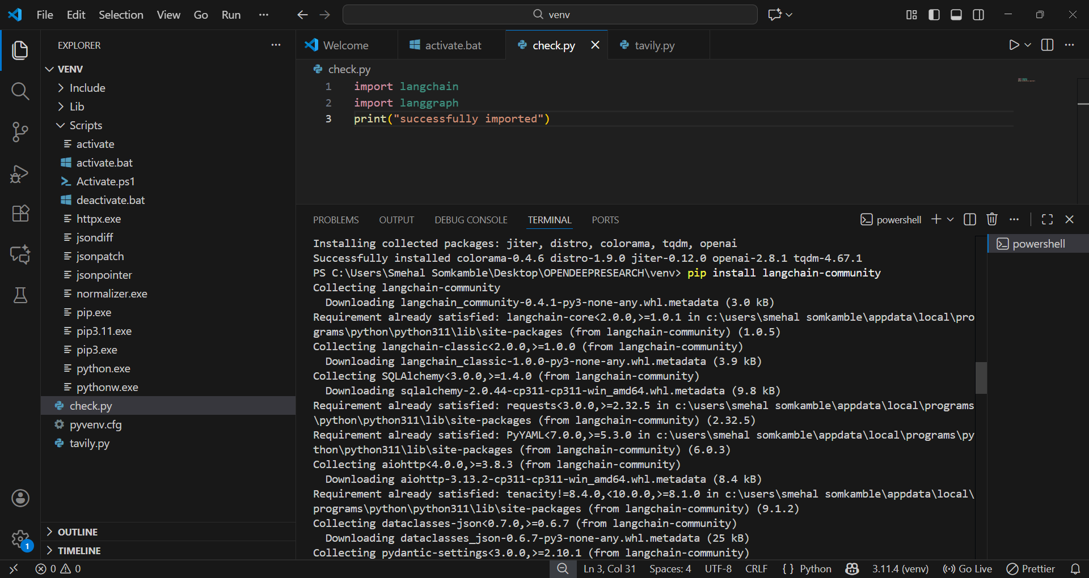
Langchain & Langgraph installed successfully
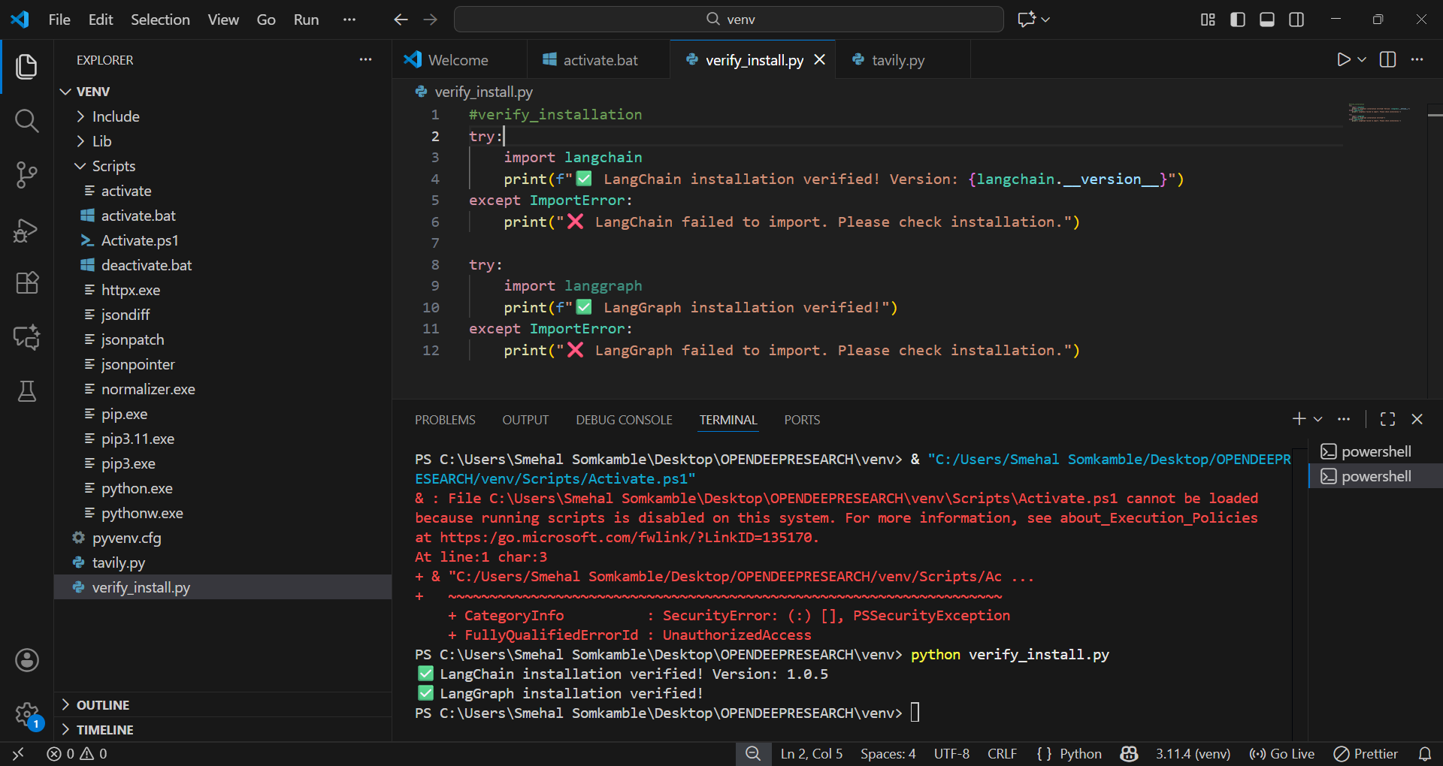

Tavily Installation:

