GITHUB Documentation

## GITHUB with Eclipse

### Upload **existing** project on GitHub:

1. Create a GitHub account and sign in.
2. Create a repository in the newly created account. This will be your remote repo.

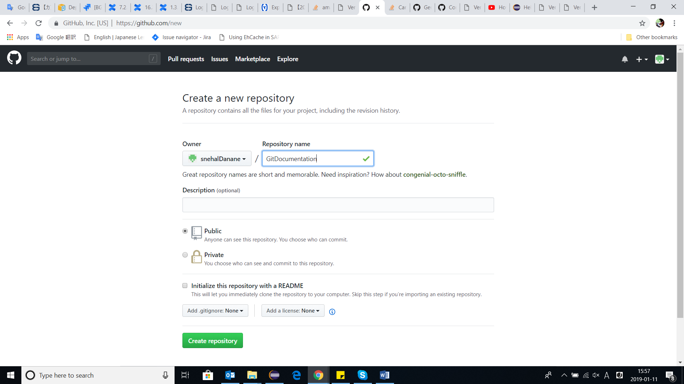

1. Open eclipse where the project to be uploaded exists. (If performing it for the first time, it is recommended to keep an extra backup copy of the project before going ahead).
2. Open the git perspective in eclipse: In quick search > Search for Git Repositories.
3. In this git repositories tab, click on ‘Clone a Git Repository’ (RHS corner).
4. Use the following guidelines to create clone the repo successfully.

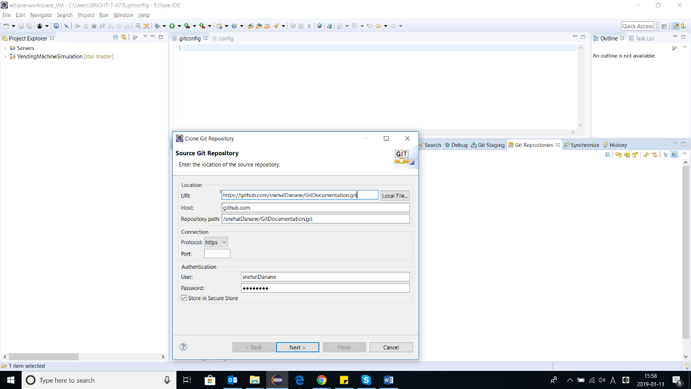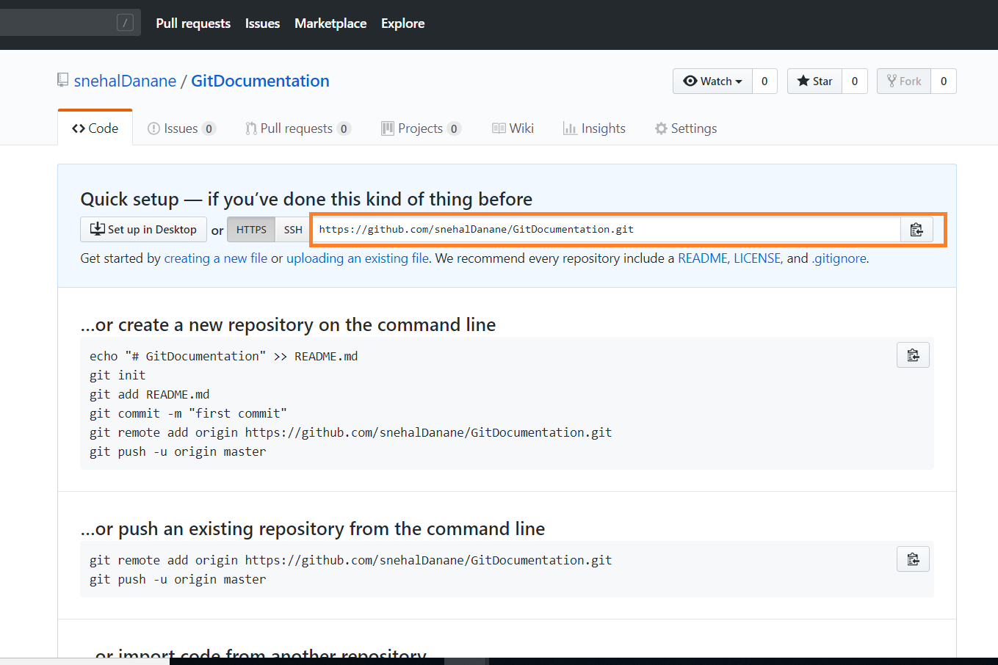

1. The following will be the destination of your local repo.
2. 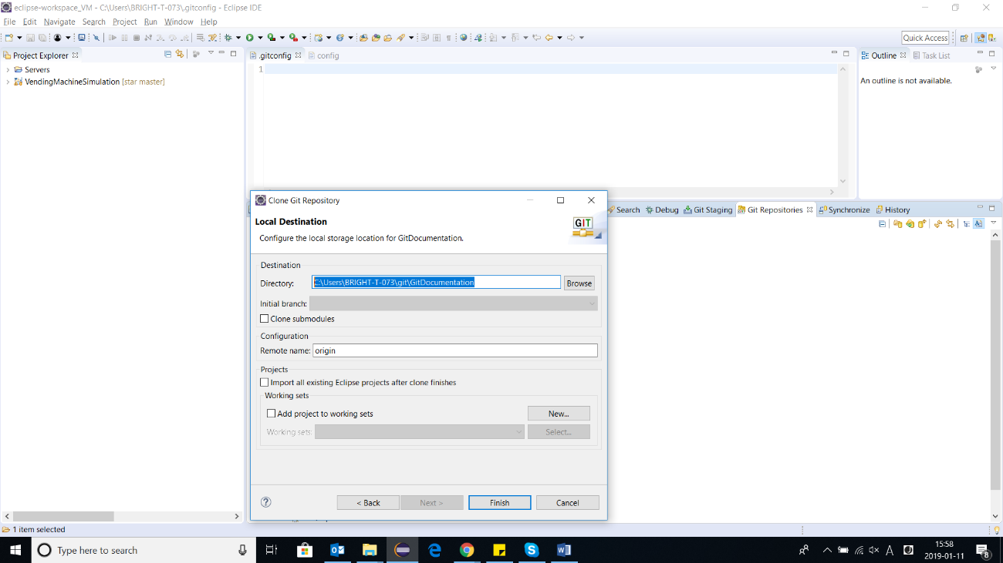Once the repository is cloned on local system without errors,
   1. Right click on your project > Team > Share project
   2. Select the newly created local repository (in step 6) from the dropdown.
3. Now your project can be used as a Git Project.
4. Next, right click on the project > Teams > Commit

A Git Staging tab shows the files for committing. Select the necessary files and click ‘Commit and Push’.

1. On completion of Push, remote GitHub will be populated the files committed.

**Note Before every commit it is recommended to make a ‘Pull’ from the remote repo.