**REPORT ON**

**STUDENT ACCOMMODATION WEB APPLICATION (INCREMENT 3)**

**Submitted by,**

**Manusha Reddy**

**Sneha Lagandula**

**Dheeraj Reddy**

**PG 11**

**IMPORT EXISTING SERVICES:**

In the third increment, bootstrap framework is integrated with web application to enhance the user interface of the application. Validations for all the log-in and registration forms have been created for student and administrator access. Database is created to store the details of students and to store the details of vacancies available at a particular place. Upon search for the accommodations at a particular location, all the details of the available vacancies along with google maps is provided. The google maps is used to check for the weather conditions at that particular locations as well as to calculate the distance from university to the desired location. Google and Twitter API are implemented to share the details of a certain available vacancy to public.

Hence, we used Facebook API, Geo Location API, Twitter API, and Direction Service in the third increment.

Geo Location API: https://developers.google.com/maps/documentation/business/geolocation/

Direction Service API: https://developers.google.com/maps/documentation/directions/

Facebook API: https://facebook.com/share/

Twitter API: <https://twitter.com/share/>

However, for the further increments, we are to implement the following APIs:

User Feedback API: http://api.sandbox.freelancer.com/User/getUserFeedback.{xml|json}

Source code for the so far developed application is uploaded in GitHub.

**DETAIL DESIGN OF SERVICES:**

* **User stories for third increment**

Third increment includes the enhancement of user interface using bootstrap. External APIs such as Facebook API, Twitter API, and Google Maps API are added to the application.

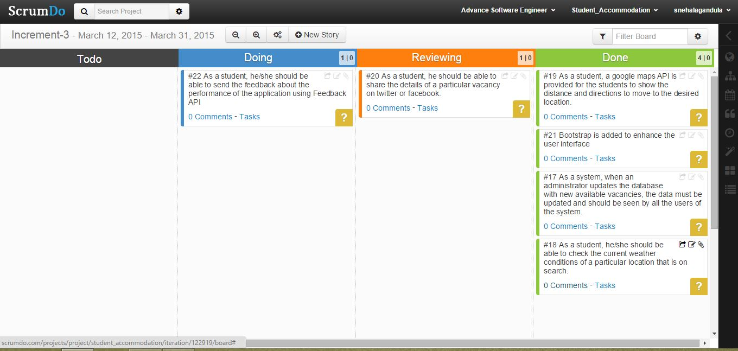

* **Design of Client Interface**



User



Web Application



Connection Pool



Database



Database

Connection

SQL Query

Formatted

Response

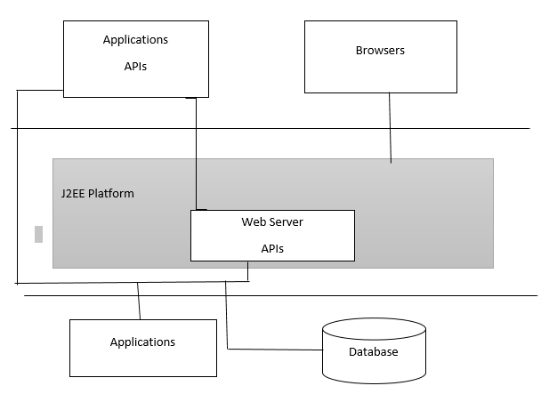

* **Sequence Diagram**

A sequence diagram is an interaction diagram that provides the collaboration of objects depending on a particular time sequence. The following is the sequence diagram that shows the flow of processes that operates one after the other in a certain order. The sequence diagram is to show the flow of student registration and login form with certain validations.

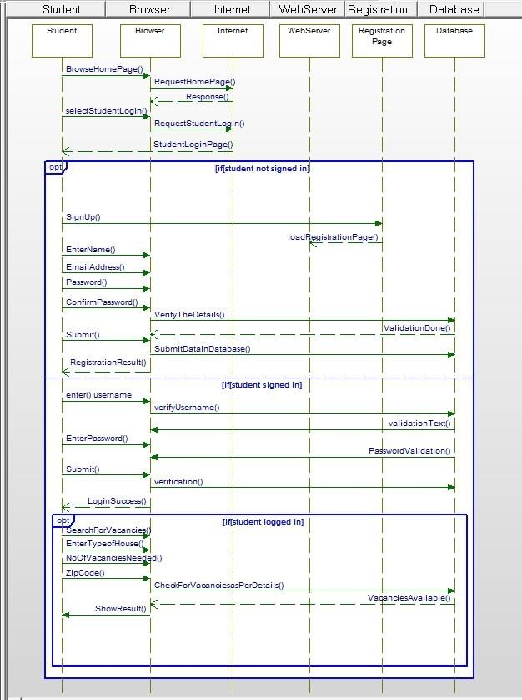

**Sequence Diagram for Admin Login:**

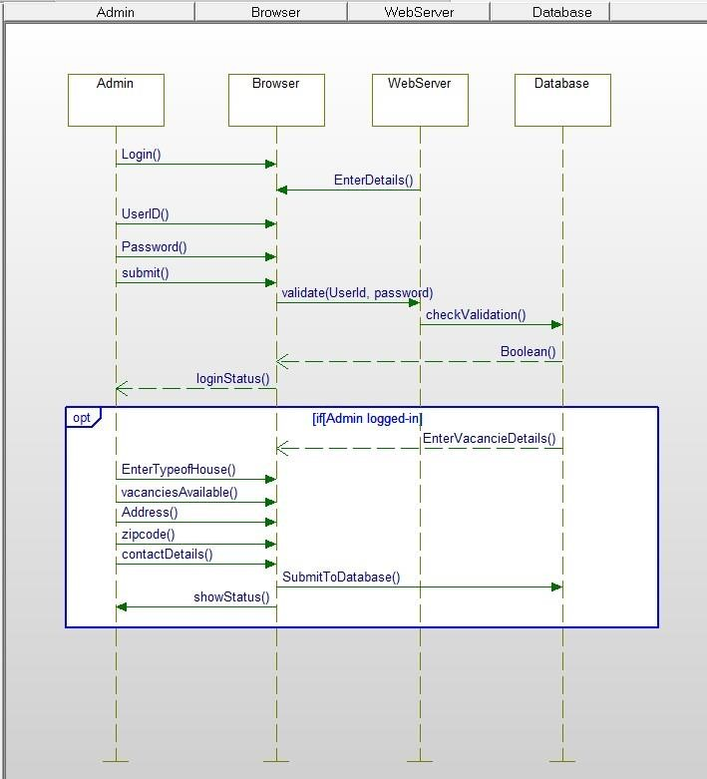

* **Class Diagram**

The following class diagram describes a student or an administrator log-in to the website.

The system has two types of users, student user and the administrator. The student log-in to the account only if the student is already registered in to the system. The student or admin logs-in to the system by entering the username and password, the system then validates the provided log-in details, and if successful, the system connects the user to the account for further access. If not successful, the system allows repeated attempts to the user and prevents the entry until the log-in is successful.

Database is created to store the information about the vacancies available at a certain location. When a student registers for the application all the details of the students are stored in a database for authorization. When a user logs in to the system, the entered details are checked in the database, if the details are availed in the database, further access is given to the system.

Upon Search for the accommodation at a certain location, a new page is displayed providing all the details about available vacancies at that location. Also, google maps from the university to the desired location is shown, this helps user estimate the distance from source to destination. We at the desired location can also be determined through Geo-locations.

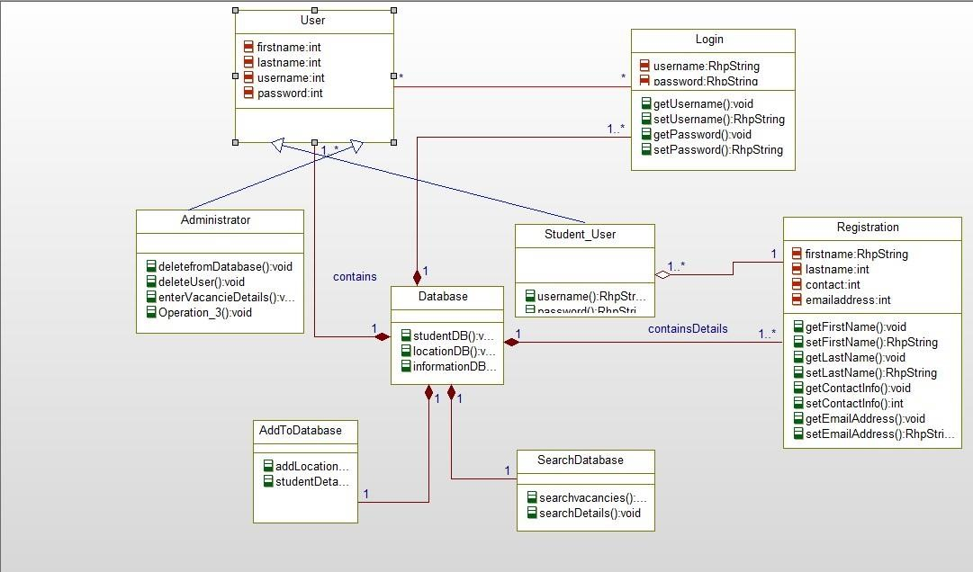

**Class Diagram for External API:**

External APIs such as Google Maps API, Facebook API, and Twitter APIs are added to the application. Up on search at a particular location, a table with available vacancies will be displayed along with google maps that shows route from the university to the desired location.

Facebook and Twitter APIs are used by the users to share the detailed information of an available vacancy.

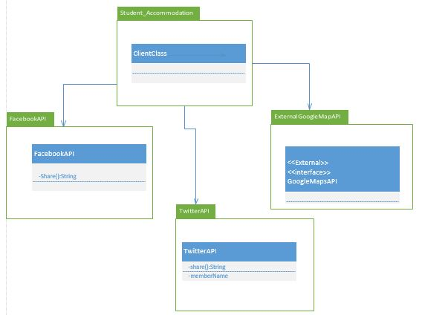

**IMPLEMENTATION:**

* **Database Testing Test Scenarios:** 
  + Table should have primary key in a column
  + Upon a page submit, check whether the data saved into database is correct.
  + Database name should be given depending on the type of the page created.
  + Length of the filed that is shown on the web page should be same as its length in database field.
  + Database fields should be designed with correct data type and data length.
  + Check the datatypes and its properties of their fields in database.
  + Verify the data in the database.
  + Logical names for the database are given according the database name.
  + For primary key column in database, null values should not be allowed.
  + All the required data tables must be created.

**TESTING:**

Testing is an important component in software development process. Testing is done to check the quality of the software that works at crucial circumstances.

**Performance Testing:**

* **Firebug Testing:** This acts as an extension to the web browser by supporting debugging and testing of the website. It also helps in monitoring the website.

We have tested home page of our web application using firebug:

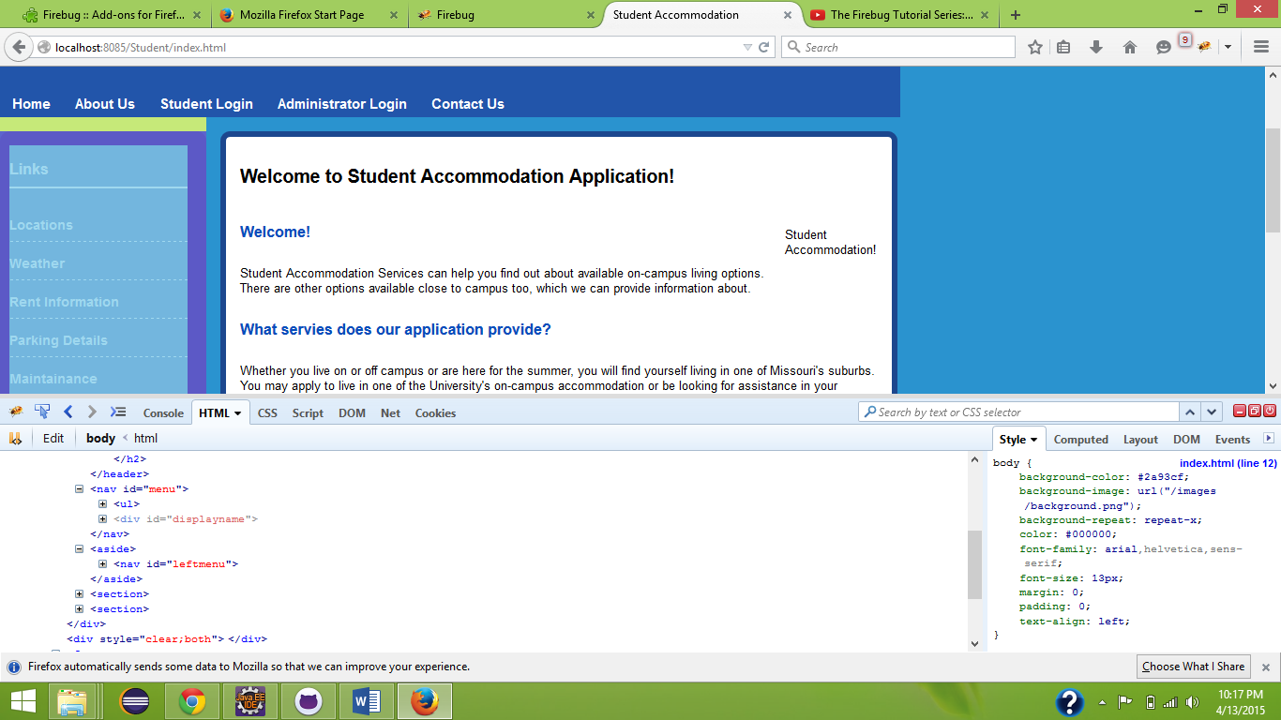

**Firebug Testing for Home Page**

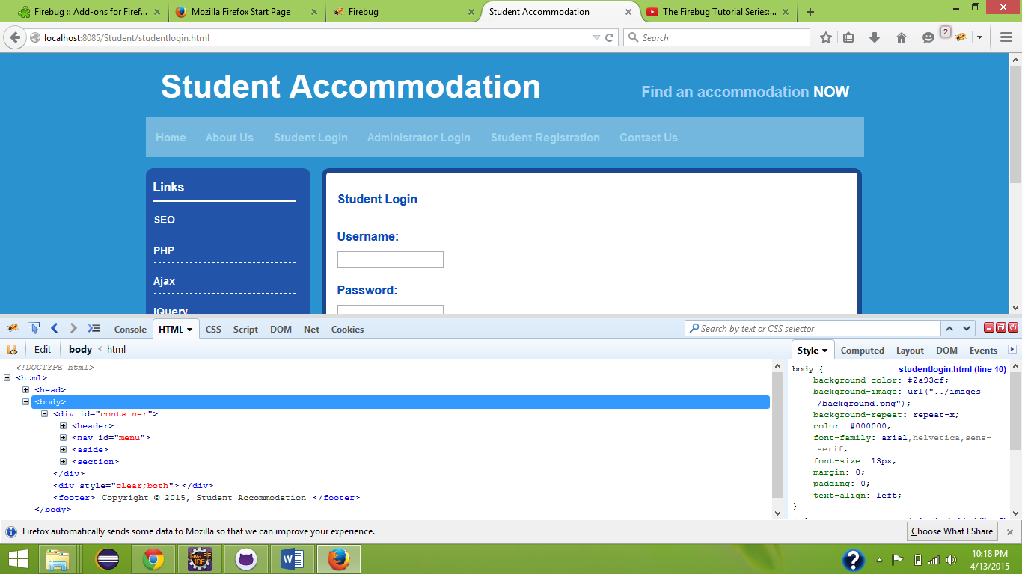

**Firebug testing for List Items**

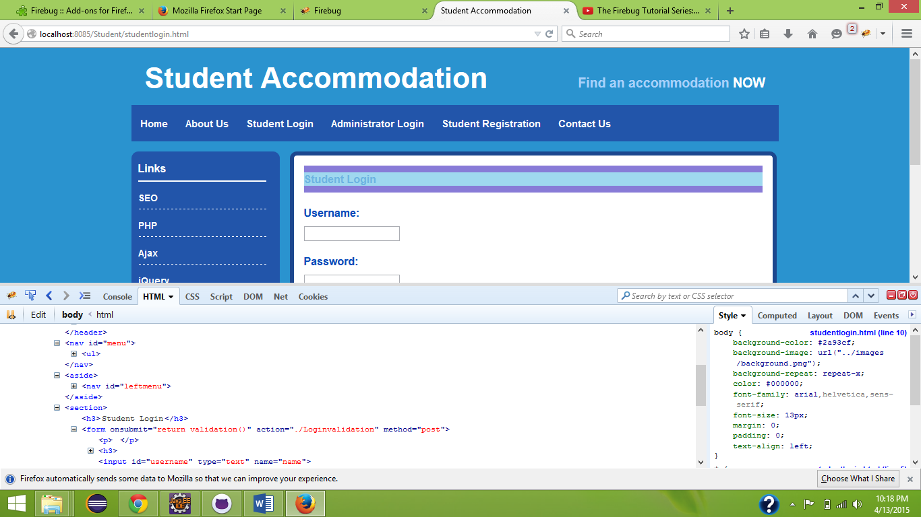

**Firebug Testing for Student Login**

**DEPLOYMENT:**

* ScrumDo Link:
* <https://www.scrumdo.com/projects/project/student_accommodation/iteration/122919/board>
* GitHub (Source Code):

<https://github.com/snehalagandula/Increment3-PG11>

**REPORT:**

The following page allows the users access the home page of our website.

Home Page:

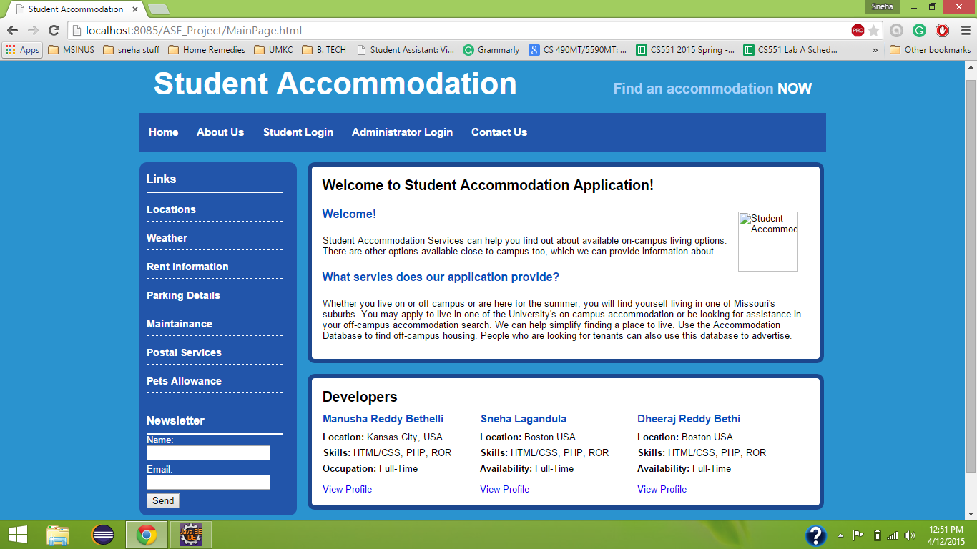

Student Login:

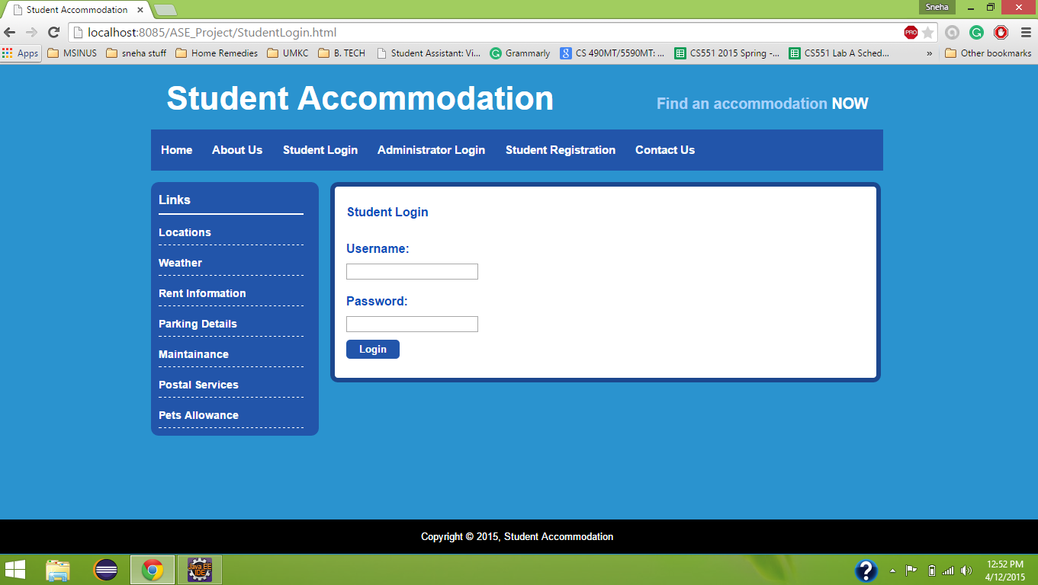

Search for Vacancies:

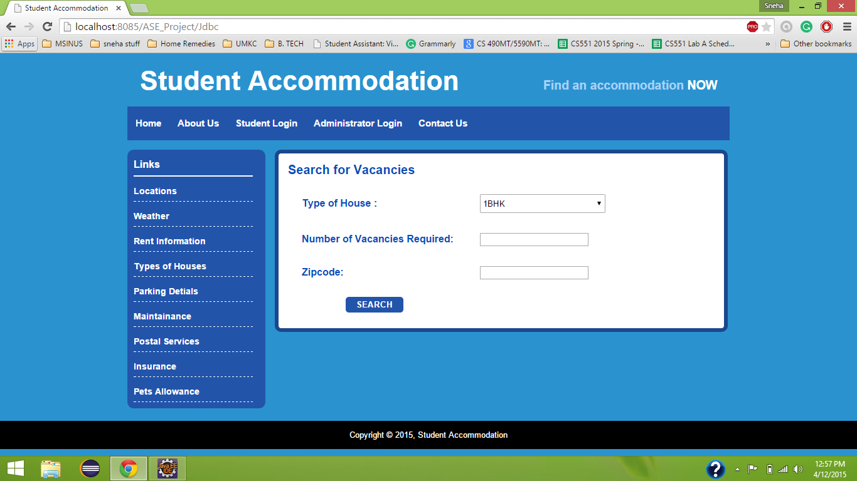

Student Failed to Login

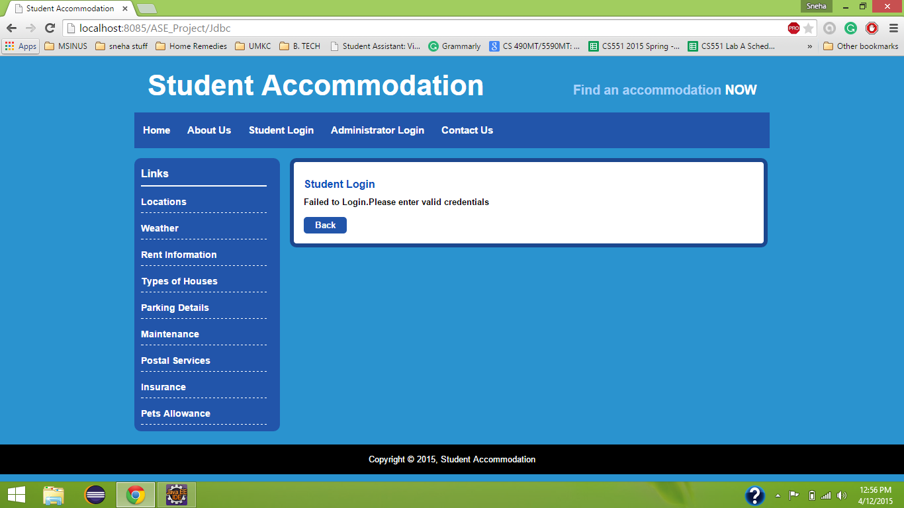

Administrator Login

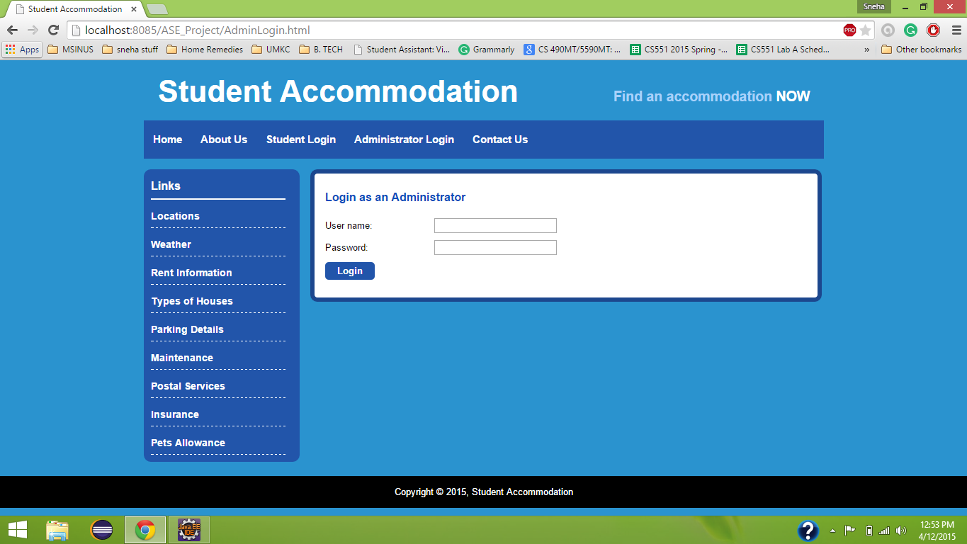

Updating with new available vacancy details

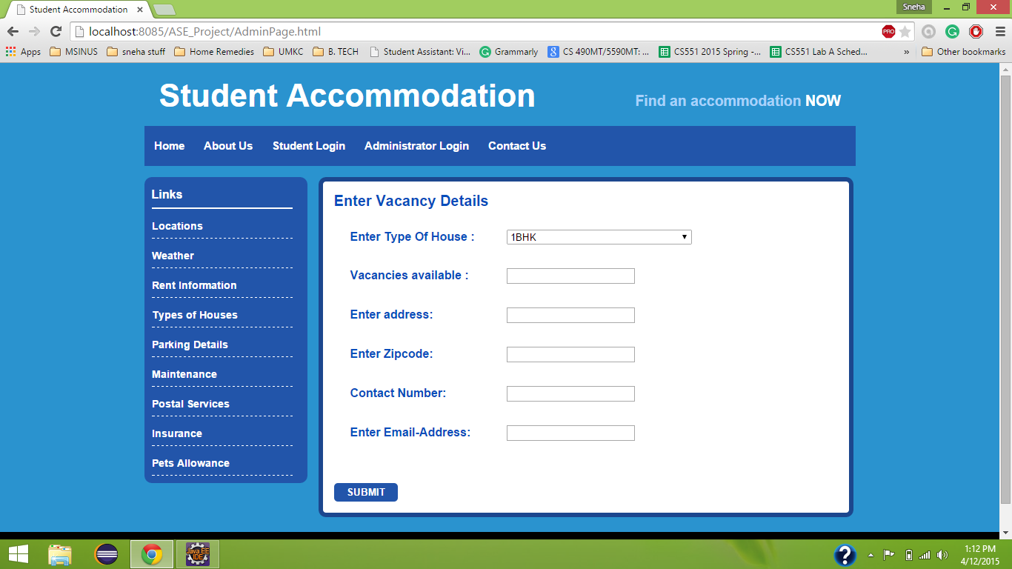

Contact Information

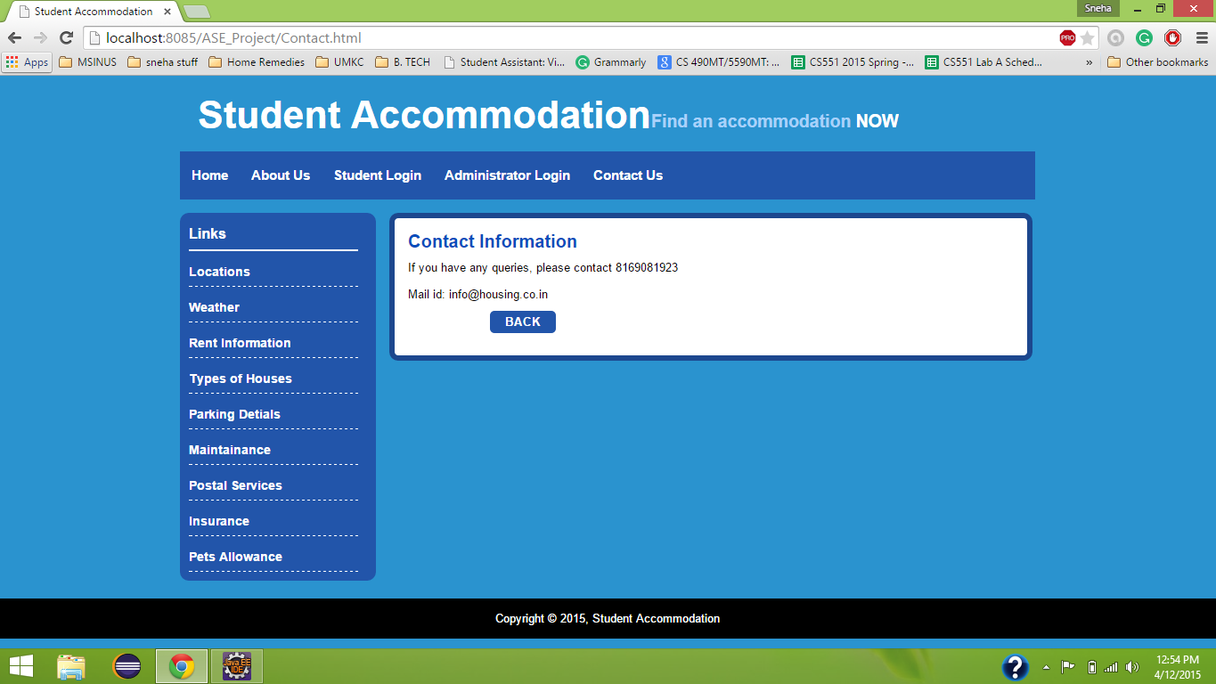

Database before Registration:

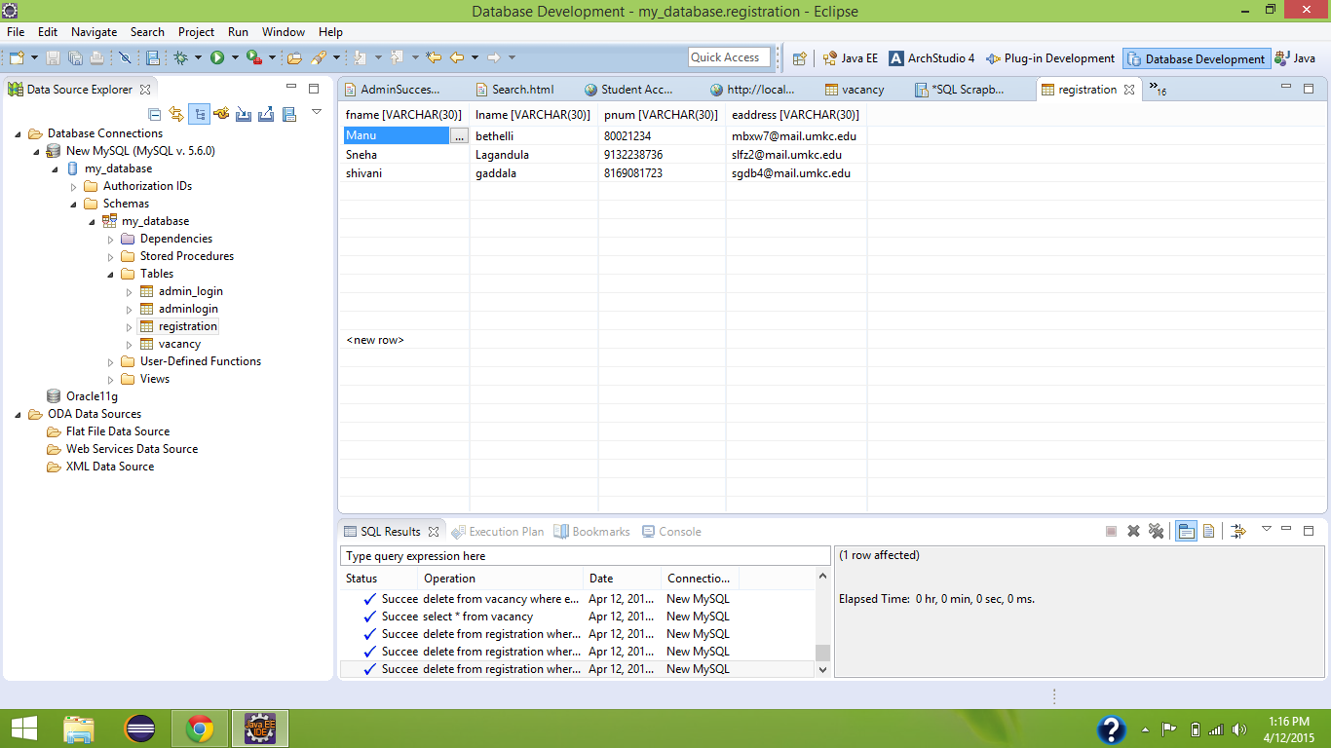

Details stored into database after registration

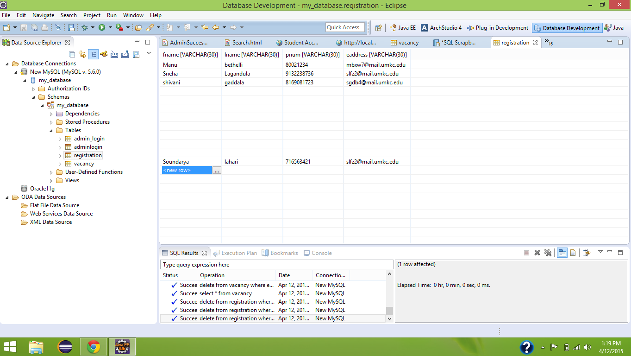

Student Registration

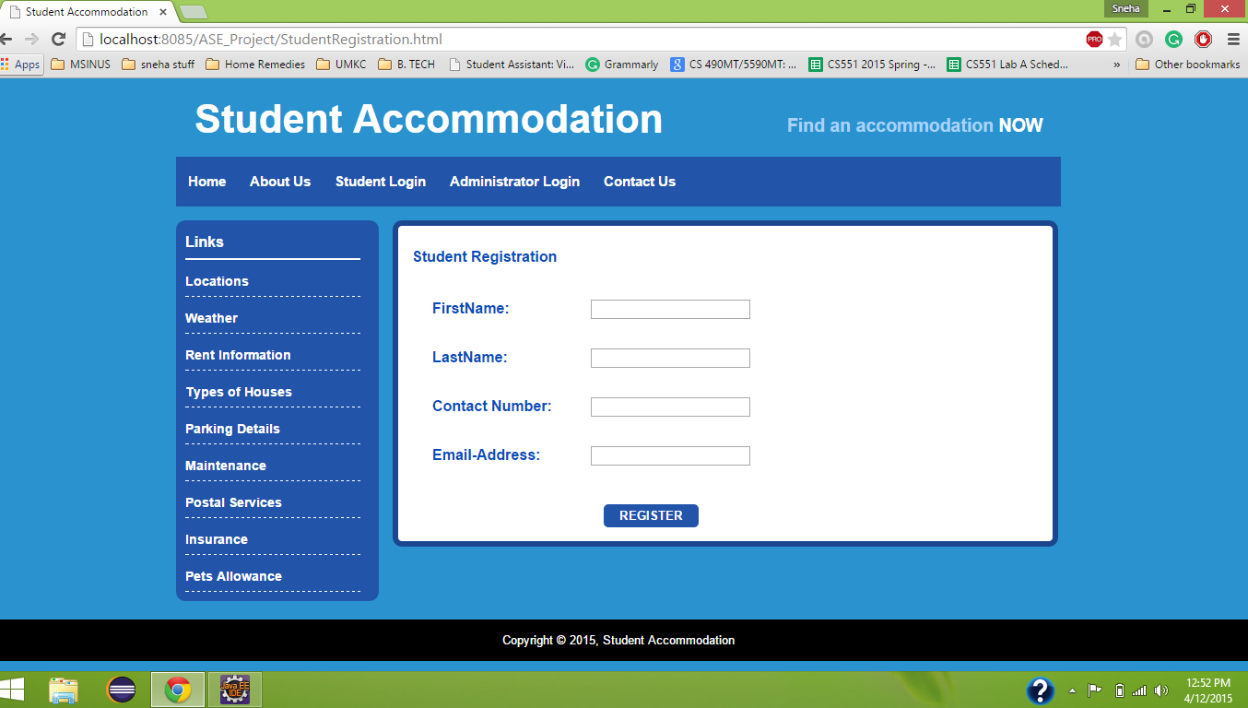

**PROJECT MANAGEMENT:**

* **Implementation Status Report**
  + **Work completed:**
    - **Description:**
    - Created database for student login, administrator login using JDBC driver.
    - Bootstrap framework is integrated to the application to enhance the user interface
    - External APIs such as Facebook API, Twitter API, Google Maps API, Geo location APIs are added to the application
    - Time taken: 40 hours