**CS­5551: Advance Software Engineering**

**Project Plan**

**11th February, 2014**

1. **Introduction**

In the world of modern technology where the mobile market has seen a revolution, Android has been an epicenter for it. About 70% of the students’ population use Android phones. The project “Student Accommodation” Android Application uses simple and effective design to help students find accommodations anywhere near their universities on the move. This application is given access to all the students in the university using their students ID’s as a primary key. This application needs internet connection to search for places near the University for an Accommodation. All the places with vacancies near the university can be found in search.

1. **Project Goals and Objective**
   1. **Specific objectives**

The whole objective of this application is to provide students with proper information about the available and convenient vacancies for accommodation. Also, provides the students with contact information about the available vacancies. Initially, a login registration form is granted. Students who wants to use the application can register the application. The moment students register for the application, they are provided with a username and password. These credentials are further used to login to the application. After a log in, students are provided with search fields where they can provide specific information such as ZIP code of the location, number of rooms required, preferred distance etc. As a result, all the vacancies available within a specific location is shown. Also, users are provided with additional information such as contact information, routing map from their current location to their desired location.

* 1. **Significance**

A lot of international students face the problem of finding a temporary or permanent accommodation at the very moment they reach university for a long stay. Hence, to resolve this problem, we came up with an idea to develop an application that help students find a place to live either with temporary or permanent accommodation.

1. **Project Background**

We students came up with this idea to help most of the international students in finding available vacancies for their accommodation. We have not found any application related to the “Student Accommodation” android application.

1. **Proposed System**
   1. **Requirement Specification**
      * **Functional Requirements**

* When a student registers for the first time he/she will be given a username and password to access the application.
* Students can search for the available vacancies at their desired locations.
* Up on the entered location, students are shown a map with all the available vacancies near that location.
* Students are provided with specific details such as contact information of the houses which are near to the university, routing map from the student’s current location to their desired location.
* Administrator has an access to portal to update the database with available vacancies at a particular location.
  + - **Non-Functional Requirements**
      * Users have access to the application all the time
      * It gives high security by providing access only to university students
      * As the database is limited to locations that are close to the university, the retrieval of information is fast.
      * Provides limited accessibility by giving access only to authorized students
    - **Technical Requirements**
* User Interface: HTML, CSS, JavaScript, Java Applets
* Back End: Java, SQL server 2014
* Architectural Design using Microsoft Visio 2013, Visual Paradigm

**Workflow Analysis**

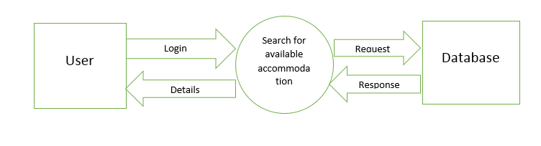

**Technological and Architectural Requirements**

* + - * Android Studio
      * SQLite
      * Google Maps API, Google Places API
  1. **Framework Specification: Build an overall system model**
     + **Assumption and Principles**
       - To build a database with all UMKC Student IDs is complex, we assume it to be limited.
       - We assume our local database to be our centralized database
     + **Methodologies**
       - Agile Software Development

**System Architecture Diagram**

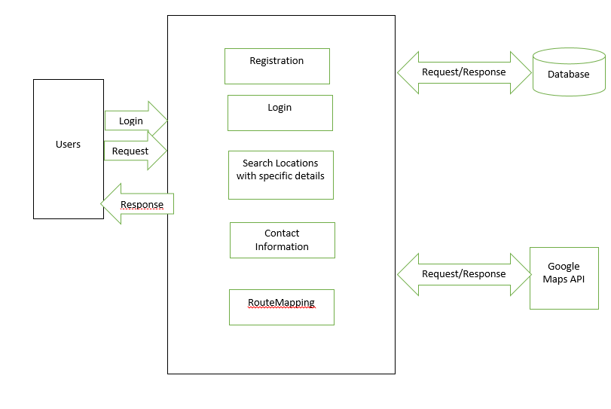

**c) System Specification: Identify Primary Services**

**Existing Services: Name, Description URL**

Name: Geo Location

Description: The Google Maps Geolocation API returns a location and accuracy radius based on information about cell towers and Wi-Fi nodes that the mobile client can detect. This document describes the protocol used to send this data to the server and to return a response to the client.

Communication is done over HTTPS using POST. Both request and response are formatted as JSON, and the content type of both is application/json.

We use this API to include location services for the user so that he can get the address of vacant houses available.

URL: https://developers.google.com/maps/documentation/business/geolocation/

Name: Direction Service

Description: The Google Directions API is a service that calculates directions between locations using an HTTP request. You can search for directions for several modes of transportation, include transit, driving, walking or cycling. Directions may specify origins, destinations and waypoints either as text strings (e.g. "Chicago, IL" or "Darwin, NT, Australia") or as latitude/longitude coordinates. The Directions API can return multi-part directions using a series of waypoints.

URL: https://developers.google.com/maps/documentation/directions/

**New Services to be built:**

**Class Diagram**

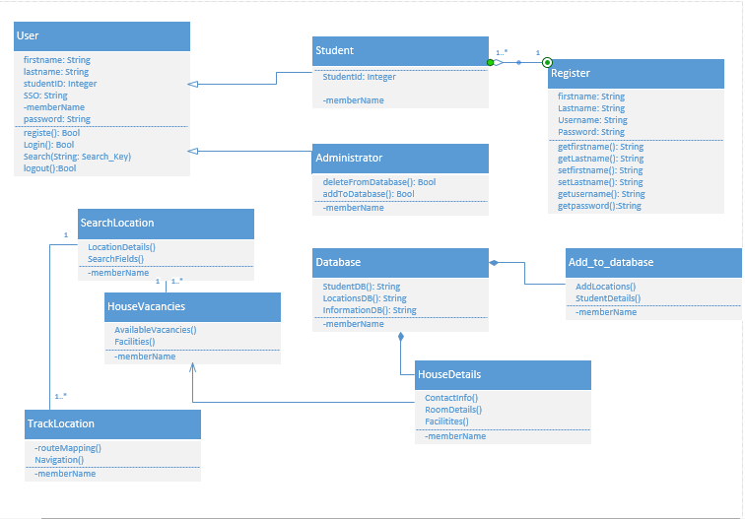

**Sequence Diagram**

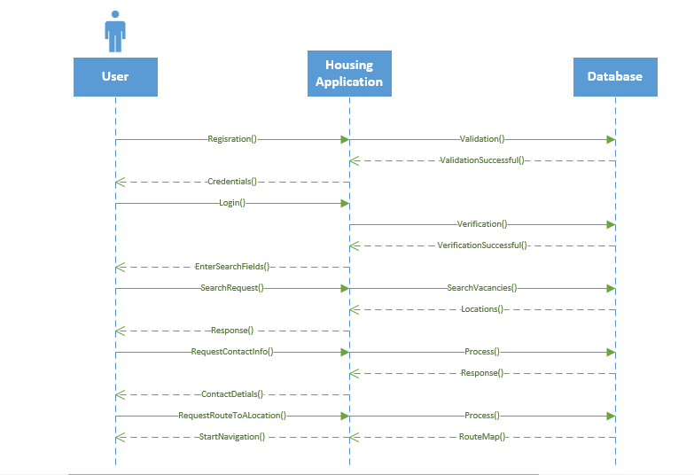

1. **Plan by Service (Scrum Do)- include screenshots to your report**
   1. **Schedule for the four different increments**

**User Stories**

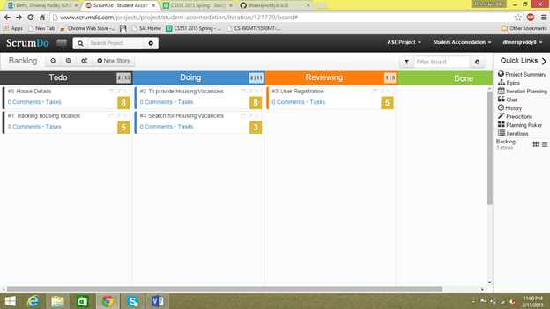

**Increments**

**1) First Increment**

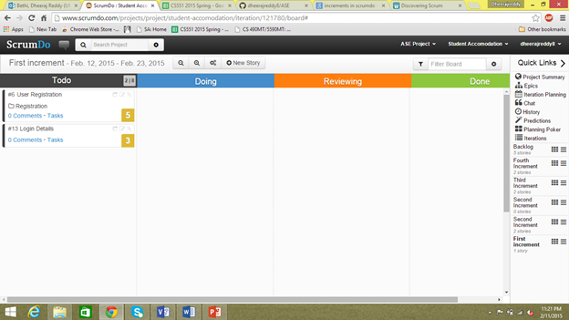

**2) Second Increment**

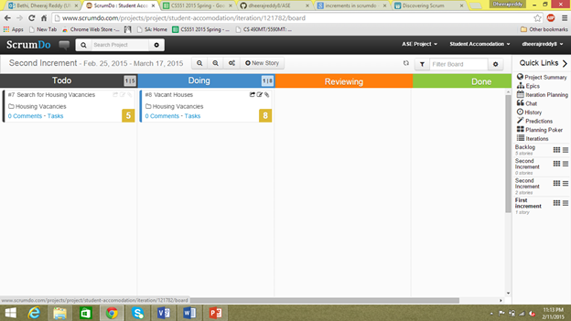

**3) Third Increment**

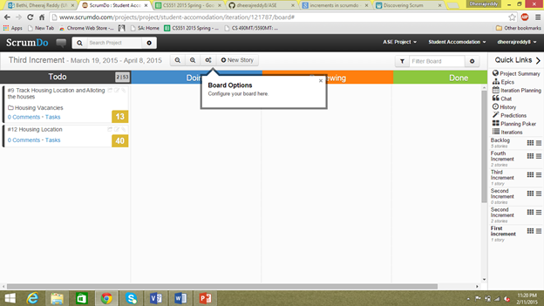

**4) Fourth Increment**

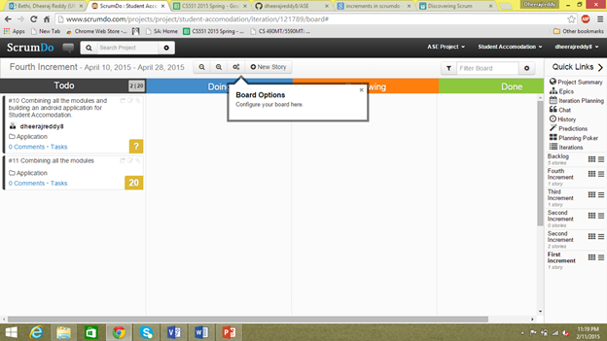

* 1. **Project Timelines, Members, Task Responsibility**

**Project Timelines:**

|  |  |  |
| --- | --- | --- |
| **Task** | **Start Date** | **End Date** |
| Gathering requirements | **2/15/2015** | **2/20/2015** |
| Planning | **2/21/2015** | **2/26/2015** |
| Implementation | **2/27/2015** | **3/27/2015** |
| Testing | **3/28/2015** | **4/10/2015** |
| Documentation | **4/11/2015** | **4/15/2015** |
| Deployment | **4/16/2015** | **4/20/2015** |

**Members:**

**PG11 (SG20, SG21)**

1) Manusha Reddy (class ID: 4)

2) Sneha Lagandula (class ID: 29)

3) Dheeraj Reddy (class ID: 5)

**Task Responsibility:**

Gathering Requirements: Manusha and Sneha

Planning: Dheeraj and Sneha

Implementation: Manusha and Sneha

Testing: Dheeraj and Manusha

Documentation: Dheeraj and Sneha

Deployment: Dheeraj and Manusha.

1. **Risk Management**
   1. **Technological and Architectural Requirements**
      * The user must have a smart phone.
      * GPS must be turned on to get real time data and to send the current location in case of emergency
      * It is compatible with all the Android phones.

**7. Bibliography**

<https://play.google.com/store/apps?hl=en>

<https://www.google.com/maps>

<https://www.google.com/maps/d/viewer?&mid=zBrq7C8N4BEM.k5H-MWQcyEec>