Sneha R
1NT20IS414

Mongo DB
Crud operations:

Creation of databse:

use sneha2
switched to db sneha2
> db.sneha2.insertOne(
... {
... name:"sneha",
... age:"20",
... usn:"1nt20is414"
... }
... )

{
"acknowledged" : true,
"insertedId" : ObjectId("6246bb50a705a5ef13ae152c")
}

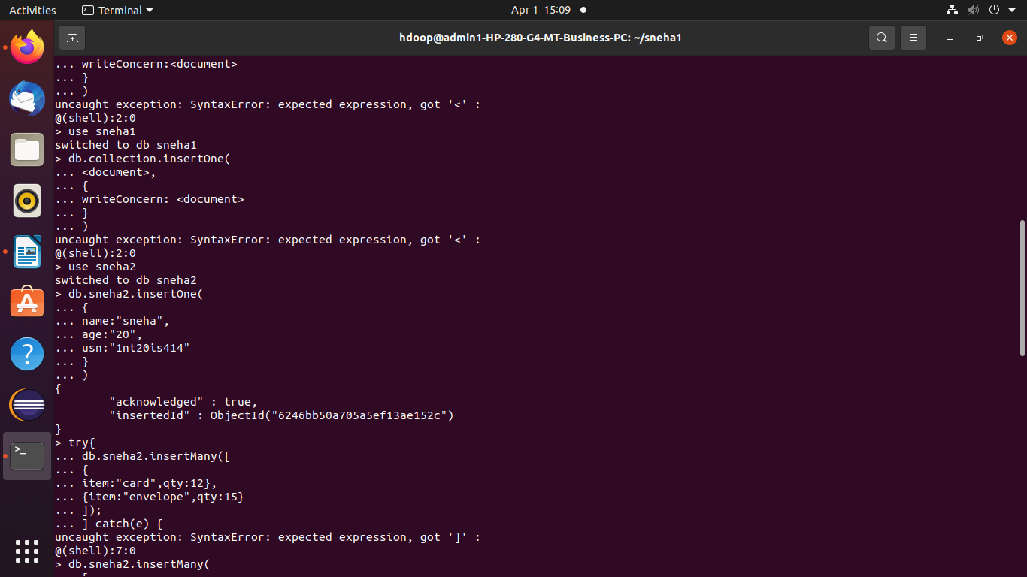

> db.sneha2.insertMany( [ { name:"sneha", usn:"1nt20is414", sec:"c", } , { name:"supriya",usn:"1nt20is412",sec:"a" }])
{
"acknowledged" : true,
"insertedIds" : [
ObjectId("6246bf0aa705a5ef13ae152d"),
ObjectId("6246bf0aa705a5ef13ae152e")
]
}

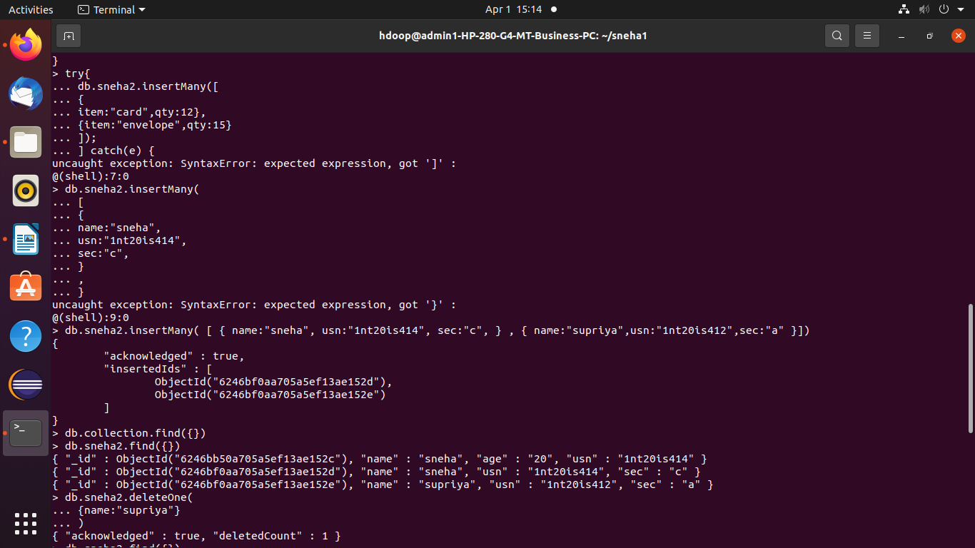

db.sneha2.find({})
{ "_id" : ObjectId("6246bb50a705a5ef13ae152c"), "name" : "sneha", "age" : "20", "usn" : "1nt20is414" }
{ "_id" : ObjectId("6246bf0aa705a5ef13ae152d"), "name" : "sneha", "usn" : "1nt20is414", "sec" : "c" }
{ "_id" : ObjectId("6246bf0aa705a5ef13ae152e"), "name" : "supriya", "usn" : "1nt20is412", "sec" : "a" }

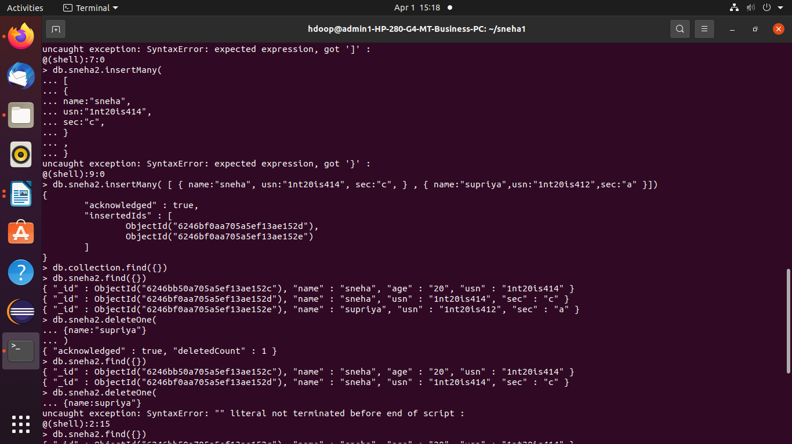

> db.sneha2.deleteOne(
... {name:"supriya"}
... )
{ "acknowledged" : true, "deletedCount" : 1 }
> db.sneha2.find({})
{ "_id" : ObjectId("6246bb50a705a5ef13ae152c"), "name" : "sneha", "age" : "20", "usn" : "1nt20is414" }
{ "_id" : ObjectId("6246bf0aa705a5ef13ae152d"), "name" : "sneha", "usn" : "1nt20is414", "sec" : "c" }

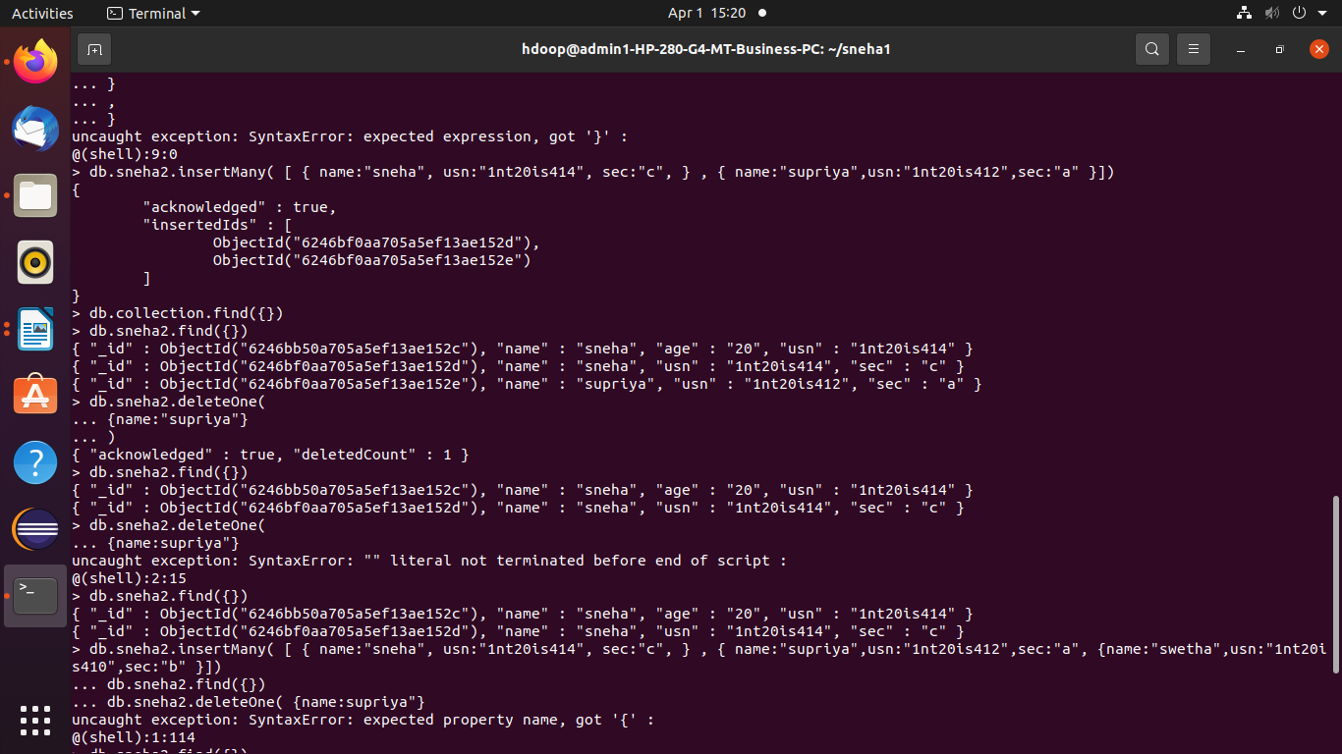

>

db.sneha2.find({})
{ "_id" : ObjectId("6246bb50a705a5ef13ae152c"), "name" : "sneha", "age" : "20", "usn" : "1nt20is414" }
{ "_id" : ObjectId("6246bf0aa705a5ef13ae152d"), "name" : "sneha", "usn" : "1nt20is414", "sec" : "c" }

