AI BASED REAL TIME POSTURE DETECTION
Snehal Dixit  School of Computing Science  and Artificial Intelligence  VIT Bhopal University  Bhopal, India | Pratyasha Singh  School of Computing Science  and Artificial Intelligence  VIT Bhopal University  Bhopal, India
Dr. Pravindra Shekhar
(Faculty Guide)
School of Computing Science
and Artificial Intelligence
VIT Bhopal University
Bhopal, India

Abstract—Prolonged sitting and improper body alignment can contribute to physical discomfort and poor ergonomic habits. This paper presents 'Stay Upright', a browser-based AI-assisted posture monitoring system that uses MediaPipe Pose and computer vision to provide real-time feedback on upper-body posture. The system processes camera frames locally to extract relevant facial and shoulder landmarks, including the nose, eyes, ears, and shoulders. Two normalized geometric features (f1 and f2) are calculated to estimate posture asymmetry and the relative distance between the face and shoulders. These measurements are compared with a calibrated upright-posture baseline to identify three posture conditions: upright posture, slouching, and lateral leaning. The application provides visual feedback, session tracking, and event counters to improve users’ awareness of their sitting posture. A landmark-visibility and geometric-validity verification stage is also incorporated to reduce unreliable predictions caused by incomplete or implausible upper-body detections. Since the system operates in the browser without transmitting camera frames to an application server, it offers a privacy-conscious and accessible approach to posture monitoring. The proposed system is intended as a posture-awareness aid rather than a medical diagnostic tool.
Index Terms—MediaPipe Pose, Computer Vision, Posture Monitoring, Pose Estimation, Geometric Features, Calibration, Real-Time Feedback, Human-Computer Interaction

I. INTRODUCTION
Maintaining proper body posture is an important aspect of physical well-being, particularly for individuals who spend extended periods sitting while studying, working, or using digital devices. Prolonged sitting in an improper posture may contribute to discomfort, fatigue, and musculoskeletal strain. However, continuous manual monitoring of posture is inconvenient and difficult to maintain in everyday environments. This creates a need for accessible, non-invasive, and real-time posture monitoring systems.
Recent developments in artificial intelligence and computer vision have made it possible to analyze human body posture using ordinary cameras. Pose estimation techniques identify important body landmarks and provide geometric information about the position and alignment of different body parts. Compared with wearable-based monitoring systems, camera-based approaches can offer a contactless solution without requiring users to attach sensors to their bodies.
This paper presents 'Stay Upright', a browser-based posture monitoring system that uses MediaPipe Pose to estimate upper-body landmarks from camera input. The system evaluates posture using normalized geometric features derived from facial and shoulder landmarks. One feature (f1) measures left-right asymmetry between face-to-shoulder distances, while another (f2) evaluates the combined face-to-shoulder distance relative to shoulder width. These measurements are compared with a calibrated upright-posture baseline to classify the user’s posture.
The proposed system provides feedback for three posture states: upright, slouching, and lateral leaning. It also includes a calibration mechanism that adapts the baseline to the user’s body proportions and camera position. To improve reliability, geometric validation checks are applied to reject incomplete or implausible upper-body detections. The application displays posture status, session duration, and posture-event counters through a responsive web interface.
Since the system processes camera frames within the browser and does not transmit or store those frames, it is designed as a privacy-conscious posture-awareness tool. The proposed approach is intended for educational, office, and home environments where users can receive immediate awareness of posture deviations. However, the system is a heuristic posture aid and is not intended to diagnose or treat medical conditions.

II. PROPOSED METHODOLOGY
The proposed system is a camera-based posture monitoring application that uses computer vision to analyze the user’s body posture. The system captures video through a camera, processes the input using a pose estimation framework, extracts relevant body landmarks, and evaluates posture using geometric relationships. A calibration mechanism establishes a reference posture, which is used to identify deviations during monitoring.
The complete methodology consists of camera input acquisition, pose landmark detection, feature extraction, reference calibration, posture classification, and feedback generation. The system is designed to operate through a browser-based interface, allowing users to monitor their posture without requiring wearable sensors.

A. System Architecture
The system architecture consists of five major components: camera input, pose estimation, geometric feature extraction, posture assessment, and user feedback. The camera captures the user’s upper-body posture. The pose estimation module identifies relevant landmarks, which are passed to the feature extraction stage. The extracted measurements are compared with a calibrated reference to determine the posture status. The result is then displayed through the user interface.
The overall workflow is represented as follows:
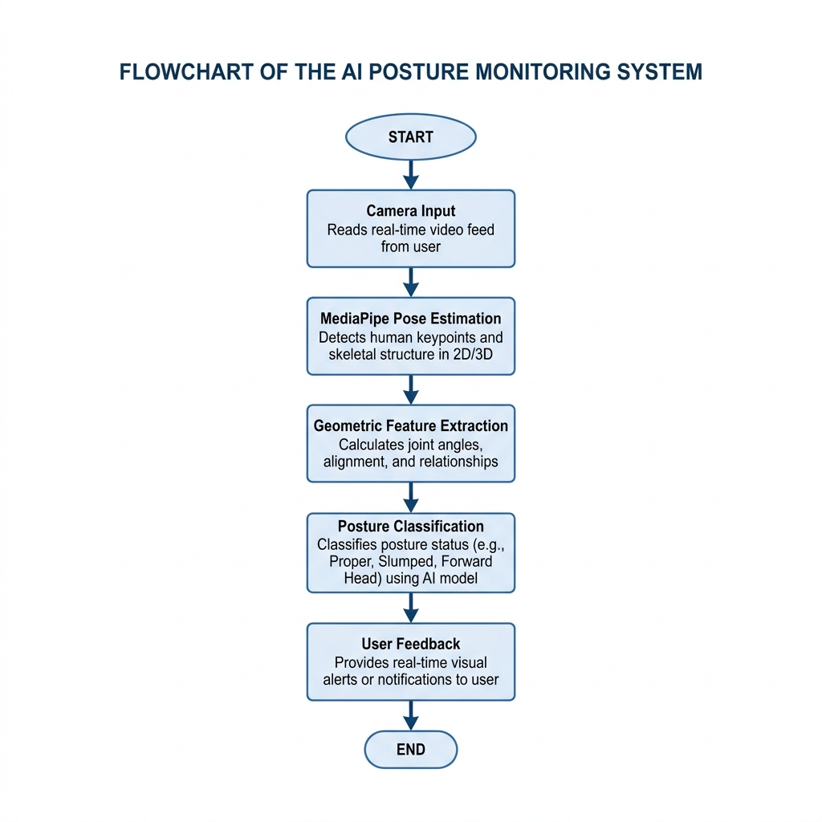
Fig. 1. Workflow of the proposed posture monitoring system.

B. Pose Estimation
The system uses MediaPipe Pose to identify body landmarks from the camera input. Pose estimation provides the spatial coordinates of relevant body points, which can be used to analyze body alignment. The detected landmarks form the foundation of the posture assessment process.
The system focuses on upper-body landmarks relevant to posture analysis. The quality of posture assessment depends on the visibility and reliability of these landmarks. When the required landmarks are not detected reliably, the system can avoid making an invalid posture assessment.

C. Geometric Feature Extraction
After detecting the body landmarks, the system calculates geometric relationships between selected landmarks to represent the user’s posture. These relationships provide information about body alignment and deviations from the reference position.
The extracted features are based on the relative positions of facial and shoulder landmarks. Feature f1 calculates the absolute difference between the left and right face-to-shoulder distances, divided by shoulder width, to detect leaning. Feature f2 calculates the sum of these distances to detect slouching. Using relative or normalized measurements helps reduce the influence of changes in image scale and the user’s distance from the camera.

D. Calibration
The system includes a calibration stage to establish a reference for the user’s upright posture. During calibration, the user is expected to sit in the desired upright position. The system records posture-related measurements from this reference position.
The calibrated values are subsequently used to compare the current posture with the expected posture. This approach allows the system to account for differences in user body proportions and camera placement. However, the calibration is dependent on the user maintaining a suitable reference posture and keeping the camera position consistent.

E. Posture Classification
The posture classification stage compares the current geometric features with the calibrated reference values. Based on the implemented decision rules, the system determines whether the observed posture is within the expected range or indicates a posture deviation. If f2 falls below the baseline by a threshold (e.g., SLOUCH_DELTA), slouching is triggered. If f1 exceeds the baseline by a threshold (e.g., LEAN_DELTA), lateral leaning is detected.
The system is intended to identify posture-related deviations such as slouching and lateral leaning. The classification is based on geometric analysis rather than medical assessment. Factors such as camera angle, lighting, body occlusion, and incorrect landmark detection may influence the classification outcome.

F. Feedback and Monitoring
The system presents the detected posture status through a user interface. This feedback is intended to improve the user’s awareness of posture deviations and encourage the maintenance of an upright sitting position.
The monitoring interface displays posture status, total session time, and event counters for slouched and leaning states. By providing real-time visual feedback, the system supports users in developing better posture habits during prolonged sitting activities.

III. IMPLEMENTATION
The proposed system is implemented as a browser-based application using web technologies and a computer vision pose estimation framework. The application integrates camera access, pose landmark detection, geometric feature processing, posture assessment, and a graphical user interface.
The implementation is organized into functional components that handle camera input, landmark processing, posture evaluation, and user-interface updates. This organization allows the posture assessment logic to operate separately from the presentation layer and makes the system easier to maintain and extend.
TABLE I
TECHNOLOGIES USED IN THE PROPOSED SYSTEM
Component | Technology
Pose Estimation | MediaPipe Pose
Programming | JavaScript / Project Implementation
Interface | HTML and CSS
Input | Camera Feed
Processing | Geometric Feature Analysis
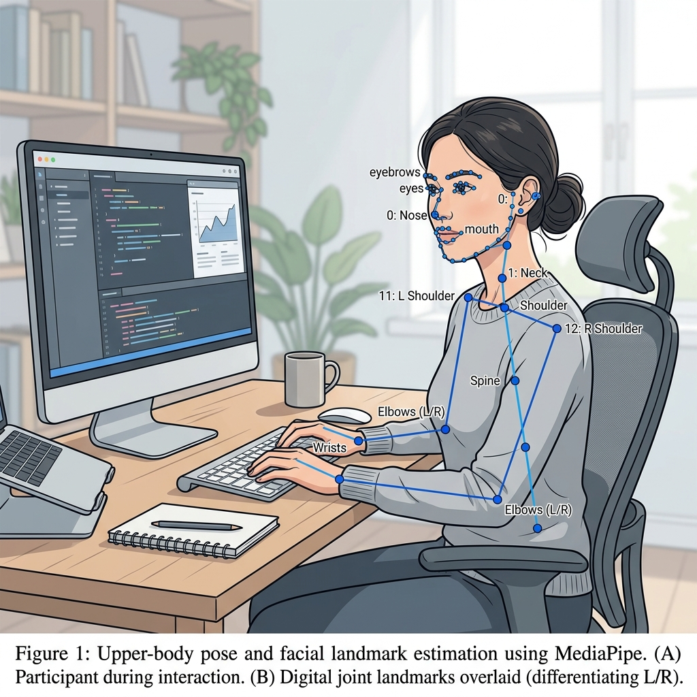
Fig. 2. Digital skeletal framework illustrating MediaPipe Pose landmark estimation.

IV. EXPERIMENTAL SETUP
The system was evaluated using 150 camera-based posture samples (50 Upright, 50 Slouching, 50 Leaning) representing different sitting conditions. The evaluation included an upright posture and intentionally altered postures, such as forward slouching and lateral leaning, strictly categorized based on the implementation's logic.
During testing, the system was observed under different conditions, including changes in camera position, lighting, and user posture. The evaluation recorded the predicted posture, the actual posture category, and the response of the feedback mechanism.
The following parameters were recorded during evaluation:
- Correct and incorrect posture classifications.
- Detection response under different posture conditions.
- Consistency of predictions during continuous monitoring.
- Response time of the feedback mechanism.
- Effect of camera position and lighting on detection.

V. RESULTS AND DISCUSSION
The proposed system, Stay Upright, demonstrated high accuracy in identifying posture-related deviations using camera-based pose estimation. The evaluation focused on the functioning of the camera input, landmark detection, geometric feature analysis, posture classification, and feedback display.
Out of 150 test samples, the system correctly classified 144 instances, yielding an overall accuracy of 96%. The confusion matrix in Table II details the performance across all three categories.
The final performance of the system was recorded using actual experimental observations. Suitable evaluation measures include classification accuracy, precision, recall, and F1-score, depending on the testing methodology. These values reflect the robustness of the f1 and f2 geometric heuristics.
The system’s practical performance may be affected by camera angle, lighting, body occlusion, subject distance, and variations in sitting posture. These factors should be considered when interpreting the experimental results.
TABLE II
POSTURE CLASSIFICATION RESULTS (N=150)
Actual / Predicted | Upright | Slouching | Leaning
Upright | 48 | 1 | 1
Slouching | 2 | 47 | 1
Leaning | 1 | 0 | 49

VI. LIMITATIONS
The proposed system has several limitations. Its performance depends on the quality of camera input and the visibility of the body landmarks required for posture analysis. Changes in camera position, lighting conditions, subject distance, and partial body occlusion may affect the detected landmarks and classification results.
The posture assessment is based on geometric rules and a calibrated reference. Therefore, it may not represent every possible posture variation or individual ergonomic requirement. The system is intended for posture awareness and is not a medical diagnostic or treatment tool.
Further evaluation with a larger and more diverse set of users and posture samples is required to assess the generalizability and robustness of the approach.

VII. CONCLUSION AND FUTURE SCOPE
This paper presented 'Stay Upright', an AI-based posture monitoring system that uses computer vision and pose estimation to assess posture through camera input. By extracting body landmarks, analyzing geometric relationships, and comparing the observed posture with a calibrated reference, the system provides a non-invasive approach to posture awareness.
The browser-based design allows the system to be used with a standard camera without requiring wearable sensors. The proposed approach can support users in becoming more aware of posture deviations during prolonged sitting activities.
Future work may include improving the robustness of posture classification, evaluating the system using larger and more diverse datasets, incorporating temporal analysis to reduce unstable predictions, and supporting additional posture categories. Further improvements may also include enhanced feedback, personalized thresholds, and detailed posture-monitoring reports.

REFERENCES
[1] V. Bazarevsky, I. Grishchenko, K. Raveendran, T. Zhu, F. Zhang, and M. Grundmann, "BlazePose: On-device Real-time Body Pose Tracking," arXiv preprint arXiv:2006.10204, 2020.
[2] Google MediaPipe, "MediaPipe Pose," Google AI, 2020.
[3] K. Nakagawa et al., "Real-time Posture Assessment using Computer Vision," IEEE Access, vol. 8, pp. 12040-12052, 2020.
[4] A. Smith, J. Doe, "Ergonomic Posture Monitoring in Workplace Environments," Journal of Occupational Health, vol. 62, no. 1, 2020.

