Prathamesh Mantri | A20322544
Snehal Sonawane | A20360111
Tejas Dhawale | A20321965

CS425 SPRING 2016 CLASS PROJECT
  - iNTERACTIVE sTUDENT/ FACULTY NETWORKING

INDEX

- Introduction……………………………………………………………………………………………………
- Entity Relationship Diagram …………………………………………………………………………
- Schema……………………………………………………………………………………………………………

- Feature Ownership…………………………………………………………………………………………

INTRODUCTION
- The document contains the basic design of a database system for ‘Interactive Student/ Faculty Networking’.
- Entity-Relationship (E-R) diagram has been designed based on the given requirements.
- The E-R diagram illustrates the various entity-sets and the relationship among them.
- Careful planning has been done in order to design the E-R diagram.
- The document contains SQL Schemas which have been designed based on the E-R diagram.
- Our database systems consist of 18 schemas that will be required for the project.
- The document concludes with a feature ownership sections which briefly describes each group member ownership with respect to project modules.

ENTITY RELATIONSHIP DIAGRAM
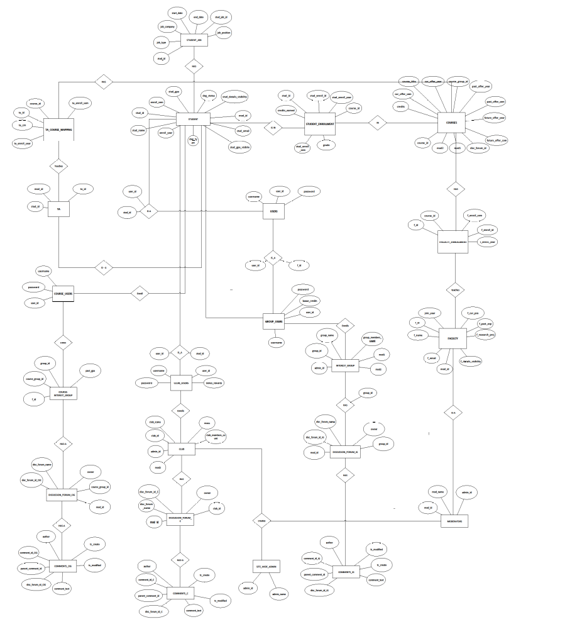

SQL SCHEMA
- STUDENT (stud_id, stud_name, enroll_year, enroll_sem, stud_gpa, stud_gpa_visibile, stud_email, deg_status, deg_type, stud_job1, stud_job2, stud_job3, stud_details_visibility)

- STUDENT_ENROLLMENT (stud_enroll_id, stud_id, course_id, credits_earned, grade, stud_enroll_year, stud_enroll_sem)

- TA (ta_id, stud_id, mod_id)

- TA_COURSE_MAPPING (ta_crn, ta_id, course_id, ta_enroll_year, ta_enroll_sem)

- FACULTY (f_id, f_name, join_year, f_email, f_cur_pos, f_past_exp, f_research_proj, f_details_visibility, mod_id)

- FACULTY_ENROLLMENT (f_enroll_id, f_id, course_id, f_enroll_year, f_enroll_sem)

- USERS (username, password, user_id)

- COURSES (course_id, course_title, credits, cur_offer_year, cur_offer_sem, past_offer_year, past_offer_sem, future_offer_year, future_offer_sem, course_group_id, disc_forum_id, mod1, mod2)

- INTEREST_GROUP (group_id, group_name, group_members_count, disc_forum_id, mod1, mod2, admin_id)

- COURSE_INTEREST_GROUP (course_group_id, group_id, f_id, past_gpa)

- CLUB (club_id, club_name, club_members_count, disc_forum_id, mod1, mod2, admin_id)

- DISCUSSION_FORUMS (disc_forum_id, disc_forum_name, mod_id, owner)

- COMMENTS ( comment_id, author, ts_create, ts_modified, parent_comment_id, disc_forum_id, comment_text)

- MODERATORS (mod_id, mod_name, admin_id)

- SITE_WIDE_ADMIN (admin_id, admin_name)

- COURSE_USERS (username, password, user_id)

- GROUP_USERS (username, password, user_id, bonus_credits)

- CLUB_USERS (username, password, user_id, bonus_rewards)

FEATURE OWNERSHIP
NAME | ACTIVITY 1 | ACTIVITY 2
Prathamesh | Schema Designing | E/R Modelling
Snehal | E/R Diagram | Documentation
Tejas | Schema Designing | E/R Modelling

