**AIM :** To demonstrate Network Address Translation (NAT)

**Network Address Translation (NAT)** is a process in which one or more local IP address is translated into one or more Global IP address and vice versa in order to provide Internet access to the local hosts.

**IP Configurations :**

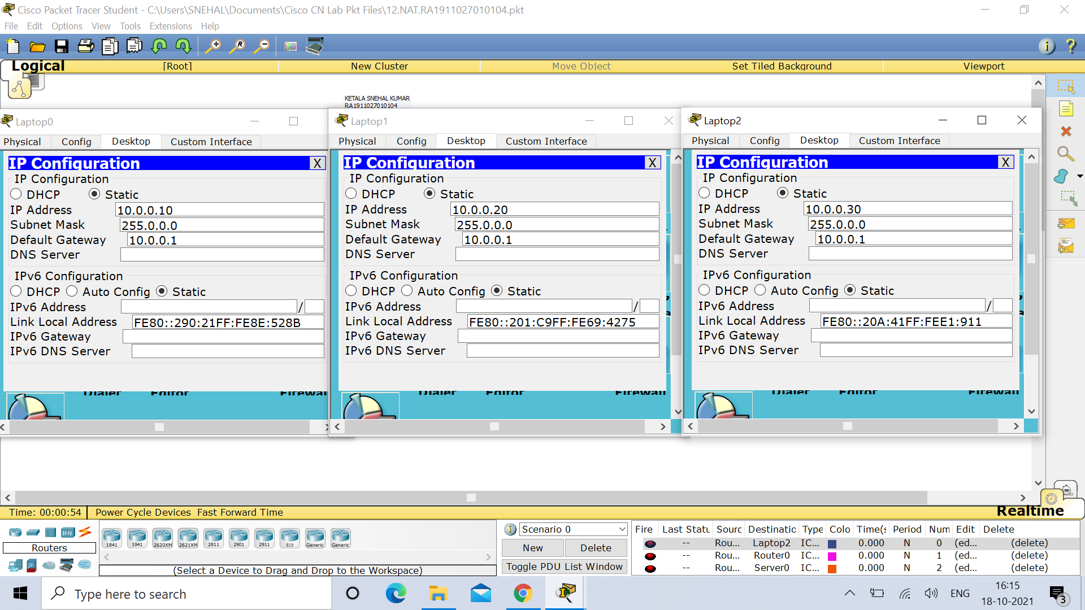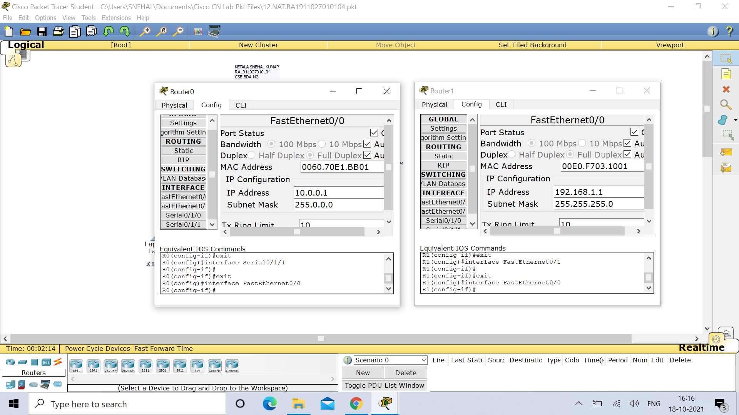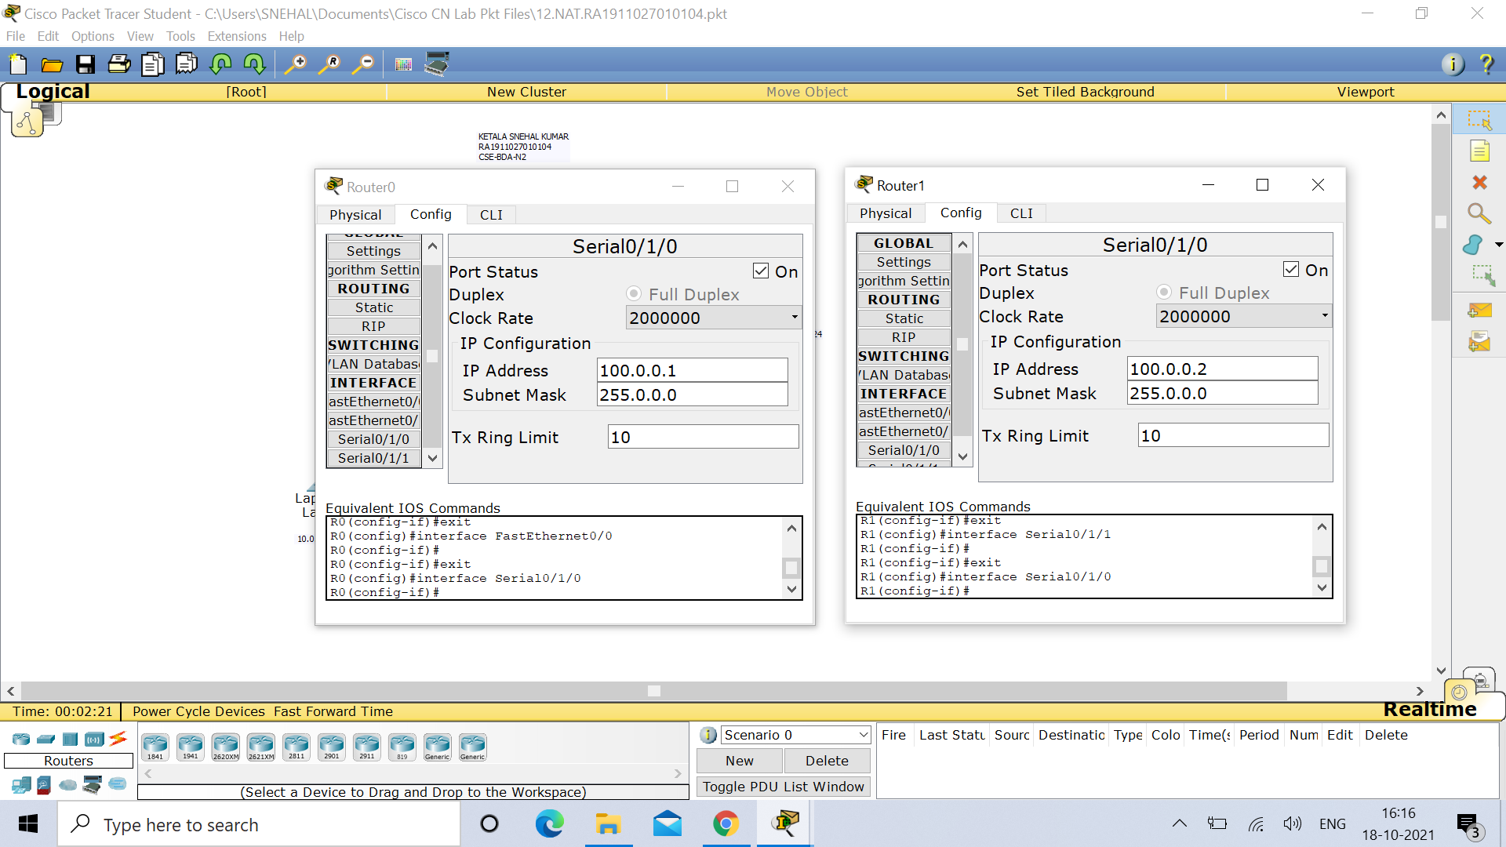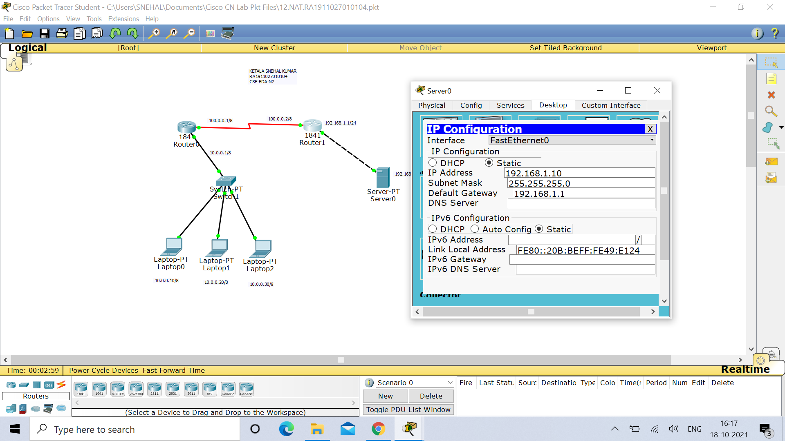

**Router 0 :**

Router>enable

Router#configure terminal

Enter configuration commands, one per line. End with CNTL/Z.

Router(config)#hostname R0

R0(config)#interface FastEthernet0/0

R0(config-if)#ip address 10.0.0.1 255.0.0.0

R0(config-if)#no shutdown

R0(config-if)#

%LINK-5-CHANGED: Interface FastEthernet0/0, changed state to up

%LINEPROTO-5-UPDOWN: Line protocol on Interface FastEthernet0/0, changed state to up

R0(config-if)#exit

R0(config)#exit

R0#

%SYS-5-CONFIG_I: Configured from console by console

R0#configure terminal

Enter configuration commands, one per line. End with CNTL/Z.

R0(config)#interface Serial0/1/0

R0(config-if)#ip address 100.0.0.1 255.0.0.0

R0(config-if)#clock rate 64000

This command applies only to DCE interfaces

R0(config-if)#no shutdown

%LINK-5-CHANGED: Interface Serial0/1/0, changed state to down

R0(config-if)#exit

R0(config)#

%LINK-5-CHANGED: Interface Serial0/1/0, changed state to up

%LINEPROTO-5-UPDOWN: Line protocol on Interface Serial0/1/0, changed state to up

R0(config)#ip nat inside source static 10.0.0.10 50.0.0.10

R0(config)#interface FastEthernet 0/0

R0(config-if)#ip nat inside

R0(config-if)#exit

R0(config)#

R0(config)#interface Serial 0/1/0

R0(config-if)#ip nat outside

R0(config-if)#exit

R0(config)#ip nat inside source static 10.0.0.20 50.0.0.20

R0(config)#ip nat inside source static 10.0.0.30 50.0.0.30

R0(config)#interface FastEthernet 0/0

R0(config-if)#ip nat inside

R0(config-if)#exit

R0(config)#ip route 200.0.0.0 255.255.255.0 100.0.0.2

R0(config)#

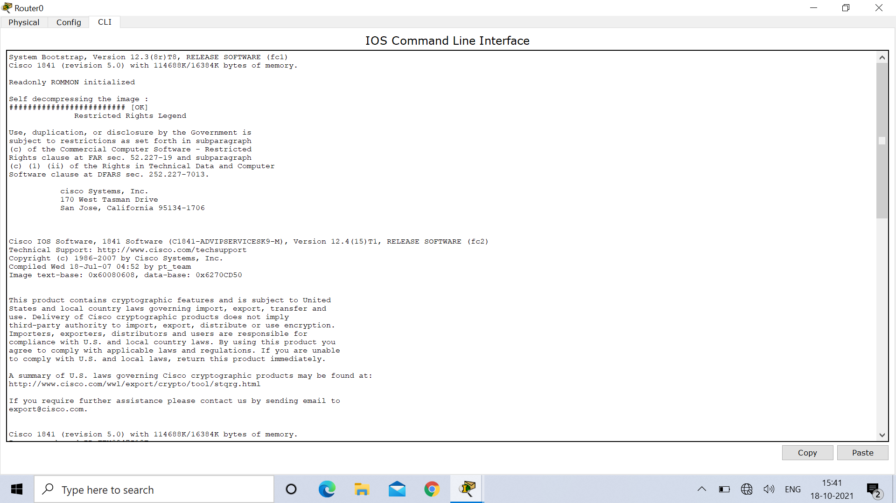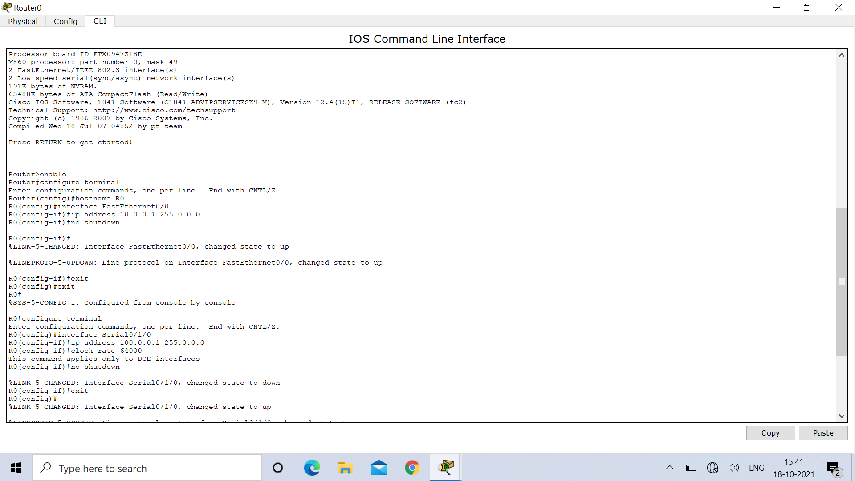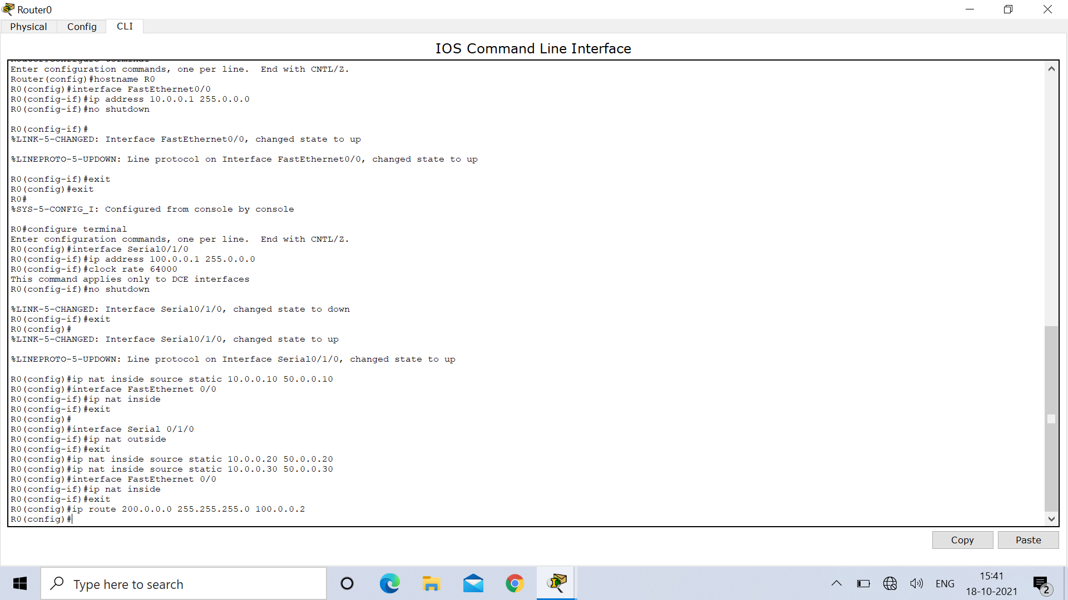

**Router 1 :**

Router>

Router>enable

Router#configure terminal

Enter configuration commands, one per line. End with CNTL/Z.

Router(config)#

Router(config)#hostname R1

R1(config)#interface FastEthernet0/0

R1(config-if)#ip address 192.168.1.1 255.255.255.0

R1(config-if)#no shutdown

R1(config-if)#

%LINK-5-CHANGED: Interface FastEthernet0/0, changed state to up

%LINEPROTO-5-UPDOWN: Line protocol on Interface FastEthernet0/0, changed state to up

R1(config-if)#exit

R1(config)#interface Serial0/1/0

R1(config-if)#ip address 100.0.0.2 255.0.0.0

R1(config-if)#no shutdown

R1(config-if)#

%LINK-5-CHANGED: Interface Serial0/1/0, changed state to up

R1(config-if)#exit

R1(config)#

%LINEPROTO-5-UPDOWN: Line protocol on Interface Serial0/1/0, changed state to up

R1(config)#ip nat inside source static 192.168.1.10 200.0.0.10

R1(config)#interface FastEthernet 0/0

R1(config-if)#ip nat inside

R1(config-if)#exit

R1(config)#interface Serial 0/1/0

R1(config-if)#ip nat outside

R1(config-if)#exit

R1(config)#ip route 50.0.0.0 255.0.0.0 100.0.0.1

R1(config)#

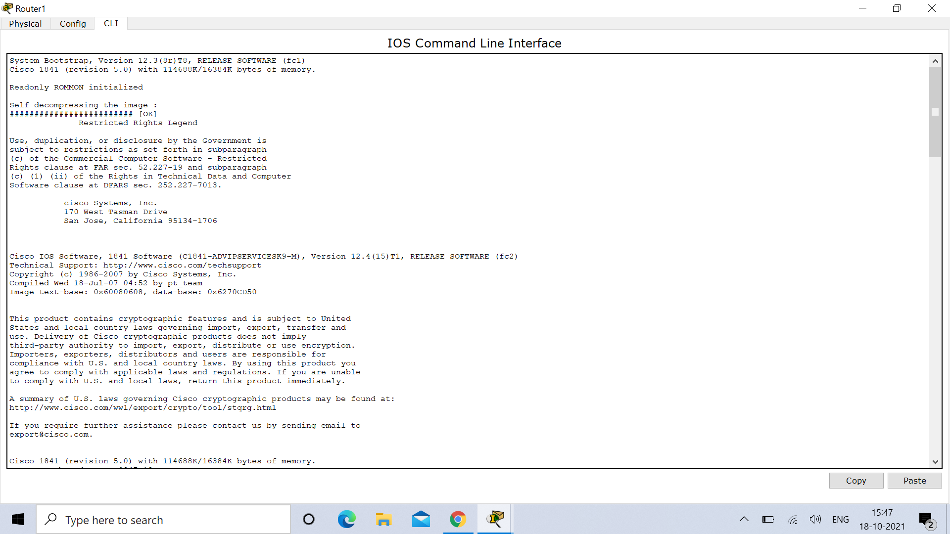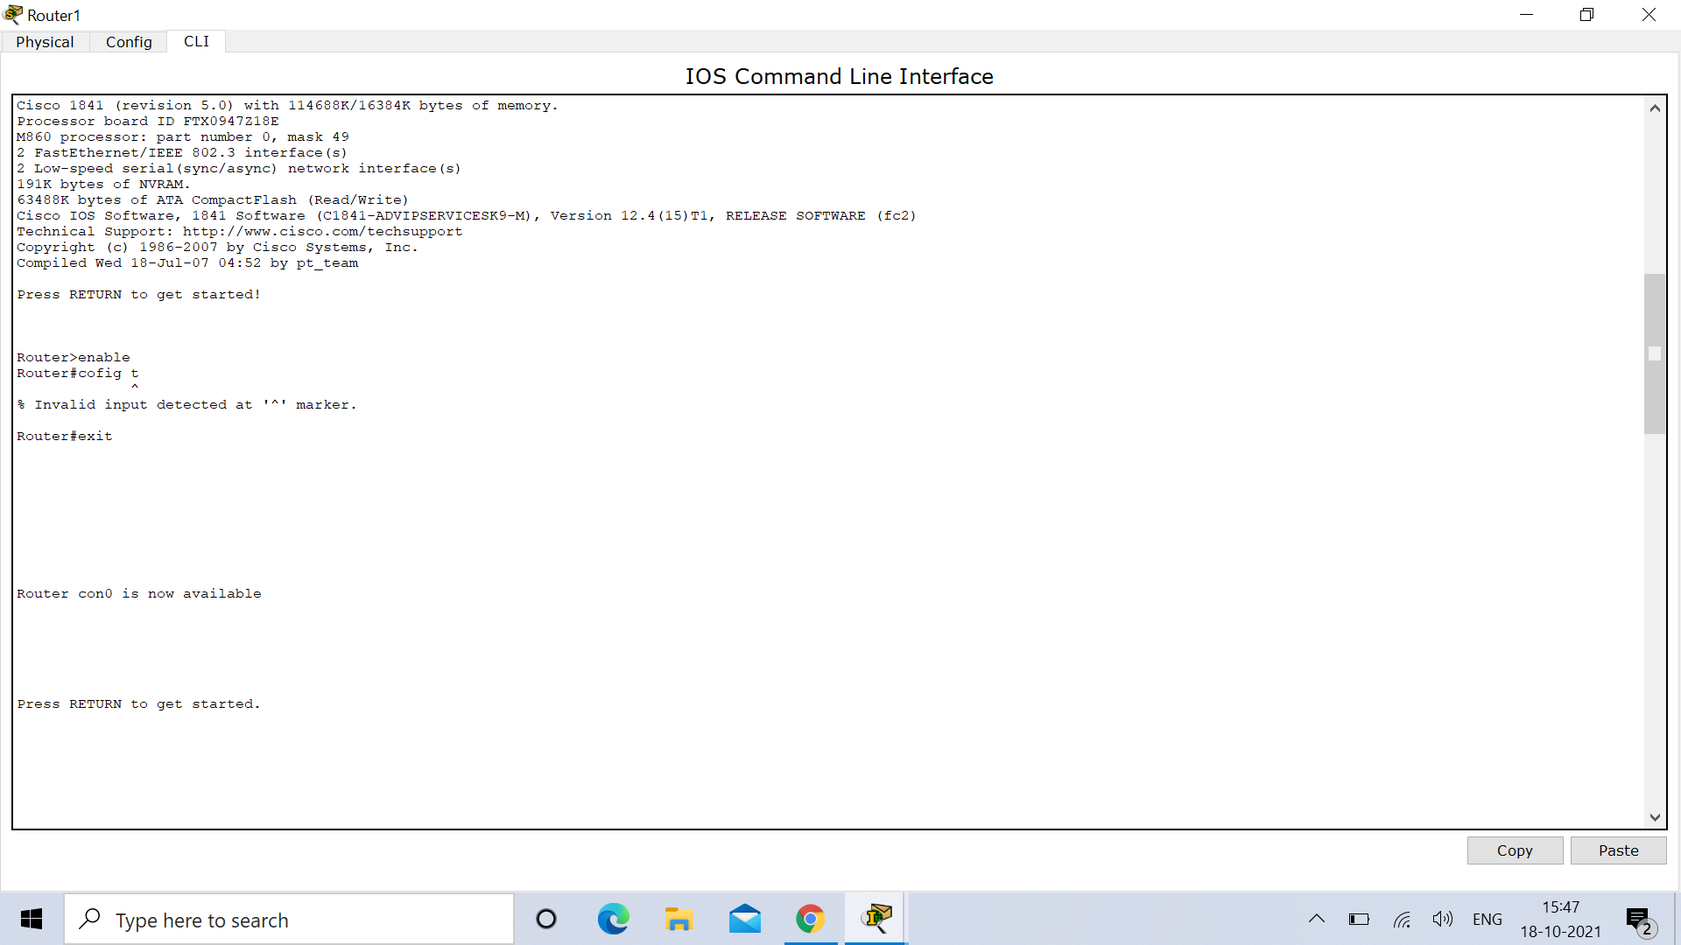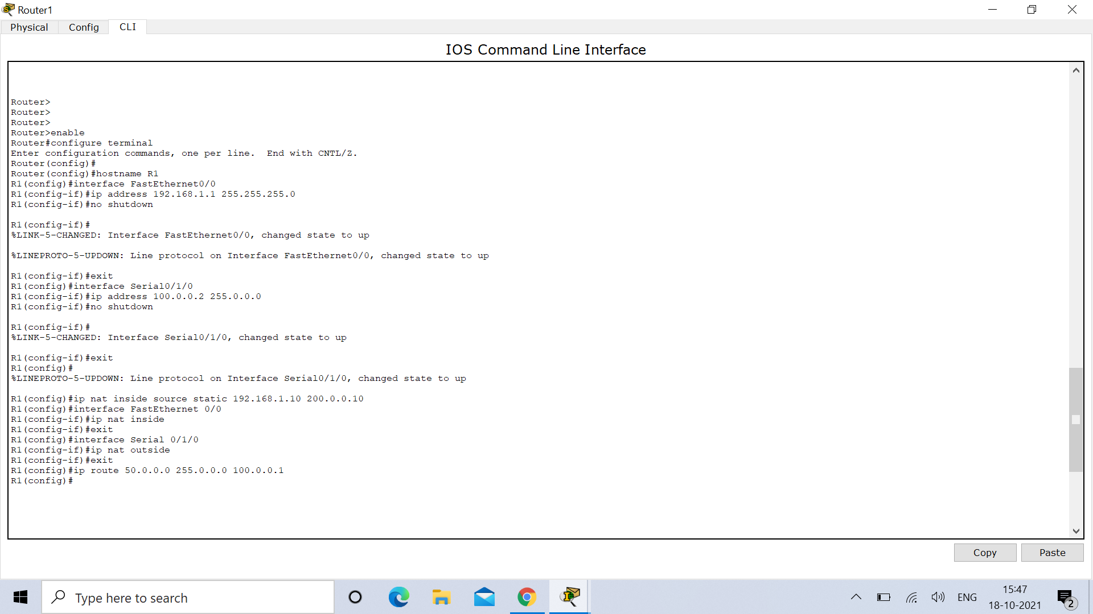

**OUTPUT :**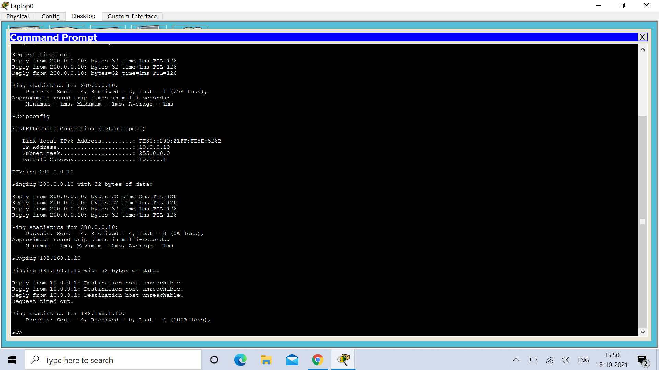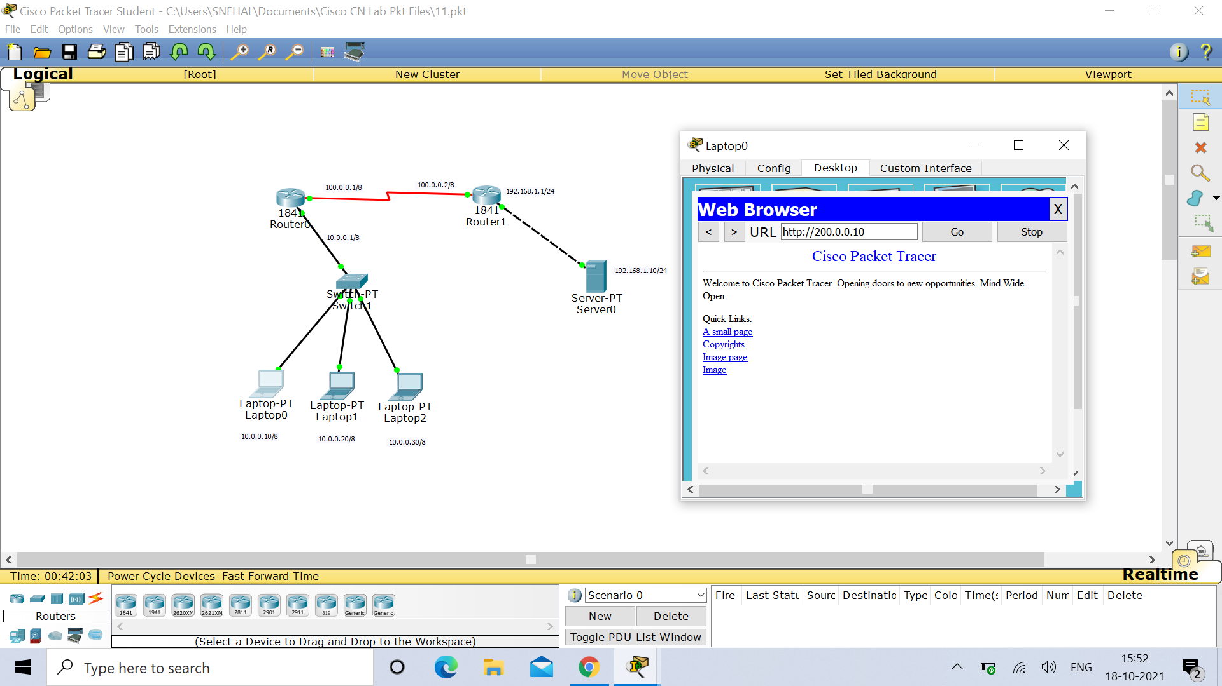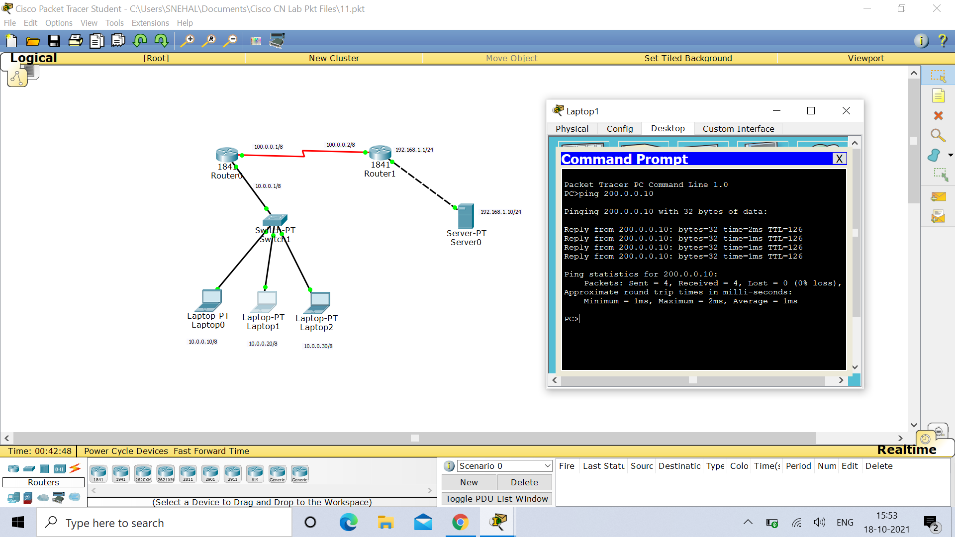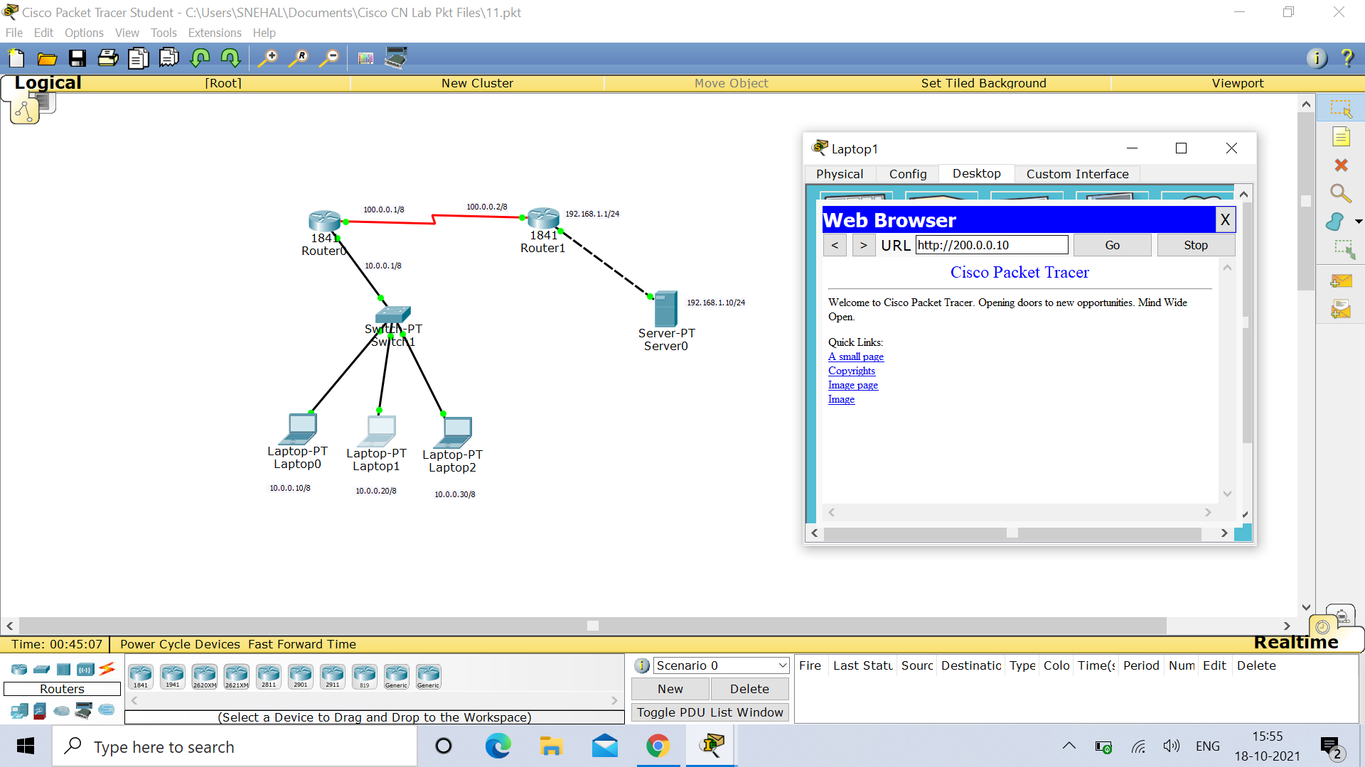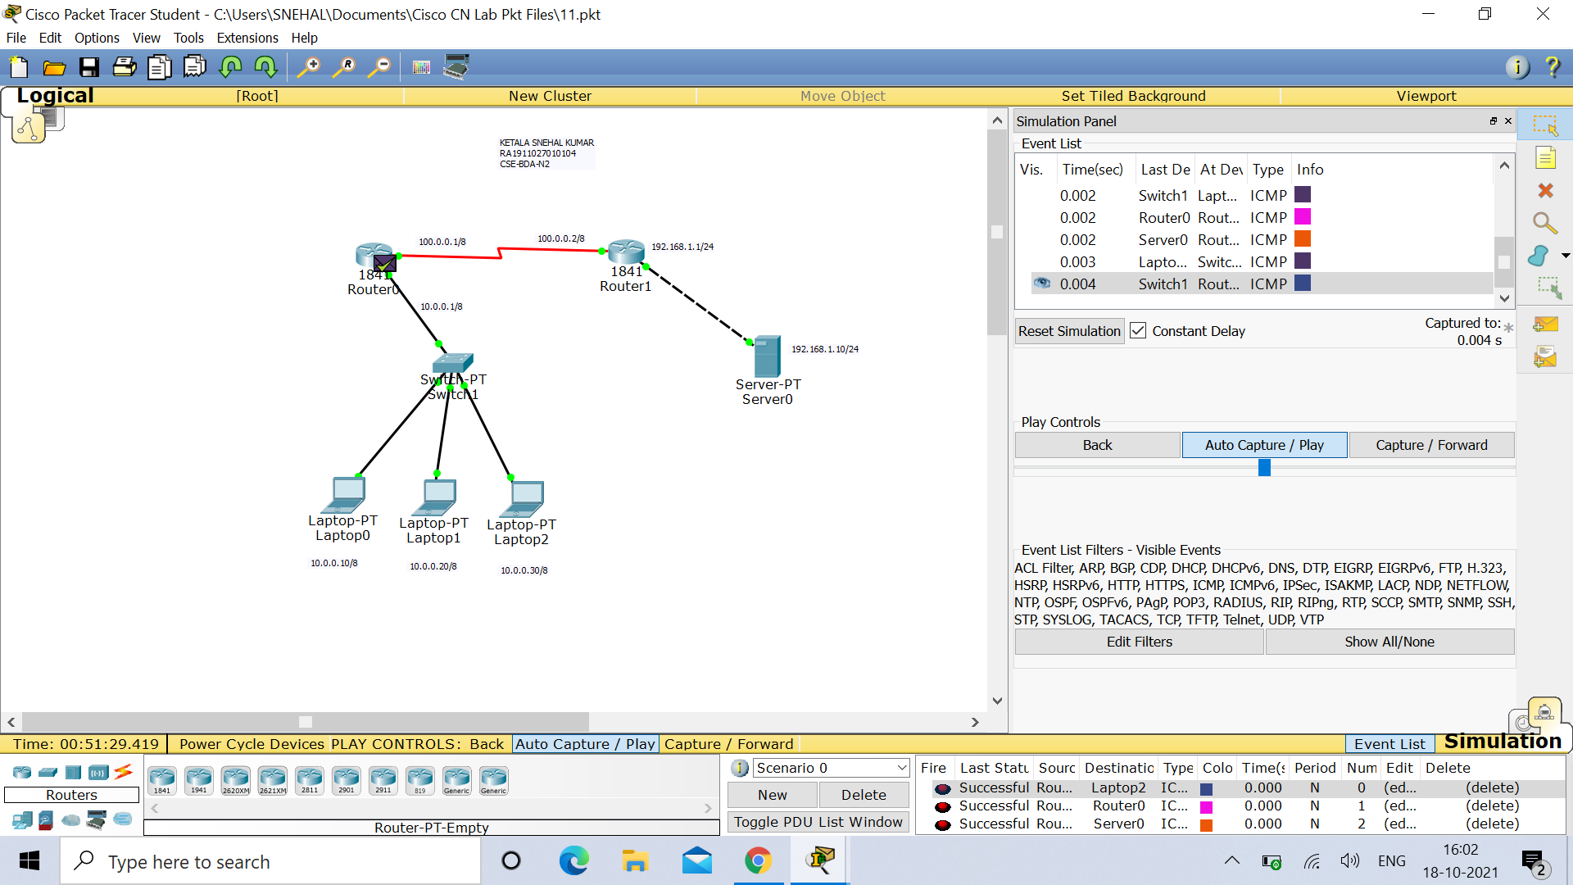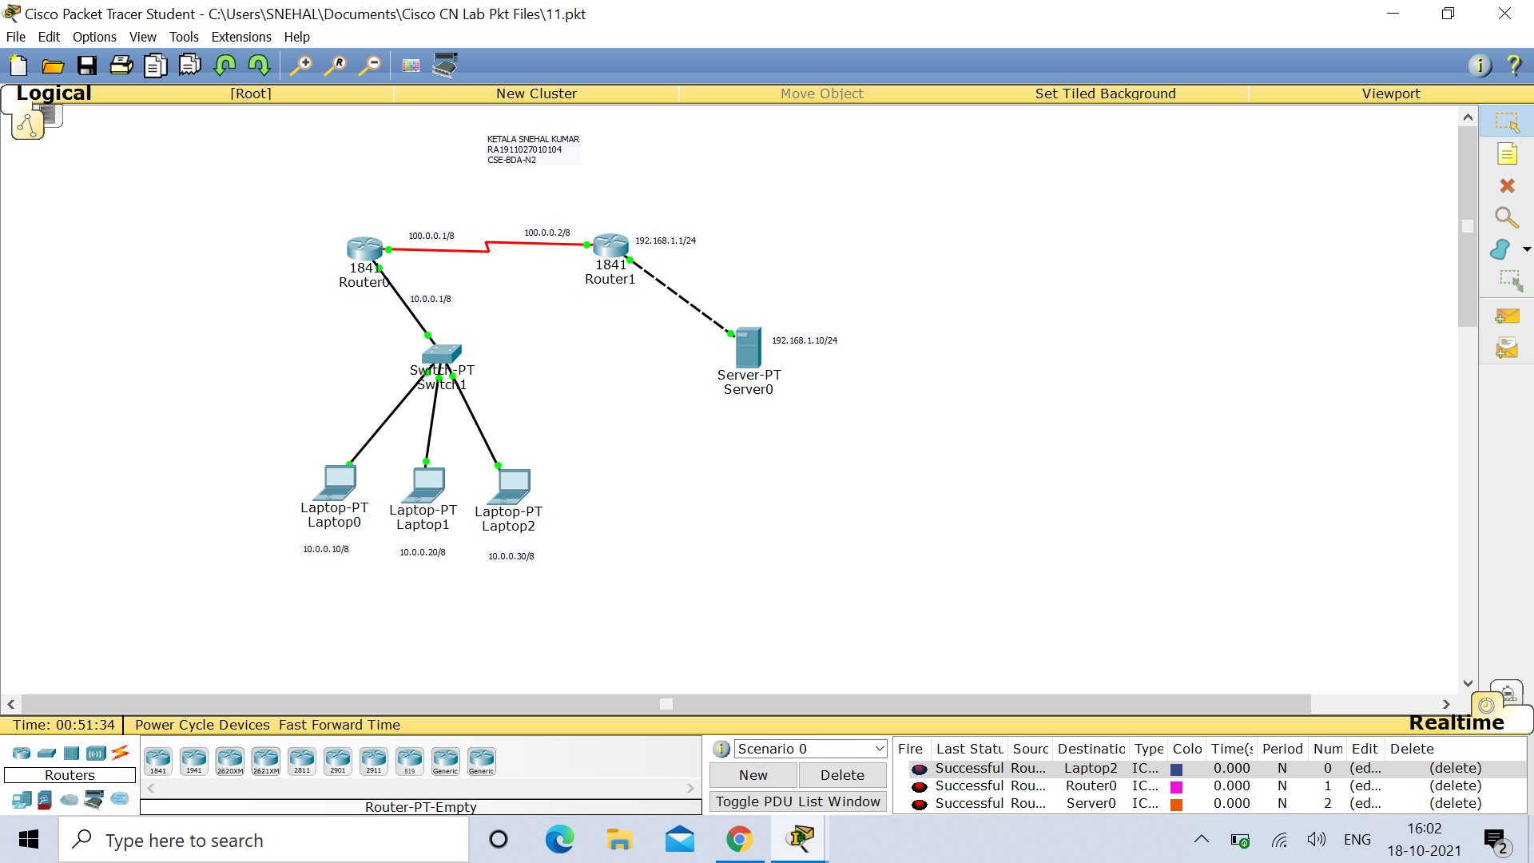

**Result :** Hence demonstration of Network Address Translation Protocol is successfully done and verified.