**AIM :** Communication Using PPP

**PPP** is a non-proprietary WAN data-link layer encapsulation protocol which can be viewed as an enhancement of HDLC as it embeds many additional features when compared with HDLC:

PPP Authentication. Supported authentication protocols are PAP and CHAO

Compression

Error detection

Multilink to provide load-balancing over multiple network interfaces

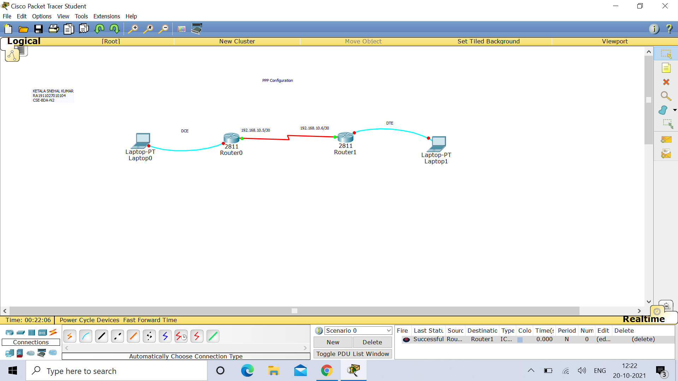

**IP Configuration :**

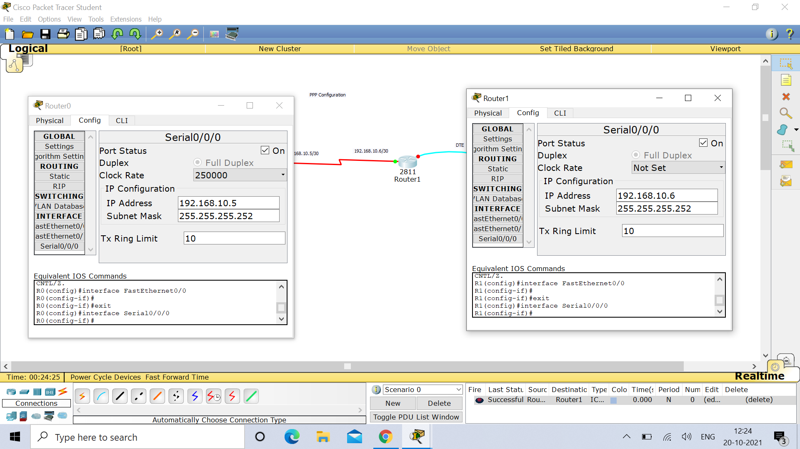

**ROUTER 0 :**

Router>enable

Router#config t

Enter configuration commands, one per line. End with CNTL/Z.

Router(config)#

Router(config)#hostname R0

R0(config)#exit

R0#

%SYS-5-CONFIG_I: Configured from console by console

R0#show controllers serial 0/0/0

Interface Serial0/0/0

Hardware is PowerQUICC MPC860

DCE V.35, clock rate 2000000

idb at 0x81081AC4, driver data structure at 0x81084AC0

SCC Registers:

General [GSMR]=0x2:0x00000000, Protocol-specific [PSMR]=0x8

Events [SCCE]=0x0000, Mask [SCCM]=0x0000, Status [SCCS]=0x00

Transmit on Demand [TODR]=0x0, Data Sync [DSR]=0x7E7E

Interrupt Registers:

Config [CICR]=0x00367F80, Pending [CIPR]=0x0000C000

Mask [CIMR]=0x00200000, In-srv [CISR]=0x00000000

Command register [CR]=0x580

Port A [PADIR]=0x1030, [PAPAR]=0xFFFF

[PAODR]=0x0010, [PADAT]=0xCBFF

Port B [PBDIR]=0x09C0F, [PBPAR]=0x0800E

[PBODR]=0x00000, [PBDAT]=0x3FFFD

Port C [PCDIR]=0x00C, [PCPAR]=0x200

[PCSO]=0xC20, [PCDAT]=0xDF2, [PCINT]=0x00F

Receive Ring

rmd(68012830): status 9000 length 60C address 3B6DAC4

rmd(68012838): status B000 length 60C address 3B6D444

Transmit Ring

tmd(680128B0): status 0 length 0 address 0

tmd(680128B8): status 0 length 0 address 0

tmd(680128C0): status 0 length 0 address 0

tmd(680128C8): status 0 length 0 address 0

tmd(680128D0): status 0 length 0 address 0

tmd(680128D8): status 0 length 0 address 0

tmd(680128E0): status 0 length 0 address 0

tmd(680128E8): status 0 length 0 address 0

tmd(680128F0): status 0 length 0 address 0

tmd(680128F8): status 0 length 0 address 0

tmd(68012900): status 0 length 0 address 0

tmd(68012908): status 0 length 0 address 0

tmd(68012910): status 0 length 0 address 0

tmd(68012918): status 0 length 0 address 0

tmd(68012920): status 0 length 0 address 0

tmd(68012928): status 2000 length 0 address 0

tx_limited=1(2)

SCC GENERAL PARAMETER RAM (at 0x68013C00)

Rx BD Base [RBASE]=0x2830, Fn Code [RFCR]=0x18

Tx BD Base [TBASE]=0x28B0, Fn Code [TFCR]=0x18

Max Rx Buff Len [MRBLR]=1548

Rx State [RSTATE]=0x0, BD Ptr [RBPTR]=0x2830

Tx State [TSTATE]=0x4000, BD Ptr [TBPTR]=0x28B0

SCC HDLC PARAMETER RAM (at 0x68013C38)

CRC Preset [C_PRES]=0xFFFF, Mask [C_MASK]=0xF0B8

Errors: CRC [CRCEC]=0, Aborts [ABTSC]=0, Discards [DISFC]=0

Nonmatch Addr Cntr [NMARC]=0

Retry Count [RETRC]=0

Max Frame Length [MFLR]=1608

Rx Int Threshold [RFTHR]=0, Frame Cnt [RFCNT]=0

User-defined Address 0000/0000/0000/0000

User-defined Address Mask 0x0000

buffer size 1524

PowerQUICC SCC specific errors:

0 input aborts on receiving flag sequence

0 throttles, 0 enables

0 overruns

0 transmitter underruns

0 transmitter CTS losts

0 aborted short frames

R0#config t

Enter configuration commands, one per line. End with CNTL/Z.

R0(config)#interface serial 0/0/0

R0(config-if)#clock rate 250000

R0(config-if)#exit

R0(config)#interface serial 0/0/0

R0(config-if)#encapsulation ppp

R0(config-if)#ip address 192.168.10.5 255.255.255.252

R0(config-if)#no shut

%LINK-5-CHANGED: Interface Serial0/0/0, changed state to down

R0(config-if)#

%LINK-5-CHANGED: Interface Serial0/0/0, changed state to up

%LINEPROTO-5-UPDOWN: Line protocol on Interface Serial0/0/0, changed state to up

R0(config-if)#exit

R0(config)#exit

R0#

%SYS-5-CONFIG_I: Configured from console by console

R0#show interfaces serial 0/0/0

Serial0/0/0 is up, line protocol is up (connected)

Hardware is HD64570

Internet address is 192.168.10.5/30

MTU 1500 bytes, BW 128 Kbit, DLY 20000 usec,

reliability 255/255, txload 1/255, rxload 1/255

Encapsulation PPP, loopback not set, keepalive set (10 sec)

LCP Open

Open: IPCP, CDPCP

Last input never, output never, output hang never

Last clearing of "show interface" counters never

Input queue: 0/75/0 (size/max/drops); Total output drops: 0

Queueing strategy: weighted fair

Output queue: 0/1000/64/0 (size/max total/threshold/drops)

Conversations 0/0/256 (active/max active/max total)

Reserved Conversations 0/0 (allocated/max allocated)

Available Bandwidth 96 kilobits/sec

5 minute input rate 0 bits/sec, 0 packets/sec

5 minute output rate 0 bits/sec, 0 packets/sec

0 packets input, 0 bytes, 0 no buffer

Received 0 broadcasts, 0 runts, 0 giants, 0 throttles

0 input errors, 0 CRC, 0 frame, 0 overrun, 0 ignored, 0 abort

0 packets output, 0 bytes, 0 underruns

0 output errors, 0 collisions, 1 interface resets

0 output buffer failures, 0 output buffers swapped out

0 carrier transitions

DCD=up DSR=up DTR=up RTS=up CTS=up

R0#

R0#

R0#

R0#

R0#

R0#ping 192.168.10.6

Type escape sequence to abort.

Sending 5, 100-byte ICMP Echos to 192.168.10.6, timeout is 2 seconds:

!!!!!

Success rate is 100 percent (5/5), round-trip min/avg/max = 1/4/15 ms

R0#

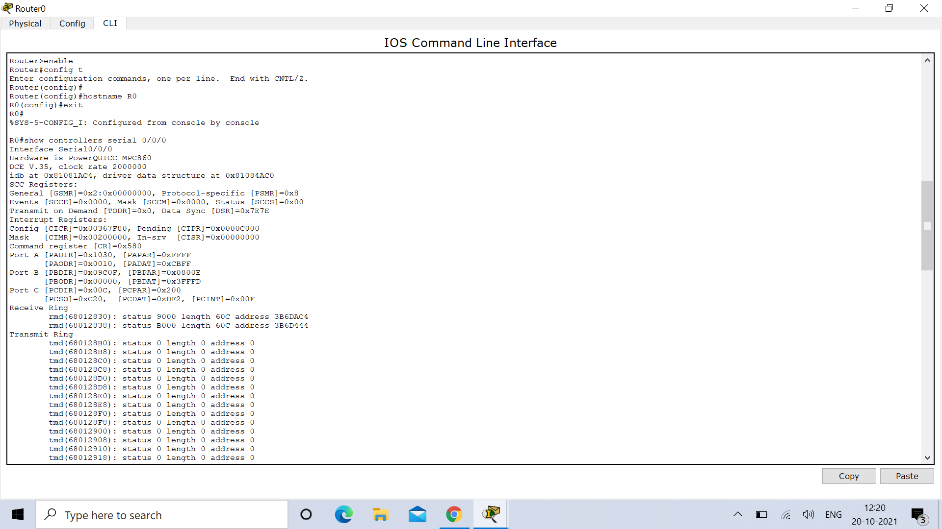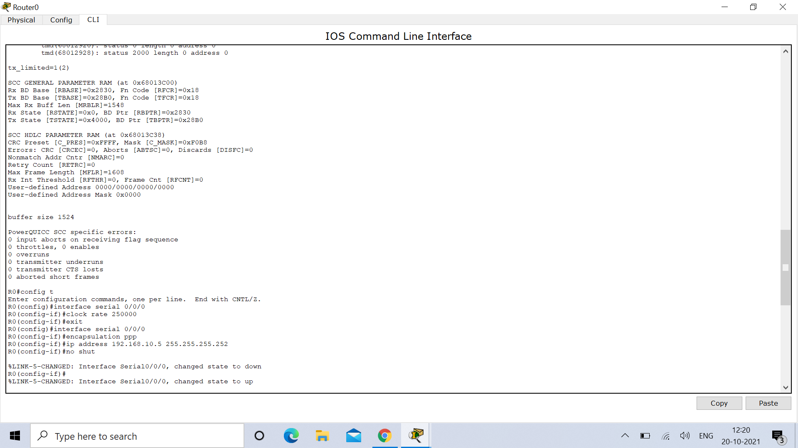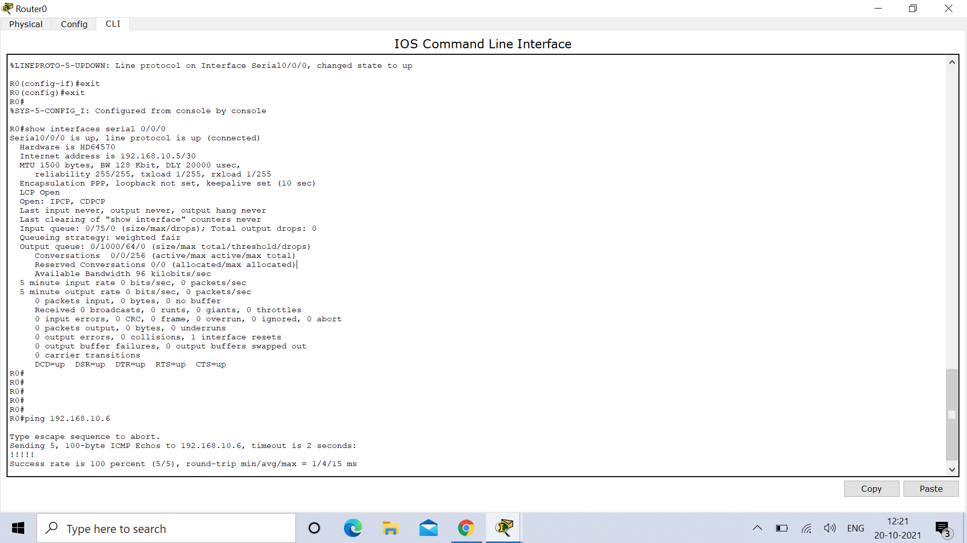

**ROUTER 1 :**

Router>en

Router#config t

Enter configuration commands, one per line. End with CNTL/Z.

Router(config)#hostname R1

R1(config)#exit

R1#

%SYS-5-CONFIG_I: Configured from console by console

R1#show controllers serial 0/0/0

Interface Serial0/0/0

Hardware is PowerQUICC MPC860

DTE V.35 TX and RX clocks detected

idb at 0x81081AC4, driver data structure at 0x81084AC0

SCC Registers:

General [GSMR]=0x2:0x00000000, Protocol-specific [PSMR]=0x8

Events [SCCE]=0x0000, Mask [SCCM]=0x0000, Status [SCCS]=0x00

Transmit on Demand [TODR]=0x0, Data Sync [DSR]=0x7E7E

Interrupt Registers:

Config [CICR]=0x00367F80, Pending [CIPR]=0x0000C000

Mask [CIMR]=0x00200000, In-srv [CISR]=0x00000000

Command register [CR]=0x580

Port A [PADIR]=0x1030, [PAPAR]=0xFFFF

[PAODR]=0x0010, [PADAT]=0xCBFF

Port B [PBDIR]=0x09C0F, [PBPAR]=0x0800E

[PBODR]=0x00000, [PBDAT]=0x3FFFD

Port C [PCDIR]=0x00C, [PCPAR]=0x200

[PCSO]=0xC20, [PCDAT]=0xDF2, [PCINT]=0x00F

Receive Ring

rmd(68012830): status 9000 length 60C address 3B6DAC4

rmd(68012838): status B000 length 60C address 3B6D444

Transmit Ring

tmd(680128B0): status 0 length 0 address 0

tmd(680128B8): status 0 length 0 address 0

tmd(680128C0): status 0 length 0 address 0

tmd(680128C8): status 0 length 0 address 0

tmd(680128D0): status 0 length 0 address 0

tmd(680128D8): status 0 length 0 address 0

tmd(680128E0): status 0 length 0 address 0

tmd(680128E8): status 0 length 0 address 0

tmd(680128F0): status 0 length 0 address 0

tmd(680128F8): status 0 length 0 address 0

tmd(68012900): status 0 length 0 address 0

tmd(68012908): status 0 length 0 address 0

tmd(68012910): status 0 length 0 address 0

tmd(68012918): status 0 length 0 address 0

tmd(68012920): status 0 length 0 address 0

tmd(68012928): status 2000 length 0 address 0

tx_limited=1(2)

SCC GENERAL PARAMETER RAM (at 0x68013C00)

Rx BD Base [RBASE]=0x2830, Fn Code [RFCR]=0x18

Tx BD Base [TBASE]=0x28B0, Fn Code [TFCR]=0x18

Max Rx Buff Len [MRBLR]=1548

Rx State [RSTATE]=0x0, BD Ptr [RBPTR]=0x2830

Tx State [TSTATE]=0x4000, BD Ptr [TBPTR]=0x28B0

SCC HDLC PARAMETER RAM (at 0x68013C38)

CRC Preset [C_PRES]=0xFFFF, Mask [C_MASK]=0xF0B8

Errors: CRC [CRCEC]=0, Aborts [ABTSC]=0, Discards [DISFC]=0

Nonmatch Addr Cntr [NMARC]=0

Retry Count [RETRC]=0

Max Frame Length [MFLR]=1608

Rx Int Threshold [RFTHR]=0, Frame Cnt [RFCNT]=0

User-defined Address 0000/0000/0000/0000

User-defined Address Mask 0x0000

buffer size 1524

PowerQUICC SCC specific errors:

0 input aborts on receiving flag sequence

0 throttles, 0 enables

0 overruns

0 transmitter underruns

0 transmitter CTS losts

0 aborted short frames

R1#

R1#

R1#

R1#config t

Enter configuration commands, one per line. End with CNTL/Z.

R1(config)#interface serial 0/0/0

R1(config-if)#encapsulation ppp

R1(config-if)#ip address 192.168.10.6 255.255.255.252

R1(config-if)#no shut

R1(config-if)#

%LINK-5-CHANGED: Interface Serial0/0/0, changed state to up

%LINEPROTO-5-UPDOWN: Line protocol on Interface Serial0/0/0, changed state to up

R1(config-if)#

R1(config-if)#exit

R1(config)#exit

R1#

%SYS-5-CONFIG_I: Configured from console by console

R1#show interfaces serial 0/0/0

Serial0/0/0 is up, line protocol is up (connected)

Hardware is HD64570

Internet address is 192.168.10.6/30

MTU 1500 bytes, BW 128 Kbit, DLY 20000 usec,

reliability 255/255, txload 1/255, rxload 1/255

Encapsulation PPP, loopback not set, keepalive set (10 sec)

LCP Open

Open: IPCP, CDPCP

Last input never, output never, output hang never

Last clearing of "show interface" counters never

Input queue: 0/75/0 (size/max/drops); Total output drops: 0

Queueing strategy: weighted fair

Output queue: 0/1000/64/0 (size/max total/threshold/drops)

Conversations 0/0/256 (active/max active/max total)

Reserved Conversations 0/0 (allocated/max allocated)

Available Bandwidth 96 kilobits/sec

5 minute input rate 0 bits/sec, 0 packets/sec

5 minute output rate 0 bits/sec, 0 packets/sec

0 packets input, 0 bytes, 0 no buffer

Received 0 broadcasts, 0 runts, 0 giants, 0 throttles

0 input errors, 0 CRC, 0 frame, 0 overrun, 0 ignored, 0 abort

0 packets output, 0 bytes, 0 underruns

0 output errors, 0 collisions, 1 interface resets

0 output buffer failures, 0 output buffers swapped out

0 carrier transitions

DCD=up DSR=up DTR=up RTS=up CTS=up

R1#

R1#ping 192.168.10.5

Type escape sequence to abort.

Sending 5, 100-byte ICMP Echos to 192.168.10.5, timeout is 2 seconds:

!!!!!

Success rate is 100 percent (5/5), round-trip min/avg/max = 1/1/5 ms

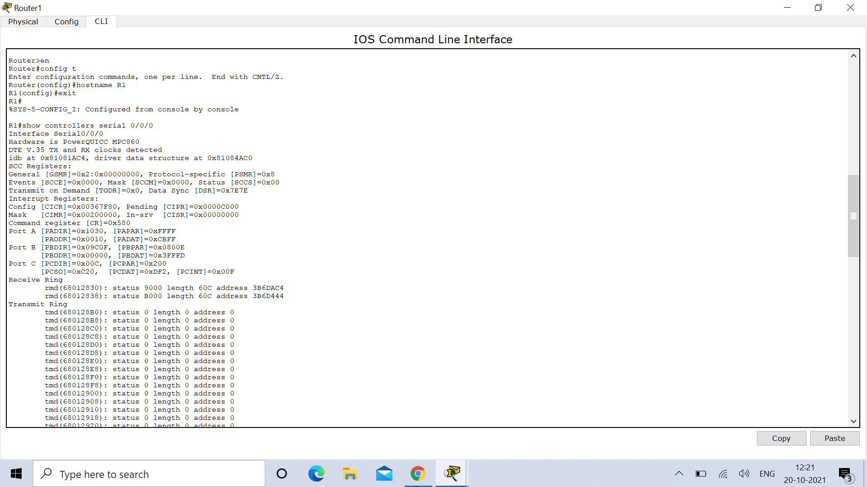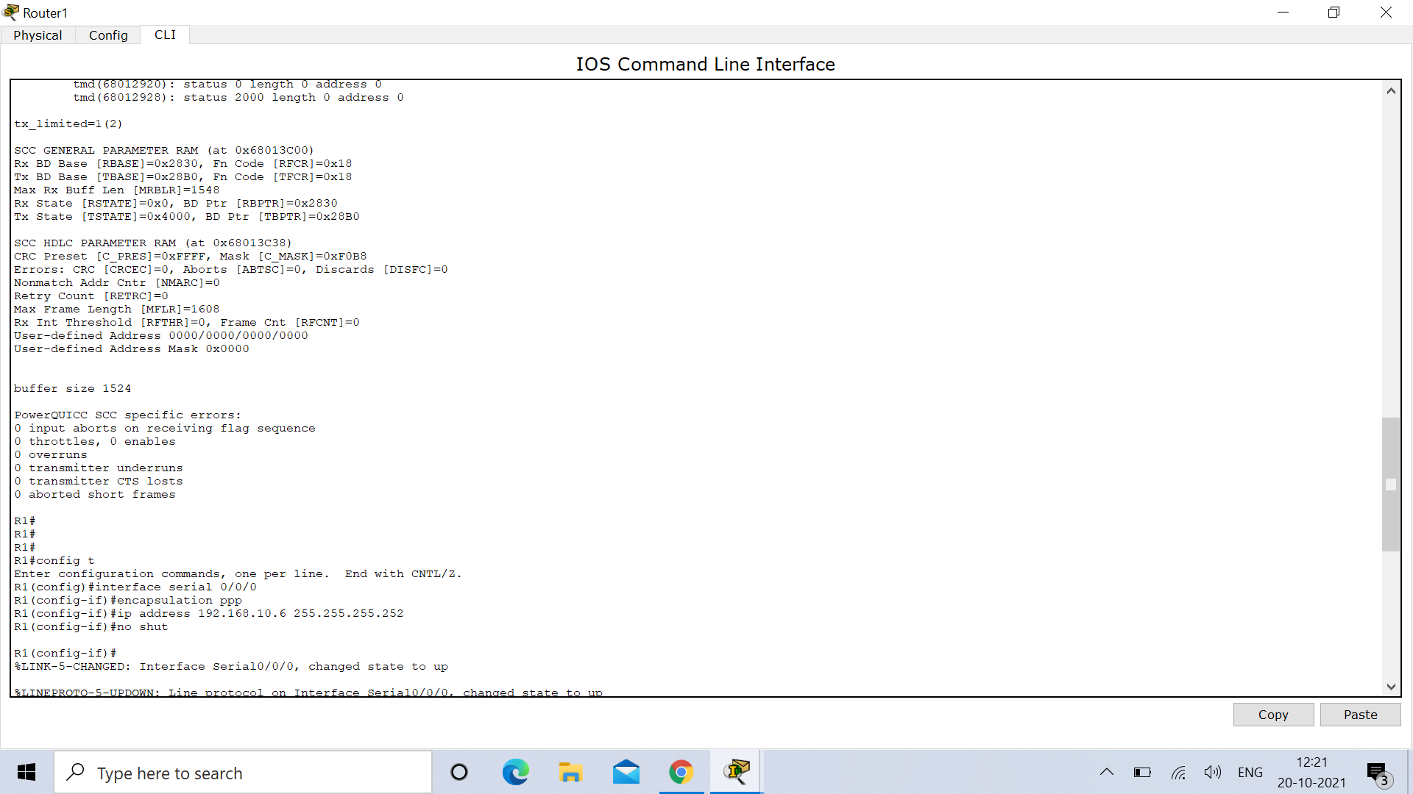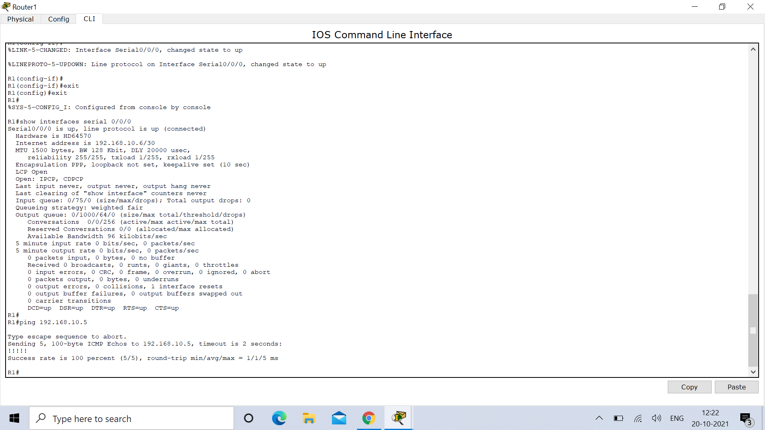

**OUTPUT :**

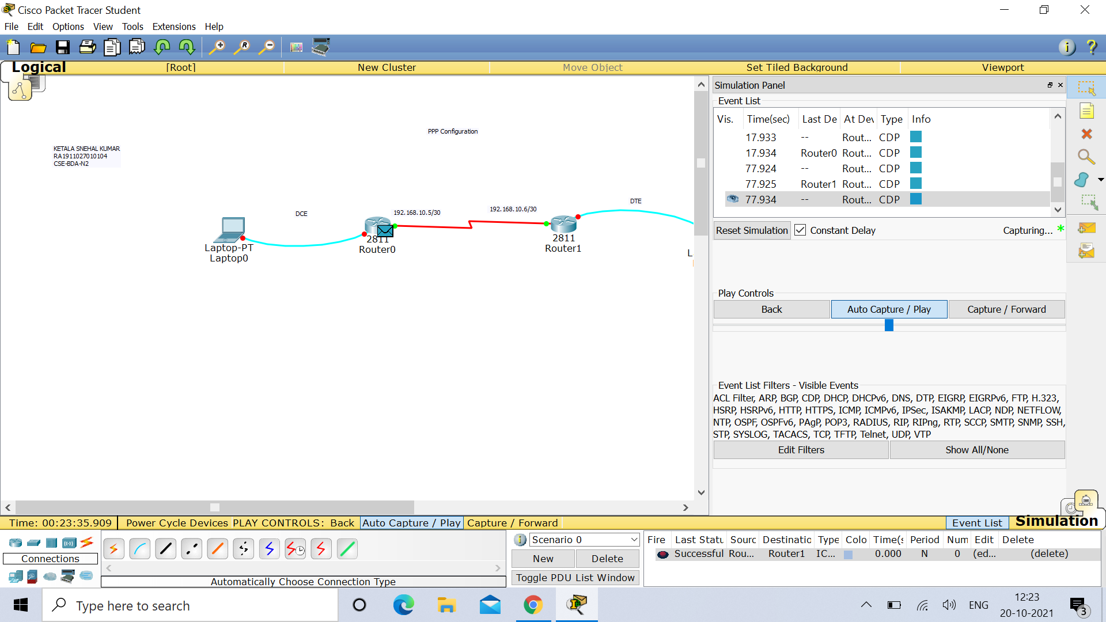

**R1 :**

R1#ping 192.168.10.5

Type escape sequence to abort.

Sending 5, 100-byte ICMP Echos to 192.168.10.5, timeout is 2 seconds:

!!!!!

Success rate is 100 percent (5/5), round-trip min/avg/max = 1/1/5 ms



**R0 :**

R0#ping 192.168.10.6

Type escape sequence to abort.

Sending 5, 100-byte ICMP Echos to 192.168.10.6, timeout is 2 seconds:

!!!!!

Success rate is 100 percent (5/5), round-trip min/avg/max = 1/4/15 ms



**Result :** Hence Implementation of Communication Using PPP is successfully done and verified.