RIP V1

* Ip address of pc0 is 10.0.0.2
* Ip address of pc1 is 10.0.0.3
* Pc0 and pc1 are connected to switch 0
* Ip address of pc2 is 20.0.0.2
* Ip address of pc3 is 20.0.0.3
* Pc2 and pc3 are connected to switch 1
* Ip address of pc4 is 30.0.0.2
* Ip address of pc5 is 30.0.0.3
* Pc4 and pc5 are connected to switch 2
* Switch 0 is connected to router 0
* Switch 1 is connected to router 1
* Switch 2 is connected to router 2
* Network between router0 and router1 is 11.0.0.0
* Network between router1 and router2 is 12.0.0.0

OUTPUT: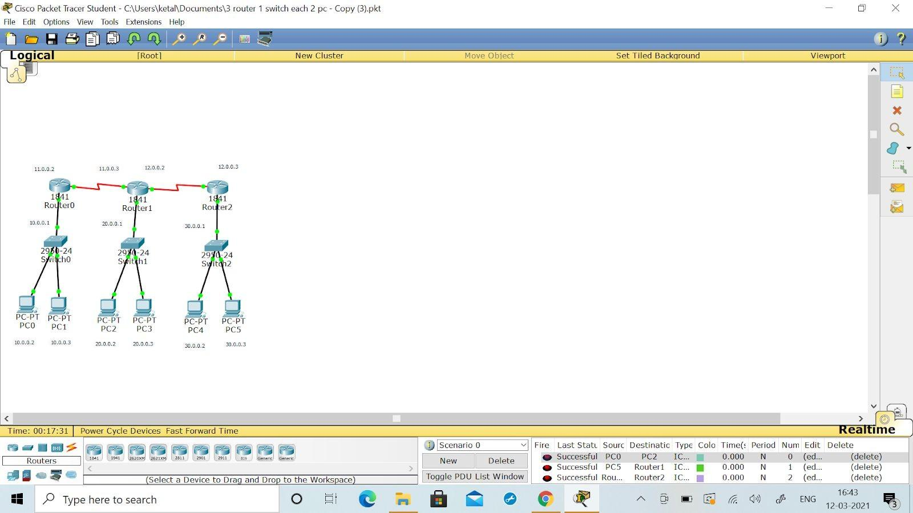

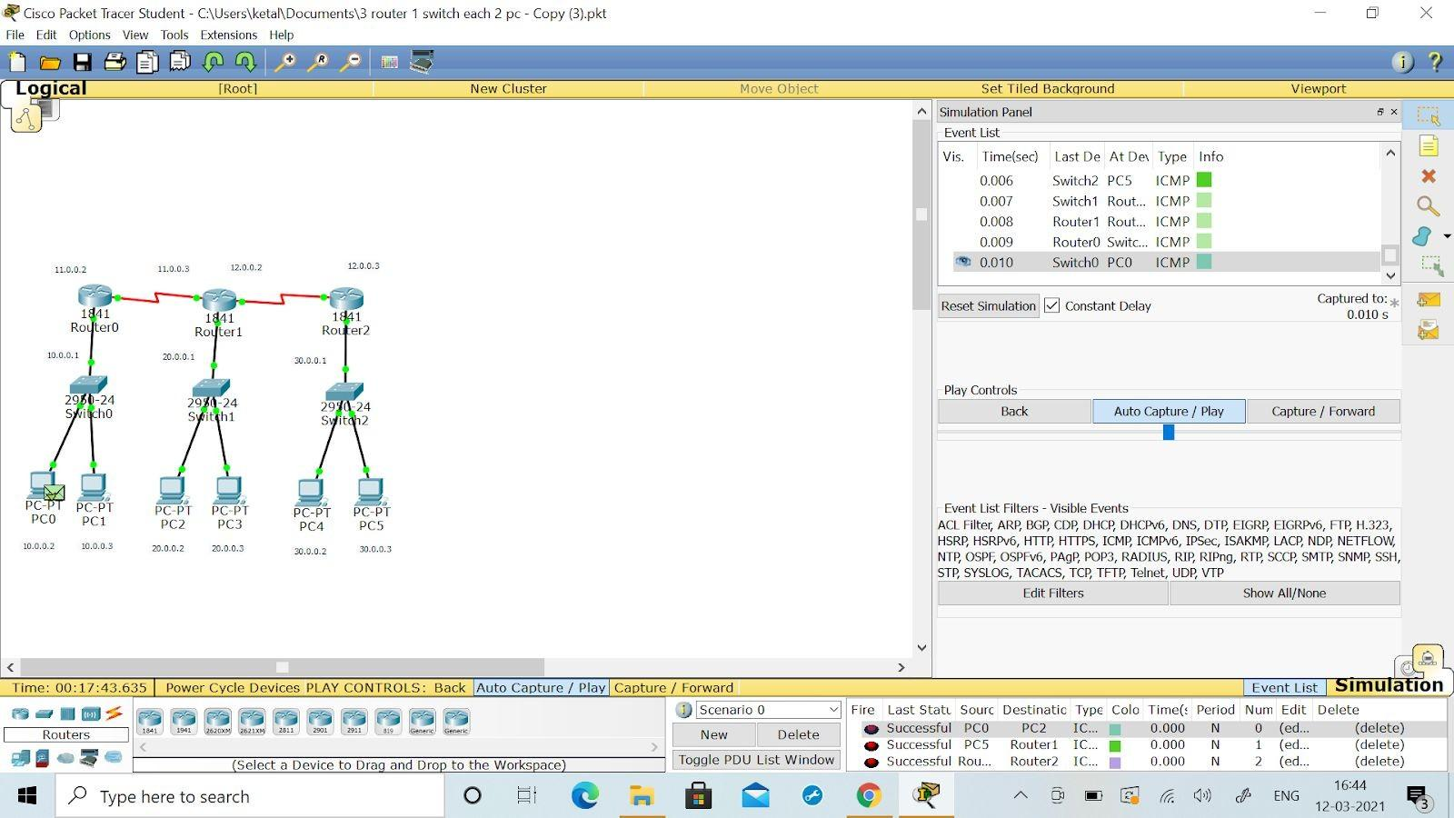

ROUTER 0: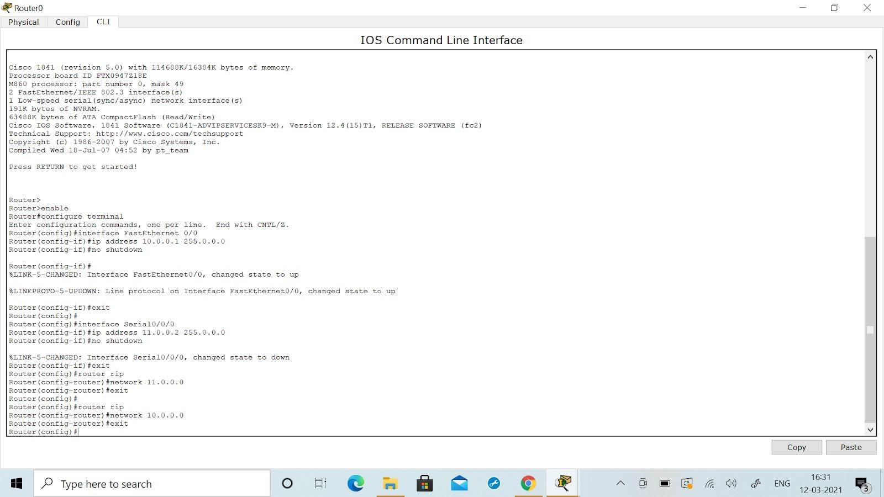

ROUTER 1: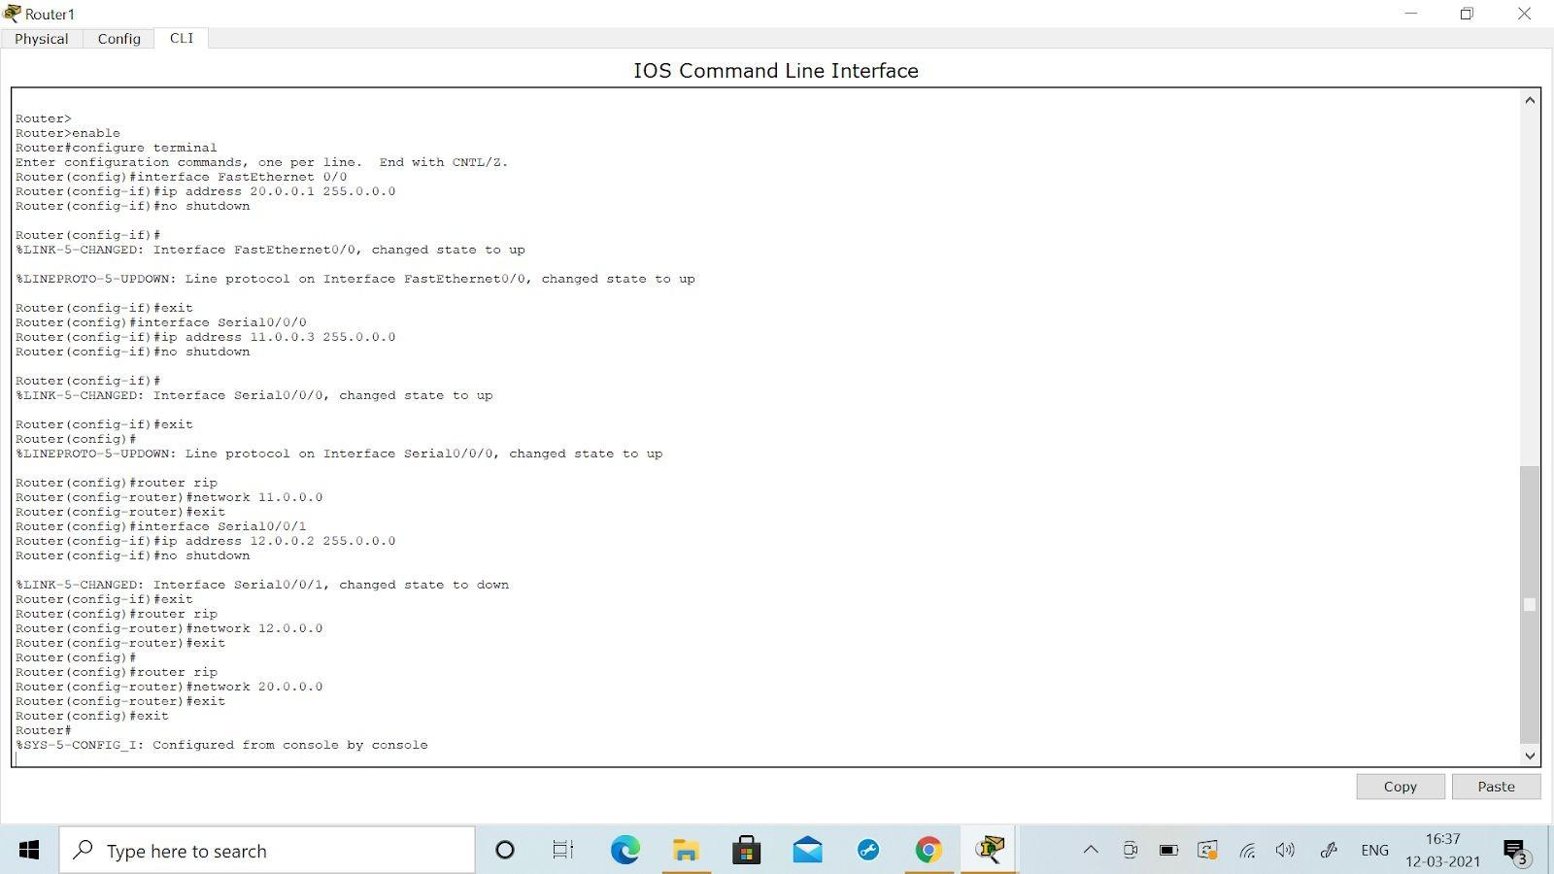

ROUTER 2:

