**AIM :** Implementation of VPN

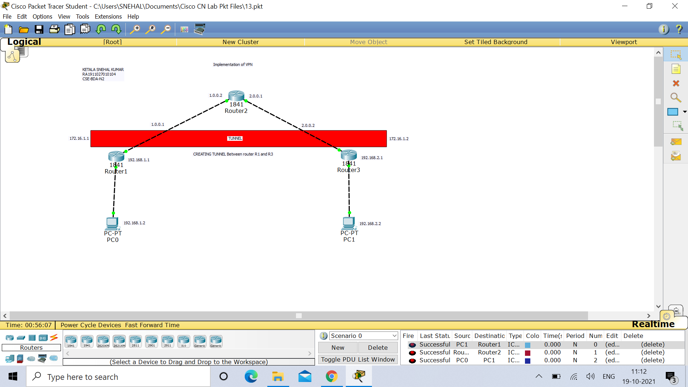

**IP Configurations :**

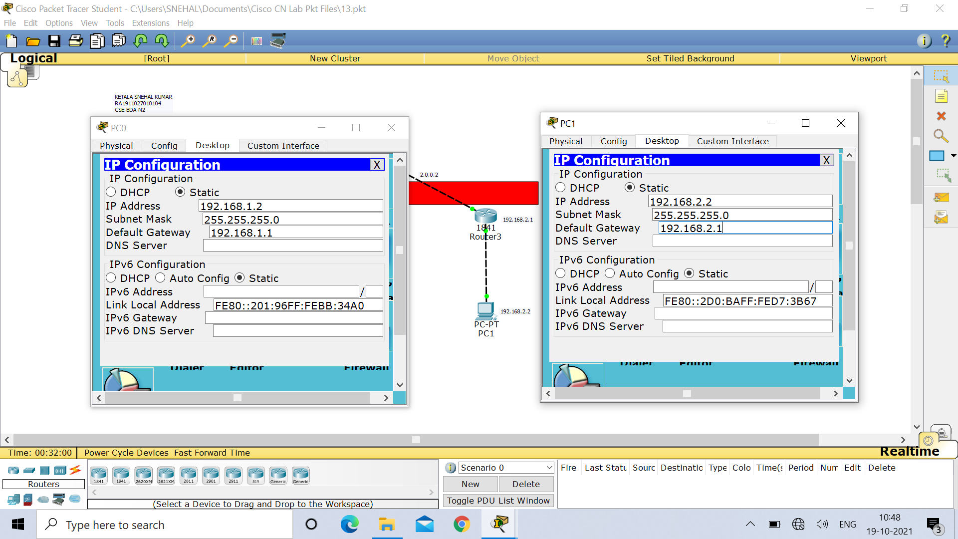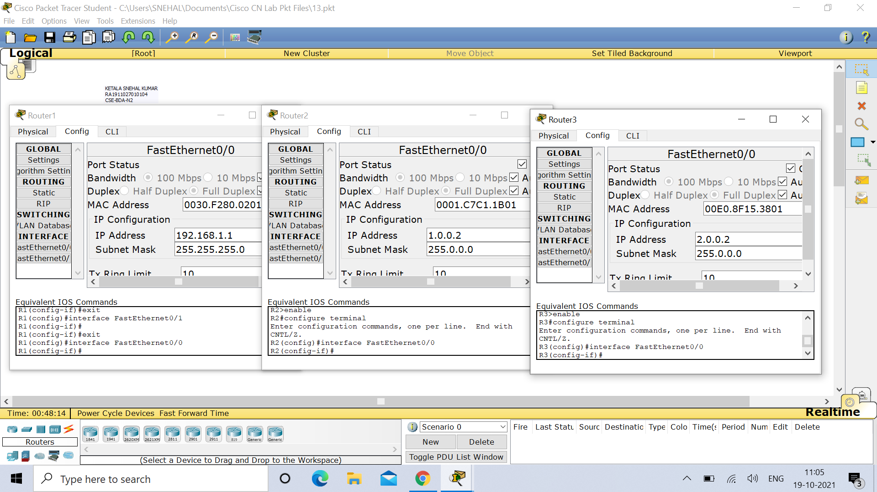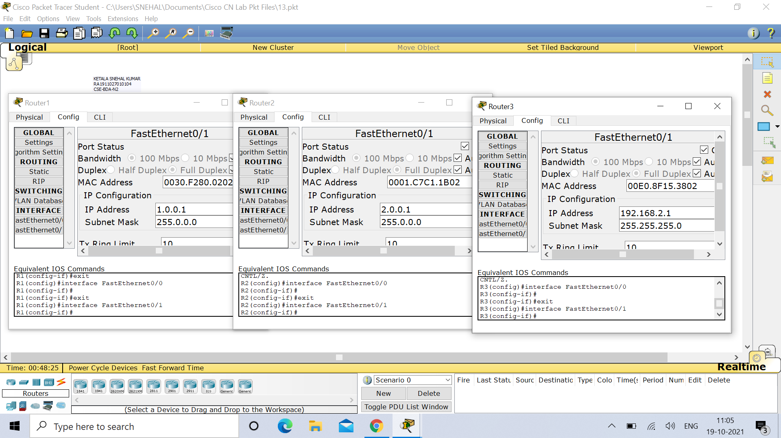

**Router 1 :**

Router>enable

Router#configure terminal

Enter configuration commands, one per line. End with CNTL/Z.

Router(config)#hostname R1

R1(config)#int fa0/0

R1(config-if)#ip address 192.168.1.1 255.255.255.0

R1(config-if)#no shut

R1(config-if)#

%LINK-5-CHANGED: Interface FastEthernet0/0, changed state to up

%LINEPROTO-5-UPDOWN: Line protocol on Interface FastEthernet0/0, changed state to up

R1(config-if)#exit

R1(config)#int fa0/1

R1(config-if)#ip address 1.0.0.1 255.0.0.0

R1(config-if)#no shut

R1(config-if)#

%LINK-5-CHANGED: Interface FastEthernet0/1, changed state to up

R1(config-if)#

%LINEPROTO-5-UPDOWN: Line protocol on Interface FastEthernet0/1, changed state to up

R1(config-if)#exit

R1(config)#exit

R1#

%SYS-5-CONFIG_I: Configured from console by console

R1#config t

Enter configuration commands, one per line. End with CNTL/Z.

R1(config)#ip route 0.0.0.0 0.0.0.0 1.0.0.2

R1(config)#exit

R1#

%SYS-5-CONFIG_I: Configured from console by console

R1#ping 2.0.0.2

Type escape sequence to abort.

Sending 5, 100-byte ICMP Echos to 2.0.0.2, timeout is 2 seconds:

..!!!

Success rate is 60 percent (3/5), round-trip min/avg/max = 0/0/0 ms

R1#ping 2.0.0.2

Type escape sequence to abort.

Sending 5, 100-byte ICMP Echos to 2.0.0.2, timeout is 2 seconds:

!!!!!

Success rate is 100 percent (5/5), round-trip min/avg/max = 0/0/0 ms

R1#config t

Enter configuration commands, one per line. End with CNTL/Z.

R1(config)#interface tunnel 10

R1(config-if)#

%LINK-5-CHANGED: Interface Tunnel10, changed state to up

R1(config-if)#ip address 172.16.1.1 255.255.0.0

R1(config-if)#tunnel source fa0/1

R1(config-if)#tunnel destination 2.0.0.2

R1(config-if)#

%LINEPROTO-5-UPDOWN: Line protocol on Interface Tunnel10, changed state to up

R1(config-if)#no shut

R1(config-if)#exit

R1(config)#exit

R1#

%SYS-5-CONFIG_I: Configured from console by console

R1#ping 172.16.1.2

Type escape sequence to abort.

Sending 5, 100-byte ICMP Echos to 172.16.1.2, timeout is 2 seconds:

!!!!!

Success rate is 100 percent (5/5), round-trip min/avg/max = 0/1/3 ms

R1#config t

Enter configuration commands, one per line. End with CNTL/Z.

R1(config)#ip route 192.168.2.0 255.255.255.0 172.16.1.2

R1(config)#exit

R1#

%SYS-5-CONFIG_I: Configured from console by console

R1#show interface Tunnel 10

Tunnel10 is up, line protocol is up (connected)

Hardware is Tunnel

Internet address is 172.16.1.1/16

MTU 17916 bytes, BW 100 Kbit/sec, DLY 50000 usec,

reliability 255/255, txload 1/255, rxload 1/255

Encapsulation TUNNEL, loopback not set

Keepalive not set

Tunnel source 1.0.0.1 (FastEthernet0/1), destination 2.0.0.2

Tunnel protocol/transport GRE/IP

Key disabled, sequencing disabled

Checksumming of packets disabled

Tunnel TTL 255

Fast tunneling enabled

Tunnel transport MTU 1476 bytes

Tunnel transmit bandwidth 8000 (kbps)

Tunnel receive bandwidth 8000 (kbps)

Last input never, output never, output hang never

Last clearing of "show interface" counters never

Input queue: 0/75/0/0 (size/max/drops/flushes); Total output drops: 1

Queueing strategy: fifo

Output queue: 0/0 (size/max)

5 minute input rate 16 bits/sec, 0 packets/sec

R1#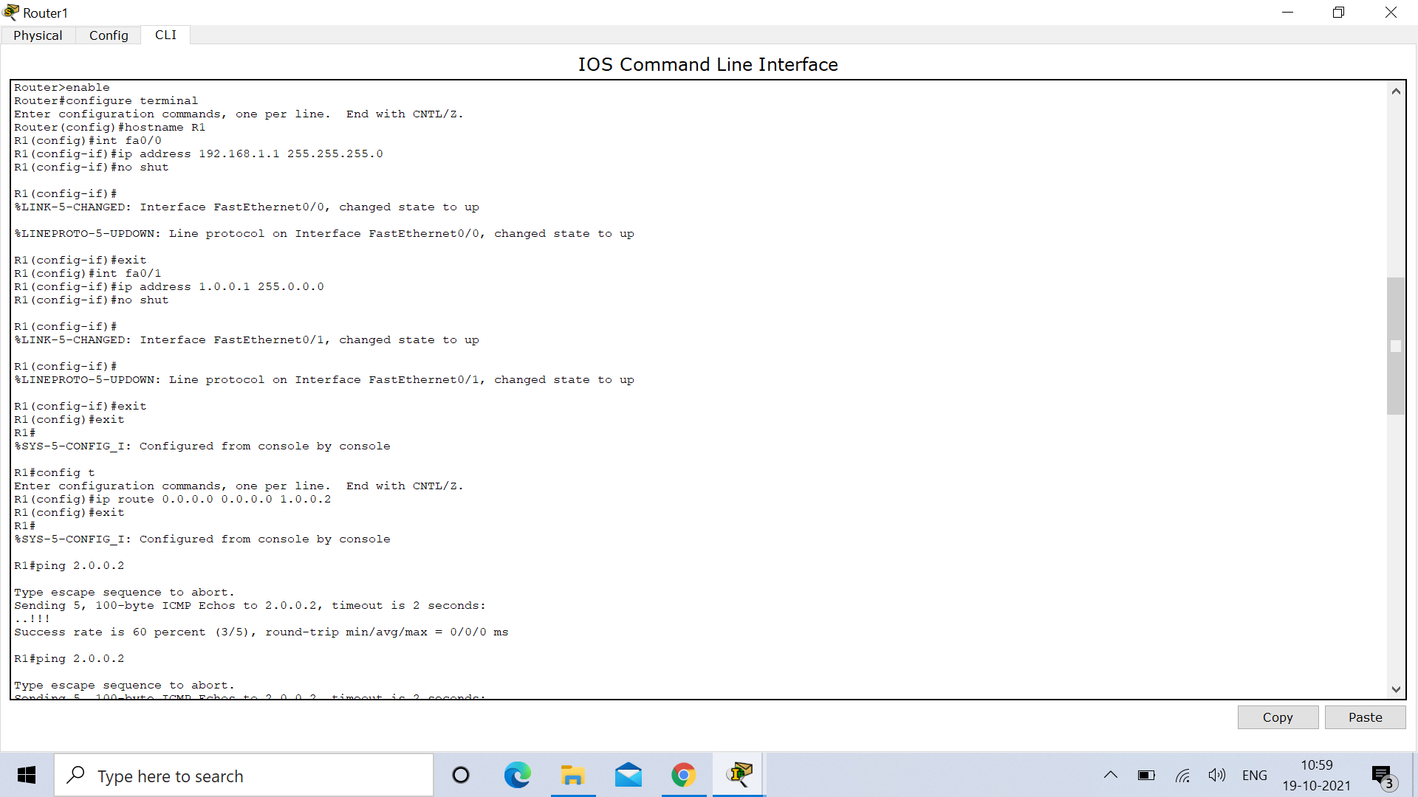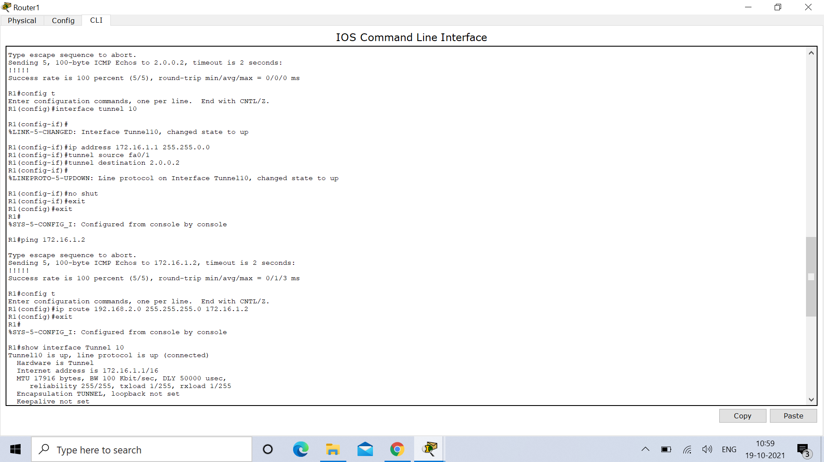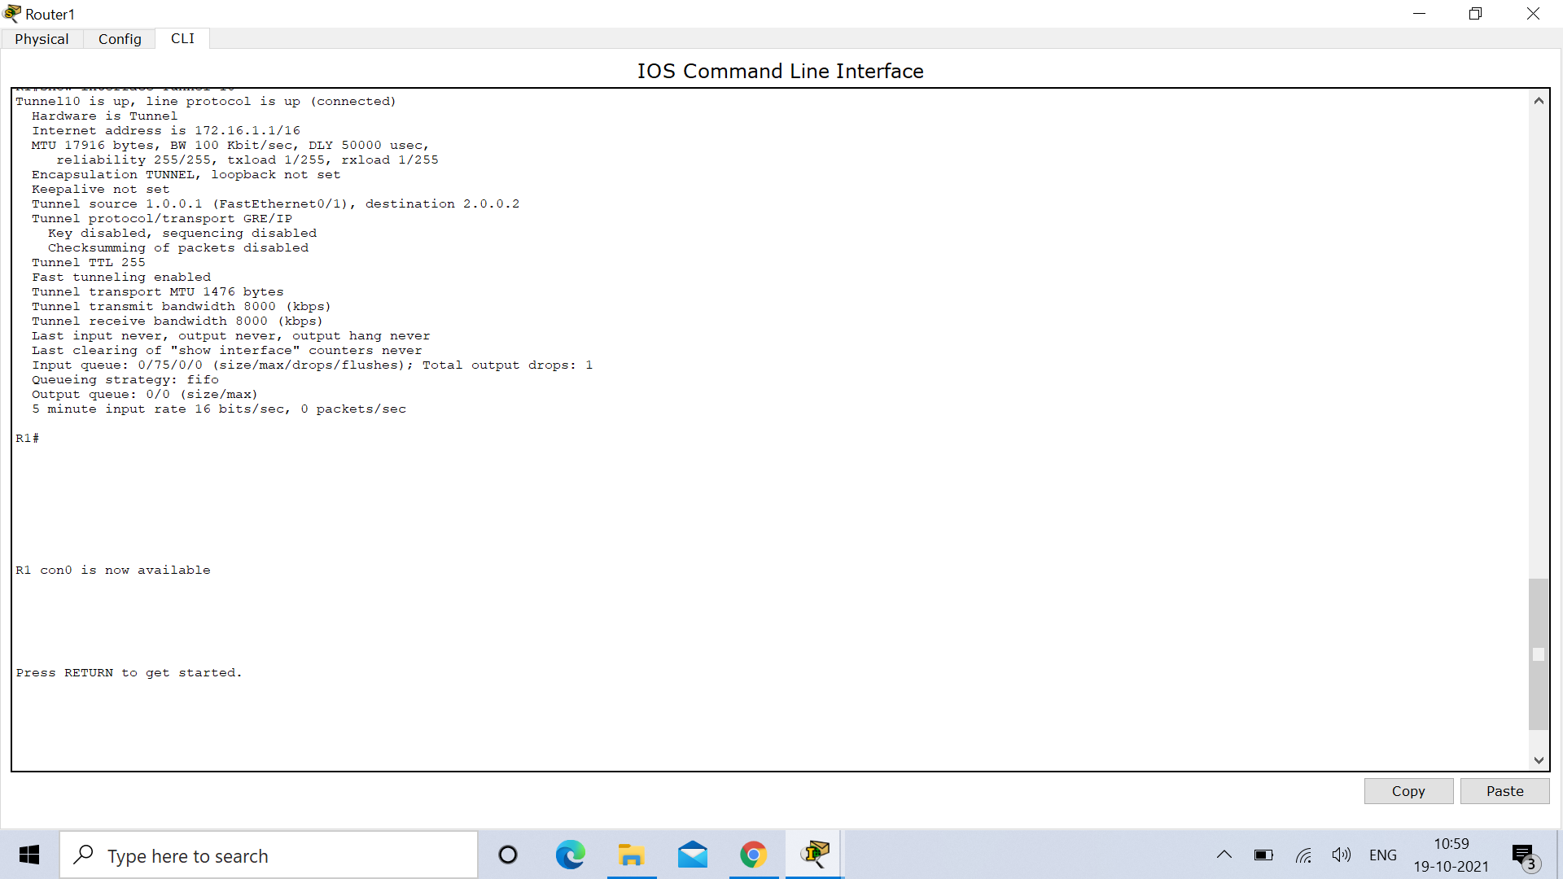

**Router 2 :**

Router>enable

Router#config t

Enter configuration commands, one per line. End with CNTL/Z.

Router(config)#host R2

R2(config)#int fa0/0

R2(config-if)#ip add 1.0.0.2 255.0.0.0

R2(config-if)#no shut

R2(config-if)#

%LINK-5-CHANGED: Interface FastEthernet0/0, changed state to up

%LINEPROTO-5-UPDOWN: Line protocol on Interface FastEthernet0/0, changed state to up

R2(config-if)#exit

R2(config)#int fa0/1

R2(config-if)#ip add 2.0.0.1 255.0.0.0

R2(config-if)#no shut

R2(config-if)#

%LINK-5-CHANGED: Interface FastEthernet0/1, changed state to up

R2(config-if)#

%LINEPROTO-5-UPDOWN: Line protocol on Interface FastEthernet0/1, changed state to up

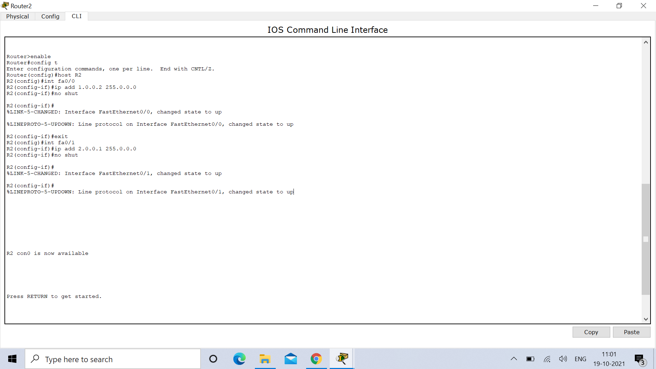

**Router 3 :**

Router>enable

Router#config t

Enter configuration commands, one per line. End with CNTL/Z.

Router(config)#host R3

R3(config)#int fa0/0

R3(config-if)#ip add 2.0.0.2 255.0.0.0

R3(config-if)#no shut

R3(config-if)#

%LINK-5-CHANGED: Interface FastEthernet0/0, changed state to up

%LINEPROTO-5-UPDOWN: Line protocol on Interface FastEthernet0/0, changed state to up

R3(config-if)#exit

R3(config)#int fa0/1

R3(config-if)#ip add 192.168.2.1 255.255.255.0

R3(config-if)#no shut

R3(config-if)#

%LINK-5-CHANGED: Interface FastEthernet0/1, changed state to up

%LINEPROTO-5-UPDOWN: Line protocol on Interface FastEthernet0/1, changed state to up

R3(config-if)#exit

R3(config)#exit

R3#

%SYS-5-CONFIG_I: Configured from console by console

R3#config t

Enter configuration commands, one per line. End with CNTL/Z.

R3(config)#ip route 0.0.0.0 0.0.0.0 2.0.0.1

R3(config)#exit

R3#

%SYS-5-CONFIG_I: Configured from console by console

R3#ping 1.0.0.1

Type escape sequence to abort.

Sending 5, 100-byte ICMP Echos to 1.0.0.1, timeout is 2 seconds:

!!!!!

Success rate is 100 percent (5/5), round-trip min/avg/max = 0/0/1 ms

R3#config t

Enter configuration commands, one per line. End with CNTL/Z.

R3(config)#interface tunnel 100

R3(config-if)#

%LINK-5-CHANGED: Interface Tunnel100, changed state to up

R3(config-if)#ip address 172.16.1.2 255.255.0.0

R3(config-if)#tunnel source fa0/0

R3(config-if)#tunnel destination 1.0.0.1

R3(config-if)#

%LINEPROTO-5-UPDOWN: Line protocol on Interface Tunnel100, changed state to up

R3(config-if)#no shut

R3(config-if)#exit

R3(config)#exit

R3#

%SYS-5-CONFIG_I: Configured from console by console

R3#ping 172.16.1.1

Type escape sequence to abort.

Sending 5, 100-byte ICMP Echos to 172.16.1.1, timeout is 2 seconds:

!!!!!

Success rate is 100 percent (5/5), round-trip min/avg/max = 0/0/0 ms

R3#config t

Enter configuration commands, one per line. End with CNTL/Z.

R3(config)#ip route 192.168.1.0 255.255.255.0 172.16.1.1

R3(config)#exit

R3#

%SYS-5-CONFIG_I: Configured from console by console

R3#show interface Tunnel 100

Tunnel100 is up, line protocol is up (connected)

Hardware is Tunnel

Internet address is 172.16.1.2/16

MTU 17916 bytes, BW 100 Kbit/sec, DLY 50000 usec,

reliability 255/255, txload 1/255, rxload 1/255

Encapsulation TUNNEL, loopback not set

Keepalive not set

Tunnel source 2.0.0.2 (FastEthernet0/0), destination 1.0.0.1

Tunnel protocol/transport GRE/IP

Key disabled, sequencing disabled

Checksumming of packets disabled

Tunnel TTL 255

Fast tunneling enabled

Tunnel transport MTU 1476 bytes

Tunnel transmit bandwidth 8000 (kbps)

Tunnel receive bandwidth 8000 (kbps)

Last input never, output never, output hang never

Last clearing of "show interface" counters never

Input queue: 0/75/0/0 (size/max/drops/flushes); Total output drops: 1

Queueing strategy: fifo

Output queue: 0/0 (size/max)

5 minute input rate 16 bits/sec, 0 packets/sec

5 minute output rate 16 bits/sec, 0 packets/sec

10 packets input, 1280 bytes, 0 no buffer

Received 0 broadcasts, 0 runts, 0 giants, 0 throttles

0 input errors, 0 CRC, 0 frame, 0 overrun, 0 ignored, 0 abort

0 input packets with dribble condition detected

10 packets output, 1280 bytes, 0 underruns

0 output errors, 0 collisions, 0 interface resets

0 unknown protocol drops

0 output buffer failures, 0 output buffers swapped out

R3#

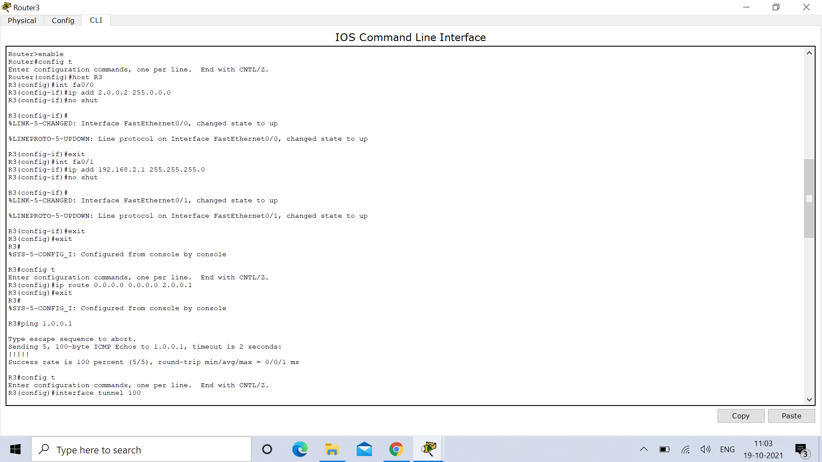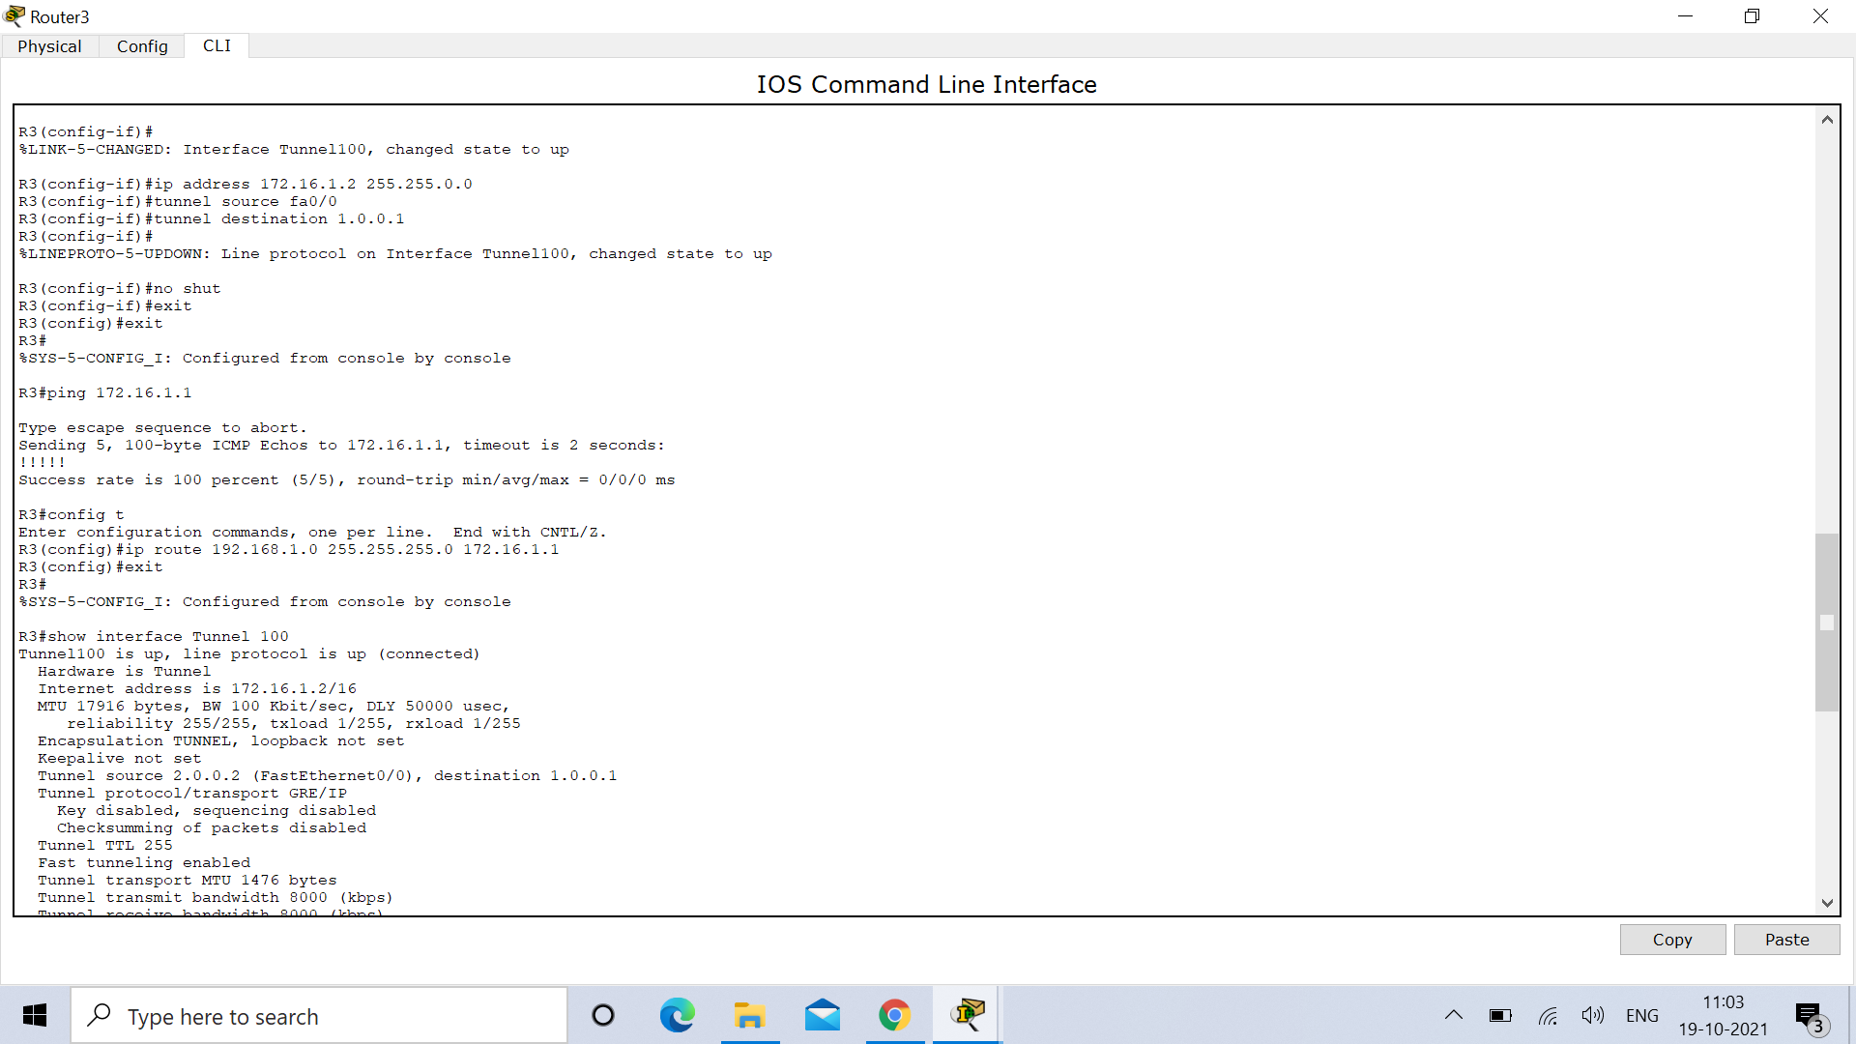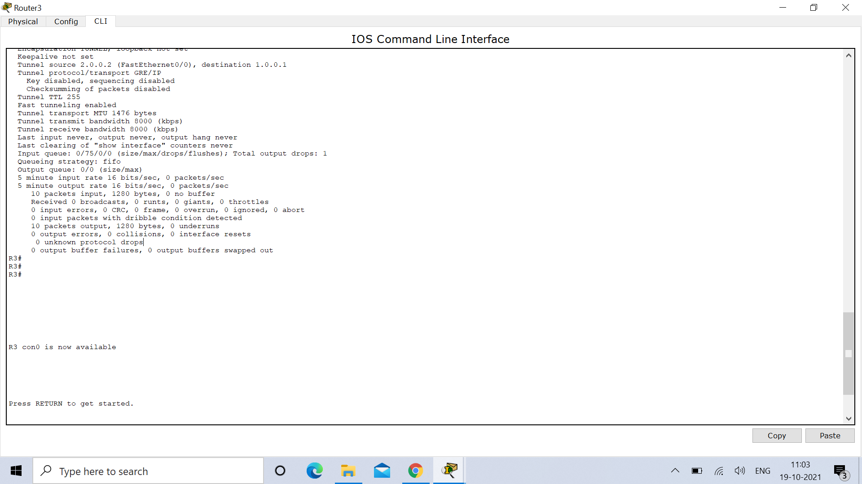

**OUTPUT :**

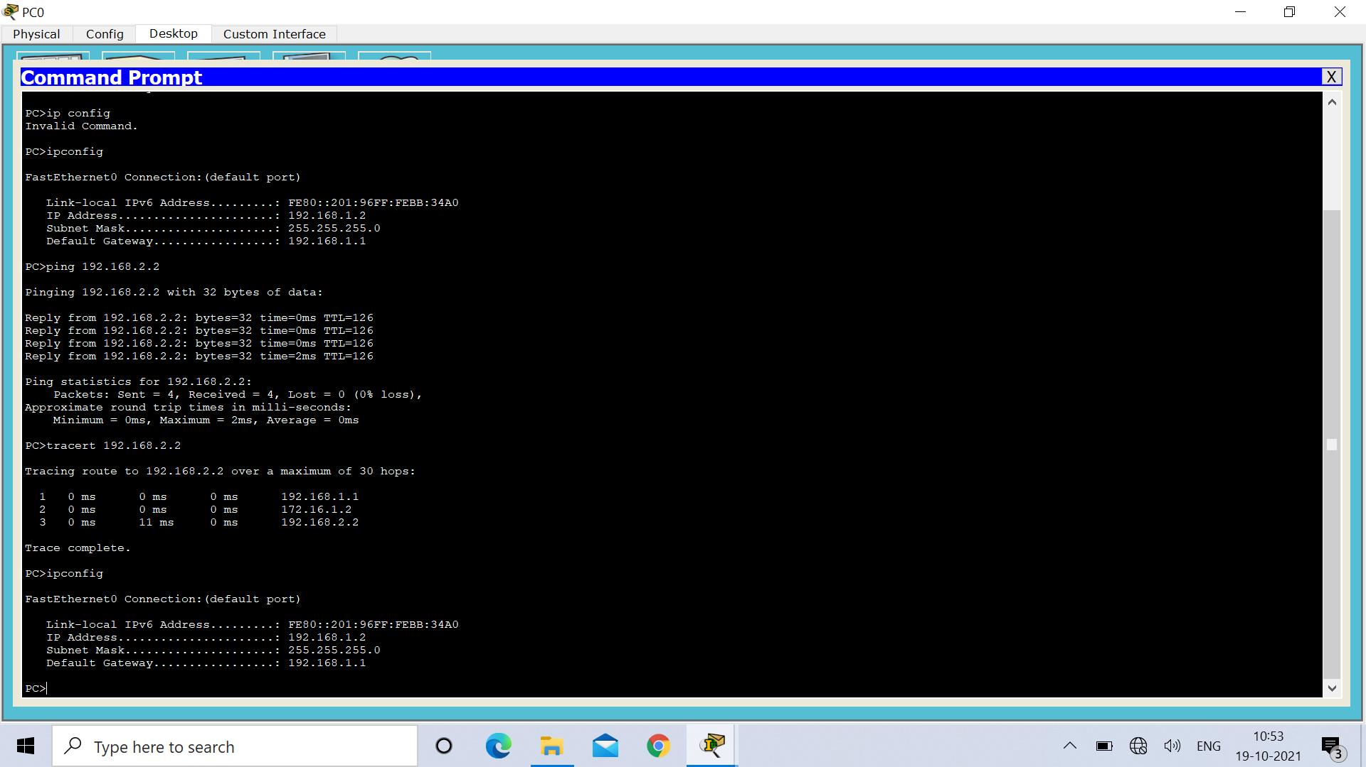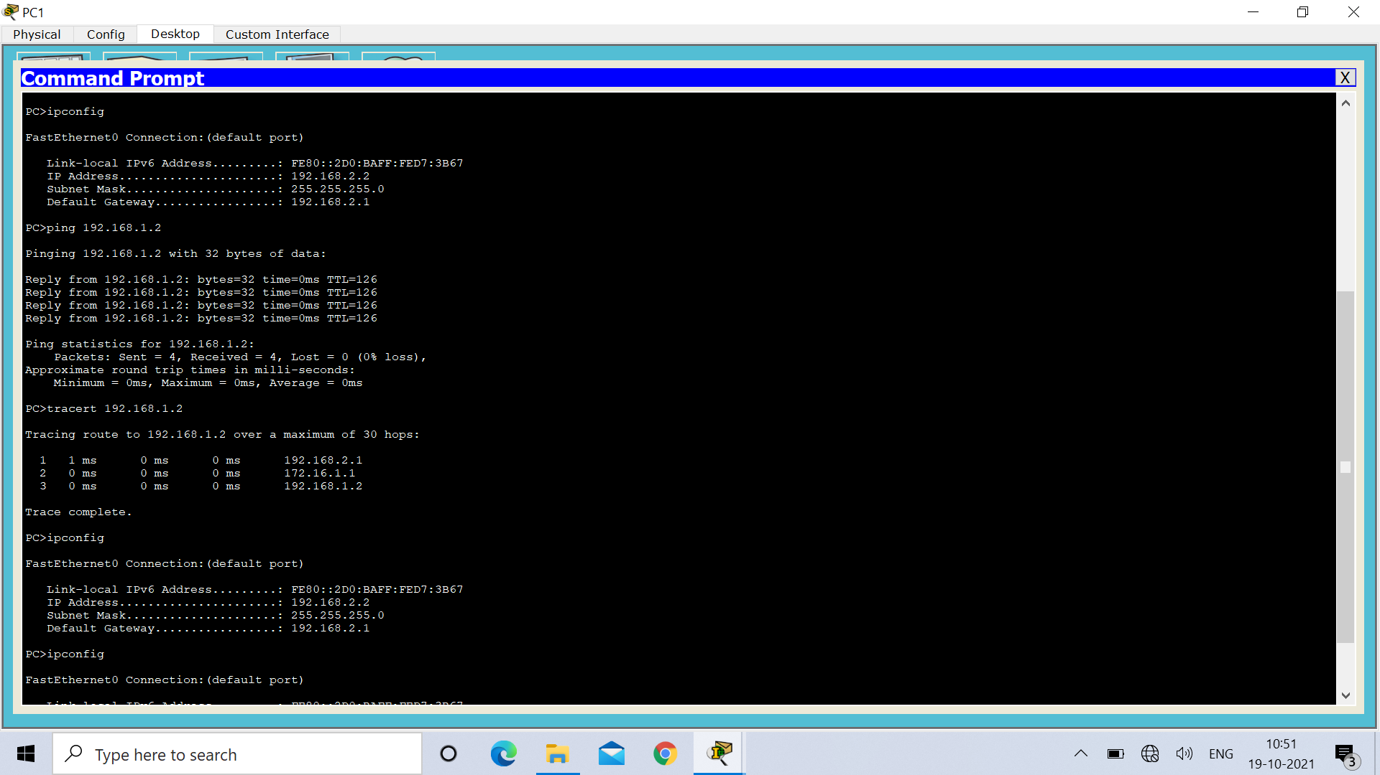

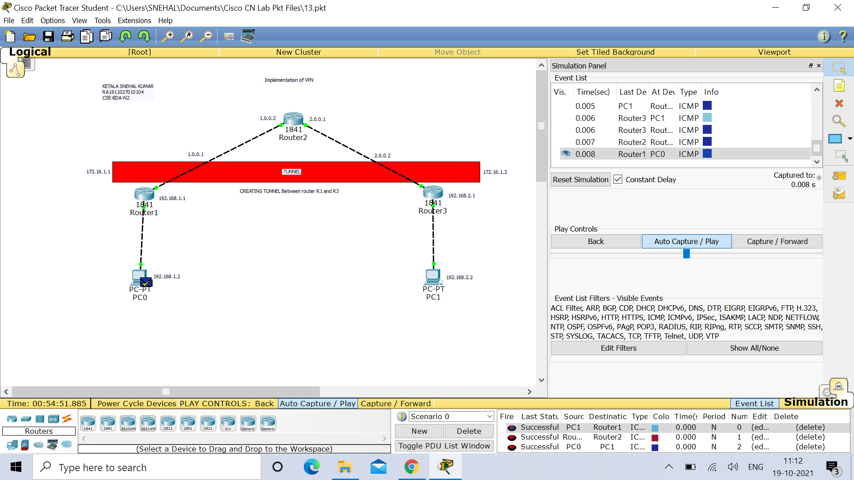

**Result :** Hence Implementation of VPN is successfully done and verified.