AI ASSISTED CODING
Assignment-14.1
Name : K.Snehal
Roll No : 2303A52114
Batch : 40
Lab 14: Web Design Application – AI-Assisted HTML/CSS/JS Generation
Lab Objectives
• Design functional, visually appealing web applications using HTML, CSS, and JavaScript with AI assistance.
• Apply responsive, accessible, and interactive design principles.
• Create practical UI components for real-world web applications.
• Use AI to optimize layout, UX, and performance.
Task 1 – Portfolio Website Design
You are building a personal portfolio website to showcase your work.
Requirements:
• Create sections for About Me, Projects, and Contact.
• Use AI to:
o Suggest color palettes and typography.
o Create a responsive layout with Grid/Flexbox.
o Add smooth scrolling navigation.

Code:
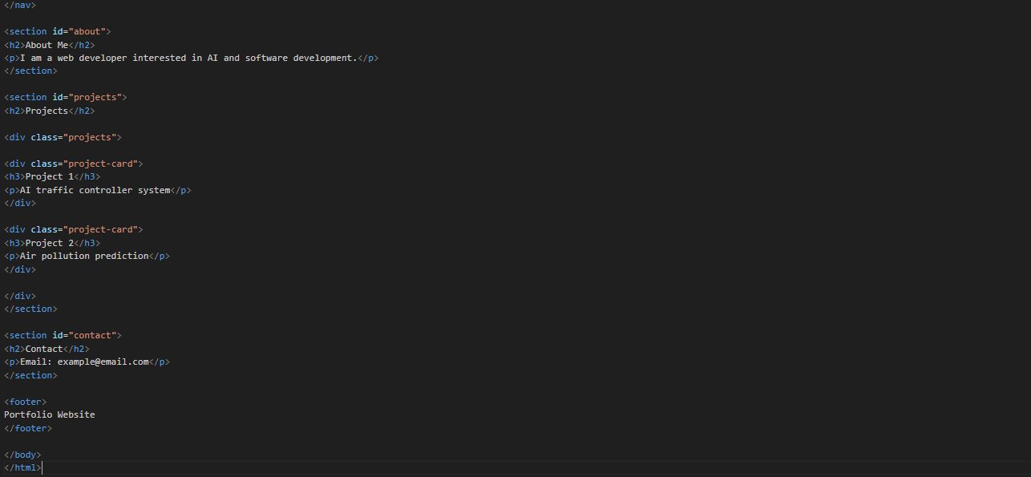
Output:
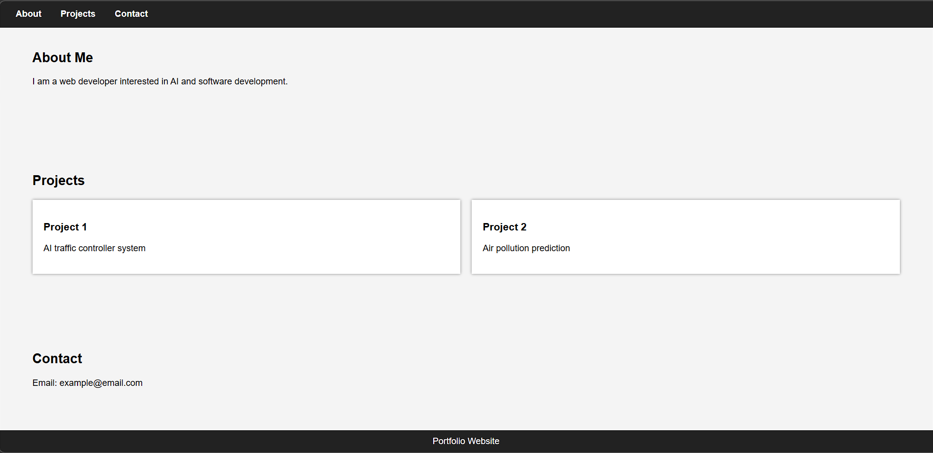

Task 2 – Online Store Product Page
Design a product display page for an online store.
Requirements:
• Display product image, title, price, and "Add to Cart" button.
• Use AI to:
o Style with BEM methodology.
o Make layout responsive.
o Add hover effects and "Add to Cart" alert.
Code: 
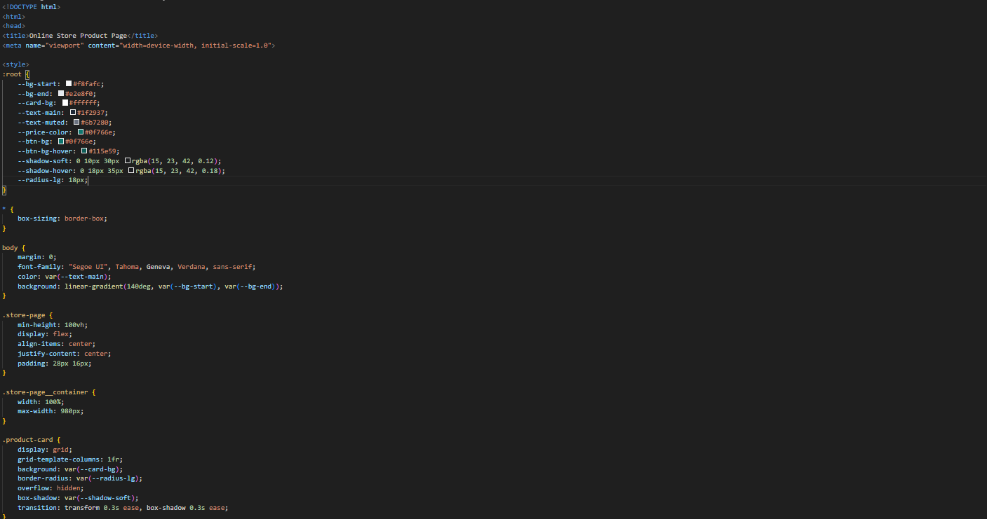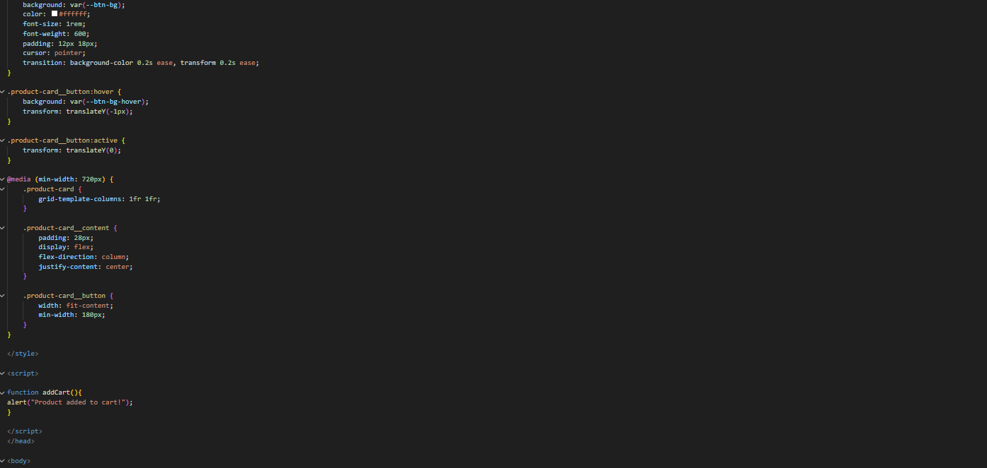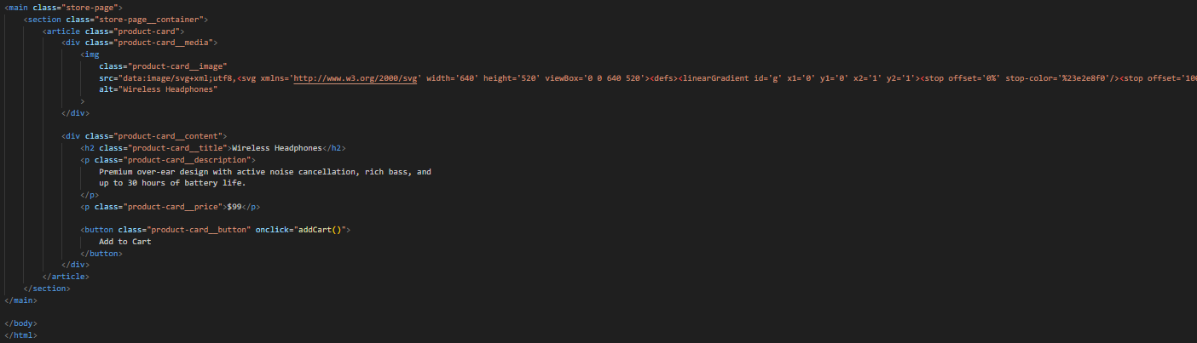

Output:
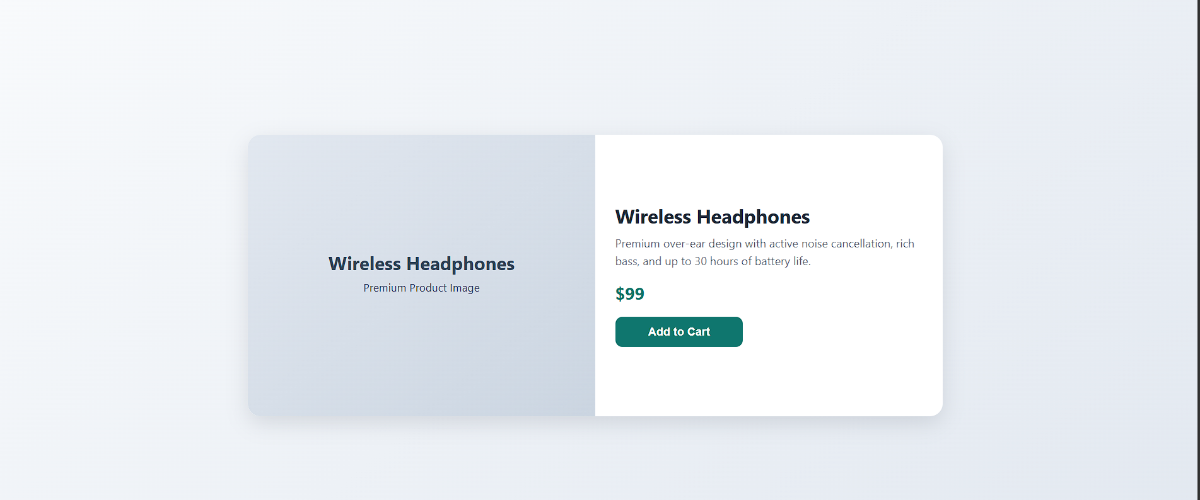

Task 3 – Event Registration Form
Build an event registration form for a conference.
Requirements:
• Collect name, email, phone number, and session selection.
• Use AI to:
o Add form validation with JavaScript.
o Make the form accessible with labels and ARIA.
o Style with a professional look.
Code: 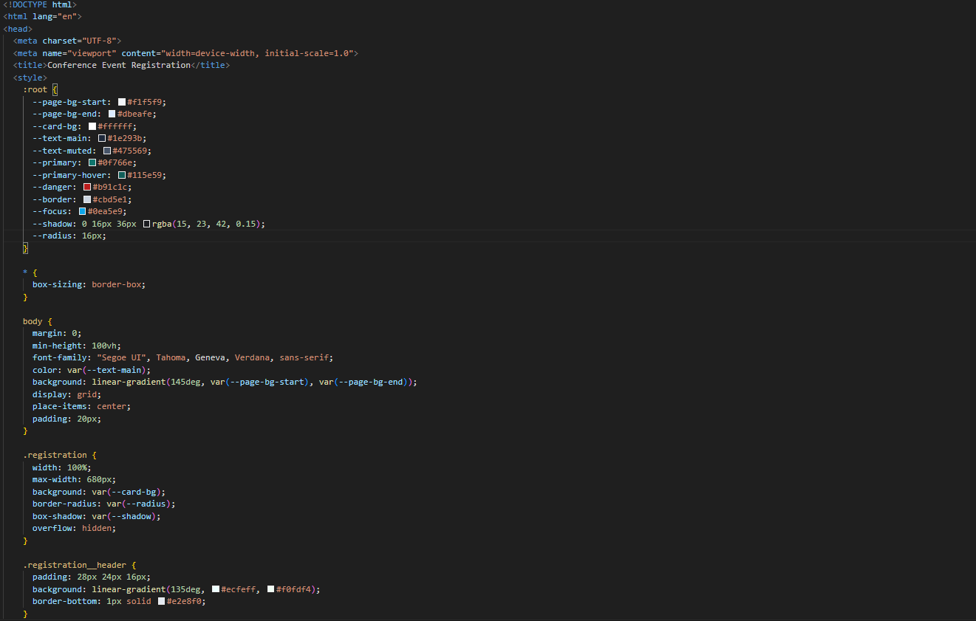  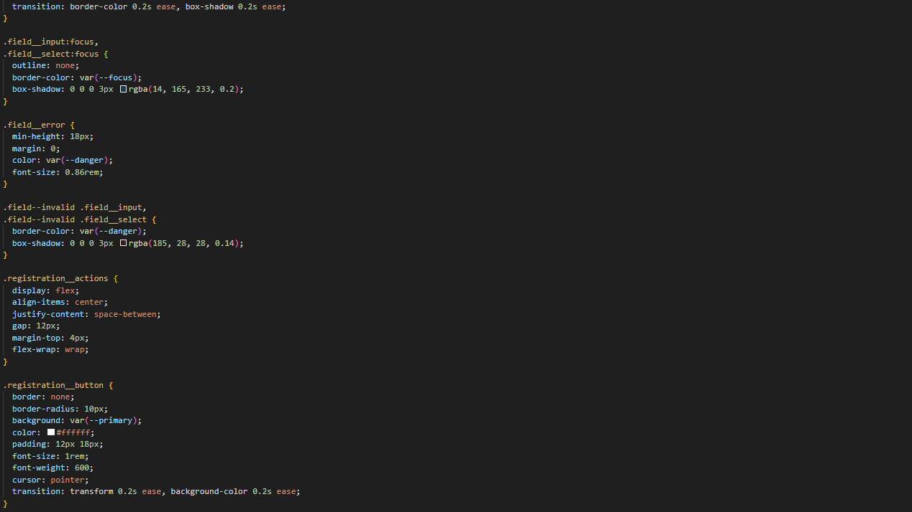 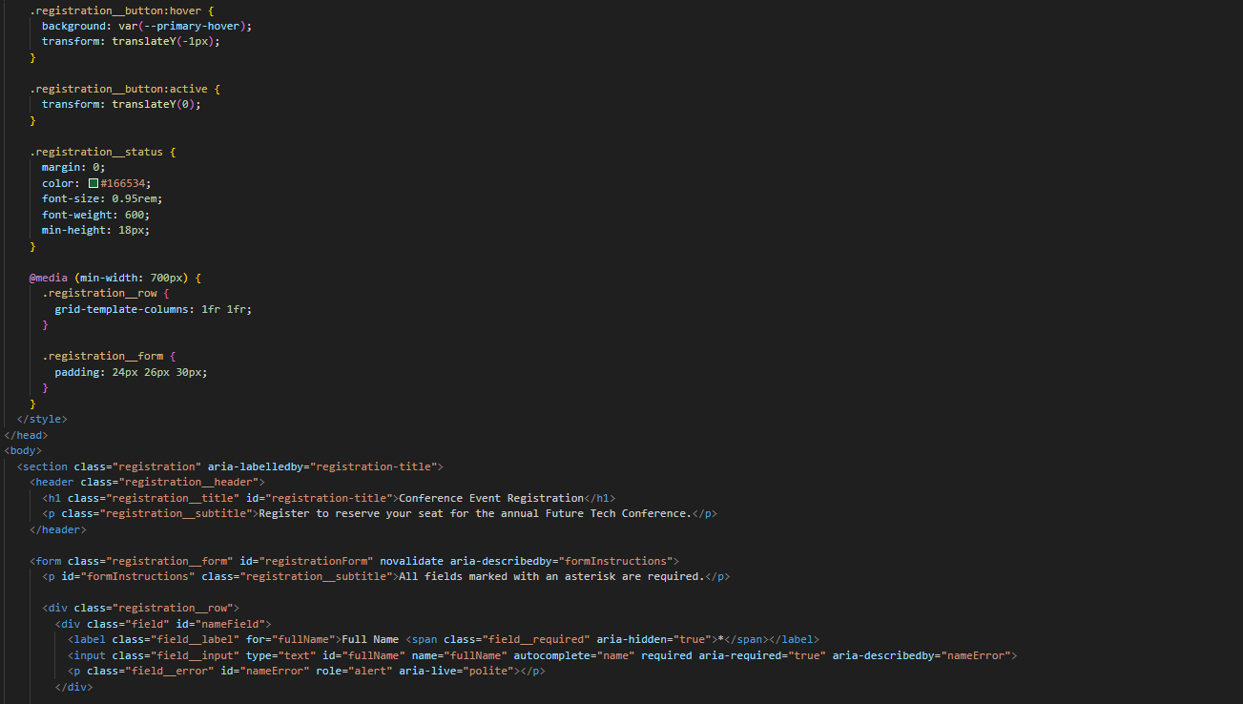 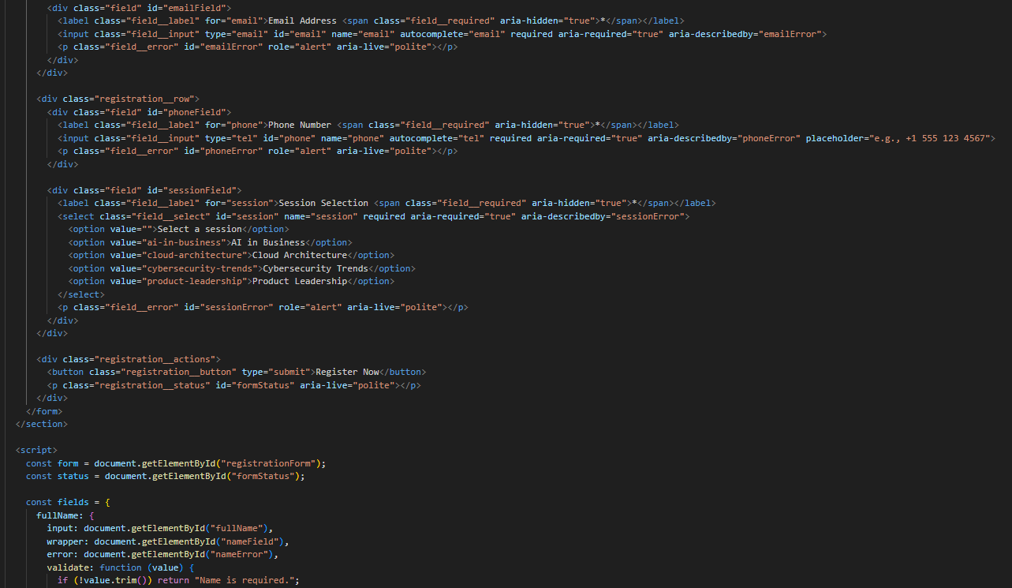 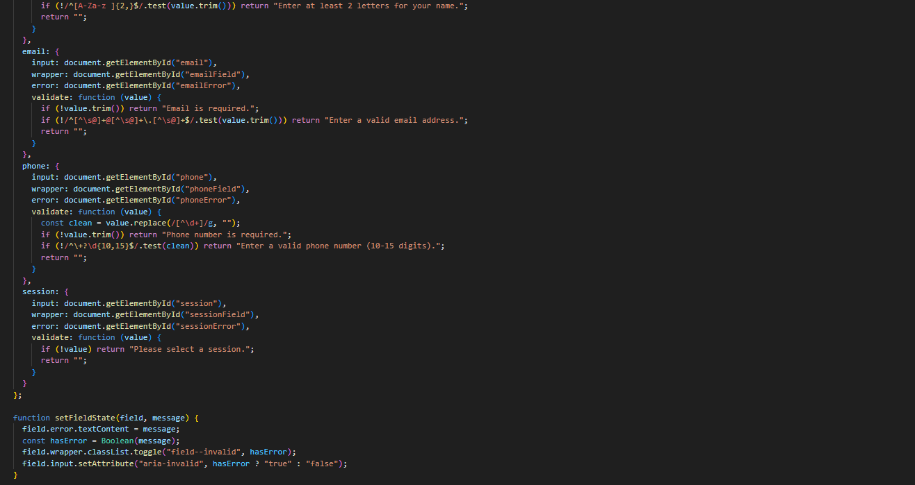 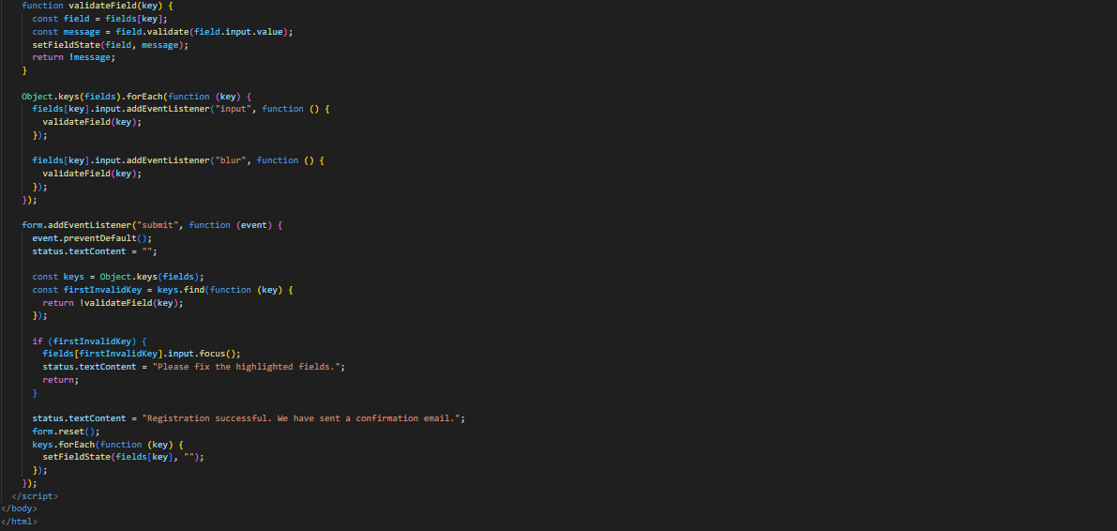
Output: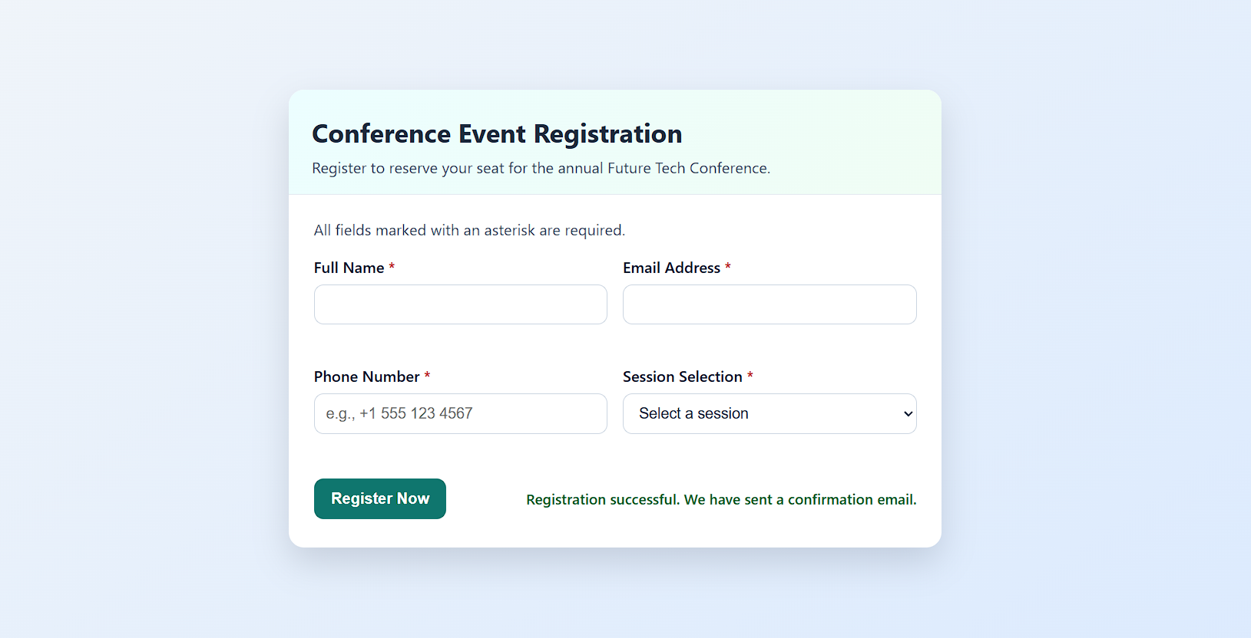

Task 4 – Resume Website
Build a one-page online resume.
Requirements:
• Sections: Profile Summary, Skills, Education, Experience.
• Use AI to:
o Propose professional typography styles.
o Align sections using CSS Grid.
o Add smooth scroll navigation between sections.
Code:
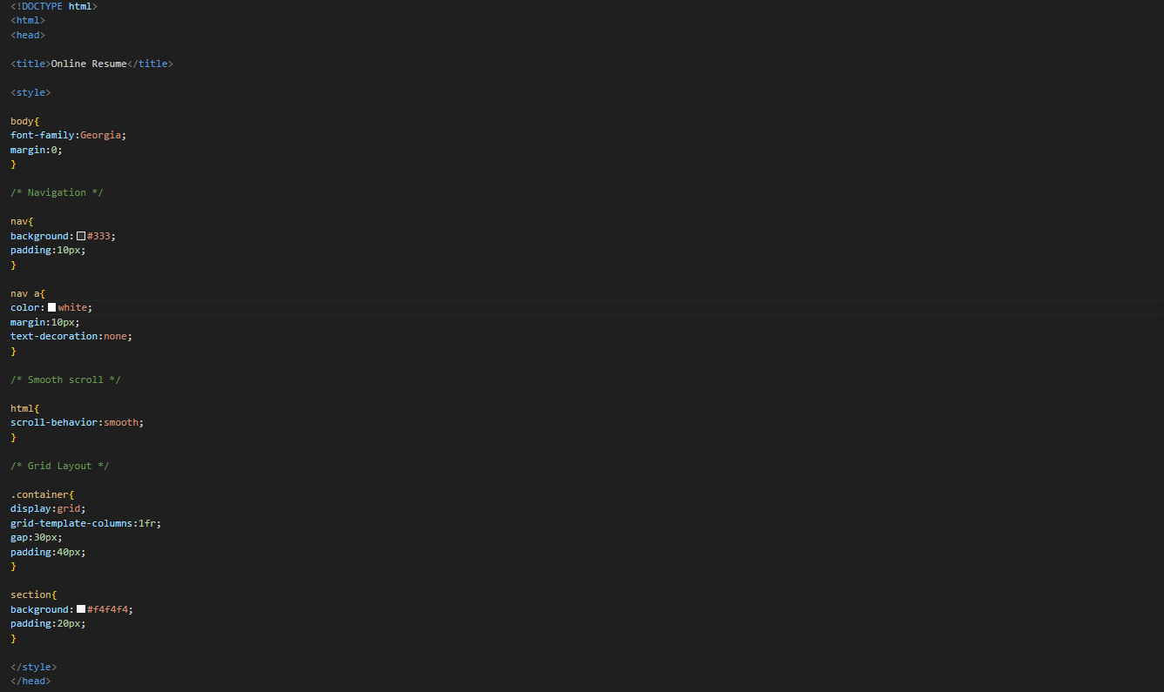
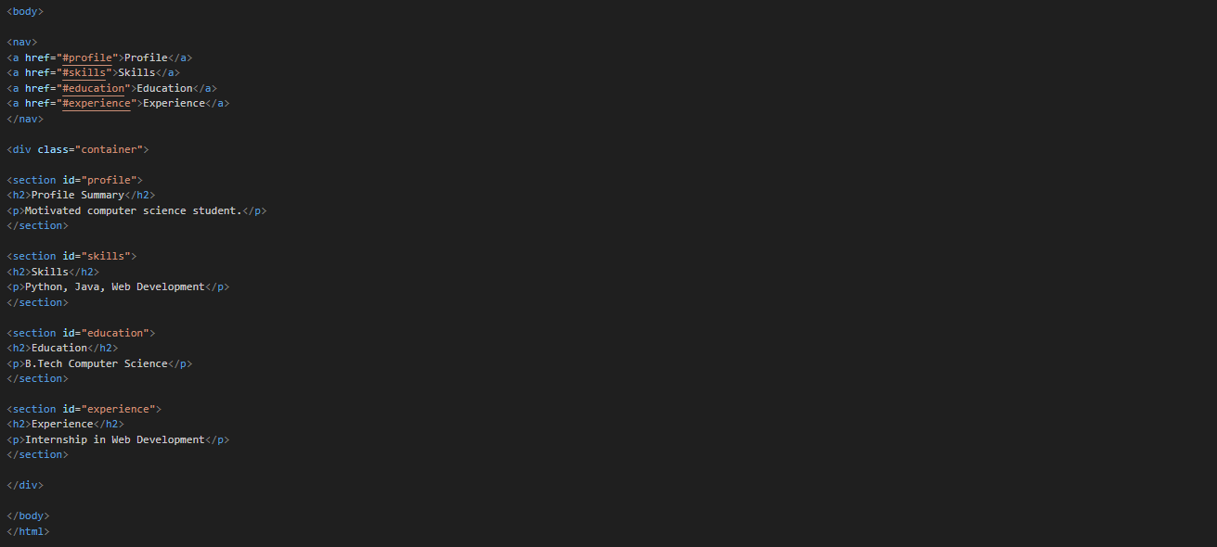
Output:
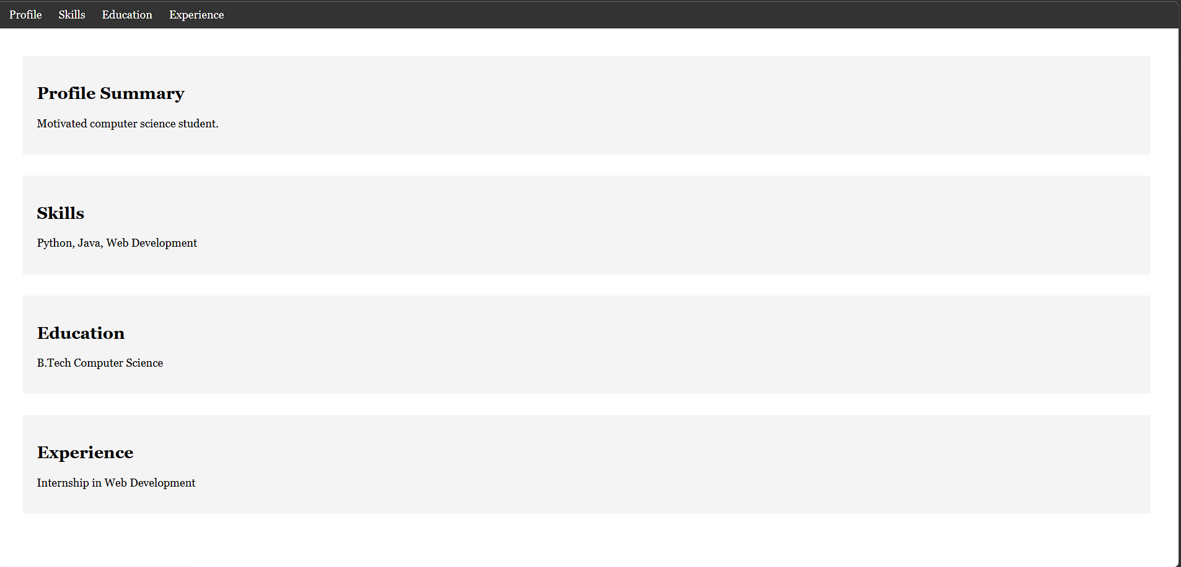

Task 5 – Restaurant Menu Page
Design a digital menu page for a restaurant.
Requirements:
• Display menu items with name, description, and price.
• Use AI to:
o Suggest a food-friendly color palette.
o Design a responsive card-based layout.
o Add hover effects on menu items.
Code:  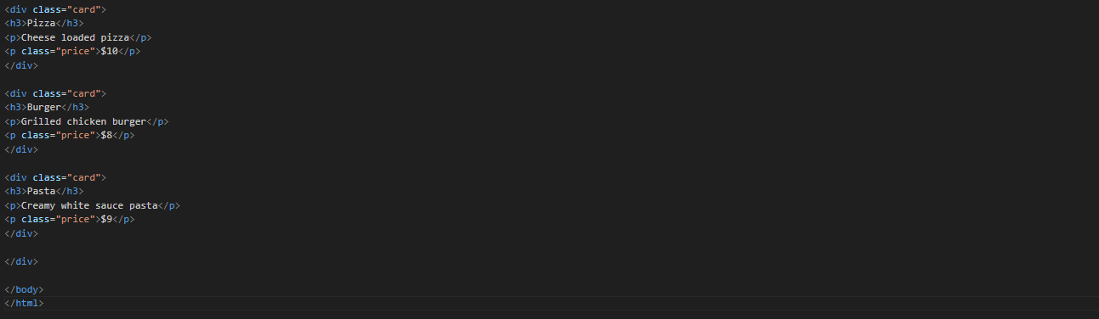
Output:
