📈 Algo-Trading System with ML & Automation

Overview
This system integrates machine learning and rule-based trading strategies with automation tools to create an end-to-end algo-trading solution. It fetches live market data, generates trade signals, executes backtests, logs trades to Google Sheets, and sends real-time alerts via Telegram. The system is modular, interpretable, and suitable for both research and deployment.
Features
- 📊 Market Data Pipeline: Real-time and historical price data access (e.g., Yahoo Finance)
- 📉 Signal Generation Module: Hybrid ML + rule-based signals (e.g., RSI + Moving Average Crossover)
- 🔁 Backtesting Engine: Performance evaluation over historical data
- 📈 Visualization Tools: Signal and trade overlays on charts
- 📬 Notification System: Telegram alerts for buy/sell signals
- 🧮 Logging Utility: Auto-log trades and metrics into Google Sheets
- 🧠 Feature Engineering Tool: Custom indicators and statistical features

Part 1: Market Data Pipeline
The fetch_data() function is responsible for retrieving historical stock price data from Yahoo Finance. This module serves as the foundation for all subsequent steps including signal generation, feature engineering, and backtesting. It ensures accurate and timely access to market data for the defined trading symbols.
Features
- 📅 Date Range Selection: Pulls data for a user-defined historical period (e.g., last 6 months)
- 💹 OHLCV Data: Retrieves Open, High, Low, Close, and Volume for each ticker
- 🛠 Ticker Support: Compatible with multiple stock symbols (e.g., ['AAPL', 'TSLA', 'MSFT'])
- 📁 Clean Output: Returns structured pandas DataFrame for seamless pipeline integration
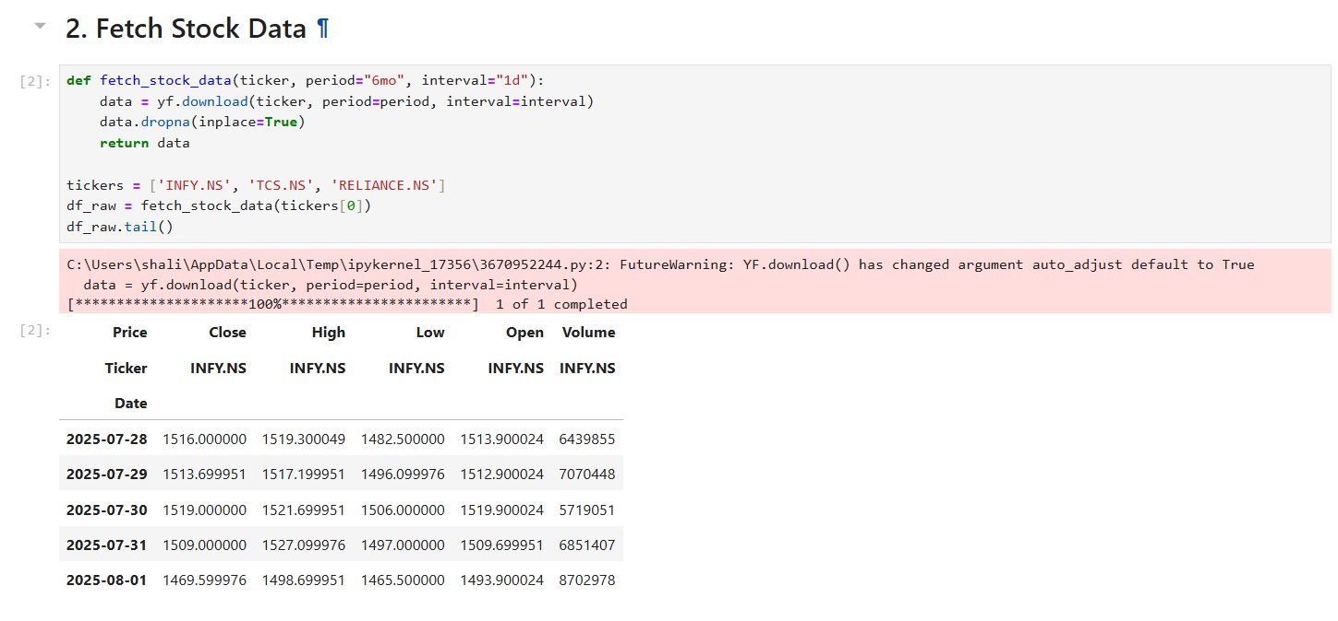
Part 2: Signal Generation Module
This module enhances raw price data with key technical indicators and uses them to generate actionable trading signals. It supports both rule-based and ML-assisted logic to identify optimal buy and sell opportunities based on market conditions.
Features
- 📐 Indicator Calculation: Adds RSI, moving averages (SMA/EMA), and other custom indicators to price data
- ⚡ Crossover Detection: Implements strategies like RSI thresholds and MA crossovers (e.g., 50/200-day)
- 🧩 Hybrid Strategy Support: Can blend rule-based logic with ML model outputs
- 🚦 Signal Labeling: Clearly marks Buy (1), Sell (-1), and Hold (0) signals
- 🧼 NaN Handling: Ensures signal logic runs only on valid, non-null data
- 📊 Scalable Design: Easily extendable to add Bollinger Bands, MACD, or other indicators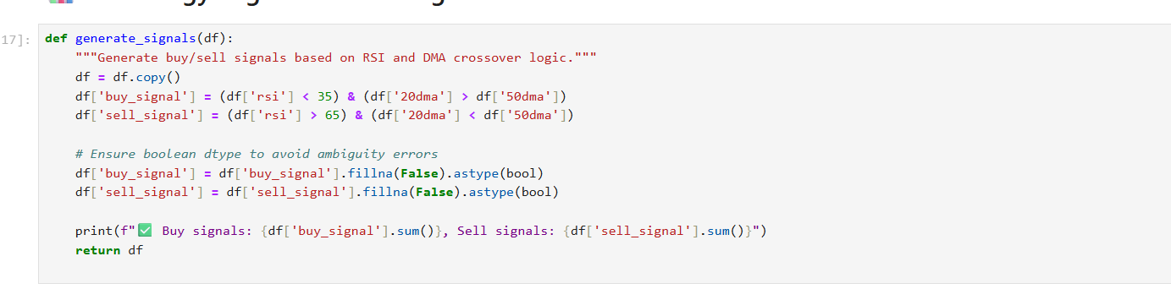
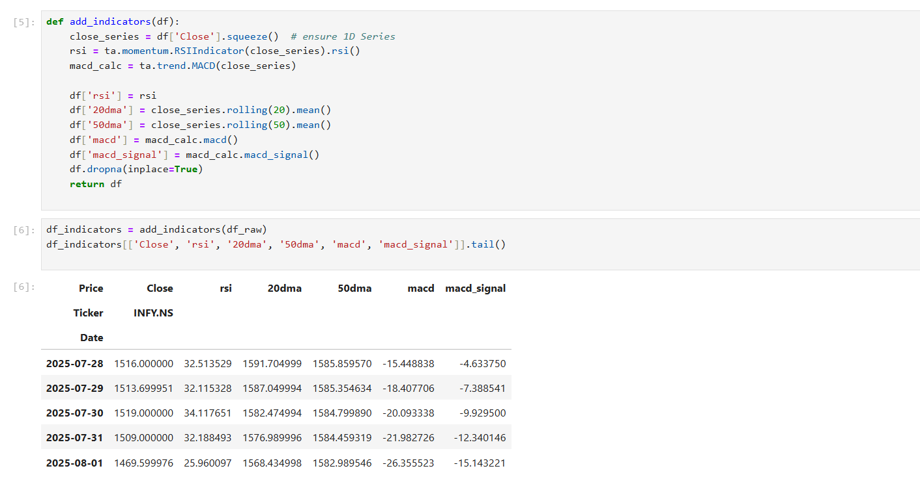

Part 3: Backtesting Engine
The backtesting module evaluates the performance of the trading strategy over historical data. It simulates trades based on generated signals and calculates key performance metrics to assess strategy viability before real-time deployment.
Features
- ⏳ Historical Simulation: Replays trades over selected time ranges to mimic real-world execution
- 💵 PnL Calculation: Computes profit and loss from buy/sell signals
- 📊 Performance Metrics: Includes win rate, total return, Sharpe ratio, and drawdown analysis
- 📍 Trade Tracking: Logs entry/exit points, signal timestamps, and trade duration
- 🔄 Position Management: Supports long-only, short-only, or long-short strategies
- 🧪 Strategy Comparison: Enables testing multiple variations or parameter sets for benchmarking
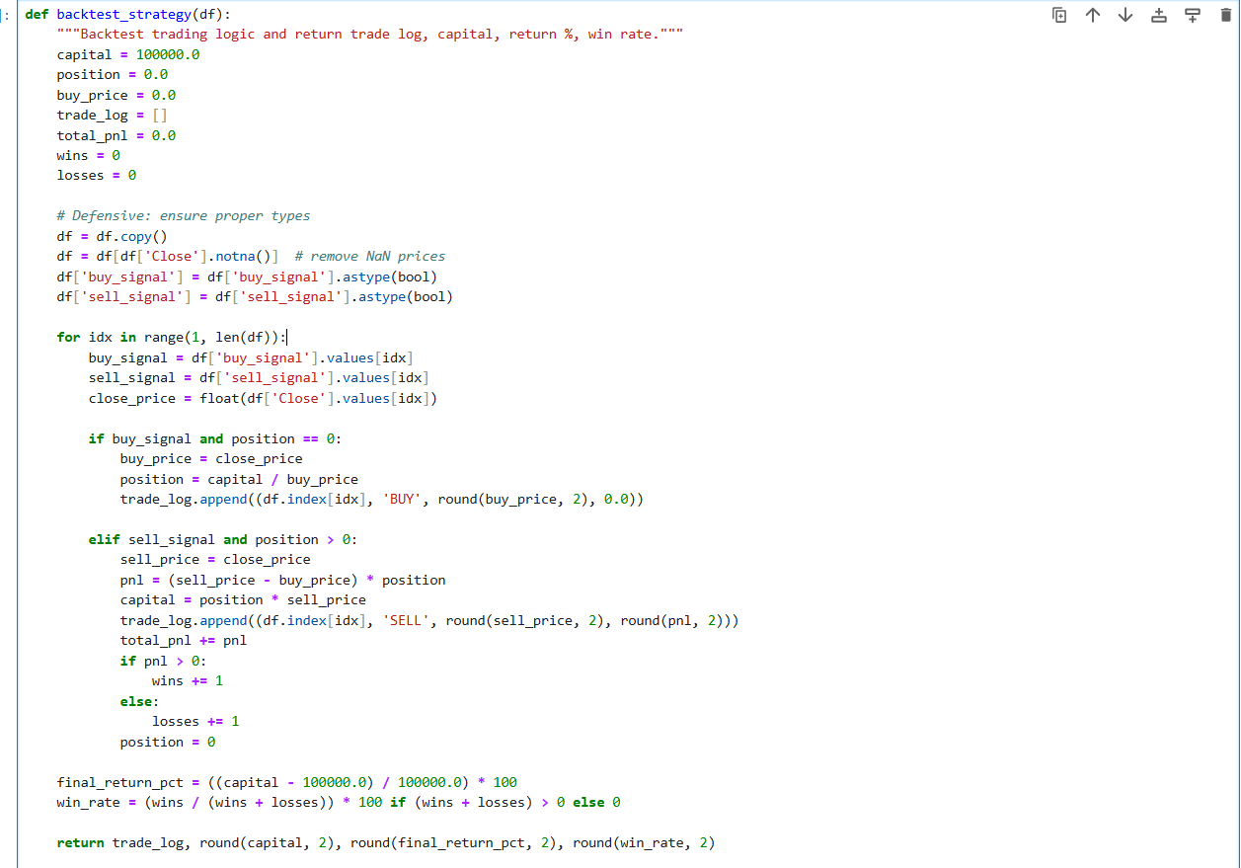

Part 4: Visualization Tools
This visualization module displays the closing price of the asset along with trading signals and technical indicators using a simple matplotlib line chart. It provides a quick and effective way to analyze strategy performance over time.
Features
- 📈 Price Line Plot: Plots the asset’s closing price over time
- 🟢 Buy/Sell Markers: Highlights buy (↑) and sell (↓) signals directly on the line chart
- 📏 Indicator Overlays: Adds moving averages (e.g., SMA/EMA) or RSI values on secondary axes
- 🗓 Date Axis Formatting: Auto-rotates and formats dates for better readability
- 🎨 Custom Styling: Color-coded signals and indicators for visual clarity
- 🧹 Minimalist Layout: Clean chart design optimized for notebooks and reports
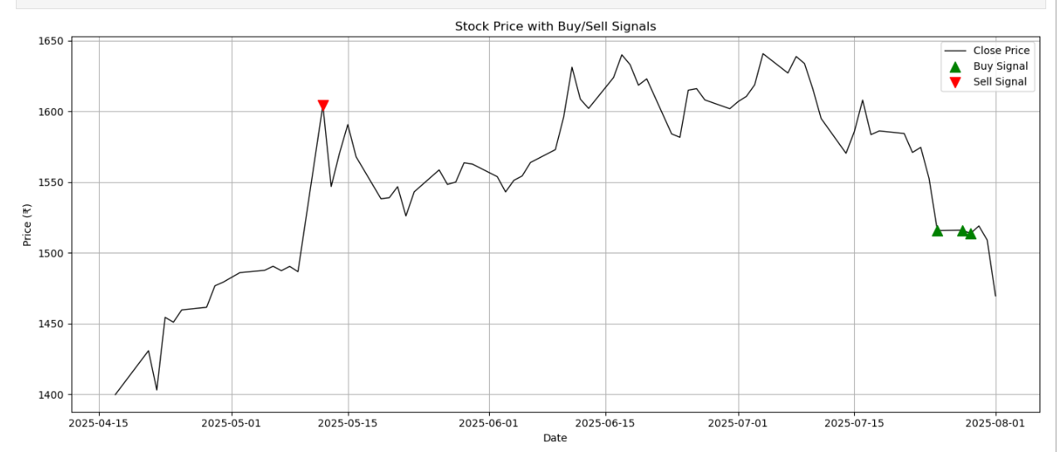
Part 5: Logging Utility
This module connects to Google Sheets via the Google Cloud Sheets API using a service account. It logs trade data, signals, and performance metrics automatically into a Google Sheet, enabling remote monitoring and persistent storage.
Features
- 🔐 Service Account Authentication: Uses a secure JSON key from Google Cloud Console for access
- 🔗 Sheets API Integration: Interacts directly with Google Sheets via the Google Cloud Sheets API
- 🧾 Trade Log Automation: Appends each trade (date, action, ticker, price, quantity, PnL) as a new row
- 🗂 Sheet Organization: Supports writing to specific sheets and ranges within the document
- 🛡 Access Control: Restricts access to only authorized Google accounts with shared sheet permissions
- 🔄 Real-Time Sync: Updates logs live during strategy execution or backtest runs
- 📈 Dashboard Ready: Enables building Google Sheets dashboards for live strategy monitoring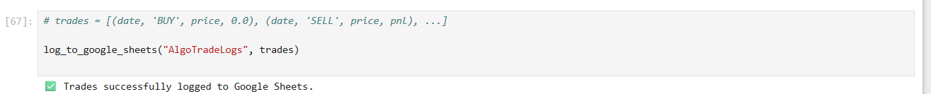
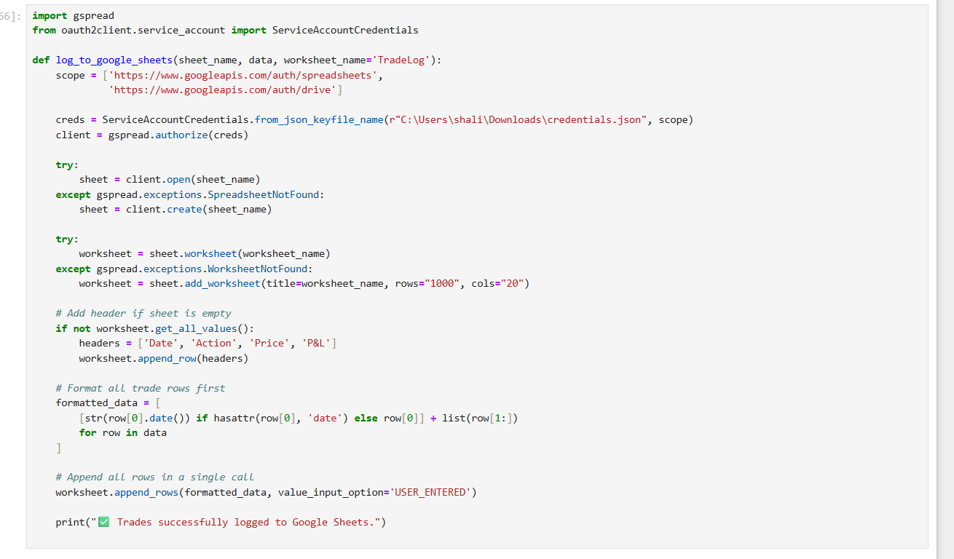

Part 6: ML Model Trainning
This module combines supervised machine learning with classic rule-based strategies (like RSI and moving average crossovers) to generate reliable trading signals. The hybrid approach enhances decision-making by leveraging both data-driven patterns and proven technical rules.
Features
- 🤖 Supervised Learning: Trains classification models (e.g., XGBoost) on labeled historical data
- 🏷 Signal Labeling: Labels Buy/Sell/Hold points using rule-based logic to create training targets
- 🔍 Feature Engineering: Uses technical indicators (RSI, SMA, EMA, etc.) as input features
- 🧪 Train-Test Split: Splits data chronologically to avoid data leakage
- 📉 Model Evaluation: Assesses accuracy, precision, recall, and F1-score on test set
- 🔗 Hybrid Signal Logic: Combines model predictions with rule filters for final trade signals
- 📦 Sklearn-Compatible: Built using scikit-learn pipelines for fast prototyping and deployment

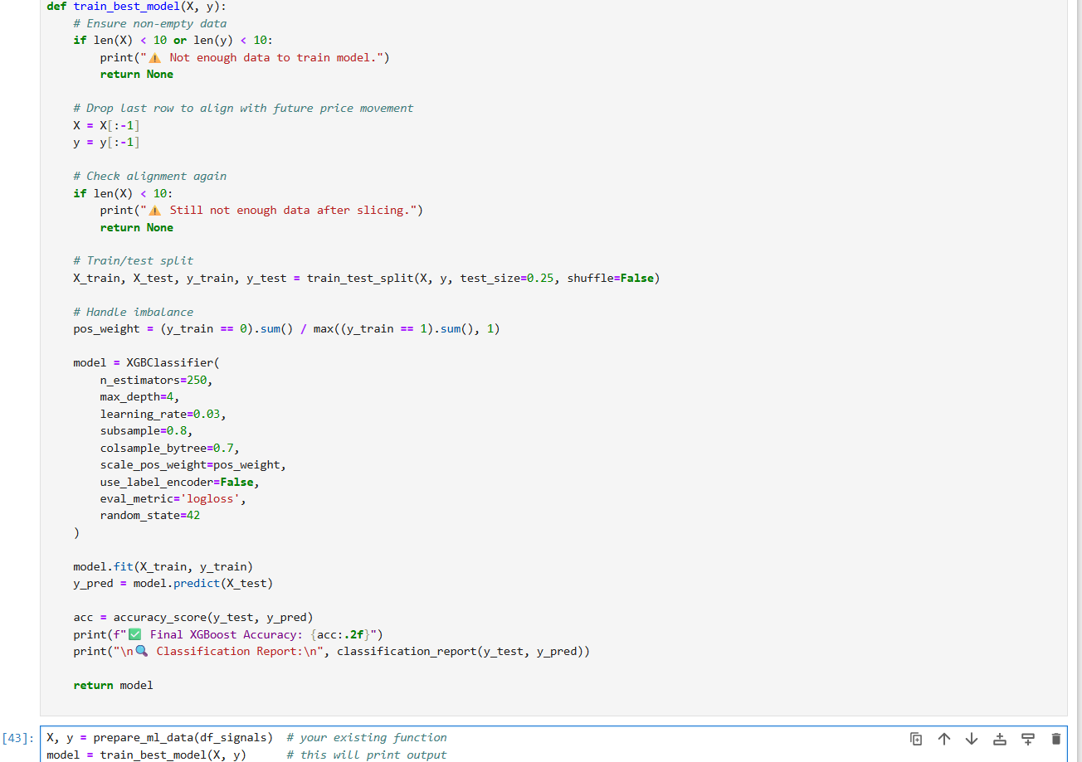

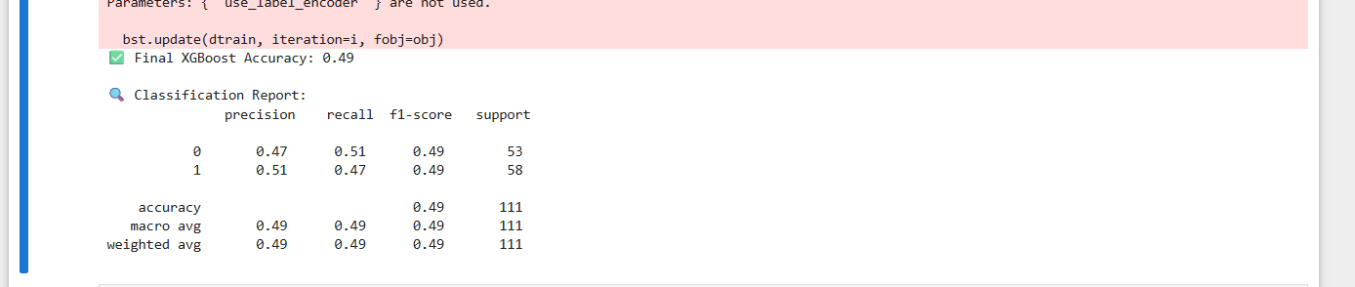

Part 7: Telegram Bot Alert
This module integrates your trading system with Telegram, allowing you to receive real-time alerts for Buy, Sell, and Hold signals directly on your phone or desktop via a Telegram bot. It enables proactive monitoring of trade events, improving decision-making speed and transparency.

Features
- 🤖 Bot Integration: Connects to the Telegram API using a secure bot token
- 🔐 Chat ID Configuration: Sends messages to your personal or group chat using your unique chat ID
- 📡 Real-Time Alerts: Sends instant notifications when a new signal is generated
- 📋 Trade Details: Includes signal type, stock name, price, and timestamp in each alert
- 📦 REST API-Based: Uses requests to call Telegram’s sendMessage API endpoint
- ⚙️ Easy Setup: Works with any strategy — just plug in your token and chat ID
- 🔁 Reusable Function: Encapsulated in a send_telegram_message() function for modular use

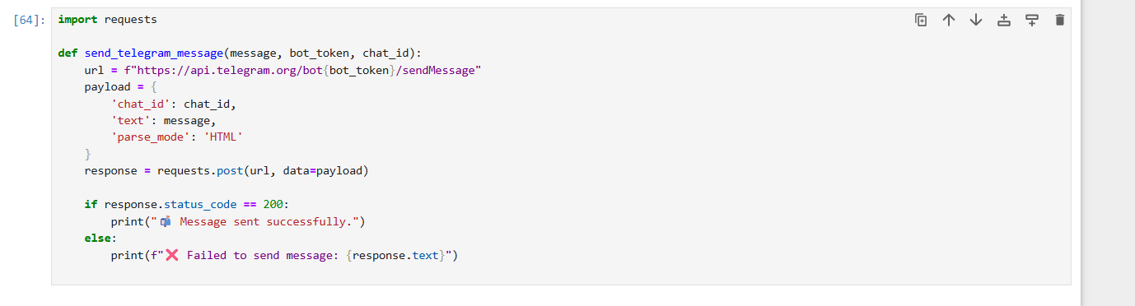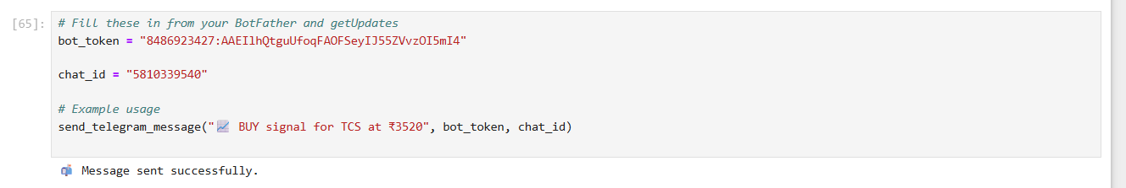

Output:
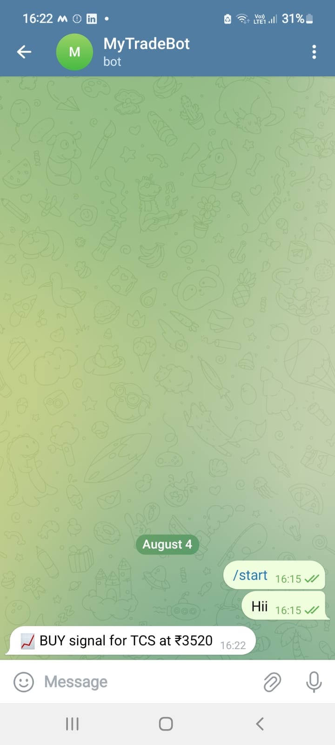

STEP BY STEP EXPLANATION:
Algo-Trading System Workflow
- Fetch Data (Yahoo Finance)
  - Retrieve historical price data (Open, High, Low, Close, Volume) for selected assets.
  - Use APIs like yfinance to access different timeframes (e.g., daily, hourly).
- Add Indicators (RSI, SMA, etc.)
  - Compute technical indicators such as Relative Strength Index (RSI) and Simple Moving Averages (SMA).
  - Store these indicators as new features in a DataFrame for further analysis.
- Label Signals (Rule-Based Logic)
  - Apply logic to identify buy, sell, or hold signals (e.g., RSI crossover or Moving Average crossover).
  - These labeled signals will serve as training data for the machine learning model.
- Train ML Model (e.g., RF/XGB)
  - Train a supervised machine learning model (like Random Forest or XGBoost) on historical indicators and labeled signals.
  - Evaluate model performance using metrics such as accuracy, precision, and F1-score.
- Generate Signals (Hybrid Logic)
  - Combine model predictions with rule-based logic to generate final trading signals.
  - This hybrid approach enhances accuracy and reduces false positives.
- Backtesting (Performance Evaluation)
  - Simulate trades over historical data to assess strategy performance.
  - Metrics include profit and loss (PnL), Sharpe ratio, drawdown, and win rate.
- Visualization (Matplotlib Charts)
  - Plot price data with indicators and trading signals using Matplotlib for visual analysis.
  - Helps in spotting false positives and refining the strategy.
- Google Sheets Logging
  - Log trades, signals, and performance metrics into Google Sheets via the Google Cloud Sheets API.
  - Ensures transparent tracking and access from anywhere.
- Telegram Alerts (Optional)
  - Send real-time buy/sell notifications to Telegram for live monitoring.
  - Useful for both manual intervention and automated execution.

WORKFLOW:
